South West Reactive Power Summer 2026 Requirements Consultation

Version control
Version | Date | Comment
V1 | 5 June 2026 | Consultation for reactive power needs in the South West region.

Legal Disclaimer and Copyright
This document has been prepared by National Energy System Operator (NESO) and is provided voluntarily and without charge. Whilst NESO has taken all reasonable care in preparing this document, no representation or warranty either expressed or implied is made as to the accuracy or completeness of the information that it contains and parties using information within the document should make their own enquiries as to its accuracy and suitability for the purpose for which they use it. Neither NESO nor any directors or employees of any such company shall be liable for any error or misstatement or opinion on which the recipient of this document relies or seeks to rely other than fraudulent misstatement or fraudulent misrepresentation and does not accept any responsibility for any use which is made of the information or the document or (to the extent permitted by law) for any damages or losses incurred. Copyright National Energy System Operator 2026, all rights reserved.

Background Context
Over the past couple of years NESO has engaged with the market with regards a Mid-term Reactive power market. Earlier in 2026 NESO ran a Pre-Market Consultation with regards to the Mid-term Reactive Power Market. NESO is now preparing for the launch of this market later in 2026.

Whilst this work continues, NESO are launching this early Requirements Consultation, seeking market feedback regarding the possibility to procure near-term reactive power capability to address acute and forecast voltage needs in the South West of England in Summer 2026, prior to the launch of the Mid-term Reactive Power market. The requirement is driven by increasing periods of low demand, high embedded generation output, and constrained outage plans.

This requirement is intended to support operability, voltage risk management and balancing cost reduction over the next 24 months, accelerating access to additional reactive reserves in this area ahead of an enduring mid-term reactive power market.

This document formally invites market participants to provide consultation feedback and provides instructions on how to do so.

Any feedback returned to NESO will help NESO understand and assess capability based on the following principles:

- Contribution to voltage risk reduction
- Available effective providers verses alternative actions
- Deliverability within the required timescales
- Operational simplicity and controllability
Please respond to this South West Reactive Power Consultation via email to .box.voltage@neso.energy by 26 June 2026

Purpose of Consultation
This is a consultation exercise only and does not part of a formal tender process at this stage.

All information provided in this document is indicative and subject to change prior to the launch of any formal tender process or contractual arrangement and a contract will not be awarded as a result of a response to this consultation.

South West Reactive Power: System Requirements
NESO is seeking feedback from Transmission and Distribution connected assets within the South West transmission region, with priority focus on assets electrically influencing the following areas and boundaries:
- Indian Queens, Alverdiscott, Taunton, Shurton, Hinkey Point, Seabank, Melksham, Sandford, Bramley, Fleet, Lovedean, Botley Wood, Chilling, Fawley, Marchwood, Nursling, Mannington, Chickerell, Axminster, Exeter, Abham, Langage, Landulph.
- Assets connected at transmission level that have a demonstrable influence on 400 kV and 275 kV voltage control in the South West.
- Assets connected to the distribution level that have a demonstrable influence on 400 kV and 275 kV voltage control in the South West.
Providers must specify the connection point they connect to, and their MVAr capability as a minimum. More details provided in the table below.
NESO will use this information to understand the electrical influence of the asset on the transmission system. Note, for any distribution level assets that respond, NESO would explore with the relevant DNO how best to access this capability.
EYTS transmission connected generation.
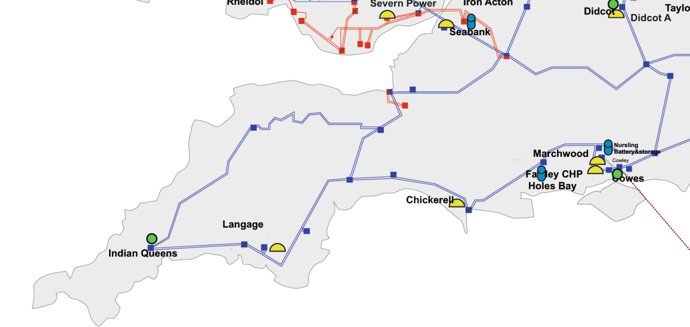

 | South West Reactive Power Requirements
Service Requirement | Controllable Reactive power absorption (induction) capacity firm or conditional.  MVAr export (capacitive) will not be considered.
Volume | Blocks of MVAr, with individual providers >= 5MVAr  Total requirement is in region of 200-400MVAr, subject to response, cost, effectiveness and delivery.
Timeframe | NESO will be considering up to 24mths timebound contracts.
Availability | The service will be required during  - low demand periods, overnight and weekends.  - Periods of high embedded generation output  - System stress scenarios related to outages or constrained transmission configurations.
Instruction | Ability to respond to instructions by NESO (ideally in mins)  Operating in the following modes  - Fixed MVAr setpoint  - Target voltage control with defined deadband and droop  - Instruction-based dispatch via agreed interface
Contract structure | Contracts may be:  - Firm availability contracts (£/MVAr availability)  - ORPS payment on utilisation.  - Conditional / seasonal contracts  - Bilateral or limited-scope call-off arrangements
Additional | Providers should  - State Maximum continuous MVAr capability  - State any limitations linked to Availability, MW dispatch, voltage, time or seasonal constraints  - Indicate hours of availability 24/7, off-peak only, seasonal etc.  - Comply with Grid Code or applicable derogations.  - Have ability to operate without creating adverse impacts  - This potential procurement is explicitly intended as an interim action, not an enduring market commitment. In future, NESO intend to use the mid-term reactive power market for these types of requirements.

South West Reactive Power: Process Overview
After receipt of all responses NESO will assess received information in accordance with the principles identified above. Based on this, NESO will determine whether there is value in running either a competitive tender, a non-competitive bilateral approach or a combination of both depending on the location and liquidity in the region.

In addition, any distribution connected asset that is interested will require further discussion with the DNO National Grid Electricity Distribution (NGED) to understand how this could be accessed.

For avoidance of any doubt, as NESO has yet to launch the Mid-term Reactive Power Market, NESO considers this mini-tender process to be outside of this market to help meet needs from 2026. In the future, requirements like these would typically be sought through the Mid-term Reactive Power Market once available.

Frequently Asked Questions

 | South West Reactive Power
Interest by providers with existing connections? | Yes, providers with existing connections can respond.  Any reactive capability offered must be in excess of any minimum Grid Code obligations.  Where providers are not obligated to provide any minimum reactive capability under the Grid Code, then the above does not apply and full capability can be offered.
Could TOs, DNOs and OFTOs respond | Interest and therefore participation is not expected due to the regulatory regime.
Can interconnector organisations respond? | Yes, we are interested to hear from Interconnectors  Any reactive capability offered must be in excess of any minimum Grid Code obligations.  Where providers are not obligated to provide any minimum reactive capability under the Grid Code, then the above does not apply and full capability can be offered.
Can reactors with a transmission licence (referred to as TO Lite) respond | Yes, we are interested to hear from participants that have a TO Lite licence.  This is in line with Ofgem’s decision about Mersey Reactive Power Limited.  Any reactive capability offered must be in excess of any Grid Code obligations.  Where providers are not obligated to provide any minimum reactive capability under the Grid Code, then the above does not apply and full capability can be offered.

Consultation Submission Information
The submission deadline for responses to this consultation is 26 June 2026
Submissions must be received by the submission deadline. Submissions should be sent to the following address: box.voltage@neso.energy

Please ensure your response, supporting documents and communications relating to this exercise are provided in English.
All communications and queries arising from this consultation should be conducted by email using the email address detailed above box.voltage@neso.energy. Any queries must be submitted no later than five days prior to the submission deadline for this exercise 19 June 2026.

Please ensure all emails in relation to this consultation include the following in the subject box: South West Reactive Power 2026 Consultation.

Following receipt of responses NESO may ask follow-up clarification questions to clarify our understanding, or if needed organise follow-up meetings with market participants to discuss the information received in more detail to clarify our understanding.

Expenses
NESO shall not be responsible for or pay for any costs or expenses that may be incurred by the market participant in the preparation and submission of a response to this consultation.

Conduction and Conflicts of Interest
For the duration of this Consultation and for the duration of any subsequent procurement process, any attempt by any market participant or their advisors to unduly influence the process in any way may result in the participant being disqualified.
Specifically, market participants shall not directly or indirectly, at any time:
- devise or amend the content of any Consultation Response in accordance with any agreement or arrangement with any other person, other than in good faith with a person who is a proposed subcontractor, funder, consultant or agent;
- enter into any agreement or arrangement with any other person as to the form or content of any other Consultation Response, or offer to pay any sum of money or valuable consideration to any person to effect changes to the form or content of any other Consultation Response;
- enter into any agreement or arrangement with any other person that has the effect of prohibiting or excluding that person from participating in this consultation.
- canvass NESO or any employees or agents of NESO in relation to this consultation; or
- attempt to obtain information from any of the employees or agents of NESO or their advisers concerning another market participant or submission.
- Collude in any way;
- Fix or set the price for the services;
- Engage in bribery by you or your appointed advisers in relation to the consultation or any subsequent procurement; or
- Inappropriately influence this consultation or any subsequent procurement event in any other way
Market participants are responsible for ensuring that no conflicts of interest exist between the bidder and its advisers, and NESO and its advisers.
NESO reserves the right to disqualify from the market, any provider if they breach these rules.

Confidentiality
All details of this consultation exercise and associated documents must be treated as private and confidential and shall not be disclosed to any other party, except where this is necessary for you to prepare and submit a response or where information is publicly available.

Market participants must ensure that they have an adequate confidentiality agreement in place with any subcontractors, consultants or agents before issuing them with any confidential information concerning the requirements of this exercise.

Details of your response to this consultation shall not be disclosed to any third party unless such disclosure is required by OFGEM, DESNZ, and/or law or court order.
NESO reserve the right (but will not be obligated) to publish an anonymised summary of responses to this consultation exercise.

Appendix A

Document Checklist for this Pre-Market Consultation
Document | Action
Pre-Market Consultation Instructions (this document) | For information
South West Reactive Power 2026 Consultation Proforma | For completion and return to NESO  (optional for those who wish to return feedback)

