NESO Independence Report
Licence Condition B.1.39

Contents
Introduction 3
Compliance Officer 3
Investigation into complaints 4
General Compliance Officer Activities 4
Impartiality and Conflicts 4
Conflict of Interests 4
Compliance Officer Activities for Conflict of Interests 5
Conflict of Interests Register 5
Statement of control effectiveness 5
Shareholding 5
Compliance Officer Activities for Shareholding 6
Shareholding Register 6
Statement of control effectiveness 6
Gifts and Hospitality 6
Compliance Officer Activities for Gifts and Hospitality 7
Gifts and Hospitality Register 7
Gifts Register 7
Hospitality Register 7
Business justifications for hospitality offered and received 8
Review of register 9
Statement of control effectiveness 9
Information ringfencing 9
Breaches of Information Ringfencing 10
Incident Reporting 10
Statement of control effectiveness 11

Introduction
NESO’s Independence Statement is published on our website. This statement is a requirement of NESO’s two licences (the electricity system operator licence and the gas system planner licence). It sets out the practices, procedures, and systems which NESO has put in place to ensure that NESO is compliant with the independence requirements set out in condition B1 of our licences. This is reviewed annually, and where change is required, approved by our Board and Ofgem.
LC.B1.39 This report compliments the Independence Statement and reports on, compliance with the independence requirements and obligations and on the implementation of the practices, procedures and systems adopted in accordance with the Independence Statement.
LC.B1.40 This Compliance Report includes:
- detail of the activities of the Compliance Officer as per B1.38(h);
- report on the impartiality of the licensee’s employees and the independence of the licensee, including a high-level summary of any perceived or real conflicts of interest with Potential Conflict Parties and the steps taken to mitigate these conflicts;
- a summary update against the supporting policies and procedures in place as described in the Independence Statement; and
- confirms that no formal complaints have been received or investigated by the Compliance Officer in relation to any breach of NESO’s independence requirements.
This report covers the reporting period up to 27th February 2026.

Compliance Officer
LC.B1.32. NESO, following consultation with the Authority, has a Compliance Officer in place for the purpose of monitoring and facilitating the licensee’s compliance with the Independence Requirements and other obligations under Licence Condition B1.
LC.B1.33. The Compliance Officer is the same person appointed under condition B1 (Independence Requirements and compliance obligations) of the Gas System Planner Licence.
LC.B1.34. The Compliance Officer is provided with adequate staff and resources; and has full access to the licensee’s premises, systems, information and documentation, that they might reasonably require for the fulfilment of the duties and tasks assigned under this licence condition.
LC.B1.35. The Compliance Officer is not engaged in the management or operation of any ISOP Affiliate or ISOP Related Undertaking, or of any Potential Conflict Parties.
Specific Compliance Officer activities relevant to each element of the statement are provided in each section of this report.

Investigation into complaints
Since the establishment of NESO, no complaints or representations have been made to the Compliance Officer in relation to any breach of NESO’s Independence Statement.

General Compliance Officer Activities
Outside of these continuous monitoring duties, the Compliance officer is the point of contact for advising on all matters relating to an actual or perceived independence issue and will recommend remediation where appropriate.

Impartiality and Conflicts

Conflict of Interests
At NESO, we take our responsibilities for achieving the highest standards of ethical behaviour very seriously and we believe in promoting a culture of openness and integrity. We have a zero-tolerance approach to unethical behaviour and will always operate fairly and transparently. Our Conflicts of Interest policy provides a framework for dealing with any actual or perceived conflicts of interest. It provides guidance for identifying, monitoring, and managing potential conflicts of interest that could arise between employees, customers, suppliers and other stakeholders. Our Conflict of Interest policy relates to financial interests, competition, External directorships, second jobs and outside activities and internal Personal Relationships. The Conflict of Interest Policy was published in 2025 and applies to all employees and contractors (not MSPs).

Compliance Officer Activities for Conflict of Interests
The Conflict of Interest Policy was published in 2025, applies to all employees and contractors (not MSPs). The Compliance officer is supported by a designated Compliance and Ethics team who manage the policy, procedure and tool in place to monitor and report on conflict of interest. An annual declaration is required, and the team proactively support the business with communication reminders and tailored functional reporting to directors so they can monitor completion rates. There is a designate. box for queries, and a published FAQ in place which is updated with new scenarios as they arise. The Executive Committee receive bi-annual reporting on Conflicts of Interests and a monthly performance measure (of completion rates) is included in the Executive Business Performance Review Pack; and the CEO receives quarterly updates.

Conflict of Interests Register
As at the reporting date for this period, completed disclosures reached 96% (target is 95% to allow for various forms of absences). The split against the disclosure categories is as follows:

Financial Interests | 10
Competition | 175
External directorships, second jobs and outside activities | 93
Internal personal relationships | 93
Confirmation of no conflicts | 2104

Statement of control effectiveness
The control of disclosure of COI is effective evidenced with the 96% compliance rate at the time of reporting.

Shareholding
Our Share Ownership and Dealing Policy applies to all employees, from our Board Members to Directors, permanent and temporary staff who work for NESO. While the rules differ for different status of employment and levels of seniority, all employees (including the Board, permanent and temporary staff – e.g. contractors) must abide by the rules relevant to them to the extent applicable. The Shareholding Policy was published in 2025, applies to all employees and contractors (not MSPs).

Compliance Officer Activities for Shareholding
The Compliance officer is supported by the Company Secretary who manage the policy, procedure and tool in place to monitor and report on shareholding. The Ethics and Compliance team proactively support the business with communication reminders and tailored functional reporting to directors so they can monitor shareholding completion rates in their function. There is a designate. box for queries, and a published FAQ in place which is updated with new scenarios as they arise. The Executive Committee monitor a monthly performance measure (of completion rates) included in the Executive Business Performance Review Pack.

Shareholding Register
At the last day of this reporting period, complete disclosures reached 96% (target is 95% to allow for various forms of absences).

Statement of control effectiveness
The control of disclosure of COI is effective evidenced with the 96% compliance rate at the time of reporting.

Gifts and Hospitality
The NESO Gifts and Hospitality Policy sets out our policy on when we will accept gifts and hospitality. A key principle is that we must not allow our decisions to be influenced, or appear to be influenced, by gifts or hospitality.
Before offering or accepting gifts or hospitality, we will ask ourselves these important questions:
- Am I serving a legitimate business purpose?
- What would our customers think?
- What would our stakeholders think?
- Is the hospitality or gift proportionate to the business purpose?
Any gifts or hospitality that has been offered, accepted or declined will be logged, regardless of value. The Gifts and Hospitality Policy was published in 2025, applies to all employees and contractors (not MSPs).

Compliance Officer Activities for Gifts and Hospitality
The Compliance officer is supported by a designated Compliance and Ethics team who manage the policy, procedure and tool in place to monitor and report on gifts and hospitality. The team proactively support the business with communication reminders and tailored functional reporting to directors so they can monitor gifts and hospitality reporting in their function. There is a designate. box for queries, and a published FAQ in place which is updated with new scenarios as they arise. The Executive Committee receive bi-annual reporting on Gifts and Hospitality and the CEO receives quarterly updates.

Gifts and Hospitality Register
At the last day of this reporting period the split against the reporting thresholds is as follows:

Gifts Register
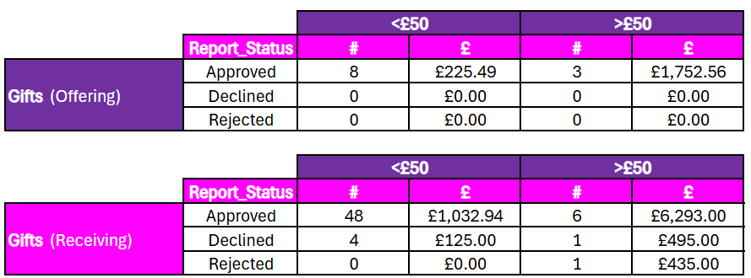

Hospitality Register

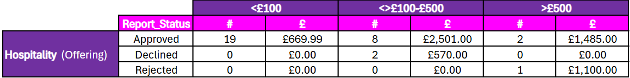
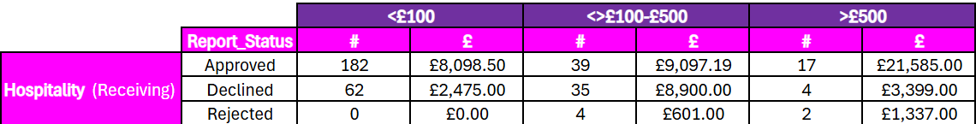

Business justifications for hospitality offered and received
As the National Energy System Operator, we sit at the centre of the UK energy ecosystem and must regularly engage with generators, networks, suppliers, regulators, technology providers and government bodies to deliver a secure and reliable national energy system. Our statutory remit requires extensive stakeholder consultation and collaboration across the sector, making external engagement a core operational activity rather than discretionary relationship management.
Many of our responsibilities—such as whole-system planning, market reform and operational coordination—depend on structured industry workshops, consultations and forums where multiple organisations participate. These engagements often involve full-day or multi-session technical discussions that naturally include working meals or event hospitality provided by host organisations.
As an independent, government-owned system operator, maintaining open and trusted relationships with stakeholders is essential to delivering transparency, effective challenge and credible decision-making. The scale and complexity of the energy transition requires frequent collaboration with industry leaders, infrastructure owners and innovators to align technical solutions and delivery timelines.
Our role also requires senior leaders and specialists to represent the organisation at sector conferences, regulatory forums and cross-industry working groups where hospitality is commonly provided.
Given the breadth of organisations involved in operating and transforming the national energy system, these engagements are numerous and often hosted externally by partners or industry bodies.
Hospitality accepted in these contexts is incidental to legitimate business discussions that support policy development, operational coordination and system planning. Therefore, the relatively high level of recorded hospitality reflects the scale of our mandated stakeholder engagement and cross-industry collaboration required to deliver our national energy system responsibilities.

Review of register
Ou gifts and hospitality disclosure and approval system has a built in workflow for the approval and review of gifts and hospitality. Senior Management is responsible for first approval, with some being triaged to the relevant director, Director of Legal and Regulation and Chief Financial Officer if they fall within the higher threshold. Business justification for the high values of hospitality received is recorded on the disclosure system and reviewed and approved by the relevant director.

Statement of control effectiveness
The control for the system of disclosure for G&H is effective.

Information ringfencing
In its role, NESO will create and receive confidential data and information that should be ringfenced from third parties other than NESO’s agents, contractors and advisors. This includes data and information which is market sensitive or related to national security, in the delivery of the obligations under condition C6 (Licensee’s obligations regarding critical national infrastructure) and condition C7 (Energy resilience and resilience reporting).
NESO Licence Condition B7 (Information ringfencing obligations) sets ourt provisions related to information ringfencing requirements, including protecting CNI, energy resilience and resilience reporting, and market sensitive data. Condition B7 also contains a specific obligation to establish and maintain a code of conduct governing the identification, disclosure and use of such data.
This code is designed to mitigate the risk of:
- Illegitimate sharing of confidential data and information with any external parties.
- Ineffective handling, storage and processing of confidential data or information.
- Use of confidential data or information for unauthorised purposes.
- Data or information access to threat actors that could be sensitive for national security.

Actions NESO takes to prevent data incidents:
- Minimising, anonymising, and securing data by default
- Enforcing retention to reduce unnecessary exposure
- Conducting DPIA pre-screening before high-risk activities
- Delivering continuous training and awareness
- Use of classification labelling on data
- Strengthening governance, standards, and assurance across the organisation

Breaches of Information Ringfencing
The tables below outline the total number of incidents reported, categorised by incident type and associated risk level. Between 1st April 2025 and 28th January 2026, a total of 90 incidents have been reported. The most frequent incident type was data emailed to an incorrect recipient, while the least frequent was loss/theft of paperwork or data left in insecure location and cyber incident.

Incident Reporting

Total Number of incidents Reported April 2025 to date | 90
Total Number of incidents reported to ICO | 1

Incidents categorised by their associated risk levels:
Incident Risk Levels | Number
High  Involving special category or highly sensitive personal data, including health information, financial details, biometric data, or government identification numbers. | 0
Medium  Incidents involving sensitive personal data such as an individual’s address, phone number, or date of birth. | 19
Low  Incidents involving no personal data or only non-sensitive personal data (e.g., name, work email). | 71
Total | 90

Incident type | Number
Data emailed / faxed to incorrect recipient | 43
Content published / accessed without permission | 18
Loss/theft of paperwork or data left in insecure location | 2
Cyber incident | 2
Incorrect process used for data sharing | 3
Incorrect permission | 13
System error | 9
Total | 90

Statement of control effectiveness
Controls for information ringfencing is effective. NESO maintains an Information Ringfencing Code of Conduct, as required under our Licence Conditions which governs the identification, handling, and disclosure of ringfenced information. To reduce the likelihood of future incidents, we are progressing with the implementation of Data Loss Prevention (DLP) system as part of our ongoing risk-mitigation and data protection strategy. This includes system functionality which will ensure mandatory classification labelling is done. All external data sharing undergoes a formal triage process to confirm legal basis and licence compliance, with an auditable log of decisions. NESO operates retention and deletion controls aligned with regulatory requirements and delivers annual mandatory training and ongoing awareness campaigns to all colleagues. NESO also provides tailored guidance aligned to the types of incidents reported, to help prevent recurrence.

