Email Template: SR Transfer Notice
All Slow Reserve Transfer Notices must fully comply with the requirements set out in paragraph (25) of the Slow Reserve (SR) Service Terms and must be emailed (with this completed Transfer Notice Email Template attached) to the email addresses set out in this Transfer Notice Template. All emails must be submitted with the following subject title:
Notice of SR Contract Transfer
In accordance with paragraph 25 of the SR Service Terms, we hereby notify our intention to transfer a SR Contract(s) (SR Contract Transfer), as set out below:
Provide details of the SR Unit awarded a SR Contract(s)
Primary Service Provider (full company name and company number):
Primary Service Provider contracted SR Unit ID:
Auction Product: | Positive Slow Reserve  Negative Slow Reserve
SR Contract ID(s)
Contracted Quantity (MW):
Provide the date and Settlement Periods for the transferred Contracted Service Period:
Provide details of the Auction Unit proposed for this SR Contract Transfer
Secondary Service Provider (full company name and company number) – If applicable*
Secondary Service Provider or own* Auction Unit ID:
Secondary Service Provider or own* Auction Unit Maximum Registered Capacity (MW):
Linking
As part of this SR Contract Transfer, does the SR Contract form part of a Linked period as set out by NESO in a Linking Notice**

PRIMARY SERVICE PROVIDER DECLARATION
By submitting and signing this SR Transfer Notice, we (the Primary Service Provider) confirm that we:
- intend to assign all our rights, title, interest, and benefit in and to the SR Contract(s) to the Secondary Service Provider;
- give our irrevocable consent to this SR Contract(s) Transfer; and have adhered to the requirements set out in paragraph 25 of the Slow Reserve Service Terms including that;
  - transferring the above SR Contract(s) will not result in holding less than four (4) contiguous SR Contract(s) of the same MW.
  - that (where applicable) all SR Contracts that form part of a linked period have been transferred to the same Auction Unit.

Primary Service Provider signature | ………………………………………………………..

SECONDARY SERVICE PROVIDER DECLARATION
By submitting this SR Transfer Notice, we (the Secondary Service Provider) confirm that we:
- consent to and accept the SR Contract Transfer;
- will perform all of the Primary Service Provider’s obligations under the SR Contract;
- have adhered to the requirements set out in paragraph 25 of the Slow Reserve Service Terms including that:
- we are a Registered Auction Participant;
- we have Plant and Apparatus which is registered as an Auction Unit pursuant to the SR Procurement Rules with sufficient SR Capacity to deliver Slow Reserve and perform the SR Contract to which the SR Contract Transfer will be made;
- we do not already have another Balancing Service Contract (including SR) for the same Contracted Service Period with respect to that Auction Unit;
- accepting the above SR Contract(s) will not result in holding less than four (4) contiguous SR Contract(s) of the same MW; and
- (where applicable) all SR Contracts that form part of a linked period have been transferred to the same Auction Unit.
Secondary service provider signature | ………………………………………………………..

Note: Any SR Transfer Notice email received by NESO less than sixty (60) minutes prior to commencement of the applicable Contracted Service Period or that in the opinion of NESO does not fully comply with the requirements of paragraph 25 of the Slow Reserve (SR) Service Terms will be rejected.
Email to: commercial.operation@neso.energy; ctr1.ccta@neso.energy; ctr1.cese@neso.energy; ctr1.cosm@neso.energy; ctr2.coem@neso.energy
*In accordance with paragraph 25.12 of the Slow Reserve (SR) Service Terms, a Service Provider (Primary Service Provider) awarded a SR Contract may nominate another of their own prequalified Auction Units to discharge their obligations to NESO for the delivery of a SR Contract or nominate another Registered Auction Participant’s (Secondary Service Provider) Auction Unit to discharge their obligations.

** Please note, SR Transfer Notices must also be provided (with the same Secondary Service Provider and Auction Unit) for all other SR Contracts Linked to the SR Contract which is the subject of this SR Transfer Notice in accordance with paragraph 25.11 of the SR Service Terms.

Appendix A
The following is intended to provide guidance on acceptable SR Contract Transfers.

Principles of the Slow Reserve Transfer rules

- Each SR Transfer Notice must be submitted to NESO no later than sixty (60) minutes prior to commencement of the applicable SR Contract.
- SR Contract Transfers must be for the full SR Contract and the entire Contracted Quantity MW and can only be transferred to one (1) other Auction Unit.
- SR Contracts cannot be transferred to any other Auction Unit that already has an SR Contract for the same Contracted Service Period. In addition, the receiving Auction Unit must remain compliant with the SR Service Terms (clause 17) in relation to the ‘Provision of other services’ such they cannot already hold a Balancing Reserve, Quick Reserve or any Dynamic Response product contract (in either direction) during the Contracted Service Period subject to the SR Contract Transfer.
- SR Contract Transfer(s) are not valid if it results in either SR Unit having less than four (4) contiguous SR Contracts of identical Contracted Quantity MW.
- Where any SR Contract subject of an SR Contract Transfer forms part of a linked period, as explained in the Linking Notice, then all other SR Contracts that form part of that linked period must also be transferred to the same SR Unit.

Examples of “Allowed” and “Not Allowed” transfers

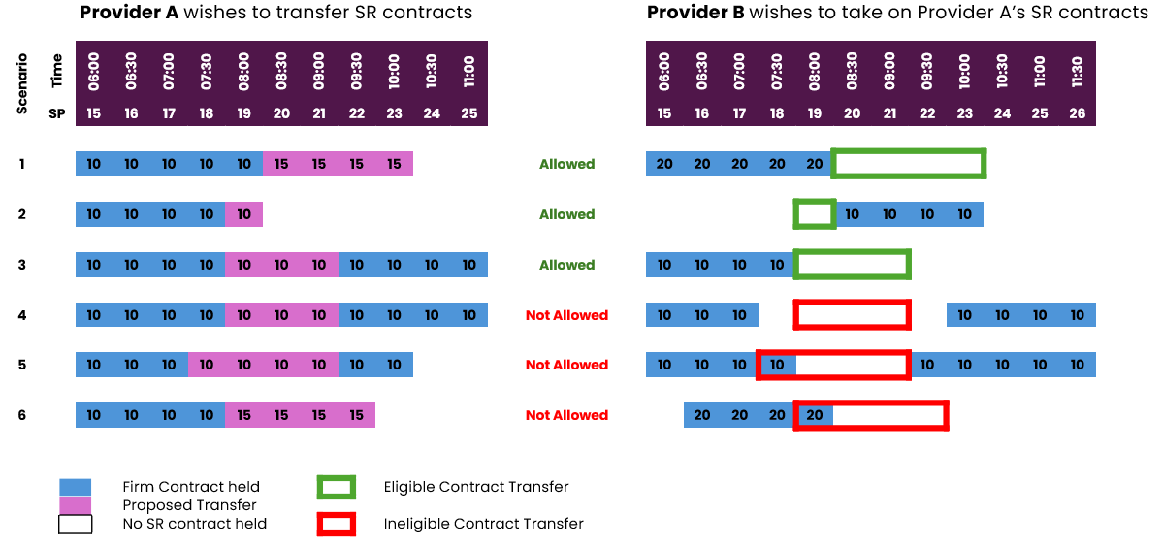

- Allowed – The proposed transfer leaves Provider A with at least four contiguous SR Contract(s) of equal MW. Provider B has no conflicting SR Contract for SP 20–23.
- Allowed – Although Provider A only wants to transfer one SP (19), they will still retain four contiguous SPs. Provider B has SP 19 available to receive the transfer, and doing so extends their contiguous SPs to five of equal MW.
- Allowed – Provider A is permitted to transfer the three contiguous SPs because they still retain sufficient contiguous contracts on either side. While the transfer covers only three SPs, this is acceptable as it increases the number of contiguous SR Contracts of equal MW held by Provider B.
- Not Allowed – Provider A is permitted to transfer the three contiguous SPs because they retain sufficient contiguous contracts on either side. However, the transfer would leave Provider B with only three contiguous SR Contracts (SP 19–21), which does not meet the minimum requirement. Therefore, the transfer cannot proceed.
- Not Allowed – The proposed transfer of SP 19–22 would leave Provider A without sufficient contiguous SPs on either side of the transferred block. Additionally, Provider B does not have SP 19–22 available to receive the SR Contracts.
- Not Allowed – Provider A can transfer the three contiguous SPs as they retain sufficient contiguous SR Contracts. However, although Provider B has SP 20–22 available, the MW values differ, resulting in only three contiguous SPs at 10 MW. This does not meet the minimum service requirement, so the transfer cannot proceed.

Service Terms extract relating to Slow Reserve Contract Transfers

25.1 At any time during the subsistence of an SR Contract, a Service Provider (“the Primary Service Provider”) may assign to another Registered Auction Participant (“the Secondary Service Provider”) all of its rights and obligations under an SR Contract.
25.2 The effect of any such assignment, once validated by NESO pursuant to this paragraph 25, is that all rights and obligations of the Primary Service Provider under these SR Service Terms with respect to the relevant SR Contract shall be transferred to the Secondary Service Provider, for the avoidance of doubt for the entirety of the Contracted Service Period in question.
  - No assignment shall be valid unless:-

    - both entities are Registered Auction Participants;
    - the Secondary Service Provider has Plant and Apparatus which is registered as an Auction Unit pursuant to the SR Procurement Rules with sufficient SR Capacity reasonably expected to be available and proven capability to deliver Slow Reserve to enable the SR Contract to be discharged during the applicable Contracted Service Period;
    - it is validly notified to NESO pursuant to paragraphs 25.4 to 25.7 inclusive and the Transfer Notice validated by NESO; and
    - where the Contracted Service Period in question is Linked, the Service Provider complies with paragraph 25.11,
and furthermore an assignment shall also not be valid if it results in any Contracted Service Period no longer being part of a series of consecutive Contracted Service Periods with the same Contracted Quantity and whose aggregate duration is at least the minimum duration of a Service Window Block (as stipulated by the SR Procurement Rules).
25.4 Each assignment shall be notified to NESO by the Primary Service Provider by no later than sixty (60) minutes prior to commencement of the applicable Contracted Service Period, and in the format designated by NESO for such purpose and published on the Industry Information Website and each such assignment is referred to in these SR Service Terms as a “Transfer Notice”.
25.5 Unless otherwise stipulated in writing by NESO from time to time, each Transfer Notice shall comprise the entirety of a Contracted Service Period, and shall specify:-

    - the identity of the Primary Service Provider and SR Unit; and
25.5.2 the identity of the Secondary Service Provider and its Auction Unit.
25.6 Each assignment shall comprise the entire Contracted Quantity associated with the SR Contract, and for the avoidance of doubt the Contracted Quantity shall not be capable of being split amongst two (2) or more Secondary Service Providers or two (2) or more Auction Units.
25.7 Each Transfer Notice must be signed by or on behalf of both the Primary Service Provider and the Secondary Service Provider.
25.8 Unless deemed withdrawn in accordance with paragraphs 25.9 or 25.10, all Transfer Notices properly submitted in accordance with this paragraph 25 shall be automatically accepted by NESO.
25.9 Where in NESO’s reasonable opinion the delivery of Slow Reserve pursuant to the SR Contract by the Secondary Service Provider’s designated Auction Unit would or might endanger operational security within the meaning of the Electricity Transmission System Operation Regulation, then NESO shall so notify both Registered Auction Participants whereupon the Transfer Notice shall be deemed withdrawn.
25.10 A Transfer Notice shall be invalid if the Secondary Service Provider’s designated Auction Unit is the subject of an SR Contract for the same Contracted Service Period, in which case NESO shall so notify both whereupon the Transfer Notice shall be deemed withdrawn.
25.11 Where the Contracted Service Period the subject of a Transfer Notice is Linked, the Service Provider shall procure that the Transfer Notice is accompanied by a valid Transfer Notice for all other SR Contracts to which it is a party for that Auction Unit with respect to each of the other Contracted Service Periods to which that Contracted Service Period is Linked, and all such Transfer Notices shall specify the same Secondary Service Provider and Auction Unit.
25.12 For the avoidance of doubt, where a Service Provider wishes to discharge its obligations to NESO with respect to the delivery of Slow Reserve pursuant to an SR Contract using an alternative Auction Unit which it has registered with NESO under the SR Procurement Rules, it may serve a Transfer Notice pursuant to this paragraph 25. With respect to each such Transfer Notice validated by NESO, NESO will monitor availability and submitted parameters, and treat delivery of Slow Reserve from that alternative Auction Unit, as if made and delivered by the Service Provider from its original SR Unit, and all references in this paragraph 25 to Secondary Service Provider shall be construed as meaning the Service Provider where the context admits.

