User Guide
Single Market Platform Portal

October 2025

Contents
Contents
1. Introduction 21
1.1. Document Purpose 21
1.2. Background to SMP 21
1.3. Supported Browsers 22
1.4. Requirement for Use 22
1.5. Disclaimer and Applicant’s Responsibility 22
1.6. Help and Support 23
2. Initial Registration & Onboarding 24
2.1. Initial Registration & Onboarding 25
2.2. First-time User Registration 26
2.3. First-time User Registration 27
2.4. First-time User Registration 28
2.5. First-time/New Prospective User Registration 29
2.6. First-time/New Prospective User Registration 30
2.7. First-time/New Prospective User Registration 31
2.8. First-time/New Prospective User Registration – Verification Method 32
2.9. First-time/New Prospective User Registration – Verification via Email 33
2.10. First-time/New Prospective User Registration – Verification Code via Email 34
2.11. First-time/New Prospective User Registration – Verification via mobile phone 35
2.12. First-time/New Prospective User Registration – authenticating via text/SMS 36
2.13. First-time/New Prospective User Registration – Confirmation of User Registration ‘Stage’ complete 37
2.14. Company Registration – UK Limited Company 38
2.15. Company Registration: UK Limited Company cont. 39
39
2.16. Company Registration: UK Limited Company cont. 40
2.17. Company Registration: UK Limited Company cont. 41
2.18. Company Registration: Non UK Company 42
2.19. Company Registration: Non UK Company (cont.) 43
2.20. Company Registration: Non UK Company (cont.) 44
2.21. Completion of Registration: First Time User 45
2.22. Completion of Registration: First Time User 46
2.18 Registered User’s: Ongoing Access 47
2.23. Registered User’s: Ongoing Access Steps 48
2.24. Registered User’s: Ongoing Access Steps 49
2.25. Registered User’s Ongoing Access Steps 50
2.26. Registered User’s: Ongoing Access Steps 51
2.27. Resetting Passwords 52
2.28. Resetting Passwords: Cont. 53
2.29. Resetting Passwords: Cont. 54
54
2.30. Resetting Passwords: Cont. 55
2.31. Resetting Passwords: Cont. 56
2.32. User’s with ‘Multiple Accounts’ 57
2.33. Legacy Users 57
2.34. Access to the EAC Platform 58
3. Updating User & Company Details 59
3.1. Making updates to your own Contact & Company Details 60
3.2. Making updates to your own Contact & Company Details 61
3.3. Update Company Details: Home Page 62
3.4. Update Company Details: Completing Your Detail Section 63
3.5. Update Company Details: Completing Your Company Details Section 64
3.6. Update Company Details: Completing Your Company Address Section 65
3.7. Update Company Details: Completing Your Company Address for Receipt of Notice 66
3.8. BSC Registration 67
67
3.9. BM Registration Documents 67
3.10. Terms & Conditions: Confirmation 70
3.11. Confirmation Notification Screen 71
4. Asset & Unit Management 72
4.1. Navigating the Landing Page for Unit & Asset Management. 73
4.2. Navigating the Landing Page for Unit & Asset Management. 74
4.3. Creating & Managing Assets 75
4.4. Create an asset. 75
4.5. Create an asset. 76
4.6. Asset Registration: Submitting Asset Information 76
4.7. Create an asset. 77
4.8. Asset Registration: Asset Details Section 78
4.9. Asset Registration: Asset Connections Section 79
4.10. Asset Registration: Asset Site Location 80
4.11. Asset Registration: Asset Site Location 81
4.12. Asset Registration: Asset MPAN Details 82
4.13. Asset Registered: Asset Tile 84
5. Creating and Managing Trading Agent (EDT) and Control Point (EDL) Records 85
5.1. Create a Trading Agent (EDT) Record 85
5.2. Trading Agent (EDT): Registration Page 85
5.3. Submitting Trading Agent (EDT) Information: Sections 86
5.4. Editing the details of the Trading Agent record 87
5.5. Submitting Trading Agent record for Approval 88
5.6. Create a Control Point (EDL) Record 89
5.7. Control Point (EDL): Registration Page 89
5.8. Submitting Control Point (EDL) Information: Sections 90
5.9. Editing the details of the Control Point record 90
5.10. Submitting Control Point record for Approval 92
5.11. Obtaining the Trading Agent and Control Point IDs 92
6. Creating & Managing Units 95
6.1. Create a Unit 96
6.2. Unit Registration: Overview Page 97
6.3. Classification of Unit Category Concept 98
6.4. Submitting Unit Information: Unit Details Section 102
6.5. Submitting Unit Information: Unit Connection Section 104
6.6. Submitting Unit Information: Unit Site Location Section 106
6.7. Linking a Control Point (EDL) to a Unit 107
6.9. Submitting Unit Information: OFTO and eGAMA Sections 112
6.10. Submitting Unit Information: Confirmation of Submission. 113
6.11. Submitting Unit Registration for Approval 115
6.12. Submitting Unit Registration for Approval 116
6.13. Modifications to Registration of Units 116
6.14. Modifications to Registration of Units: cont 118
6.15. Modifications to Registration of Units: cont. 119
6.16. Modifications to Registration of Units: cont. 120
6.17. Deregistration of Units 121
6.18. Process for Deregistering Units 122
6.19. Process for Deregistering Units - cont 123
6.20. Process for Deregistering Units -cont 124
7. Creating Interconnector Users 125
7.1. Create an Interconnector User record 125
8. Asset to Unit Alignment 129
8.1. Grouping Assets by Unit (Asset Alignment) 130
8.2. Grouping Assets by Unit (Asset Alignment) 131
8.3. Selecting Unit for Grouping 132
8.4. Match & Un-matching selected assets to Unit for Grouping 133
8.5. Match & Un-matching selected assets to Unit for Grouping 134
8.6. Asset Alignment for multiple units 135
9. Prequalification for Services 136
9.1. Identifying Units to participate in Pre-qualification. 137
9.2. Pre-qualification Home Page 138
9.3. De-selecting Services to apply for pre-qualification for selected Unit. 139
9.4. De-selecting Services to apply for pre-qualification for selected Unit: Cont 140
9.5. Completing Pre-qualification Criteria Sections by Service: Unit Calibration Section 141
9.6. Obtain Service Values Feature 142
9.7. Obtain Service Values Feature: Cont 142
9.8. Completing Pre-qualification: Attaching Supplementary Evidence 143
9.9. Confirmation of Upload Completed 143
9.10. Completing Pre-qualification Criteria Sections by Service: Asset Testing Section 144
9.11. Qualifying for the Balancing Mechanism Service 144
9.12. Completion of Pre-qualification Criteria: Terms & Conditions Section 145
Using Authorised Signatories 146
9.13. Selecting Authorised Signatory & completing Application Submission 147
9.14. Selecting Authorised Signatory & completing Application Submission (Continued) 148
9.15. Selecting Authorised Signatory & completing Application Submission (Continued) 149
9.16. Selecting Authorised Signatory & completing Application Submission (Continued) 150
9.17. Confirmation of Submission of Pre-qualification Application Request. 150
9.18. 10.1 Selecting Authorised Signatory & completing Application Submission (Continued) 151
9.19. Automated Email Notifications 152
9.20. Automated Email Notifications (Continued) 153
9.21. Customisation of Digital Document & Electronic Signature Capture by Authorised Signatory 153
9.22. Customisation of Digital Document & Electronic Signature Capture by Authorised Signatory 154
9.23. Customisation of Digital Document & Electronic Signature Capture by Authorised Signatory (Continued) 155
9.24. Confirmation of Signing Process - Complete 157
9.25. Pre-qualification Process Application Closure: 157
10. ABSVD Delivery Allocation 159
10.1. CDV View 159
10.2. ABSVD Allocation 161
10.3. ABSVD Bulk Allocation 163
11. Global Versioning 167
11.1. What is Global Versioning? 168
11.2. Changes permitted through Global Versioning 169
11.3. Changes not permitted through Global Versioning 169
11.4. Why is Global Versioning required? 170
11.5. What types of Global Versioning apply to Units? 171
11.6. Conditions for Re-evaluating Prequalification Applications 172
11.7. Global Versioning Process Steps 173
11.8. Selection of ‘Primary’ Unit. 173
11.9. Selection of ‘Primary’ Unit: Cont 174
11.10. Creation of Global Versioning Basket – Basket Rules 174
11.11. Creation of Global Versioning Basket – Basket Steps 175
11.12. Creation of Global Versioning Basket – Selection of the ‘Primary’ Unit. 175
11.13. Creation of Global Versioning Basket – Selection of the ‘Primary’ Unit. 176
11.14. Completion of Global Versioning Application Form 177
11.15. Step 1: Selecting the action type 177
11.16. Step 2.a: Use Case 1: Modifying Asset(s) exclusively.- Increase in Total Capacity. 178
178
11.17. Step 2.b: Use Case 1: Modifying Asset(s) exclusively: Re-evaluation of existing Prequalification Application Data 179
11.18. Step 3: Use Case 1: Modifying Asset(s) exclusively: Submission of the Versioning Application Form. 180
11.19. Trigger of Manual Versioning Conditions 181
11.20. Submission of Basket– Validate Basket Step 182
11.21. Submission of Basket– Committal of Basket for processing 183
11.22. Completion of Global Versioning Process 183
11.23. Limitations whilst Global Versioning Process is ‘In-flight’. 184
11.24. Variation to the Global Versioning Application Form 185
11.24.1. Reduction in Capacity via modification to individual asset(s) 185
185
11.24.2. Increase in Capacity (or no net change in Capacity) due to re-alignment or change in composition of asset(s) 186
11.24.3. Increase in Capacity (or no net change in Capacity) due to re-alignment or change in composition of asset(s) 187
11.25. Distinction between Primary and Impacted Units 188
11.26. Distinction between Primary and Impacted Units 189
11.27. Errors in Processing Global Versioning Requests 190
11.28. Managing Associated Units that share Assets that have been subject to Global Versioning 191
11.29. 11.4 Global Versioning Scenarios & Global Versioning Criteria 192
12. Global Versioning: ‘Benching’ a Unit 196
12.1. ‘Benching a Unit’ 197
12.2. Primary Use Case for Benching 197
12.3. Pre-requisite conditions for Benching 197
12.4. Why is benching required as part of Global Versioning? 198
12.5. Additional considerations for ‘Benched’ Units 198
12.6. Existing Prequalification applications affiliated to a Benched Units 198
12.7. Benched Units & EAC Auction Participation 198
12.8. Re-activating a Benched Unit 200
10.8 Global Versioning Email Alerts 201
12.9. Global Versioning Email Alerts 202
12.10. Global Versioning Email Alerts 203
13. User Management 204
13.1. User Management Role Approach 205
13.2. User Management Role Framework 206
13.3. Super Users & Secondary User Registration Approvals 207
13.4. User Role Business Rules 208
13.5. User Role Business Rules – cont 209
13.6. Approval of Secondary User Registration Requests by the Super User 210
13.7. Approval of Secondary User Registration Requests by the Super User 211
13.8. Approval of Secondary User Registration Requests by the Super User – Acknowledgement Screens 212
13.9. Approval of Secondary User Registration Requests by the Super User- Email Alerts 213
13.10. Approval of Secondary User Registration Requests by the Super User- Email Alerts 213
13.11. Rejection of Secondary User Registration Requests by the Super User- Email Alerts 214
13.12. Onboarding Users to the EAC Platform 215
13.13. Assigning the Trader Role 216
13.14. Restrictions on Users with exclusively Trader Role 216
13.15. Visibility of the Trader Role on the SMP Portal 217
13.16. Visibility of the EAC ‘hyperlink’ on SMP for Trader Role Users 217
13.17. Managing Registered Secondary Users (Active) 218
13.18. Adding additional roles to Secondary Users (Active) 219
13.19. Adding Authorised Signatory 220
13.20. Removing existing role(s) from Secondary Users (Active) 221
13.21. Removing existing role(s) from Secondary Users (Active) 222
13.22. Deactivating Secondary Users 222
13.23. Deactivating Secondary Users – User’s Switching from Active List to In-active List 223
13.24. Deactivating Super Users 224
13.25. Deactivating Super Users – Request Notification 225
Related Entity: Establishing an Agreement & Delegation of Asset(s) 226
13.26. Definition of Related Entity 227
13.27. Conditions of Related Entity 227
13.28. Initiating (Nomination) Requests 228
13.28.1. Locating a prospective Agent 228
13.29. Locating a prospective Agent – Entering in the Market Provider Details 229
13.29.1. Locating a prospective Agent – Confirmation of Submission of Nomination Request 230
13.30. Accepting/Rejecting Nomination Requests 231
13.30.1. In portal notification – Prospective Agent 232
13.30.2. Consenting to the Terms & Conditions – Agreement Copy 232
13.30.3. Pending Agreement Notification – Asset Owner 233
13.31. Agreement Business Rules 234
13.31.1. Notification that an existing Agreement is in place 234
13.31.2. Notification that one of the parties is still pending approval 235
13.31.3. In portal notification – Prospective Agent 235
13.31.4. Confirmation of Agreement in Place – Asset Owner’s view 236
13.31.5. Confirmation of Agreement in Place – Prospective Agent’s view 237
13.32. Locating a prospective Asset Owner/Service Provider 238
13.33. Confirmation Email Alerts 239
13.33.1. Confirmation Email Alert Template 1 239
13.33.2. Confirmation Email Alert Template 3 239
239
13.34. Confirmation Email Alert Template 4 240
13.34.1. Confirmation Email Alert Template 5 240
13.34.2. Confirmation Email Alert Template 241
13.35. Delegating Asset(s) for Transfer 242
13.36. Transfer of Asset(s) Business Rules 242
13.36.1. Selection of the Agent 243
13.36.2. Selection of the Asset(s) 244
13.36.3. Selection of the Asset(s) – identification of asset(s) 245
13.36.4. Confirmation notification – selection of asset(s) 245
13.36.5. Confirmation decision – selection of asset(s) completed 246
13.37. Visibility of Transferred Assets 247
14. Related Entity: Withdrawal or Natural Expiry of Agreements & Relegation of Asset(s) 248
14.1. Ending a Related Entity Agreement 249
14.2. Outcome Options for ‘Delegated’ Assets 249
14.3. Outcome Options for ‘Delegated’ Assets (continued) 250
14.4. Identifying Asset(s) tied to Committed Unit(s) 251
14.5. Initiating (Termination) Request/Order 252
14.5.1. Locate the Agent & Agreement 252
14.6. Initiating (Termination) Request/Order: (Cont) 253
14.7. Initiating (Termination) Request/Order: (Cont) 254
14.8. Natural Expiry of Agreement 255
14.9. Update to a Business Rule on Related Entity Agreement 256
14.10. Visibility of Assets & Units post Agreement 257
257
14.11. Visibility of Assets & Units post Agreement (cont) 258
258
14.12. Visibility of Assets & Units post Agreement (cont) 259
15. Related Entity: Agreement Extensions 261
15.1. Extension Requests 262
15.2. Initiating an Extension Request – Agent Option 262
15.3. Initiating an Extension Request – Asset Owner Option 263
15.4. Consent Exchange Process 264
15.5. Consent Exchange Process 265
15.6. Consent Exchange Process – Extension Agreed 266
15.7. Consent Exchange Process – Extension Rejected 267
15.8. Email Alert Templates 268
15.9. Email Alert Templates (Cont) 269
15.10. Email Alert Templates (Cont) 270
270
16. Inter-company Sharing Agreements 271
16.1. Definition of Inter-Company Sharing Agreements 272
16.2. Scope of Inter-Company Sharing Agreements 272
16.3. Distinction between Company/Market Provider Agreement Types 273
16.4. Conditions of Inter-Company Sharing Agreements 275
16.5. Agreement Business Rules 276
16.6. Agreement Considerations 277
16.7. Initiating (Nomination) Requests 278
16.8. Locating a prospective Secondary Account 278
16.9. Locating a prospective Secondary Account– Entering in the Market Provider Details 279
16.10. Locating a prospective Secondary Account – Entering the Company Details 280
16.11. Locating a prospective Secondary Account – If a Company cannot be located or the pre-conditions have not been met 281
16.12. Locating a prospective Secondary Account – Entering the Agreement Dates 282
16.13. Consenting to the Terms & Conditions as the Primary Account Representative 283
16.14. Locating a prospective Secondary Account – Confirmation of Submission of Nomination Request 284
16.15. Expiry of Initiation (Nomination) Requests 285
16.16. Expiry of Nomination Requests - Email Alert 286
16.16.1. Confirmation Email Alert Template 286
Recipients of (Nomination) Requests – Secondary Account 287
16.17. Accepting/Rejecting Nomination Requests as the Secondary Account. 287
16.18. Nomination Request Listing/Offer 288
16.19. Consenting to the Terms & Conditions – Agreement Copy 289
16.20. Prevention of completing the formation of an Inter-Company Sharing Agreement. 290
16.21. Notification that an existing Agreement is in place 290
16.22. Notification that one of the parties is still pending approval 291
16.23. In portal notification – Secondary Account Portal Super User 291
Post Formation of Inter Company Sharing Agreement 292
16.24. Ability to ‘Account Switch’ between Primary and Secondary Account(s) 292
16.25. The Trader Role in the context of Primary & Secondary Account Access. 293
16.26. Extending Access for Additional Users from the Primary Account – Granting Access 294
16.27. Extending Access for Additional Users from the Primary Account – Removing Access 295
16.28. Confirmation Email Alerts 296
16.28.1. Confirmation Email Alert Template 1 296
16.28.2. Confirmation Email Alert Template 2 296
16.29. Confirmation Email Alerts 297
16.29.1. Confirmation Email Alert Template 3 297
16.30. Registering an additional account 297
17. Providing Financial Banking Details 301
17.1. Recording Financial Payment Details 302
17.2. Recording Financial Payment Details: Cont 303
17.3. Recording Financial Payment Details: Cont 304
17.4. Recording Financial Payment Details: Cont 305
18. Contract (Auction Results) Data 307
18.1. Accessing Contract Data 308
18.2. Accessing Contract Data (cont.) 309
19. Market Entry Page 310
19.1. Market Entry Landing Page 312
19.2. Market Entry Landing Page: Cont 313
19.3. Market Entry Landing Page: Cont 314
19.4. Market Entry Landing Page: Cont 315
19.5. Market Entry Landing Page: Cont 316
20. Reports 317
20.1. Introduction to Reporting 318
20.2. Locating Reports 318
20.3. Pre-defined reports 318
20.4. Creating New Reports 321
21. Registering RDP MW Dispatch Assets 326
21.1. Create an Asset 327
21.2. Asset Registration: Submitting Asset Information 328
21.3. Asset Registration: Asset Details Section 329
21.4. Asset Registration: Asset Connections Section 330
21.5. Asset Registration: Asset Site Location 331
21.6. Asset Registration: Asset MPAN Details 332
21.7. Asset Registration: Save Asset Detail Submission. 333
21.8. Asset Registered: Asset Tile & Updating the Asset 334
21.9. Asset Registered: Asset Tile & Updating the Asset 335
21.10. Asset Registered: Asset Tile & Updating the Asset 336
21.11. Unit Creation 337
21.12. Identifying Units for RDP Unit Pricing 338
21.13. Recording RDP Unit Pricing 339
21.14. Unit Pricing History 340
22. Onboarding Checklist 341
23. SMP Overview Dashboard 344
23.1. SMP Overview Dashboard 345
23.2. Total Numbers of Units, Assets and Alignments 345
23.3. Units classified by Status and Category 345
23.4. Prequalification requests by Status and Service 346
23.5. Units grouped by Service pre-qualification 346
23.6. Units grouped by Assets and Assets grouped by Service 347
24. Accessing Invoice Links 348
24.1. How to access Invoice Links 348
25. Glossary of Terms 349
25.1. Glossary of Terms 350
25.2. 19. Updates - Release 2.13 352
26. FAQs 353
26.1. FAQs 354

Introduction

Document Purpose

The purpose of this document is to help readers access, navigate and use the Single Market Platform (SMP) Portal to enable Providers and Agents market entry to engage in Ancillary Services. This includes the administrative functions, initial registration and onboarding, submission & management of Assets and their respective Units including the Versioning of Units & Assets, Management of the Pre-qualification Application Process, Managing Secondary Users, Establishing Related Entities with other Market Providers and determining access to third party systems such as Enduring Auction Capability Platform to submit and manage auction bids for service delivery. In essence, the document illustrates the detailed steps entailed across the functionality of the Portal.

Background to SMP

Customer and stakeholder feedback highlighted substantial opportunities to transform our interactions at all stages in market participation with the Electricity System Operator (National Energy System Operator). As we transition and transform our markets to closer to the day procurement, Single Market Platform (SMP) will be the go-to place for market entry and participation; it will facilitate participation in new smart and sustainable markets, aiming to lower barriers to entry, attracting higher volumes, ensuring new technologies are onboarded faster, markets are cleared, and payment is made swiftly and accurately. As we transition and transform our markets to closer to the day procurement, SMP will be the go-to place for market entry and participation; it will facilitate participation in new smart and sustainable markets, aiming to lower barriers to entry, attracting higher volumes, ensuring new technologies are onboarded faster, markets are cleared, and payment is made swiftly and accurately.

As stated in our RIIO-2 business plan, SMP will provide a single point of entry for market participants to access data related to: how they can become a provider, how they can sell their services in a co-optimised way, how they can manage the lifecycle of their contractual relationship with National Energy System Operator, review how they are performing (both operationally and financially).

Supported Browsers

For the best experience, we recommend that the latest version of Google Chrome is used to access the portal, otherwise key functionality may not render on screen.

We do not recommend any version of Internet Explorer as this site has not been designed to use this browser and therefore you may encounter errors.

Requirement for Use

Access to the internet and a mobile phone to receive two factor authentication codes.

Disclaimer and Applicant’s Responsibility

The information supplied with, contained in, or referred to in this Document, and all other information is given in good faith. However, no warranty or representation or other obligation or commitment of any kind is given by National Energy System Operator Limited, its employees or advisors as to the accuracy or completeness of any such information or that there are not matters material to the arrangements and matters referred to therein other than is contained or referred to in such information. Neither National Energy System Operator Limited nor its employees or advisors shall be under any liability for any error or misstatement or as a result of any failure to comment on any information provided by National Energy System Operator Limited or the recipient of the Documentation or any other person or any answers to any questions or for any omission and none of such information shall constitute a contract or part of a contract.

Help and Support

For any queries on registering and completing a User Registration & Login should be sent to box.digitalhelp@neso.energy

For any queries relating to any other Functionality in this guide should be sent to commercial.operation@neso.energy
or you can contact the team on 01926 65 4611. For any technical issues, you can contact the helpdesk on +44 800 917 7111.

Initial Registration & Onboarding

Initial Registration & Onboarding
With Release 2.8, a new Registration and Login Framework is being adopted and rolled out across the National Energy System Operator estate, including access to the Single Market Platform. This change is called the introduction of a Customer Access and Identity Management System (CIAM) which will allow both prospective users to register and existing users to login using a Single Sign-On Functionality. This will have Authentication functionality built in. In short users will be expected to log in using their email address and use a Mobile Phone Number to authenticate. This will grant them access to their individual universal National Energy System Operator Limited Account.

The new Universal National Energy System Operator Limited Account will in the future enable users to sign in for all National Energy System Operator Limited Systems using the same set of credentials included but not limited to the following platforms.

- Single Market Platform (SMP)
- Enduring Auction Capability (EAC)
- Data Analytics Portal (DAP)

Users will now be provided with a centralised touchpoint or gateway for their National Energy System Operator Limited Account on the National Energy System Operator Limited Website and will be able to manage or update their Account Details and communication preferences including data subscriptions from the one location.

First-time User Registration

If you and your organisation/company are new to National Energy System Operator Limited and to the SMP Portal, then it is required that you register directly by navigating to the new National Energy System Operator Limited Website.
If you or your colleagues have previously completed registration prior to SSO and were able to login into the SMP Portal directly, your SSO credentials will be set up on your behalf in advance and you will only be required to reset your password and supply a mobile number if not previously provided in order to enable you to authenticate. Your username will be the email address you originally supplied at the point of registration for the SMP Portal.
If you are a user whom has previously had several ‘sets’ of SMP Account Login’s, a ‘primary’ Account will be identified and this will be the Account for whom your SSO credentials will be set up in advance. For all other ‘secondary’ or additional Account(s) your existing SMP Portal Usernames will be consolidated into your (primary) singular SSO Credential in order to enable you to login in moving forward. In this instance you will require support from the NESO Account Management Team in order to grant you access your additional accounts by through one singular login.
Please note that all prospective(secondary) additional Users for Accounts where at least one Active User exists can still be added to the same Account however the process has altered from previous Releases and will be explained in full detail on the Chapter ‘User Management’.

Please also note that if as a First Time and only user you wish to register and gain access to one or more NEW Accounts (Primary and subsequent Secondary Accounts) using the same set of singular SSO Credentials then you will require support from the NESO Account Management Team to assist you in registering the Secondary Accounts and arranging for the Accounts to be linked.

First-time User Registration

- Navigate to the Continue to Registration Link

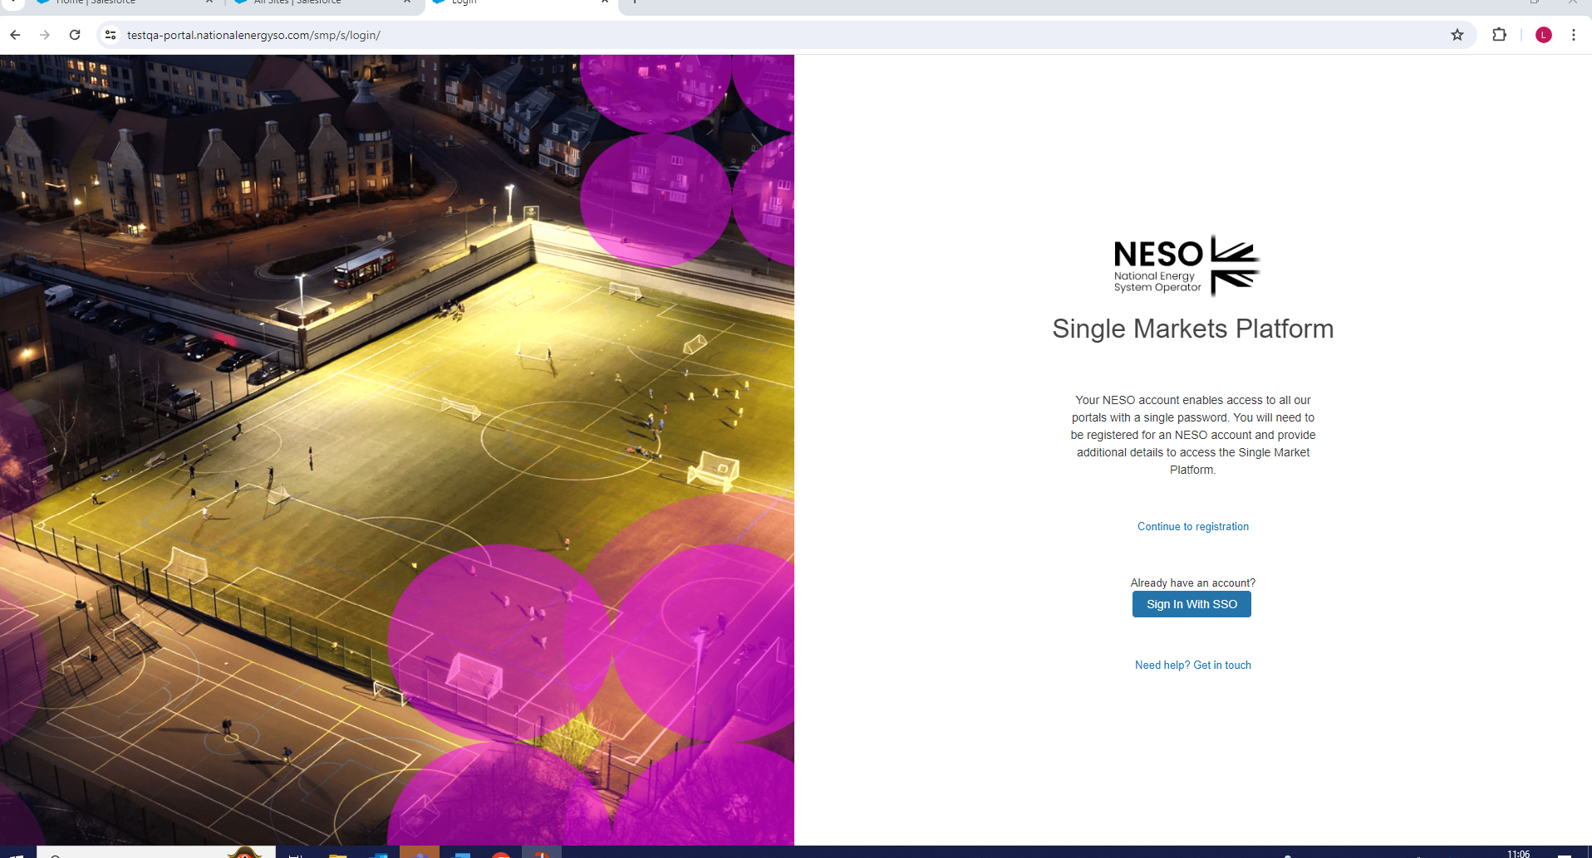

The section below will illustrate the steps required for First Time User Registration
- Prospective Users must visit the National Energy System Operator Limited Website and will be presented with the screen below.
- Select ‘Register Now’

First-time User Registration

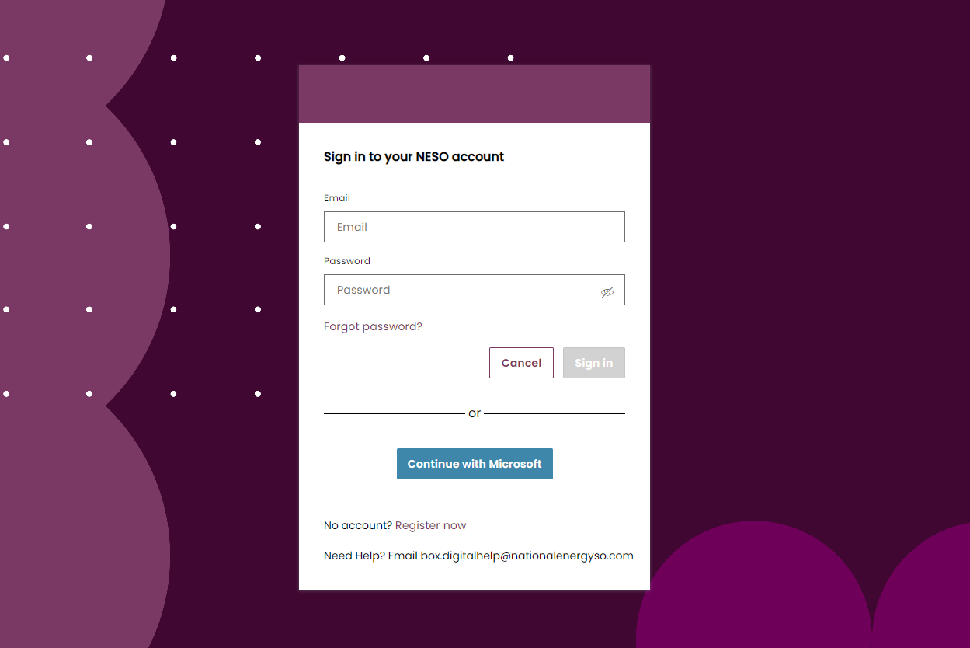

The section below will illustrate the steps required for First Time User Registration
- Prospective Users must visit the National Energy System Operator Limited Website and will be presented with the screen below.
- Select ‘Register Now’

First-time/New Prospective User Registration
- Click Next

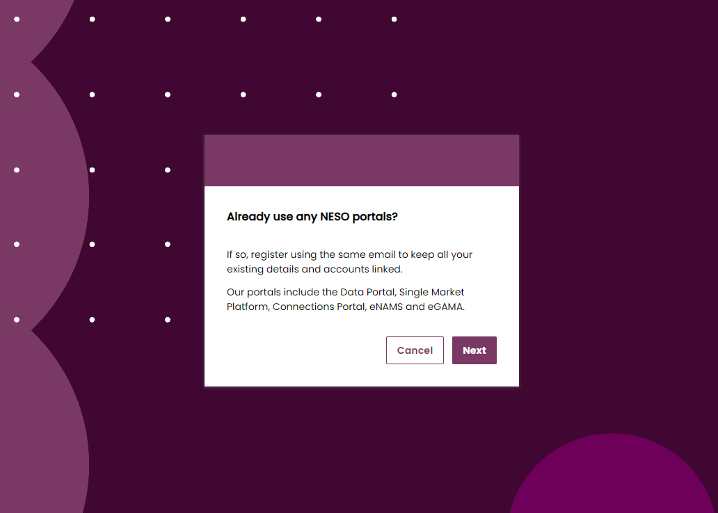

First-time/New Prospective User Registration
- Enter your Email Address
- Right click the ‘terms and conditions’ hyperlink to open up in a new tab.
- Read through the terms and conditions and switch back to the main tab.
- Click the checkbox ‘I accept the terms & conditions’ in order to enable you to proceed to the next screen.
- Select ‘Next’. If you wish to abort the process then click on ‘Cancel’.

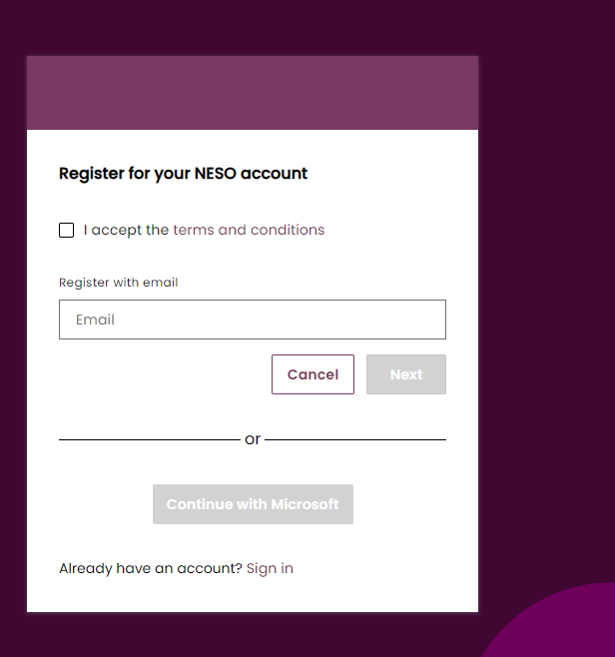

First-time/New Prospective User Registration
- Enter your Contact Details; First name, Last name and Password.
- Re-enter your password to confirm it is correct.
- Ensure you comply with the Minimum Password Requirements
- Click the custom button ‘Create Account’ if you wish to complete your User Registration
- Select ‘Cancel’. If you wish to abort the process..

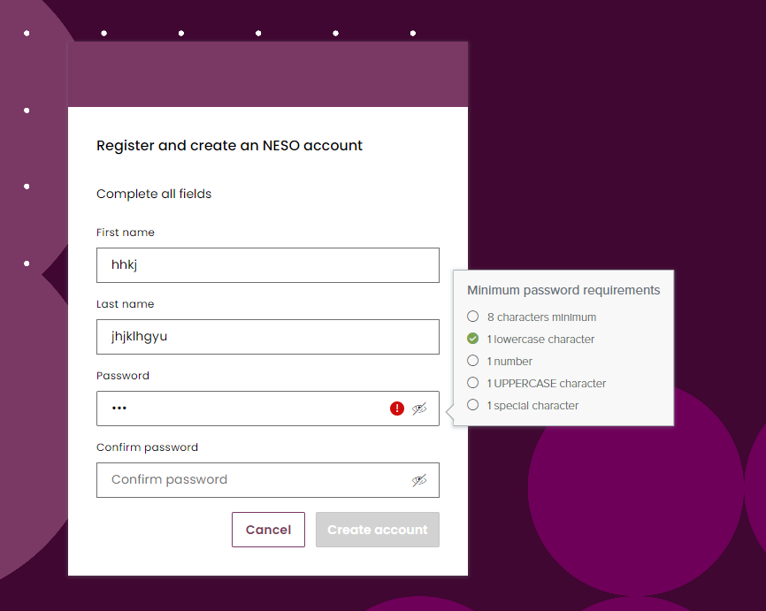

First-time/New Prospective User Registration – Verification Method
- You will be prompted to select which method you wish to authenticate – mobile number or email address
- Select your preference and then click the ‘Get Code’ button

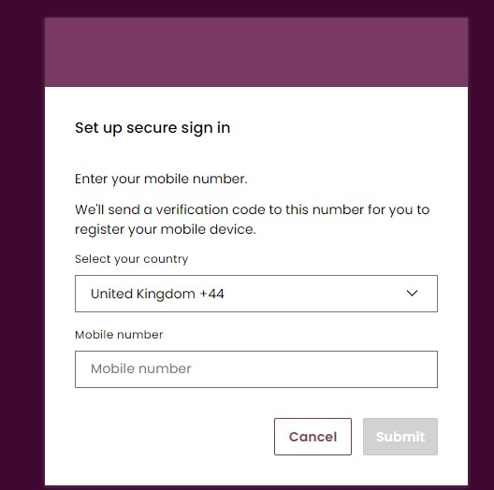

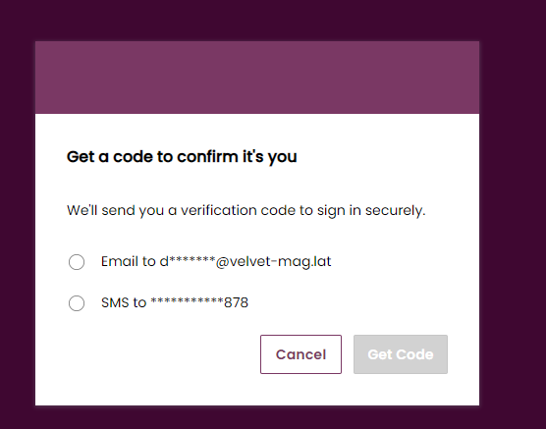

First-time/New Prospective User Registration – Verification via Email
- An Automate Email Alert will be generated with a randomised alpha -numeric code and sent to the provided Email address

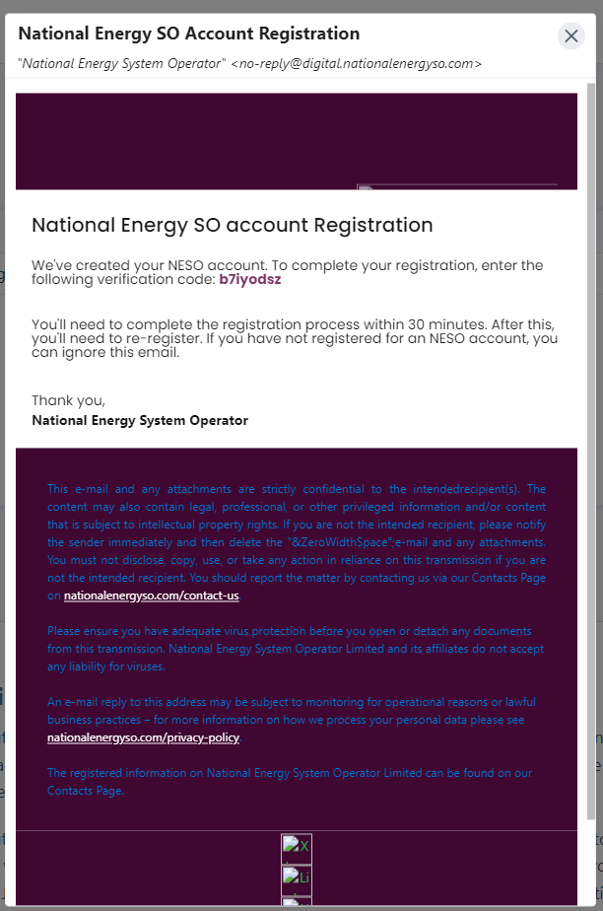

First-time/New Prospective User Registration – Verification Code via Email
- Enter your Verification Code which will automatically be sent to the Email Address provided prior.
- Click the custom button ‘Verify’ to proceed.
- Select ‘Cancel’. If you wish to abort the process
- If a Verification Code Email isn’t received within a couple of minutes within your inbox, please check your spam or junk mail first and then click the ‘Didn’t receive an email? Resend’ hyperlink.

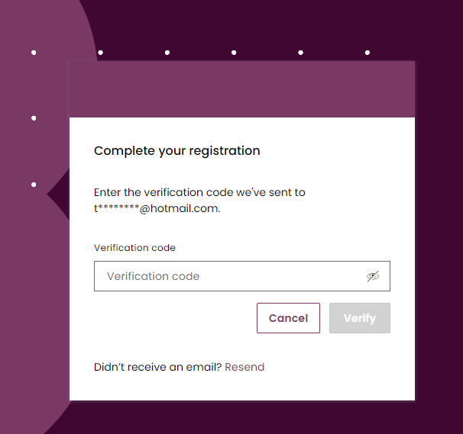
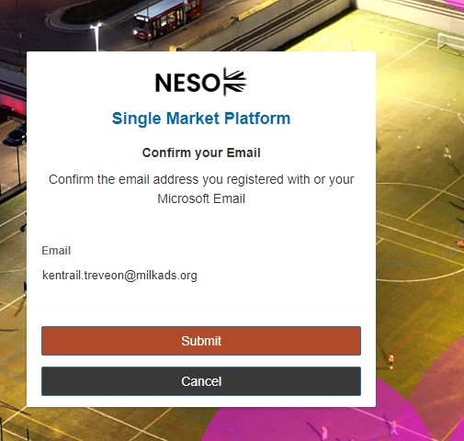

First-time/New Prospective User Registration – Verification via mobile phone

- If you opt to authenticate via mobile phone, then an Automated SMS text will be generated with a randomised alpha -numeric code and sent to the mobile phone number provided

First-time/New Prospective User Registration – authenticating via text/SMS
- Enter your Verification Code sent by text/SMS
- Click the custom button ‘Verify’ to proceed.
- Select ‘Cancel’. If you wish to abort the process
- If a Verification Code isn’t received within a couple of minutes then click ‘Resend’ to generate a new text/SMS – you may wish to pause a couple of minutes to do so

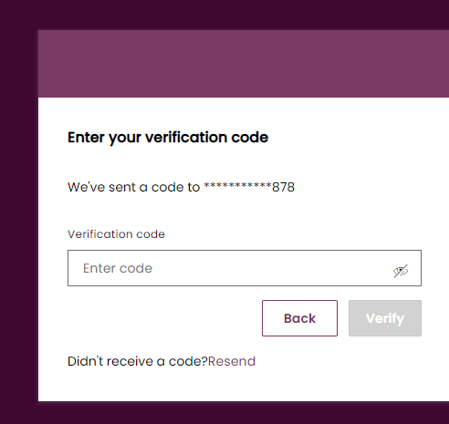

First-time/New Prospective User Registration – Confirmation of User Registration ‘Stage’ complete
- Following the Verification Exercise, a screen will appear to acknowledge confirmation and prompting the second stage of registering the Account (Company Details) to follow.

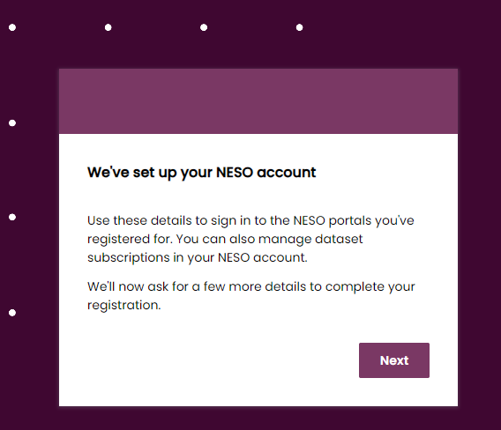

Company Registration – UK Limited Company

The section below will illustrate the steps required for First Time User’s Company Registration if their Company/Organisation is based in the UK.
- Select your Company/Organisation as a UK Limited Company
- Select Next
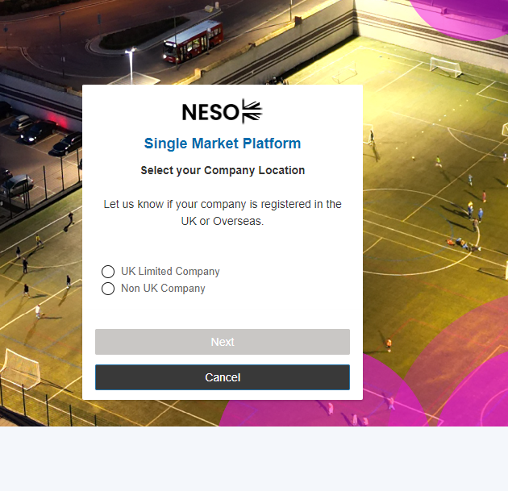

Company Registration: UK Limited Company cont.
- Enter your exact Company Name and Company Registration Number. Please note that the Company will be required to be registered with Companies House, as SMP will cross check the Companies House Database to locate your Company. Please also ensure that the precise Company Registration Number is entered to ensure the accurate and exact match is made.

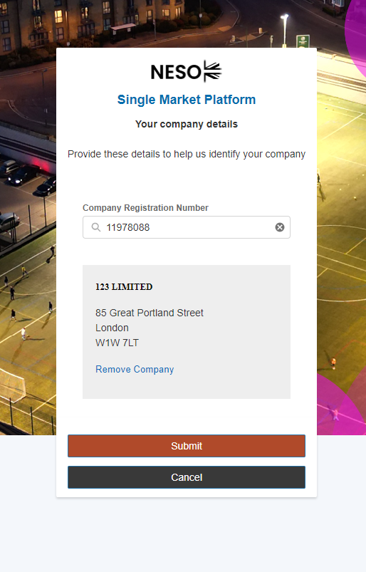

Company Registration: UK Limited Company cont.
In order to proceed to the next screen and the ‘submit’ button to be released – an exact match must be found when the Company Registration Number is entered in the search dialog box. The full address will be shown on screen to help you verify it is the correct Company. You have the option to start the search again by selecting ‘Remove Company’.

Company Registration: UK Limited Company cont.
Confirmation that the registration process is complete will end with this screen notification.
- If you are a first time registrant, then your registration request will be reviewed by the Contracts & Account Management Team before granting you full authorisation. When authorisation is granted you will receive an acknowledgement email, equally if the authorisation is rejected, then you will receive an Email Notification accordingly.
- If you are a secondary or additional registrant to an existing ‘Account’ (Company) already known to SMP, then your designated Super User will receive notification of your registration request. They will require authorising your request and upon doing so, you will receive an acknowledgement email, equally if the authorisation is rejected, then you will receive an Email Notification accordingly.

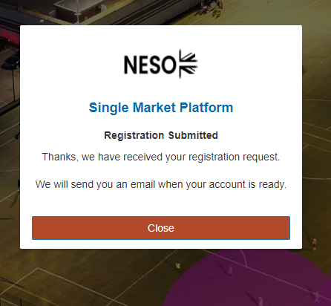

Company Registration: Non UK Company

The section below will illustrate the steps required for First Time User’s Company Registration if their Company/Organisation is not based in the UK.
- Select your Company/Organisation as Non UK Company
- Select Next

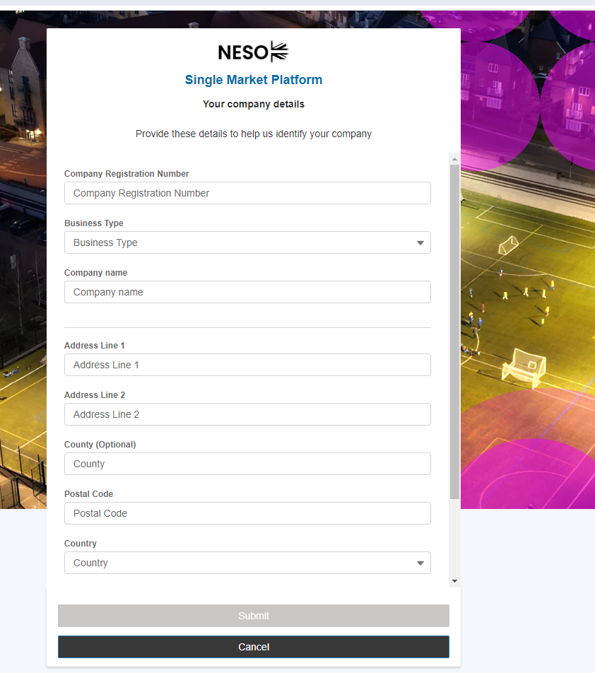

Company Registration: Non UK Company (cont.)

- You will be required to supply your Company/Organisation’s a) Company Registration Number and b) Full Address
- In order for you to proceed and the ‘Submit’ Button to be released, you will be required to supply Address Line 1, Address Line 2, Post Code, Country and Country of Incorporation.

Company Registration: Non UK Company (cont.)
Confirmation that the registration process is complete will end with this screen notification.
- If you are a first time registrant, then your registration request will be reviewed by the Contracts & Account Management Team before granting you full authorisation. When authorisation is granted you will receive an acknowledgement email, equally if the authorisation is rejected, then you will receive an Email Notification accordingly.

- If you are a secondary or additional registrant to an existing ‘Account’ (Company) already known to SMP, then your designated Super User will receive notification of your registration request. They will require authorising your request and upon doing so, you will receive an acknowledgement email, equally if the authorisation is rejected, then you will receive an Email Notification accordingly.

- If you are the first time User for your Company/Organisation, then you will automatically allocate the Super User Role. This will be made apparent in the Email Acknowledgement Template. In the event that you do not wish to be allocated the Super User Role or there is a subsequent User whom registers for the same Account and should be re-allocated the Super User Role, then this will have to be managed though the Accounts and Contract Management Team.

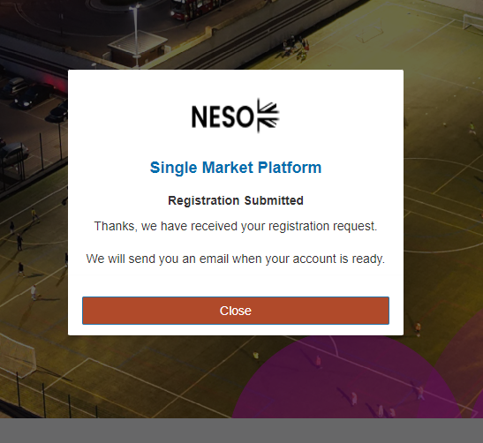

Completion of Registration: First Time User

Email Acknowledgement: Approval of Registration Request Template
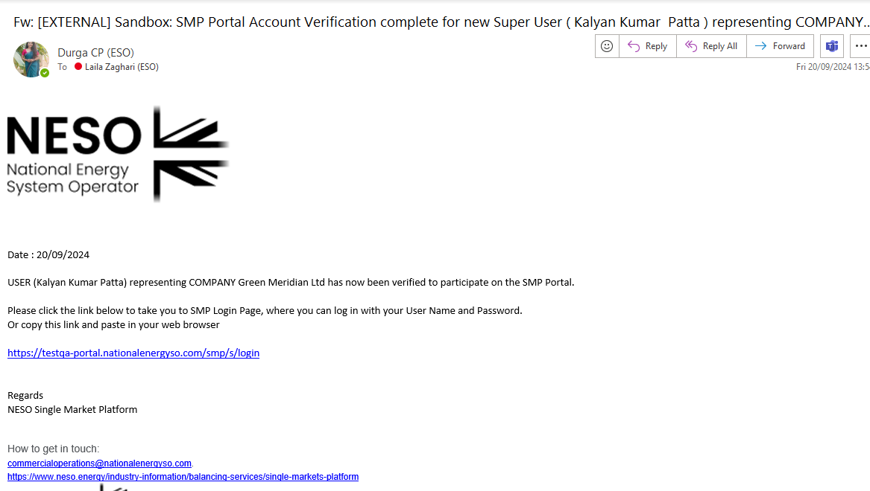

Completion of Registration: First Time User

Email Acknowledgement: Rejection of Registration Request Template

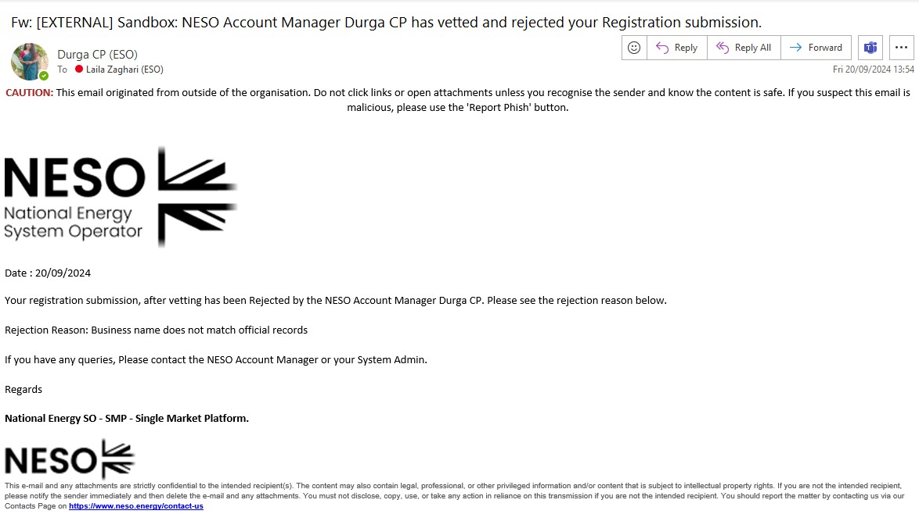

2.18 Registered User’s: Ongoing Access

- For both existing User’s (migrated users) whom have had SSO credentials set up for them (previous active SMP Users) and new registered User’s whom have acquired their credentials through the SSO registration process, the ongoing login process will be the same.
- Users navigate to the NATIONAL ENERGY SYSTEM OPERATOR LIMITED Website, are presented with the screen below and will instead enter their Email address (which will act as their Username) and be prompted for a password.
- As a one off task for existing ‘migrated users’ only, they will enter their existing SMP Portal User password, and then will be prompted to re-set the password.
- Where a password has been reset, or in the instance of new User’s if thereafter their new password has been forgotten, they have the option to click ‘Forgot password’ and are provided with another opportunity to create a new password entirely. If the user experiences any difficulties throughout they can send an email to the helpdesk highlighted below. The steps for resetting passwords as standard is illustrated in the sections overleaf.

Registered User’s: Ongoing Access Steps
- The first step to resume access is to simply enter your Username (Email Address) or (SMP Username) and then enter your Password.
- If any difficulties are experienced please send an email to the address highlighted in the green box.

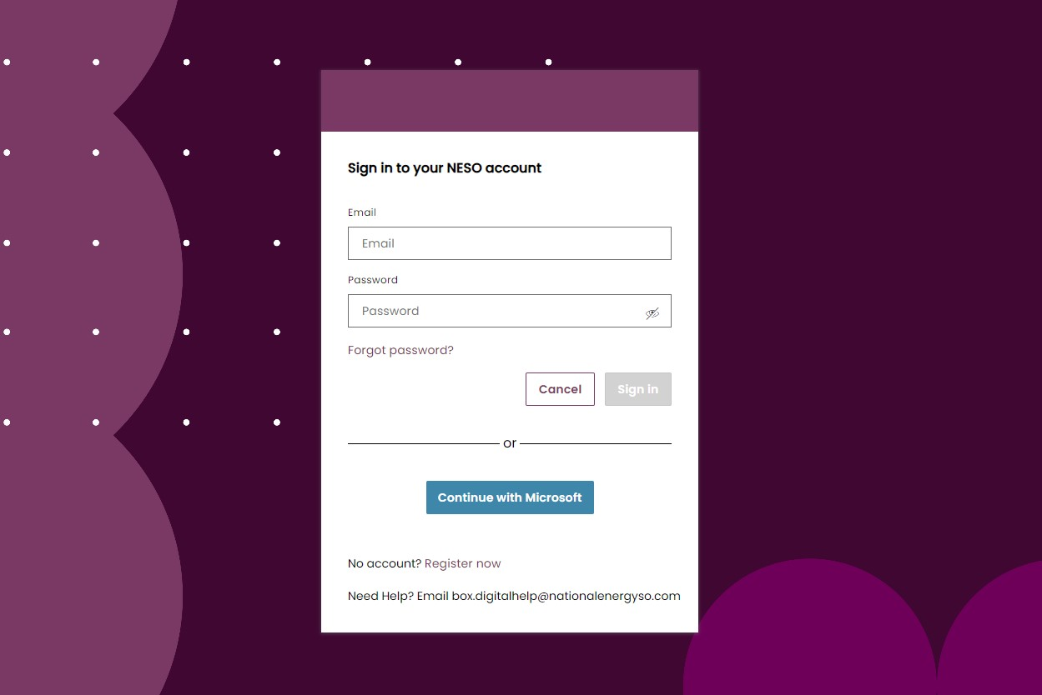

Registered User’s: Ongoing Access Steps
- Following on from the Username and Password being entered, you will be prompted to verify your email address by clicking ‘Submit’.
- *Please ignore the reference to ‘Microsoft Email’ if you Email Provider/Application is different
- You can abort the process by selecting Cancel – which will in turn navigate you back to the ‘home page’ for the National Energy System Operator Website

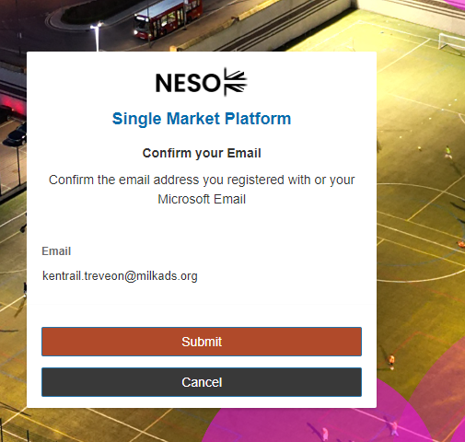

Registered User’s Ongoing Access Steps
- A verification code will be sent to the designated Mobile Phone number provided at the point of registration.
- You will be expected to enter the code and select ‘Verify’.
- If a Text/SMS Message has not been received with the code within a couple of minutes, please proceed with clicking the ‘Didn’t receive a text message’ Resend link to generate a new code with a secondary attempt.
- If after secondary attempt no code is generated, then please send an email to the box.digitalsupport@neso.energy helpdesk email.
- If these steps have been followed successfully, you will be instantly granted access to the SMP Portal.

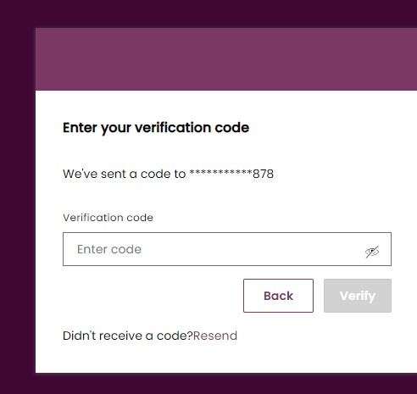

Registered User’s: Ongoing Access Steps
- A verification code will be sent to the selected Email Address and you will be expected to enter the code and select ‘Verify’.
- If an Email with the code is not successfully received within a couple of minutes, please ensure it hasn’t landed in your spam or junk boxes and then proceed with clicking the ‘Didn’t receive a text message’ Resend link to generate a new code with a secondary attempt.
- If after secondary attempt no code is generated, then please send an email to the box.digitalsupport@neso.energy helpdesk email.

Resetting Passwords
- In the instance a password has been forgotten, it can be reset by selecting the ‘Forgot Password’ hyperlink.

Resetting Passwords: Cont.
- You will be prompted to enter your Email Address (also your SSO Username for Primary Accounts)
- Please ensure you enter the Email in the correct format before proceeding with clicking on the ‘Submit’ button.

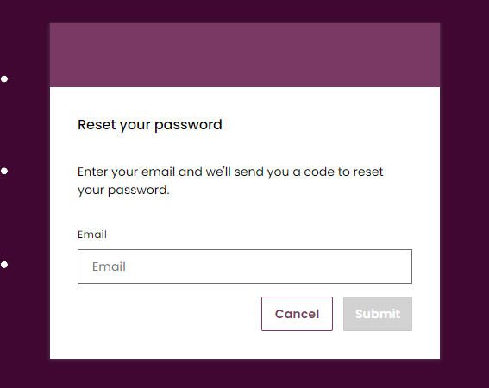

Resetting Passwords: Cont.
- You will be prompted to enter your Email Address (also your SSO Username for Primary Accounts)
- Please ensure you enter the Email in the correct format before proceeding with clicking on the ‘Submit’ button.
- An Autogenerated Email will be sent to your Mailbox as illustrated below. Please copy and paste the code from the body of the Email Template and enter into the field entitled ‘Recovery Code’.

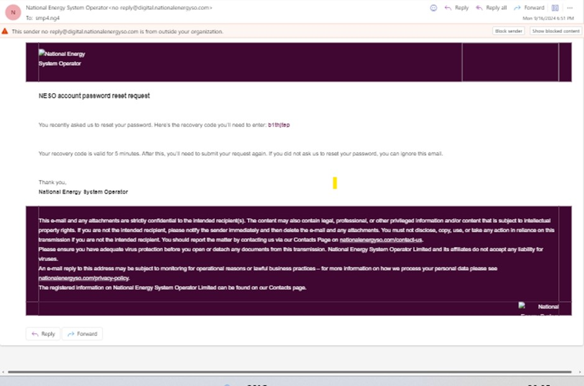

Resetting Passwords: Cont.
- Once you enter the Recovery Code, you will also be prompted to enter the New Password and Confirm the New Password by re-entering it in the ‘Confirm new Password’ field.
- Once this is complete, the ‘Save’ button should be released for selection.
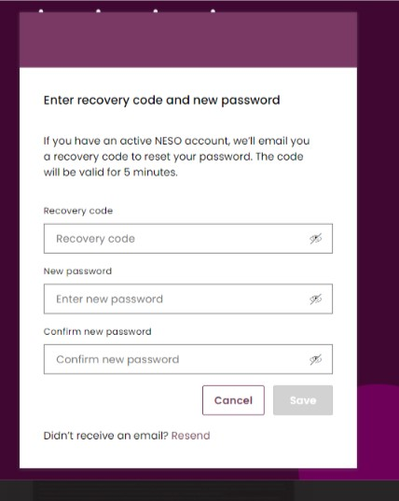

Resetting Passwords: Cont.
- The final step to complete the resetting of password process is to undergo verification which will be identical to the verification by mobile phone text/SMS applied at the point of registration
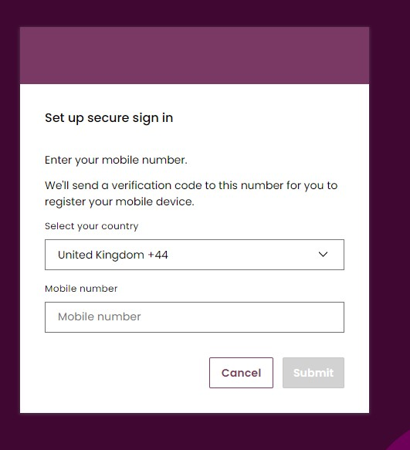

User’s with ‘Multiple Accounts’

Legacy Users
For a select number of User’s they will have been provided with access to several different Company Accounts and consequently have required a separate set of credentials to login into each Account on SMP. Moving forward these User’s will continue to have access to said Accounts with their approval, however only one of the select accounts will be included in the data migration. This means that access to one account will be automatically set up, whilst the others if continued access is required will need their SSO login’s reviewed and appraised for consolidation by your respective Account Manager.

The key differences in accessing Multiple Accounts for these User’s is as follows;

- The Username for the ‘main’/’primary’ Account (the migrated account) will be the User’s Email Address
- The Username for any additional ‘secondary’ Account(s) will be the existing/inherited SMP Username.
- The User can continue to use the same Email Address across multiple User Accounts
- The User can use the same Mobile Number to authenticate across multiple User Accounts
- Users must be associated with an individualised Email Address and cannot use generic email addresses i.e. ‘queries@neso.energy’

As of Release 3.5, all users whom have previously been able to access Multiple Accounts using different sets of SSO Credentials will have the opportunity to consolidate these into a singular SSO with the introduction of Inter Company Agreements that allow one user to ‘account switch’ and access both their main (primary) and any secondary or additional accounts through one set of SSO login. To learn about this feature, please visit the chapter on Inter-Company Agreements.

Access to the EAC Platform
For any user wishing to gain access to the EAC Platform it is a prerequisite they have the following;
- A SSO login credential
- An ‘Active’ SMP Portal User with the ‘Trader’ Role OR
- An Active’ SMP Portal User with the ‘Trader’ Role AND ‘Unit Manager’ Role
It is imperative that User’s must have Trader Role in particular to be able to gain access to the EAC Platform from within SMP. To learn how to be assign a Trade Role, please visit the Chapter on ‘User Management’.
Once Users have logged in and directed to SMP, they can in turn be re-directed automatically to the EAC Platform without having to login in separately by simply clicking on the EAC Icon on the SMP Home Page. For more information on navigating to the EAC Platform, please visit the Chapter on ‘User Management’.

Updating User & Company Details

Making updates to your own Contact & Company Details

- In the event that a User/Contact’s own details or those of his Company have changed or need updating or amending, a user is only able to make limited amendments.
- The user must navigate to the right-hand section of the ‘’Unit Management’’ Page. This is currently the default Landing/Home Page upon initially logging in.
- An ‘avatar’ icon will appear and the user must click on this. They will then be presented with a drop-down pop-up screen with options to either ‘Manage account’ or ‘Contact us.
- The user should click on ‘Manage account’.

Managing Contact & Account Details Screen
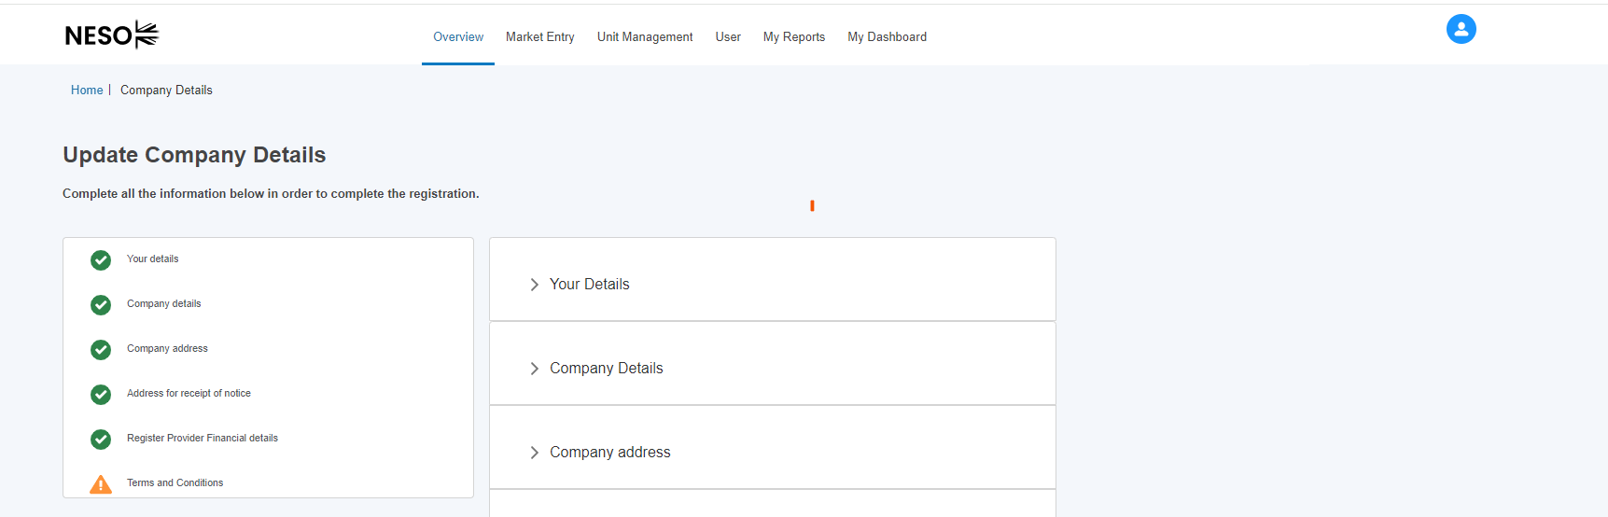
- The User will then select be prompted with an option to ‘Update Company Details’ as illustrated in the figure below.

Making updates to your own Contact & Company Details

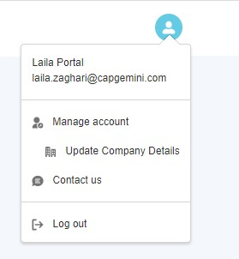

Update Company Details: Home Page
- The user is then navigated to the Update Company Details Page as illustrated in Figure below
- The user can click on either the ‘accordion’ feature on the left-hand side to navigate to a particular subsection directly OR they can click on the subsection heading e.g. ‘Your Details’. This ‘opens’ up the section for granular level of information/fields to update or edit.

Update Company Details Home Page Screen
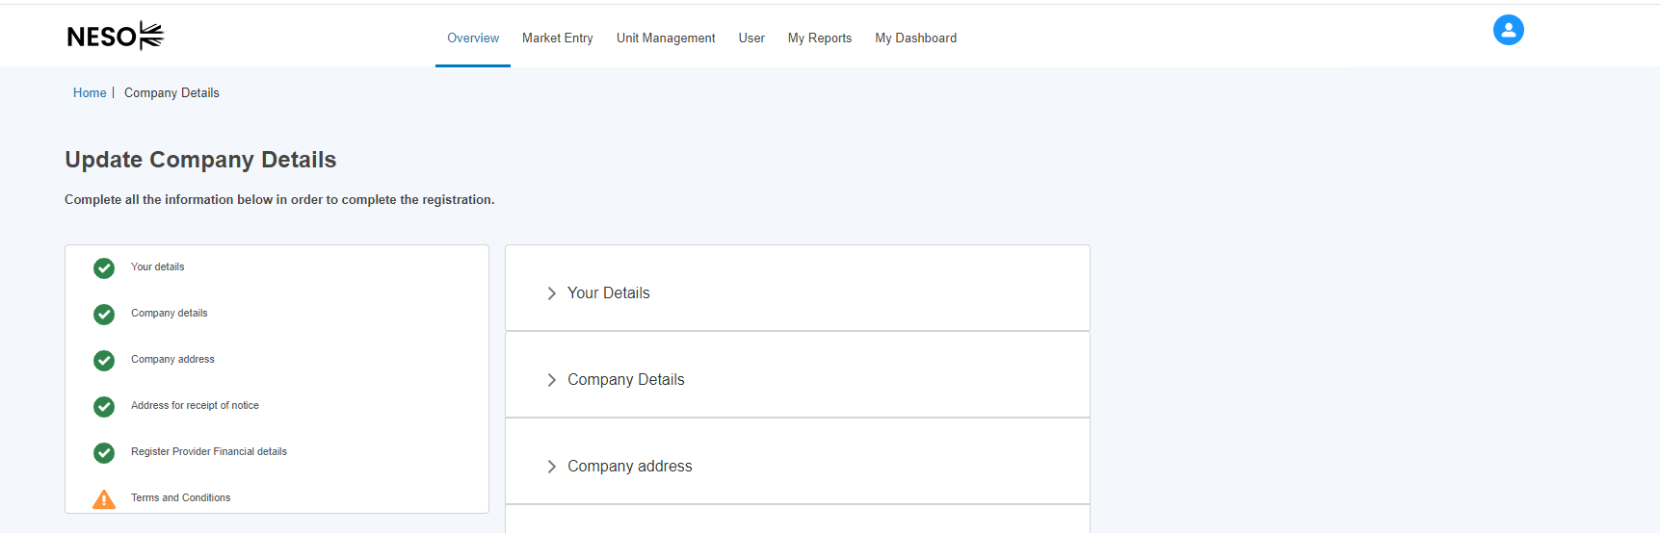

Update Company Details: Completing Your Detail Section
- The user is no longer able to edit the First Name, Last Name, Mobile Phone fields and Email Address directly.
- The reason for this is that they are tied to their respective SSO credentials and therefore any modification will require a change to their SSO User Record. If any of these fields require modification, then a query will need to be raised by emailing the helpdesk: box.digitalsupport@neso.energy

Update ‘Your Detail’ Section
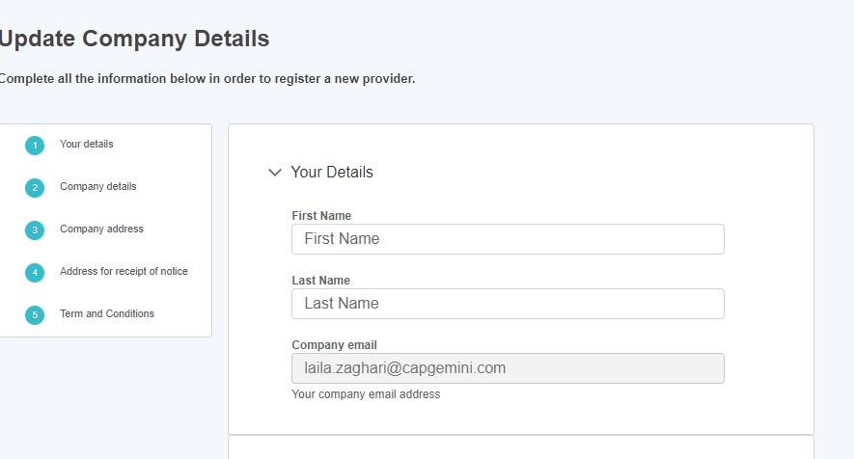

Update Company Details: Completing Your Company Details Section

- The user is also not able to update the Company Name or Company Registration Number. However, the Company Phone Number and Company Address Fields can be modified or updated. If the Company Name or Company Registration Number require updating, a query should be raised with your Account/Contract Manager directly.
- Please note that the Company Phone Number is marked with a red asterisk, which indicates that it requires a specific format and if a number is entered incorrectly, an error message will appear to this effect.

Update ‘Your Company Details’ Section

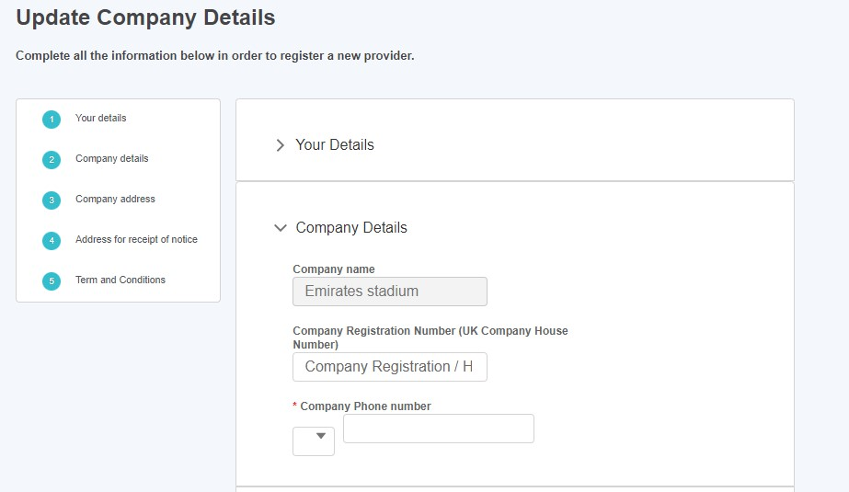

Update Company Details: Completing Your Company Address Section
- The user is able to update all fields with the exception of the Country of Incorporation field. If the User requires a change to this field, they should approach the National Energy System Operator Account Managers directly via email or phone.
Update ‘Your Company Address Details’ Section
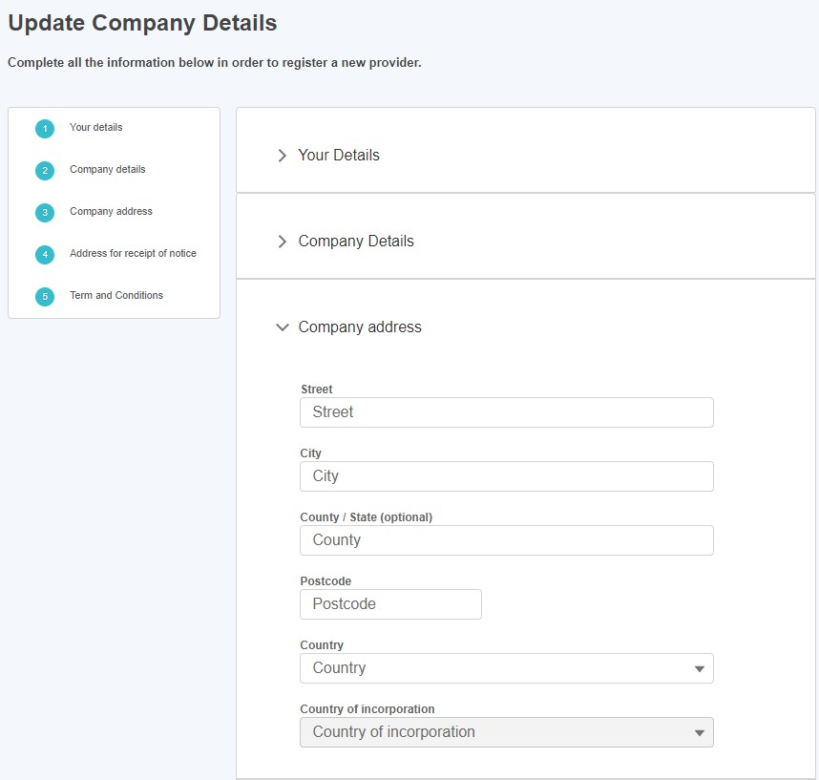

Update Company Details: Completing Your Company Address for Receipt of Notice

- The user is able to update all fields with the exception of the Country of Incorporation field. If the User requires a change to this field, they should approach the National Energy System Operator Account Managers directly via email or phone.
- Please ensure the check box is ticked if the Address for receipt of notice is different from the Company address if this is the case.
Update ‘Your Company Address for Receipt of Notice’ Section

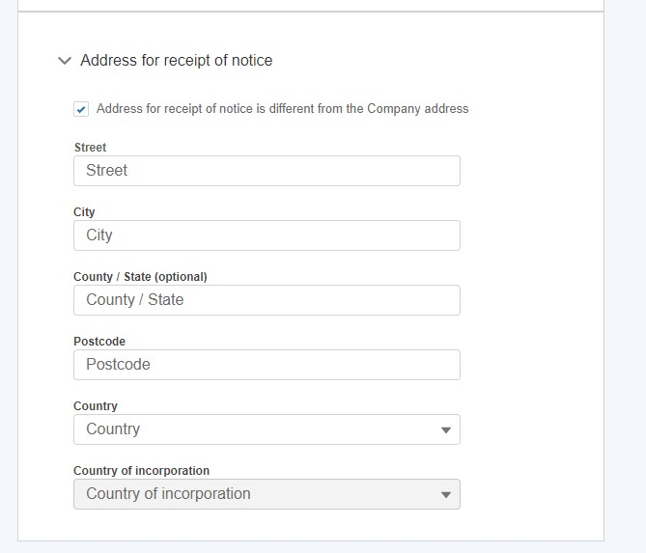

BSC Registration

The user will have the option to update the Elexon Organization ID and BSC Signatory Fields if there are no values present for them. When values are present the user will no longer have the ability to update the fields.

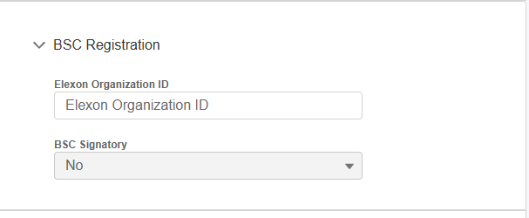

BM Registration Documents

The user can upload documents relating to BM Registration in this section. These will then be visible to the registrations team for appraisal when they come to approve the registration of a BM Unit. Please note, the following must be uploaded in order for a unit to be accepted based on the Category of the Unit:

Unit Category | Document Needed
Primary BMU | CUSC
Secondary BMU | CUSC & VLPA
Additional Supplier BMU | Supplier Agreement
Additionally, for an Interconnector User record to be Accepted, the Use of System Interconnector Agreement document must be uploaded.

To upload a file, click on the ‘Upload Files’ button in the relevant section. Select the File from your machine and press ‘Done’ when the file has finished uploading.

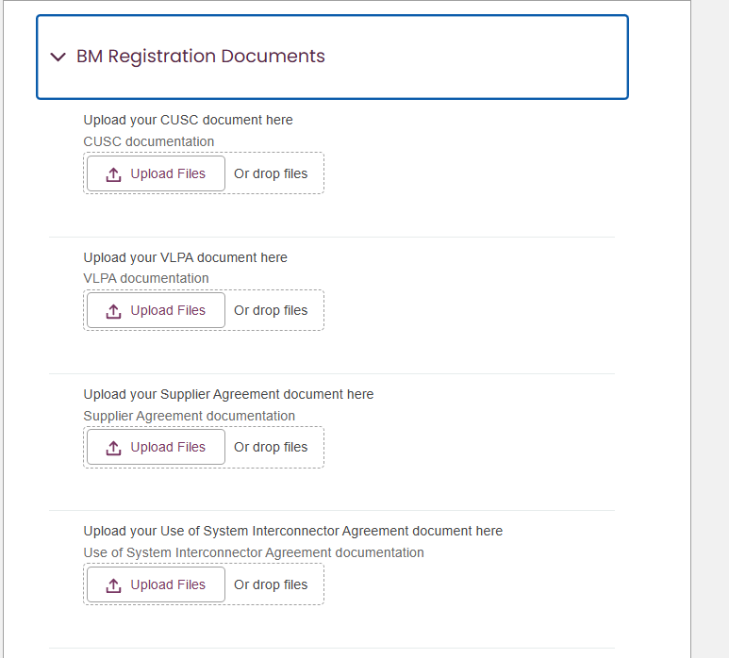

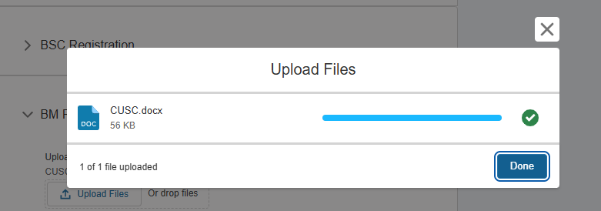
The file will then be visible and available to re-download to the user. Only 1 file can be uploaded per section. If the file needs to be changed or removed, please get in touch with the NESO Registrations team
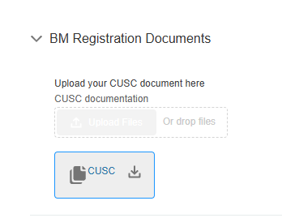

Terms & Conditions: Confirmation
- Upon varying, updating or modifying the User’s contact or Company (Account) Details sections, they are expected to adhere to the Terms & Conditions and therefore complete this section before being granted the ability to save the record details or changes made.
- Please ensure the check box is ticked otherwise the user will be prevented from saving the changes successfully.

Confirm ‘Terms & Conditions’ Section

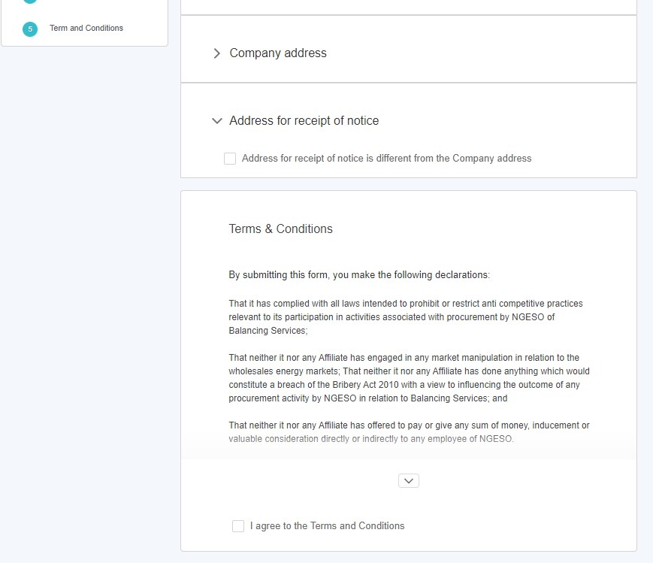

Confirmation Notification Screen
- Once the Terms & Conditions section is completed, the User will be presented with a pop-up notification screen as acknowledgment that their changes have been saved. They then have the option to navigate to the Home Page (Unit Management) by selecting the ‘Go to Dashboard’ button.

Confirmation of Changes Notification Screen
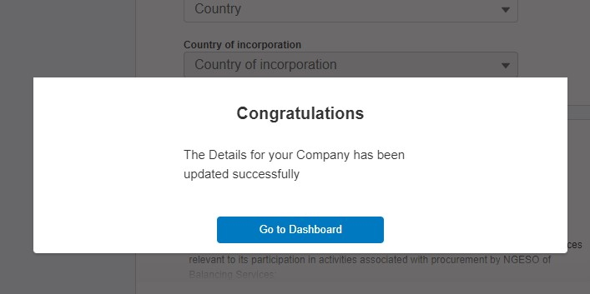

Asset & Unit Management

Navigating the Landing Page for Unit & Asset Management.
- The Unit Management Page is made up of several components as follows:
- Unit Management Tab: Click on this to always land back on this page.
Units & Asset Sub Tabs: Click on these to switch between the collection of Units and collection of Assets.
Trading Agent (EDT) Sub Tab
Control Point (EDL) Sub Tab
- Search bar: Enter text into the search bar to help you find a specific Unit/Asset. This will narrow down the tiles that are displayed, so that tiles are only displayed if the search text matches the start of the Unit/Asset name.
- Create New Unit: Click on this to register a new unit*
- Align assets to Units: Click on this to undertake the alignment of assets to Units*
*Subsequent sections in this guide will cover each of these features in depth.

Navigating the Landing Page for Unit & Asset Management.
Asset & Unit Management Home Page Screen

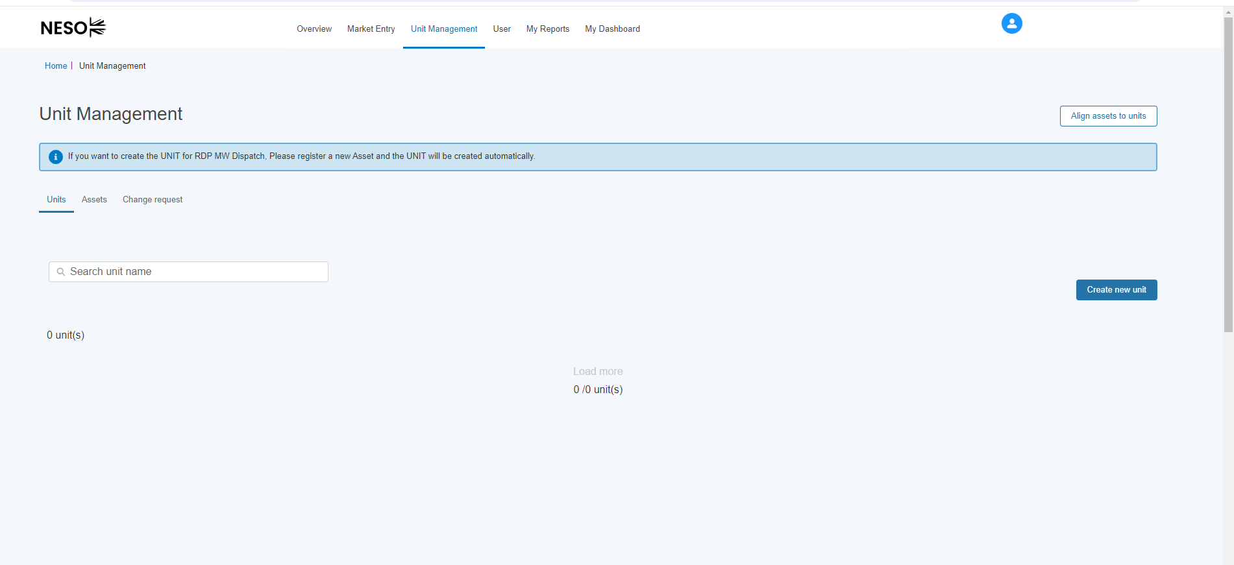

Creating & Managing Assets

Create an asset.
- To register a new asset, the first step is to click on the ‘Create new asset’ where a user will be presented with the screen illustrated in Figure 22.0 ‘New Asset registration’ where a unique asset name will be required. Please note that, firstly, an asset cannot be created without an asset name, and secondly, the name must be unique in naming convention to the asset in question. Once the asset name is provided, the user will be able to progress to the next step by clicking Create.
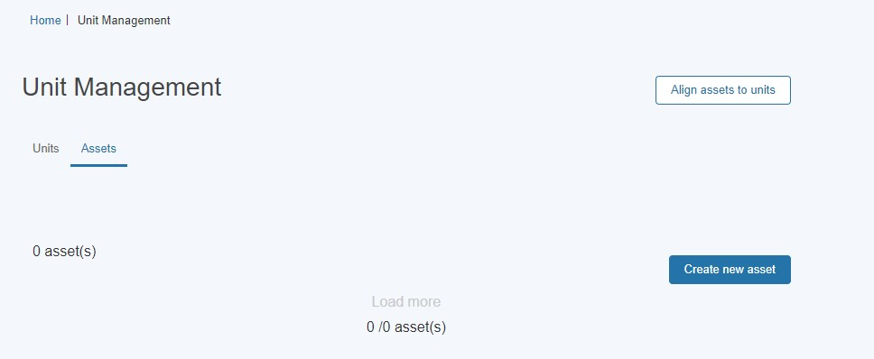
Creating Assets- Asset Registration

Create an asset.

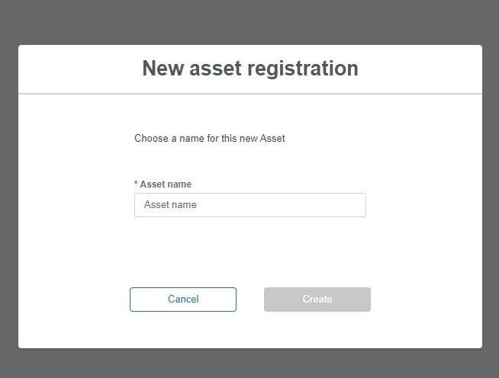

Asset Registration: Submitting Asset Information
- The user is navigated to the Asset Registration Page as outlined in Figure overleaf, the format is similar to the Account Management Page structure with an accordion section on the left-hand side for direct navigation to a specific section or the user can select the subsection they wish to complete.
- The figure illustrates the unique named asset for which the details are being registered; ‘Roe dean Windfarm’.
- Please note that the user is not able to progress the registration process for a created asset without completing all the sections and corresponding fields. The icon next to each subsection heading on the left-hand side will reflect the state the subsection is in.
- A circular green icon with a tick indicates that the all the mandatory fields in the subsection have been completed.
A triangular amber icon with an exclamation mark indicates that some but not all of the mandatory fields in the subsection have been completed.
- A circular blue icon with a number indicates that none of the mandatory fields have been completed yet.

Create an asset.
Figure below shows the Asset Registration Detail Page where Subsection 1 has been completed, Subsection 2 is in progress while Subsections 3 & 4 are yet to be started.

Asset Registration Detail Page

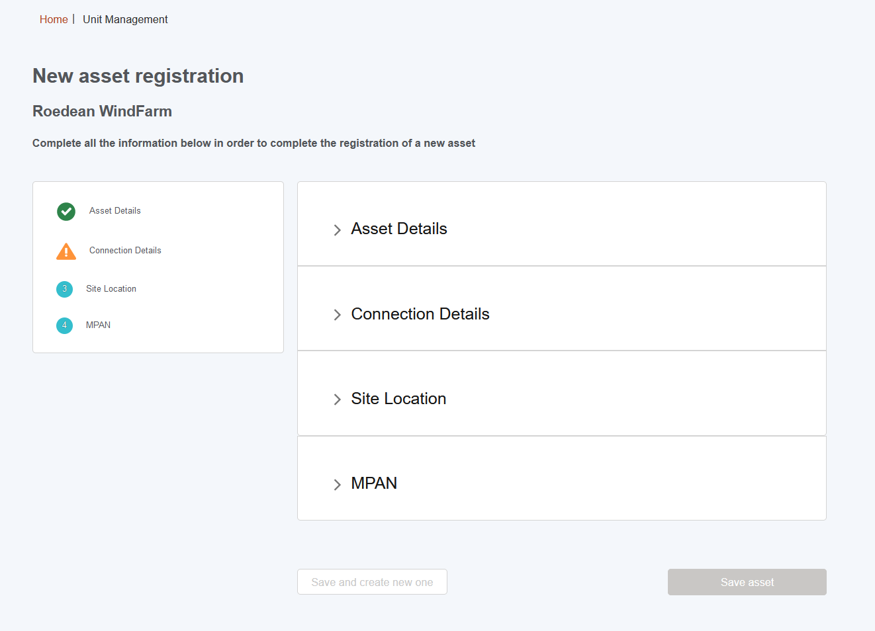

Asset Registration: Asset Details Section
- Figure below illustrates the Detail Section for the Asset.
- Please note that as the Asset Ownership, Asset Type, the Effective from Date and Fuel Type are all mandatory and therefore marked with a red asterisk. It is essential that these fields have information submitted.
- Please consult the Glossary Appendix for a translation of the Fields if the User is not clear about what is being requested.

Completing the ‘Asset Details’ Section

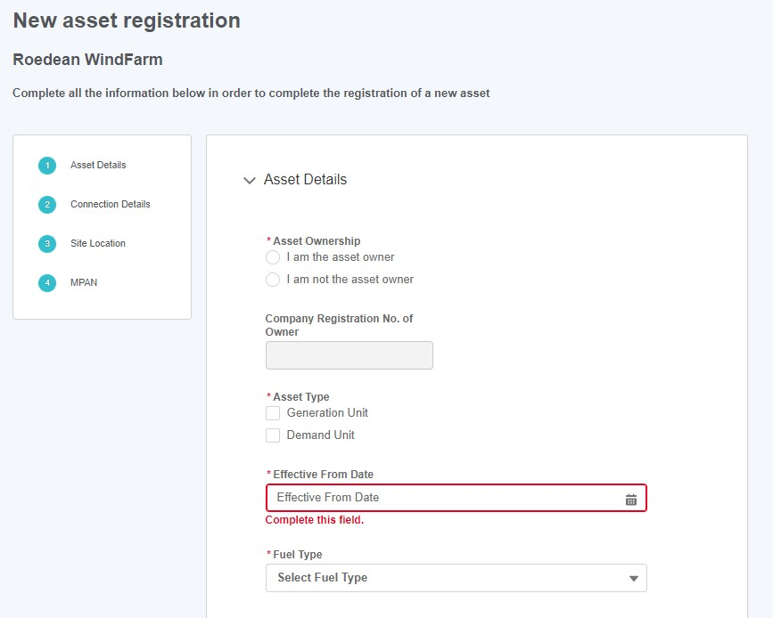

Asset Registration: Asset Connections Section
- Figure below illustrates the Asset Connection Details Section for the Asset.
- Please note that as the Generation Capacity, Demand Capacity, the Connection Type are all mandatory and therefore marked with a red asterisk. It is essential that these fields have information submitted.

Completing the ‘Asset Connection Details’ Section

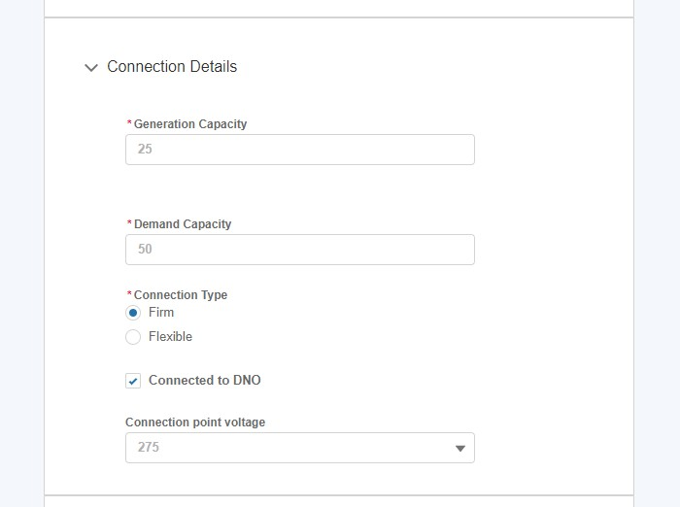

Asset Registration: Asset Site Location
- Figure below illustrates the Site Location Section for the Asset.
- Please note that the Asset Latitude, Asset Longitude, the Nearest Node, Grid Supply Point, GSP Group ID, GSP Group ID (location picklist), Primary Dispatch phone number & Secondary dispatch phone number are all mandatory and therefore marked with a red asterisk. It is essential that these fields have information submitted.
- The Grid Supply Point (GSP) field is multiple choice, so a user can select several values as indicated in the figure below.
- Please ensure that the following fields meet the requirements:
- The Asset Latitude field requires a value between -90 and 90.
- The Asset Longitude field requires a value between -180 and 180.
- The phone number and fax fields require a value with 10 digits.
- The Agent/Applicant Operational Email field requires the value to be in a valid email format.

Asset Registration: Asset Site Location

Completing the ‘Asset Site Location Details’ Section
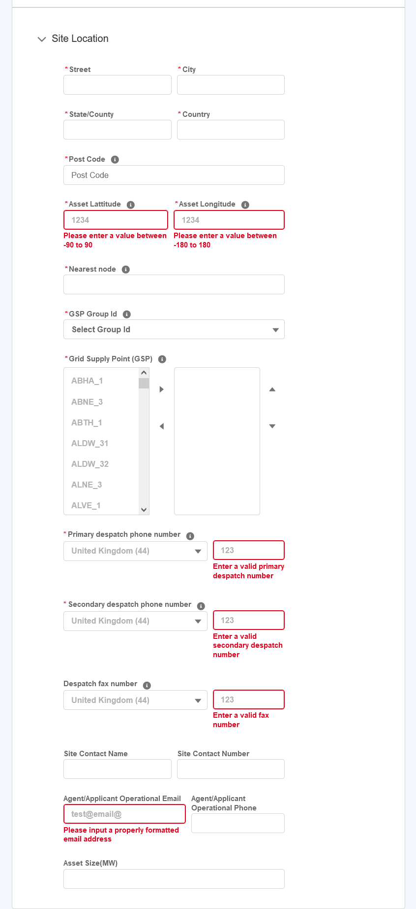

Asset Registration: Asset MPAN Details
- Figure below illustrates the MPAN Details Section for the Asset.
- Please note that the Operational Metering Availability is mandatory and therefore marked in a red asterisk.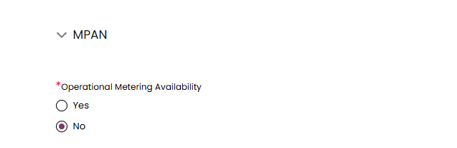
- The user must enter a value into either MPAN Import OR MPAN Export fields, and give MPAN Effective From and To Dates for the value(s).
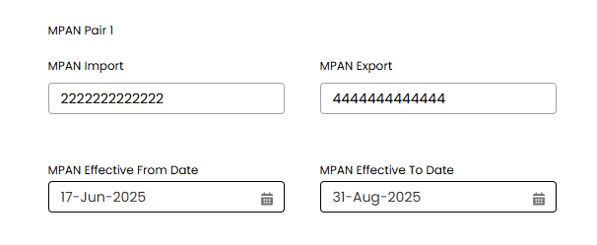
- The user must also indicate whether or not they give consent for those values to be shared by SVAA with the Supplier as detailed by the BSC by selecting ‘True’ or ‘False’ in the MPAN Import/Export Consent fields, and then give Start and End Dates for that Consent.
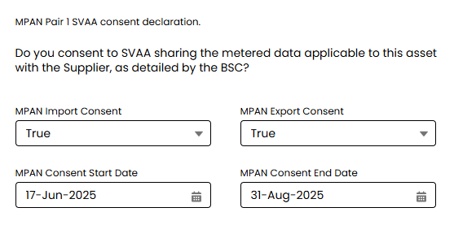
- The user has the option to add another MPAN Pair by clicking on ‘Add New MPAN Pair’.

Clicking on this bring up another set of fields for the user to enter the details and consent details for another pair of MPANs
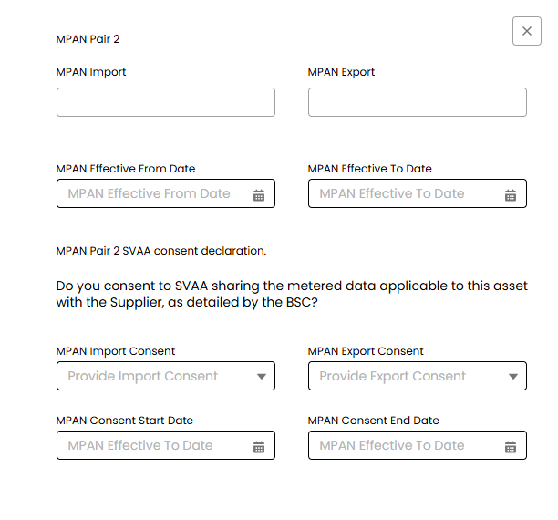
- The user must tick the ‘I consent to the verification of the above MPAN details with Elexon’ box for the Save Asset button to be enabled.
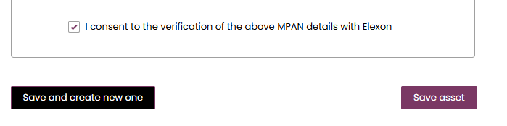

Asset Registered: Asset Tile

Following on from the Asset Registration, the asset tile will appear on the Unit Management Home Page under the ‘Asset Tab’. Each asset will have a corresponding tab. The tile displays the ‘key or summary information’. To view the full registration details, click on the three dots on the right-hand corner of the tile. The user then selects the ‘View Asset Details’ link to be re-directed to the Asset Detail page expanded version.

Please note that Users will be expected to submit all asset information at once. Upon ‘saving the asset’ registration details, the Asset Status will appear as ‘Accepted’ automatically as illustrated in Figure below

Asset Tiles

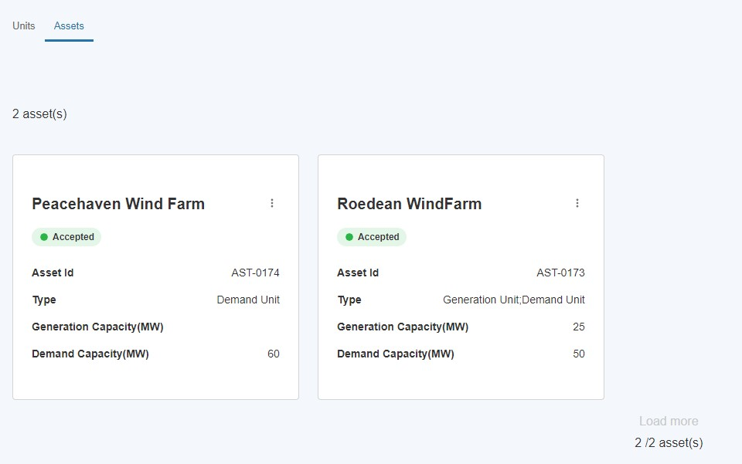

- Creating and Managing Trading Agent (EDT) and Control Point (EDL) Records
As part of the BM Registration process, users will have to pair their Unit to Trading Agent and Control Point records using their respective IDs. This can be existing record, the list of IDs for which can be obtained from the NESO Registrations Team. If the user needs to register a new Trading Agent, follow these instructions to do so. The ID for the new record will be auto-generated at the end of this process.

Create a Trading Agent (EDT) Record
- To register a new Trading Agent, select the ‘Trading Agent (EDT)’ Tab, then press ‘Create new Trading Agent (EDT)’
- Enter a Trading Point Name and press ‘Create’ to be taken to the registration page
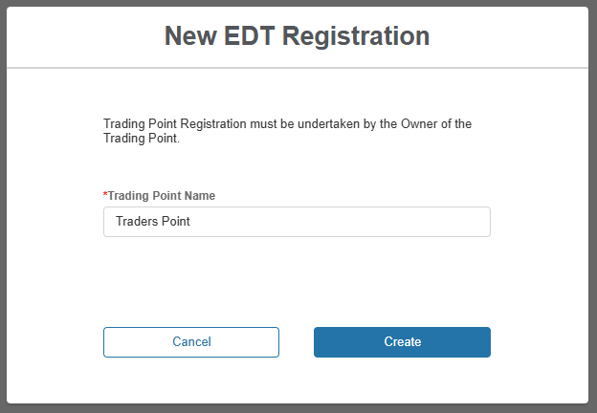

Trading Agent (EDT): Registration Page
- The user is navigated to the Trading Agent Registration Page as outlined in Figure below, the format is similar to the Asset Registration Page structure with an accordion section on the left-hand side for direct navigation to a specific section or the user can select the subsection they wish to complete
- Please note that the user is not able to progress the registration process for a created Trading Agent without completing all the sections and mandatory fields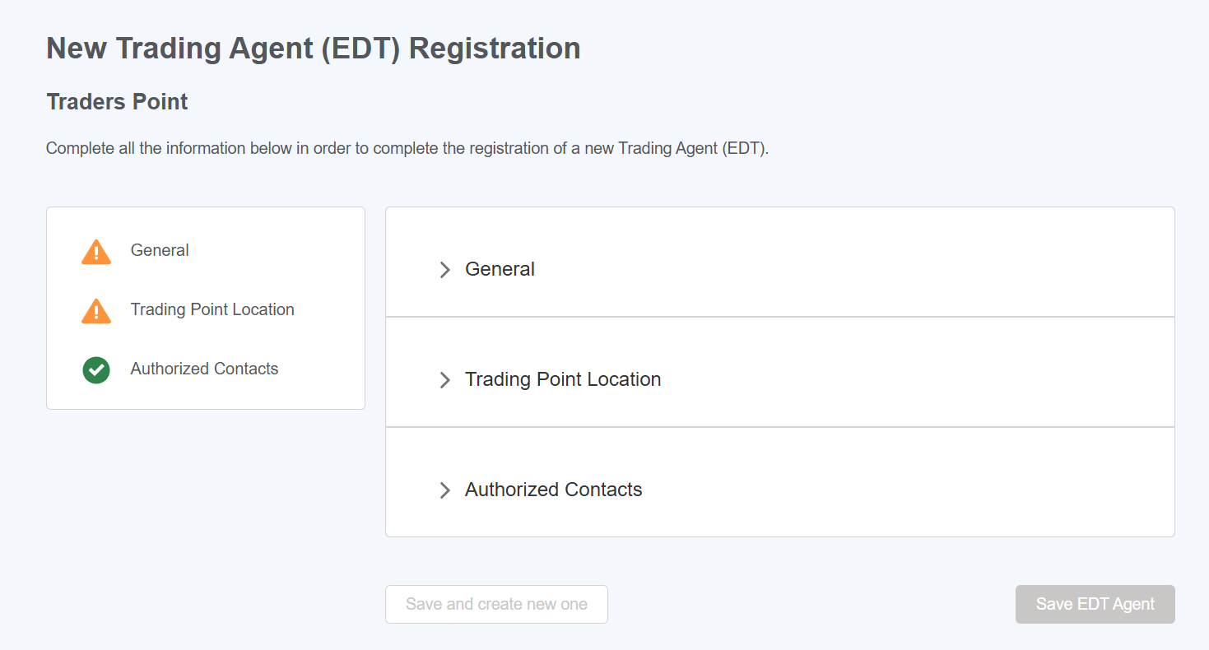

Submitting Trading Agent (EDT) Information: Sections
- Trading Agent record has 3 sections to complete – General, Trading Point Location, Authorized Contacts
- Figure below illustrates the General Section of the Trading Agent
- Fields marked with a red asterisk are mandatory and so the user will not be able to save the record without populating these fields

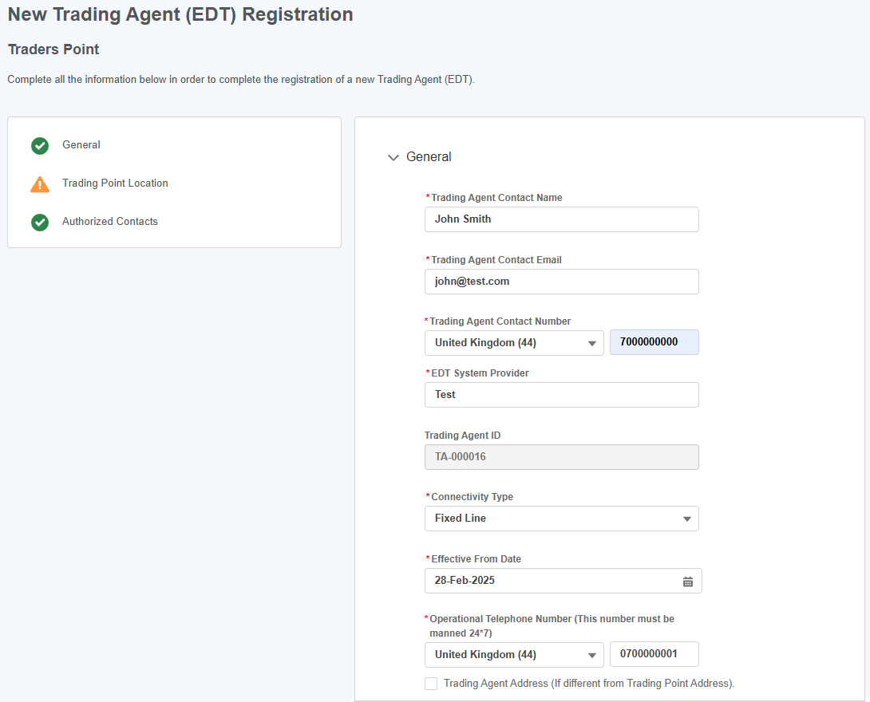

Editing the details of the Trading Agent record
Once saved initially, the record is in ‘Draft’ status, meaning the user can update it prior to submission. To edit the record, locate it on the list of Trading Agents associated with the user’s account, select the button in the ‘Actions’ column then select ‘View Details’
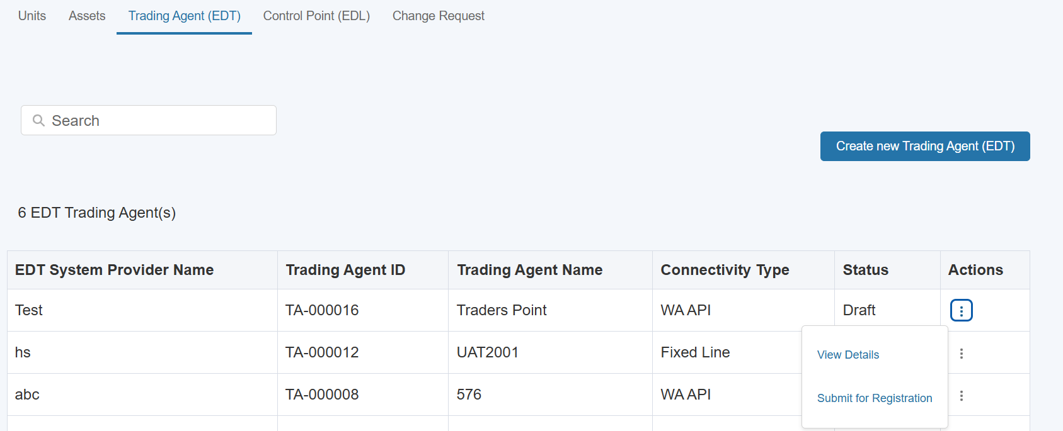

The user will then be taken to the detail page of the record. Select ‘Edit EDT Information’ to proceed with editing the record.
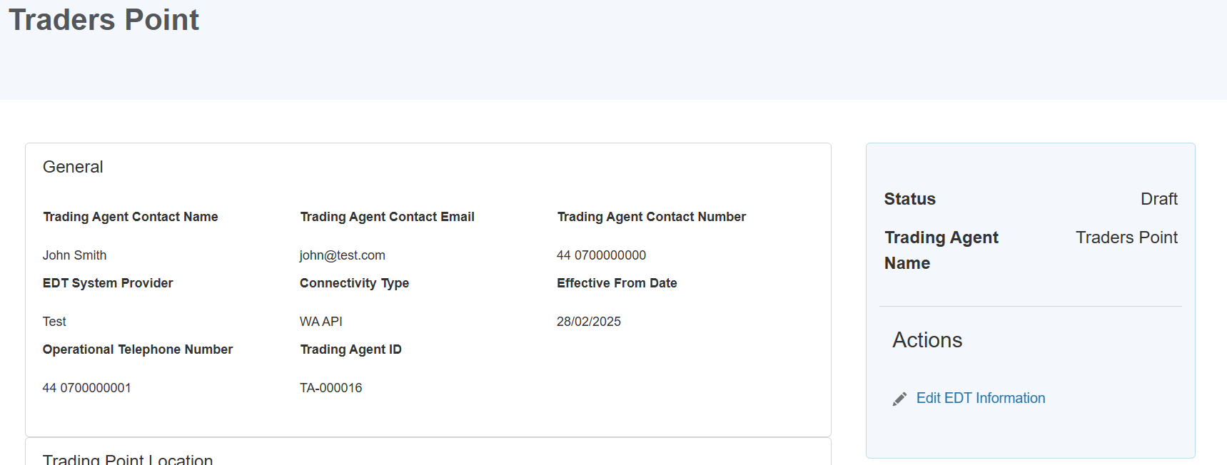
When edits to the record have been finalised, select ‘Update EDT’ to save the record and be returned to the Unit Management page.
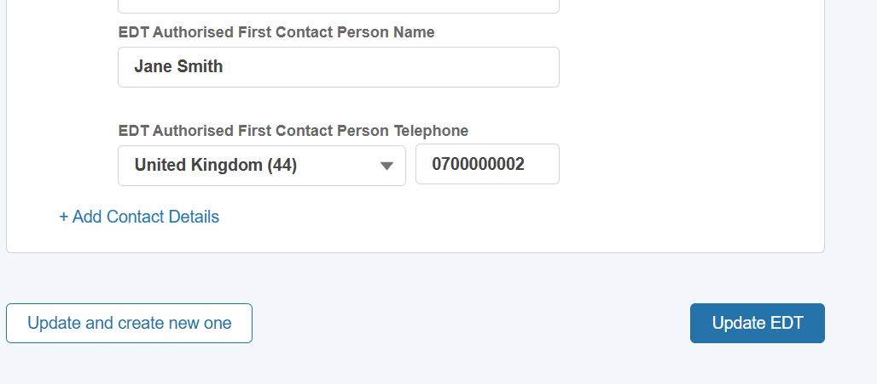

Submitting Trading Agent record for Approval
Once details have been finalised, the user can submit the Trading Agent for appraisal by the Registrations Team at the National Energy System Operator. Please note that Trading Agent records must be in Submitted or Approved state to align them to a BM Unit.
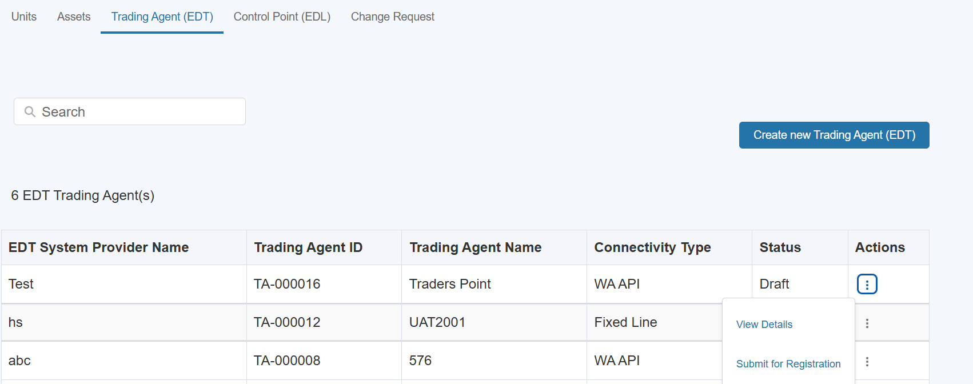

Create a Control Point (EDL) Record
- To register a new Control Point, select the ‘Control Point (EDL)’ Tab, then press ‘Create new Control Point (EDL)’
- Enter a Control Point Name and press ‘Create’ to be taken to the registration page
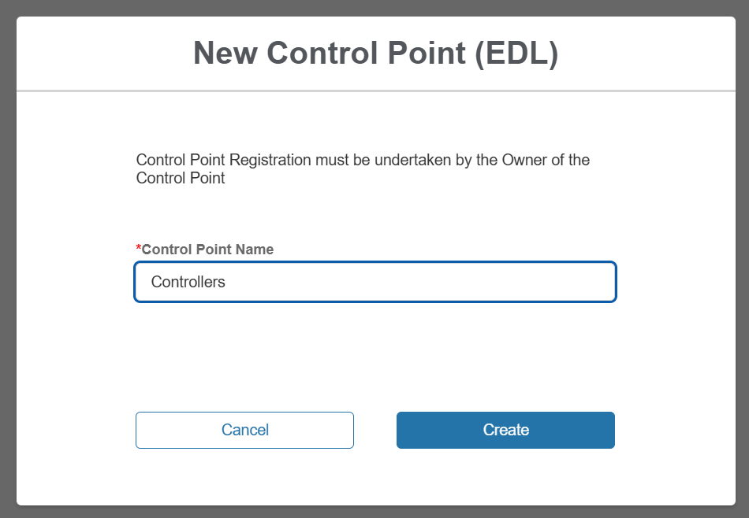

Control Point (EDL): Registration Page
- The user is navigated to the Control Point Registration Page as outlined in Figure below, the format is similar to the Asset Registration Page structure with an accordion section on the left-hand side for direct navigation to a specific section or the user can select the subsection they wish to complete
- Please note that the user is not able to progress the registration process for a created Control Point without completing all the sections and mandatory fields 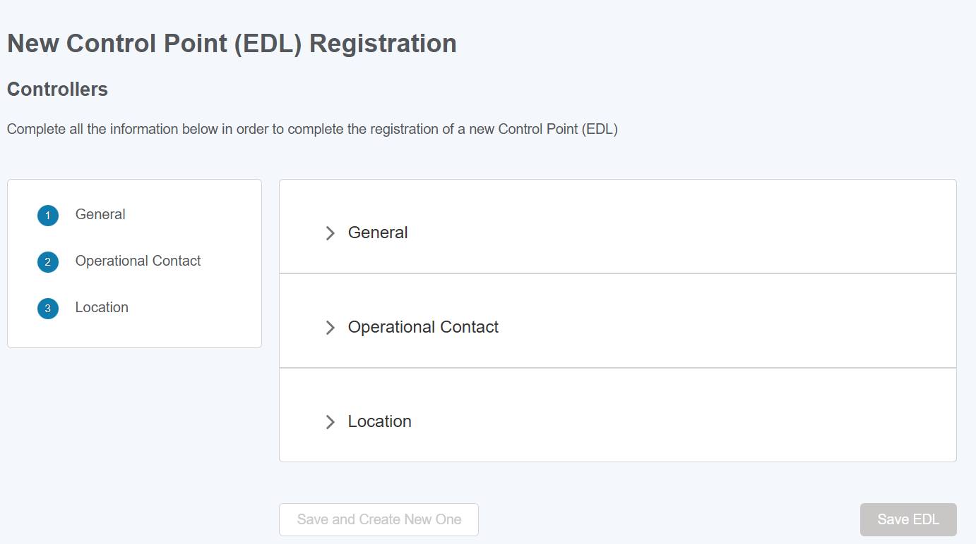

Submitting Control Point (EDL) Information: Sections
- Control Point record has 3 sections to complete – General, Operational Contact, Location
- Figure below illustrates the General Section of the Control Point
- Fields marked with a red asterisk are mandatory and so the user will not be able to save the record without populating these fields

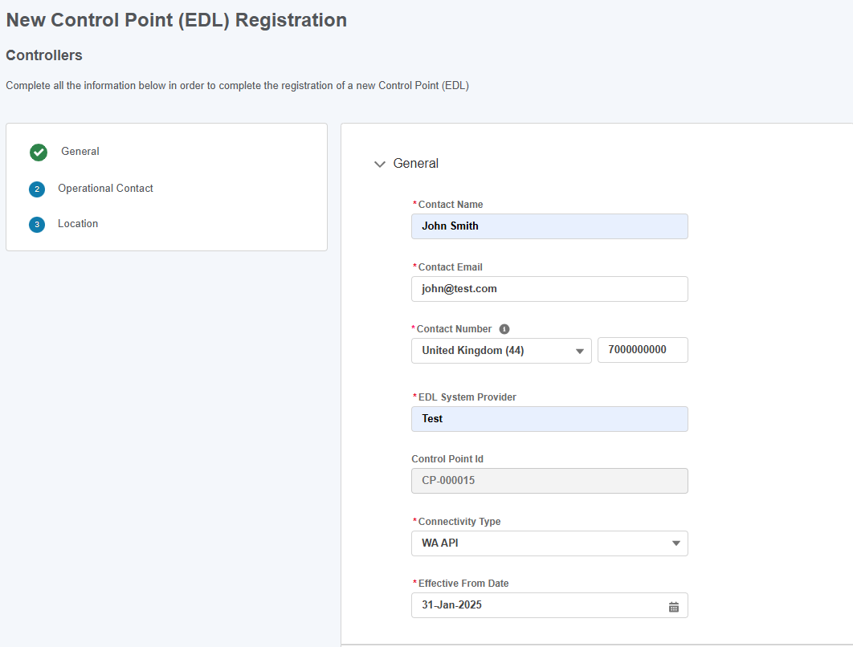

Editing the details of the Control Point record
Once saved initially, the record is in ‘Draft’ status, meaning the user can update it prior to submission. To edit the record, locate it on the list of Control Points associated with the user’s account, select the button in the ‘Actions’ column then select ‘View Details’
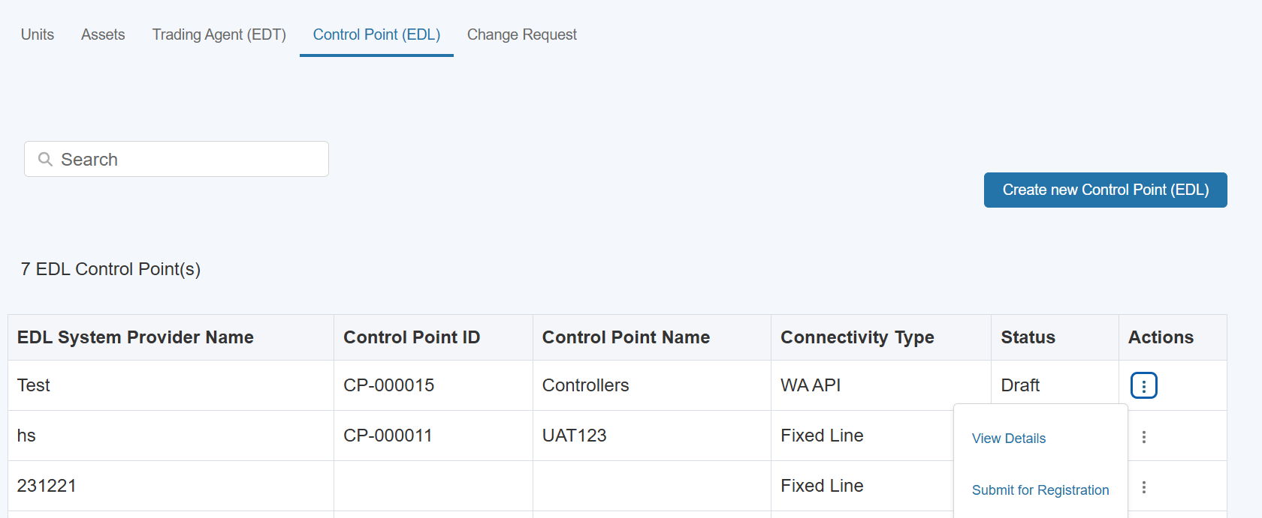

The user will then be taken to the detail page of the record. Select ‘Edit EDL Information’ to proceed with editing the record.
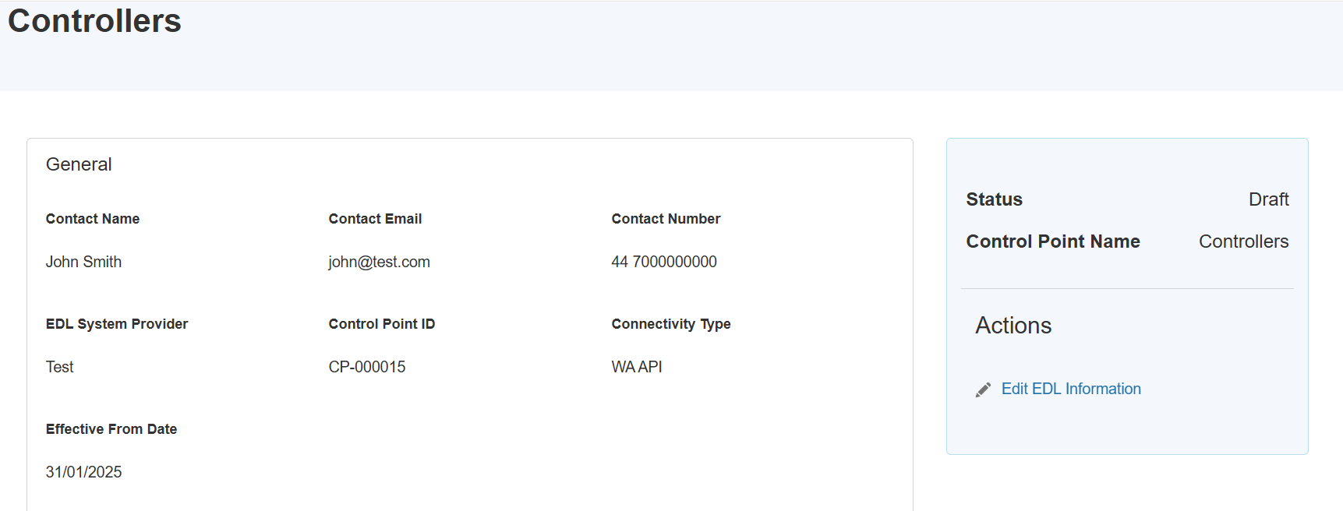
When edits to the record have been finalised, select ‘Update EDL’ to save the record and be returned to the Unit Management page.
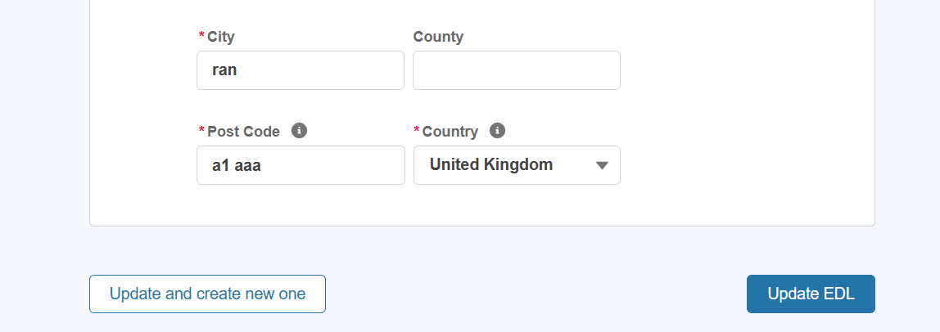

Submitting Control Point record for Approval
Once details have been finalised, the user can submit the Control Point for appraisal by the Registrations Team at the National Energy System Operator. Please note that Control Point records must be in Submitted or Approved state to align them to a BM Unit.
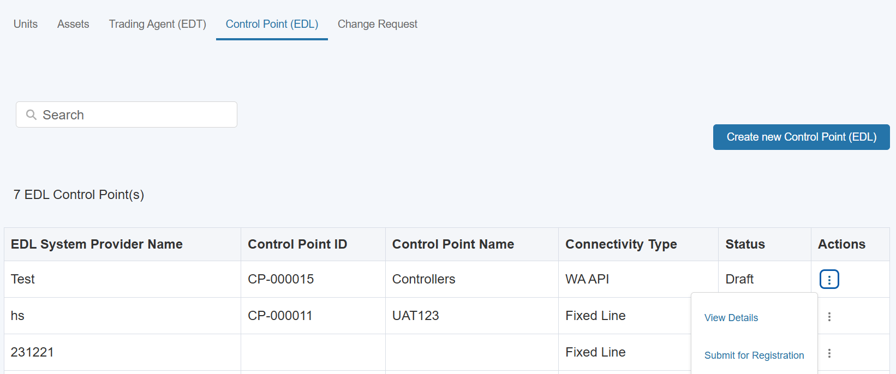

Obtaining the Trading Agent and Control Point IDs

For records directly associated with the user’s account, IDs for Trading Agent and Control Point can be obtained on the list view on their respective tabs. It is recommended to make a note of these if the user intends to set up a Unit linked to them

Available Control Points and Trading Agents not associated with the user’s account can be obtained by contacting the NESO BM Registrations team

Creating & Managing Units

Create a Unit
- To register a new Unit, the first step is to click on the ‘Create new unit’ where a user will be presented with the screen illustrated in Figure below ‘New Unit registration’ where a unique Unit name will be required. Please note that, firstly, a Unit cannot be created without a Unit name and secondly, the name must be unique in naming convention to the Unit in question. Once the Unit name is provided, the user will be able to progress to the next step by clicking Create.
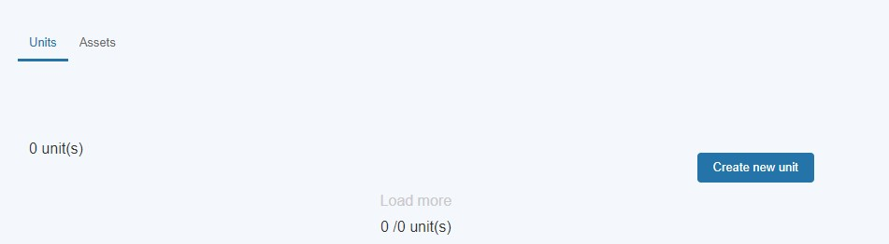
Create Unit

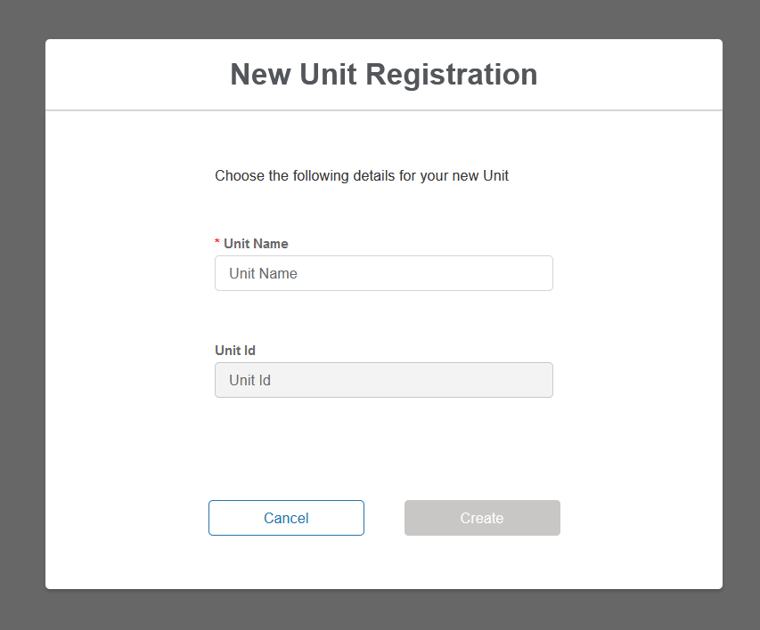

Unit Registration: Overview Page
- The user is navigated to the Unit Registration Page as outlined in Figure below, the format is similar to the Asset Registration Page structure with an accordion section on the left-hand side for direct navigation to a specific section or the user can select the subsection they wish to complete.
- The figure illustrates the unique named Unit for which the details are being registered; ‘Sussex Coast Renewables’
- Please note that the user is not able to progress the registration process for a created Unit without completing all the sections and corresponding fields.

When any of the following is selected as the Unit Category:
- Primary BMU
- Secondary BMU
- Additional Supplier BMU

The user will be prompted to enter additional Balancing Mechanism specific

information. Additional fields will be added to the existing sections and four new

sections will be added to the form for the user to complete, namely:
- Control Point (EDL)
- Trading Agent (EDT)
- OFTO
- eGAMA
Unit Registration Detail Page

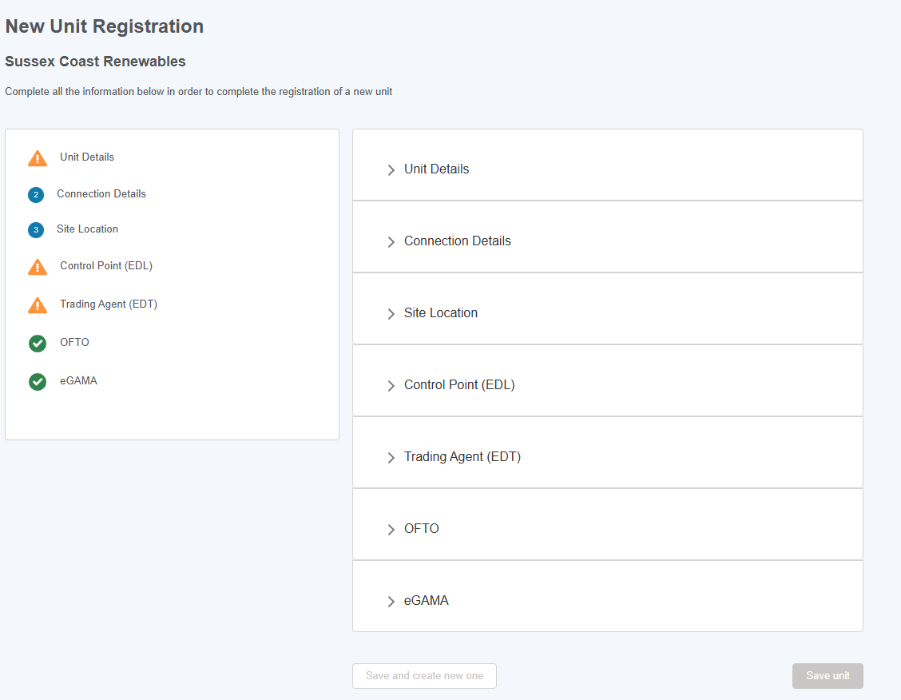

Classification of Unit Category Concept

As of Release 2.7, the user must select a Category for their unit. If Demand Flexibility Service is selected as the Applicable Market, ‘Non-BMU’ will be automatically selected as the Category. If the Category is not known, the user can click ‘Find Unit Category’ to be guided through a wizard that will help them determine their category.

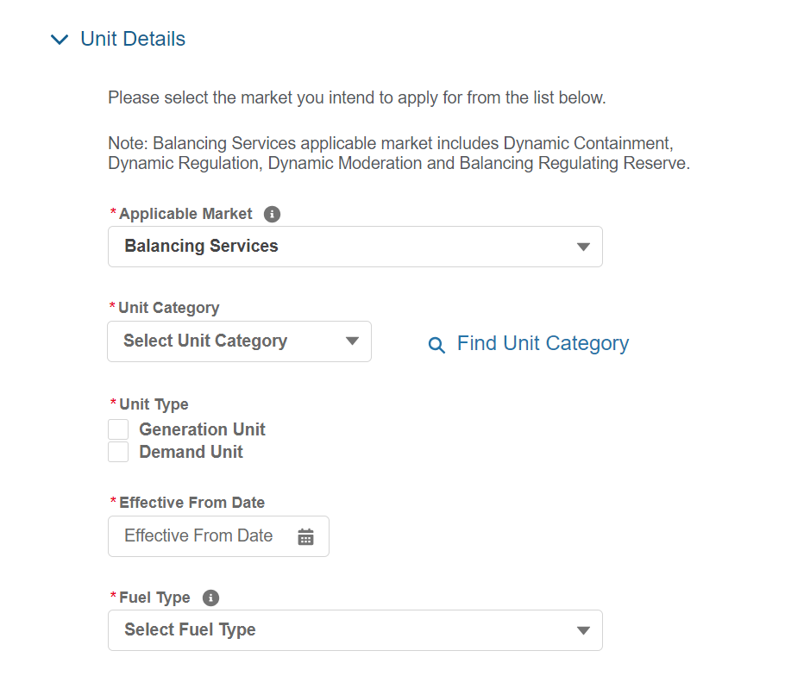

Upon selecting ‘Find Unit Category, the user is asked if they are registering a BMU or Non-BMU unit.
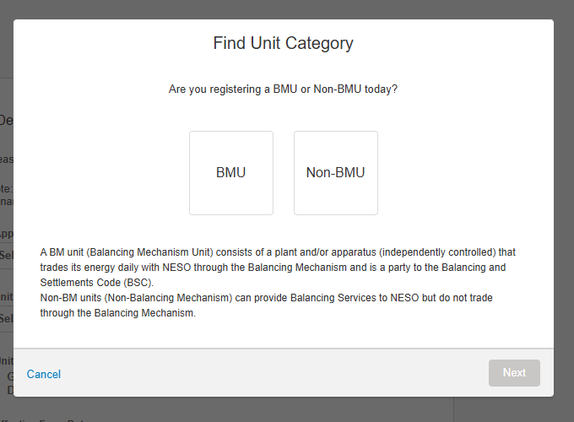

Selecting ‘Non-BMU’ will lead to a recommendation of non-BMU as a category. Pressing ‘Select’ on this screen will automatically populate the value of the Category field. Selecting ‘BMU’ will lead to the user being asked if they know their National Energy System Operator
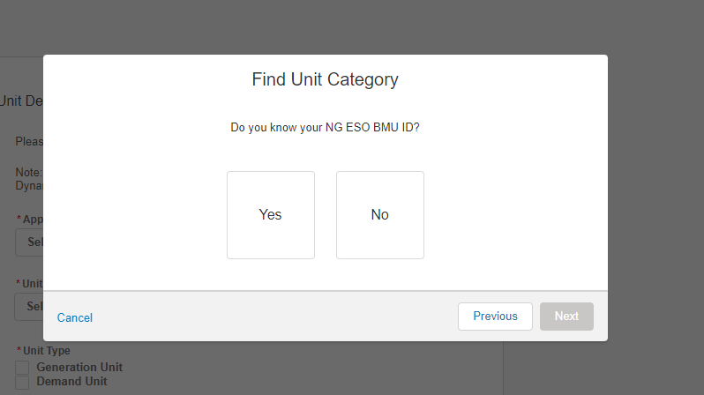
If ‘Yes’ is selected, the next screen will advise the user to cancel the wizard to get their Unit ID and then select the category of their unit on the registration screen.
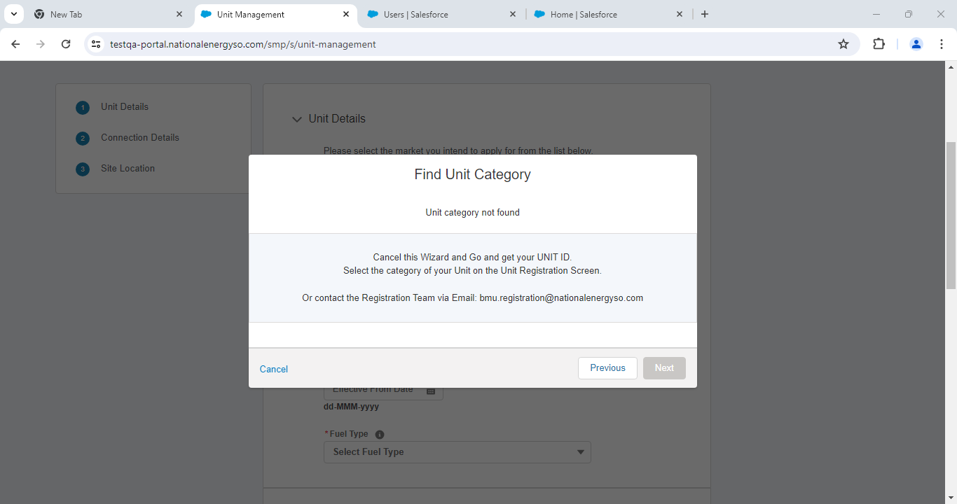

If ‘No’ is selected, the user is asked if they know their Elexon BMU ID Prefix for this Unit.
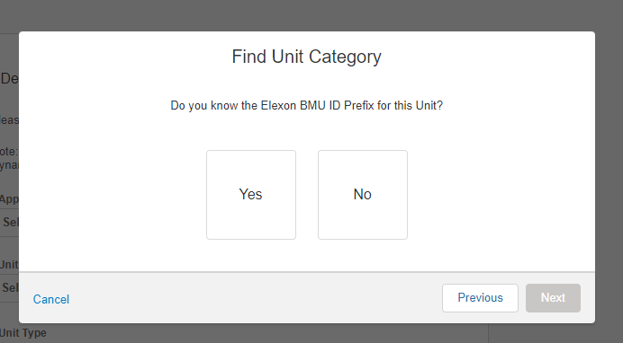
Selecting ‘No’ will lead to a screen advising the user to contact the Market Entry team at Elexon.
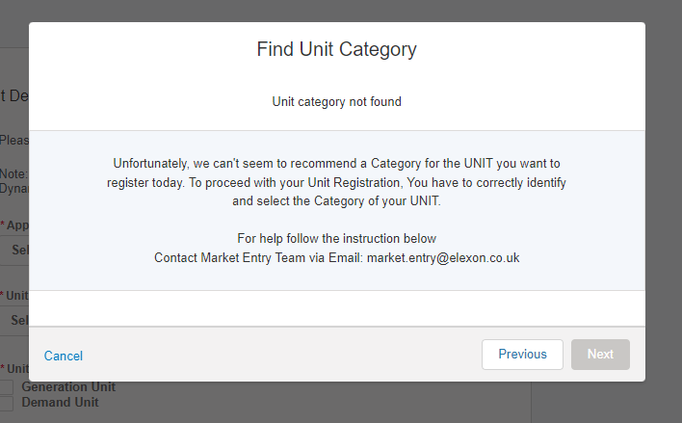

Selecting ‘Yes’ will prompt the user to select the Elexon BMU ID Prefix they have.
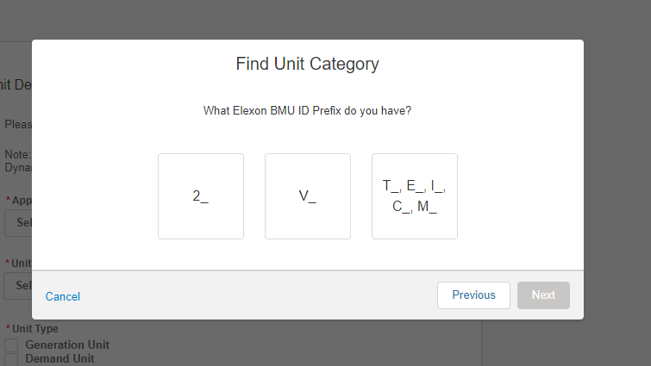

2_ will identify the unit as Additional Supplier BMU
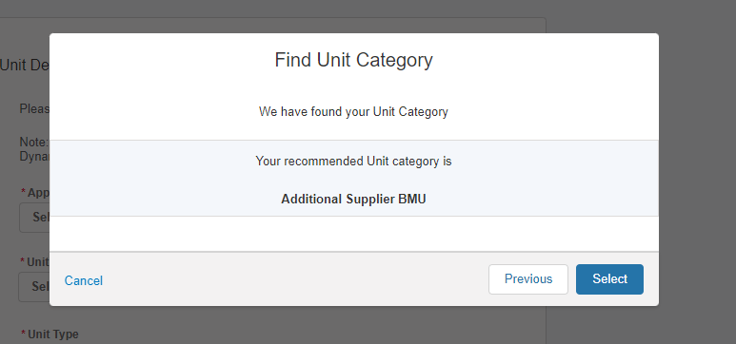
V_ will identify it as ‘Secondary BMU
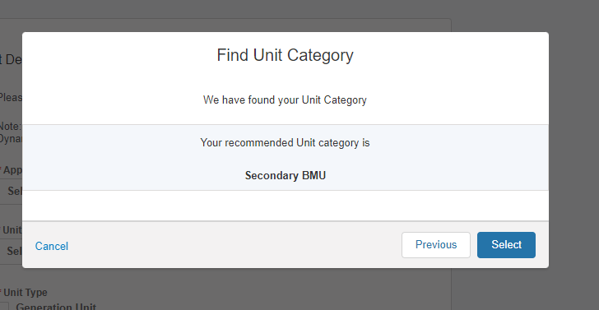
T_,E_,I_,C_,M_ will identify it as ‘Primary BMU’
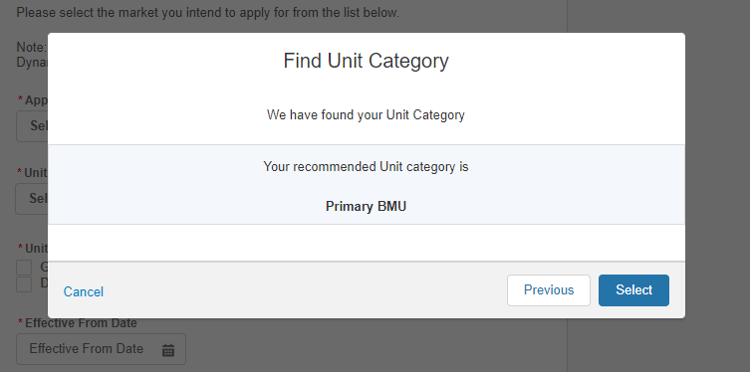

Submitting Unit Information: Unit Details Section

- Figure below illustrates the Detail Section for the Unit where the Category is Non-BMU
- Please note that the Unit Type, the Effective from Date and Fuel Type are all mandatory and therefore marked with a red asterisk. It is essential that these fields have information submitted.
Completing the ‘Unit Details’ Section – Non-BMU
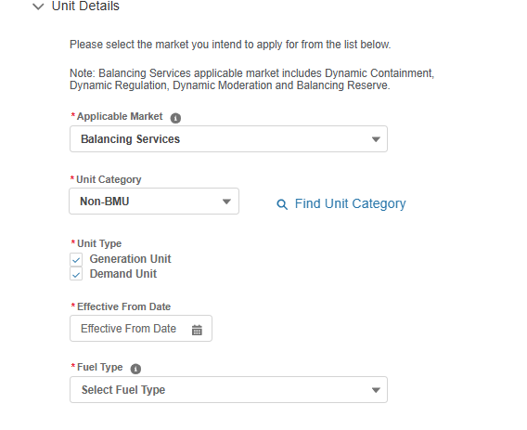
Completing the ‘Unit Details’ Section – BMU
- Figure below illustrates the Detail Section for the Unit where the Category is Primary BMU, Secondary BMU or Additional Supplier BMU
- Please note that the Unit Type, the Effective from Date, Fuel Type, Application Contact Email and Application Contact Number are all mandatory and therefore marked with a red asterisk. It is essential that these fields have information submitted. Elexon Organisation ID, BSC Signatory and Party EIC Code (Type X) are pre-filled and cannot be edited by the user.
- 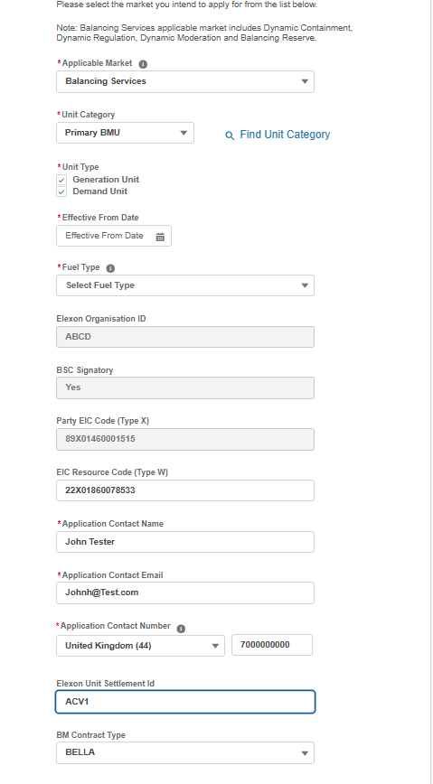

Submitting Unit Information: Unit Connection Section

- Figure below illustrates the Unit Connection Details Section for the Unit where Category = Non-BMU
- Please note that the Generation Capacity, Demand Capacity, Connection Type and DNO Type (picklist field) are all mandatory and therefore marked with a red asterisk. It is essential that these fields have information submitted.

Completing the ‘Unit Connection Details’ Section – Non BMU

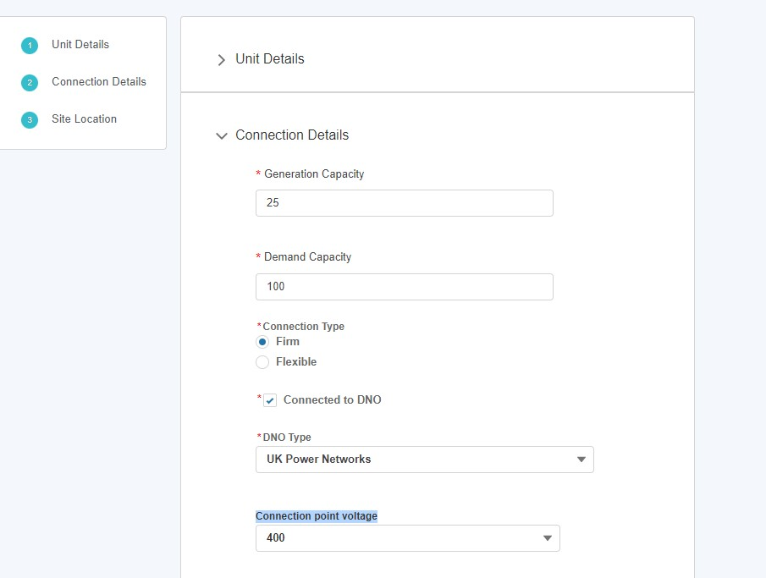

- Figure below illustrates the Unit Connection Details Section for the Unit where Category = Primary BMU, Secondary BMU or Additional Supplier BMU
- Please note that the Generation Capacity, Demand Capacity, Connection Type ,DNO Type, FPN Flag, Control Telephony Number and System Telephony Number are all mandatory and therefore marked with a red asterisk. It is essential that these fields have information submitted.

Completing the ‘Unit Connection Details’ Section – BMU
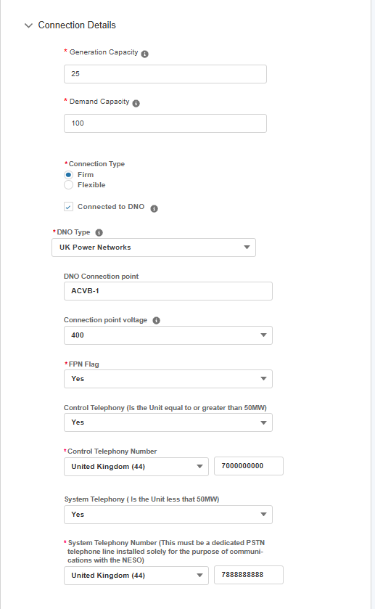

Submitting Unit Information: Unit Site Location Section
- Figure below illustrates the Unit Site Location Section for the Unit
- Please note that the Grid Supply Point, GSP Group ID, GSP Group ID (location picklist), Primary Dispatch phone number & Secondary dispatch phone number are all mandatory and therefore marked with a red asterisk. It is essential that these fields have information submitted.
- The Grid Supply Point (GSP) field is multiple choice, so a user can select several values as indicated in the figure below.

Completing the ‘Unit Site Location Details’ Section
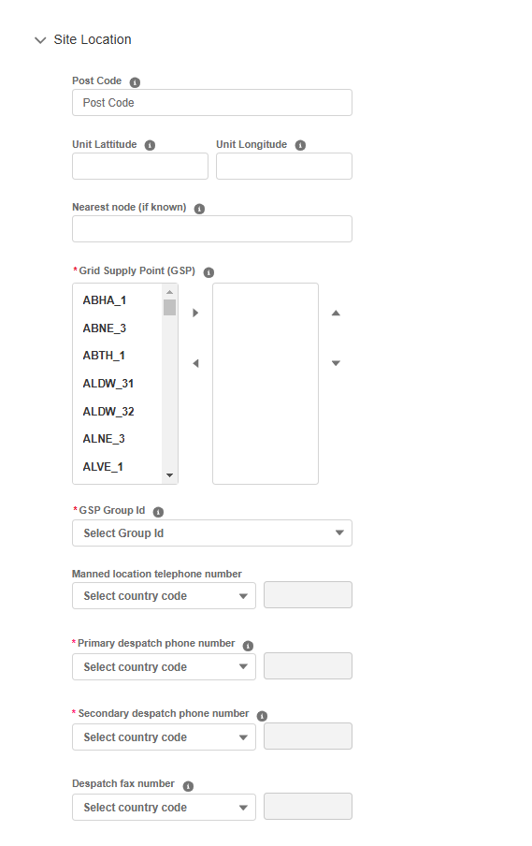

Linking a Control Point (EDL) to a Unit

The user will have the option to either link an existing Control Point (where the Status is Submitted or Accepted) or create a new Control Point record to proceed with the registration. To link an existing Control Point, populate the Control Point ID field. The user can find IDs of Control Points linked to their account on the Control Point (EDL) tab of the Unit Management page. If the Control Point is not owned by the user’s account they will need to obtain it from the NESO BM Registration team.

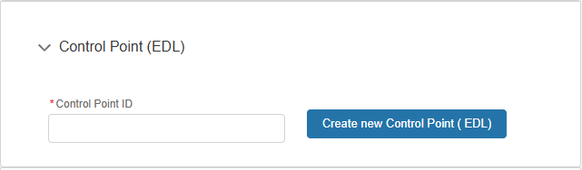

Upon input of the Control Point ID, the name of the associated Control Point record will appear. Click on the name to populate the field.

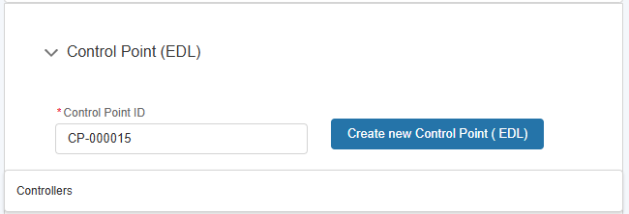

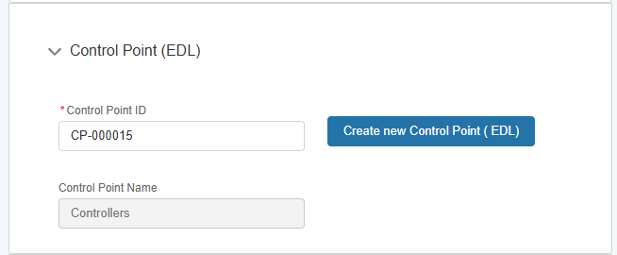

If there is no existing Control Point record to link to, the user can select ‘Create new Control Point (EDL)’. Input a name and press ‘Create’ to be taken to the New Control Point (EDL) Registration overlay (this will not exit the registration page for the Unit)

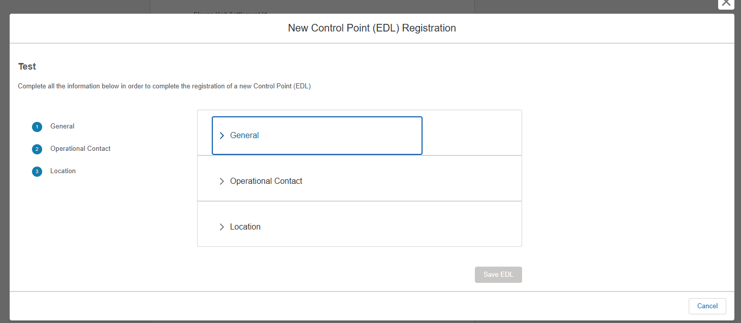

When all mandatory information has been added, press ‘Save EDL’
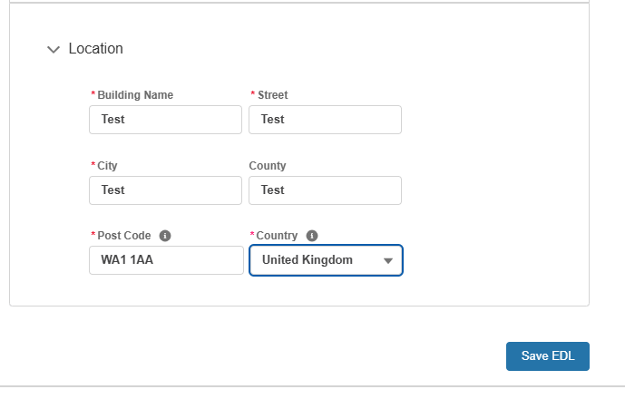

The Control Point ID and Control Point Name fields will then be populated with the details of the record. The Control Point record will automatically created with a status of Submitted, meaning the user will not be able to edit any details of it in SMP.
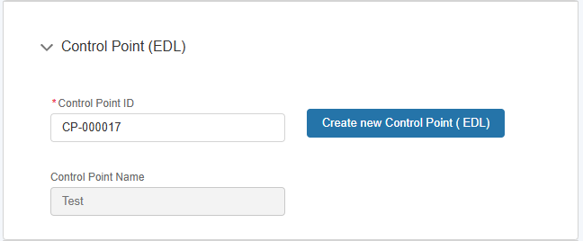

Linking a Trading Agent (EDT) to a Unit

In the same manner as the linking of a Control Point, the user will have the

option to either link an existing Trading Agent (where the Status is Submitted or

Accepted) or create a new Trading Agent record to proceed with the

registration. To link an existing Trading Agent, populate the Trading Agent ID

field. The user can find IDs of Trading Agents linked to their account on the

Trading Agent (EDT) tab of the Unit Management page.

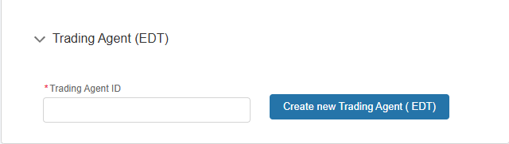

Upon input of the Trading Agent ID, the name of the associated Trading Agent

record will appear. Click on the name to populate the field.

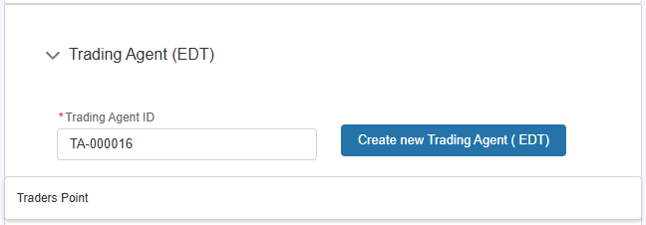

If there is no existing Trading Agent record to link to, the user can select ‘Create new Trading Agent (EDT)’. Input a name and press ‘Create’ to be taken to the New Trading Agent (EDT) Registration overlay (this will not exit the registration page for the Unit)

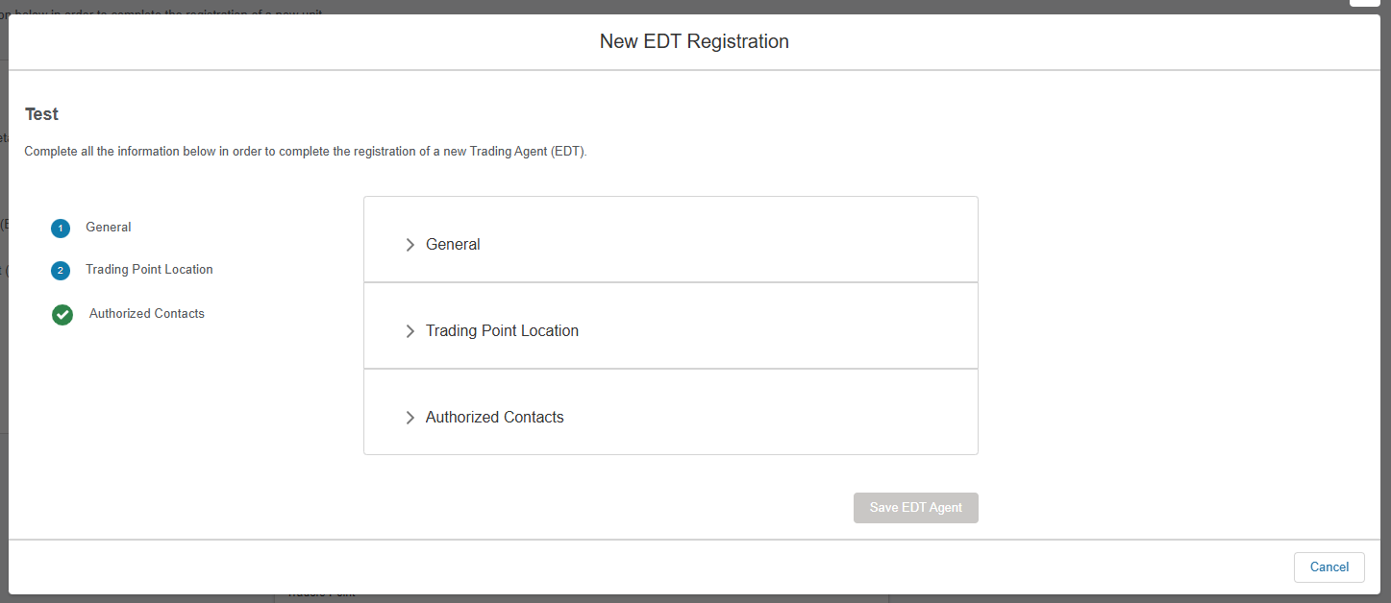

When all mandatory information has been added, press ‘Save EDT Agent’
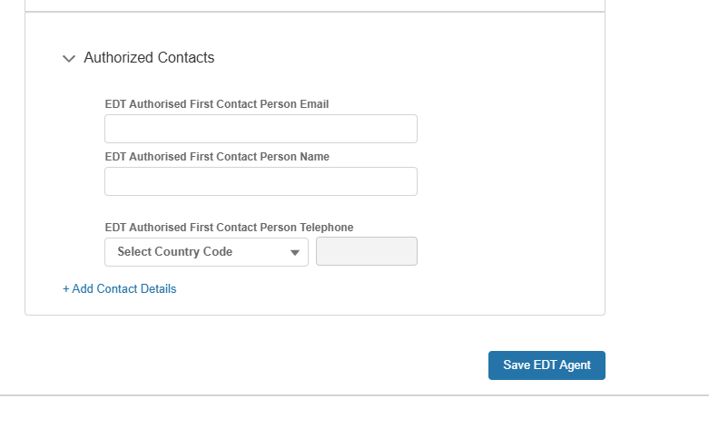

The Trading Agent ID and Trading Agent Name fields will then be populated with the details of the record. The Control Point record will automatically created with a status of Submitted, meaning the user will not be able to edit any details of it in SMP.
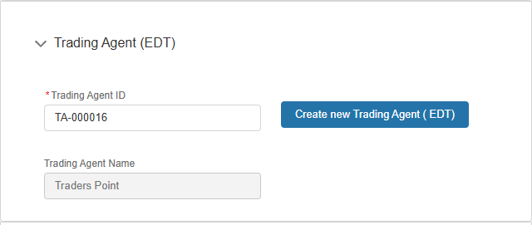

Submitting Unit Information: OFTO and eGAMA Sections
- Figure below illustrates the OFTO Section for the Unit where Category = Primary BMU, Secondary BMU or Additional Supplier BMU.
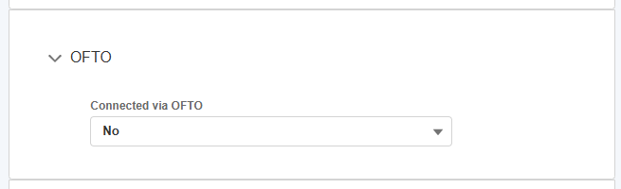
- Figure below illustrates the eGAMA Section for the Unit where Category = Primary BMU, Secondary BMU or Additional Supplier BMU.
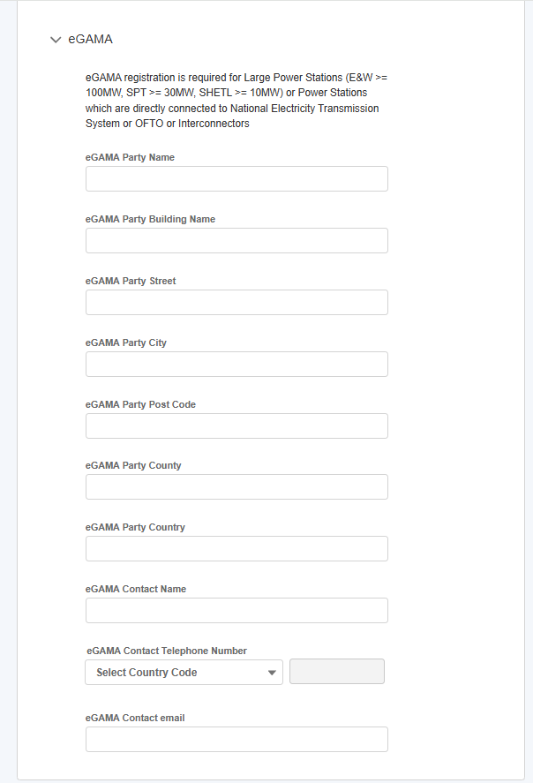

Submitting Unit Information: Confirmation of Submission.
- Once all the sections are completed correctly, then the ‘Save Unit’ button will appear in a blue background, enabling the user to complete the registration process for creating the Unit.
- If the User wishes to repeat the exercise and create subsequent Units, they can select the ‘save and create new one’ button instead.
- Please note for Balancing Mechanism Units registration is not considered to be complete until the Unit Service has been submitted too – see Chapter 8 for details.

Confirmation of Unit Saved Successfully.

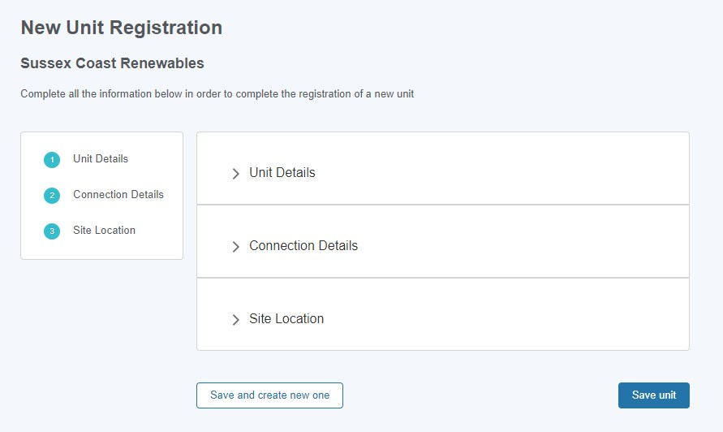

Submitting Unit Registration for Approval

Once the finalised alignment of Asset(s) to Unit has been completed, to signify the submission of the Unit Registration has been undertaken, the Portal User will have to select the ‘Submit for Registration’ option on the drop down menu as indicated on the picture below.
Once this option is selected, the Unit is considered for appraisal by the Registrations Team at the National Energy System Operator . Please note that Units in Submitted State are considered different then Draft, where the assumption is that alignment or Asset(s) has not taken place or not finalised.

Submitting Unit Registration for Approval
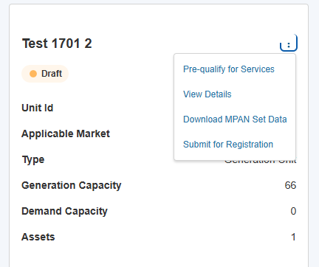

Modifications to Registration of Units
- Following on from the Unit Registration, the asset tile will appear on the Unit Management Home Page under the ‘Units’ Tab. Each asset will have a corresponding tab. The tile displays the ‘key or summary information’. To view the full registration details, click on the three dots on the right-hand corner of the tile. The user then selects the ‘View Unit Details’ link to be re-directed to the Unit Detail page expanded version.
- Users have the ability to retrospectively edit Unit Registration Details before final submission. Upon ‘saving the Unit’ registration details, the Unit Status will appear as ‘Draft’ automatically as illustrated in Figure 35.0
- To make edits, the user should click on ‘Edit Unit Details’ link to be re-directed to the Unit Detail page expanded version. They then have the ability to edit the sections or specific fields desired. The Unit Status will appear as ‘Submitted’ once the Unit is finally submitted for consideration.
- Once the Unit is submitted for approval, the National Energy System Operator Registration Team will a) assign the Unit a Unit ID (which will auto populate on the Unit Id field) b) set the Unit Status field from ‘submitted’ to ‘approved’ or ‘rejected’.

Modifications to Registration of Units: cont
Unit Tiles
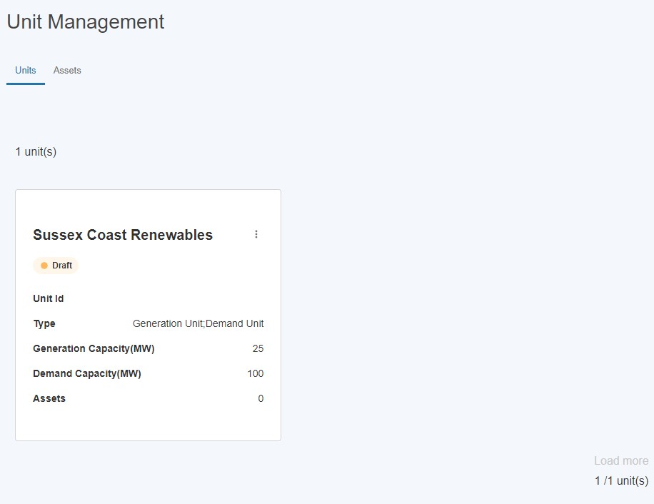

Modifications to Registration of Units: cont.

Edit Unit Details & View Expanded Unit Details Page for Editing

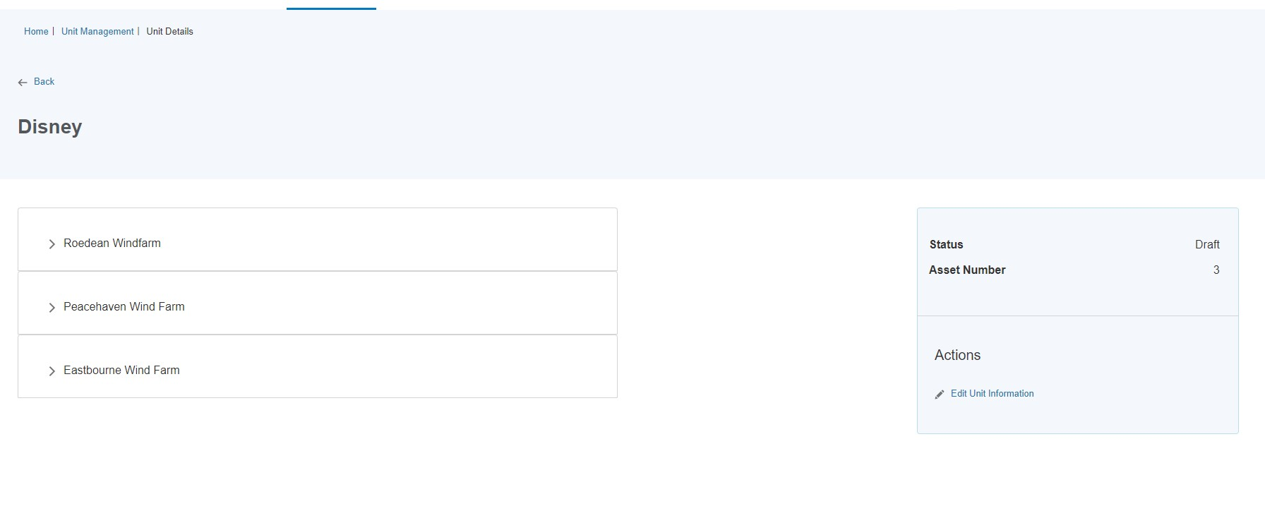
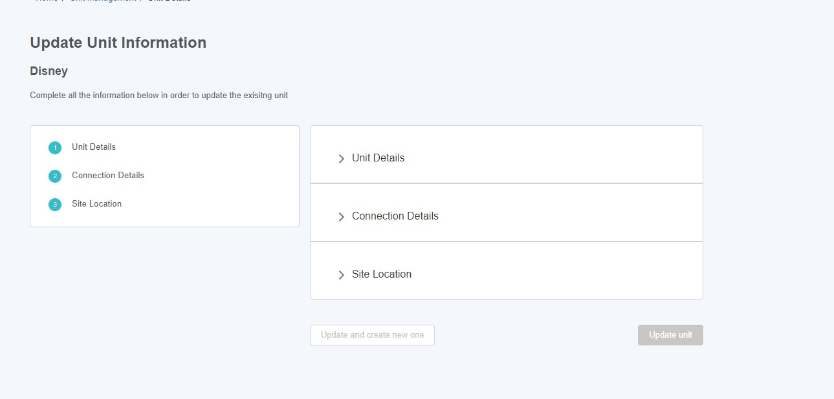

Modifications to Registration of Units: cont.

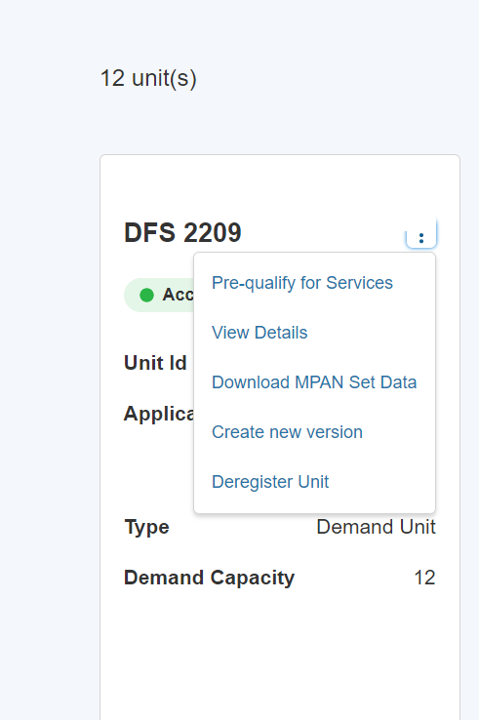
Then select ‘Edit Unit Information’.
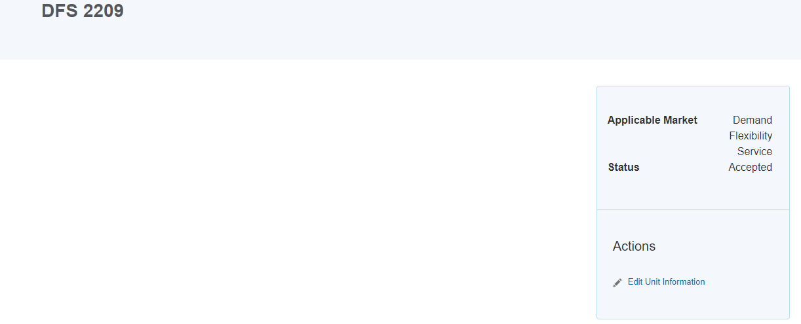

Deregistration of Units

- Portal User can initiate the de-registration of a Unit only on the condition it is in ‘Accepted’ Status. A Unit that warrants De-Registration is defined as a Unit that ceases to continue operating.
- To start the process, click the icon containing three dots on a tile of an accepted unit and then click ‘Deregister Unit’, as illustrated in Figure overleaf
- A pop-up window (shown in Figure below) will appear, which informs the user that an email will be sent to the National Energy System Operator Registration Team, who will complete the process offline. Click ‘Continue’ to proceed with the deregistration of the unit.
- Another pop-up window (shown in Figure overleaf) will appear, asking the user to select an ‘Effective to’ date. This date needs to be in the future and cannot be less than the ‘Effective from’ date of the Unit’s original version. After clicking ‘Submit’, a green confirmation banner will appear at the top of the screen.
- The Approval Request will be directed towards the National Energy System Operator Registration Team who will either decide to Approve or Reject the Unit De-registration request.
- If the Decision is to approve the request, then the Unit will no longer appear on the Unit Management screen and the user will also receive an email to confirm that the Unit has been deregistered (See Figure overleaf).
If however the Registration Team Reject the deregistration request, then the user will receive an email to let them know the request was rejected.
Once the ‘Effective to’ date has passed, the unit will no longer be visible on the Unit Management page.

Process for Deregistering Units

Deregister a Unit
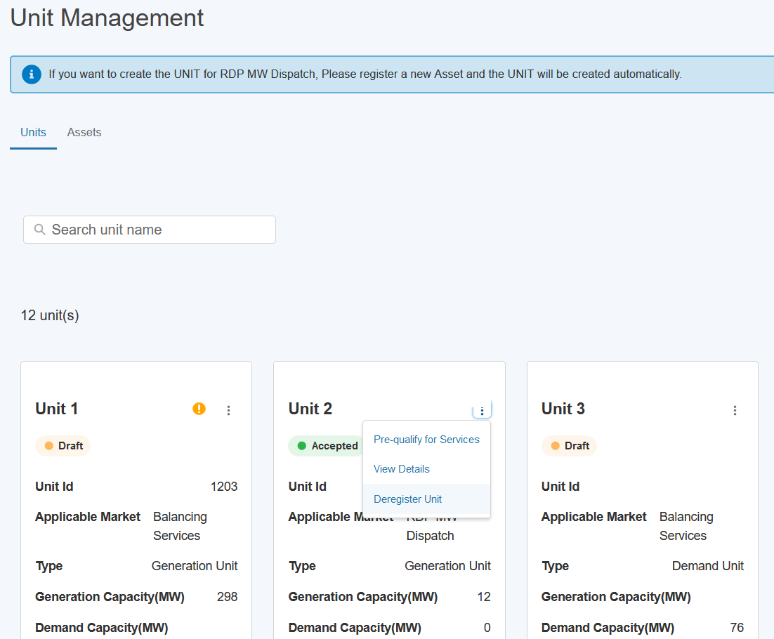

Pop-up Window for Deregistering a Unit

Process for Deregistering Units - cont

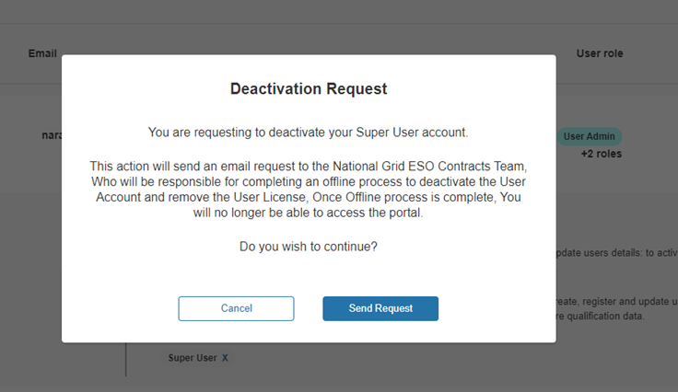

Figure 35.4: Pop-up Message for ‘Effective To’ Date

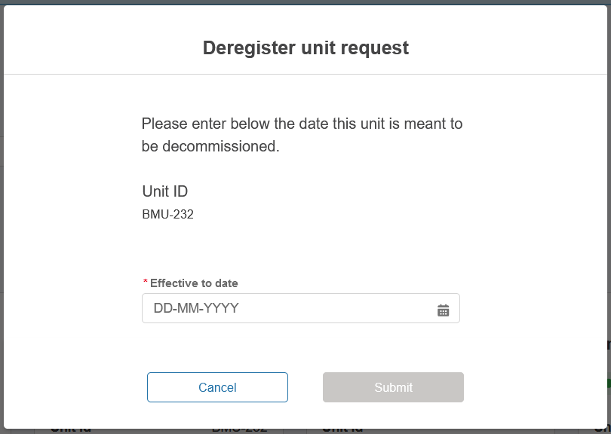

Process for Deregistering Units -cont

Figure 35.4: Deregistration Request Email
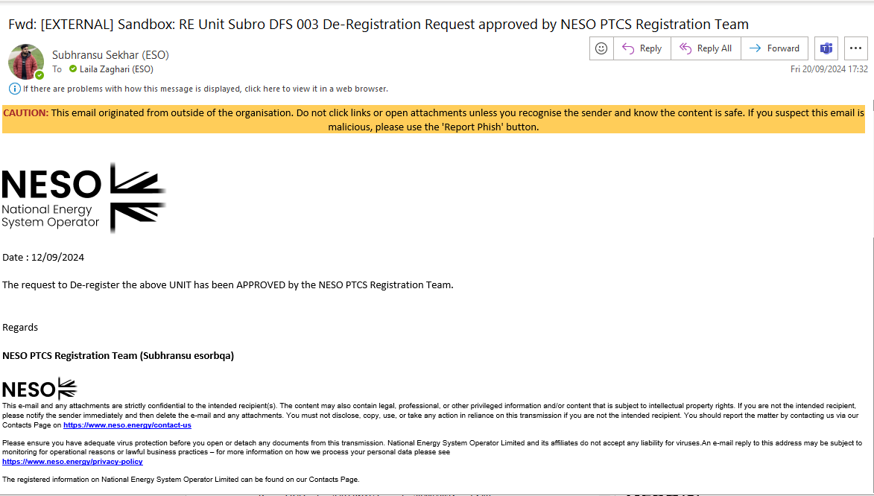

- Creating Interconnector Users

Create an Interconnector User record

To Create a new Interconnector User, select the Unit Management tab, then the Interconnector User tab. Press the ‘Create new Interconnector User’ button, enter a name for your record and press ‘Create’.
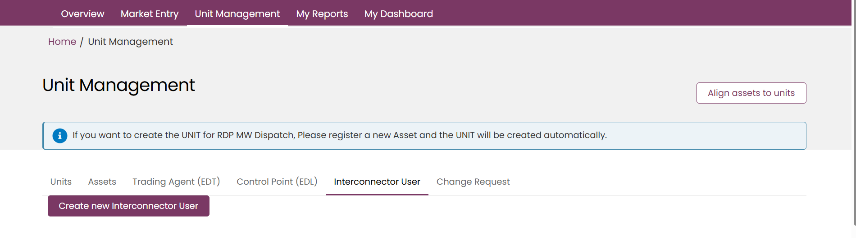
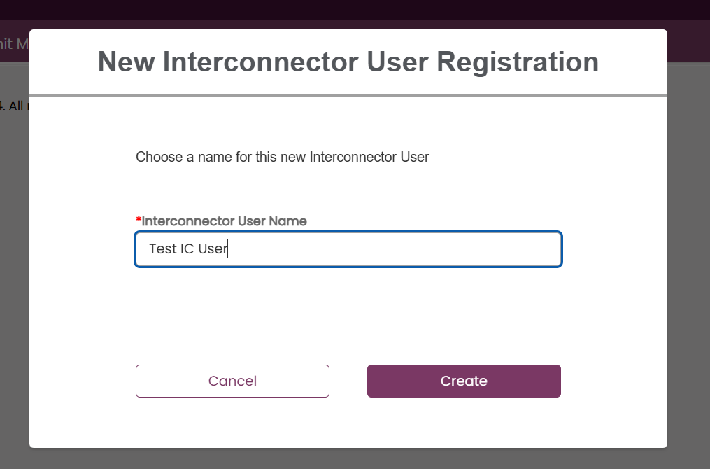

On the new Interconnector User page, you will be greeted with 3 collapsible sub-sections –
- Interconnector User Details
- Lead Party Details
- Lead Party Declaration
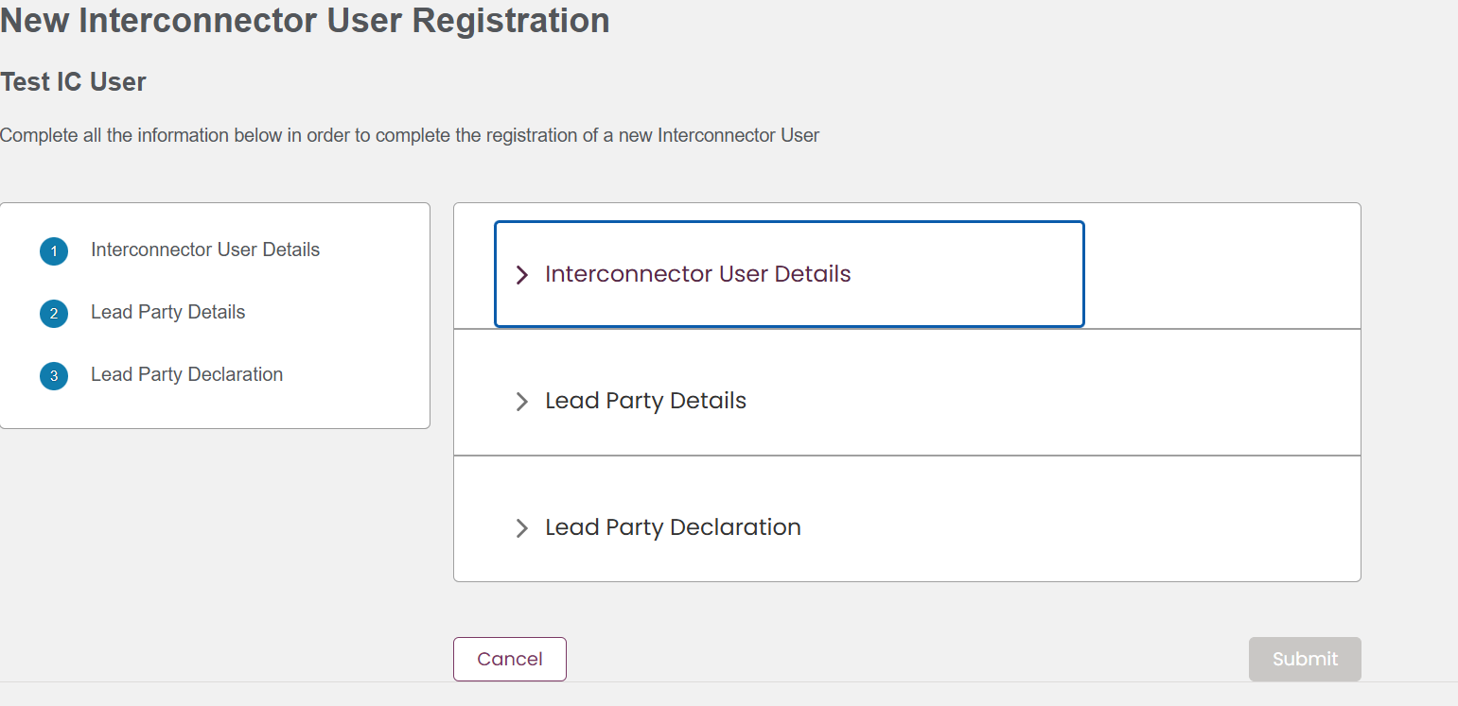

Expand each one to view the mandatory and optional fields within. Mandatory fields are indicated with a red asterisk.
Please note that the selection of the Interconnector Cable will determine the value of the Fuel Type, and this will not be editable by the user.
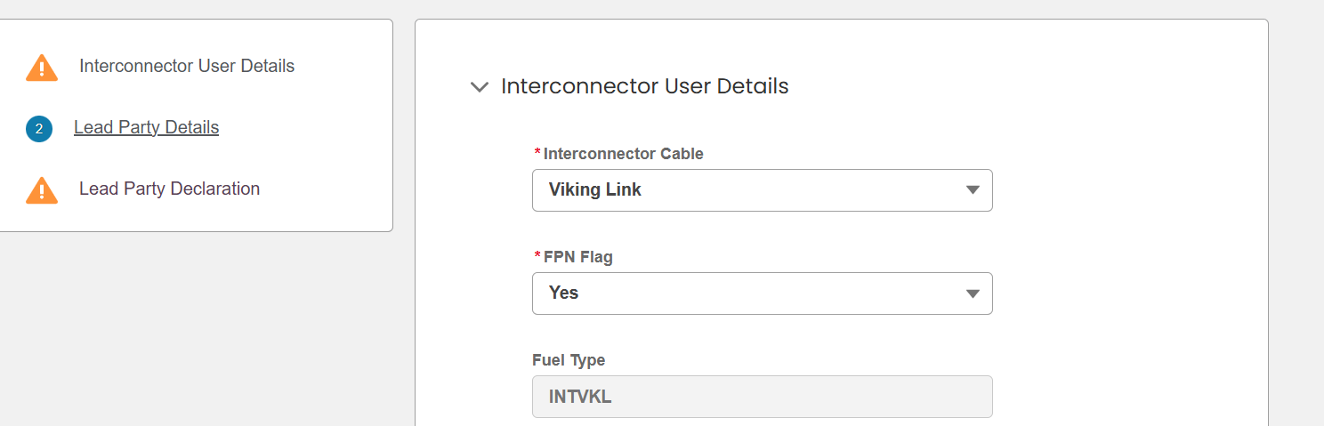

The user’s account is also only able to create one Interconnector User record per Interconnector Cable – e.g. if there is already an Interconnector User record for the Viking Link Interconnector Cable, that option will not appear in the drop-down list.
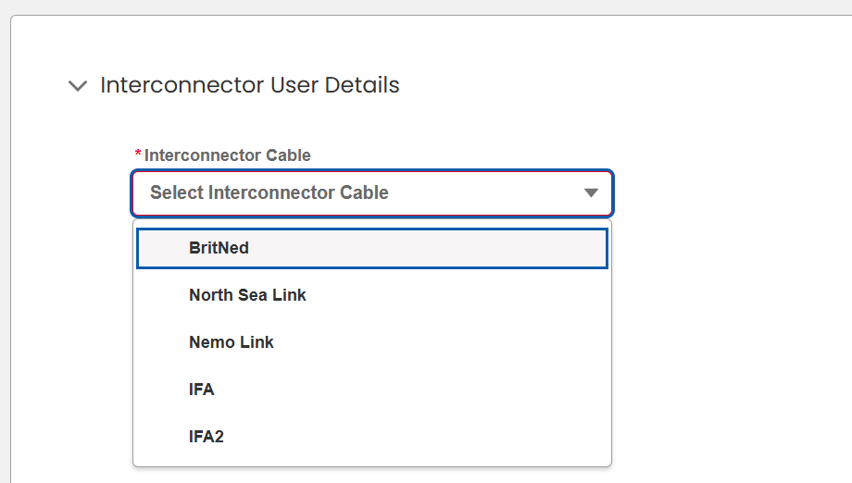
Once all mandatory fields have been populated, including the Lead Party Declaration, the Submit button will be enabled. Please not the record will be saved with a status of Submitted for appraisal by the NESO Registrations team, and the user will not be able to edit the record.
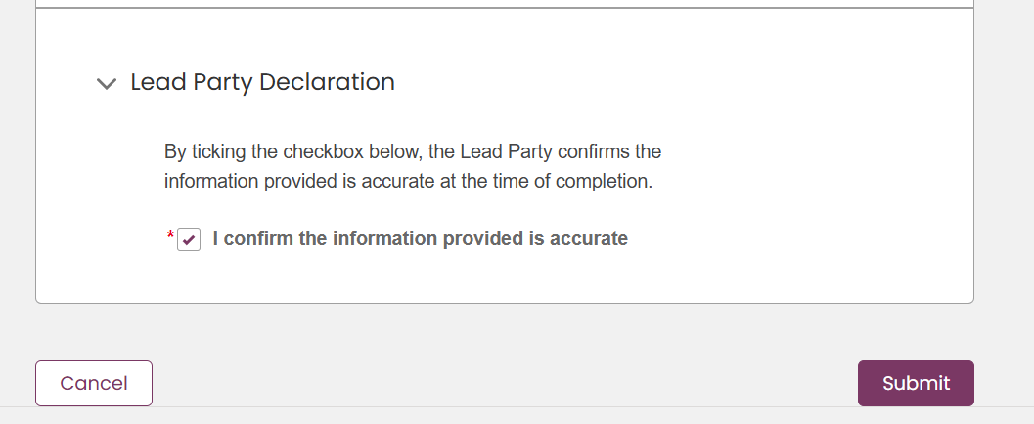

If your account does not have an Active CUSC or Use of System Interconnector Agreement file associated to it, this warning message will appear, but the Interconnector User record will still be created. Please see section the chapter on updating User and Company Details (specifically Chapter 3.7) on how to upload these documents.
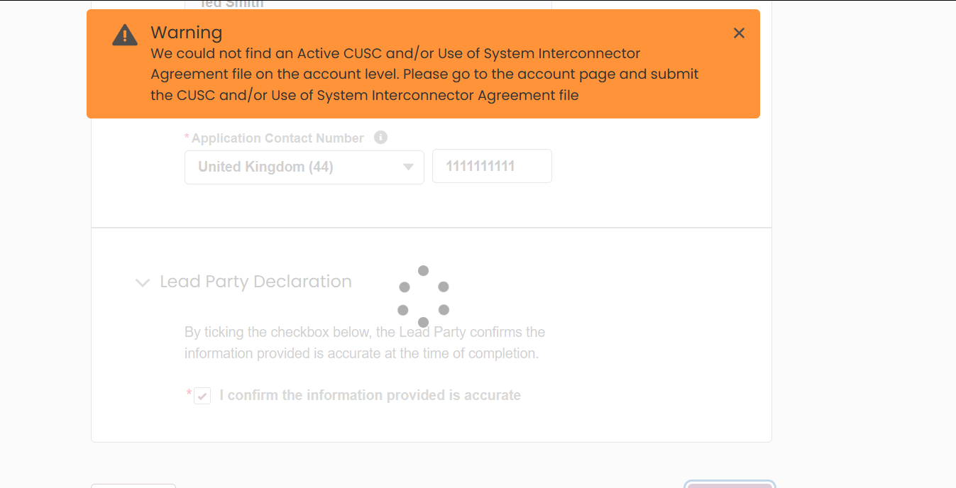

Interconnector User records created for the account will then be available to view under the sub-tab. Generation and Demand Unit IDs will appear once they have been assigned by the NESO Registrations team.
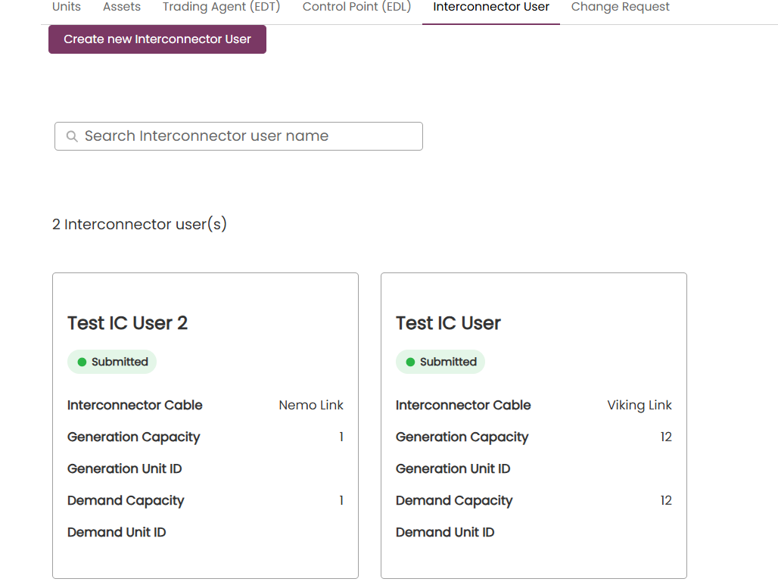

Asset to Unit Alignment

Grouping Assets by Unit (Asset Alignment)

- Prior to initiating the Pre-qualification Process, the registered asset(s) must be aligned to a specified Unit(s). To align assets to units, it is pre-supposed that the asset(s) and the unit(s) have all been registered in advance. If this is not the case, the user must ensure these steps are completed.
- Upon initial registration of an asset the ‘status’ will be set to ‘Accepted’ by default as indicated on the tile in Figure below
- When ready, the User must select ‘Align Assets to Units’ on the Unit Management Landing Page

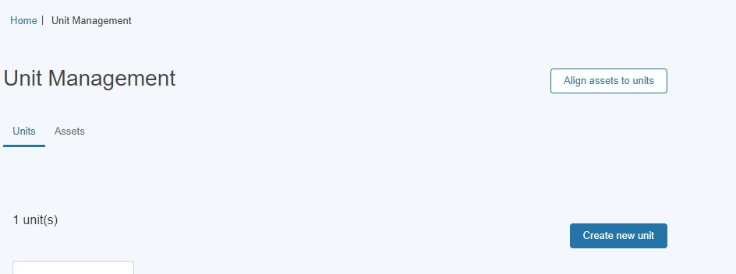
Align Assets to Unit

Grouping Assets by Unit (Asset Alignment)

Selecting Unit for Grouping
- The User will be prompted to select or identify the Unit for grouping or alignment. The user can search by entering the Unit Name in the search bar. Please note the exact naming of the Unit to produce a successful search result.
- The exact generic name of the Unit must be entered in the search bar in order to determine a successful result.
- A unit can only be aligned if its Status is equal to ‘Draft’. Once has a Unit has been appraised by the Registrations Team and set to ‘Accepted’ it is no longer available for re-alignment. If the situation arises where the Unit in question requires an amendment or modification to its asset(s) then the Unit in question must undergo the Unit Versioning Process. To learn more about Unit Versioning, refer to the Chapter on Unit Versioning.
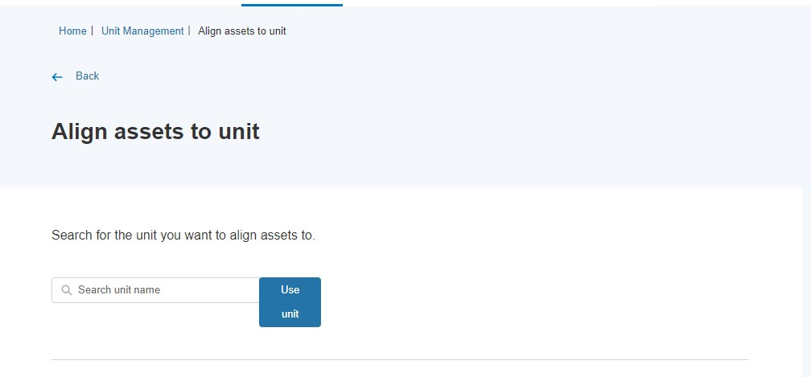

Match & Un-matching selected assets to Unit for Grouping
- The User will be presented with two adjacent columns 1) the Unit selected in the search result on the left-hand column and 2) all available registered assets eligible for grouping on the right-hand side.

Asset Alignment Screen

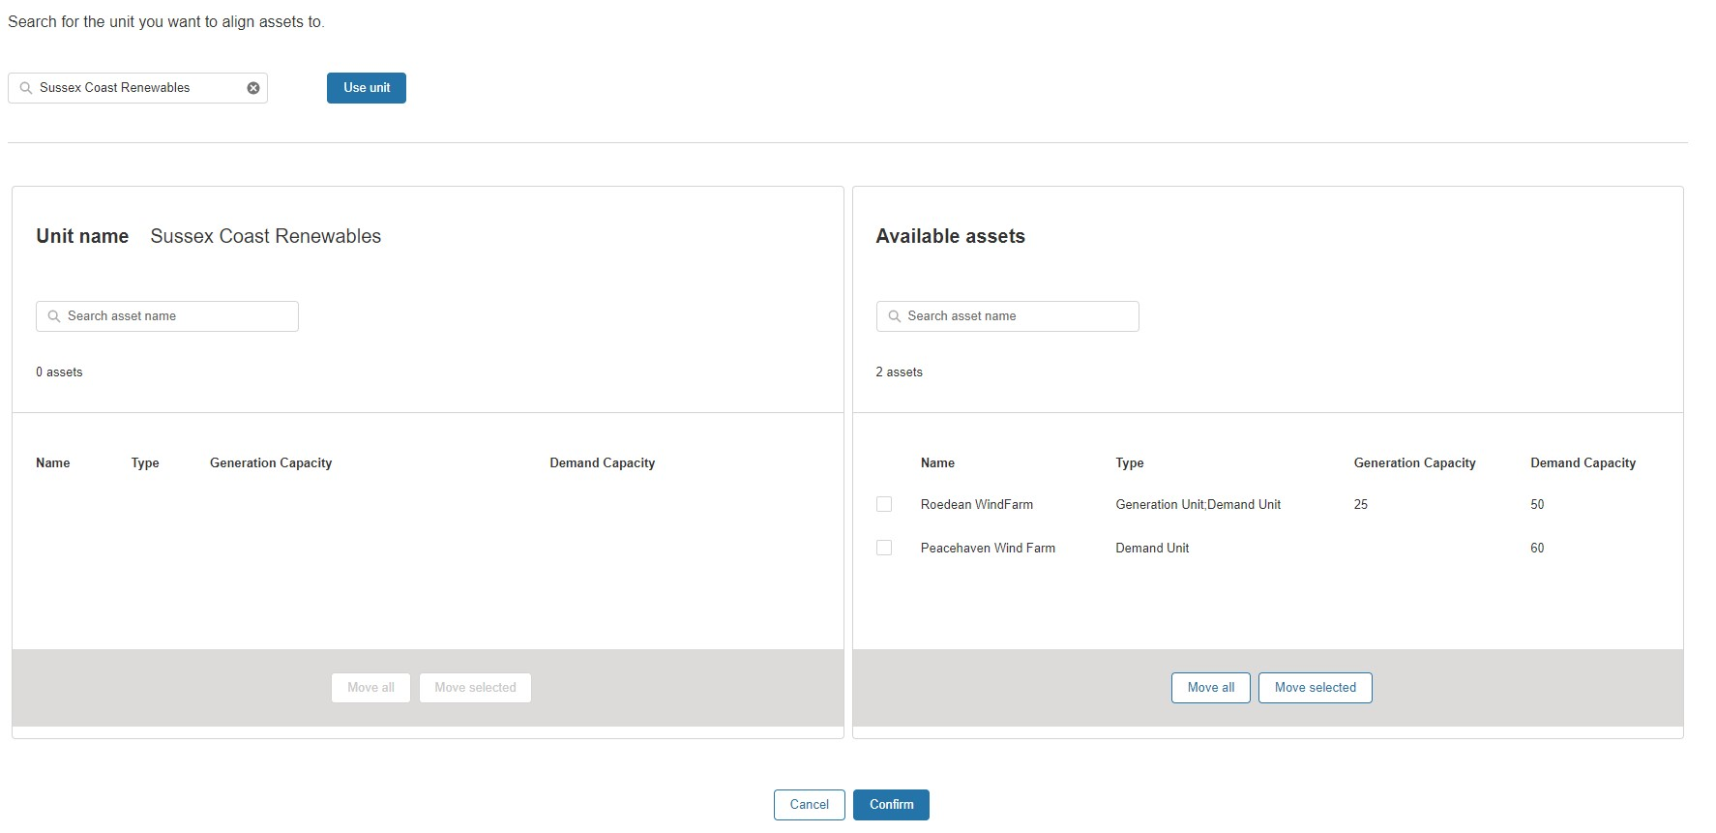
- If an asset is not listed, then the user will still have the option to use the search button to undertake a secondary search of the asset in question. The user must ensure they have the correct unique name reference to ensure a successful search result match. Once the asset(s) are identified, the User can either choose to a) ‘move all’ or b) ‘move selected’ assets to be grouped or aligned with the desired unit.
- Once the User is satisfied with the grouping they can then confirm the selection or alignment by selecting the Confirm button as illustrated in Figure overleaf in the adjacent page.
- The User has the option to switch assets out of the grouping by ‘moving selected’ from the left column (unit name) to the right column (available assets) if they decide it was an incorrect grouping of assets for alignment and wish to reverse their decision before final confirmation. To enable this feature, the user must check the box against each asset on the left-hand column and select ‘’Move Selected’’ to transfer the assets back into the right-handed column (available assets). This may be required when a user decides it was an incorrect grouping of assets for alignment and wish to reverse their decision before final confirmation.
- The User will receive a confirmation pop up notification to alert them to the Unit Grouping being completed.

Match & Un-matching selected assets to Unit for Grouping

Asset Alignment Screen – Reverse decision
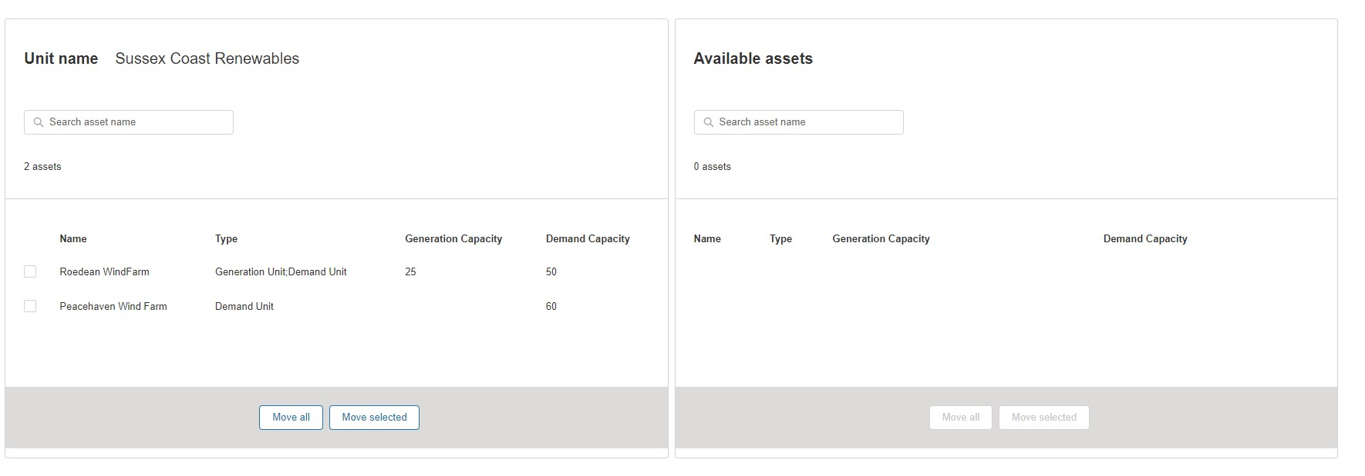

Asset Alignment for multiple units

- There will be a requirement for Users to undertake secondary alignments between assets and additional units beyond the initial grouping. In this instance, users are given the ability to deploy the same assets to be grouped under different Units.
- Figure below illustrates the example where 2 Units have been created, but both Units will be aligned to one specific asset. For example, Hampshire Coast Renewables Unit is made up of both Peacehaven Wind Farm AND Roe dean Wind Farm. Sussex Coast Renewables is only made up of Peacehaven Wind Farm. Therefore, the Asset Peacehaven Wind Farm is being aligned to 2 independent Units. This configuration is possible during the registration stage by repeating the asset alignment exercise for each Unit in turn.
Multiple Units for Alignment with existing assets
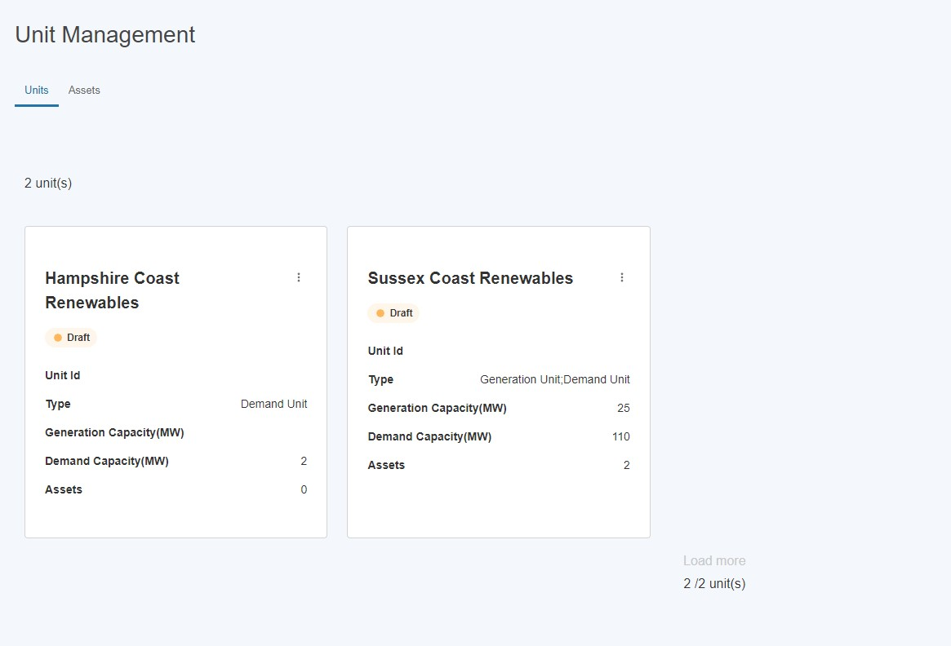

Prequalification for Services

Identifying Units to participate in Pre-qualification.
Once the Units and Assets have been registered and the Alignment exercise has been undertaken, the user is in a position to identify units they wish to elect for participation in the Market and subject to the pre-qualification process.
To start, the user must navigate to the selected unit on the Unit Management home page and hover over the right hand three corner and click on the three dots on the Unit tile as highlighted in the Figure below. They will be prompted with the link ‘pre-qualify for services.
Pre-qualify for Services Link

Pre-qualification Home Page
The user will then be presented with the Pre-qualify for Services Page as illustrated in Figure below and prompted to then select the services to pre-qualify the Unit for.

Pre-qualify for Services Page

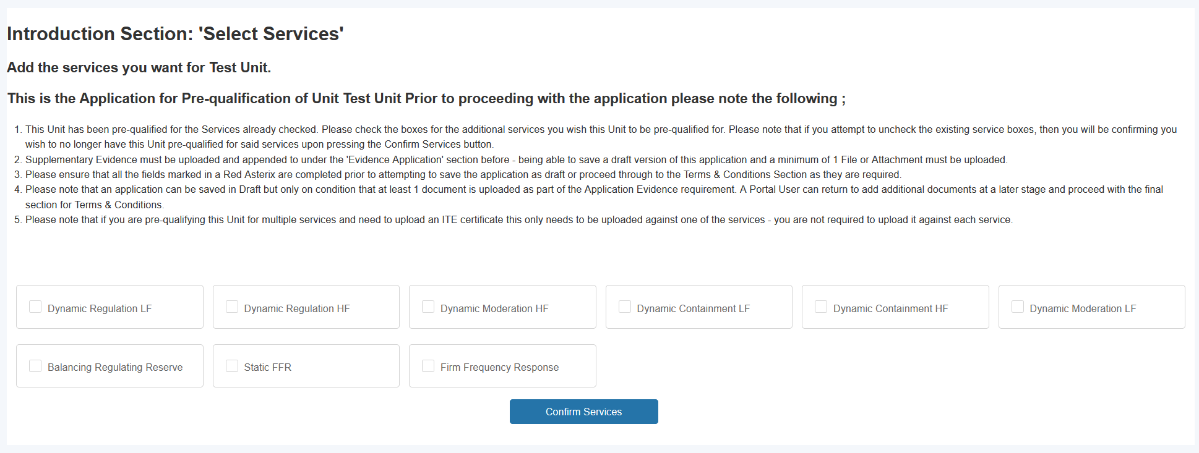
- The user will then be presented with the current seven Balancing Services they can select from. To select the user checks the checkbox. A user can select all or one of the services.
- The user then selects the ‘’Confirm Selection’’ button to proceed to the next step.

De-selecting Services to apply for pre-qualification for selected Unit.
- If the user makes an error or wishes to reverse the decision to not select a particular service, they can simply uncheck the tick box before proceeding to the next step. If a user decides to make this decision after proceeding with completing the Service ‘data capture’ sub-sections, this is also possible by unchecking the service checkbox and clicking the ‘confirm services’ button.
- The user must note that if they proceed to populate service specific information for more than one service for the same Unit, in several attempts or over a duration of time (i.e. they submit information for service x on day 1, but then go onto update the portal with additional submission of information for service x on day 3) that they can keep track of which service is still in flight (or ‘draft’) as opposed to ‘submitted’ by referencing the ‘Service Status’ field. If the field value = Incomplete, then the submission for that service in example below ‘’Dynamic Containment LF’’ has yet to be completed, and therefore will require the user to select the ‘Confirm Services’ button again.
- This will ensure the secondary service submission has been accepted. If the Service Status Field = Submitted, then the application for that particular service, in the example below ‘’Dynamic Regulation HF’’ has already been ‘registered’.

Service Status Field

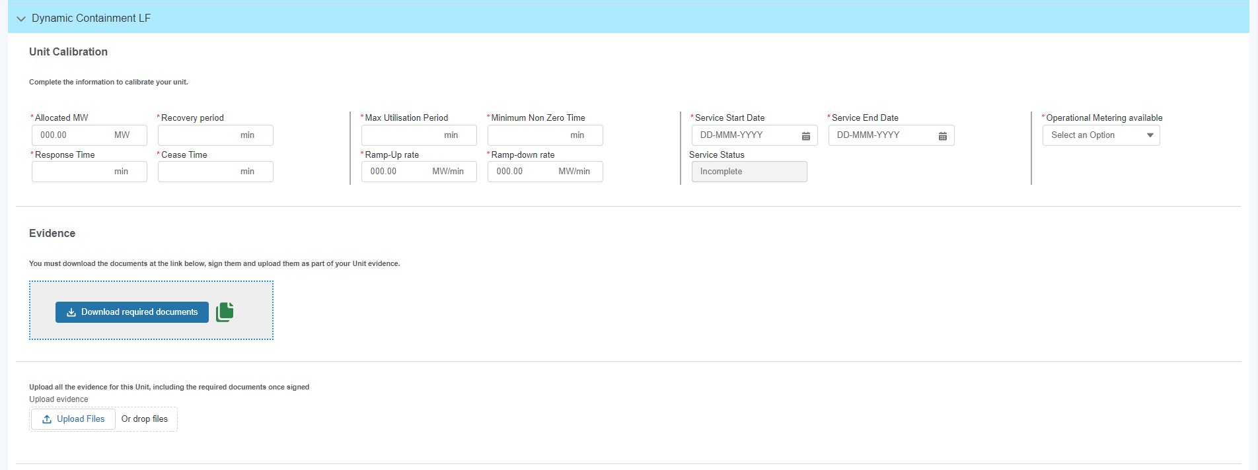

De-selecting Services to apply for pre-qualification for selected Unit: Cont

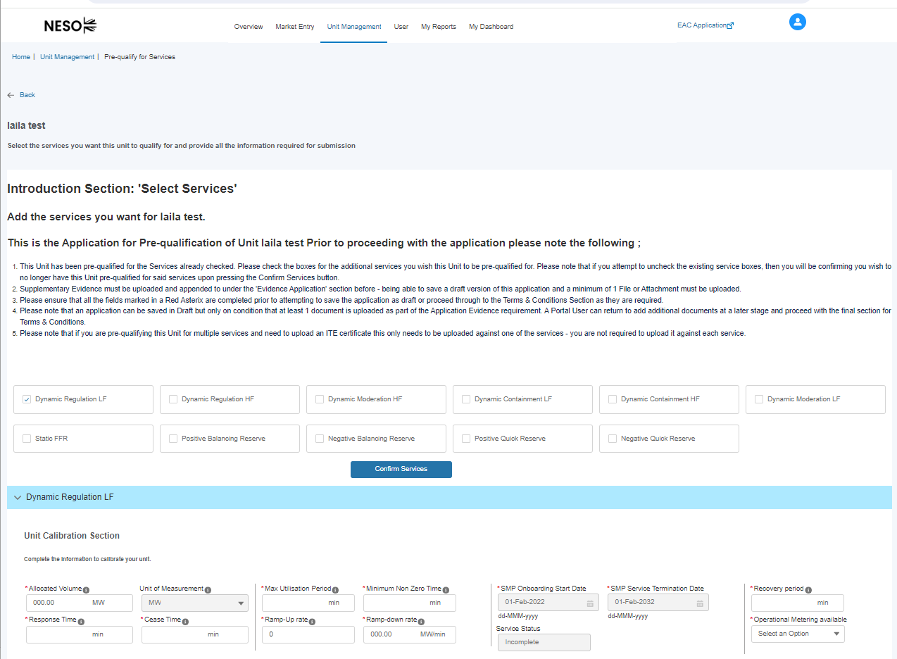

Completing Pre-qualification Criteria Sections by Service: Unit Calibration Section

- Each service selected will present the user with a series of sub-sections to complete with criteria specific fields. Each service is identified by the highlighted row illustrated in the figure below.
- The first subsection is entitled Unit Calibration and the user is expected to populate the corresponding fields. All the metric fields in this section are marked with a red asterisk and therefore mandatory. A user will not be able to proceed with the pre-qualification process without submitting information.

Services Specific Subsection – Unit Calibration
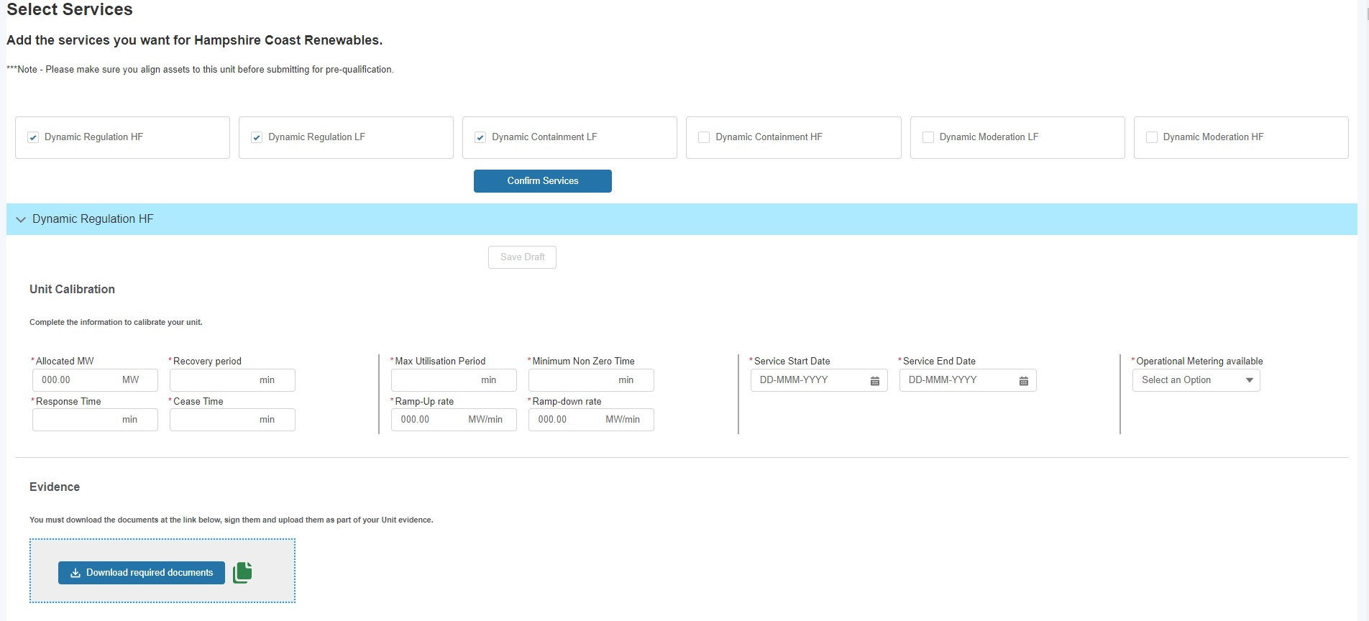

Obtain Service Values Feature

Obtain Service Values
Where a portal user has already made a prequalification for another service for the same Unit, they are able to ‘copy’ over the identical values from the existing application under the Unit Calibration Section over the new corresponding section under the new application by clicking ‘Obtain Service Values’ and selecting the Service for which they want to copy the pre-existing values over from and then selecting the Confirm button to complete the exercise.

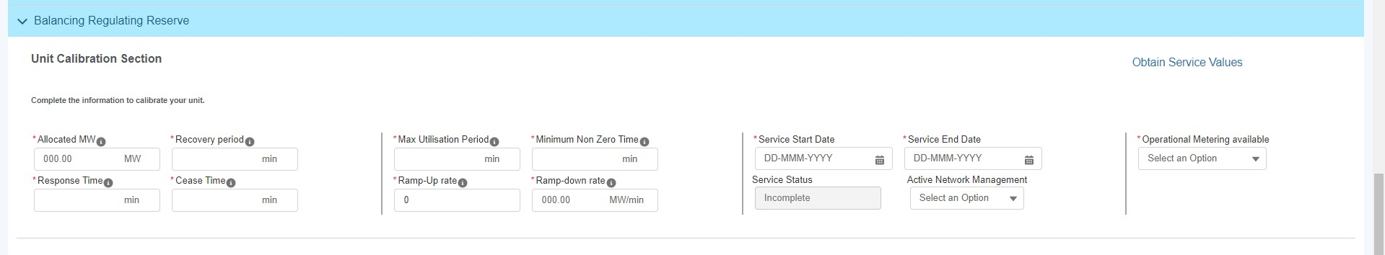

Obtain Service Values Feature: Cont

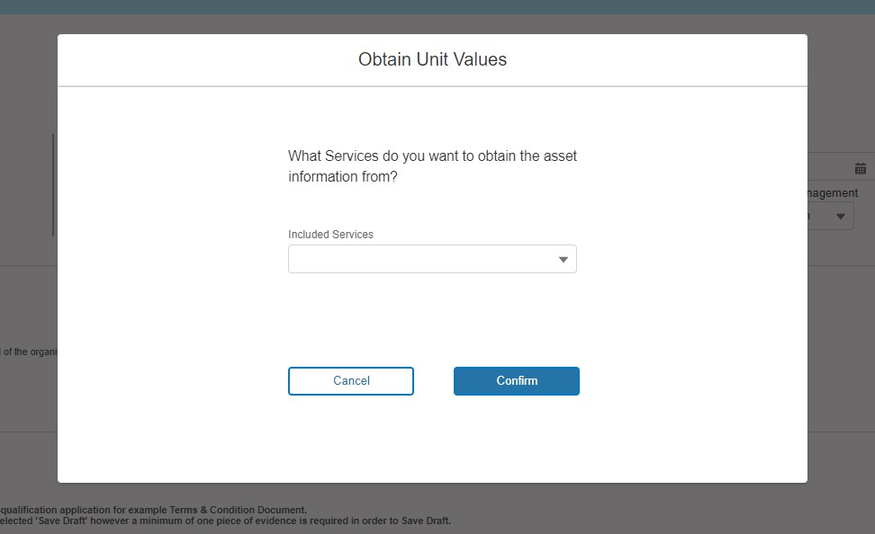

Completing Pre-qualification: Attaching Supplementary Evidence

Services Specific Sub section

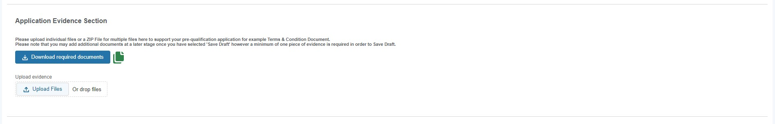
Once the Authorised Signatory is selected (this step is covered in the next section), the portal user is expected to upload any supporting evidence using the Upload Files button. Once selected the Portal User can upload files from their desktop etc and confirmation the documents or the zip file of multiple documents should highlight in blue with the ‘Done’ outcome.
Whilst this requirement applies to Frequency Response & RDP MW Dispatch Services yet it does not apply to Balancing Reserve or Demand Flexibility Service, it is however a mandatory system requirement that at least one document is uploaded to the portal to proceed with the submission process. With this in mind in the instance where no evidence is required to support the application, then it is advised that a ‘placeholder’ blank document is uploaded instead. This can be in any format (Word, Jpg, png etc)

Confirmation of Upload Completed
Services Specific Subsection
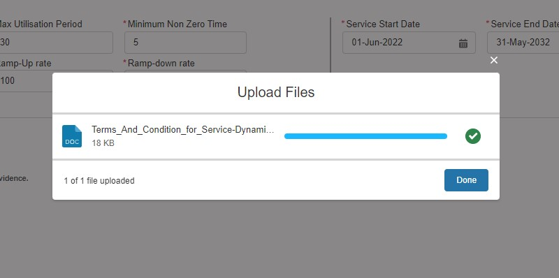

Completing Pre-qualification Criteria Sections by Service: Asset Testing Section

- The final sub-section to be completed requires gathering information on Asset Testing requirements for selected Service.
- As Figure below illustrates, each asset aligned to the Unit being considered will be listed and the corresponding asset testing data fields are expected to be populated by the user.
- Please note that whilst the fields are not marked with a red asterisk and therefore not currently designated as mandatory, a Unit cannot proceed with the pre-qualification request without the asset testing fields being completed.

Services Specific Asset Testing

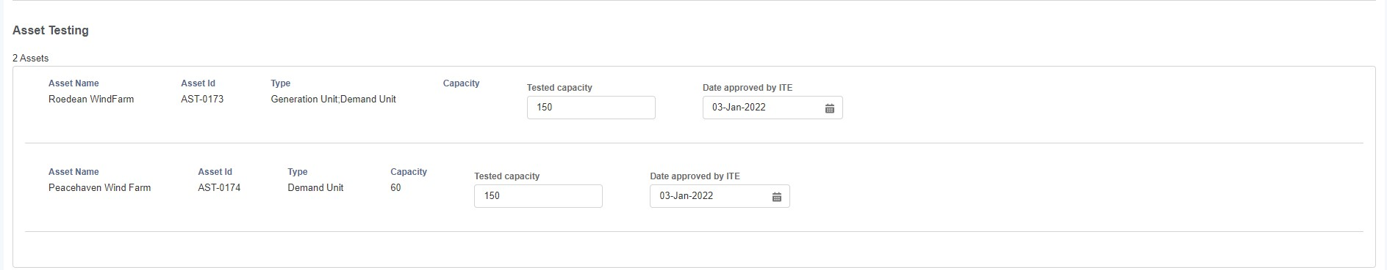

Qualifying for the Balancing Mechanism Service

When the user has selected Balancing Mechanism as the service they wish to qualify for, as of Release 3.9 there is no information required in the Unit Calibration section, so the user can proceed to upload a copy of the Lead Party form or use the Authorised Signatory functionality as detailed in the following chapter to sign the form electronically before submitting their application.

Completion of Pre-qualification Criteria: Terms & Conditions Section
- The step preceding final submission involves completing the Service Specific Terms & Conditions Checkboxes.
- To complete the Pre-qualification process, the user must click on the ‘Save Draft’ button. This will appear in blue in its activated state on condition that all the prior subsections have been completed correctly. If it is in the shaded state, the user must revisit the subsections and ensure that the fields are populated and the evidence has been uploaded correctly. The user has the option to review the draft application at a later stage when they next login to the portal.
- When the user is ready to submit the Unit for pre-qualification application for approval, they then select the Submit button in Figure 48.0. In this instance, the National Energy System Operator Account Manager will be notified and undertake an internal appraisal of the application for the selected Unit and Service.
- To apply for additional Units for Pre-qualification, the user simply repeats the steps in this chapter for each respective Unit.

Services Specific Terms and Conditions

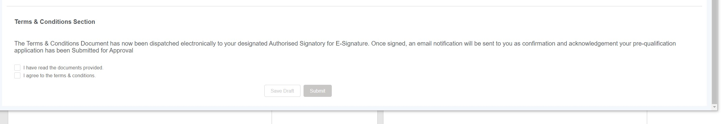

Using Authorised Signatories

Selecting Authorised Signatory & completing Application Submission
Following SMP Release 2.2a, Portal Users will have the option to either.
- Upload a Wet Signed Form B (Manual) with their Authorised Signatory’s signature embedded in the Document.
OR
- Select up to 3 Designated Authorised Signatories to whom a digitised version of customised Form B will be sent to directly for electronic signature.
In order to select any of the three Authorised Signatories, a pre-requisite step is required whereby the named person must be registered by the applicant under the User section of the Portal and the ‘Authorised Signatory’ Role is selected against their name. To complete this step, please follow the instructions under the User Management Section/Chapter.
Once the person is registered, they will appear under the search box when entering their name or identifiable in the drop-down list of Users – to proceed simply enter the name or navigate to the name in question.
Please note that if a user is selected whom has not been assigned an Authorised Signatory Role then they will not be able to proceed with the application as an error message will appear prompting the user to revise the selection and ensure that all of the names selected are Authorised Signatories (see Figure 50.1 for error message).
The portal user (the applicant) will be expected to complete the task of entering the subsequent secondary and third authorised signatories where applicable. Please note that only a minimum of 1 Authorised Signatory is required to proceed with their application.
The first authorised signatory will be sent the documentation to sign automatically to the signatory’s email address. If the Authorised Signatory has failed to read and electronically sign the document after five consecutive days, then the second authorised signatory will be sent the documentation to sign. Finally, there has been no response from the second authorised signatory after five consecutive days, then the documentation will be sent to the third authorised signatory.
Alternatively, A portal user (applicant) can choose to download the Form B Template and arrange to have this signed in person and a scanned version uploaded instead by clicking the ‘Download required documents’ button. After signing these documents by hand, users will then have to scan the documents and upload them using the ‘Upload evidence’ section.
In order to click the ‘Submit’ button, the Portal User will have to either select at least one authorised signatory or upload a scanned copy of the hand-signed documents.

Selecting Authorised Signatory & completing Application Submission (Continued)

Correct selection of Authorised Signatory.
As an applicant the Portal User may select a secondary user who does not possess the Authorised Signatory Role, instead they may have chosen another secondary user inadvertently. In this instance, an error message will appear when the applicant selects Submit to notify them that an incorrect User has been selected as a designated Authorised Signatory.

Selecting Authorised Signatory & completing Application Submission (Continued)

Prequalification Screen – Authorised Signatory Section

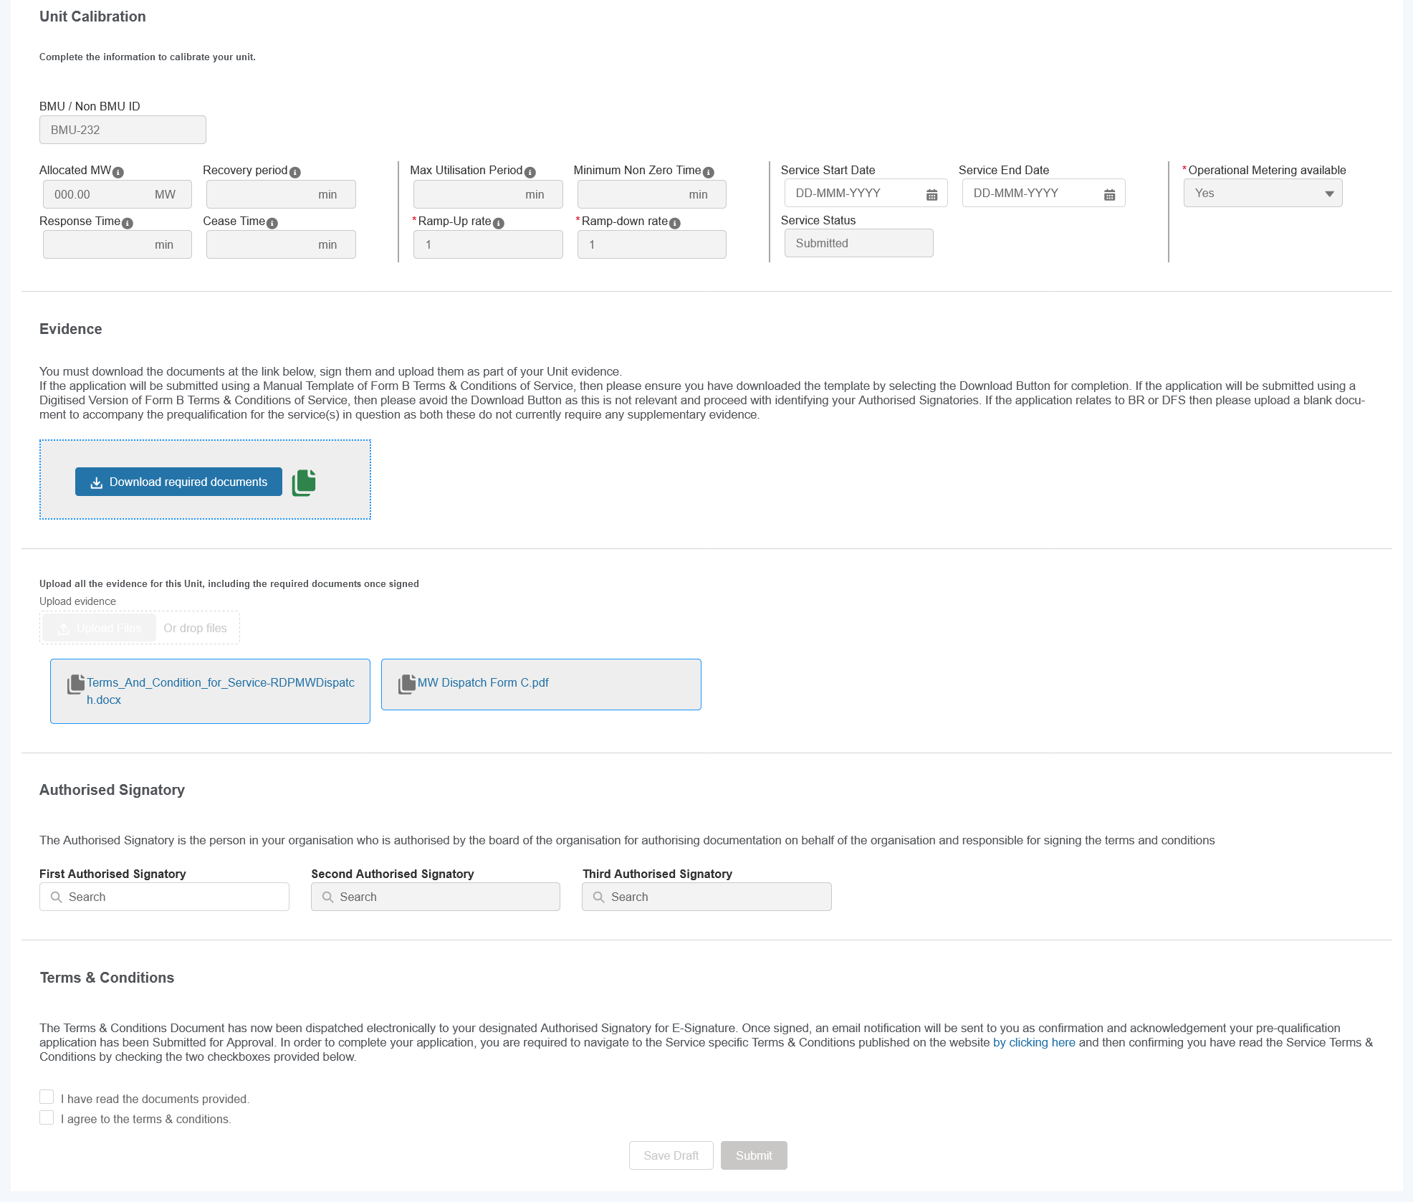

Selecting Authorised Signatory & completing Application Submission (Continued)

Error message if a User without the Authorised Signatory role is selected as one of the Authorised Signatories
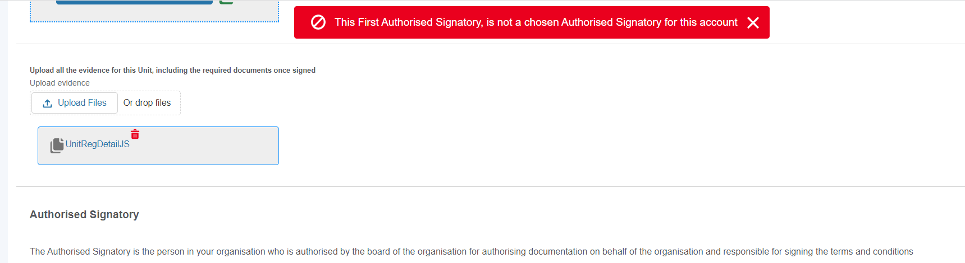

Confirmation of Submission of Pre-qualification Application Request.

The final step required by the portal user is to check the checkboxes under the Terms & Conditions, when the Submit button will be made available to click. Upon clicking the Application considered ‘finished’ and awaiting the capture of the electronic signature by the authorised signatory – until the document is signed, the application is still in submit status and not complete and the application will remain in the ‘signature in progress’ state.

The Status Field will indicate the ‘live’ status of the application – therefore it will change from ‘Incomplete’ to ‘Signature in Progress’ to Submitted to eventually ‘Approved’ or ‘Rejected’ once appraised by the Contract Management Team.

Prequalification Screen – Application Status Field

10.1 Selecting Authorised Signatory & completing Application Submission (Continued)

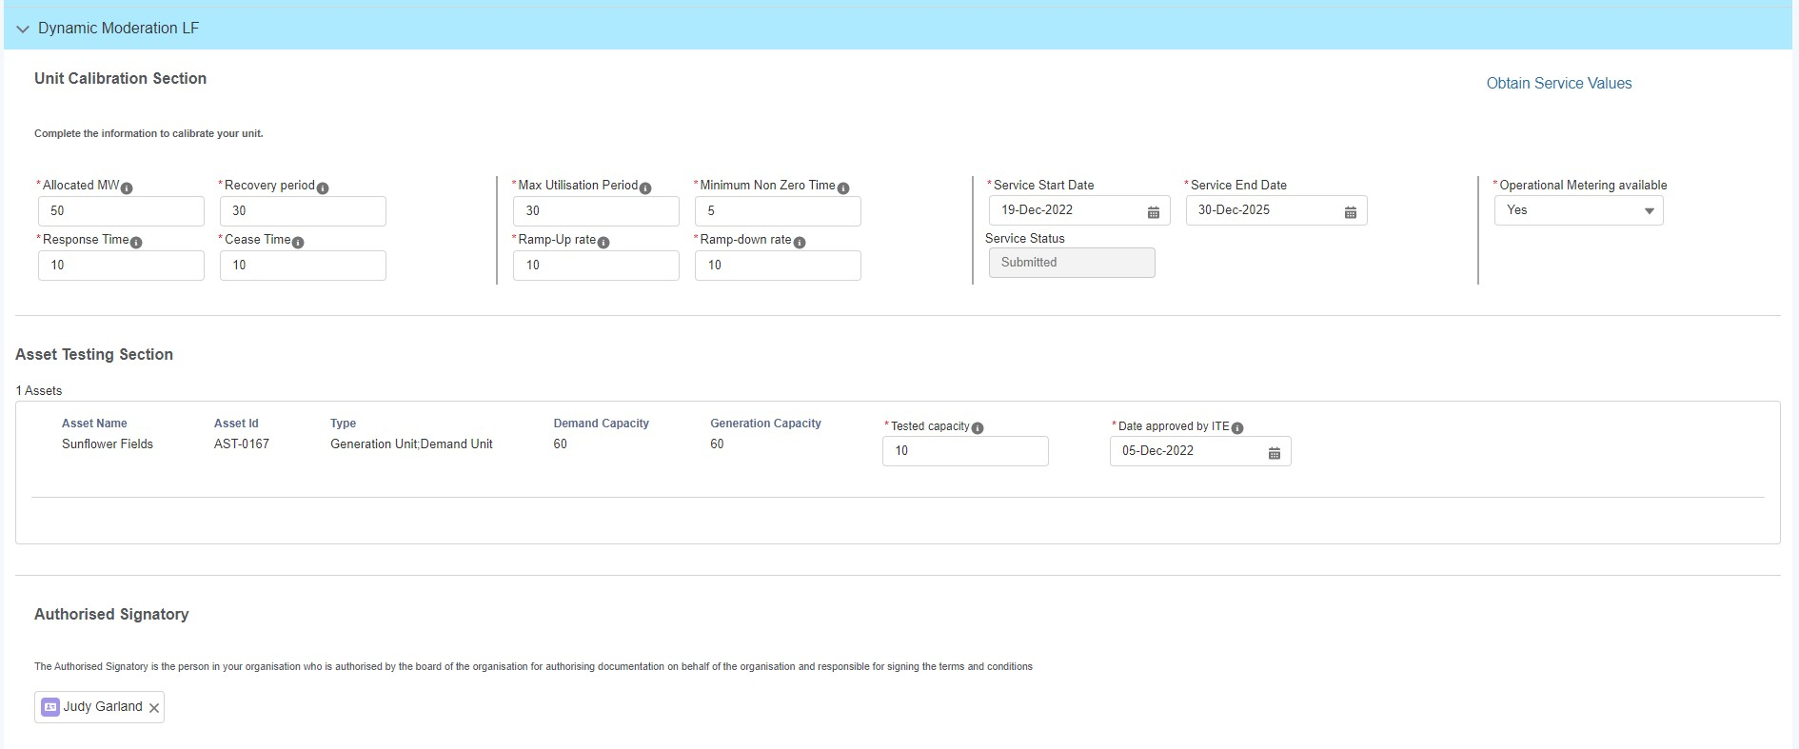

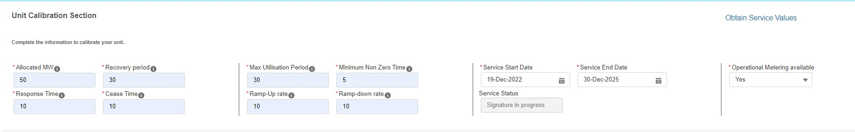

Automated Email Notifications

Upon submitting the prequalification application, the Authorised Signatory will receive an automated email instantly with a link to the electronic Form B, now customised with the Provider’s details. The email will also contain National Energy System Operator Limited branding to make it clear to the recipient that the email is sent on behalf of National Energy System Operator Limited . The figure below illustrates the email template sent.

Email Template – ‘Request to sign’

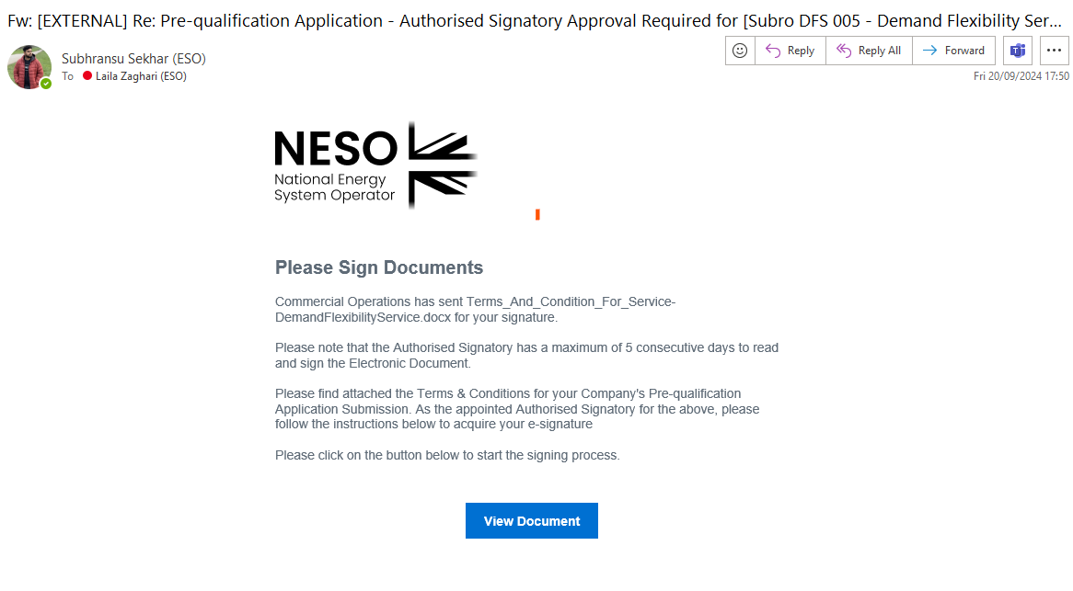
Email Template – ‘Signing Complete’
The portal user (original applicant) will receive notification when their respective Authorised Signatory has completed signing. The figure below illustrates the email template sent.

Automated Email Notifications (Continued)

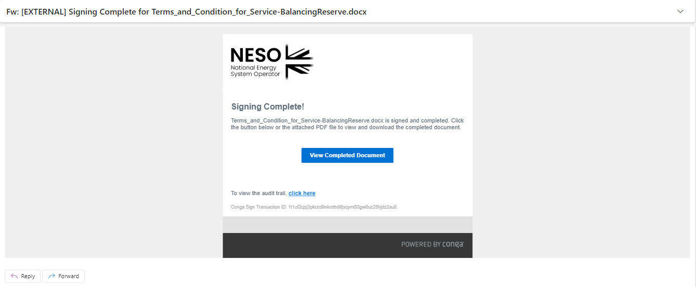

Customisation of Digital Document & Electronic Signature Capture by Authorised Signatory

Opening the Customised Document (Form B)
The Authorised Signatory will be transported to the document which will contain the Name of the Service Provider and Company Registration Details as illustrated in the figure below. This data is extracted from the SMP Portal. The Signatory should read through and scroll the document to the Signature blue box in Figure 55.0 and double click on the blue box. If the Signatory decides to abort the process at this point, they can navigate to the top right-hand side and select ‘Cancel Transaction’.

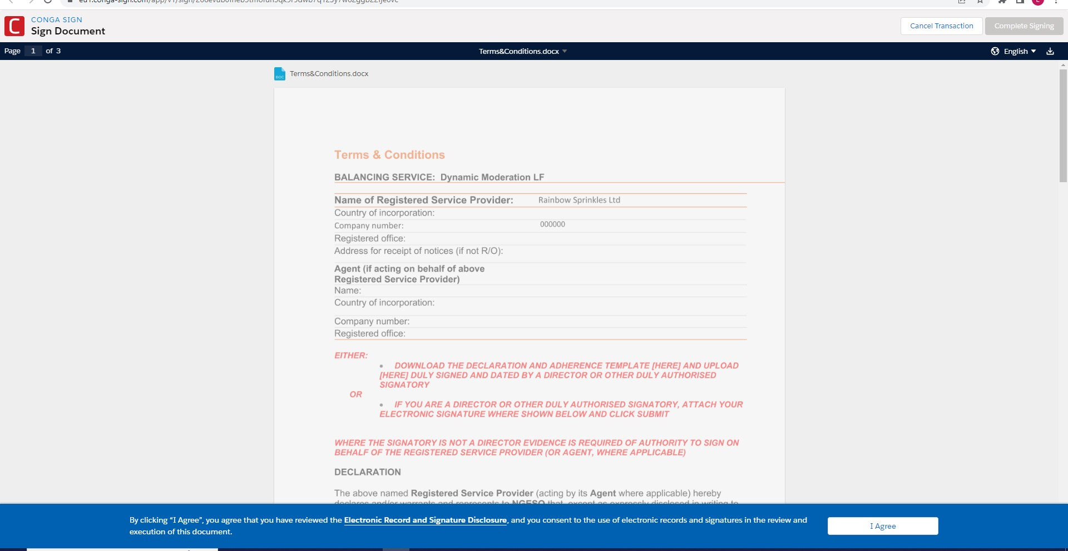

Customisation of Digital Document & Electronic Signature Capture by Authorised Signatory

Completing the ‘Wet Signature’ step (Form B)
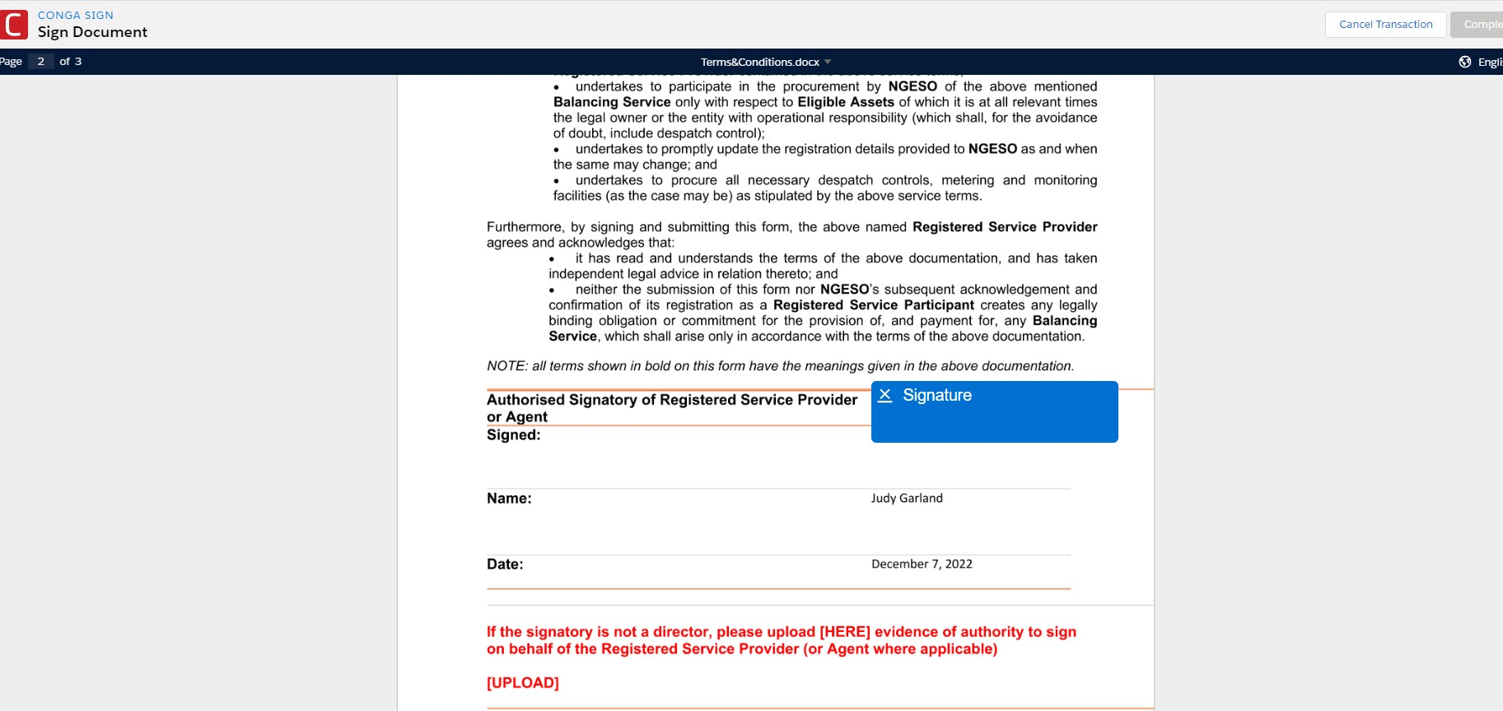

Capturing the Wet Signature step (Form B)
The signer can select a number of methods to capture their signature as indicated in the tabular options in the figure overleaf.

Customisation of Digital Document & Electronic Signature Capture by Authorised Signatory (Continued)

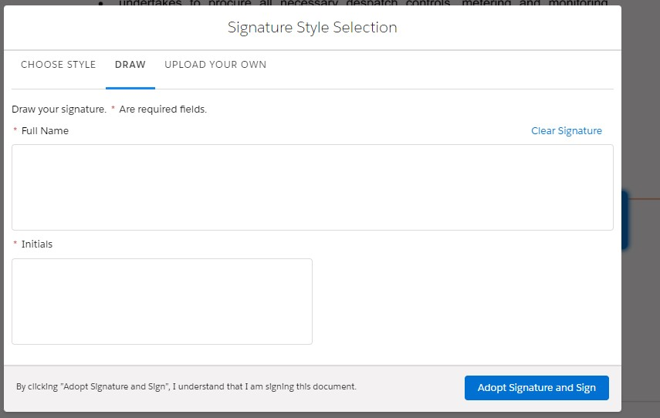

Upon capturing the signature, the signer should navigate to the ‘Adopt Signature and Sign’ custom button on the bottom right-hand side. Once finished, the signature will appear embedded in the document under ‘Signed’ section alongside the printed name and the Date the signature was captured. The signer should complete the process by selecting ‘Complete Signing’ on the top hand side of the document by scrolling to the top of the screen.

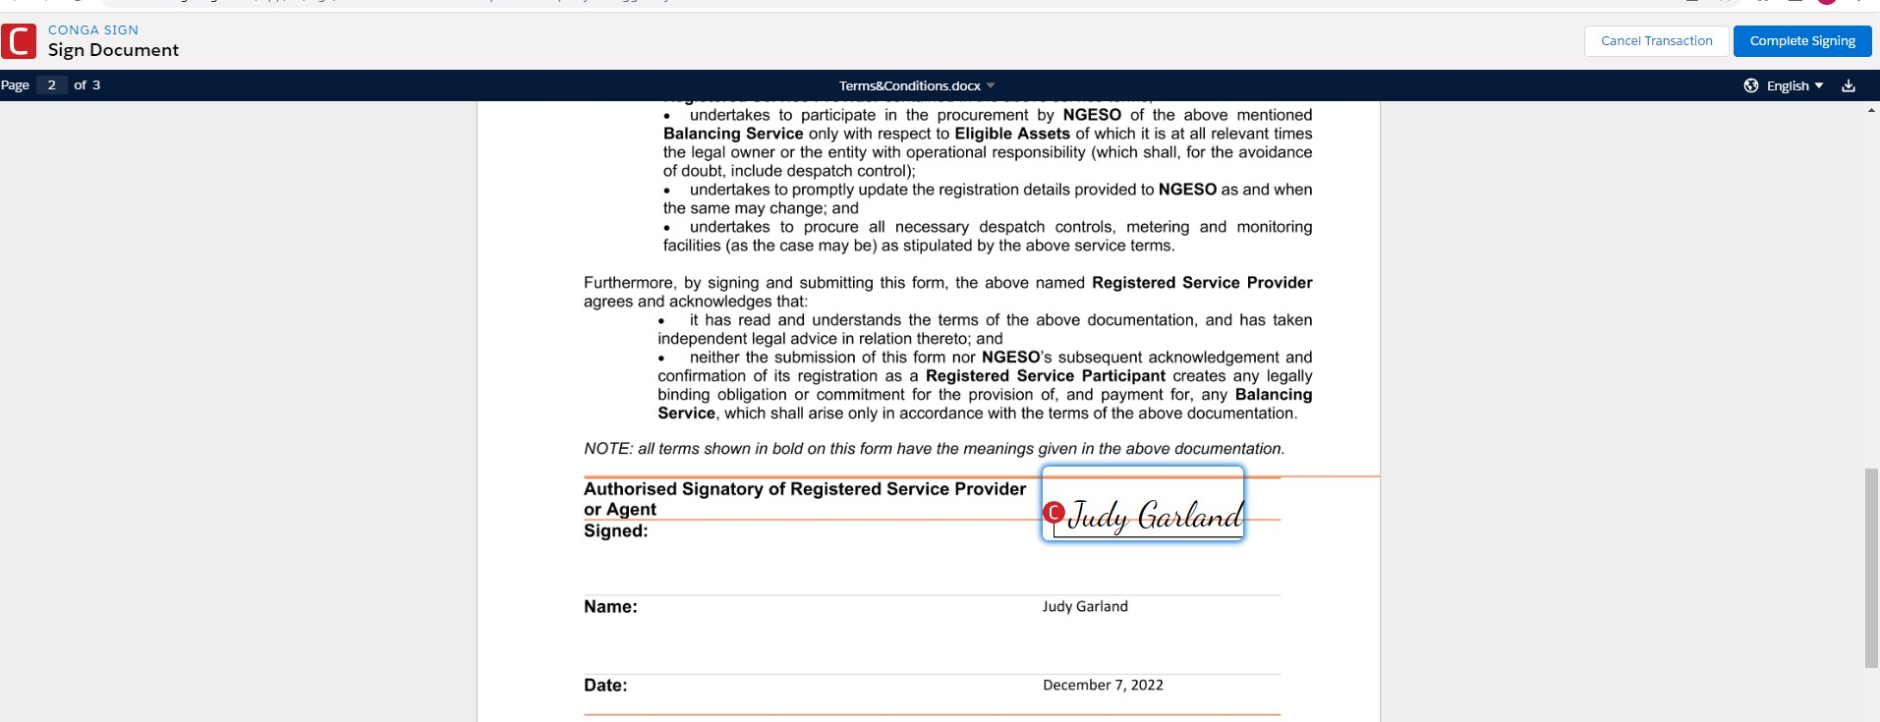

Confirmation of Signing Process - Complete

Document completed.
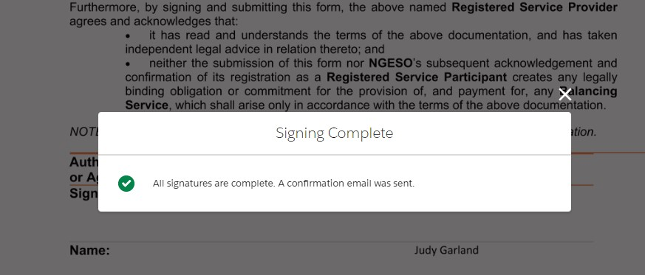

A notification will appear on screen, followed by the second automatically generated email notification sent to the portal user (applicant) to acknowledge receipt of the completed Form B Template Document. This document will be uploaded to the portal under the Prequalification Screen under the relevant Service application and made available to Contract Managers internally to accompany the respective Pre-qualification application.

Pre-qualification Process Application Closure:
The internal approval document known as Form C will be appended and available for the applicant (portal user) to access once the internal prequalification appraisal process has been undertaken internally (see Figure 58.0). The Status field will also be changed to ‘Approved’ when the Form C is attached.

Uploaded Form C
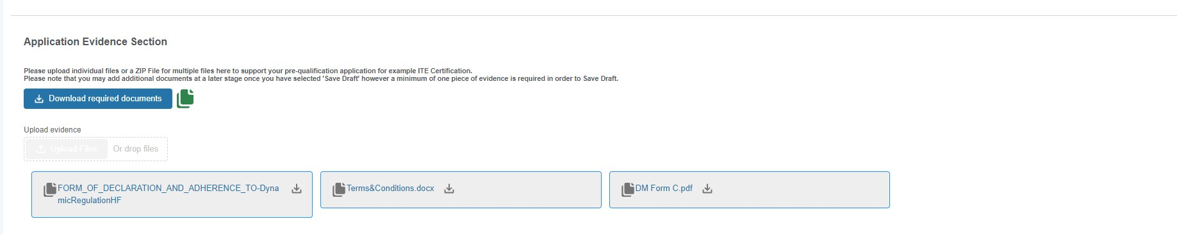

Pre-qualification Application Approval Email
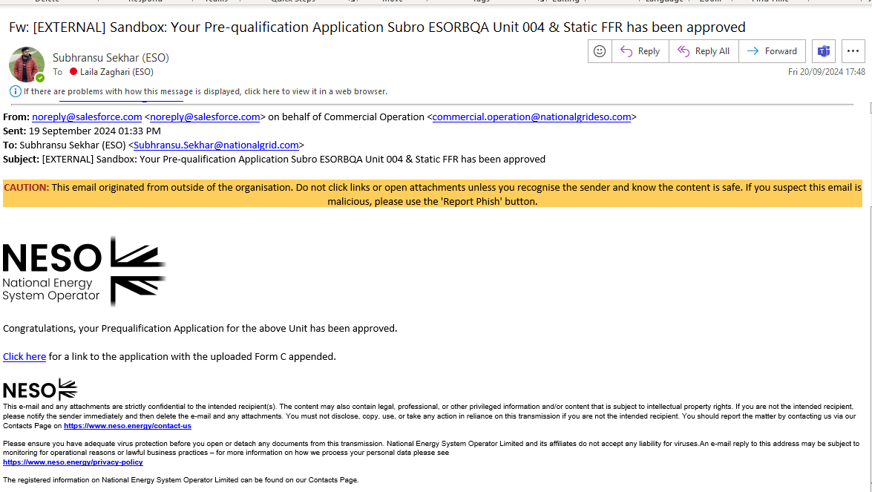
- ABSVD Delivery Allocation
Applicable Balancing Services Volume Data (ABSVD) is the volume of Balancing Services that was successfully delivered (rather than the instructed volumes), collared at the instructed level, for each unit and Settlement period.
In SMP the user is able to search for records that require volumes to be inputted and input them either manually or as a group by using a CSV file.
Access the Applicable Balancing Services Volume Data Delivery Allocation screen by selecting the tab. Please note if your user exclusively has the Trader role assigned you will not be able to access the tab.

CDV View
Here the user can search for their Collared Delivered Volume (CDV) records.
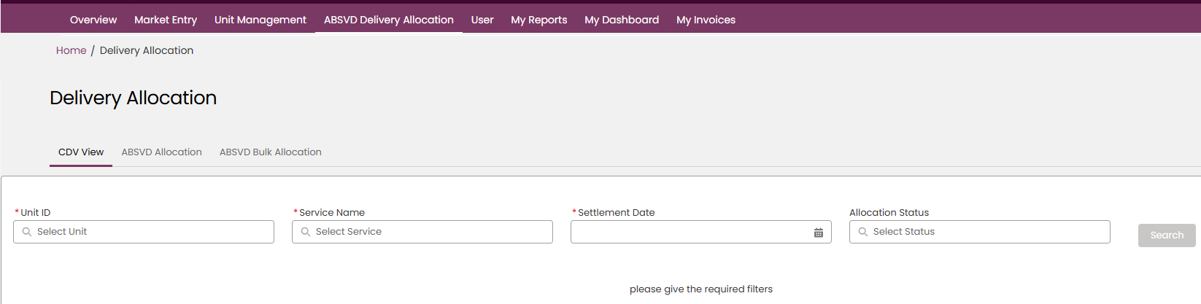
The Unit ID, Service Name and Settlement Date fields are mandatory so must have values in order for the search to be enabled.
In the Unit ID field, the user can type the start of the Unit ID to narrow down the list of Units available, then click to select the Unit.
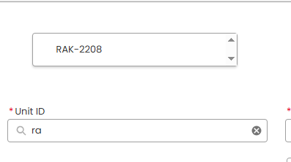
Multiple Units can be added to this search box.
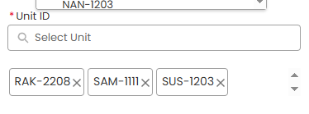
Select the Service Name from the list of available Services.
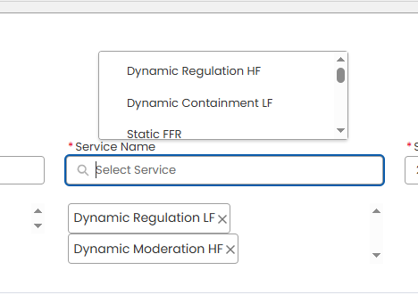

Input the Settlement Date
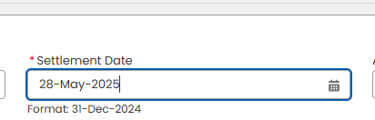

And optionally select an Allocation Status.
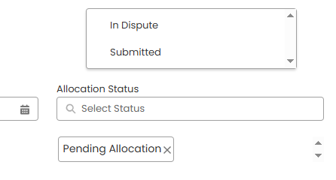

Press ‘Search’ and the records that match your search criteria will appear.
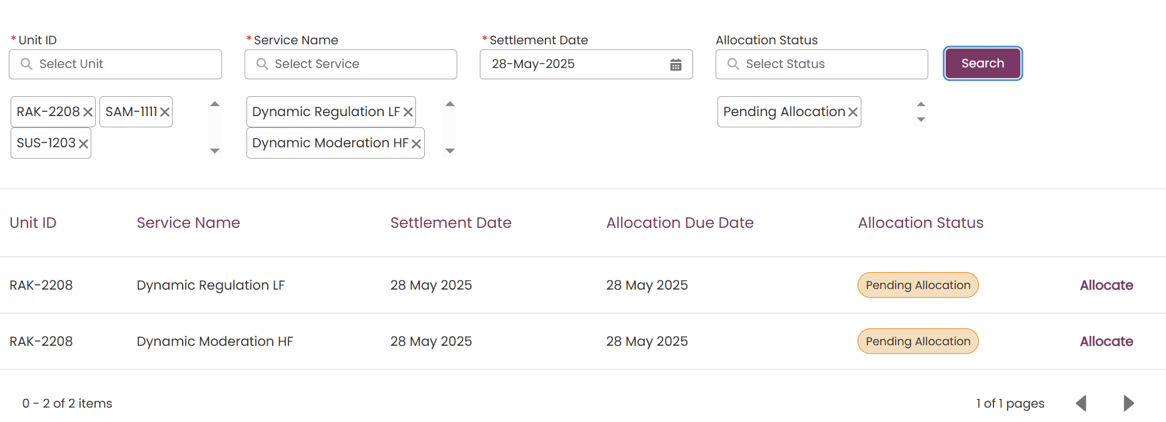
If the record’s status is ‘Pending Allocation’, you will then be able to press ‘Allocate’ to take you to the ‘ABSVD Allocation’ screen for that record.

ABSVD Allocation
On this sub-tab, the user can submit ABSVD Delivery Allocation values for every MPAN pair associated with an Asset per Settlement Period.

On this screen the user again uses the Unit ID, Service Name and Settlement Date to search, though if the Allocate link on a CDV record has been used, the filters will be pre-filled
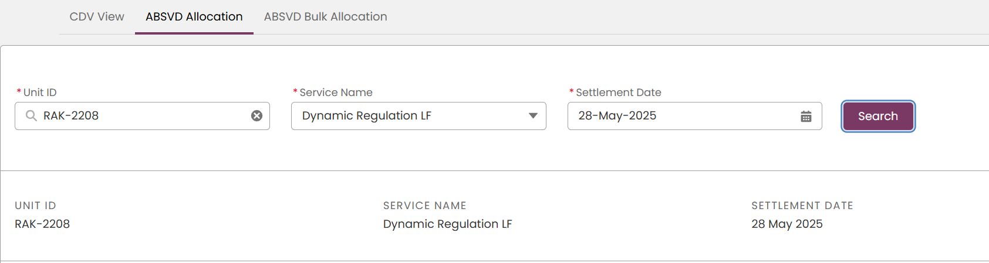
On pressing Search, if results are found the below table will load for the selected Unit, Service and Settlement Date
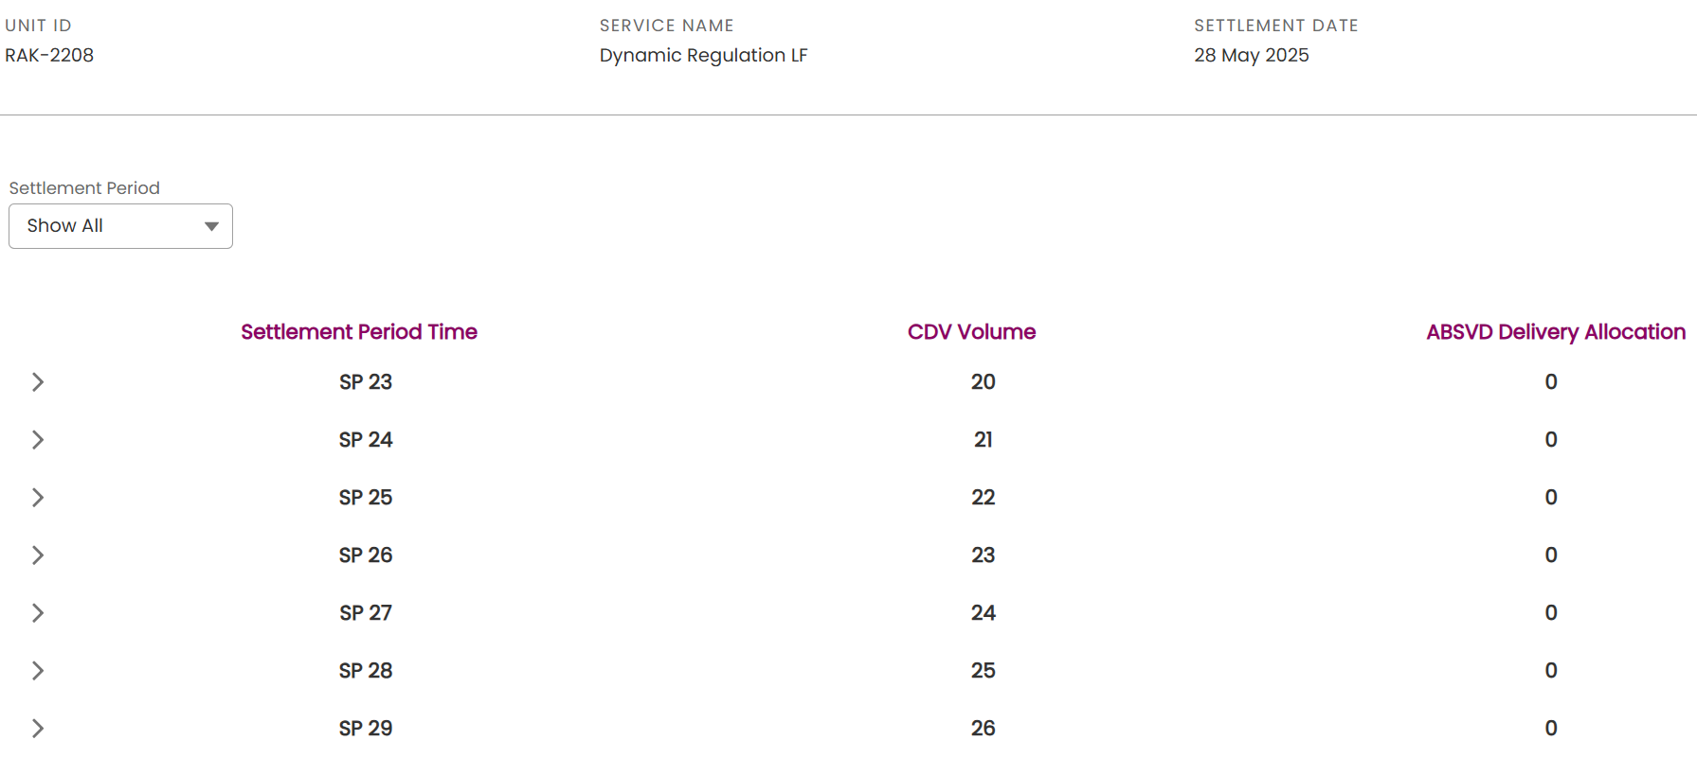
The user then has the option to filter using the Settlement Period
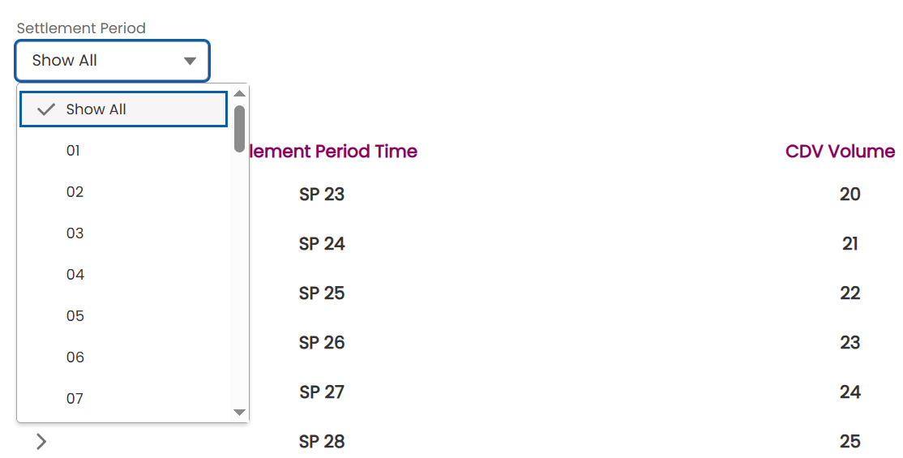

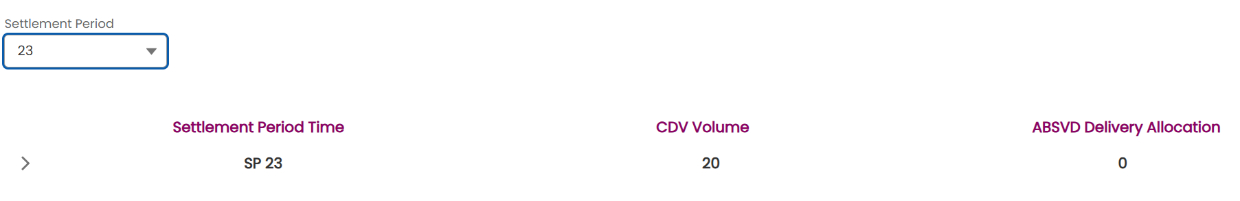

Click on the down arrow on the row to expand. Every row will be for an MPAN pair associated to that Asset. Enter the allocation value into the MPAN Import/Export (MWh) field. If the CVD volume for the record is positive a positive value must be entered and if it negative a negative value must be entered. 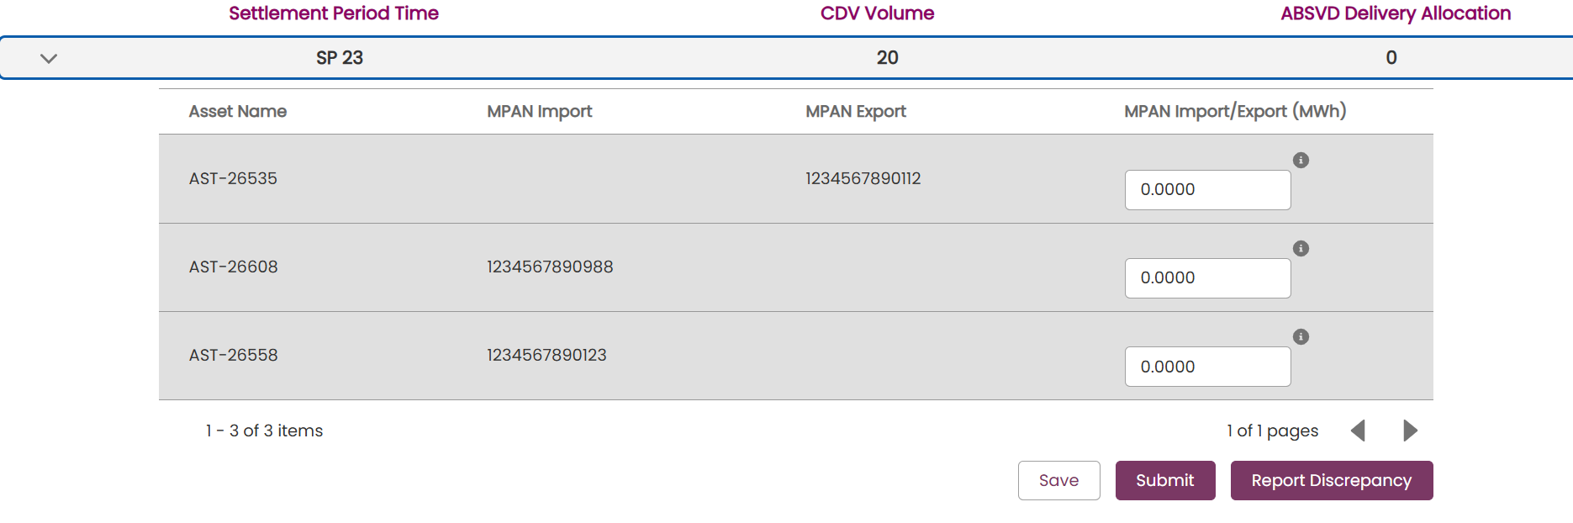
The total of the values entered must match the value of the CDV Volume for that Settlement Period. If the user does not believe the CDV Volume to be correct, press the ‘Report Discrepancy’ button. This will update the CDV Status to ‘In Dispute’ for the NESO Settlements team to review.
Pressing Save will save the values and allow the user to come back later to submit. Please note that submission must take place before the Allocation Due Date.
On pressing Submit then user will see a Success message and the status of the allocation will update to ‘Submitted’ for the NESO Settlements team to review.
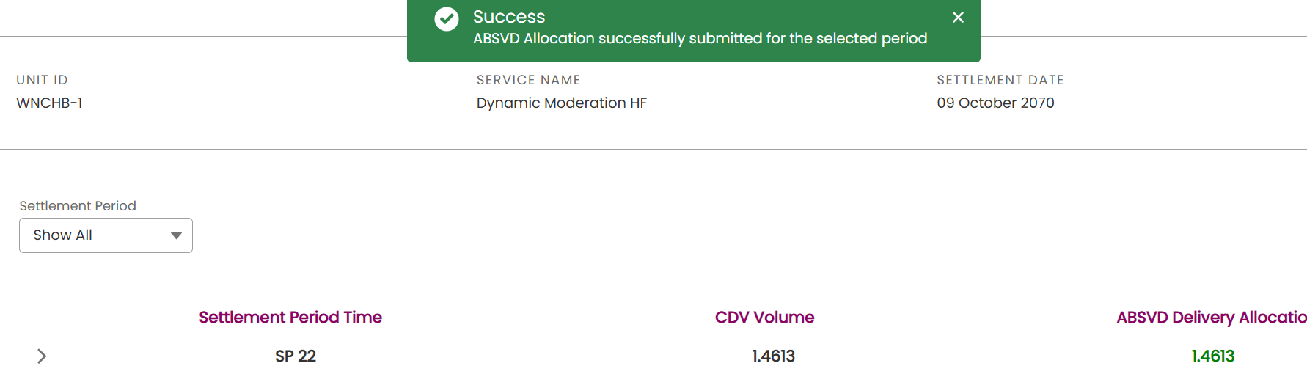

ABSVD Bulk Allocation
The ABSVD Bulk Allocation tab allows the user to download CDV records in a CSV file, then having inputted the desired allocation values into the file, upload and submit them into SMP.
To find pending allocation records, search using the filters below. The Bulk CDV Download button will be enabled if matching records are found

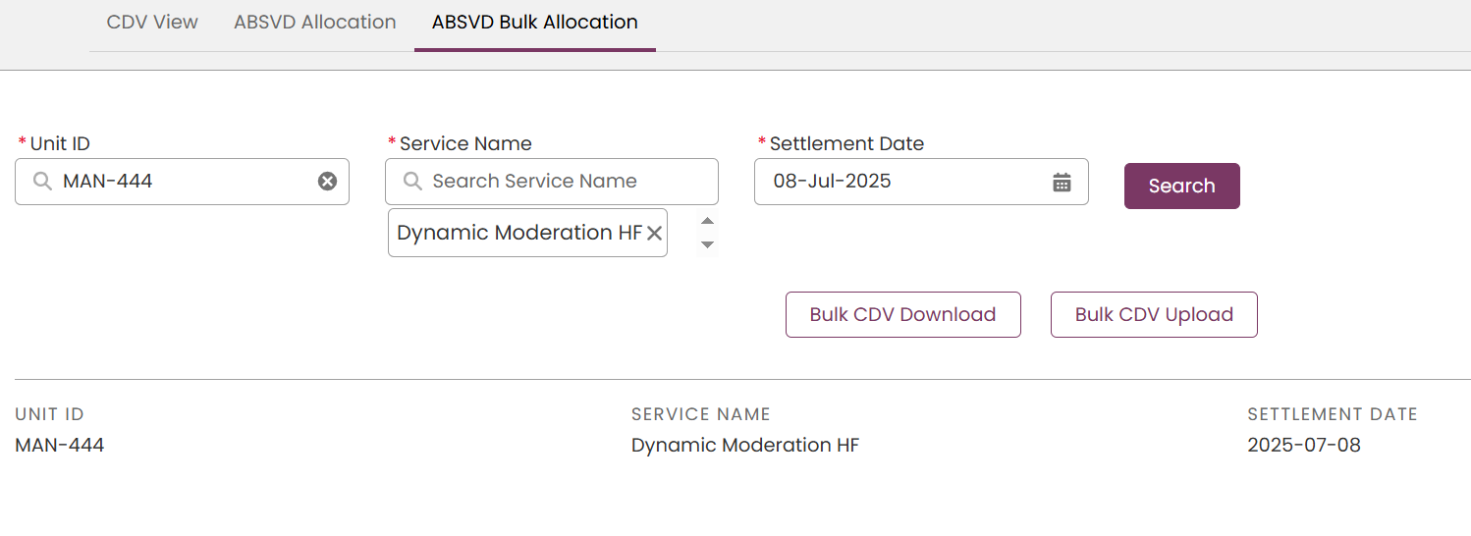
On pressing ‘Bulk CDV Download’, a CSV file will generate with the below headers:
SETTLEMENT DATE | SETTLEMENT PERIOD | Unit ID | Service Name | Asset ID | CDV Volume (MWh) | MPAN IMPORT | MPAN EXPORT | Volume (MWh)

The user can then prepare the file for upload. The columns in the upload will have to match the columns obtained in the download file. Please note that the values in the ‘SETTLEMENT DATE’ column for the upload must follow YYYY-MM-DD format and MPAN IMPORT and MPAN EXPORT must be stored as numbers with 0 decimal places.

Input the Allocation values in the Volume(MWh) column. The values must total the CDV Volume (MWh) for the Settlement Period e.g. if the CDV Volume(MWh) is 30 there are multiple entries for the same Settlement Period these must total 30.
Once the file is ready, select ‘Bulk CDV Upload’ then the ‘Upload Files’ button.

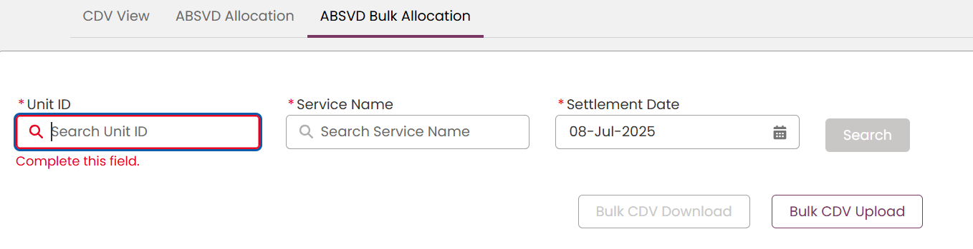

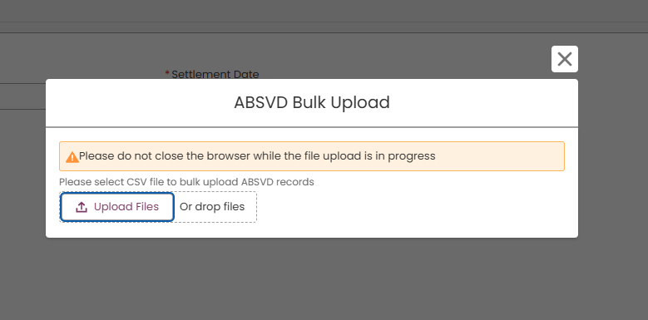

Upon successful upload, a success message will appear at the top of the screen.
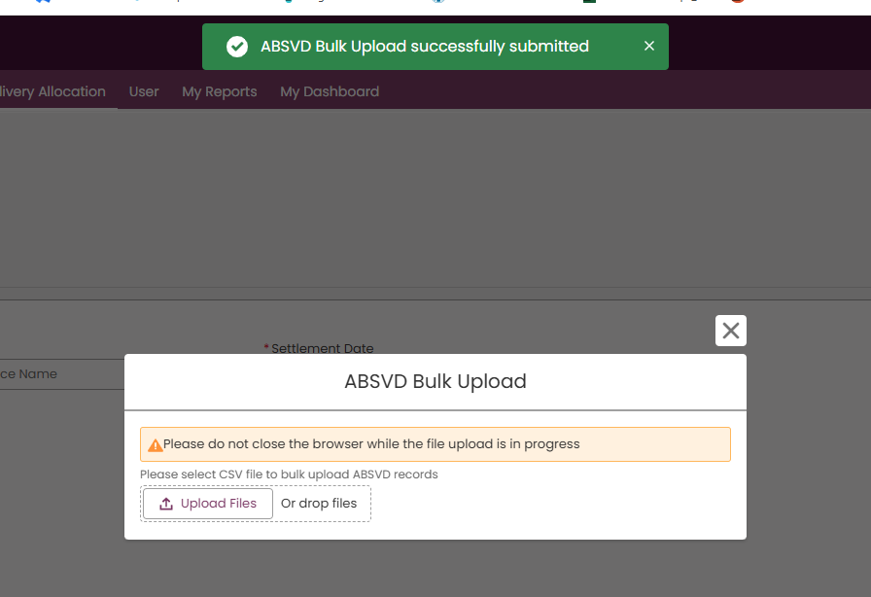

The status of the allocation will update to ‘Submitted’ for the NESO Settlements team to review. This can be verified by returning to the CDV view and searching for the same records
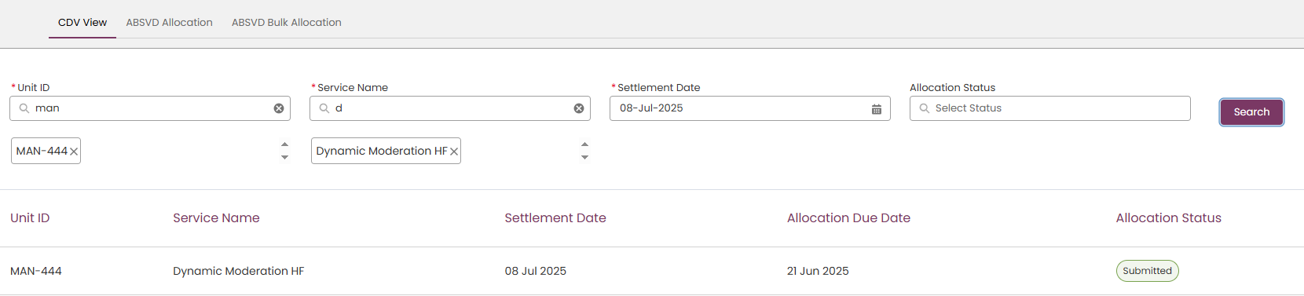

- Global Versioning

What is Global Versioning?

The term Global Versioning refers to the process whereby a Market Provider can modify or alter the Unit, the Unit’s composition of Asset(s) and the re-evaluation of any existing prequalification applications to ensure their continued eligibility to participate in the services it had originally been qualified for.

The process has been designed to be more streamlined so that all prospective modifications and/or alterations are captured in one instance from Market Providers and any tests or conditions are applied in real time and the outcome is calculated instantly where possible and the subsequent changes are applied to the Unit automatically.

The Global Versioning Process comprises of the following stages;
- The identification of the Unit in question and the capture of information relating to the Unit and associated asset(s) and updates to the connected prequalification applications.
- The verification of the data supplied in line with Versioning Criteria and the outcome decision on the modifications/alteration.
- The automated processing of the Unit to generate the latest Unit Version and the associated records to reflect the latest changes/alterations.
- The communication of the latest Unit Version and associated records to downstream systems such as the EAC platform.

Changes permitted through Global Versioning

As of Release 2.12 Global Versioning permits the following modifications or alterations to be made.

A Unit is subject to versioning when it requires a change or modification to its properties or to a change or modification to its composition of asset(s). This can include any of the following combination.
  - An Increase or Decrease in the Total Demand or Generation Capacity resulting from an alteration in the composition of asset(s)
  - The addition or remove/withdrawal of asset(s)
  - A Modification to the Demand or Generation Capacity at an individual Asset Level.

A Unit and it’s connected Asset(s) can be subject to multiple iterations of Global Versioning during its lifetime. For example, a Unit can require several changes over time and each change will constitute a case for Versioning – therefore one Unit within a provider’s portfolio may have 1 Version whilst another may have 10 more.

Please note that as of Release 2.12 a ‘standalone’ asset is not eligible for Global Versioning after it has been registered. Only asset(s) that are committed to a Unit at the point of embarking on Global Versioning are eligible to be ‘modified’.

Changes not permitted through Global Versioning

Please note that as of Release 2.12 any other ‘Parameter’ on the Unit or the corresponding Asset outside of the Demand and/or Generation Capacity is not eligible for Global Versioning, meaning any modifications to such parameter values will require the Market Provider to liaise with the Account Manager to establish if modifications can be made to registered Units and Assets.

Why is Global Versioning required?

The main rationale for introducing Global Versioning on the SMP Portal is to keep track of changes of a Unit & a connected Asset over time which are documented and available for the Registrations & Contracts Team to monitor for auditing purposes as well as recording the history of a Unit and an Asset as it evolves or changes during its lifetime. Essentially, when changes are made to the Unit, it’s composition of Assets or the individual Assets, a cloned copy of the original record is produced with the original retaining its original properties, allowing a new version (cloned) to be subject to modifications or updates by the Portal User(s).

Moreover, ‘related’ or supplementary records linked to the Unit will also be cloned automatically. For example, if the origin Unit has a pre-qualification ‘application’ attached, the application record will also be cloned – critically retaining the Status at the point of Versioning. Equally all corresponding Asset Testing Data and Supplementary Evidence pegged to the original application will be tagged against the latest version of the Unit automatically. It is important to note that if the Unit satisfies particular ‘‘Service Criteria’’ or conditions then as a result of the modifications made by the Portal User, then additional information or evidence will be required to support the modification request.

It is important to note that with the introduction of User Roles, all Unit and Asset Records including those Versioned will be available to view and edit or manage exclusively by User(s) with the ‘Unit Manager’ Role assigned to their User Record/Profile by their respective Super User. For more on User Roles please visit the Chapter on User Management. Moreover, it is recommended that only one user at any one time is solely responsible for undertaking the task of Versioning a Unit.

For the purposes of the Guide, the naming convention will run as follows; the origin Unit and Asset will be referred to as Version 1.0 and the second iteration of the Unit and Asset will be referred to as Version 2.0. Any subsequent iterations will follow the same logic, so a third version will be referred to as 3.0.

What types of Global Versioning apply to Units?
There are currently two different types or instances of Global Versioning. These are as follows;
Manual  Versioning | If the alterations to (or the composition of) assets connected to the Unit in question result in a total increase in either/both Demand and Generation Capacity, then the Unit will require appraisal by the Registrations Team before approval.  Any associated impacts on the Service Criteria for all or any of the Services the Unit is already approved to participate in will be evaluated and an outcome determined automatically.  Any associated existing prequalification post evaluation deemed ineligible will be classified as ‘Rejected’ automatically with an external notification sent to Portal Users associated with the Market Provider to notify them of the outcome decision at the point the Global Versioning Application ‘Form’ has been completed but whilst the Unit is pending manual appraisal.  A Unit subject to Manual Versioning cannot complete the Global Versioning Process until the Unit has been approved by the Registrations Team despite the connected pre-qualifications re-evaluated automatically and deemed eligible or ineligible to continue.
Automated Versioning | If the alterations to (or the composition of) assets connected to the Unit in question result in a total decrease in either/both Demand and Generation Capacity, then the Unit will not require appraisal by the Registrations Team, instead it will be granted automatic approval.  Any associated impacts on the Service Criteria for all or any of the Services the Unit is already approved to participate in will be evaluated and an outcome determined automatically.  Any associated existing prequalification post evaluation deemed ineligible will be classified as ‘Rejected’ automatically with an external notification sent to Portal Users associated with the Market Provider to notify them of the outcome decision at the point the Global Versioning Application ‘Form’ has been completed but whilst the Unit is pending manual appraisal.  A Unit subject to Automated Versioning is able to complete the Global Versioning Process as it has been classified as ‘approved’ (Accepted) automatically, independently of the connected pre-qualifications which are also re-evaluated simultaneously and deemed eligible or ineligible to continue.

Conditions for Re-evaluating Prequalification Applications

Existing Prequalification applications subject to re-evaluation as part of Global Versioning will be in ‘Approved’ Status and the following key conditions are applied as part of the re-evaluation conditions to determine if the Unit remains eligible or is deemed ineligible.

- Where either a total increase or reduction in Generation and/or Demand Capacity results in drop below The Service Minimum threshold (SMT).
- Where the total increase or reduction in Generation and/or Demand Capacity results in a drop below, the adjusted/revised Allocated Volume is then checked against the SMT for the specified Service.
- Where the adjusted/revised Allocated Volume has also dropped below the SMT then the Unit is deemed ineligible to continue to participate in the service when the latest version of the Unit takes effect.
- If the total increase or reduction in Generation and/or Demand Capacity results does not result in a drop below The Service Minimum threshold (SMT) then the Unit is eligible to continue to participate in the service in question.

*The SMT is defined as the baseline Generation and/or Demand capacity volume a Unit is expected to deliver for the respective Service. Each Service will have a universal ‘constant’ threshold figure determined as part of the original specification by the National Energy System Operator when a service is devised.

Global Versioning Process Steps

Selection of ‘Primary’ Unit.
To initiate the GV process, you will be required to firstly identify the ‘Primary’ Unit that you wish to submit for Global Versioning. Please note the following;
- Only Units in ‘Accepted’ Status can qualify for GV
- A Unit must have at least one Asset ‘aligned’ to it.
The Portal User must navigate to the Change Request Tab on the Unit Management Landing Page and then select ‘Add Basket for Versioning’ custom button.
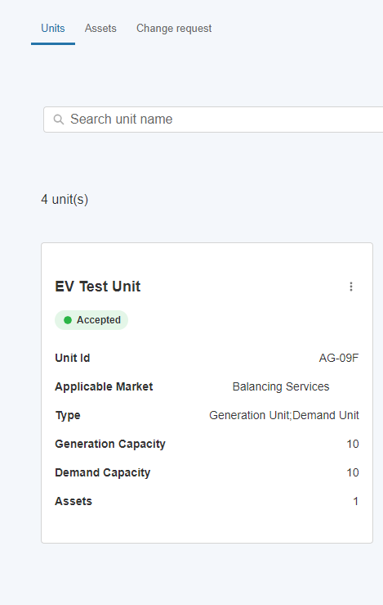
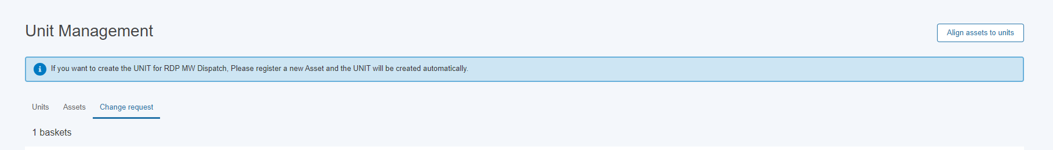

Selection of ‘Primary’ Unit: Cont
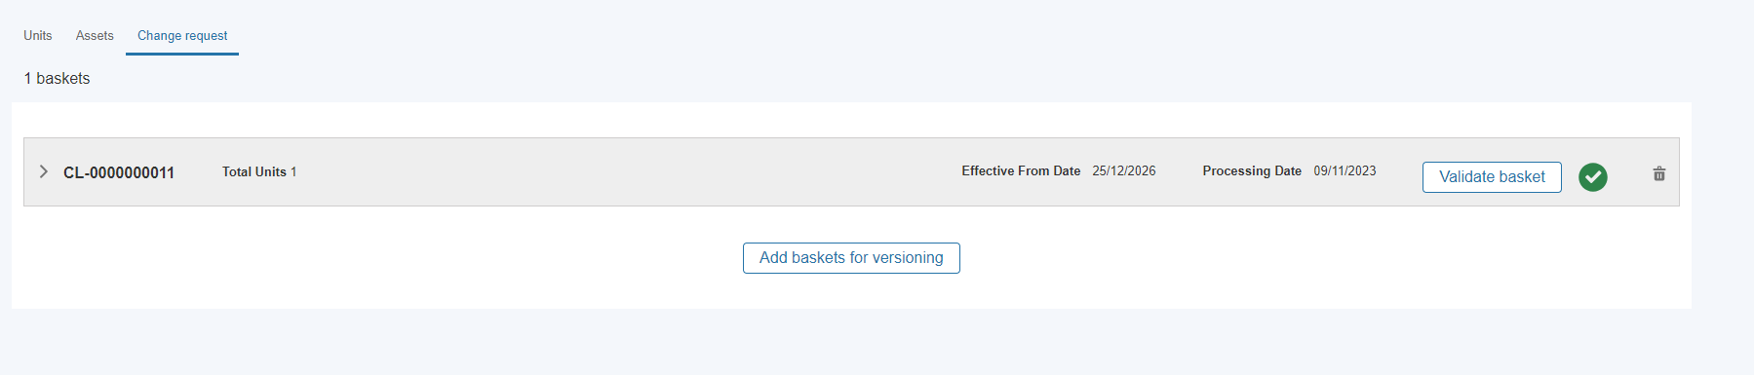

Creation of Global Versioning Basket – Basket Rules
Global Versioning uses the concept of Baskets to contain all of the Units that are subject to changes. The Basket ‘Rules’ are as follows;
- A Basket can contain one or more Units. These can be ‘Primary’ or ‘Impacted’ Units.
- Primary Units are those selected by the Market Provider
- Impacted Units are those Units identified as sharing at least one or more common assets as part of the composition of assets. Modifications made to the common asset will result in subsequent changes to other Units by virtue of the asset(s) being shared. These Units will be identified automatically and ‘pulled’ into the same Basket for the Portal User to preview and either approve or make further changes if required.
- All Units within a given Basket must share a Universal Basket ‘Effective From Date’ This Date is when the latest Version of the Unit will take effect. This date can be amended with future alternative dates.
- Each Basket also has a ‘Basket Processing Date’. This Date is calculated automatically and is currently used as a ‘cut-off’ date for committing the proposed changes (captured in the GV Application Form for each individual Unit) to be ‘executed’. This Date is currently 10 days from the Effective From Date. The 10 day period allows for any National Energy System Operator Approval or Intervention to be undertaken. If the Effective From Date is adjusted by the Portal User, then the Processing Date is adjusted automatically.
- A Basket can only be ready for processing when the following conditions are met;
- The Processing Date has been reached or lapsed.
- Every Unit in the Basket has a completed Application Form.
- All Units in the Basket (Primary and Impacted) have been marked as ‘Eligible’ in the Eligibility Outcome Status.
- The User has submitted the Basket for final Validation (and the Validation Tests have passed)
- The User has selected the ‘Process Basket’ Link contained within the Basket.

Creation of Global Versioning Basket – Basket Steps

When the Portal User selects the Create New Basket, they will be prompted to set the Effective From Date entering a specific format of DD-MM-YYYY. To proceed, select ‘Confirm’.

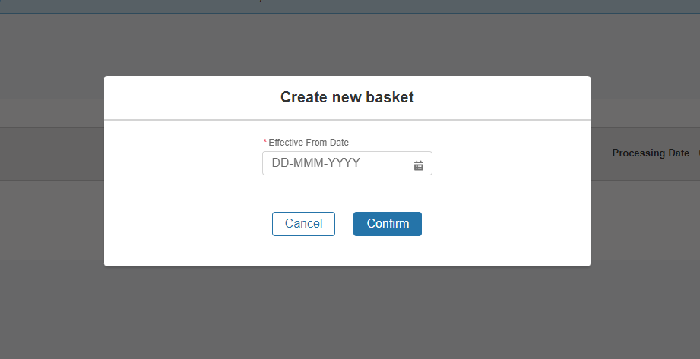

Creation of Global Versioning Basket – Selection of the ‘Primary’ Unit.

When the Basket is created, the Portal User will be prompted to select the Unit by entering the Name in the Search Box and then pressing the ‘+’ button adjacent to it. If the Unit is found, it will instantly be added to the Basket and appear as a ‘line item’.
The Basket Reference Number will always use the prefix CL-‘000000000’. If any Units fail the Validation Tests, the internal teams can use this reference to locate the corresponding Error Logs.
A Basket can be deleted at any stage prior to ‘Basket Committal’ (as outlined in the conditions overleaf). Once deleted all the Units contained within the Basket and any associated Versioning Application Forms will also be ‘deleted’.

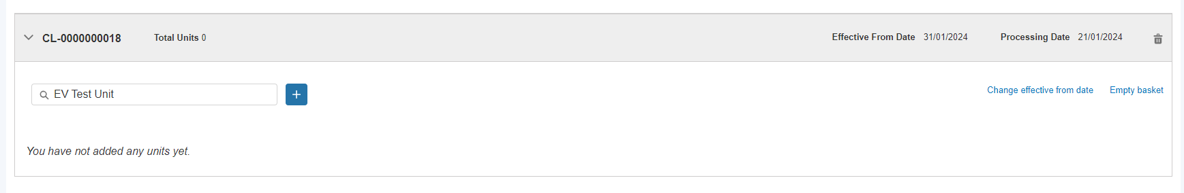

Creation of Global Versioning Basket – Selection of the ‘Primary’ Unit.

Once selected the Unit will appear as illustrated below. The Line Item entry will contain the headline data for each Unit and will display the ‘before’ and ‘after’ the modifications or alterations have been made by way of completion of the Versioning Application Form for the Unit in question.
The ‘after’ columns shaded in Grey will be updated in real time upon completion of the Versioning Application Form with the latest updated parameters.
At the point a Unit is added to the Basket, the Eligibility Test Outcome Status will automatically be set to ‘Draft’. The next step is to complete the application form. To do this, the portal user will need to navigate to the three drop down buttons and select the option ‘Proceed with application’
The option ‘Preview Unit Details’ will enable the Portal User to review the existing Unit’s ‘data’ and current parameter values.
The option to ‘Remove Unit from Versioning’ allows the Portal User to withdraw the Unit from the Basket completely.
The option to ‘Cancel’ an individual Versioning Application Form once ‘started’ is available throughout by selecting the option ‘Cancel Versioning’ which is located on the bottom left hand side of the ‘Application Form’ Screens.

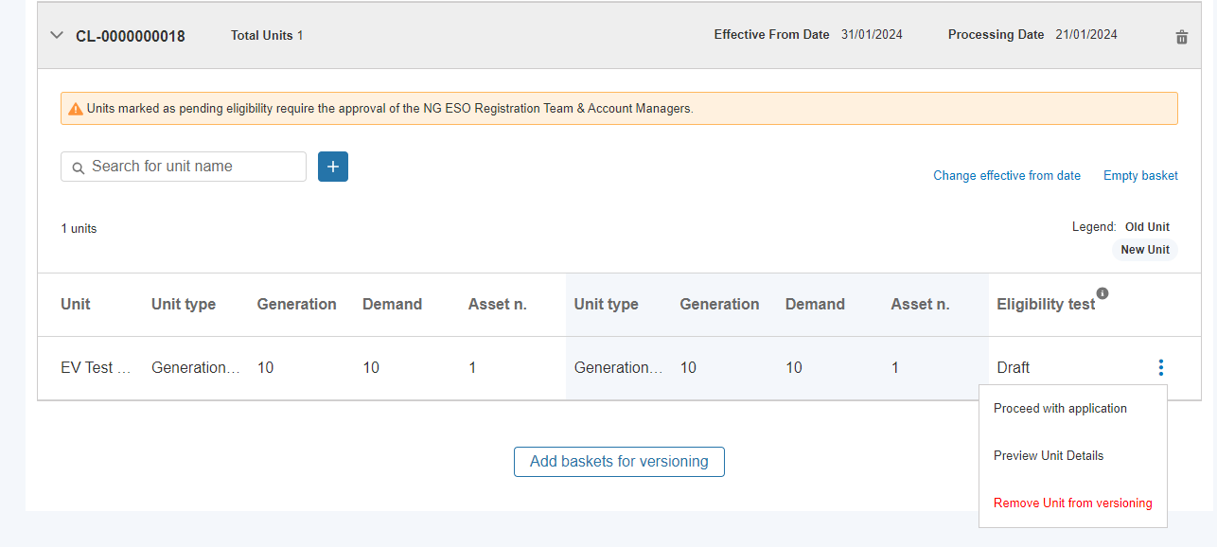

Completion of Global Versioning Application Form

By completing the Global Versioning Application Form you are able to notify us of;
- Any alteration to the composition of the primary asset(s)
- Any modification to primary individual asset(s)
- Both alteration the composition of the primary asset(s) & the modification to any individual primary asset(s)

Step 1: Selecting the action type
The Form allows the Portal User to capture changes resulting from either Adding/Removing Asset’s and/or also modifications to existing Asset(s) within the same Form. These are labelled as ‘Versioning Categories’.
Once the category options are selected, the Portal User is able to proceed with the Form by pressing ‘Confirm’.

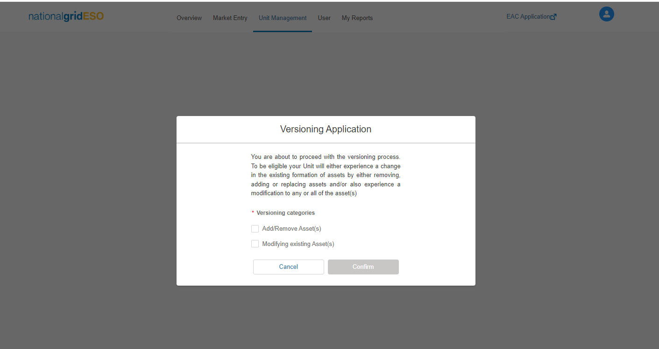

Step 2.a: Use Case 1: Modifying Asset(s) exclusively.- Increase in Total Capacity.

This example will cover the instance where only one more Asset(s) that compose the Unit require a modification to the Demand and/or Generation Capacity.

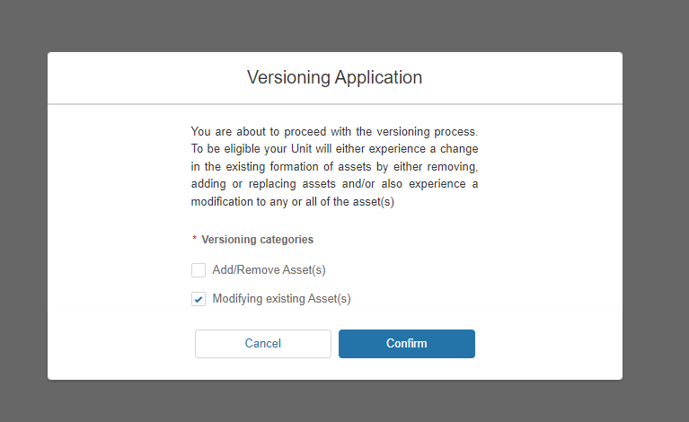

This next section in the Form will prompt the Portal User to provide the revised/latest Values for the Demand and/or Generation Capacity. Once entered, to proceed to the next section, the portal user will be prompted to select ‘next’ on the bottom right hand screen.

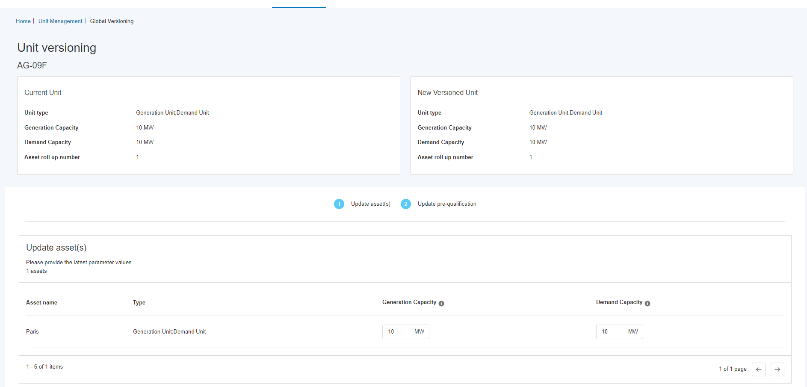

Step 2.b: Use Case 1: Modifying Asset(s) exclusively: Re-evaluation of existing Prequalification Application Data

Where the Total Capacity has increased at the Unit Level, the system will detect that any existing Prequalification Applications in Approved State will require attention. An orange banner with yellow warning will appear on this section of the form, providing the portal user the opportunity to update the relevant pre-qual application.
- The Portal User will be prompted to update or ‘re-affirm’ the Prequalification Parameters for any associated Prequalification applications that were previously approved.
- The mandatory field value is the Allocated Volume; however it is expected at this point of the application form to also included the Tested Capacity Volume.
- Currently as of Release 2.12, a revised ITE Certificate and a Date of said revised ITE Certificate is not mandatory for existing asset(s)..

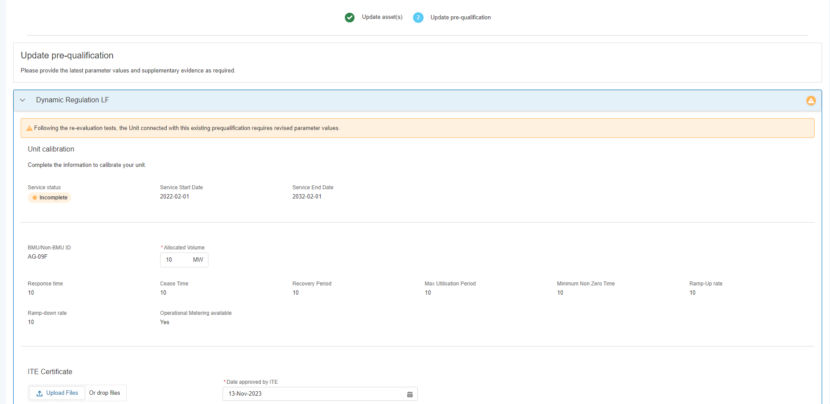

Step 3: Use Case 1: Modifying Asset(s) exclusively: Submission of the Versioning Application Form.
To mark the completion of the Versioning Application Form for an individual Unit, the Portal User will be presented with two subsequent ‘pop-up’ notification screens as illustrated below. To proceed, click on the ‘Submit’ followed by the ‘Go back to the Versioning Basket’ Screen to navigate to the ‘Change’ Request’ Page and the Basket.

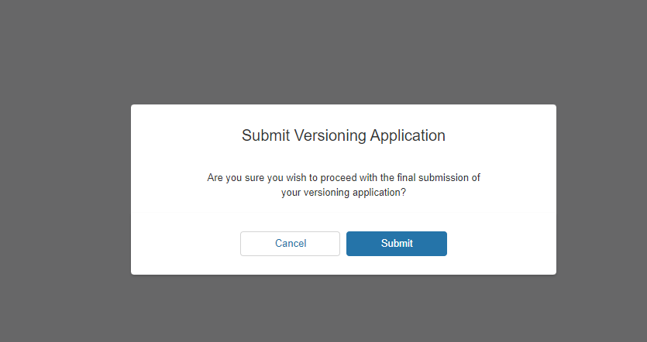

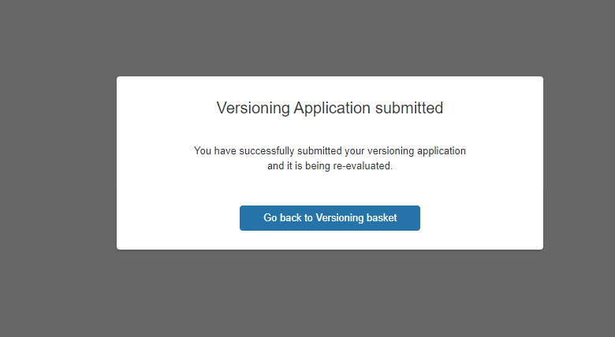

Trigger of Manual Versioning Conditions
In the Use Case example where the origin Primary Unit has increased in its total capacity, the Unit will be treated as follows;
- The Eligibility Test Outcome will be classified as ‘In Review’ in the Basket
- Any impacted Units that share the Asset in common will appear under the ‘Impacted ‘ Units Tab. These Units will also be classified as ‘In Draft’ in the Basket
- The Cumulative Value for the Demand and/or Generation Capacity Field will be updated in the ‘Grey’ Shaded columns (New Unit)
- The National Energy System Operator Business Units will be expected to appraise the Units (Both Primary and Impacted) to approve the changes. Once done, the Eligibility Test Outcome will change to ‘Eligible’ unless upon final Validation checks, errors in the associated Unit or Asset(s) have been identified that need National Energy System Operator input in which case the status will change to ‘Partially Eligible’.

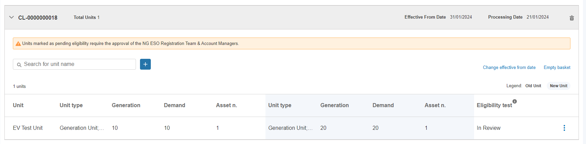

Submission of Basket– Validate Basket Step
Once all the Units in the Basket have been classified as ‘Eligible’, the Portal User can proceed with subjecting the Basket for ‘Validation’ by clicking on the ‘Validate Basket’ button on the top right hand corner.
- Validation means that a final check on the individual Data (fields/parameter values) on all associated records do not incur any errors or missing data prior to committing the Unit to the completion of the Versioning Process. The Validate Basket Button can be selected prior to the Processing Date and can be selected on successive attempts -if Validation of the Basket fails the first time. A message will appear to confirm Validation is in progress. Simply refresh the page & navigate to the ‘Change Request’ Landing Page.
- The outcome of the Validation Tests is instant; however a notification is only sent out to the National Energy System Operator Internal Teams to as they are in a position to investigate the root causes of the Validation Error. They will arrange to liaise with Market Providers/Portal Users to ensure the Errors are dealt with accordingly. The Eligibility Test Outcome for the respective Unit will appear as ‘Partially Eligible’ in the Basket.
- Once this exercise is complete, the Portal User will be prompted to repeat the task of selecting the Validate Basket Button in order to achieve a successful Validation Test result in order to prime the basket for processing. When the Validation errors have been rectified with input from the National Energy System Operator, the Eligibility Test Outcome for the respective Unit will appear as ‘Eligible’ in the Basket.
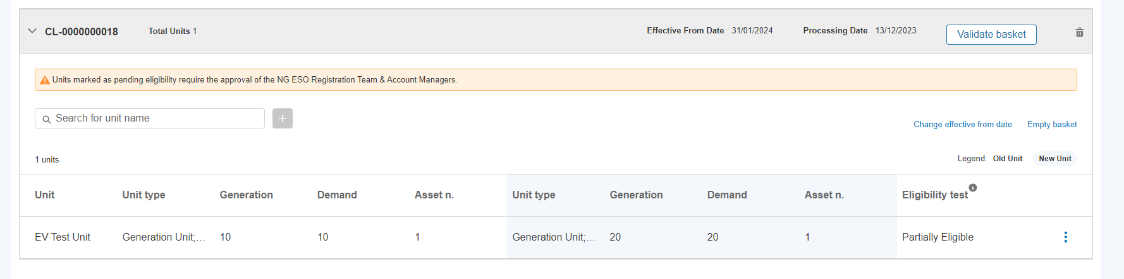
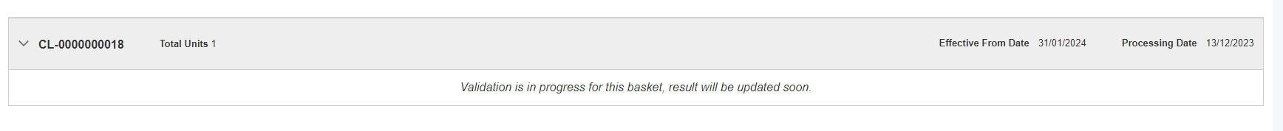

Submission of Basket– Committal of Basket for processing
Once the conditions for Processing the Basket have been met as stated earlier in the guide, then a ‘Green Banner’ will appear at the top of the Basket and embedded in the text is a hyperlink to allow the Portal User to proceed with ‘Process Basket’ and commit the changes, completing the Global Versioning Process.
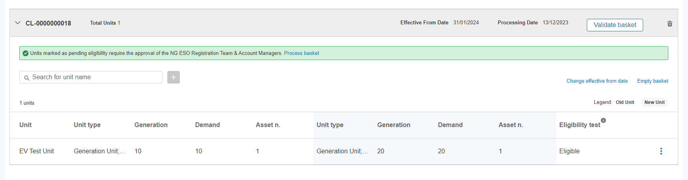
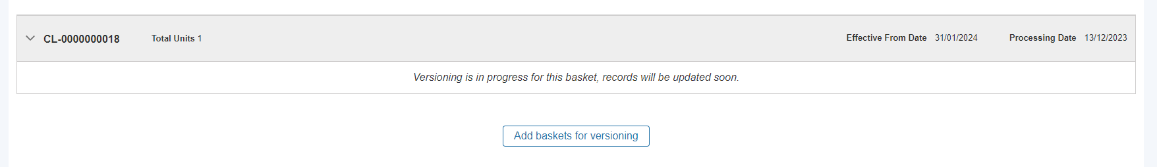

Completion of Global Versioning Process

When Processing is complete, a ‘Unit Tile’ is instantly created for the latest Version of the Unit (Version 2.0) and adjacent to it will be the predecessor Version (V1.0).
The Unit ‘Versions’ are distinguishable by the Status ‘Value’. Version 2.0 (the most recent will display as ‘Accepted’ and the predecessor Version 1.0 will display as ‘Versioned’. The Unit Tile marked Versioned’ will not be available to make any further edits or for example submit any prequalification applications under.
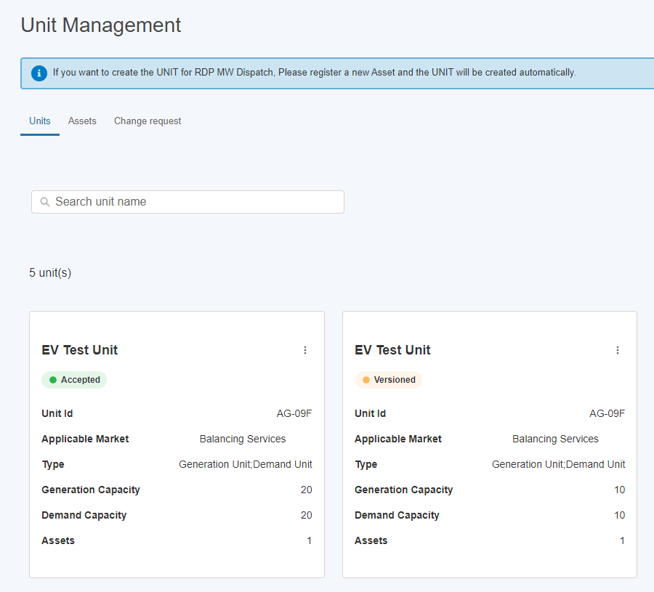

Limitations whilst Global Versioning Process is ‘In-flight’.

Once a Unit has been subject to Global Versioning, there are several limitations in place to prevent any further activity from occurring whilst the Global Versioning Process is in flight.
- Portal User are unable to modify or make repeated changes to the same Unit or any implicated Assets after Global Versioning has been initiated.
- Portal User are unable to prequalify the Unit for new services after Global Versioning has been initiated.
- Portal User are unable to re-align the same Unit with any new assets whilst in flight via the standard alignment process under Unit Management, as such changes will be encompassed through the Global Versioning process.
A Unit Tile is marked as ‘locked’ or ‘frozen’ whilst Global Versioning is in flight using a ‘I’ symbol adjacent to the name of the Unit.
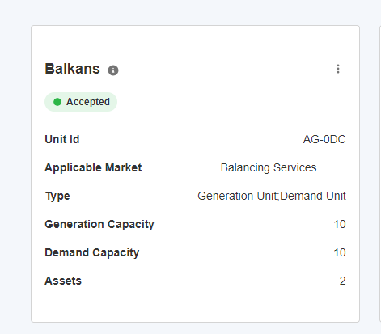

Variation to the Global Versioning Application Form

Reduction in Capacity via modification to individual asset(s)
In the instance that a Unit ‘s ‘Use Case’ for Global Versioning is due to an overall reduction in Demand or Generation Capacity, either by way of a change in the asset composition or a modification to an individual asset, the steps adopted to initiate Global Versioning as the same as previously outlined. It is critical to ensure the steps to confirm/update the prequalification parameters are also undertaken to ensure the accurate eligibility status is arrived.

When the Versioning Tests are concluded the Unit is deemed as ‘Eligible’ on the assumption that the ‘automated’ versioning criteria is satisfied. This eligibility status is also awarded if the Unit has any existing associated prequalification applications that have since been classified as ‘Rejected’. In this instance, these prequalification applications for specific service delivery will no longer be eligible to continue as of the effective from date for Version 2.0 (or the latest version). A supporting email notification will be issued to confirm this outcome for each respective prequalification application affected as advance warning.

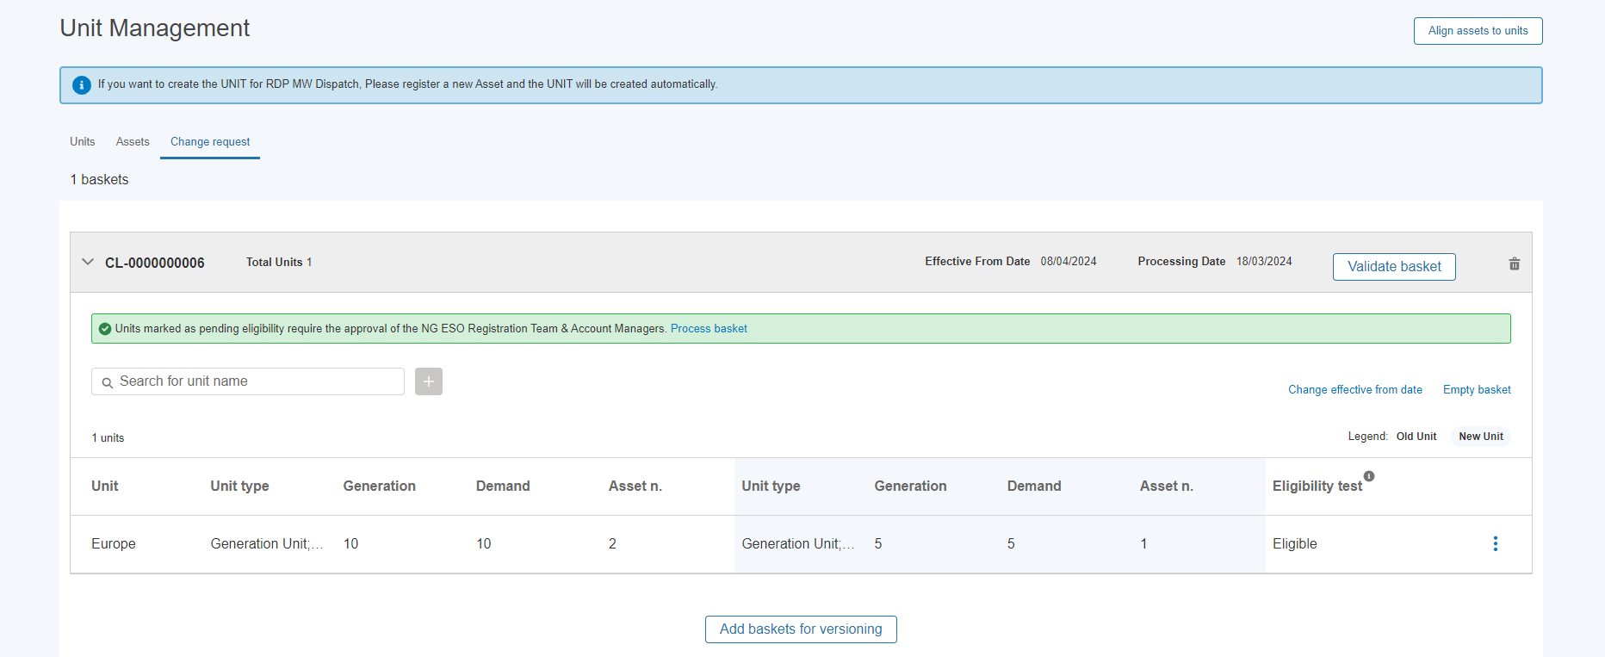

Increase in Capacity (or no net change in Capacity) due to re-alignment or change in composition of asset(s)

In the instance that a Unit‘s ‘Use Case’ for Global Versioning is due to an overall increase in Demand or Generation Capacity (or results in no net change in the total capacity) by way of a re-formation of asset composition - the steps adopted to initiate Global Versioning as the same as previously outlined.
The Portal User must ensure when completing the Global Versioning Application Form that they select the correct option on the first screen to only ‘Add/Remove’ Asset(s).
The Portal User will also be expected to complete the re-alignment section to confirm the new formation of assets.
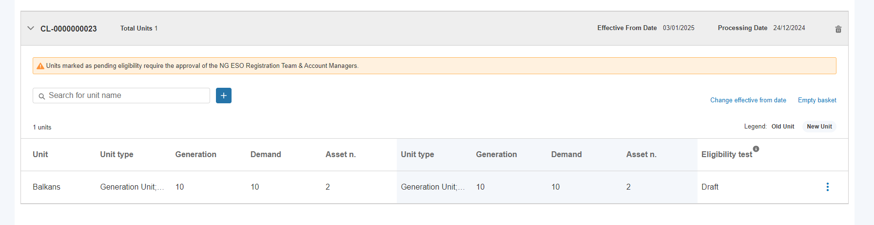

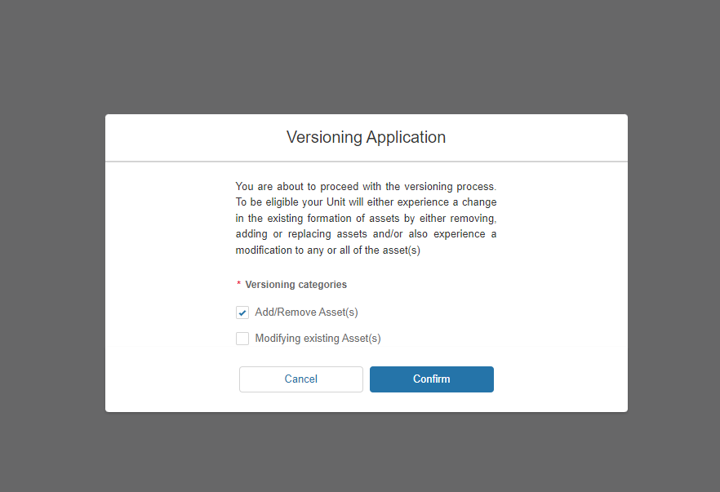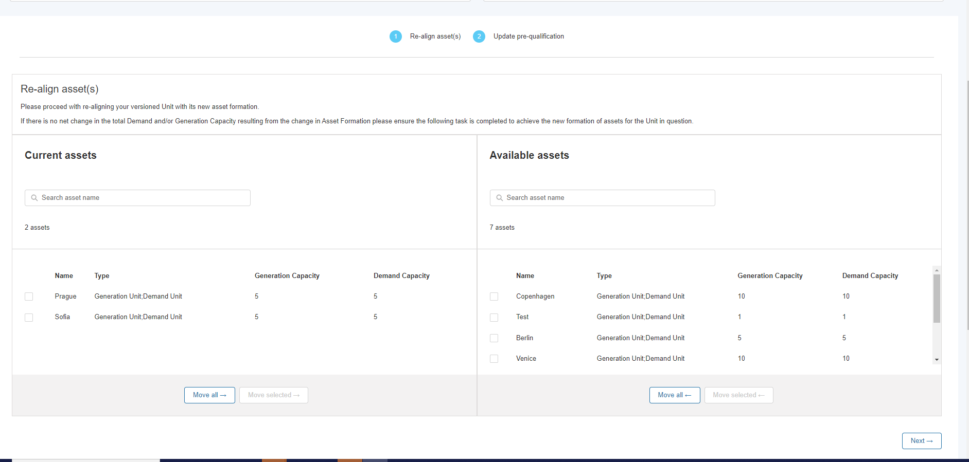

Increase in Capacity (or no net change in Capacity) due to re-alignment or change in composition of asset(s)
Where the Unit’s Total Capacity increases, the eligibility outcome status will change to ‘In Review’ immediately after the Global Versioning Form is completed. It will be routed to the National Energy System Operator Registrations Team to appraise and change the status to Eligible.

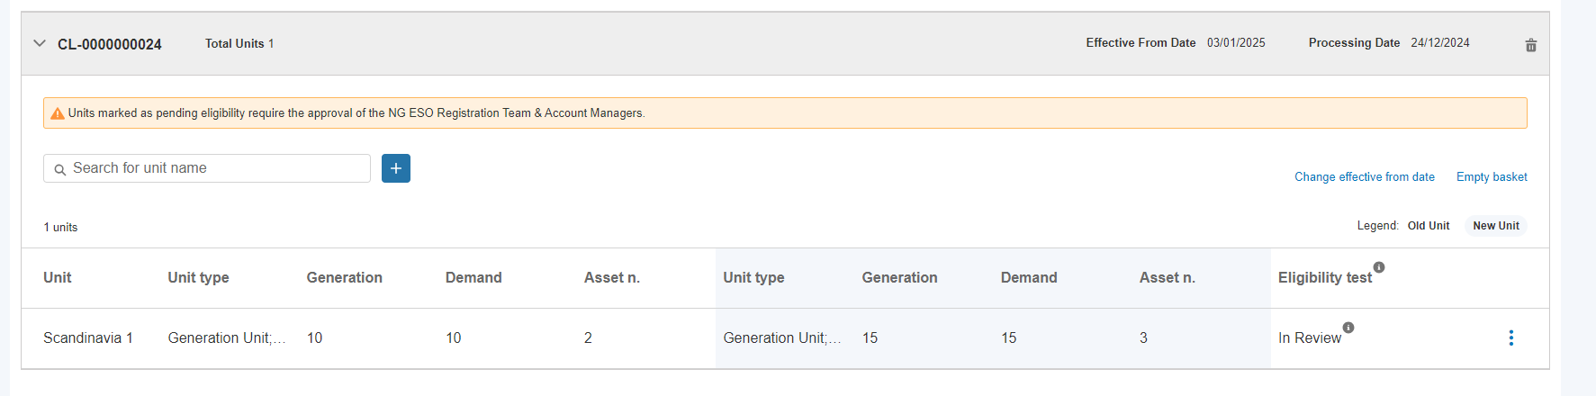

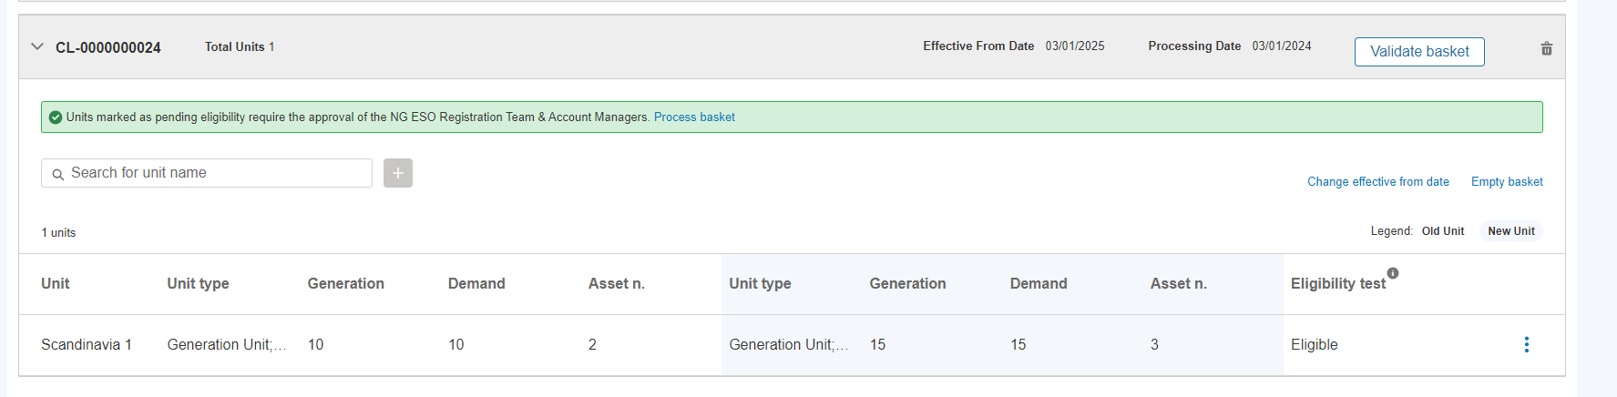

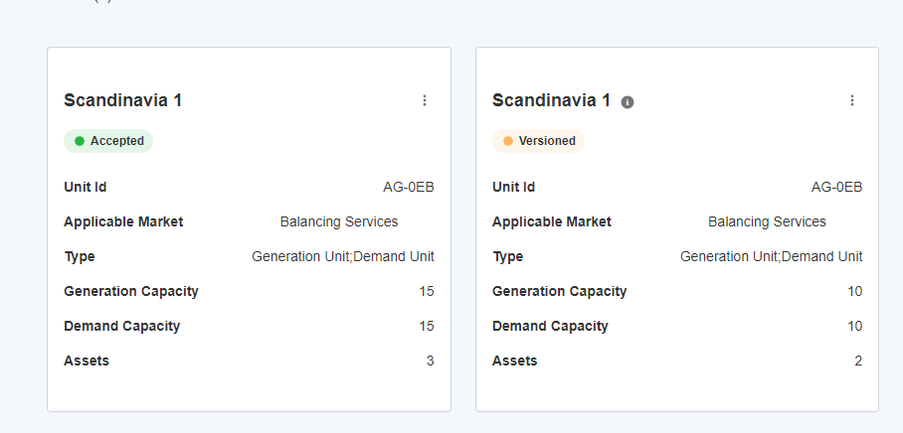

Distinction between Primary and Impacted Units

Primary Units are considered as those which the Market Provider intentionally selects for Global Versioning. Impacted Units are those Units which share at least one common asset that is subject to modification. The Global Versioning Process rules will detect and implicate any connected Units at the point the ‘primary’ Unit’s asset(s) have been modified and at the end of the Global Versioning Application Form completion.
Impacted Units will be ‘pulled’ into the same Global Versioning Basket as the Primary Unit and will require the same approach as the primary Unit in order to allow the Basket to complete processing. This means, that an application form will require completion for every impacted Unit in the same basket.
The application form for Impacted Units has been adjusted however to allow Portal Users the option to indicate the following options;
- No further changes to be added.
- Additional changes required – subsequent changes to the current composition of asset(s)
- Additional changes required – subsequent changes to prequalification section only as a direct result of the modification to the connected asset(s)
An example of listed impacted Units connected to a Primary Unit will display as illustrated below within a given basket.
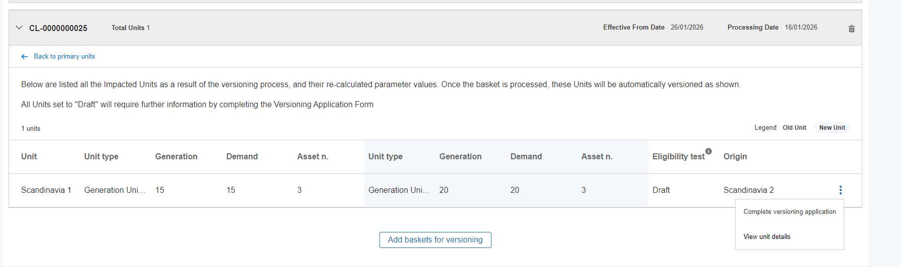
Additional Customised Options for Impacted Units only

Distinction between Primary and Impacted Units

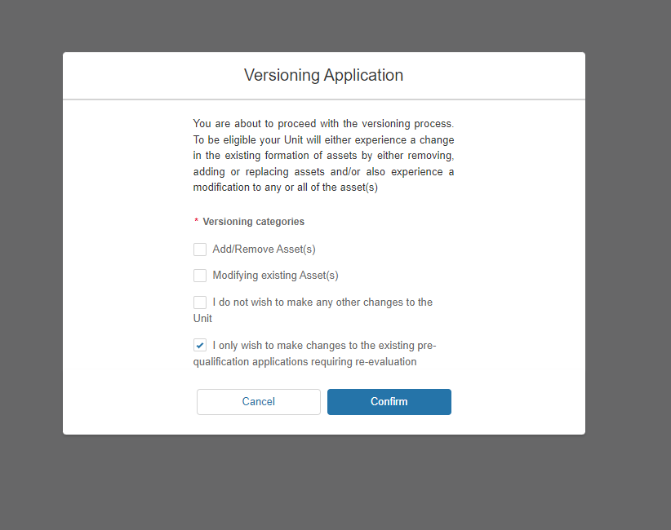

Errors in Processing Global Versioning Requests

Upon submitting Global Versioning Application Forms for every Unit in the Basket and the Validate Basket Custom Button has been selected, there may be occasion for an individual Unit to fail the Validation Tests.
The eligibility test outcome will display as ‘partially eligible’ for such Units, however the National Energy System Operator internal teams will be alerted to the root cause of the Validation Fail and will be expected to investigate and rectify the issue connected to the Unit in question. Once the Validation issue is rectified, the National Energy System Operator internal teams (Contract/Account Managers) will notify the Portal User directly. Following this, the Portal User will be expected to ‘re-select’ the Validate Basket button again, in which instance the expectation is that the Validation Test will pass, enabling the Portal User to continue with the processing of the basket.
Causes behind Validation Test errors can be due to any of the following;
- Issues with or the data collected through the Versioning Application Form
- Issues with poor or missing data on the origin records
- A combination of the two above
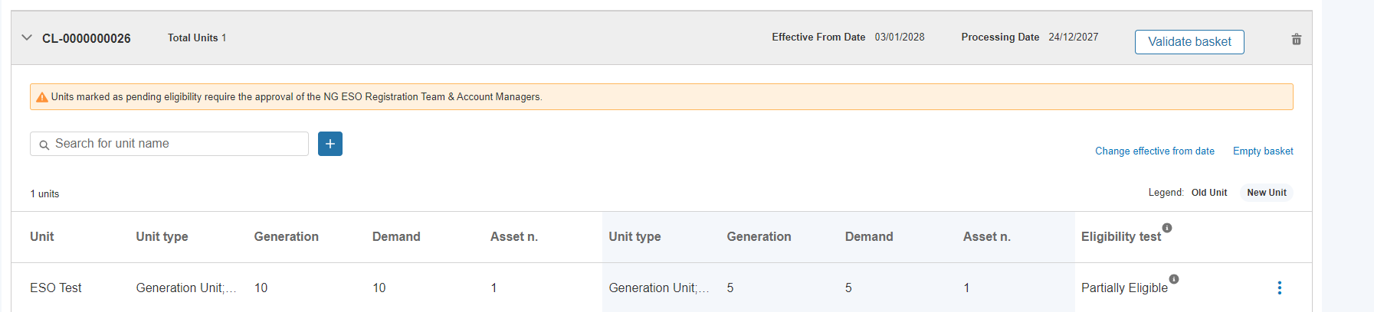

An error message will appear when the ‘I’ icon is hovered over to explain the Status.
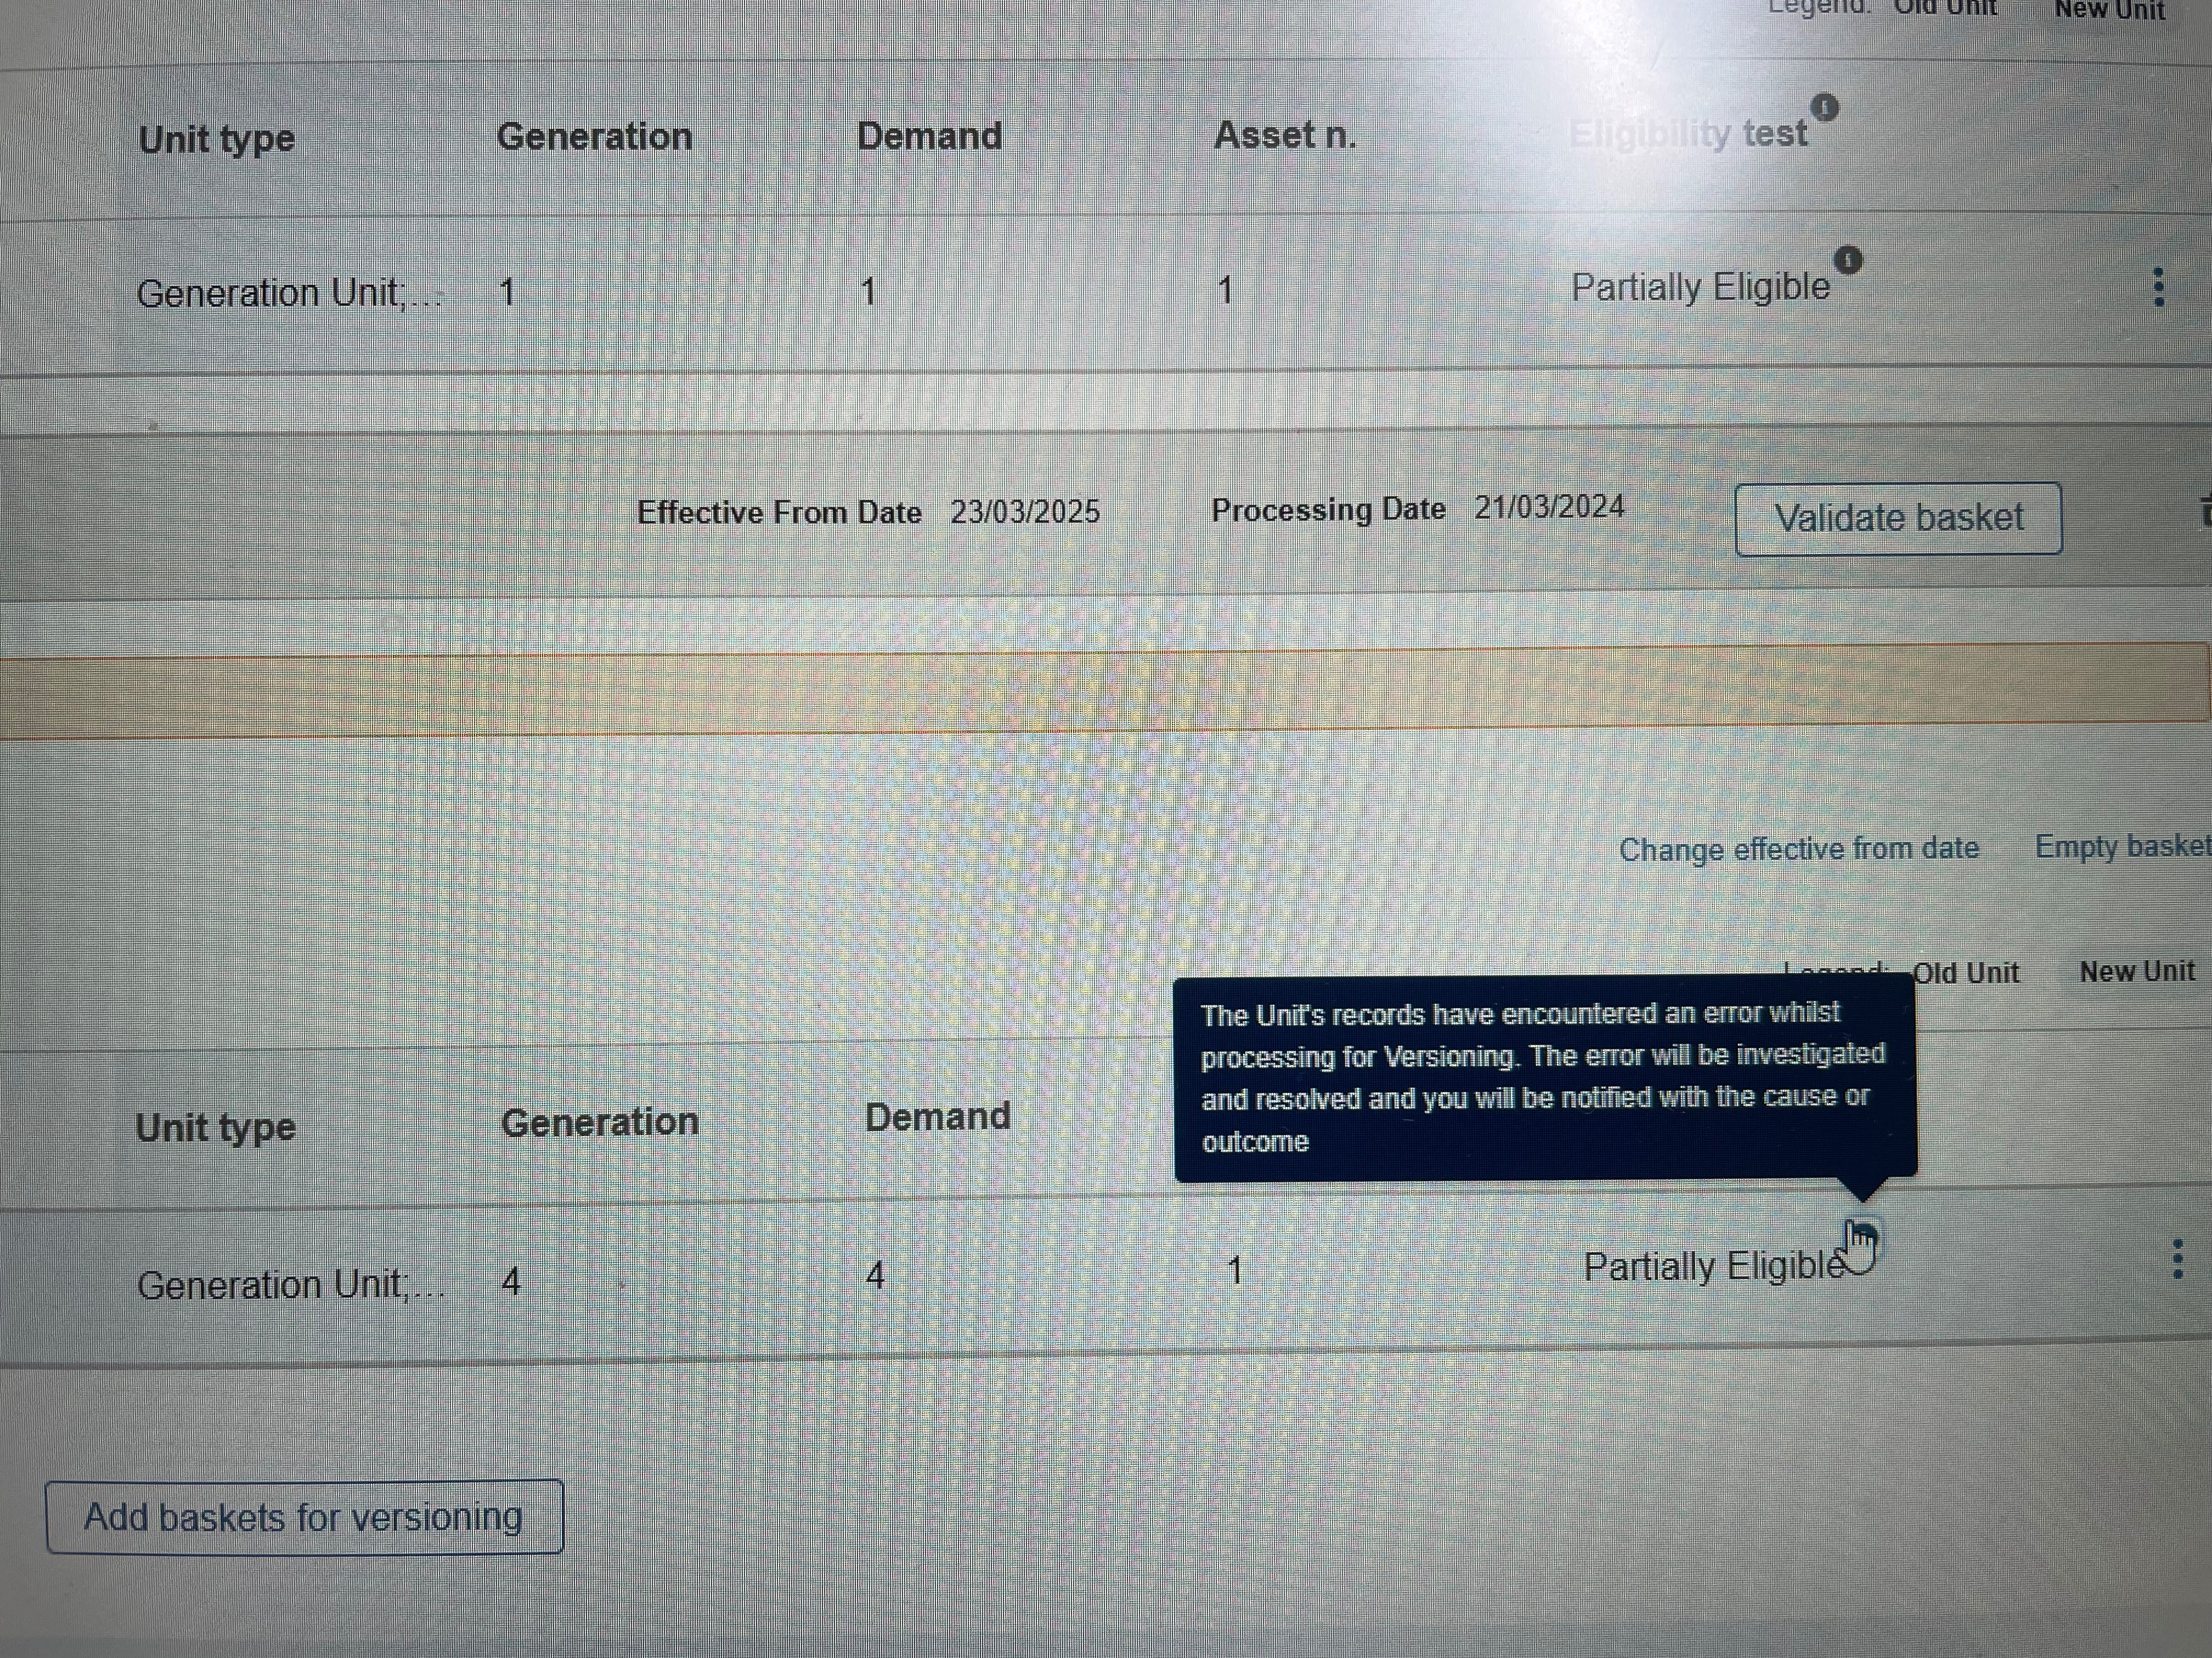

Managing Associated Units that share Assets that have been subject to Global Versioning

Unit Formation
If an asset has been aligned to a Unit in ‘Draft’ or ‘Submitted’ States , where the asset has been subject to Global Versioning it is expected that the Portal User must essentially refresh the Unit’s alignment to factor in the latest incarnation of the Asset that has been versioned.

This may require the Unit to be re-aligned and then re-submitted to the National Energy System Operator Business Unit for appraisal.

Existing Pre-qualifications associated with Assets that have been subject to Global Versioning
If an asset has been aligned to a Unit in ‘Draft’ or ‘Submitted’ States that also has premature prequalification applications (Draft, Incomplete, Signature in Progress) then it is also expected that a new prequalification is applied for to ensure the latest asset version is referenced, and the correct asset testing data is factored in the application.

11.4 Global Versioning Scenarios & Global Versioning Criteria
Evaluation Criteria & Scenario’s for Versioning Types.
Use Case | Example |  | Requires Versioning | Versioning Type | Eligibility Status
My Unit’s total capacity will reduce beyond the current capacity as a result of removing or modifying the capacity on an existing asset(s)  AND  The total capacity will reduce below the Service Minimum Threshold for the Service(s) for ALL OR ANY it has been pre-qualified for already | Capacity on Version 1.0 | 20 MW | Yes | Unit: Automated  Prequalification: Automated | Eligible  (Unit = Accepted)  (Prequalification = Rejected)
 | Allocated Volume for DC HF | 10 MW | Yes | Unit: Automated  Prequalification: Automated | Eligible  (Unit = Accepted)  (Prequalification = Rejected)
 | Allocated Volume for DC LF | 15 MW | Yes | Unit: Automated  Prequalification: Automated | Eligible  (Unit = Accepted)  (Prequalification = Rejected)
 | Capacity Version 2.0 | 10 MW | Yes | Unit: Automated  Prequalification: Automated | Eligible  (Unit = Accepted)  (Prequalification = Rejected)
Service Minimum Threshold (SMT)

DC HF (8 MW)
DC LF (8 MW)
Use Case | Example |  | Requires Versioning | Versioning Type | Eligibility Status
My Unit’s total capacity will reduce beyond the current capacity as a result of removing or modifying the capacity on an existing asset(s)  BUT  The total capacity will remain above the Service Minimum Threshold for the Service(s) for ALL OR ANY it has been pre-qualified for already | Capacity on Version 1.0 | 50 MW | Yes | Unit: Automated  Prequalification: Automated | Eligible  (Unit = Accepted)  (Prequalification = Approved)
 | Allocated Volume for DC HF | 10 MW | Yes | Unit: Automated  Prequalification: Automated | Eligible  (Unit = Accepted)  (Prequalification = Approved)
 | Allocated Volume for DC LF | 15 MW | Yes | Unit: Automated  Prequalification: Automated | Eligible  (Unit = Accepted)  (Prequalification = Approved)
 | Capacity Version 2.0 | 20 MW | Yes | Unit: Automated  Prequalification: Automated | Eligible  (Unit = Accepted)  (Prequalification = Approved)
Service Minimum Threshold (SMT)

DC HF (10 MW)
DC LF (10 MW)
Use Case | Example |  | Requires Versioning | Versioning Type | Eligibility Status
My Unit’s total capacity will increase beyond the current capacity as a result of adding or modifying the capacity on an existing asset(s)  AND  The total capacity will increase above the Service Minimum Threshold for the Service(s) for ALL OR ANY it has been pre-qualified for already | Capacity on Version 1.0 | 20 MW | Yes | Unit: Manual Versioning required.  Prequalification: Automated Approval. | In Review  (Unit = In Review)  (Prequalification = Approved)
 | Allocated Volume for DC HF | 10 MW | Yes |  | In Review  (Unit = In Review)  (Prequalification = Approved)
 | Allocated Volume for DC LF | 15 MW | Yes |  | In Review  (Unit = In Review)  (Prequalification = Approved)
 | Capacity Version 2.0 | 30 MW | Yes |  | In Review  (Unit = In Review)  (Prequalification = Approved)
Service Minimum Threshold (SMT)

DC HF (10 MW)
DC LF (10 MW)

Global Versioning: ‘Benching’ a Unit

‘Benching a Unit’
As of Release 3.7, a new dimension to Global Versioning has been introduced, resulting from feedback from Market Providers.
In a nutshell, an existing Unit in Accepted State where required can have all of the existing asset(s) removed from the logical grouping, in effect, all asset(s) are ‘de-aligned’ leaving an ‘empty’ Unit to continue to exist. For the purpose of this guide, this concept is referred to as ‘Benching’ a Unit.

Primary Use Case for Benching
A Unit should be considered for benching where it has at least one or more asset(s) aligned and the Unit Owner wishes to dismantle the logical grouping of the Unit and remove the asset(s) but without having to pursue complete de-registration of the Unit. In effect, the Unit will remain ‘alive’ and crucially retain the original ‘properties’/credentials secured as part of the registration process, namely it’s BMU NON BMU ID.
Benching has been introduced parallel to the new feature updates for Related Entity Agreements, so as to ensure that where an agreement is due to expire or end prematurely, any aligned asset(s) can be removed from the Unit’s logical grouping without incurring any impediments to the ‘’release’’ of the asset(s) in question.
As of Release 3.7 Units can remain in a ‘benched’ state of existence (where they are indefinitely void of any aligned asset(s) however this is subject to approval of the NESO Contract Management Team)

Pre-requisite conditions for Benching
A Unit can only be subject to Benching if it meets the following conditions;
- It has already completed the original registration & alignment exercise and has been classified as ‘Accepted’
- It will have an effective from date in the past (therefore it is a ‘live’ Unit)
- It must have at least one or more asset(s) aligned
- It may or may not possess existing pre-qualification applications, but where it does those existing pre-qualification applications must be in approved state

Why is benching required as part of Global Versioning?
Where Unit(s) that potentially qualify for Benching have already been appraised by the NESO Registrations Team, any modifications to the Unit which may result in the benching outcome - are considered changes that will need to be subject to the Global Versioning Process to evaluate the impact of removing the asset(s) in question to the Unit and any associated Pre-qualification applications.

Additional considerations for ‘Benched’ Units
The standard Global Versioning steps must be taken to Bench a Unit as follows with a slight variation;
- The Basket must be created, a new Effective from Date to be set (this is the date that the new benched Unit will take effect)
- The Unit is added to the basket, and an application form is completed for the Unit to enable the removal of the asset(s) – the ‘alignment’ step.
- When the User is prompted for the latest allocated volume for the affected prequalification applications, then the value must be set as 0.01 MW in order to complete the GV exercise. (** this will be rectified in an upcoming release to preclude the need for prequalification updates on such Units)
- If any impacted Units that share a singular common asset are automatically added to the Basket and these Units will also result in 0 Asset(s) being logically grouped, then the same steps must be enacted in order to ensure these Units are Benched moving forward.

Existing Prequalification applications affiliated to a Benched Units
The key difference is that any Units that are classified as Benched, will in effect have their existing prequalification applications curtailed as of the new Effective From Date. The SMP system will ‘archive’ the original applications and adjust their service end date to ‘Day – 1’ of the new Benched Unit’s Effective From Date.

Benched Units & EAC Auction Participation
As with any Unit’s that are subject to Global Versioning, the existing Version (current state) must have Globally Versioned completed by the standard cut off date which is a minimum of 2 days before the Effective End Date of that Version’s lifecycle in order to avoid disruption to the Auctioning capability. Where the latest Version of the Unit has associated new & eligible prequalification applications, the earliest opportunity for performing trades with the Unit will be the new Effective From Date.

Re-activating a Benched Unit
Where a Unit is considered for ‘re-activation’ – therefore in a position to be re-aligned with one or more asset(s), it is permissible to do this but adopting the same Global Versioning Steps for a new iteration. It is recommended liaising with your NESO Contract Manager to discuss the possibility of re-activation and ensure sufficient lead in time is allowed for.

10.8 Global Versioning Email Alerts

A series of Email Alerts are sent to all Portal Users for a given Market Provider that share the Unit Manager & Related Entity Role, even where Global Versioning is initiated by a particular Portal User.

Enclosed are example templates;

At the point that the Provider is expected to commit to the final changes and authorise process completion for Global Versioning to conclude.

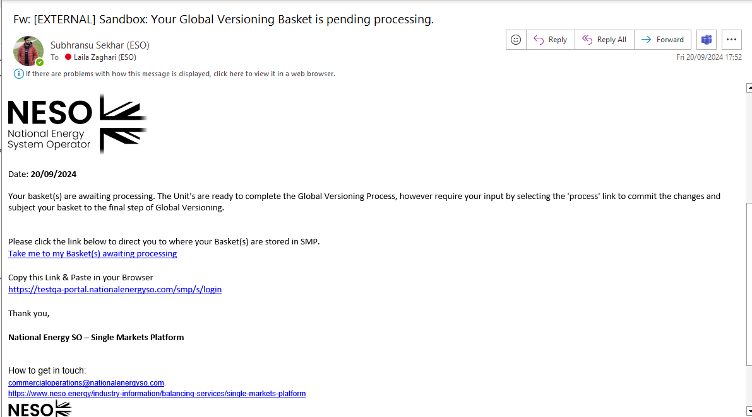

Global Versioning Email Alerts

At the point that the Provider is notified that an existing Prequalification Application is no longer eligible to continue

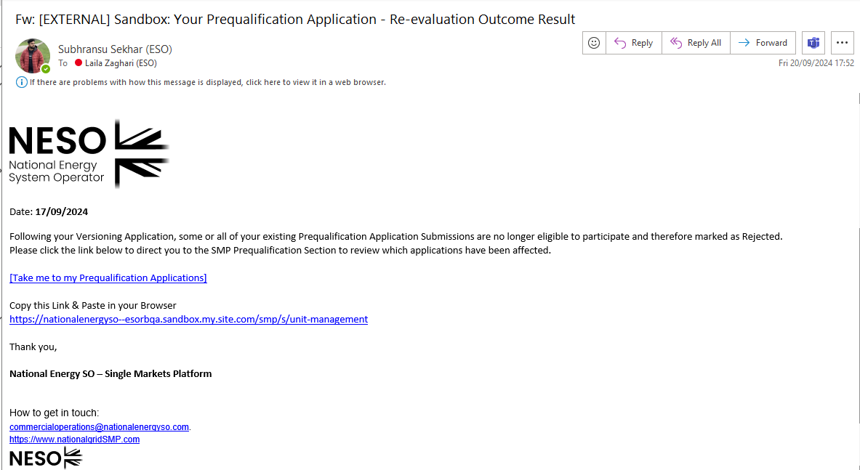

Global Versioning Email Alerts

At the point that the Provider is notified that an existing Prequalification Application is eligible to continue

User Management

User Management Role Approach

This functionality facilitates an end-to-end self-service capability for users to manage access and permissions across their organisation on the SMP Portal. With the advent of the Single Sign-On Functionality in effect as of Release 2.8, all secondary or additional users for the same Market Provider (Account) will be required to complete the standard registration process akin to first time user registration in order to allow them to acquire their SSO login credentials.

All or any prospective secondary or additional users for the same Account (Market Provider) will still require ‘authorisation’ from their respective Super User in order to be added to the Account in question. The only pre-requisite is that an Active Super User is assigned to the Account in question prior so they are in a position to receive registration requests from prospective users which will be routed to them upon logging into SMP. This chapter will cover the steps required to authorise registration requests as a Super User.

The existing User Role Framework will remain in place and once Secondary/Additional Users have completed registration, their Super User will remain able to take advantage of the User Management Functionality.

User Management Role Framework

User Group Roles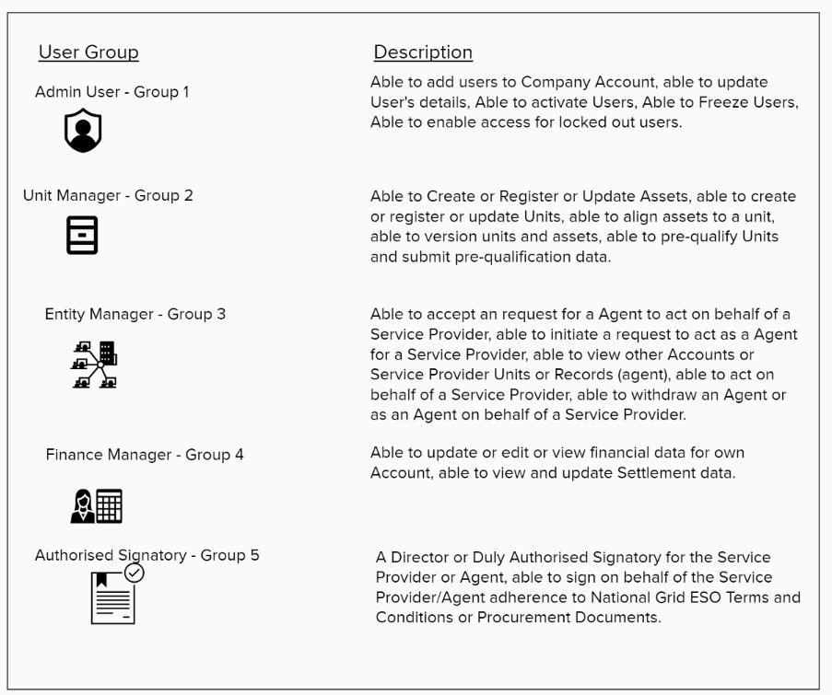

Super Users & Secondary User Registration Approvals

In order to provide an organisation with agency to apply and manage the roles listed in the table overleaf, an overarching role entitled ‘Super User’ has also been created. As of Release 2.8 the key feature of the Super User Role is to enable them to specifically appraise inbound registration requests generated from the National Energy System Operator Website in order to complete the registration process and allow access to the SMP Portal by extension.

As of Release 2.8 only one Super User Role will continue to be allocated for each company or organisation. Where a company or organisation has multiple users currently registered, a single user should be nominated for the Super User Role to manage the other existing users.

As of Release 2.8 the Super User Role has now been combined with the previous User Admin Role. The Super User will be able to fulfil both tasks of authorising registration requests and managing the suite of User Roles.

The Super User role is exclusively assigned and managed by the Contracts Management Team in line with Business Rules.

User Role Business Rules

The User Management approach has been designed to allow for flexibility and agility in what level of access and visibility to functionality on the portal are granted, recognising that this may evolve or change over the user’s lifetime. With this in mind these are currently the business rules;

- As of Release 2.8, the default Role assigned to every active User universally at the point registration is complete and they have been allocated their SSO credentials allowing them access to SMP is the Unit Manager Role.
- Super Users can elect to supplement this Unit Manager Role with additional roles; however the default role will remain. This will also apply to the Role entitled ‘Authorised Signatory’. This will be restored in the next Release, allowing Users to be assigned the Authorised Signatory exclusively if so required.
- Roles are not mutually exclusive: A user can be assigned more than one role at any time with the exception of the Super User Role which is allocated from the outset and by the Contract’s Management Team. For example a secondary user can be assigned a combination of ‘Unit Manager’ and ‘Related Entity Manager’ role. Moreover, provision has also been made for the same User to be assigned an Authorised Signatory Role and remain a Unit Manager. As of Release 2.8 due to a restriction, A User cannot be allocated exclusively an Authorised Signatory Role both at the point of registration and thereafter. This will be remedied in an upcoming Release.
- A Super User can also assign themselves all other roles if they so wish.
Roles can be assigned or de-assigned at any point in time by the Super User on behalf of other secondary users. For example if a secondary user was assigned the ‘Related Entity Manager Role’ initially, then it can be withdrawn at a later stage.

User Role Business Rules – cont
De-activation of User’s Access to SMP Portal: As of Release 2.8, Super User’s remain exclusively under the control and management of the Account/Contract Management Team, therefore their Super User Role can only be revoked by the team in question. Secondary Users however can now be de-activated from accessing the SMP Portal by their respective Super User.
- In the instance of a Super User no longer requiring access to the SMP Portal or wishing to re-assign their Super User status to another User, it is imperative that the user in question contacts their respective Account Manager to action this request.
- As of Release 2.8, it is now imperative that any SMP Portal Accounts with at least one active User must have a Super User Role assigned. This will ensure that any prospective secondary or additional users wishing to register and gain access to the same Account will be able to take advantage of the registration process in its entirety.
- Where an SMP Portal Account has only one active User assigned and they are the designated Super User, if the Super User is not replaced and there are no other active Portal Users associated with that Account, then it is within the remit of the Contracts or Account Management Team to remove access to SMP for the User(s) in question and/or remove their Super User Role for the purposes of Data Protection and Compliance.
- Designated Authorised Signatories will remain able to be selected on prequalification applications in order to take advantage of the digital signature capability on behalf of your company/organisation. However, the User’s in question must be assigned the Authorised Signatory Role prior. This will be a one-off exercise, once set up they will be in a position to access the digital signature capability for all future prequalification applications.
- New Roles can be onboarded for use on the SMP Portal with future Releases, and therefore the current portfolio of User Roles are not restricted.
- Each Company/Organisation is allocated a universal quota of five capped User Licences, to increase this allowance, then the Market Provider must approach their Contract/Account Manager directly.

The following sections will address the methodology to allocating User Roles on the SMP Portal for Release 2.8

Approval of Secondary User Registration Requests by the Super User

As a Super User, all future or prospective Secondary Users associated with the same Company/Account (on the basis of an identical Company Registration Number and Company Name) will automatically be routed to the designated Super User for the Account (Company) in question. Moreover, an automated Email Notification will be issued and sent to the Super User to alert them to each prospective secondary user pending their approval.
- As the Super User, you will login into the SMP Portal using the standard SSO procedure.
- You will be transported to the SMP Portal, where you can then navigate to the User Tab to access the User Management Functionality.
- A new tab has been added entitled ‘Registration Requests’ where all prospective registration requests are routed and will be displayed as an itemised ‘list view’.
- As the Super User, you will be able to either opt to ‘Accept’ or ‘Decline’ the Registration Request.
- A pop up notification will appear offering you the opportunity to confirm your decision to Accept or Decline accordingly.
- If you select ‘Accept’ an Email Notification will be generated to the User in question to acknowledge confirmation and equally If you select ‘ Decline’ an Email Notification will be generated to the User in question to acknowledge rejection of the request.
- Finally, accepted requests are transferred to the ‘Active Users’ Tab and ‘Declined’ request are transferred to the ‘Inactive’ Users Tab accordingly. The Requests should disappear from the ‘Registration Requests’ Tab as itemised listings.

Approval of Secondary User Registration Requests by the Super User

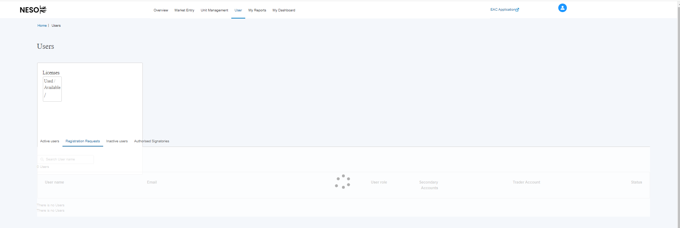

Approval of Secondary User Registration Requests by the Super User – Acknowledgement Screens

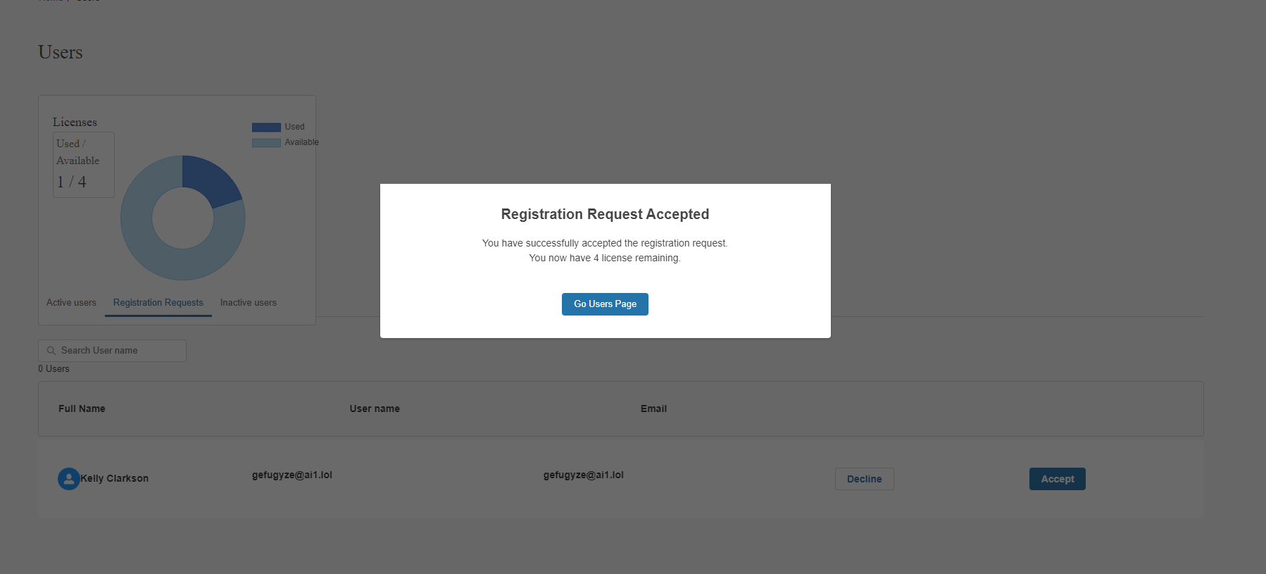
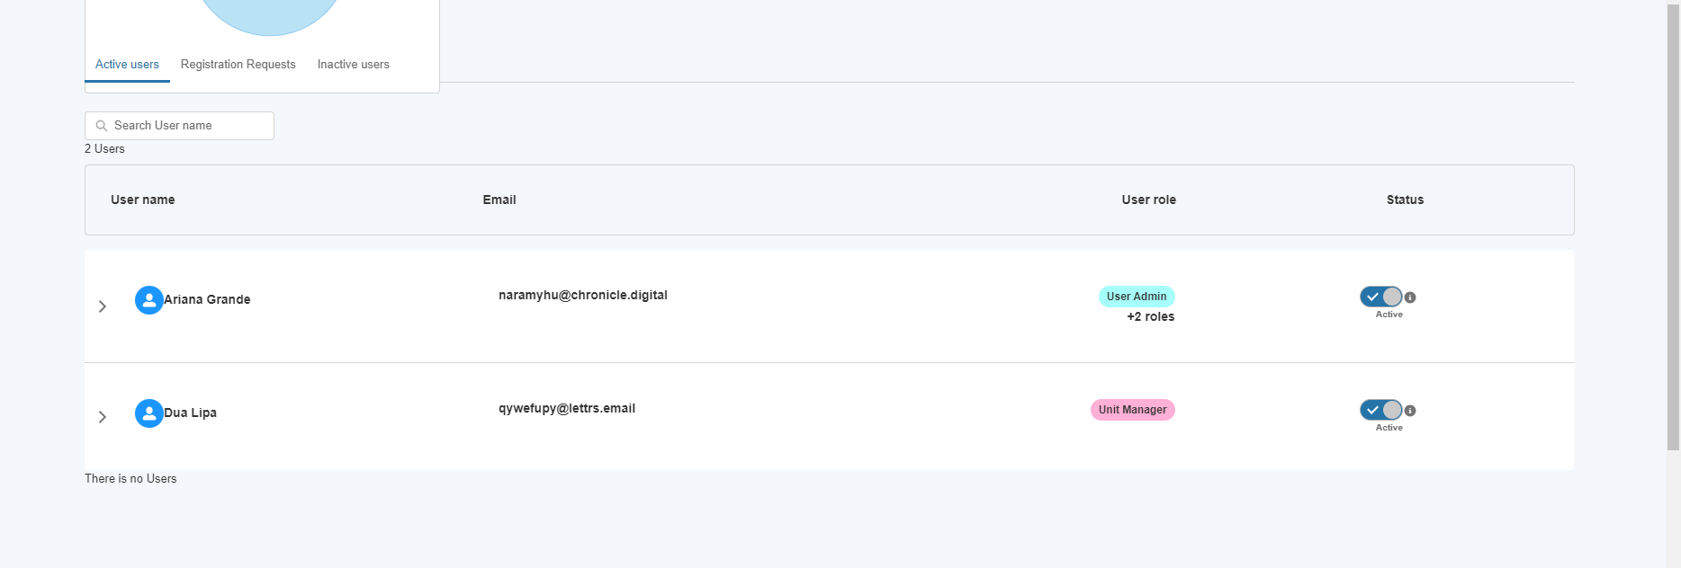
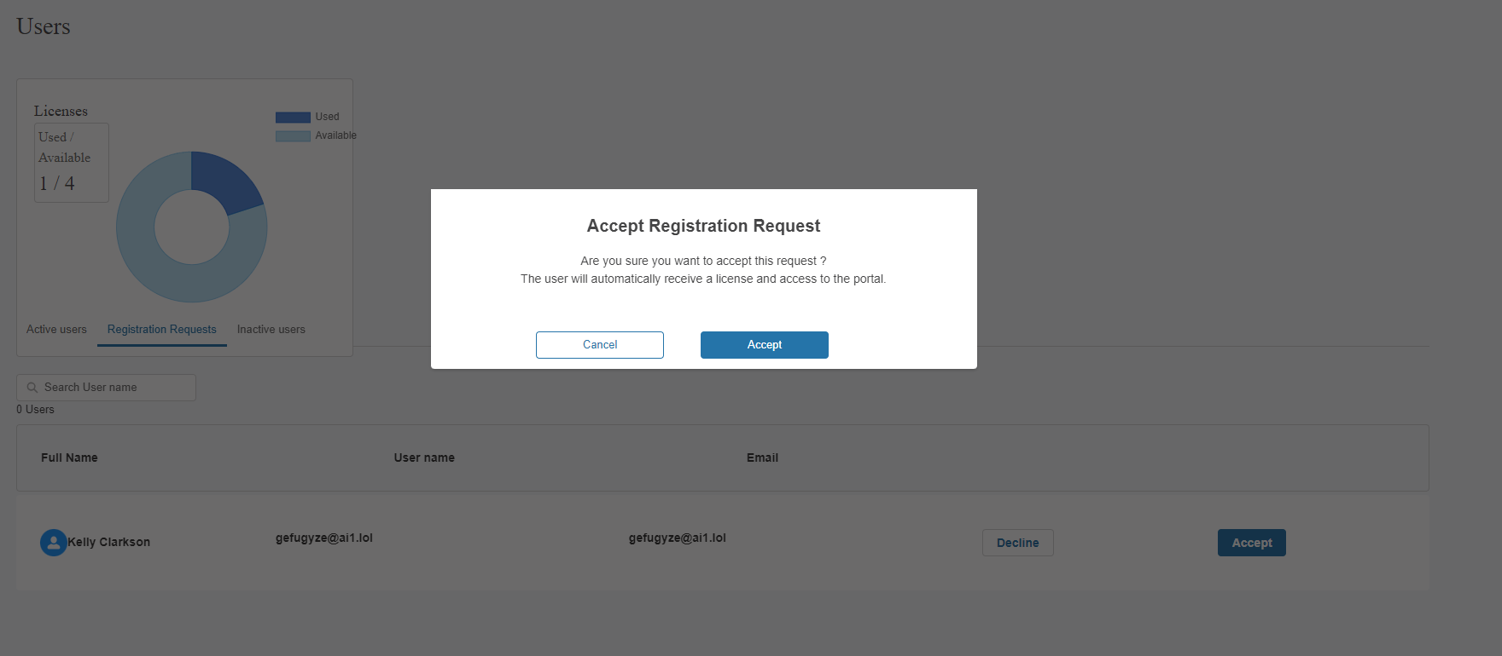

Approval of Secondary User Registration Requests by the Super User- Email Alerts
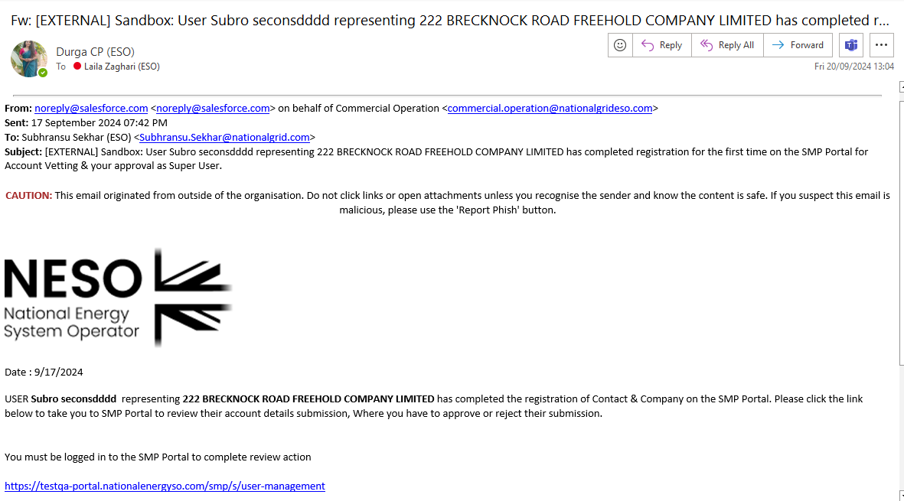

Approval of Secondary User Registration Requests by the Super User- Email Alerts
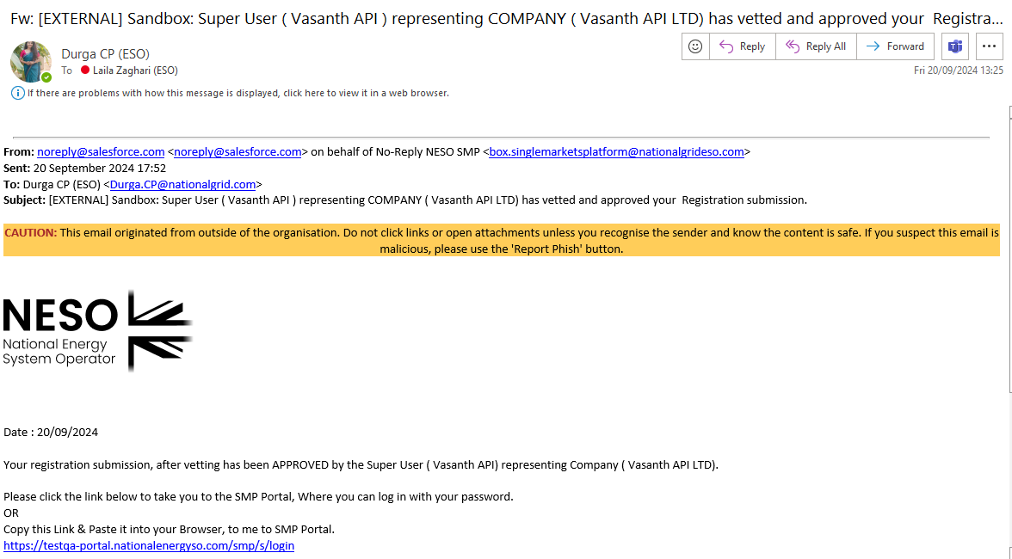

Rejection of Secondary User Registration Requests by the Super User- Email Alerts
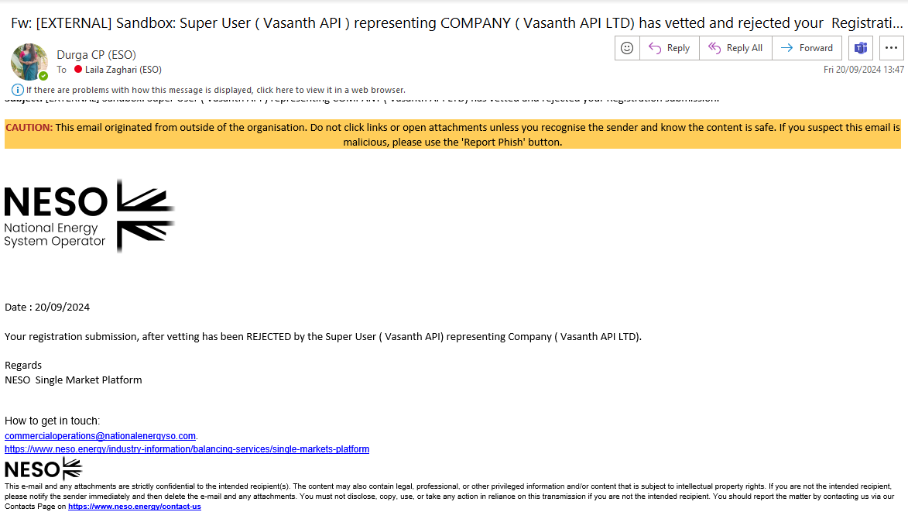

Onboarding Users to the EAC Platform

In order for any SMP Portal (Active) Users to gain access to the EAC Platform it is mandatory they are assigned the Trader Role by their respective Super User.
- To do this, the Super User will assume the usual steps for assigning new roles to Active Users with the only exception being they ensure they add they select the Trader Role.

- When the User is assigned the Trader Role, it will appear under their ‘profile’ under their respective listing on the Active Users Tab.

- Upon next logging on the User will be able to view the EAC Application Tab on the top right hand side of the SMP Portal Home Page/Screen. Upon clicking on this, they will automatically be re-directed to the EAC Platform without the need to login again.

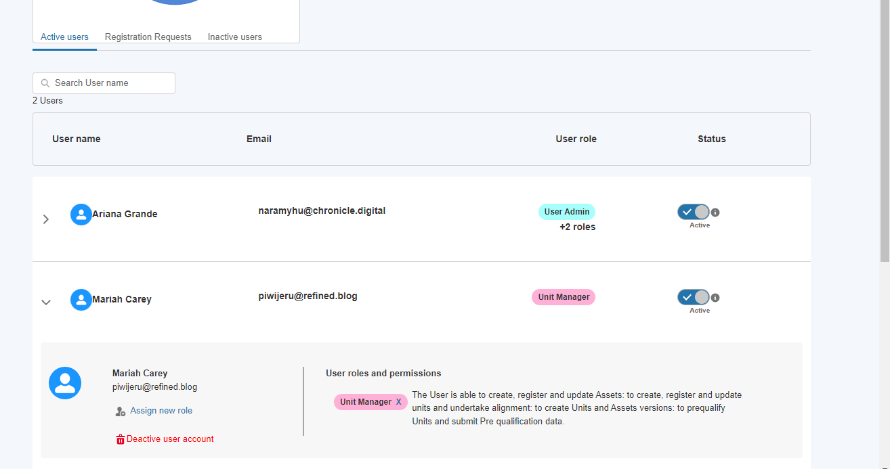

Assigning the Trader Role

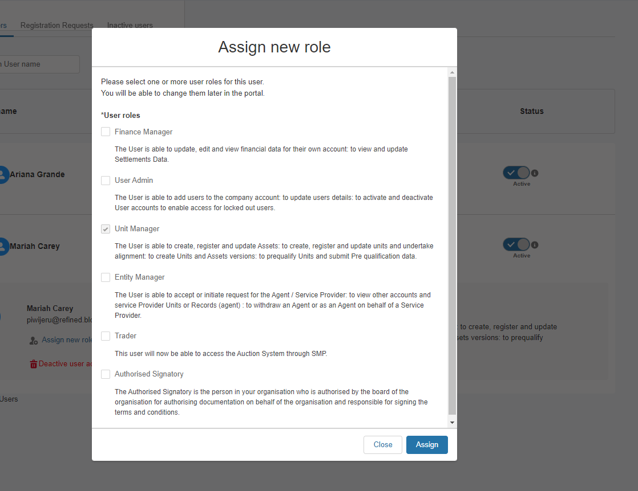

Restrictions on Users with exclusively Trader Role

Following feedback from Market Providers the Trader Role has been adapted to allow Users with exclusively this role to view the Unit and Asset Portfolio without the ability to make changes or manage the Unit and Asset Portfolio and pre-qualifications. If Users wish to be able to do both, then they will require the Unit Manager AND the Trader Role assigned.

Visibility of the Trader Role on the SMP Portal

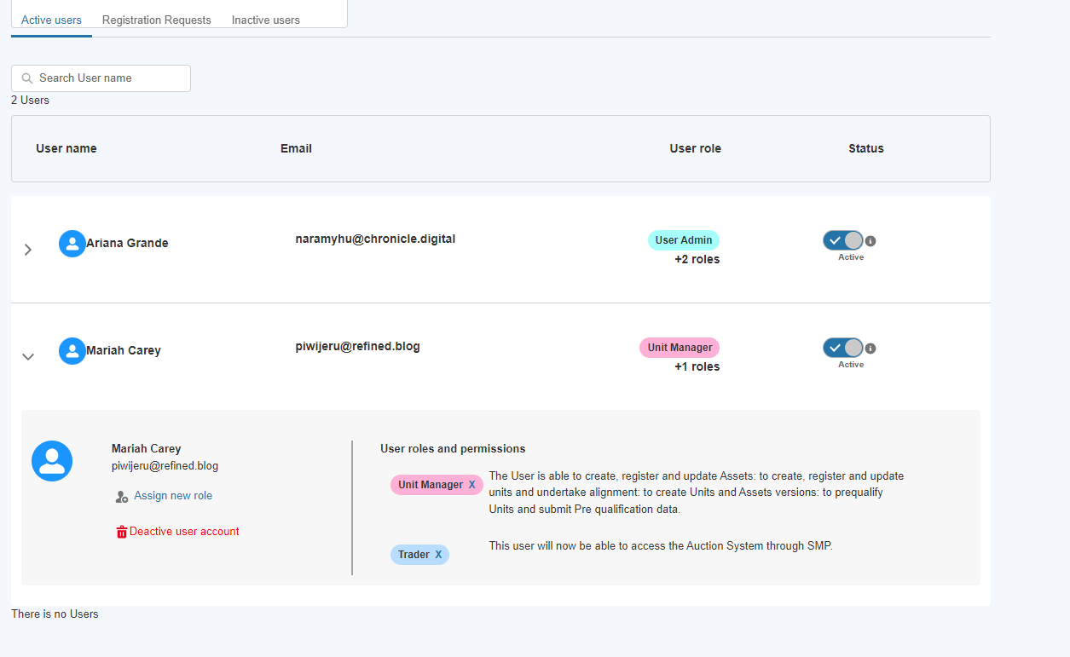

Visibility of the EAC ‘hyperlink’ on SMP for Trader Role Users

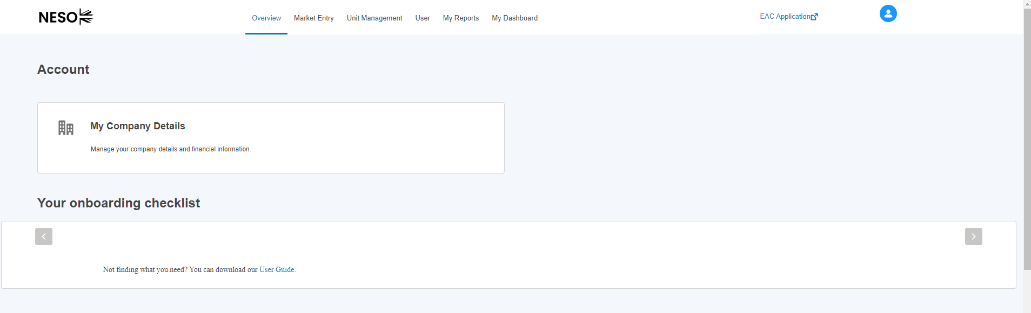

Managing Registered Secondary Users (Active)

- Once the new secondary user is approved – they will be instantly added to the ‘Active’ Users tab as an itemised User. This will mark the end of the registration process following the SSO verification and authentication pre-requisite steps that take place prior to the secondary user registration request being routed to the Super User. Conversely, if the secondary user is rejected, then they will ‘shift’ to the inactive Users Tab.
- In the example below, Jessica Simpson’s will present as an itemised line with a summary view, to look at her ‘profile’ in more detail, the user can select the drop down arrow adjacent to her name. A collapsible section will appear with her profile’s details including the User roles assigned under the User and permissions sub-section.
- The Active toggle button is for read-only purposes. As of Release 2.8, Users with the Super User Role continue not to be able to de-activate secondary users directly using this functionality.

Adding additional roles to Secondary Users (Active)
Assign new Role Screens
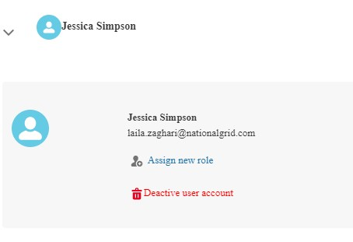
- To add additional roles to an existing User’s ‘Profile’, a User Admin Role based User must select the Assign new role option as illustrated in Figure 11.5
- The Assign new Role screen will appear prompting the User to select from the list the additional supplementary roles to add to the user’s profile. The existing Roles already allocated will appear as checked. Once complete, select Assign.
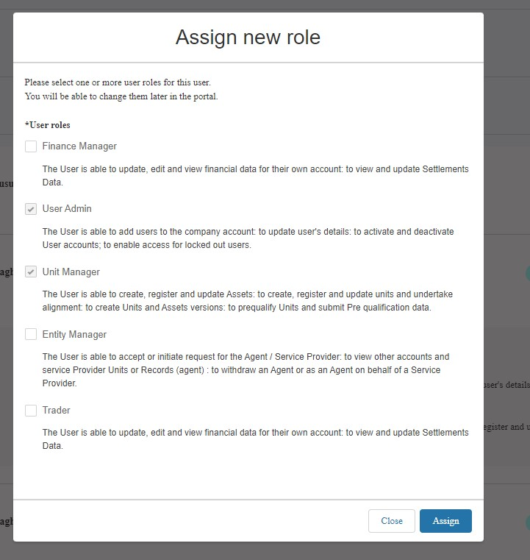

Adding Authorised Signatory

In order to leverage the Digital Signature functionality, the Authorised Signatory must be registered by the Super User/User Admin in advance of the pre-qualification process being started.

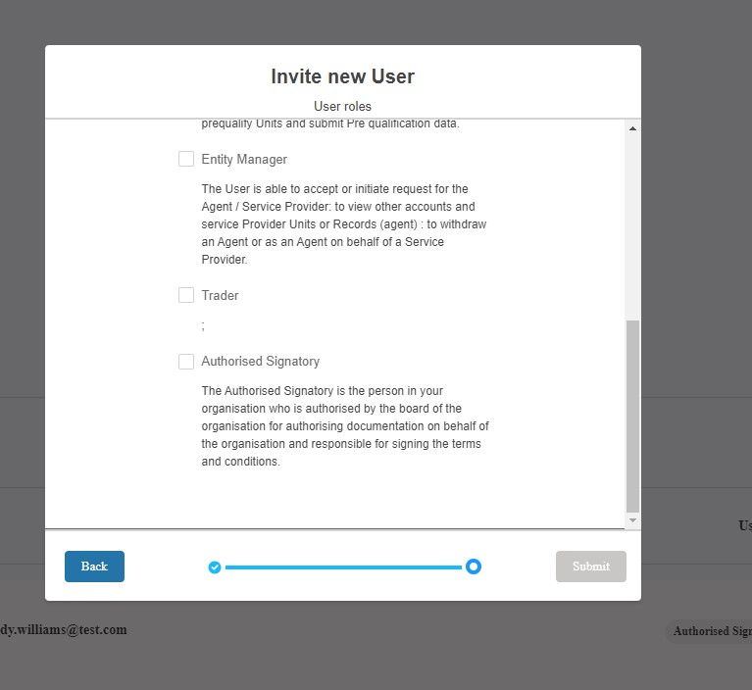

Removing existing role(s) from Secondary Users (Active)

Unassign existing Role(s) Screens
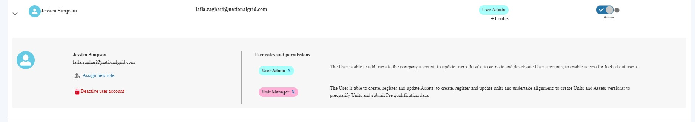

- To remove an existing role from the user’s profile, navigate to the Role name under the User role and permissions subsection and press the ‘X’ adjacent to the role name as highlighted in the figure above. This task will have to be repeated for each individual role. In the example above, the ‘X’ will require removing two fold, once for the ‘User Admin’ and once for ‘Unit Manager’.
- A pop-up notification will appear promptly reminding the portal user to confirm they wish to remove the user role. To proceed select ‘Confirm’, to abort select ‘Close’.
- In order to swap, exchange or switch roles, the methodology of removing and then adding roles to a user’s profile is the only way to enable this.

Unassign existing Role(s) Screens
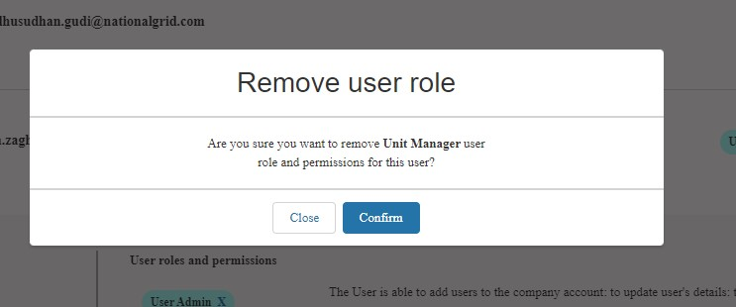

- If the User Admin Role experiences any errors or difficulties whilst using the User Management functionality, they should reach out the Contracts Management Team in the first instance by email.

Removing existing role(s) from Secondary Users (Active)

- As of Release 2.8, all existing Users can have all roles un-assigned with the exception of the Unit Manager Role.

Deactivating Secondary Users
- As of Release 2.8, Portal Users who have been assigned the ‘Super User Role’ have the ability to deactivate Secondary Users, so that they can no longer access SMP. The reason for this feature is to take ownership of restricting secondary users access in the event it is no longer required.
- Please note that de-activation from the SMP Portal does not mean de-activation of their User Account on the National Energy System Operator Website. They will still retain their SSO credentials, they will simply no longer be able to login into SMP. Equally if the User also has access to the Connections Portal, their access will resume.
- To deactivate a Secondary User account, Super Users should log into the SMP Portal and navigate to the ‘User’ tab at the top of the screen. They should then locate the name of the user they wish to deactivate and click the arrow to expand the section.
- When section has expanded, there will be a link to ‘Deactivate User Account’. After clicking this link, a green confirmation banner will appear at the top of the screen to indicate that the user has been successfully deactivated. An email will be sent automatically to the deactivated user’s email address to inform the user that their account has been deactivated and that they can no longer access the SMP Portal.
- This deactivated user can now be found in the list of Inactive Users. A Super User can reactivate the deactivated user, by clicking on the arrow next to the name to expand the section.

Deactivating Secondary Users – User’s Switching from Active List to In-active List

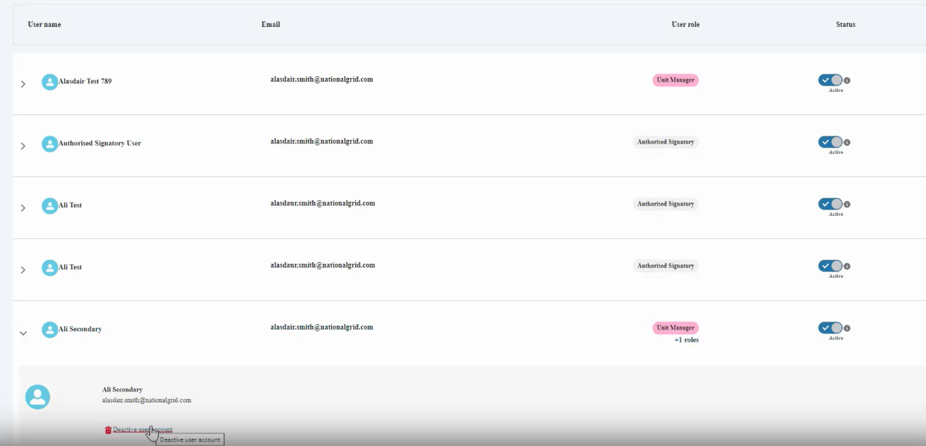

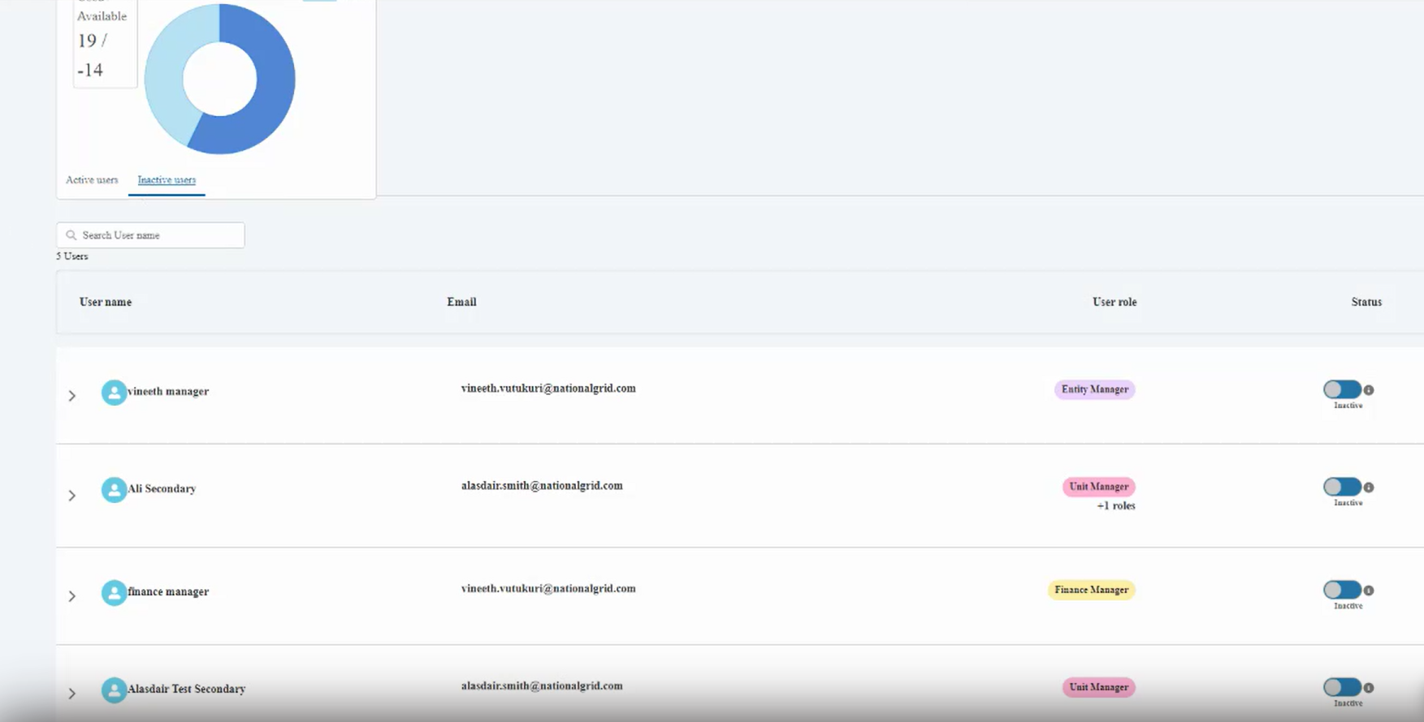

Deactivating Super Users

- As of Release 2.8, Super Users have the ability to request the deactivation of their own account if they are no longer the designated Super User or they no longer require access to SMP. Please note that as only One Super User can be allocated per Account (Company/Organisation) it is imperative that an alternative Super User is identified and assigned the Role to ensure that the Provider is in a position to continue managing their secondary users. To set up an alternative Super User, then person in question must approach their Contract Manager.
- To deactivate their account, Super Users should log into the SMP Portal and navigate to the ‘User’ tab at the top of the screen. They should then locate their name in the list of users and click the arrow to expand the section.
- When section has expanded, there will be a link to ‘Deactivate User Account’. After clicking this link, a pop-up message will be displayed, asking the User to confirm the request to the Contracts Team.
- After clicking ‘Send Request’, a green confirmation banner will appear at the top of the screen to indicate that an email has been sent to the National Energy System Operator Contacts Team. After the Contracts Team has processed the request, the user will no longer be able to access SMP.

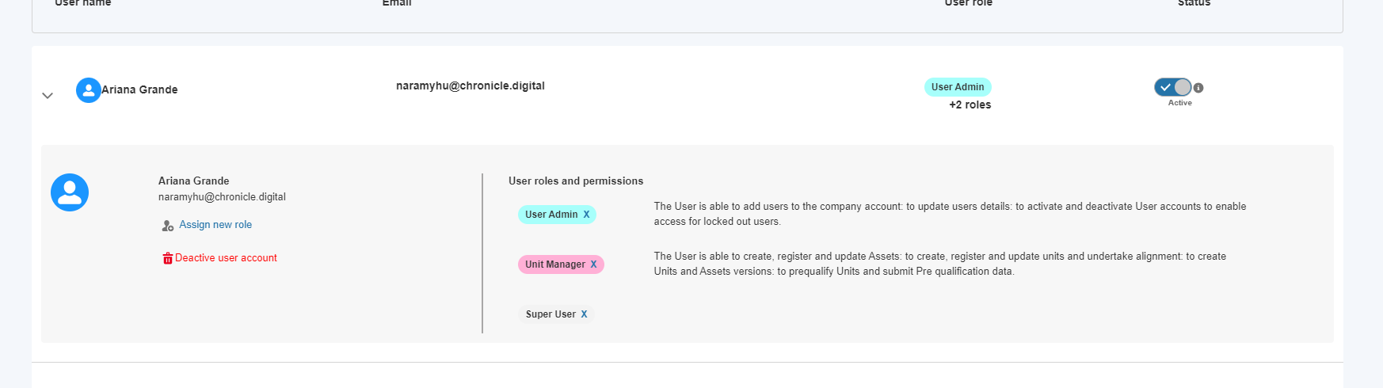

Deactivating Super Users – Request Notification

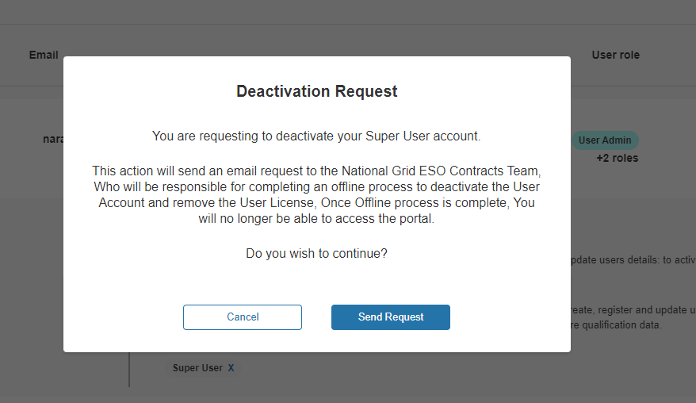

Related Entity: Establishing an Agreement & Delegation of Asset(s)

Definition of Related Entity
For the purposes of SMP, a Related Entity is defined as a Service Provider who has entered into a contractual relationship with an Agent to represent the Asset or Assets owned by said Service Provider. In this respect, the Unit will be owned by the Agent and the Assets making up the logical grouping or aggregation will be owned by either a singular Service Provider or a number of Service Providers.
The SMP Portal’s role is to enable Market Providers threefold;

- The ability to initiate relationship requests and select from the set of Market Providers whom have been onboarded on SMP
- The ability to determine the duration of the relationship and enter into an Agreement for this period
- The ability to transfer or delegate specific assets on the part of the Asset Owner from within their ‘Asset’ Portfolio and the ability to ‘recall’ or withdraw specific assets within the agreement period.

With Release 2.14 Market Providers can initiate requests acting in both capacities - so as Service Providers (Asset Owners) or as Agents.
Equally with Release 2.14 we have introduced the ability for Service Providers (Asset Owners) to specify individualised assets to delegate responsibility to a nominated agent.

Conditions of Related Entity
In order for any market provider to take advantage of delegate responsibility to a nominated agent, they must fulfil a set of conditions prior;
- The Asset Owner must be registered on the Portal (with at least one Active User), even if they are not a Unit Owner or acting as an agent on behalf of other service providers OR intended to access the SMP Portal.
- The Asset Owner’s main contact must be notified by their prospective agent to expect email notifications generated by SMP to ‘invite them’ to accept the agent’s nomination request.
- The prospective agent must possess the Company Registration Number of the service provider in question in order to reference it in the Related Entity process.
- The Super User/User Admin must assign the Related Entity Role to the Portal Users who are tasked with managing Related Entity

Only when this conditions have been satisfied will an Asset Owner be able to select Asset(s) to delegate for transfer to a prospective agent

Initiating (Nomination) Requests

Locating a prospective Agent

If you are initiating the request as a service provider/asset owner wishing to nominate a particular prospective agent to represent you. To locate and select the agent’s company a) select the ‘My agents tab’ and b) select the ‘Find an Agent’ custom button to initiate the search

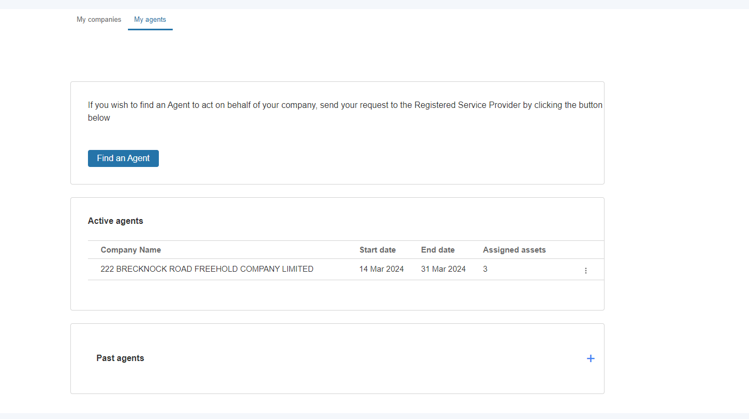

Locating a prospective Agent – Entering in the Market Provider Details
The pop-up screen prompting the prospective agent will ask for two mandatory pieces of information a) the Company Registration Number in the search box and b) the representation dates. Please note that without entering a valid number, the process will be aborted. When a valid Registration number is detected, the corresponding Company Details are displayed.

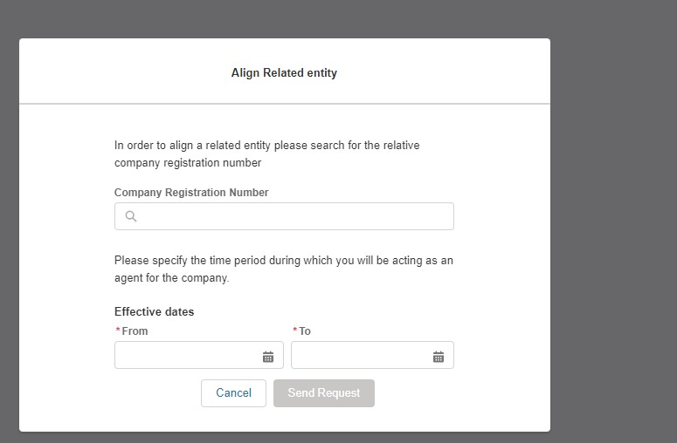
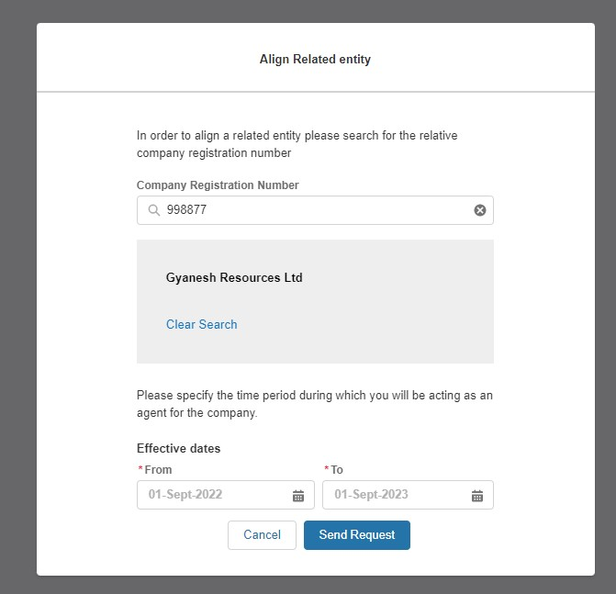

Locating a prospective Agent – Confirmation of Submission of Nomination Request

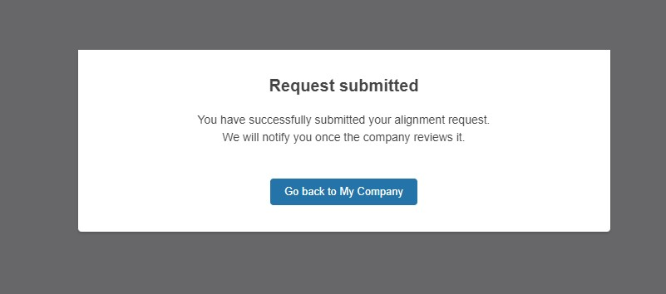

Accepting/Rejecting Nomination Requests

Once the request has been confirmed, the prospective agent’s associated Portal Users will be sent an Email Alert prompting them of the pending nomination request. They will be expected to click on the hyperlink in the body of the email or login directly to the SMP Portal to be able to complete the acceptance or rejection of the nomination request exercise.

As the prospective agent, the associated portal user will click on the Related Entity Tab and then proceed to the ‘My Companies’ Sub Tab – there they will see the New Agent Request notification with the option to Accept or Reject the request. Prior to selecting Accept option they will be required to visit the Terms & Conditions Page to review the content. It is recommended they do this in a different tab on their browser.

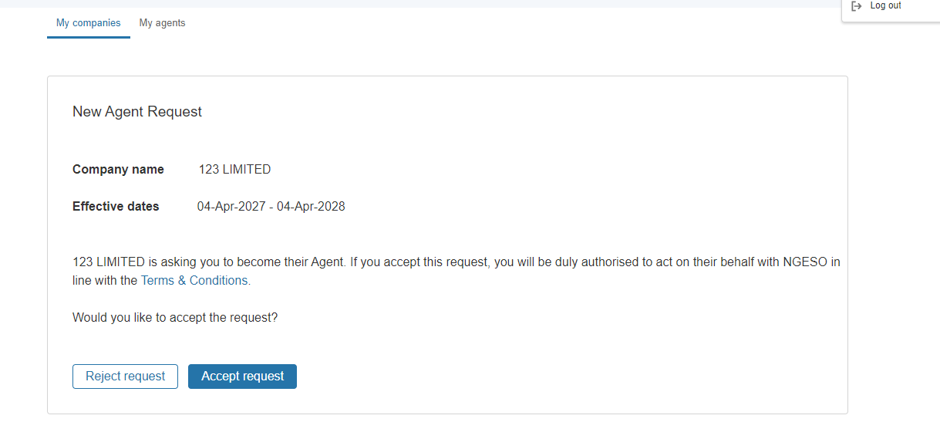
Accepting Nomination: Upon selecting this option the following actions will occur;
- The Asset Owner’s associated Users will be notified by Email and via an in portal notification
- They will be expected to login into SMP and replicate the Acceptance of the Terms of Conditons
- Once they have reciprocated and accepted the ‘pending agreement’ the Status will move to Accepted and the Agreement will officially be formalised on SMP. A record of the Portal User whom accepted the agreement and consented to the Terms & Conditons and the date of consent for both parties will documented on SMP internally.
Rejecting Nomination: : Upon selecting this option the following actions will occur
- The Asset Owner’s associated Users will be notified by Email of the Rejection Outcome.

In portal notification – Prospective Agent
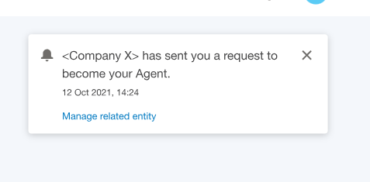

Consenting to the Terms & Conditions – Agreement Copy
The image below provides the description of Terms & Conditions legal text that both parties are expected to adhere to
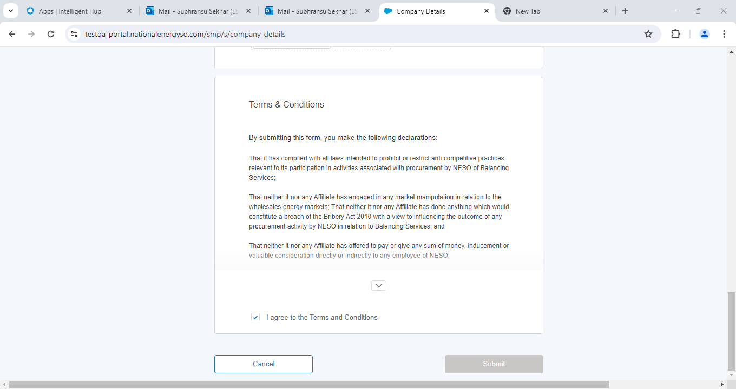

Pending Agreement Notification – Asset Owner

The Asset Owner’s portal users will be presented with the screen below, when at least one of the User’s in the case of mulltiple user’s either selects Reject or Accept, the pending agreement notification will remain on the SMP Portal.

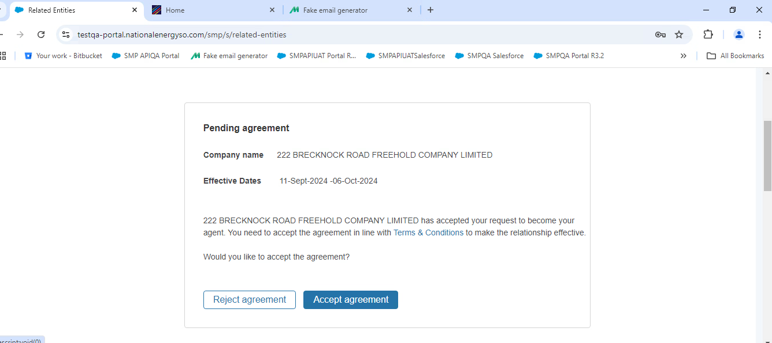

Accepting Nomination: Upon selecting this option the following actions will occur;
- The Prospective Agent associated Users will be notified by Email that the Agreement Offer has been ratified and the Agreement is now created
- Once they have reciprocated and accepted the ‘pending agreement’ the Status will move to Accepted and the Agreement will officially be formalised on SMP. A record of the Portal User whom accepted the agreement and consented to the Terms & Conditons and the date of consent for both parties will documented on SMP internally.
Rejecting Nomination: : Upon selecting this option the following actions will occur
- The Prospective Agent’s associated Users will be notified by Email of the Rejection Outcome.

Agreement Business Rules

- A Market Provider cannot submit duplicate nomination requests to the same provider for the same representation date window.
- A Market Provider can however extend an agreement but submitting a new request with a different set of dates with the same provider
- A Market Provider cannot submit multiple nomination requests to different providers with different or the same representation date window.
- There is no longer a cap on the number of agents an asset owner can have at the same time.
- Both parties have to accept the agreement and consent to the terms and conditions before the agreement is formalised on SMP. If either party fails to accept or reject, the agreement remains in ‘pending’ state.
- If either party rejects the agreement, it is made redundant and the process and the agreement exchange is terminated.

Notification that an existing Agreement is in place

If a Market Provider’s Portal User attempts point 1 above during the nomination stage, this message will appear on screen.

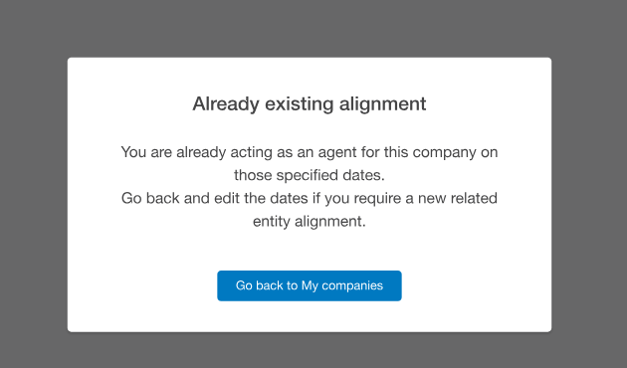

Notification that one of the parties is still pending approval
If either of the Market Provider’s Portal Users are yet to accept or reject the nomination request, this message will appear on screen if they attempt to initiate a duplicate request to the same Market Provider for the same representation dates. This will block any potential duplicate requests being ‘created’ on SMP.
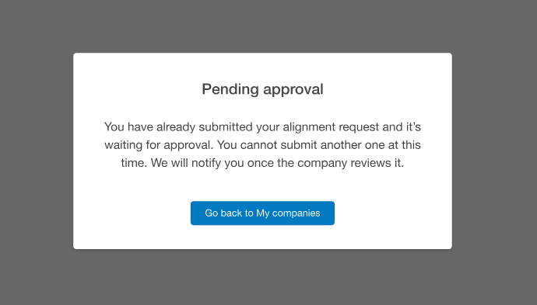

In portal notification – Prospective Agent
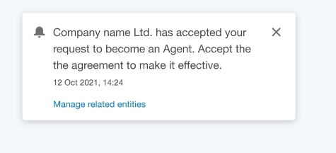

Confirmation of Agreement in Place – Asset Owner’s view
Once the Related Entity Agreement has been established between both parties (accepted), then both parties can log into SMP and view evidence of the Agent/Asset Owner’s Agreement Details including the Company Name, the Representation Start and End Date and the overall number of assets assigned. (The transfer/delegation of assets are covered in the next Chapter)
Once an Agreement has expired, the Agent in question will appear under the ‘Past Agents’ section.

Confirmation of Agreement in Place – Prospective Agent’s view
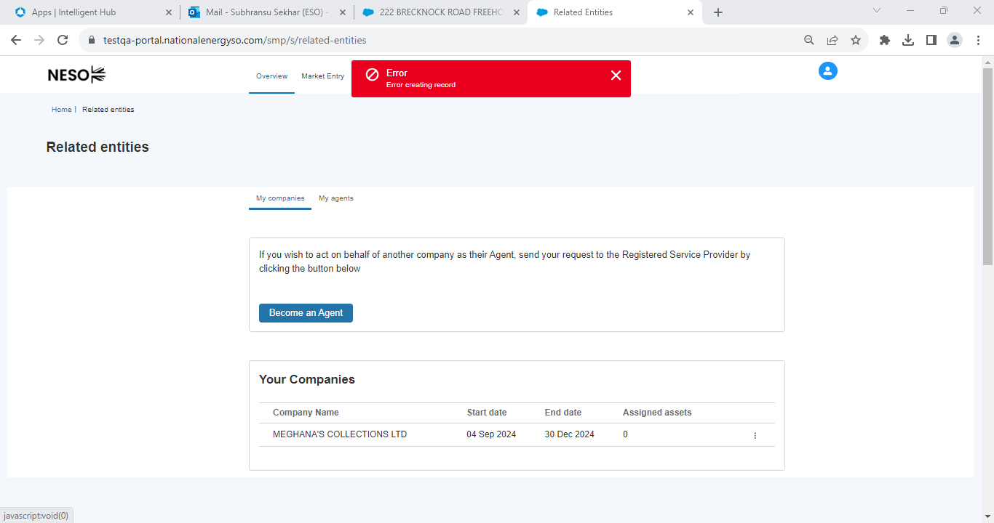

Locating a prospective Asset Owner/Service Provider

If a Market Provider is acting as a prospective Agent wishing to nominate an asset owner/service provider as their Related Entity, the steps they adopt are identical to those outlined under the section outlined for ‘’Locating a prospective agent’’ instead, the Market Provider will select the ‘’Become An Agent’’ option under the ‘My Companies’ Tab.

Confirmation Email Alerts
Outlined below are the various Email Alert notifications that are issued to Market Providers throughout the Related Entity Process steps.

Confirmation Email Alert Template 1
Request initiated by either party

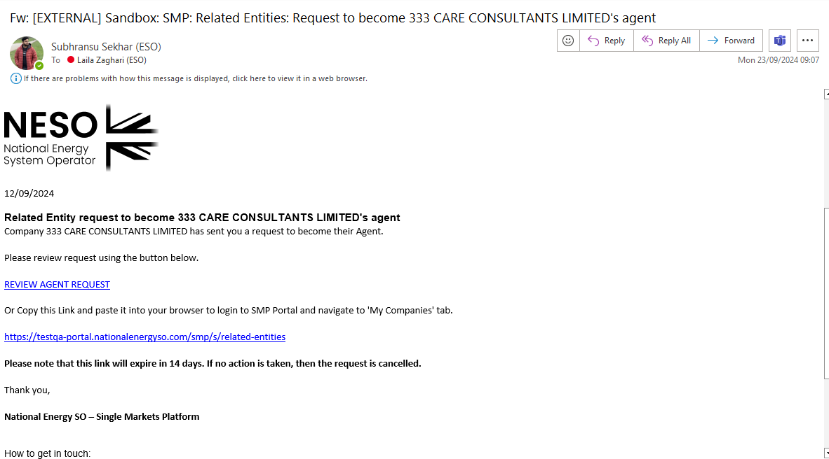

Confirmation Email Alert Template 3
Request Nomination Rejected

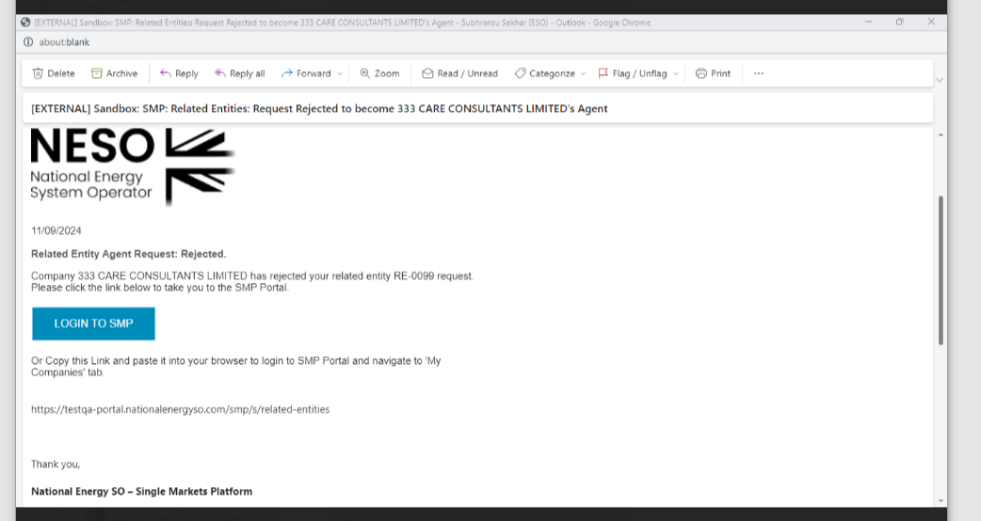

Confirmation Email Alert Template 4
Reminder Alert to take action on the nomination request
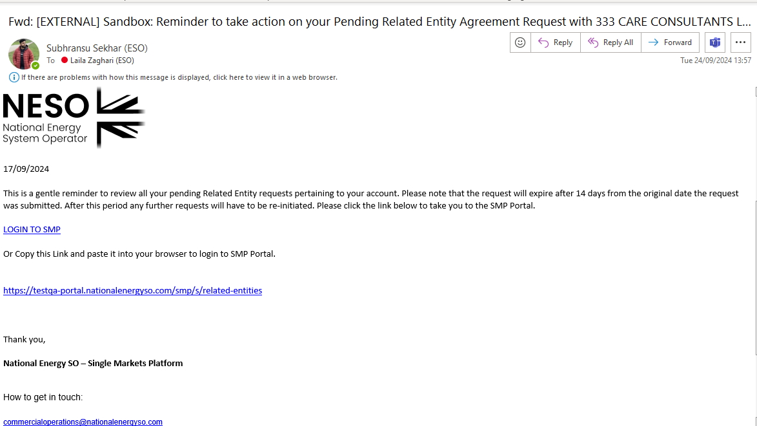

Confirmation Email Alert Template 5
Confirmation Email – Agreement Accepted
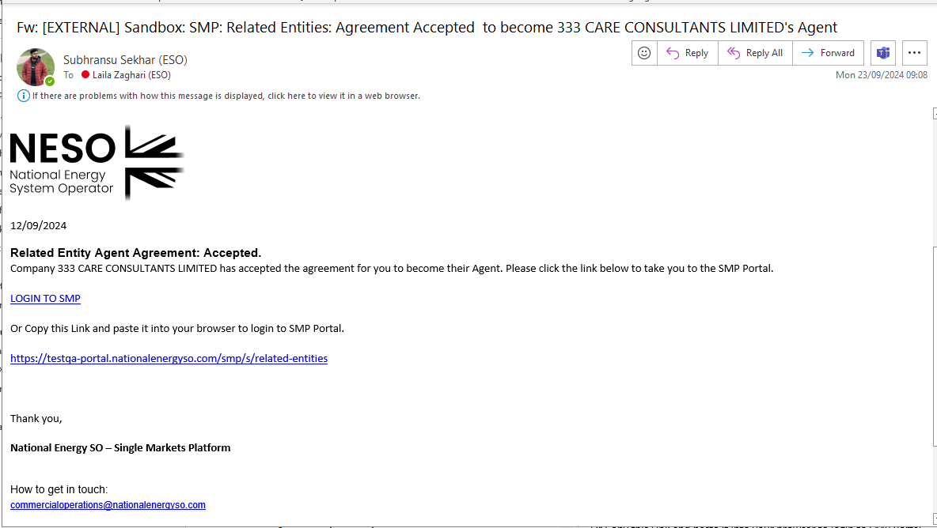

Confirmation Email Alert Template

Confirmation Email – Agreement Rejected
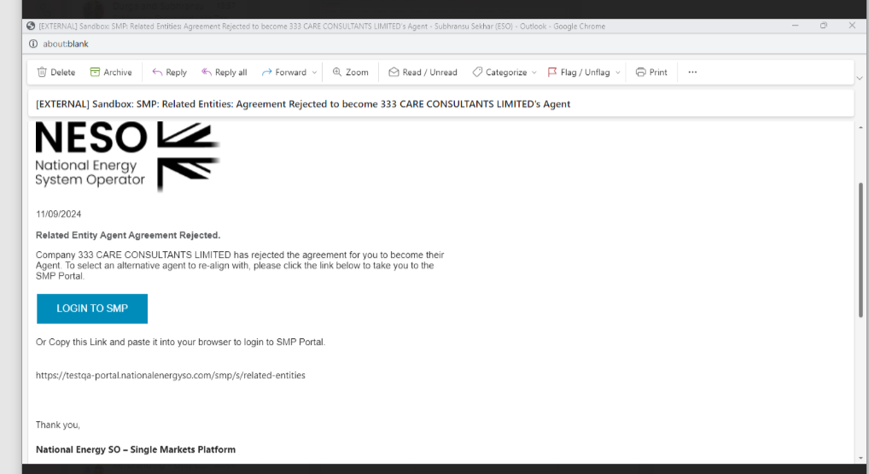

Delegating Asset(s) for Transfer

The section below outlines the steps required by the Asset Owner/Service Provider to select and delegate or transfer the asset(s) to their respective Prospective Agent.

Transfer of Asset(s) Business Rules
- An Asset Owner cannot transfer or delegate any assets unless they have entered into an Agreement in accepted state
- The Asset(s) will only become available to the Prospective Agent on Day 1 of the representation period.
- It is recommended that when setting the representation dates, the asset owner and prospective agent must allow for sufficient lead or onboarding time to ensure the agent is in a position to form a new Unit and prequalify successfully prior to auction timeframes.
- An Asset Owner is only permitted to transfer or delegate responsibility of asset(s) within the agreement representation dates, if the asset owner wishes to transfer an asset beyond those dates, they will have to establish a new agreement with the same party.
- Only Asset Owners can transfer or delegate responsibility of asset(s) that they own within their own portfolio
- If an Asset’s Effective From Date is set in the future – therefore beyond the agreement representation dates, the asset is prohibited from being available for transfer or delegation within the context of that agreement
- If an Asset is committed to an existing Unit or Unit(s) in Accepted State then the Asset is prohibited from being available for transfer or delegation and will be marked as ‘Requires’ Global Versioning’ to effectively release the Asset from the existing Units.
- Following successful completion of the Global Versioning exercise, the Asset will be made available for transfer.
- There may be instances where there are missing parameter data on existing assets selected for transfer, if the missing parameter data breeches N NATIONAL ENERGY SYSTEM OPERATOR LIMITED Business Units validation rules, then the Asset is prohibited from being available for transfer or delegation until the data is rectified. In this instance an error message will appear and the onus will be on the Asset Owner to liaise with the Contracts Team to rectify the source of the error
- Once the Asset(s) are successfully transferred, the Asset Owner will not be able to leverage them to form Units or prequalify throughout the duration of the agreement. They will however be able to view the Asset(s) on SMP as a point of reference.

Selection of the Agent
The first step an asset owner should take is to identify the Agent they wish to delegate the asset to under the list of agents, then navigate to the three drop down buttons and select the option to ‘manage assets’

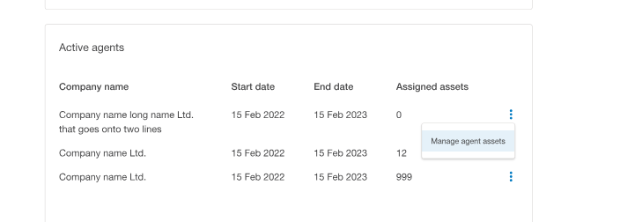

Selection of the Asset(s)
The next step is to select the ‘assign’ assets button

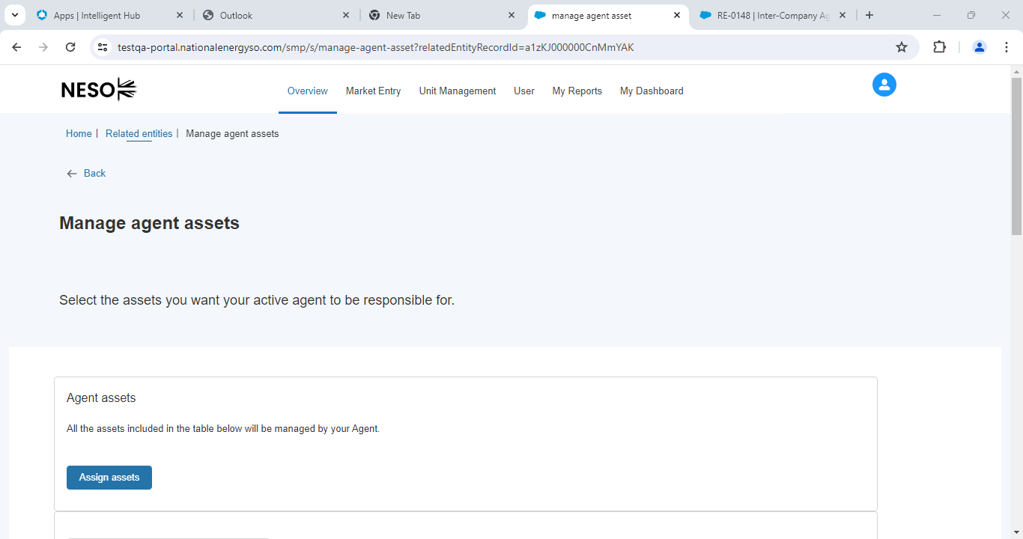

Selection of the Asset(s) – identification of asset(s)
The next step is to select the asset(s) in question from the list of assets owned by the Asset Owner. All assets should display, however those assets committed to at least one or more Units in Accepted State will have a column marker which indicates the Asset requires Global Versioning to release it from its current Unit or Units. To select the asset that is available, simply check the box in the first column. When all the asset(s) are selected the ‘Confirm’ button should be selected.

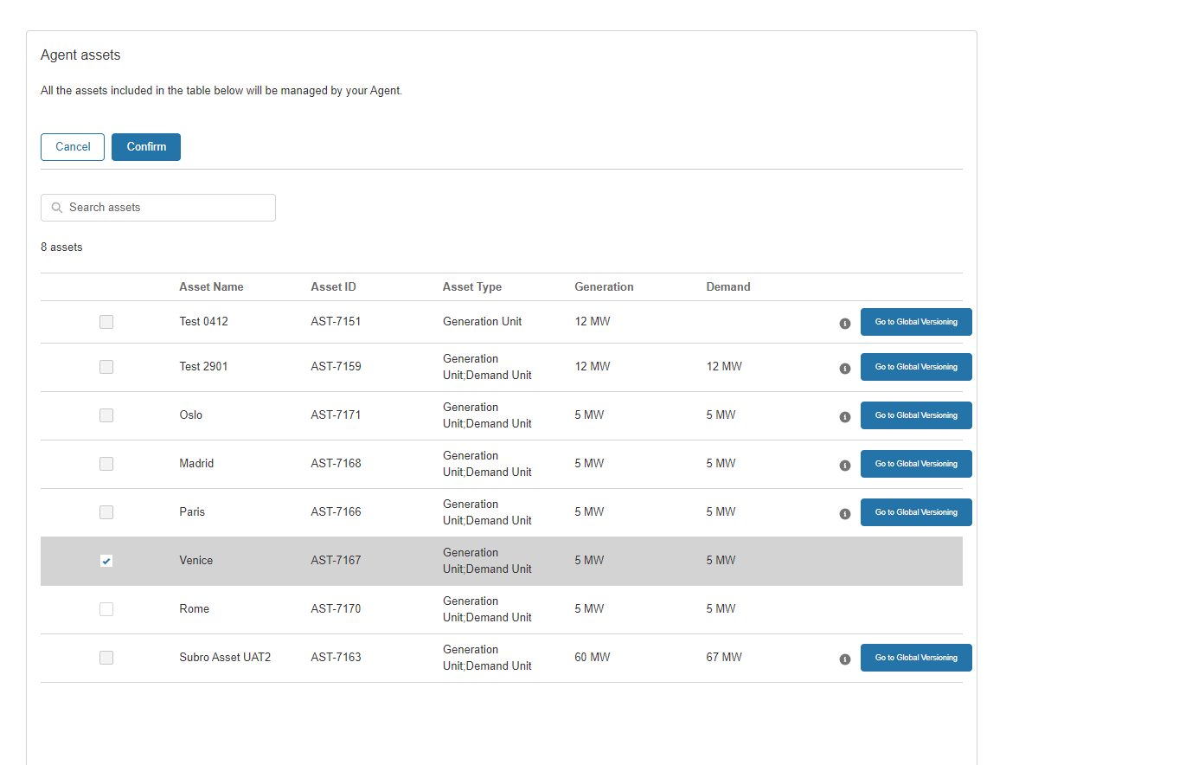

Confirmation notification – selection of asset(s)

An onscreen notification will display to acknowledge that the user wishes to proceed with the transfer, there is an option to abort the process by selecting ‘cancel’

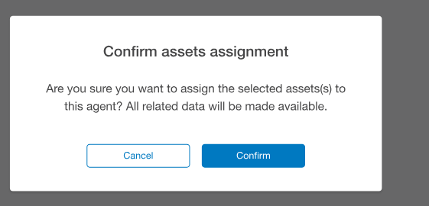

Confirmation decision – selection of asset(s) completed

If ‘Confirm’ is selected, then an onscreen notification will appear to confirm that the asset(s) have been transferred.

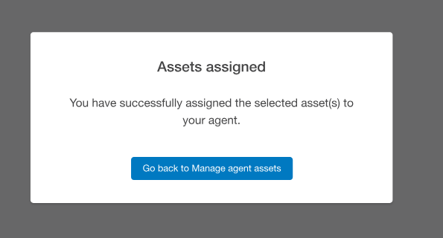

Visibility of Transferred Assets

As mentioned previously, asset(s) are only made available to the prospective agent on Day 1 of the representation Effective From Date, however prior to this date the agent can view the number of assigned assets under the Your Companies listing under the Related Entity Section of SMP.
To view the actual asset on Day 1, Portal Users should navigate to the Asset Tab under Unit Management, where the Asset Tile will display and be available for Unit alignment.

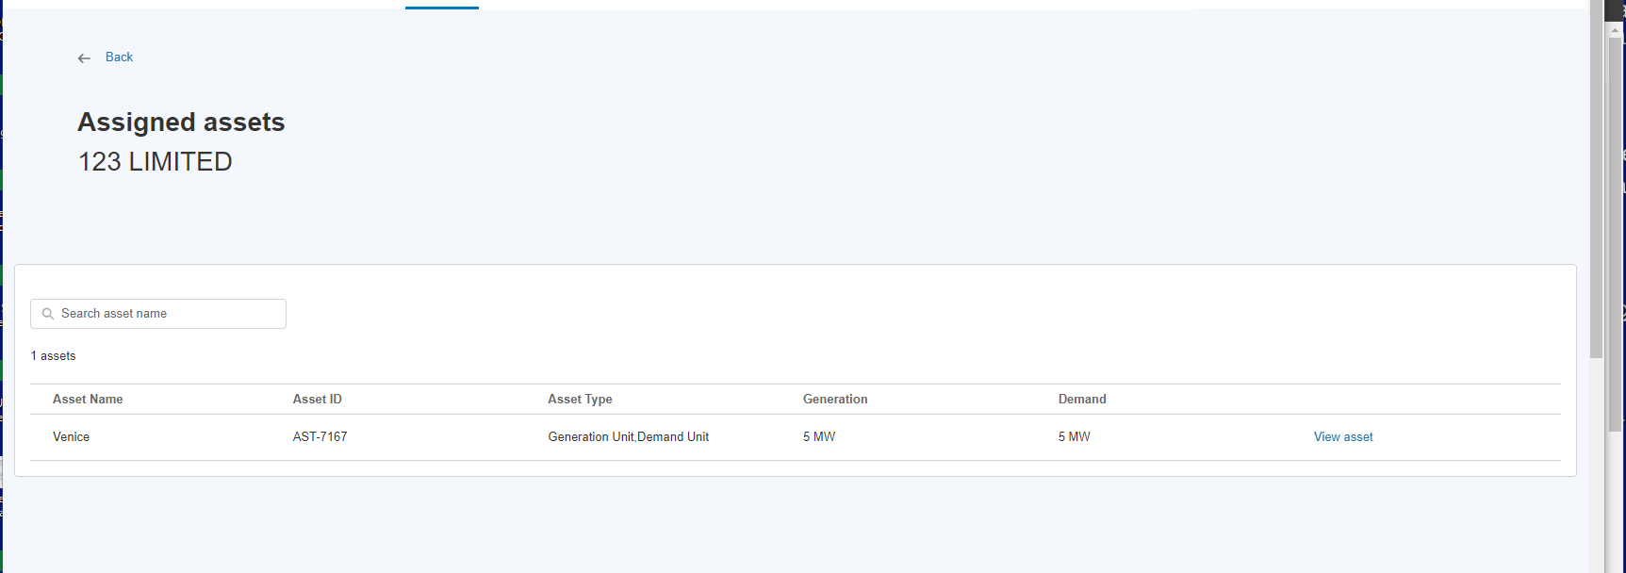

Related Entity: Withdrawal or Natural Expiry of Agreements & Relegation of Asset(s)

Ending a Related Entity Agreement
As of Release 3.7, only a Service Provider (asset owner) can opt to withdraw/terminate an existing Related Entity Agreement. It is recommended that the Service Provider collaborates with the Agent offline to ensure that where applicable any affected asset(s) tied to Unit’s (Committed Units) are prepped/management for the removal of the asset(s) in advance as far as possible in readiness for the termination date.

The SMP Portal’s role is to enable Market Providers fourfold;
- The ability to initiate the termination of an existing relationship with one or more agents and specify the termination date by the Asset Owner
- The ability to release asset(s) from committed Unit’s in advance of the termination date through the mechanism of Global Versioning by the Agent(s)
- Where inaction or no action is taken by the Asset Owner, the Agreement will naturally be expired automatically, and any ‘uncommitted asset(s)’ will be relegated back to the asset owner automatically.
- Where inaction or no action is taken by the affected Agent(s) then the mechanism of Global Versioning will be automatically actioned on behalf of both parties to ensure the asset(s) are extricated from the committed Unit(s) and are relegated to the Asset Owner in question.

Outcome Options for ‘Delegated’ Assets
Asset(s) owned by the Asset Owner’s whom is terminating a Related Entity Agreement can be face different ‘states’ from the outset, each of these ‘states’ require different courses of action (outcomes) in order to ensure they are ready for relegation back to their owner upon termination of the agreement;

State 1: ‘Free-floating’ asset(s): These are asset’s that have been delegated by the asset owner to the agent, however the agent has not opted to align or leverage them into a Unit (accepted) state, meaning that they have not been committed to any Unit and as such are deemed ‘free-floating’. These do not include any assets aligned to Units in Draft state.
Free-floating asset(s) do not require any action on the part of the asset owner or the agent and will automatically be transferred back to the Asset Owner upon termination of the agreement

Outcome Options for ‘Delegated’ Assets (continued)

State 2: No asset(s) delegated: There may be instances that an agreement was established, however no assets were delegated originally or over the course of the agreement, all the owned assets have been individually relegated back to the asset owner. Where at the point of termination there are no assets delegated, then no action is required on the part of the asset owner or the agent as the agreement will be terminated automatically

State 3: ‘Committed Unit with singular Asset Ownership’: These Units contain at least one or more asset that belongs to the same asset owner whom is wishing to the terminate the agreement. These Units will require all the assets to be removed through the pre-requisite exercise of Globally Versioning in advance of the termination date by the Unit Owner (Agent) –( this is the revised effective end date of the agreement). In the process of extricating these assets, it will result in a ‘Benched Unit’ and prequalification application(s) will be curtailed where they were previously approved.
If no action/inaction has been taken and Committed Units exist, then SMP will systematically manage the removal of all the affected assets 2 Days before the existing Effective End Date of the Agreement and set the affected Unit(s) as ‘Benched’

State 4: ‘Committed Unit with a hybrid profile of Asset(s) Ownership’: These Units contain at least one or more asset that belong to different asset owner’s including the asset owner whom is wishing to the terminate the agreement. These Units will also require the affected asset(s) to be removed through the pre-requisite exercise of Globally Versioning in advance of the termination date by the Unit Owner (Agent) –( this is the revised effective end date of the agreement). In the process of extricating these assets, it will result however in a new Version of the Unit, retaining the other asset(s) as part of the original logical grouping/formation and prequalification application(s) will be re-evaluated and assessed as to whether they are eligible to continue where they were previously approved.

If no action/inaction has been taken and Committed Units exist, then SMP will systematically manage the removal of all the affected assets 2 Days before the existing Effective End Date of the Agreement.

Identifying Asset(s) tied to Committed Unit(s)
An asset owner can easily identify those asset(s) that are committed to a Unit by navigating to the Related Entity Page, selecting the Agent under the My Agents Tab and navigating to the Agent in question, selecting the drop down dots and opting for ‘Manage Agents’ Option.
An itemised List View will be displayed with all the assets covered by the agreement.
- Asset(s) Committed to a Unit(s): will display with a ‘red flag’ and a ‘I’ icon – when hovering upon will explain that the Asset will require extricating through Global Versioning
- Asset(s) not Committed to any Unit(s): will display without a ‘red flag’

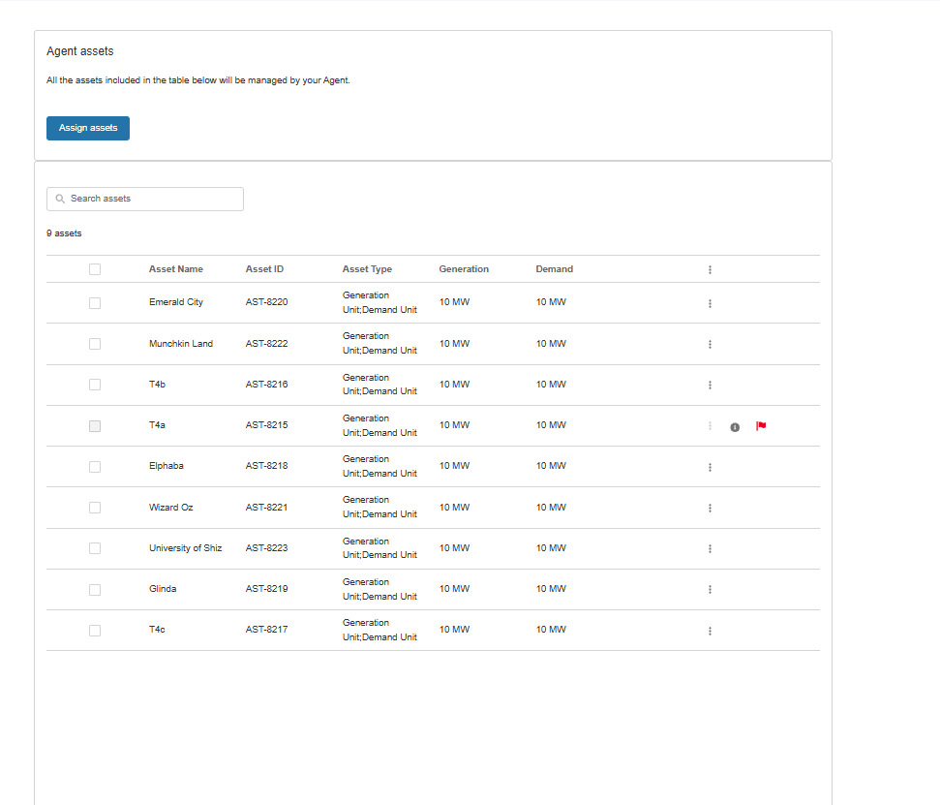

Initiating (Termination) Request/Order

Locate the Agent & Agreement

If you are initiating the request as a service provider/asset owner you should navigate to the ‘My Agents’ Tab, the Agent listing and then scroll to the three drop down dots to select the ‘Terminate Agreement’ option.

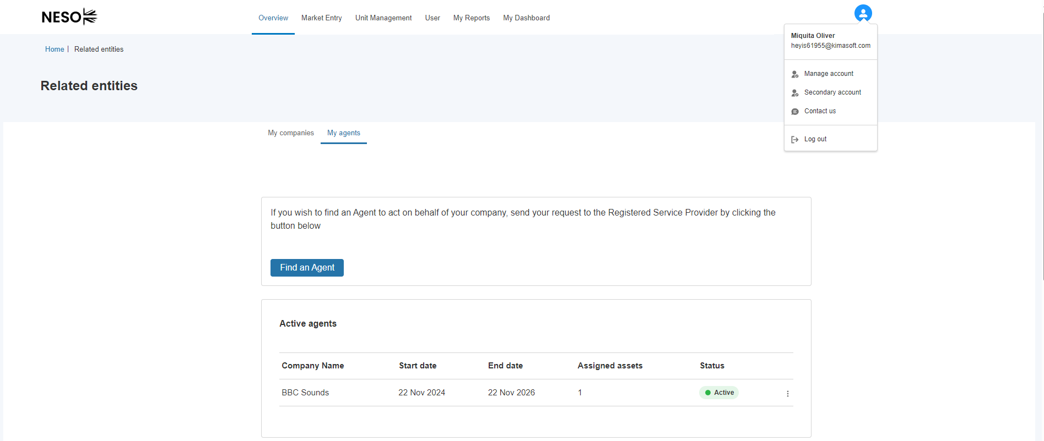

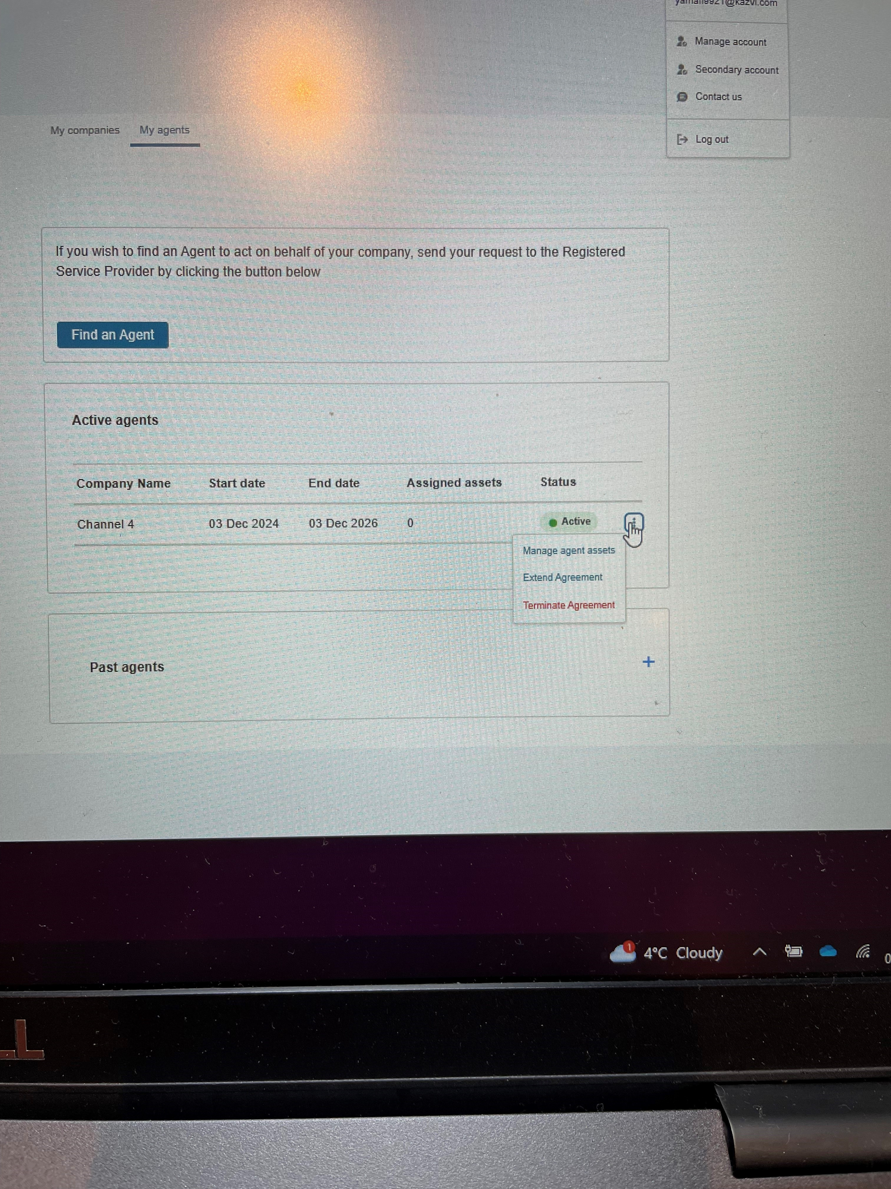

Initiating (Termination) Request/Order: (Cont)
A prompt screen will request the revised/new Termination Date for the Agreement. The Date entered must be successive and cannot overlap with the current end date.
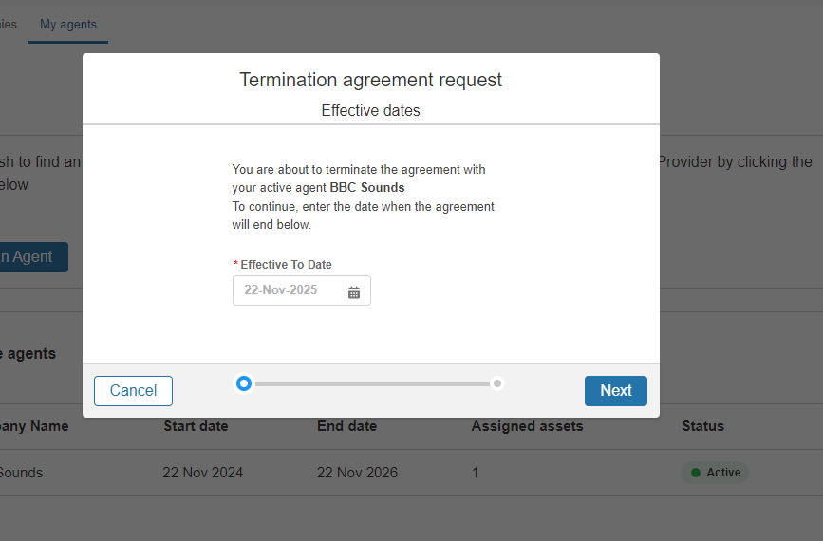
A summary preview of the new details will be displayed
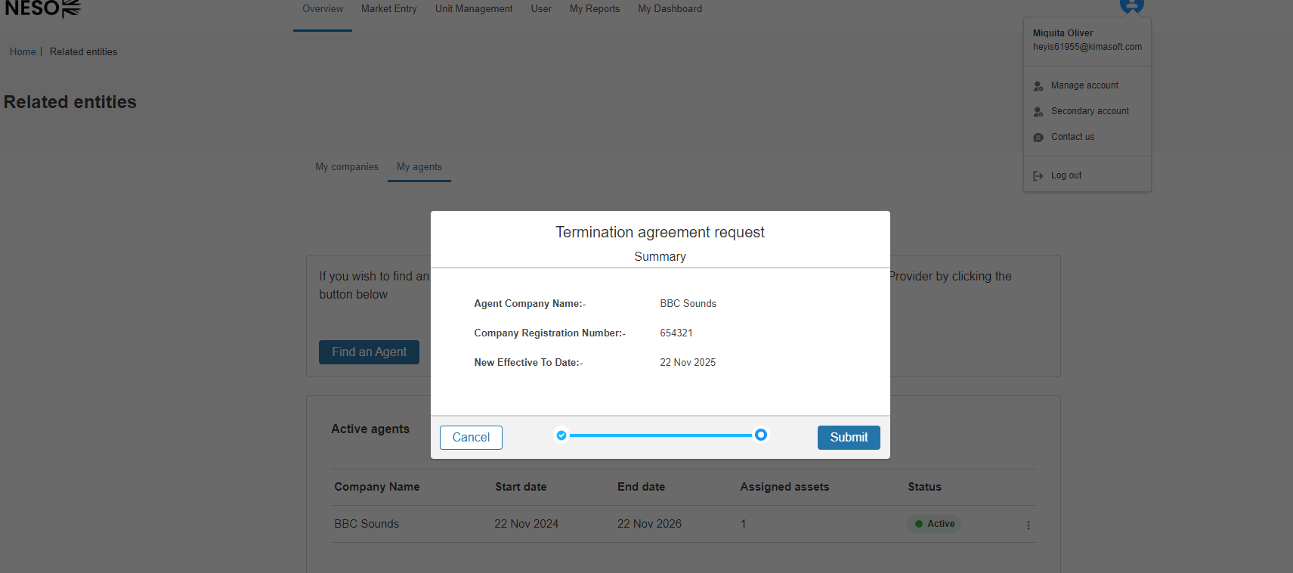

Initiating (Termination) Request/Order: (Cont)
A summary confirmation and instructions on what follows will appear, this marks the end of the initiation request/order to terminate the agreement. In the interim period, it would be advisable to liaise with the Agent in question to ensure their portfolio containing Committed Units with the asset(s) affected will ensure that they perform Global Versioning in sufficient lead in time. Failure to do so, will result in the Agent’s Unit’s being subject to systematic Global Versioning 2 days before the revised terminated (effective to) date.
Upon pressing the Go Back to My Agents custom button will direct the user back to the Related Entity Management Page. The Status under the Agent Listing will change to ‘Termination Pending’ until the Date has arrived, when the Status will change to ‘Agreement Terminate’ .
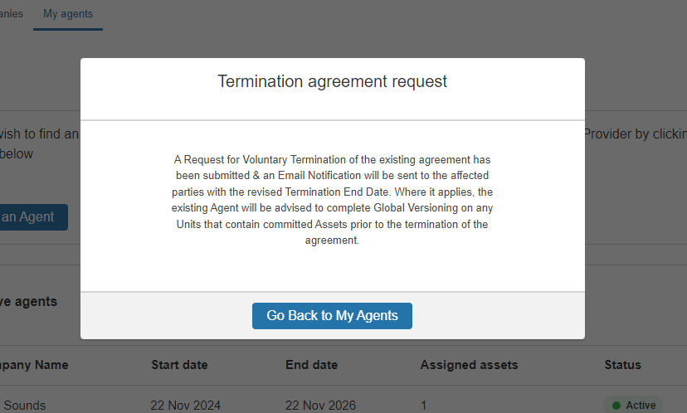

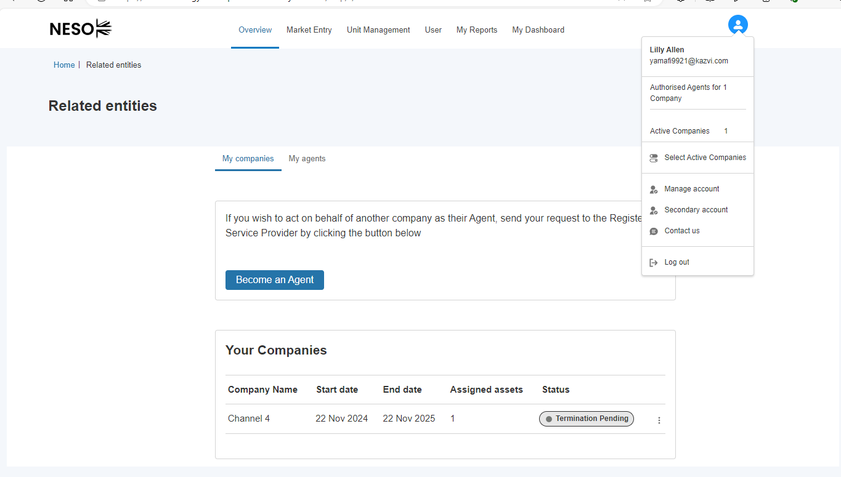

Natural Expiry of Agreement
Where an agreement naturally comes to end and therefore the Asset Owner has not initiated a premature termination of the agreement nor has the asset owner or the agent decide to extend the agreement period, the SMP System will automatically ‘end ‘ the agreement to take effect the Day + 1 of the Effective End Date. On the portal, under either the My Companies Tab or the My Agent Tab;
- The agreement listing will appear in the ‘past agreement’ sub section
- The Status will appear as ‘Agreement Expired’
- Any originally delegated assets will be automatically ‘relegated’ to the asset owner however the original total number of assets assigned displayed will remain as a visual reference only.
- Any assets that are committed to a Unit belonging to an agent will be subject to the Global Versioning Process and extricated accordingly.
- The assets in question will no longer be available to the Agent to perform trades with on the Effective End Date + 1 Day of the Agreement
- The assets in question will be made available to the Asset Owner to perform trades with on the Effective End Date + 1 Day of the Agreement
An example of an Agreement that has expired naturally – the Status value will display as ‘Expired’ on the Effective End Date + 1 Day of the Agreement.

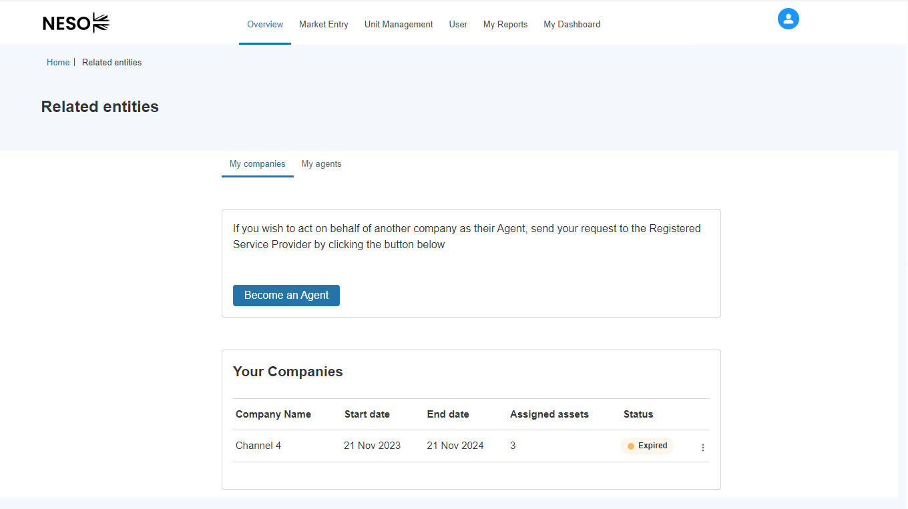

Update to a Business Rule on Related Entity Agreement
As of Release 3.7 an update has been made affecting Asset(s). Any registered asset(s) that have a ‘future’ effective from date that exceeds the End Date of any current Related Entity Agreement will be prohibited from being available to the Asset Owner to delegate to the Agent unless the Asset Effective From Date is adjusted so it falls within the timeframe of the agreement. Any adjustments must be requested with your NESO Contract Manager to update post asset registration.

Visibility of Assets & Units post Agreement
As of Release 3.7, the asset owner will be afforded the ability to view ‘relegated’ asset(s) in a more streamlined fashion. For those asset(s) affected, the latest version (accepted) will display as a Tile on the Assets Sub Page as standard, however if user wishes to view the historic changes and predecessor versions of the individual asset, then they are able to do this by clicking on the three drop down dots, selecting the option to ‘View Details’ and navigating to the ‘View Asset Version History’ on the right hand section of the screen

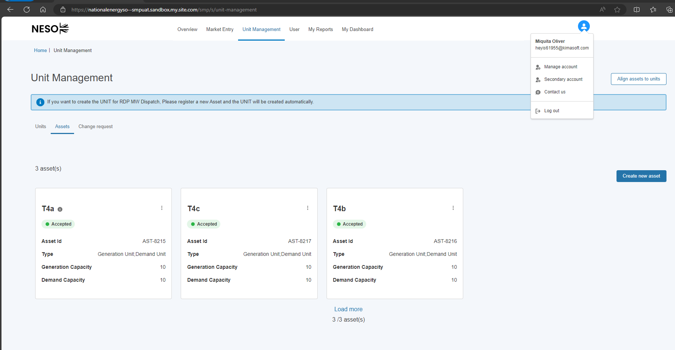
Viewing Asset (Version) History as the Asset Owner
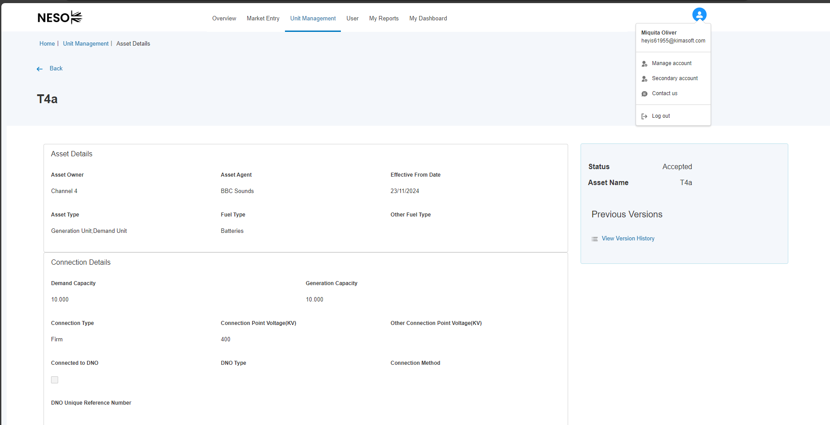

Visibility of Assets & Units post Agreement (cont)
A new screen/page will display with an itemised history of all the previous iterations/versions of the Asset with relevant column information e.g where the asset was delegated to an agent, and when it was relegated back

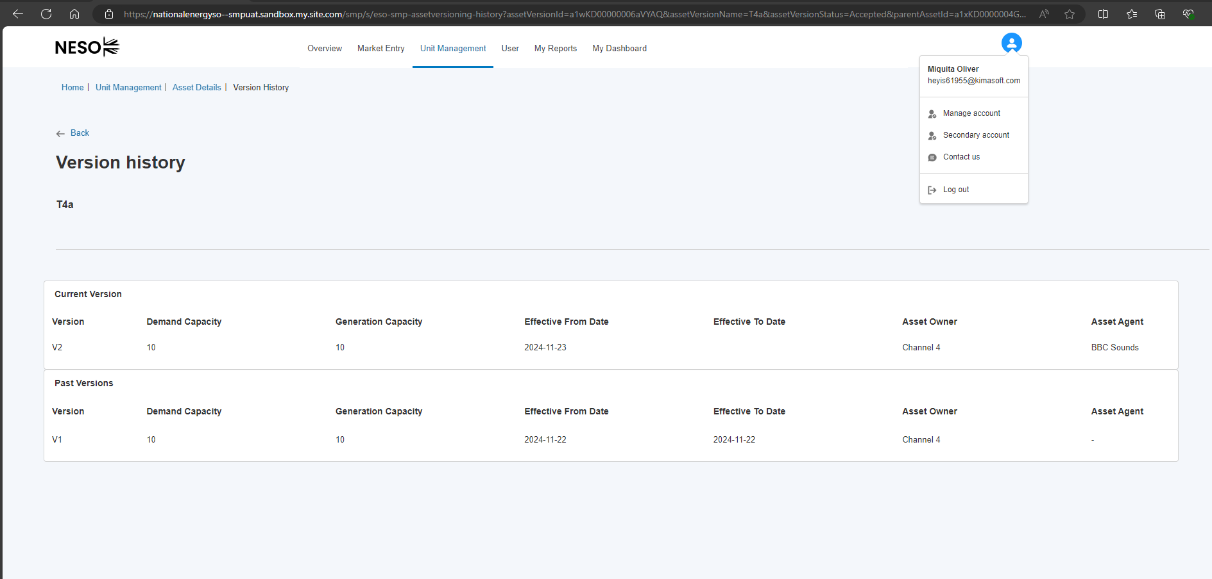

As of Release 3.7 an agent, following Globally Versioning and the release of Assets from a Committed Unit, where applicable the User will be able to differentiate between a ‘Benched’ Unit and ‘Non Benched’ Unit through the Aggregate Value for Assets on the Unit Tile – which will display as ‘0’.
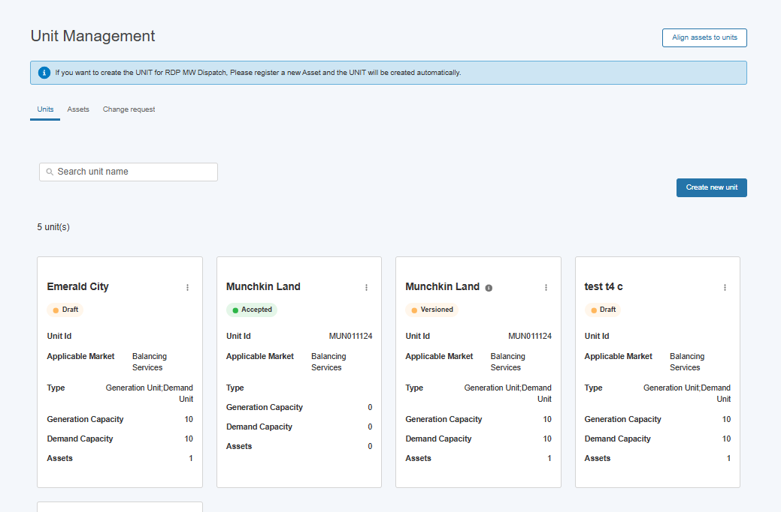

Visibility of Assets & Units post Agreement (cont)

As of Release 3.7 an agent will continue to have visibility of assets that have been relegated back to their owner, however the assets will display as ‘Accepted’ but they will not be available to the agent following the expiry/termination of an agreement. For example, a user will be prohibited from being able to leverage the asset in alignment

The Agent will also not be able to view the Asset History unlike the Asset Owner. 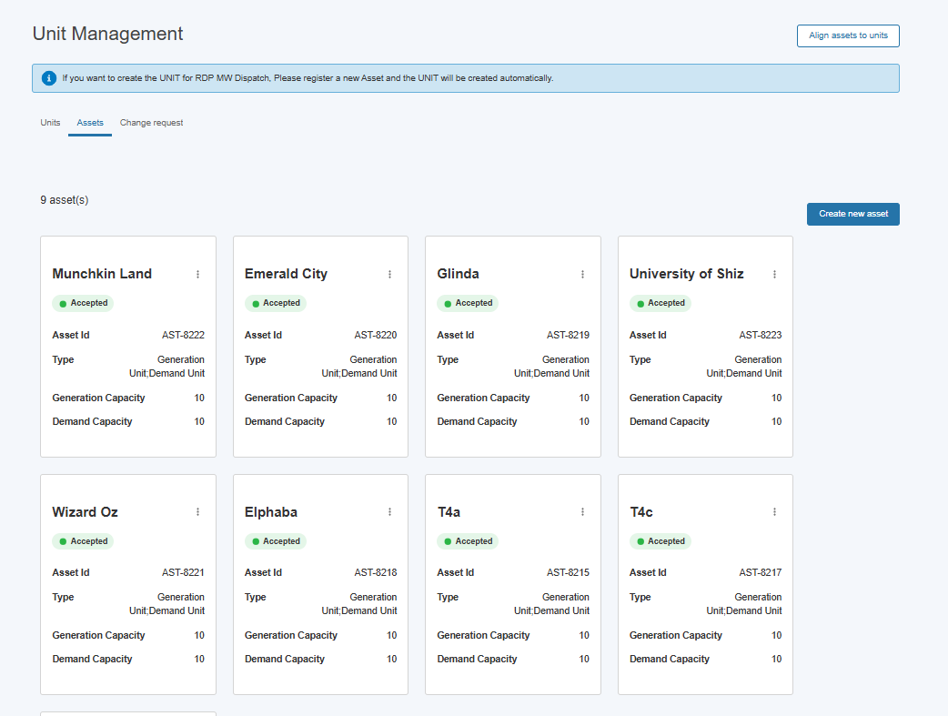
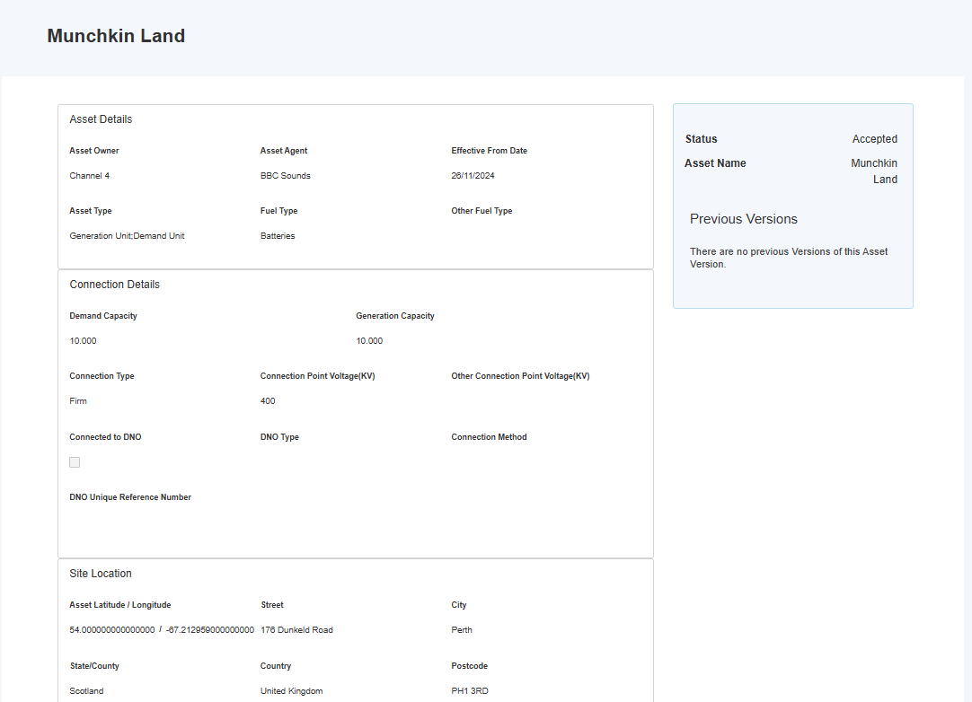

Related Entity: Agreement Extensions

Extension Requests

As of Release 3.7 - extending the timeframe for a current agreement can be made by making an extension request by either party. Agreements can only be extended if both the asset owner and the agent consent. The agreement exchange process is identical to the original initial agreement request upon formation.
Where an exchange is consented to, then the Agreement End Date will be updated to the new date and the portfolio of delegated asset(s) remain intact.
Where an exchange is not consented to by either party, then the current agreement will run it’s course and the Systematic Procedure for Terminating Agreements will take effect.

Initiating an Extension Request – Agent Option
Where a User is acting on behalf of the agent, they can select the drop down option ‘Extend Agreement’
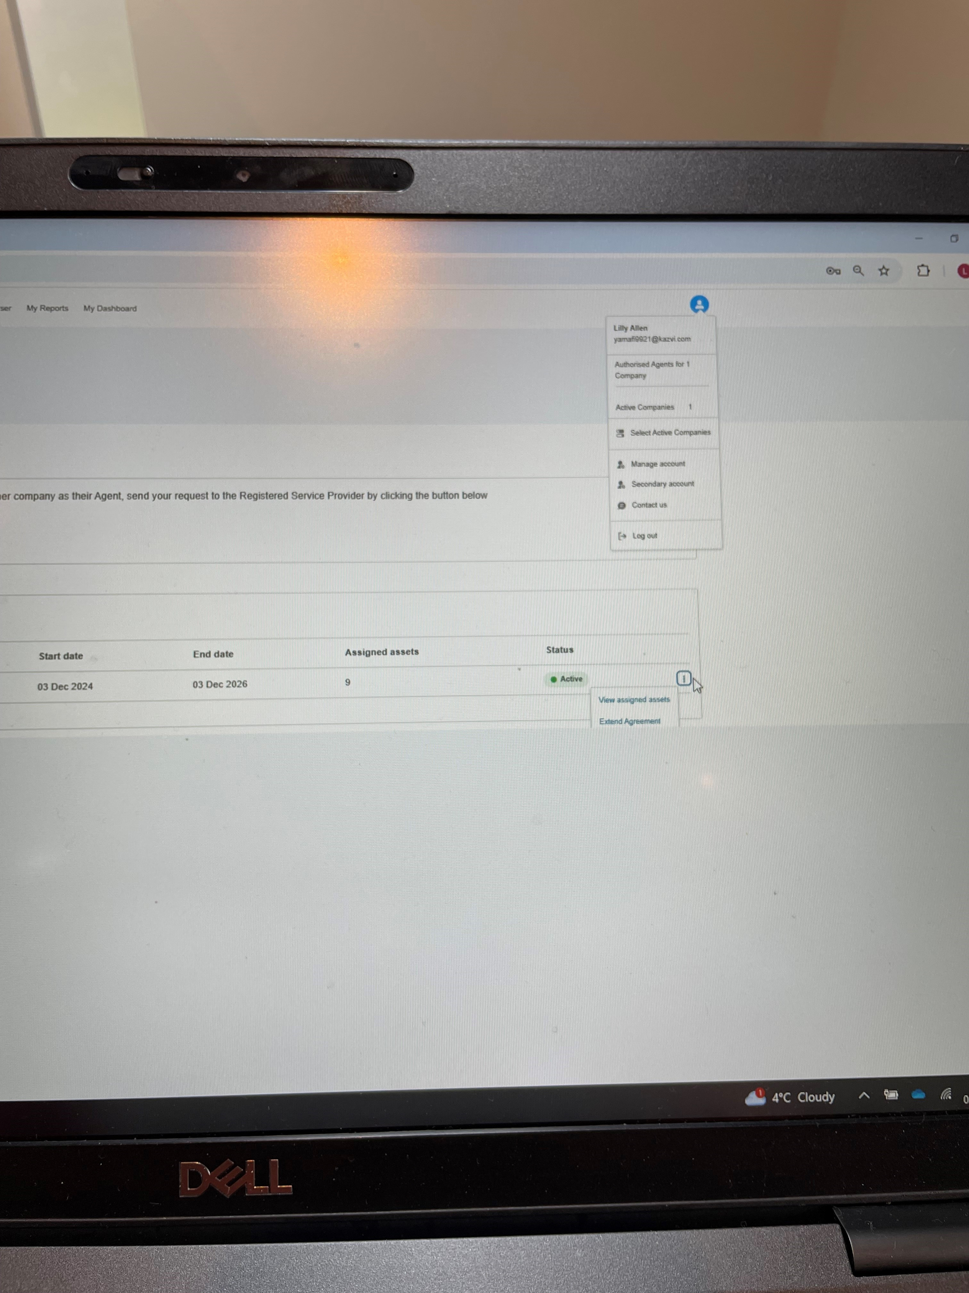

Initiating an Extension Request – Asset Owner Option
Where a User is acting on behalf of the asset owner, they can also select the drop down option ‘Extend Agreement’

Consent Exchange Process
The user will be prompted to enter the new agreement date (revised effective to date)
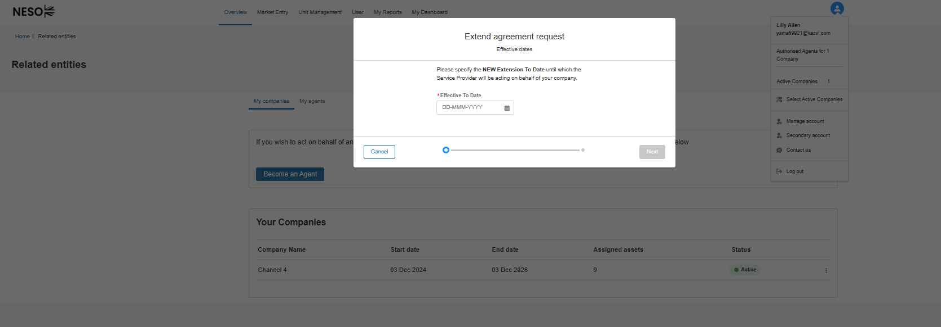

A summary preview will display
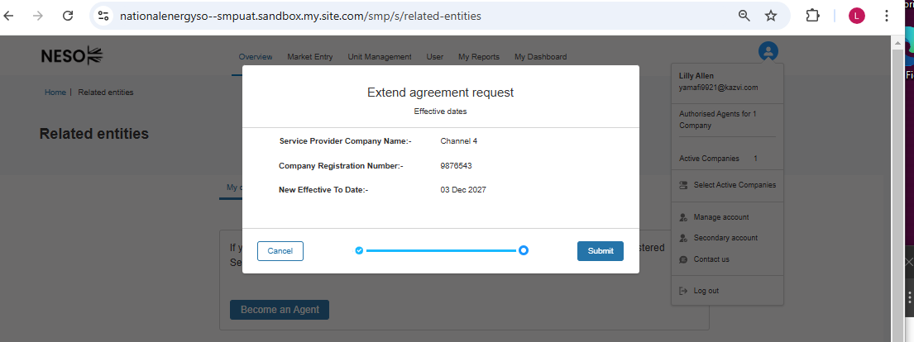
To confirm the request, select Submit and a pop up notification is displayed.

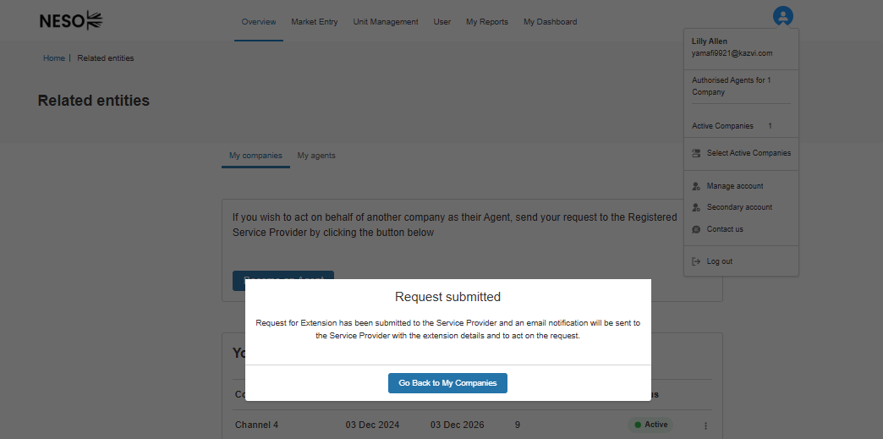

Consent Exchange Process
Any users whom have the Related Entity Manager Role will be able to login to the Portal and accept or reject the extension request from the other party. If the user is acting on behalf of the agent, they will find the request under the ‘My companies’ tab and vice versa.

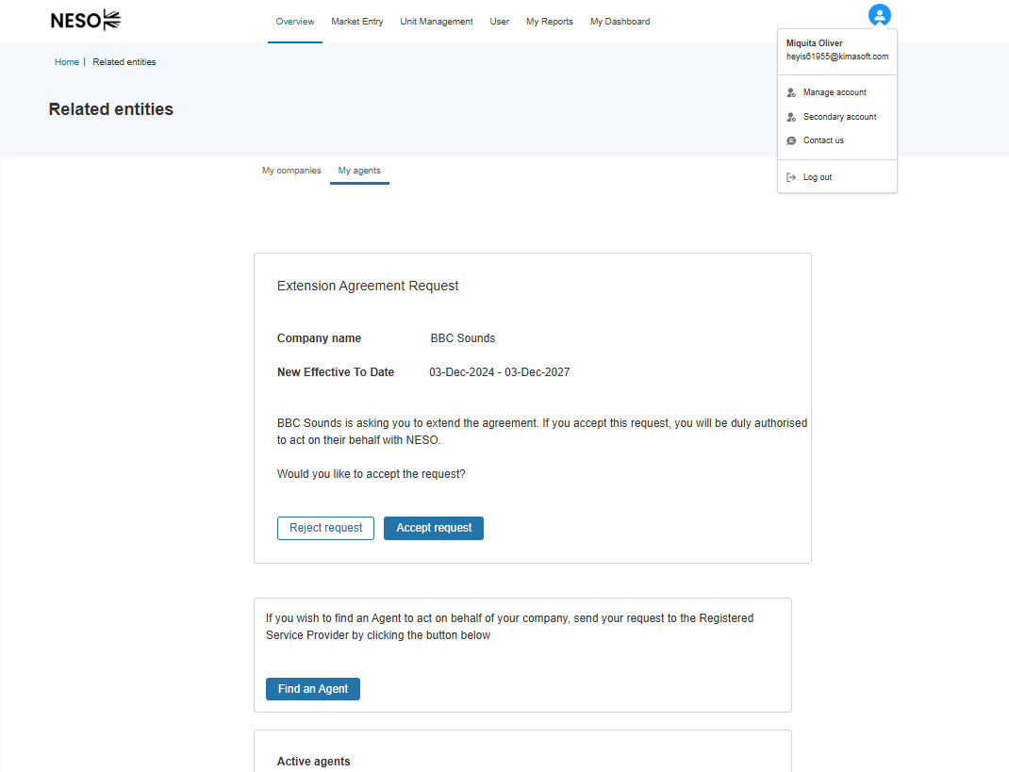

Consent Exchange Process – Extension Agreed
Where consent is granted, the status remains as ‘active’ but the end date will be adjusted automatically to reflect the new date.
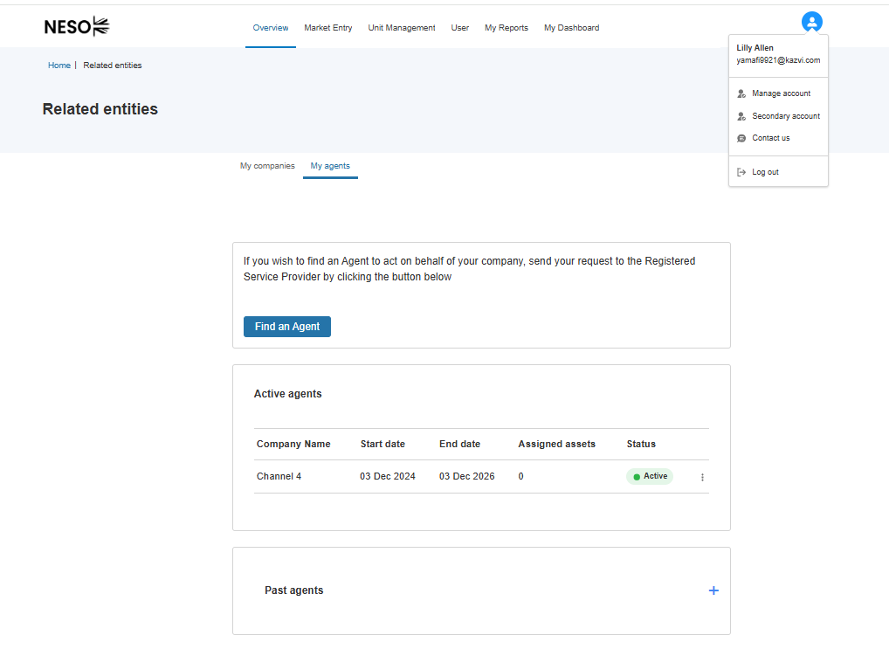

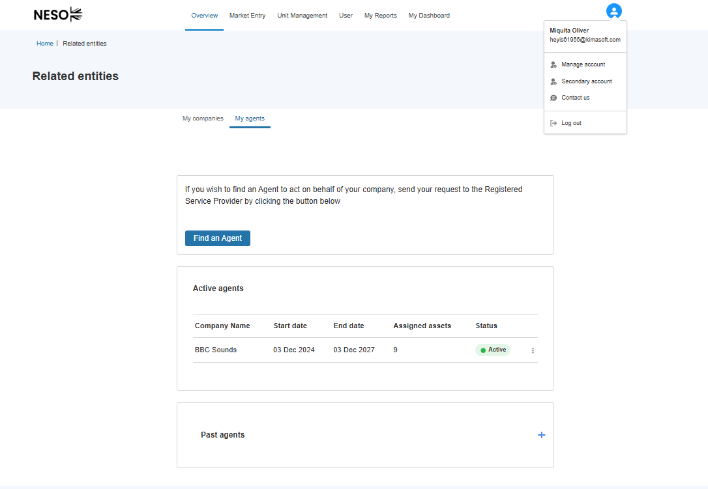

Consent Exchange Process – Extension Rejected
Where consent is not granted, the status remains as ‘active’ and there is no change to the existing date. The other party’s users will receive an email notification to acknowledge the rejection outcome.
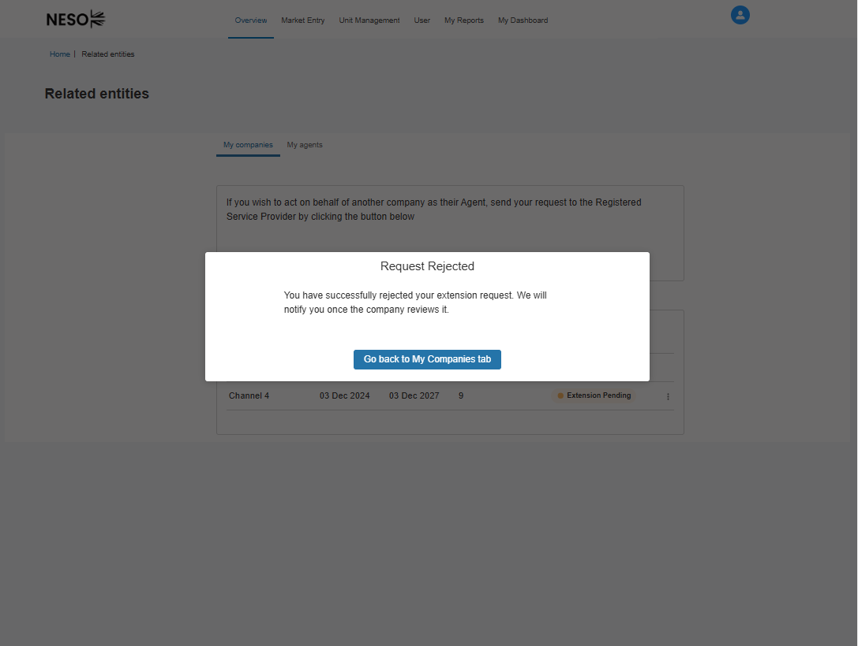

Email Alert Templates
The screenshots below, illustrate example templates for all the Email Alerts sent to Users in connection with Related Entity Process.

Example 1: Email to the Agent to confirm that the Asset Owner has initiated the ‘Termination Request/Order Instruction’
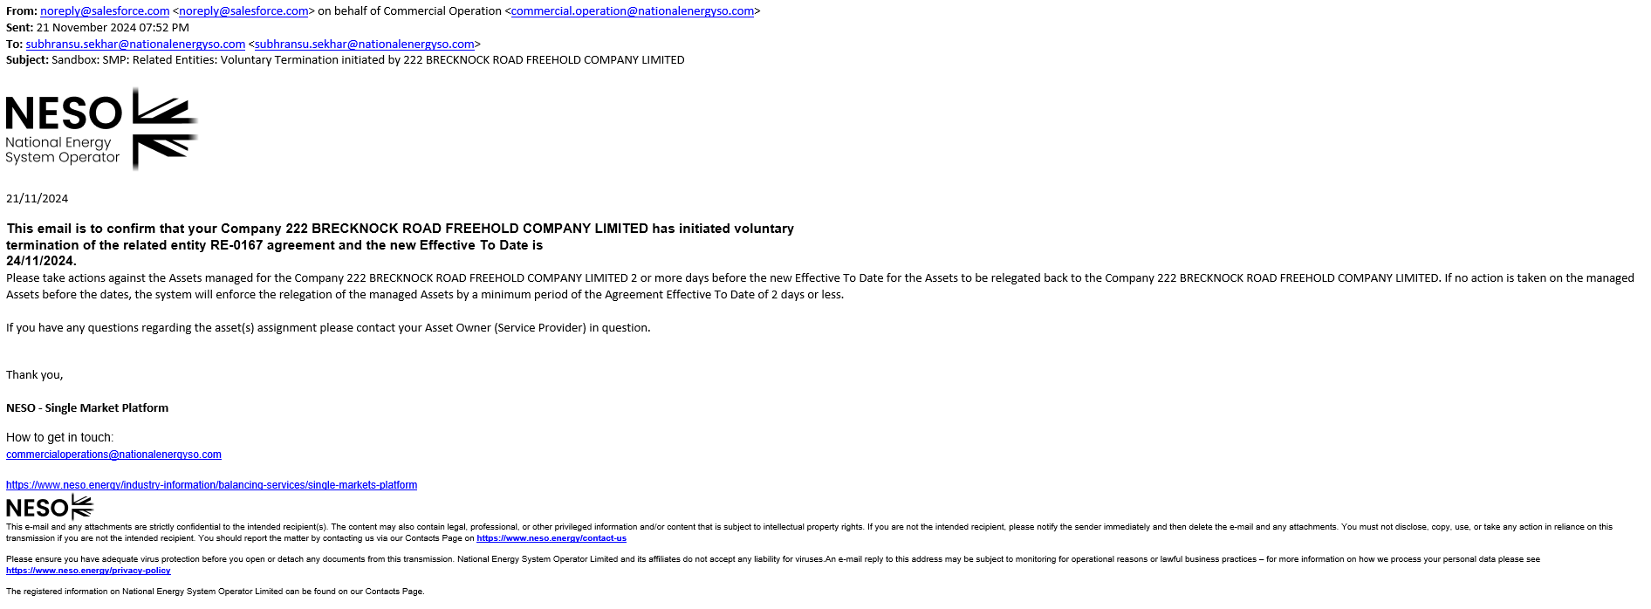

Example 2: Email to the Agent to confirm that the automatic Global Versioning of Committed Units will take effect. 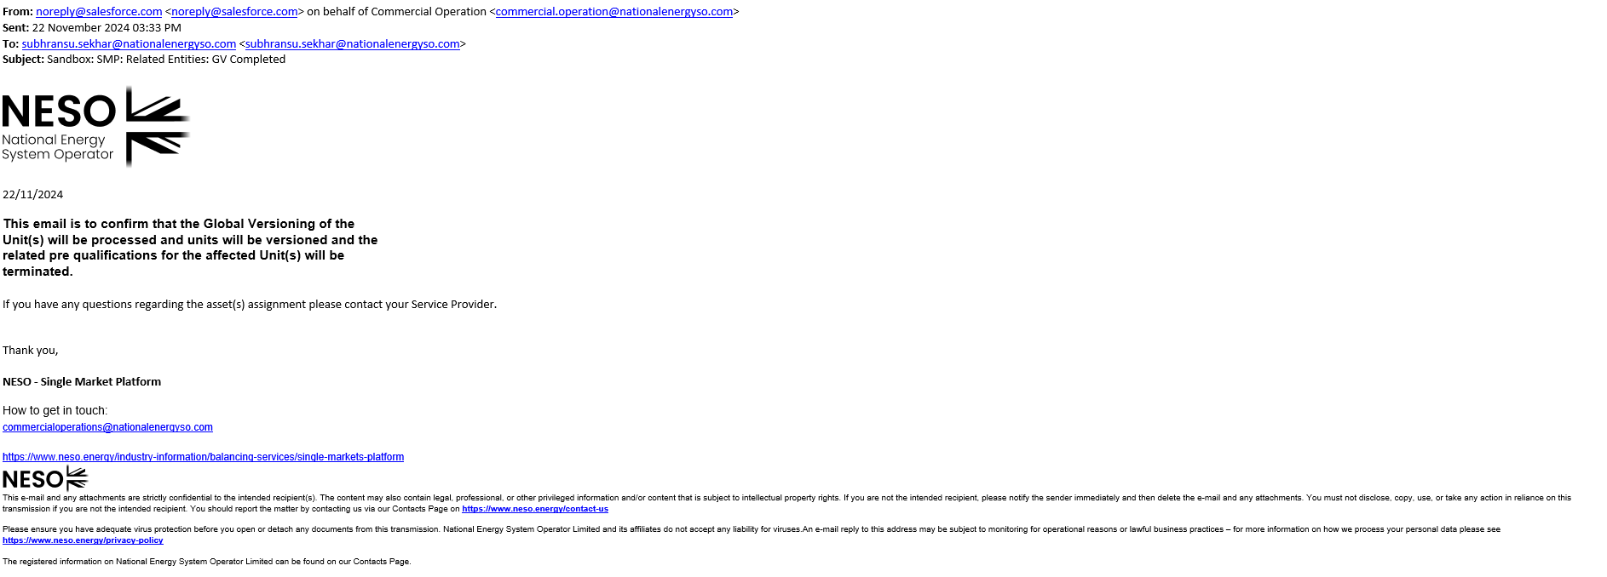

Email Alert Templates (Cont)
Example 3: Email to the Agent to confirm that the automatic Global Versioning of Committed Units will take effect. 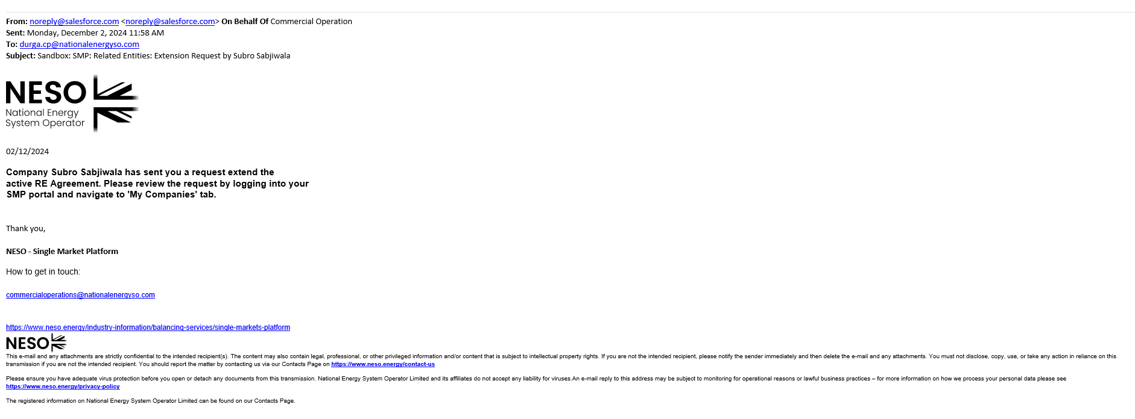
Example 4: Email Acknowledgement of Consent to Extend Agreement sent to Agent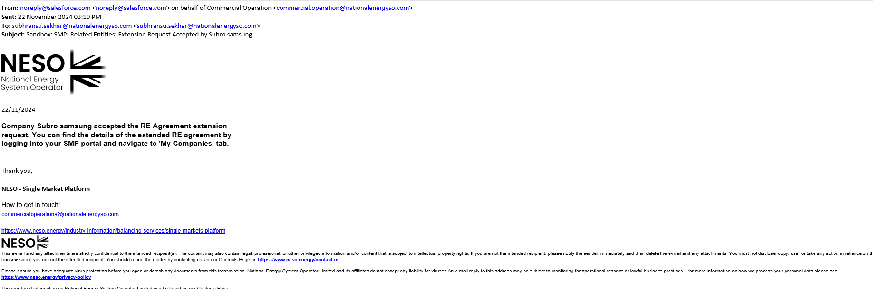
Example 5: Email Acknowledgement of Consent to Extend Agreement sent to Asset Owner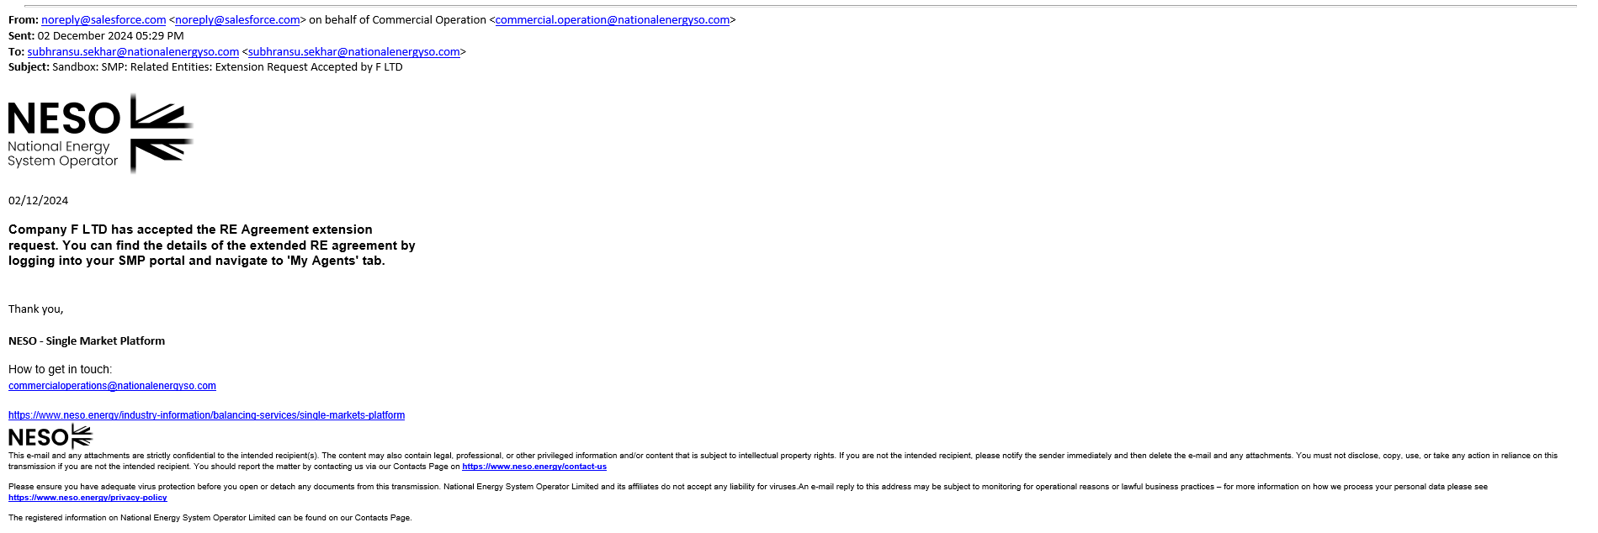

Email Alert Templates (Cont)
Example 6: Email to the Agent or the Asset Owner to acknowledge that the consent was not granted for extension request

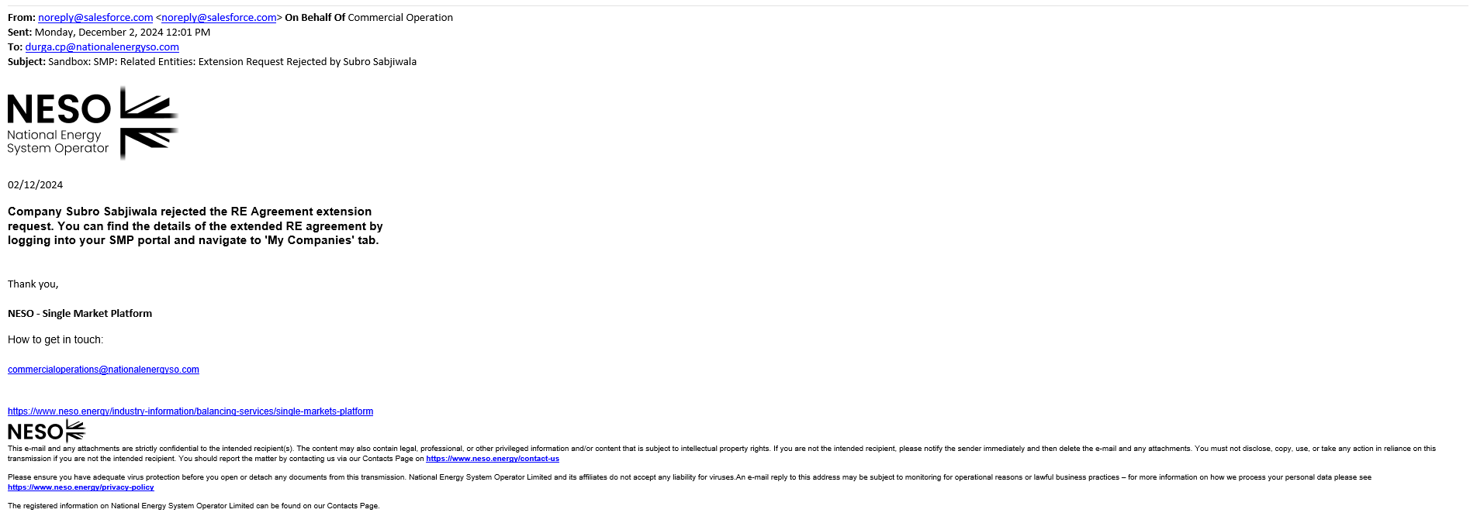

Inter-company Sharing Agreements

Definition of Inter-Company Sharing Agreements

In the context of SMP, an Inter-Company Sharing Agreement has been defined as a whereby a Market Provider (Company A) has entered into a representational relationship with another Market Provider (Company B) for a defined period to enable them to acquire and manage the existing ‘Portfolio’ on their behalf.
The portfolio is defined as the following;
- All Units (in either Draft, Submitted AND Accepted State) owned by Company A
- All Assets (in accepted state) either owned directly by Company A or acquired by Company A through a Related Entity Agreement Transfer** (**where the Related Entity Agreement is still valid)
- All Existing Prequalification Applications (in either Draft, Submitted, Submitted for Signature, Incomplete AND Approved State)
- Any Asset Testing Documentation (ITE Certification) provided as appendages to the prequalification Applications
- Reporting & Data Analytics associated with Units, Assets and Prequalification Applications contained within the Portfolio.

Scope of Inter-Company Sharing Agreements

The Inter-Company Sharing Agreement is primarily designed for Market Providers whom are part of a Corporate/Legal Structure with other Market Providers such as Parent Companies whom Subsidiary Companies or Companies whom acquire other Companies through mergers and acquisitions. However, it can also encompass the needs of Market Providers whom are independent of one another.
The key objective of an Inter-Company Sharing Agreement and the respective functionality on SMP is to allow such Companies to enable access to their ‘Portfolio’ and the ability to directly manage the portfolio on their behalf whilst continue to manage their own native portfolio simultaneously for the duration of the agreement period.

Distinction between Company/Market Provider Agreement Types

An Inter-Company Sharing Agreement has a distinct purpose from a Related Entity Agreement as follows;
Inter-Company Sharing Agreement: Enables a Market Provider (Company A) aka ‘Primary’ Account to directly access and manage at least one (or more) Market Provider’s (Company B, C, D etc) aka ‘Secondary’ Whole Portfolio for a pre-defined given time period whilst being able to also access and manage their own portfolios.
Management activities does encompass the core functionality of SMP;
- Update or Alter an existing Unit’s logical grouping through the Global Versioning Process
- Apply for new Services for existing Units already pre-qualified for existing Services acting as the Secondary Account
- Add or remove existing Asset(s) directly owned by Company B, C, D etc ( ‘Secondary Account’) to new Unit(s) or existing Units (through Global Versioning)
- Add or remove existing Asset(s) not directly owned by Company B, C, D etc ( ‘Secondary Account’ but ‘leased’ from a third party Market Provider through the medium of a Related Entity Agreement (transfer/delegation of asset(s))
- Directly register or onboard new Units acting as the Secondary Account.
- Directly register or onboard new asset’s acting as the Secondary Account.
- Align new Unit(s) with asset(s) and prequalify Unit(s) for services acting as the Secondary Account
- Representatives (Employees aka Portal Users) on behalf of the Primary Account can ‘Account Switch’ between their own Company’s Portfolio and alternate any Secondary Account Portfolio’s using their native/own SMP Account and login in using only one set of login credentials

Management activities do not encompass the following functionality of SMP;
The ability to access EAC (Enduring Auction Platform) and submit bids for Trading using ANY of the Secondary Account’s eligible Unit(s) is prohibited.
Access to EAC (Enduring Auction Platform) will only be permitted for User’s native Account (Primary)
Related Entity Agreement: Is essentially exclusive to management of Asset(s) specifically.
- It enables a Market Provider (Company B, C, D etc – Service Provider) to delegate management of select Asset(s) they own to another Market Provider (Company A - Agent) for a pre-defined given time period.
- It enables a Market Provider (Company A - Agent) to directly register or on behalf of (Company B, C, D etc – Service Provider)
- The Agent only uses their own native account to create or modify Units with said Asset(s) AND prequalify their own Units for Services.
- The Service Provider is prohibited from leveraging the delegated asset(s) to align to Units or add to existing Units throughout the duration of the agreement.

The Asset Owner relegates responsibility of the delegated asset(s) for the duration of the agreement period and is prohibited from performing any management activities on SMP with said asset(s).
The Agent is permitted to submit bids using asset(s) to which they have been granted delegation exclusively for the period of the Agreement period.

Conditions of Inter-Company Sharing Agreements
The following pre-requisites conditions are required for providers to take advantage of an Inter-Company Sharing Agreement and the functionality;
- Both Market Provider’s must be registered on SMP by at least one Company’s representative. This means the Company and the User must self-register prior to access SMP.
- Where an existing Market Provider ‘Company’ is registered however there are no associated ‘active’ portal user(s) associated with the Company registered, then it is expected that at least one or more Company’s representatives/employees must self-register. If prospective User(s) wish to clarify if their Company’s Account is already known to ESO and if any existing ‘active’ portal user(s) have already registered on SMP, then they are advised to approach to their respective Contract Manager in advance.
- In the instances that no employees are associated with the Secondary Account(s) or the same employee is affiliated to both the Primary Account and the Secondary Account(s), then subject to approval by the Contract Management Team then it is permissible for the employee representing the Primary Account to enter into an Inter-Company Sharing Agreement with one or more Secondary Account(s) and subsequently access the Secondary Account(s) using their native set (Primary Account Username & Email Address) of SSO Login credentials. Where this applies, a request must be submitted to the Contract Manager. An internal procedure will be followed to enable this access.
- Access to Secondary Account(s) Portfolio cannot be granted without a ‘live’ Inter-Company Sharing Agreement in place. The Company whom initiates the request to establish a Company Sharing Agreement is classified as the ‘Primary’ Account. Any Market Provider registered on SMP can initiate a request to establish a Company Sharing Agreement.
- An Active Portal User representing the Primary Account must possess the ‘Super User’ Role in order to be able to send an initiation request to another Company.
- Only an Active Portal User representing the Secondary Account in possession of the Super User Role can accept or reject an initiation request from a Primary Account. ** (With the exception of the case where no other active portal user is affiliated with the Secondary Account)
- Only selective User’s associated with the Primary Account can access any Secondary Account(s) portfolios. Access must be determined by the Super User through User Management Functionality on the SMP (User Interface) Portal.
- Users associated with the Secondary Account will continue to be able to directly access their own portfolios despite an Inter-Company Sharing Agreement in place, therefore there is a risk of both User’s affiliated with the Primary Account AND User’s affiliated to the Secondary Account managing the same portfolio at the same time.

Agreement Business Rules
- A Market Provider cannot submit duplicate nomination requests to the same provider for the same representation date window.
- A Market Provider can however extend an agreement but submitting a new request with a different set of dates with the same provider
- A Market Provider cannot submit multiple nomination requests to different providers with different or the same representation date window.
- Both parties have to accept the agreement and consent to the terms and conditions before the agreement is formalised on SMP. If either party fails to accept or reject, the agreement remains in ‘pending’ state. **(With the exception of the case where no other active portal user is affiliated with the Secondary Account)
- If either party rejects the agreement, it is made redundant and the process and the agreement exchange is terminated. **(With the exception of the case where no other active portal user is affiliated with the Secondary Account)
- The ability to access EAC (Enduring Auction Platform) and submit bids for Trading using ANY of the Secondary Account’s eligible Unit(s) is prohibited throughout the duration of the agreement period. This rule extends to where a Primary Account is in a singular relationship or multiple relationships concurrently.
- Access to EAC (Enduring Auction Platform) will only be permitted for User’s native Account (Primary)
- The Secondary Account(s) Portfolio Records will only become available to the Primary Account’s respective User’s on Day 1 of the representation period.
- Once the Agreement Period has expired, unless the agreement has been extended, then the access to the Secondary Account’s Portfolio will be revoked the Day after the last day of the Representation Period (Effective To Date). Users associated with the Primary Account will no longer be able to gain access to the Secondary Account’s Portfolio records.

Agreement Considerations
- It is recommended that when setting the representation dates, Both the Primary & Secondary Account(s) representatives ensure they allow for sufficient lead or onboarding time to ensure that the Primary Account’s User’s are in a position to form a new Unit and prequalify successfully prior to auction timeframes.
- It is recommended that when a representative from a Primary Account wishes to submit a pre-qualified Unit for Trading on EAC the Unit MUST be owned by the Primary Account. Therefore when creating new Unit’s they must perform this action as the Primary Account (native).
- Any existing Pre-qualification Applications for Services tied to Units in Accepted State that have been created previously by a Secondary Account User may subjected to the requirement to have a new ‘Form B’ Service Agreement re-submitted with the approval of an Authorised Signature representing the Primary Account. This can apply to Pre-qualifications in the following states;
  - ‘Draft’
  - Submitted (previously by the Secondary Account Users)
  - Signature in Progress, Incomplete (previously by the Secondary Account Users)
In order to enable this, your Contract Manager can revert the existing applications to ‘Draft’ State in order to allow them to be re-submitted for a new Form B. In readiness for this however it is important that a) an Authorised Signatory has been onboarded to the Primary Account and b) Has been extended access to the Secondary Account. Please visit the Chapter on User Management for further details on how to onboard an Authorised Signatory

Initiating (Nomination) Requests

Locating a prospective Secondary Account

If you are initiating the request (Active Portal User) representing the Primary Account.
*You will require the ‘Super User’ Role. To verify you can navigate to the User Management Screen, where assigned roles are listed against ‘active’ users. To acquire the Super User Role, you will need to reach out to your Contract Manager whom can assign the role to your User Record.
- As a Super User, you will see the ‘My Additional Accounts’ Tab appear on the Overview/Home Page Screen.
- Select this option to initiate an Inter-Company Agreement
- Alternatively you can opt to select the ‘Secondary Account’ option upon clicking on your Avatar to display the ‘Mini’ Screen

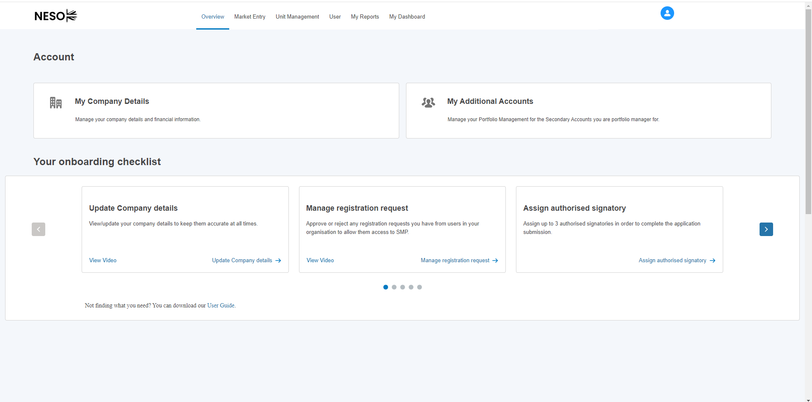
Proceed with navigating to the ‘Find Secondary Accounts’ Custom Button and click
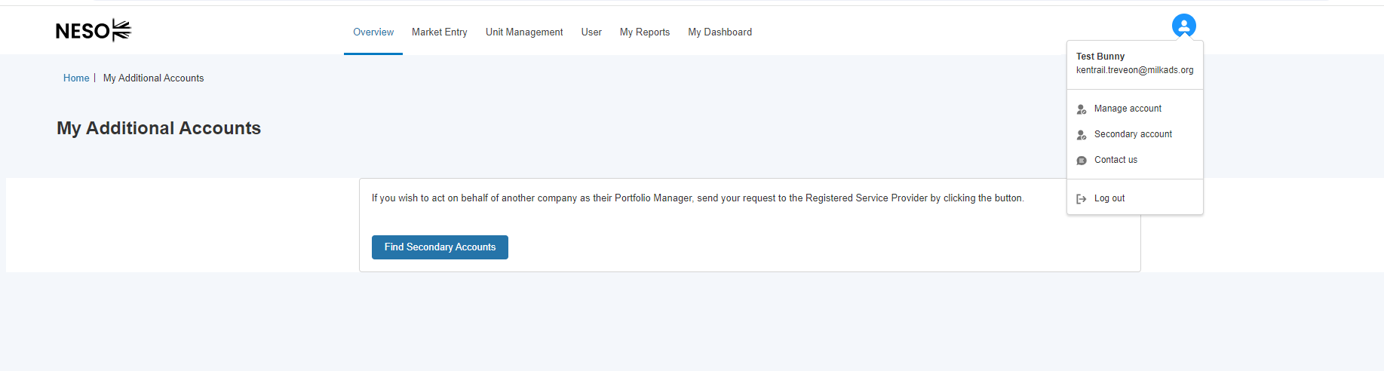

Locating a prospective Secondary Account– Entering in the Market Provider Details
The pop-up screen prompting the prospective Company will ask for two mandatory pieces of information a) the Company Registration Number in the search box and b) the representation dates. Please note that without entering a valid number, the process will be aborted. When a valid Registration number is detected, the corresponding Company Details are displayed.

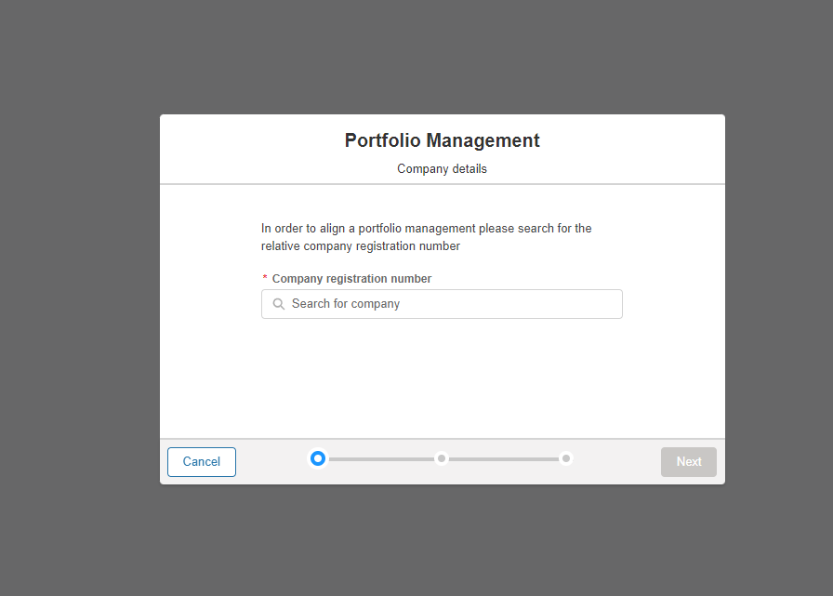
v
v

Locating a prospective Secondary Account – Entering the Company Details

The search result will appear, to confirm select ‘Next’, if the search result returns a result which was not correct or expected, then the process can be abandoned by selecting ‘Cancel’ allowing a new search to be performed if required.

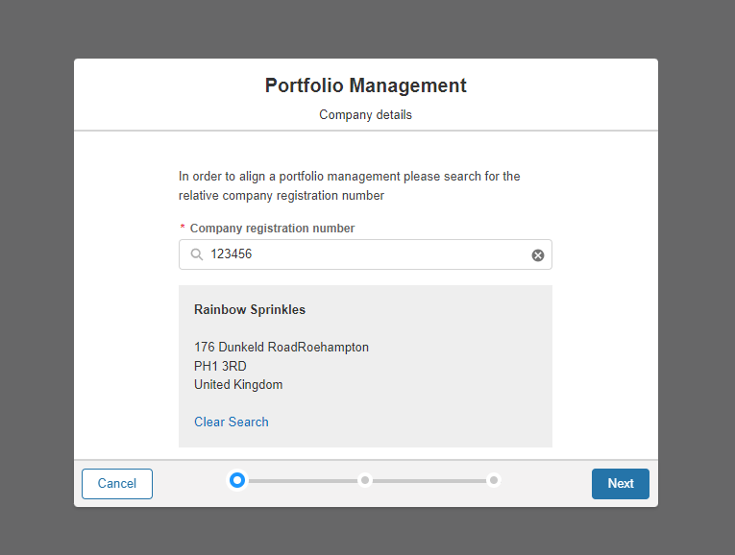

Locating a prospective Secondary Account – If a Company cannot be located or the pre-conditions have not been met
If the search returns an error message, it will be due to the fact the number entered is incorrect or the intended Account does not have a Super User affiliated to it. In this instance, as per Section 11.4 Conditions of Inter-Company Agreements, it will not be possible to continue with the exercise unless a Super User has been onboarded onto the Secondary Account in question (With the exception of the case where no other active portal user is affiliated with the Secondary Account)

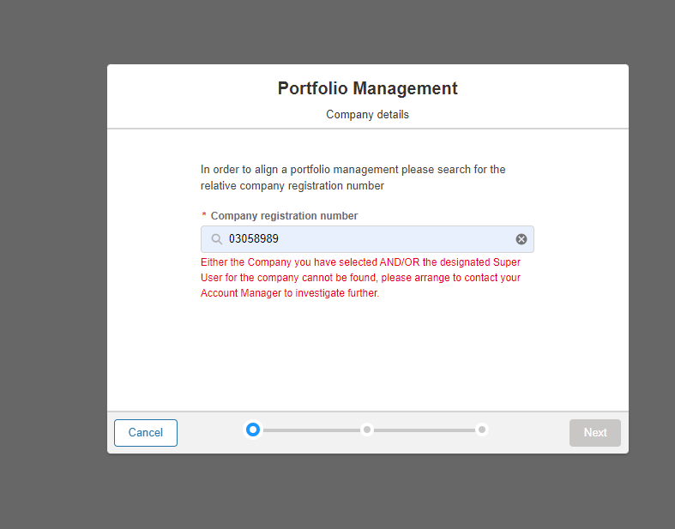

Locating a prospective Secondary Account – Entering the Agreement Dates
Next proceed with entering the Effective From and the Effective To Dates in the format specified. It is mandatory to specify the two sets of dates, so if these are not known, then the process can be abandoned by selecting the ‘Cancel’ option.

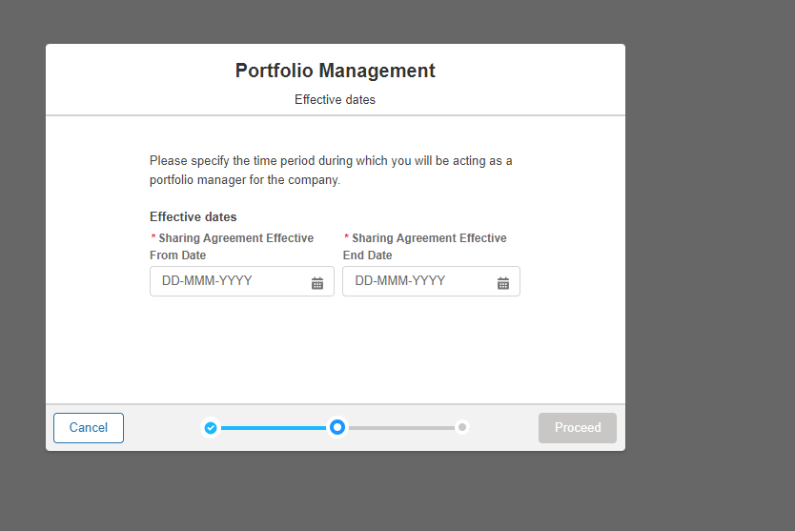

Consenting to the Terms & Conditions as the Primary Account Representative
The next screen to appear will present the ESO Terms & Conditional Clauses that must be reviewed and either Accepted or Rejected before completing the exercise of initiating the Inter Company Agreement Request. If the ‘Rejection’ option is selected, then the Agreement process will be revoked, requiring either a new request be made or indicates that the process has been abandoned.

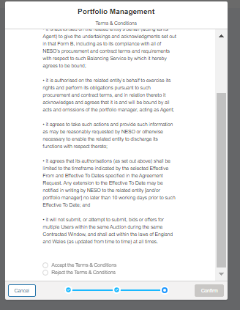

Locating a prospective Secondary Account – Confirmation of Submission of Nomination Request
The pop up screen below will appear to confirm the end of the initial nomination request exercise and awaiting the representative from the Secondary Account to perform their reciprocal actions.
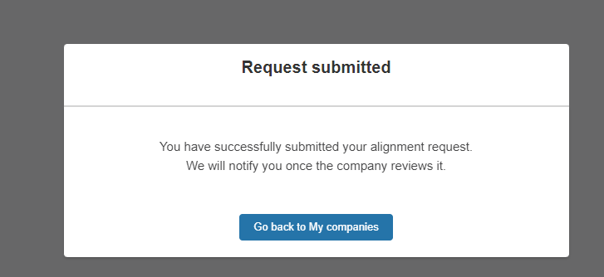

Expiry of Initiation (Nomination) Requests

Once the Initiation Request is generated, the representative of the Secondary Account (where this applies) must respond and complete the formation of the agreement within a given time period of 14 days from when the request was made.

A scheduled reminder will be sent if the Secondary Account’s representative has yet to accept or reject the nomination request within this period.
- At the point the request was made an email will be automatically generated and sent to the other party’s representative to accept or reject the agreement
- 7 Days (consecutive) after the date the request was initiated and the first email was dispatched, where the agreement has only been partially agreed to by one party

If the Agreement has not been formed 14 days from when the original request was made then the Nomination Request will be marked as ‘cancelled’ and expire. If both parties wish to resume the original task then a new nomination request will be required.

It is therefore imperative that the representatives for both providers are fully aware and anticipate the email exchange within the 14 day period .

Expiry of Nomination Requests - Email Alert

Confirmation Email Alert Template
Agreement Nomination Request – Reminder Email Template*
The reminder template is standard across both Related Entity and Inter Company Agreement Nomination Requests

Recipients of (Nomination) Requests – Secondary Account

Accepting/Rejecting Nomination Requests as the Secondary Account.
Once the request has been confirmed, the Super User associated with the Secondary Account will be sent an Email Alert prompting them of the pending nomination request. They will be expected to click on the hyperlink in the body of the email or login directly to the SMP Portal to be able to complete the acceptance or rejection of the nomination request exercise.

As the prospective Secondary Account representative, the associated portal user will click on the ‘My Additional Accounts’ Tab on the Overview/Home Page or alternatively they can navigate to their Avatar and select the option ‘Secondary Account’ from the list.

The Asset Owner’s portal users will be presented with the screen below, when at least one of the User’s in the case of mulltiple user’s either selects Reject or Accept, the pending agreement notification will remain on the SMP Portal.

The request notification with the option to Accept or Reject the request will display under the My Additional Accounts Page. Prior to selecting Accept option they will be required to visit the Terms & Conditions Page to review the content. It is recommended they do this in a different tab on their browser.

Nomination Request Listing/Offer

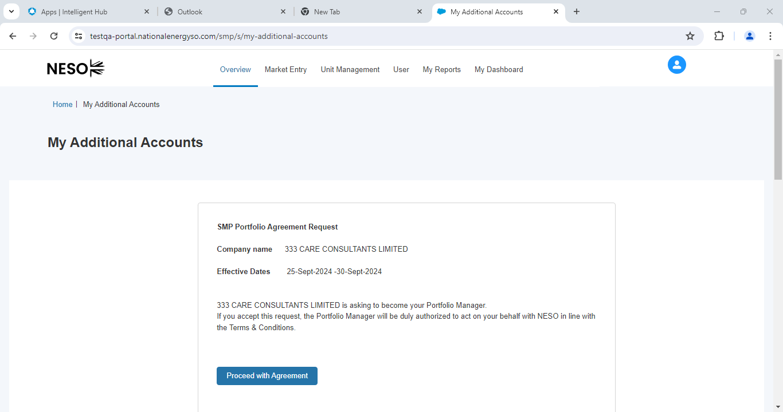

Accepting Nomination: Upon selecting this option the following actions will occur;
- The Primary Account’s Super User will be notified by Email and via an in portal notification
- They will be expected to login into SMP and replicate the Acceptance of the Terms of Conditions
- Once they have reciprocated and accepted the ‘pending agreement’ the Status will move to Accepted and the Agreement will officially be formalised on SMP. A record of the Portal User whom accepted the agreement and consented to the Terms & Conditons and the date of consent for both parties will documented on SMP internally.
Rejecting Nomination: : Upon selecting this option the following actions will occur
- The Primary Account’s Super User will be notified by Email of the Rejection Outcome.

Consenting to the Terms & Conditions – Agreement Copy
The image below provides the description of Terms & Conditions legal text that both parties (respective Super Users for the Primary and Secondary Account) are expected to consent to in order to complete the formation of the agreement

Prevention of completing the formation of an Inter-Company Sharing Agreement.

One of the Business Rule conditions enforced is to ensure that a prior agreement between both parties is not already in place to avoid duplicate agreement records being created on the system, where a Primary Account representative attempts to initiate a request to the same Company/Market Provider for the same representation period dates and a ‘live’ agreement is already in place, any additional requests are blocked.

Notification that an existing Agreement is in place
If a Market Provider’s Portal User attempts a repeat request above during the nomination stage, this message will appear on screen.

Notification that one of the parties is still pending approval
If either of the Market Provider’s Super User’s are yet to either a) consent to the Terms & Conditions or b) the nomination request is still in a pending state during the 14 day period, this message will appear on screen if they attempt to initiate a duplicate request to the same Market Provider for the same representation dates. This will block any potential duplicate requests being ‘created’ on SMP.

In portal notification – Secondary Account Portal Super User

Post Formation of Inter Company Sharing Agreement

Ability to ‘Account Switch’ between Primary and Secondary Account(s)
Once an Inter-Company Sharing Agreement has been established the Super User from the Primary Account will be granted access to the Secondary Account ‘Portfolio’ the same day.
When referring to the ‘Portfolio’, it essentially means that the Secondary Account SMP Portal will be visible to the Super User from the Primary Account.
- To enable this feature, always navigate to the Avatar and select the Drop Down Menu. This allows a Super User to alternate between Portal Screens, they can leverage the ‘Account Switch’ feature by simply navigating to the ‘toggle’ button listed against the Secondary Account Name.
In the diagram below, there is a listing for two companies; a) ‘Rainbow Sprinkles’ and b) 123 Limited. Rainbow Sprinkles is classified as the ‘Primary Account’.
- By dragging the toggle from Left to Right for 123 Limited, the Screen will switch to the Secondary Account (123 Limited).
- Conversely by dragging the toggle from Left to Right for Rainbow Sprinkles , the Screen will switch back to the Primary Account.
- When the toggle indicator is shaded in grey, it indicates that this Account is in ‘sleep’ mode. It is not possible to ‘toggle’ on more than one Account at any given time when logged into SMP.

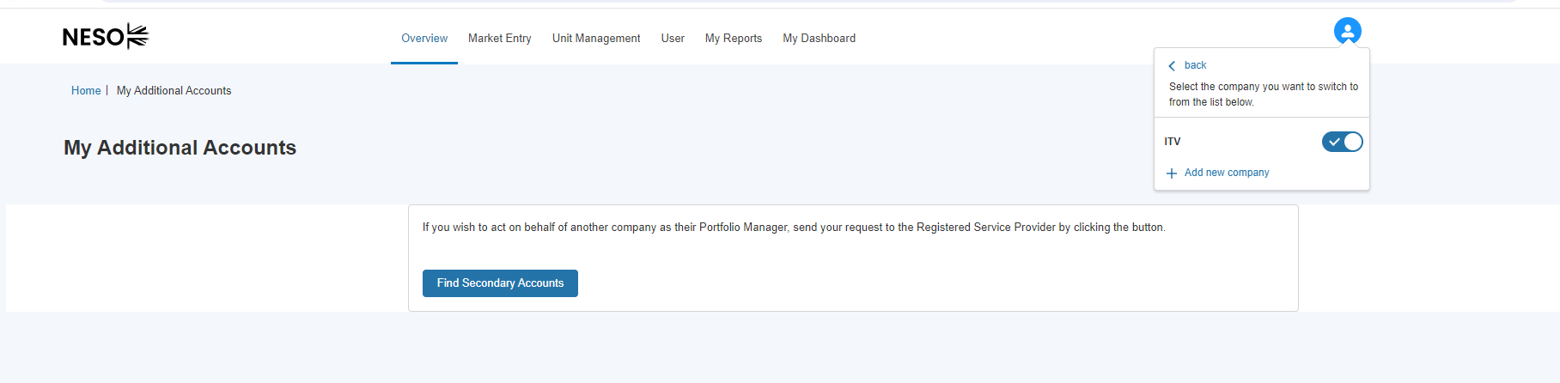

In the diagram above, the Account Portfolio for the Secondary Account is on display. The Super User is able to perform the duties/activities as outlined in Section 11.3 with the exception of accessing EAC with the Secondary Account Portfolio.

The Trader Role in the context of Primary & Secondary Account Access.
As it stands with the introduction of the Inter-Company Sharing Agreement Feature, User’s with the Trader Role and the Super User Role will not be able to perform account switching to secondary accounts but will continue to have access to their own Portfolio and as such be able to click the EAC custom link button to submit bids and participate in Auctions for Units ‘owned’ by the Primary Account
This restriction applies throughout the duration of the Inter-Company Sharing Agreement period.

Extending Access for Additional Users from the Primary Account – Granting Access

Where a Super User wishes to grant access to one or more Secondary Account(s) for their own additional active portal users, then they will need to update the User’s ‘profile’ on the Portal under the User Management Section.

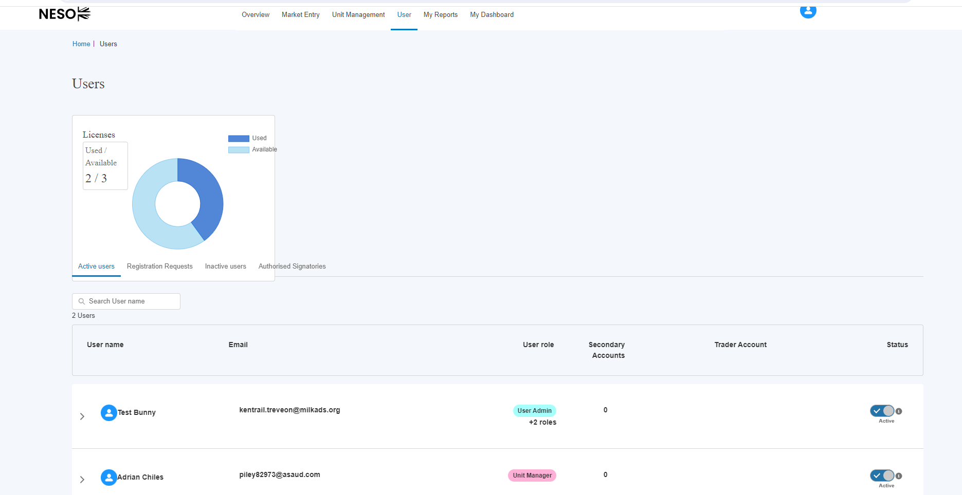

Navigate to the User in question and click on their name, navigate to the Secondary Account listing and click on the Account in question to move it from the left column to the right column.

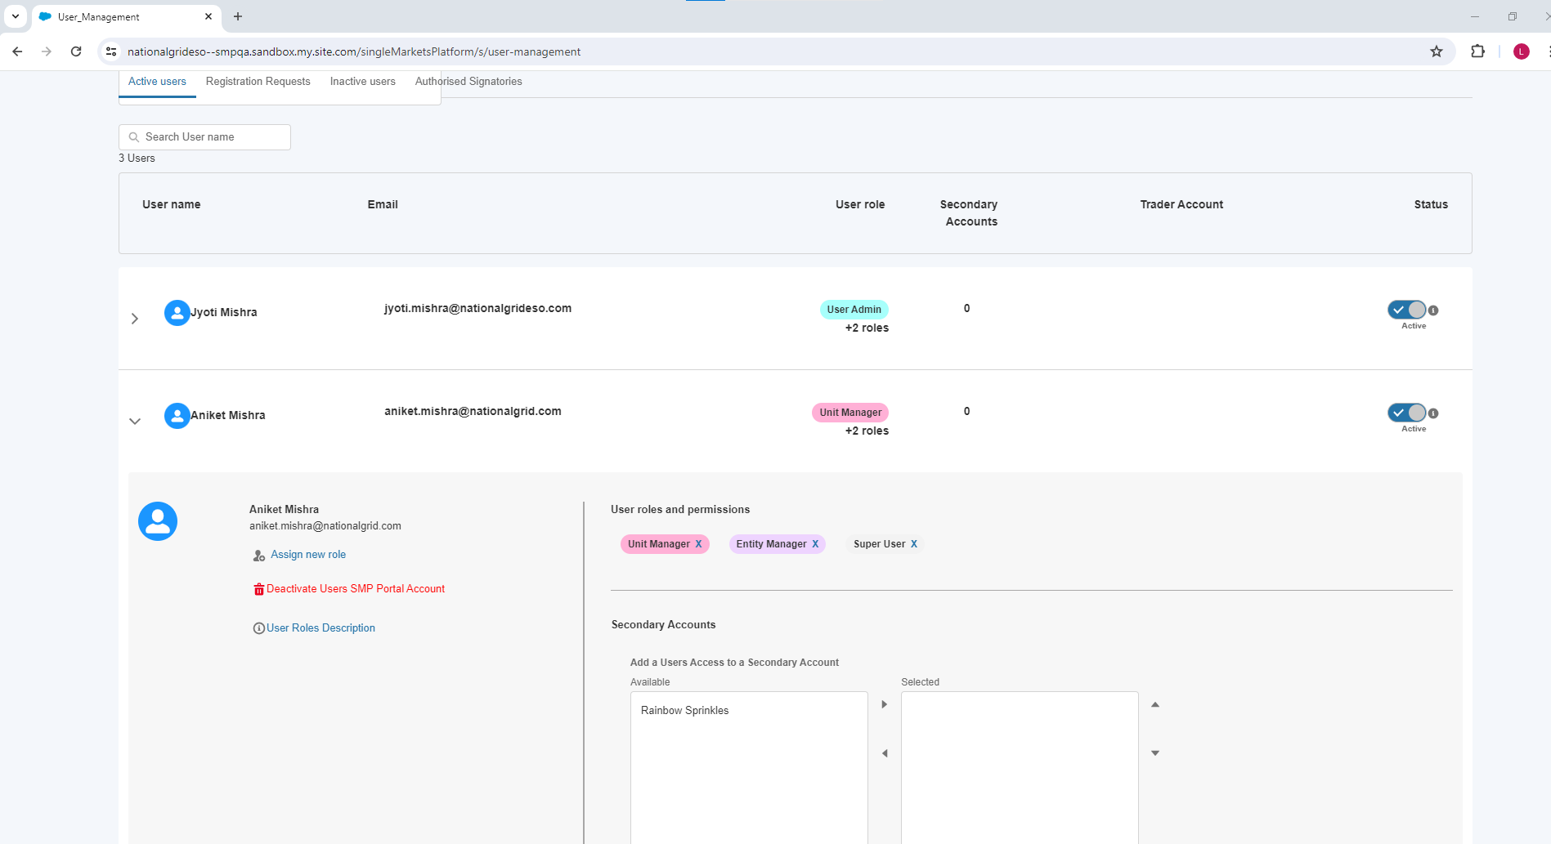

Extending Access for Additional Users from the Primary Account – Removing Access

Access can also be revoked by conversely reversing the same sequence of steps - Navigate to the User in question and click on their name, navigate to the Secondary Account listing and click on the Account in question to move it from the right column to the left column.

Confirmation Email Alerts
Outlined below are the various Email Alert notifications that are issued to Market Providers throughout the formation of the Inter Company Agreement Process.

Confirmation Email Alert Template 1
Request initiated by either party

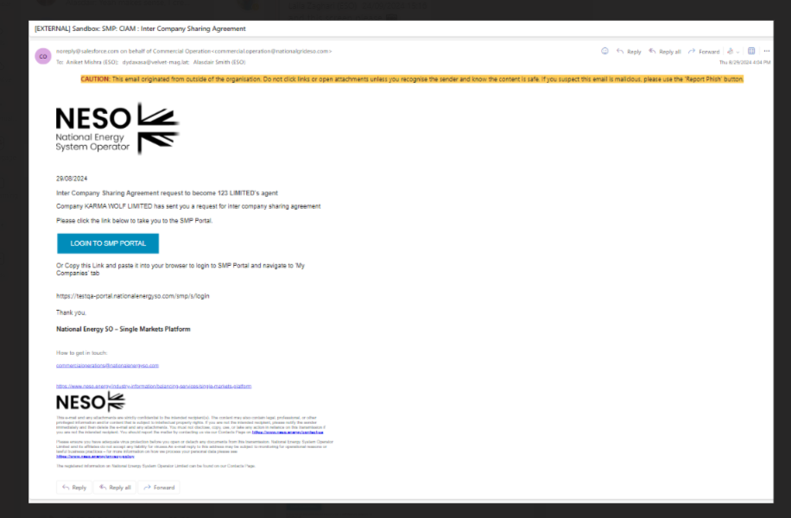

Confirmation Email Alert Template 2
Request – Accepted: Agreement Successful
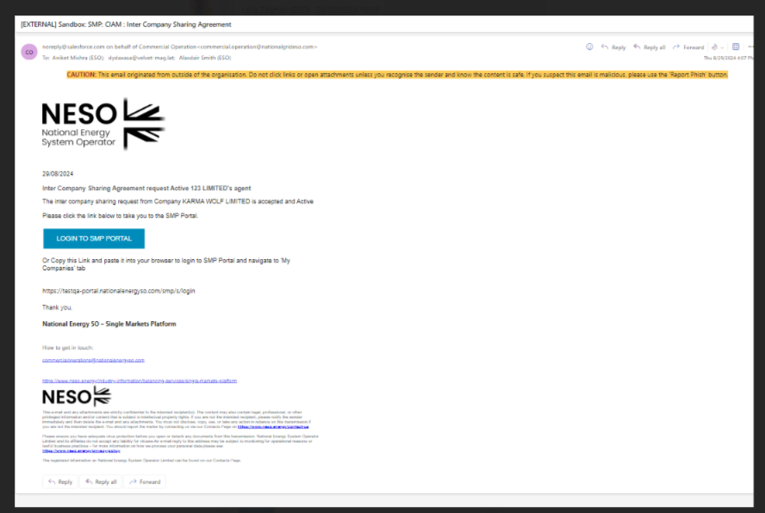

Confirmation Email Alerts
Outlined below are the various Email Alert notifications that are issued to Market Providers throughout the formation of the Inter Company Agreement Process.

Confirmation Email Alert Template 3
Request – Rejected: Agreement not successful

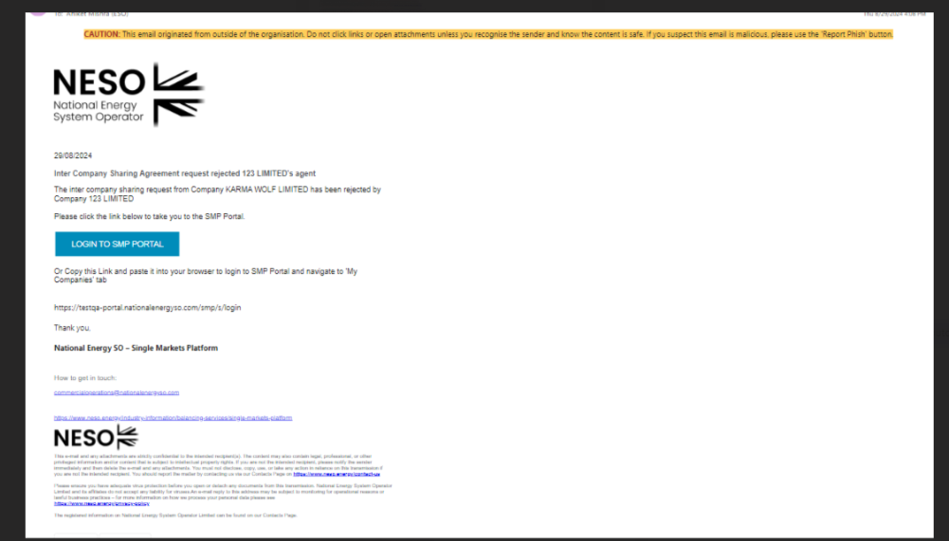

Registering an additional account

To register an additional account not registered yet in SMP, locate the profile icon in the top right corner of the page and select ‘Secondary Account’
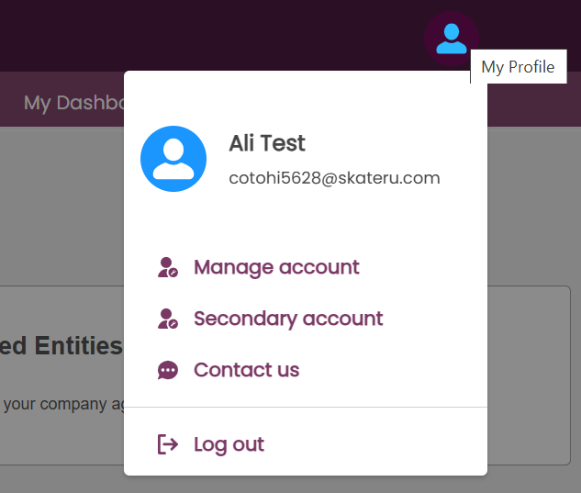
Then click the ‘+ Add new company’ link
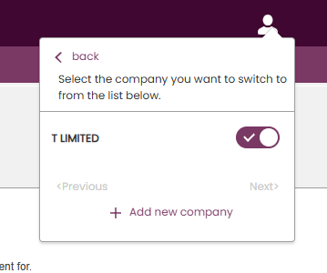
The user is taken to the My Additional Accounts page. Here, select ‘Register Additional Company’
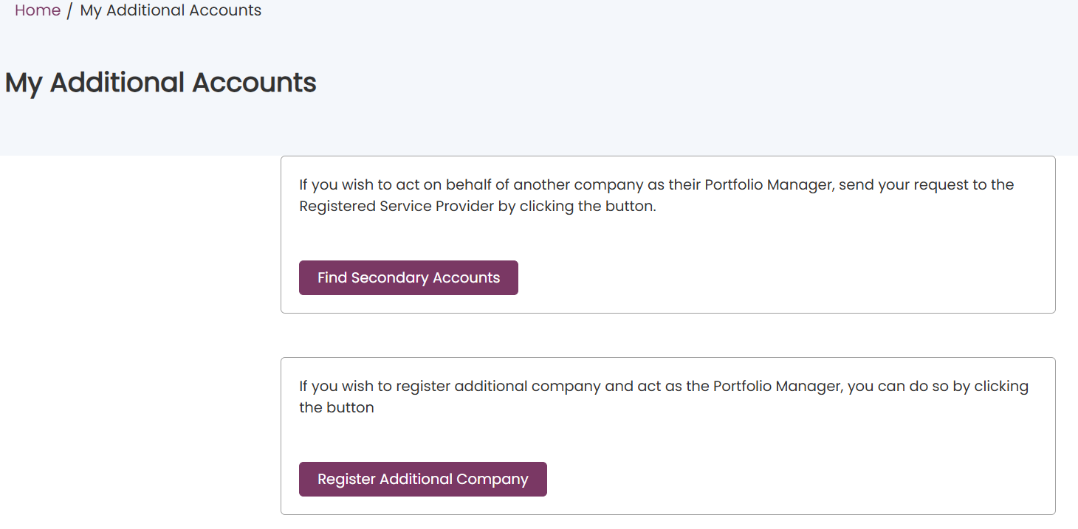
Select whether the company you wish to register is a UK Limited Company or Non UK Company, then press Next
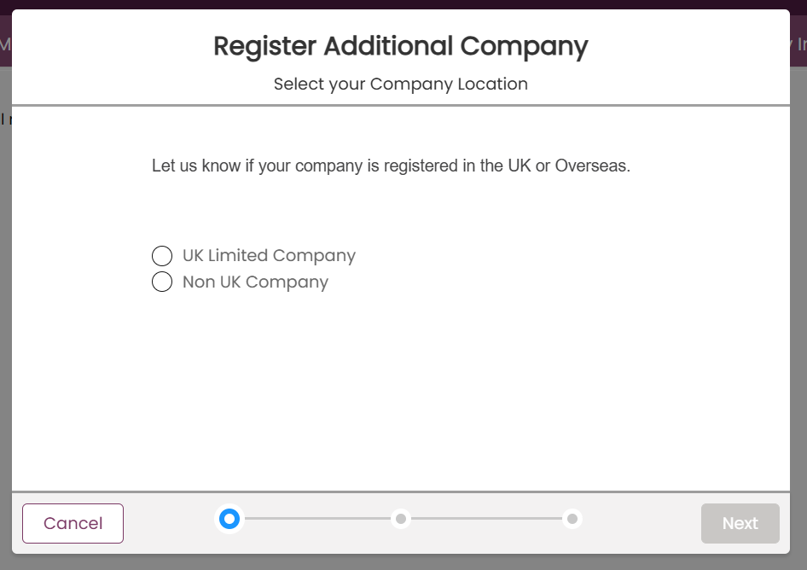
If UK Limited Company is selected, enter the Company Registration (Companies House) number of the organisation, then press Proceed.
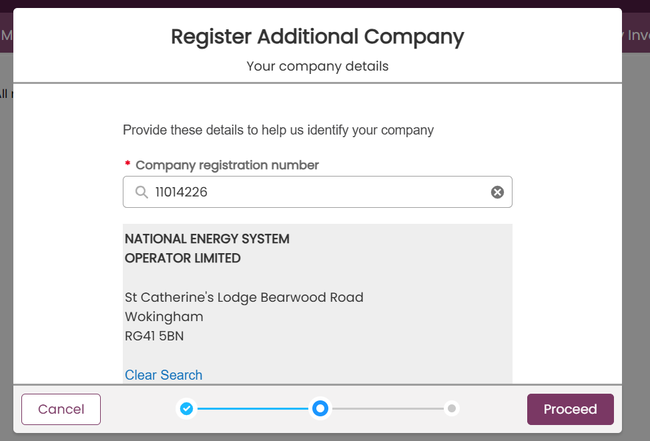
If Non UK Company is selected, enter all the information requested, including the company name and address of the organisation, then press Proceed.
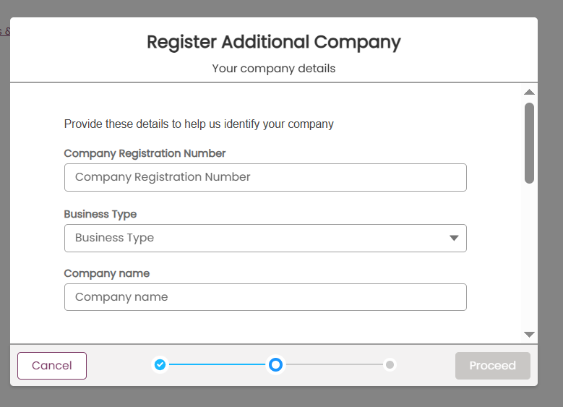
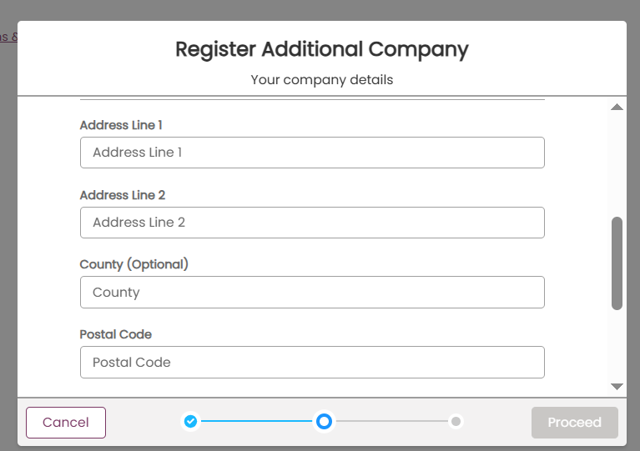
Enter the from and end dates that access is needed to the company in SMP. If access is needed right away, select today’s date as the Effective From Date, and press Confirm.
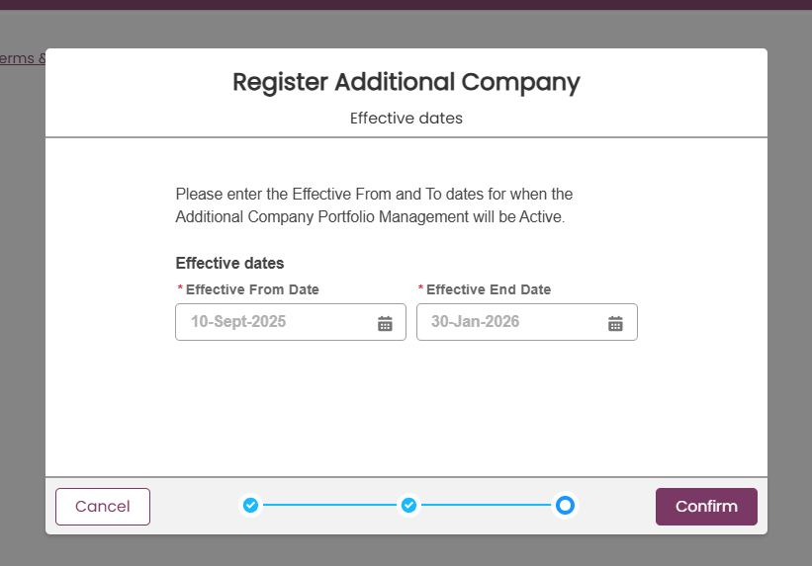

The request to register the additional company will now be with the NESO Contract Manager team to approve. When they have done so, the user will be able to switch to the newly registered account by again selecting the profile icon and then Secondary Account
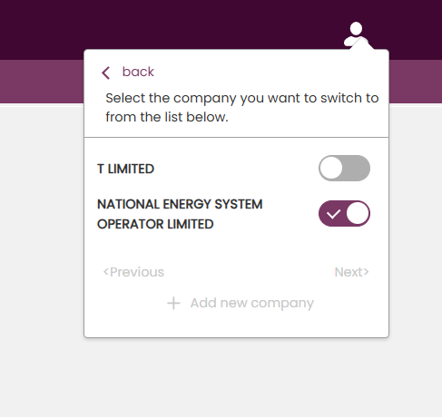
The user can now access the account with delegated Super User, User Admin and Unit Manager permissions.

Providing Financial Banking Details

Recording Financial Payment Details

A provider should supply their Financial Payment information on the Portal under Company Details section of the portal. Moving forward all providers will be expected to provide and update their financial details on the SMP Portal in order to ensure the most accurate banking details are captured.
A portal user must have the Finance Manager Role in order to access this feature. Click on the Avatar icon or navigate to the My Company Details Tile on the Overview Tab/Landing Page.

Figure 14.1: Accessing Company Details Screen

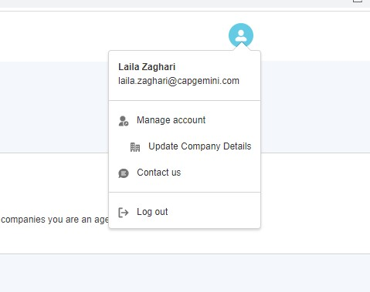

Recording Financial Payment Details: Cont

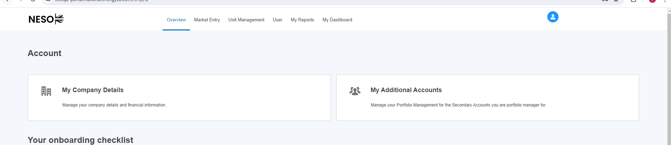
v

Figure 14.1: Update Company Details Screen

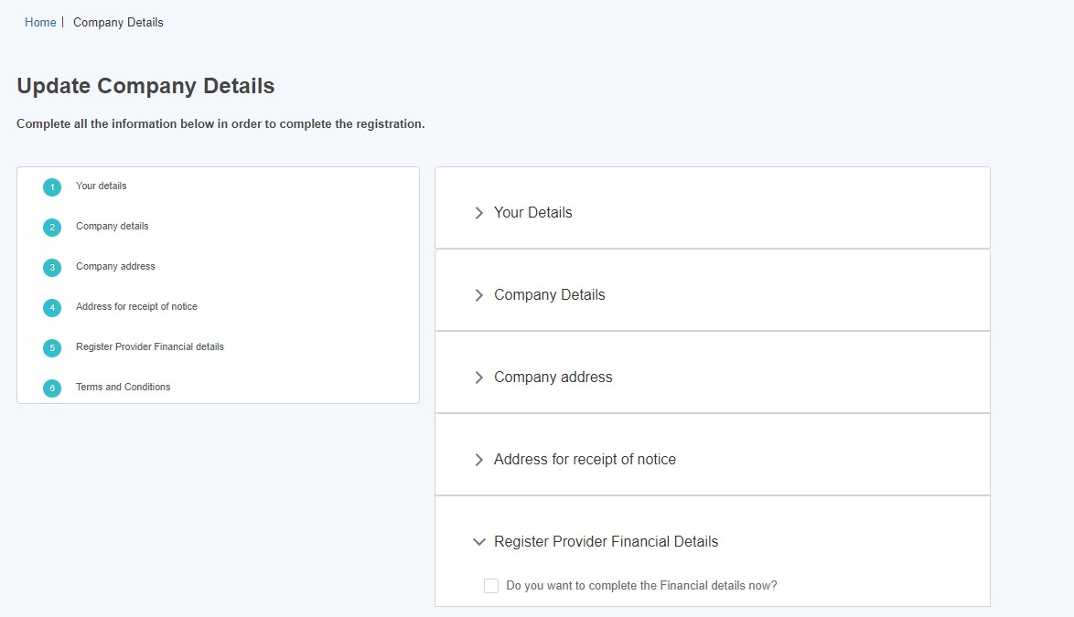
v
v

Select the ‘Registered Provider Financial Details’ subsection as illustrated in Figure 14.1.

Recording Financial Payment Details: Cont
Figure 14.1: Update Company Details Screen – populate details.
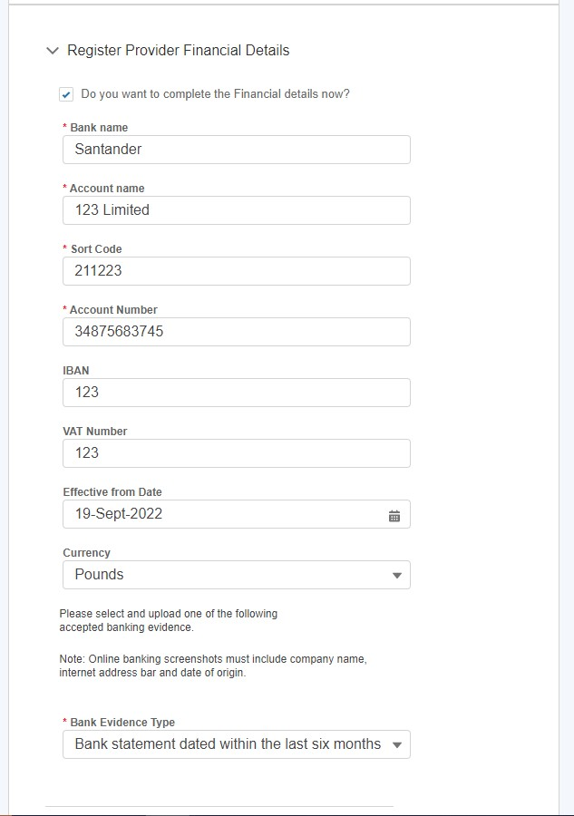

Recording Financial Payment Details: Cont
v

In order to save the details provided and the Submit button to be ‘released’ - it is mandatory to also upload the supporting evidence and answer the fields marked with a red asterisk. Finally, the checkbox under Terms & Conditions must be checked.
v

In order to update any financial details post submission, it is essential that the mobile number stored in the Your Details is populated.

v

Figure 14.2: Updating Financial Details – Contact Details Validation
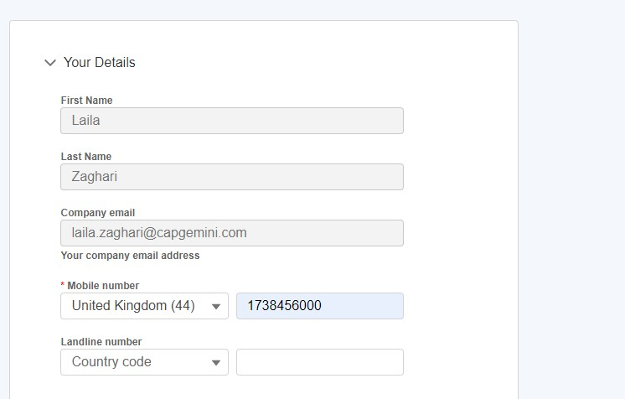
v

Contract (Auction Results) Data

Accessing Contract Data

As of Release 2.7, Portal Users are able to view Auction Result Data in the shape of ‘Contract’ Records for each of their prequalified Units.
- The resulting data will be accessible in a Report Format and each Auction Result is grouped under its respective Unit.
- To navigate to an individual Contract, the Portal User will have to possess the Unit Manager Role.
- They will then navigate to the My Reports Tab on the navigation bar.
- They will see a listing of Report Templates, they must hover to the one entitled ‘Contracts’ and then proceed to click on the ‘Contracts’ Report Name link as illustrated in the figure below.

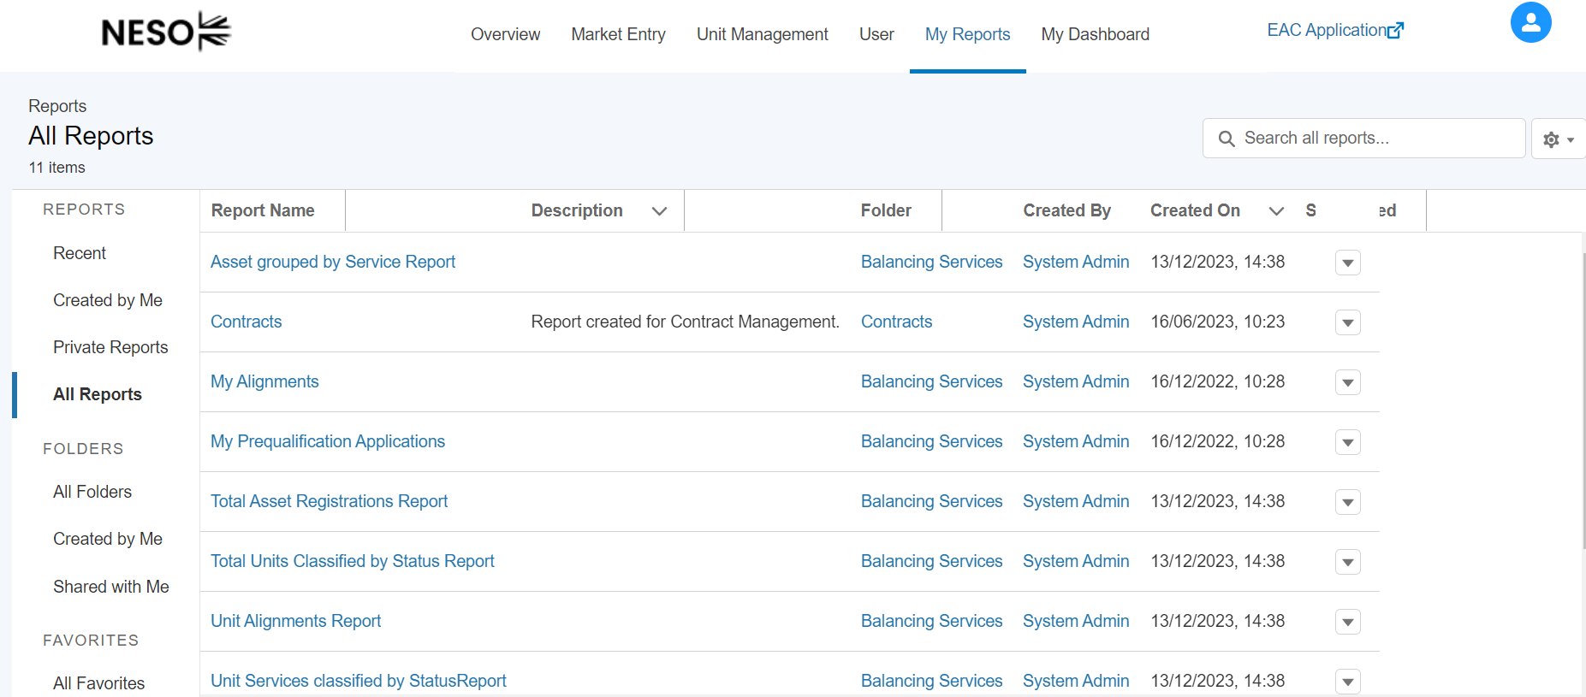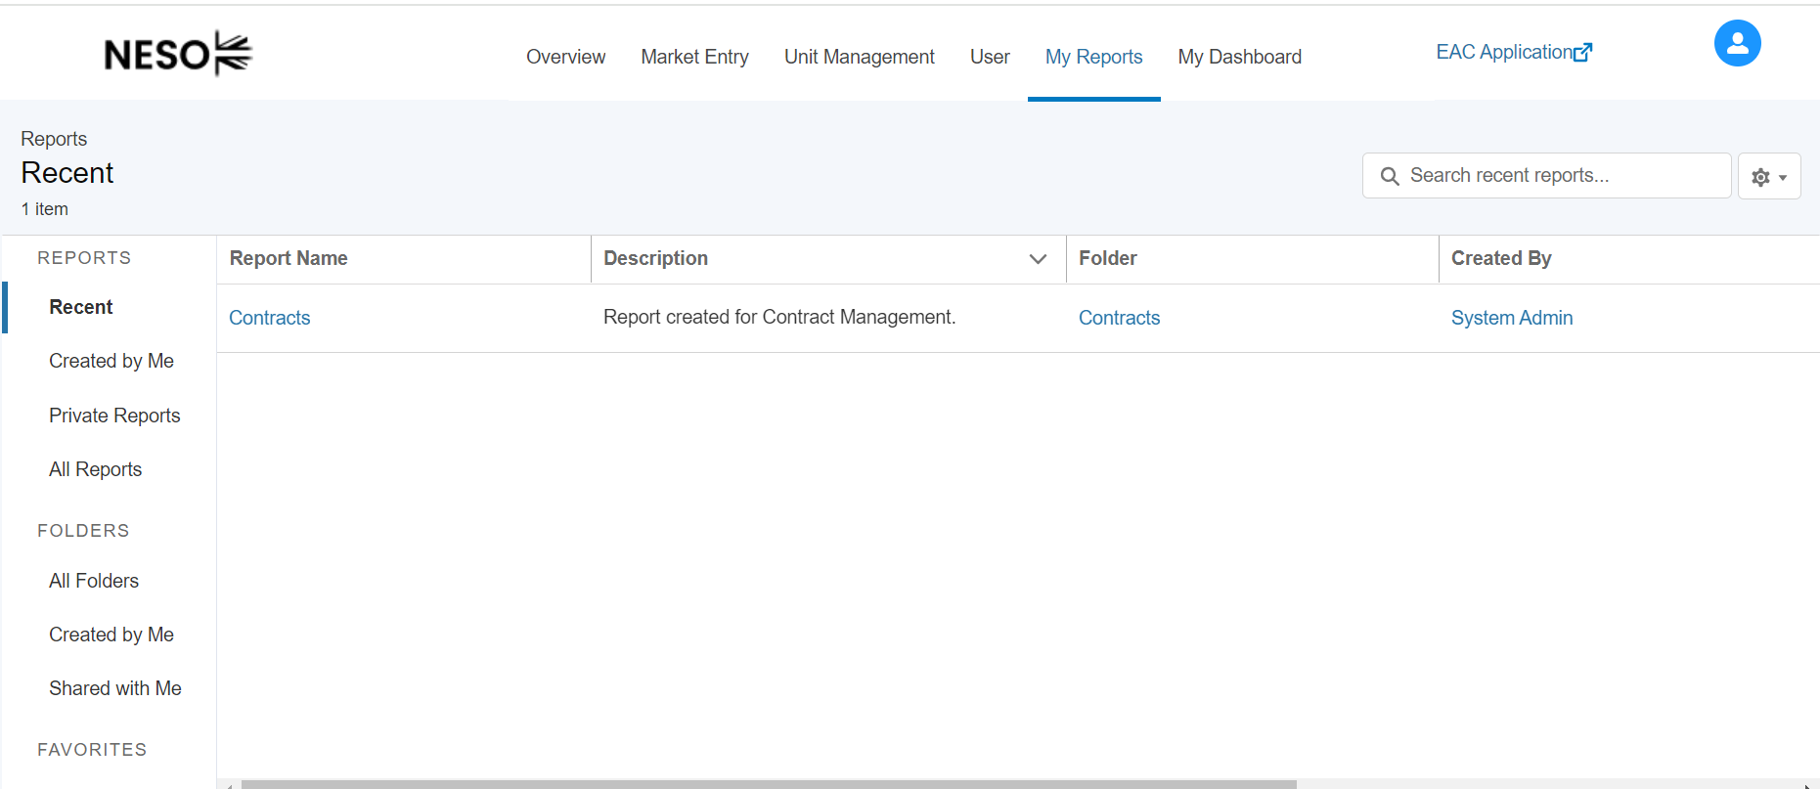

Accessing Contract Data (cont.)

An itemised list view of each Contract Record will be displayed, to review the details of each individual Contract (Auction Result) the Portal User will need to click on the Contract ID (1st Column) as displayed in the illustration below. This will ‘open’ the individual record with the granular details or output.

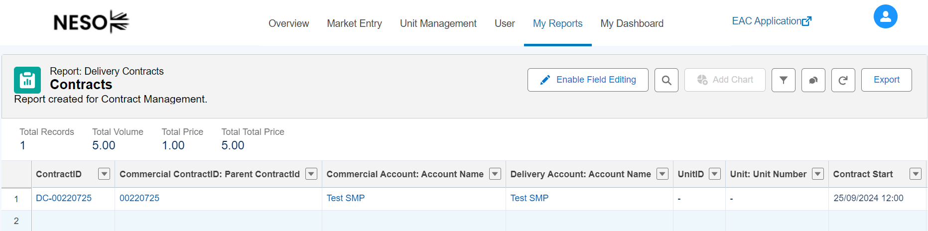

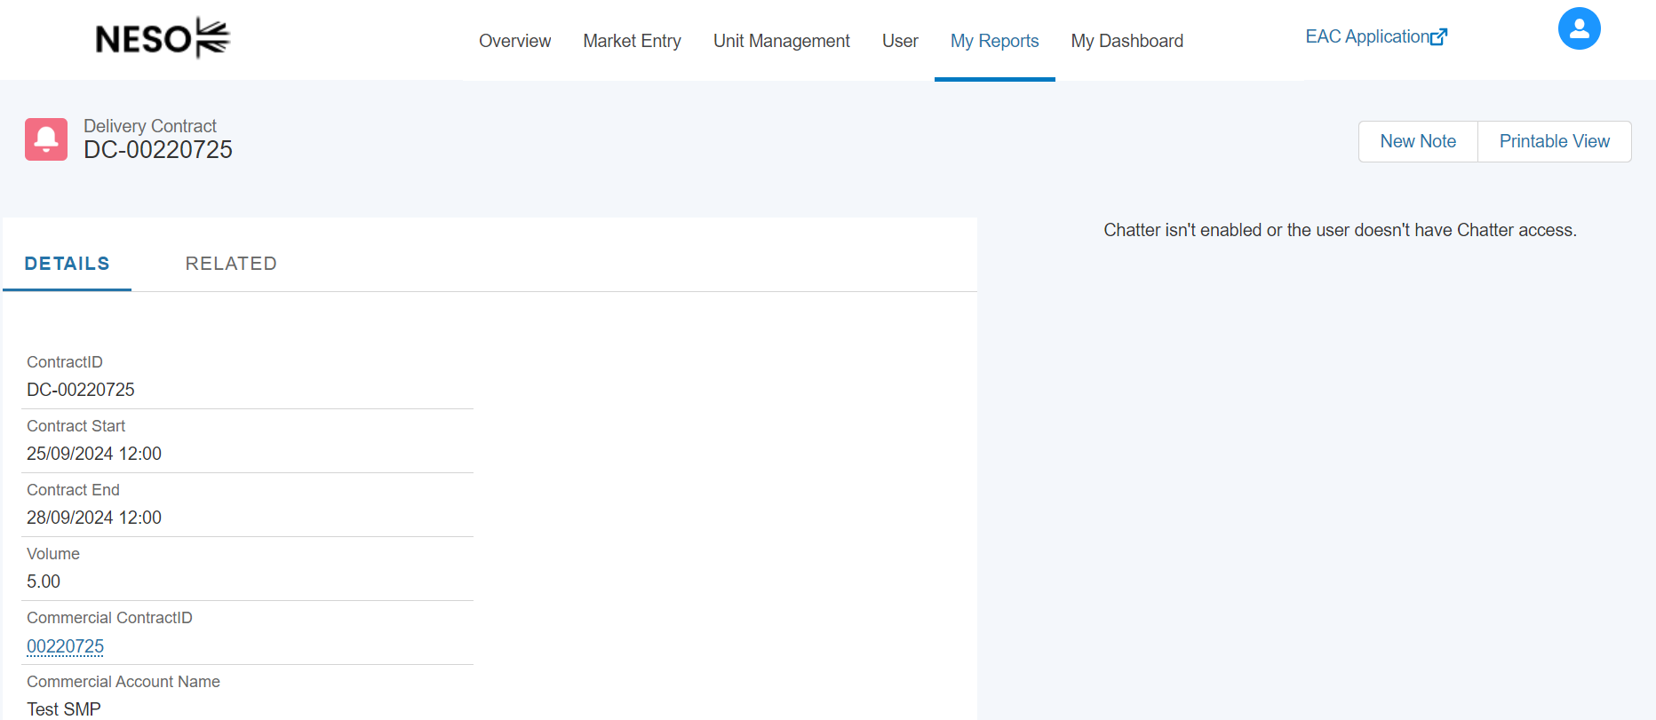

To navigate back to the Home Page simply click on the Overview Tab on the navigation bar.

Market Entry Page

Market Entry Landing Page
The Market Entry page provides a dashboard view of the Units the user has submitted, with components displaying the percentage of accepted units, a bar chart on Units by Status, a list of most recently submitted units with their Unit IDs and a table view of all Units submitted.
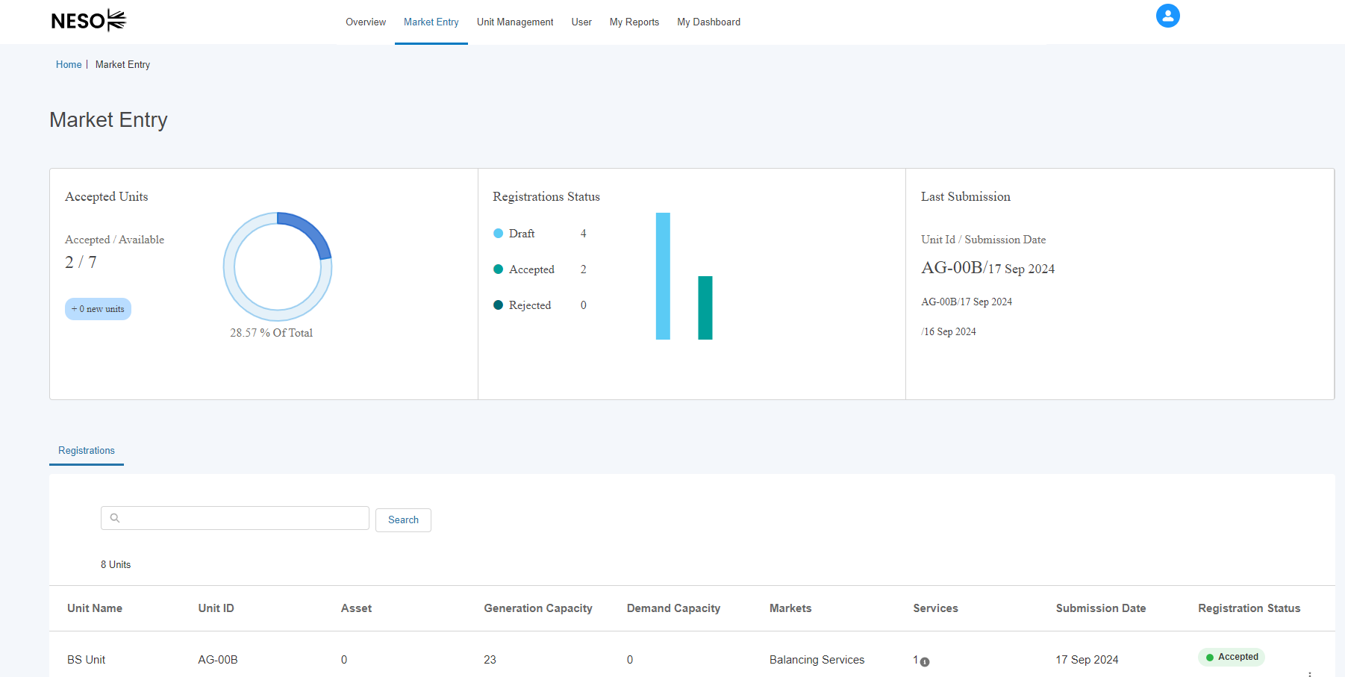

The Accepted Units component shows the number of Units in total with a subdivision showing the number Accepted and this expressed as a percentage. In the bottom left it also displays the number of Units submitted in the last week.

Market Entry Landing Page: Cont

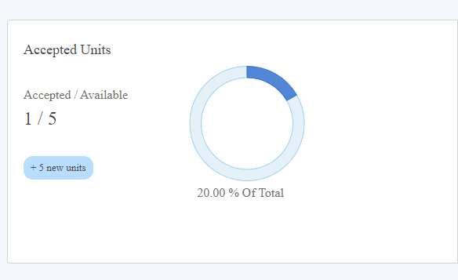

The Registration Status component breaks down the Units by Status into bars for Draft, Accepted and Rejected.

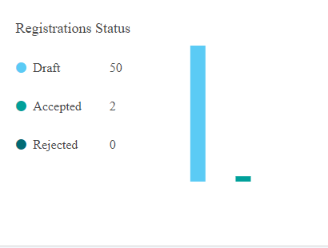
The Last Submission component displays Unit ID and the date it was submitted.

Market Entry Landing Page: Cont

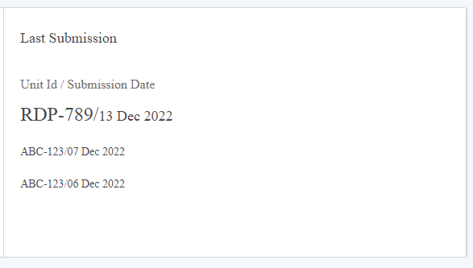

Your registrations table displays Unit’s row-by-row, with the following information:
- Unit Name
- Unit ID
- Number of Assets the Unit is aligned to.
- Generation & Demand Capacity
- Markets the Unit is applicable for
- The number of Services the Unit is prequalified for.
- Date the Unit was submitted.
- Status

Market Entry Landing Page: Cont

- 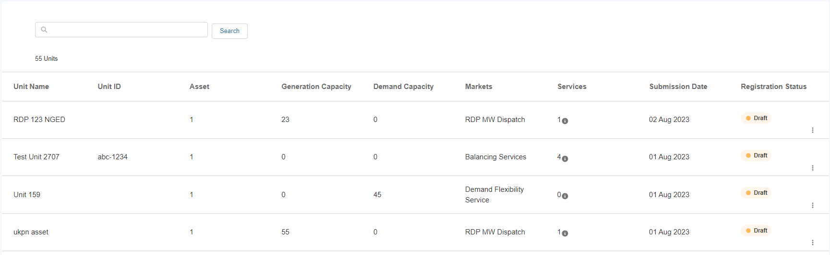

The user is also able to access the following pages by clicking on the 3 dots at the end of the row.
- Pre-qualify for Services.
- View Details
- Create new version (Accepted Units only)

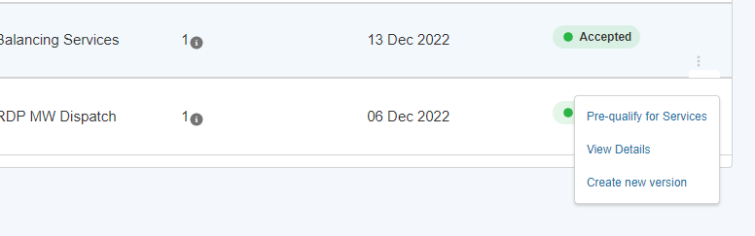
The table also has a search function for the user to filter their units by Unit Name or ID. Enter the Name or ID into the search bar and click ‘Search’ to filter the table.

Market Entry Landing Page: Cont

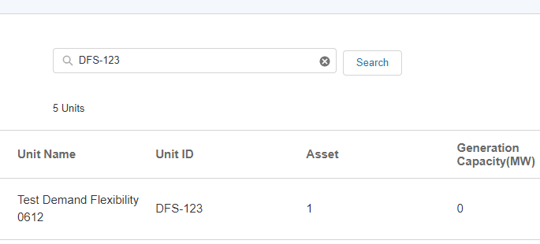

Reports

Introduction to Reporting
The Portal Report Tools have been introduced to allow portal users to track data related to their SMP Portfolio of Units and Assets. A set of pre-defined Reporting Templates have been curated and are designed to report on data and metrics in real time. Additionally users are able to create and save their own reports. The following chapter will run through how to access, create and save reports.
Please note that only Users with the Unit Manager Role are able to view and run reports.

Locating Reports

To access all reports, navigate to the My Reports Tab.
Figure 18.2. My Reports Tab

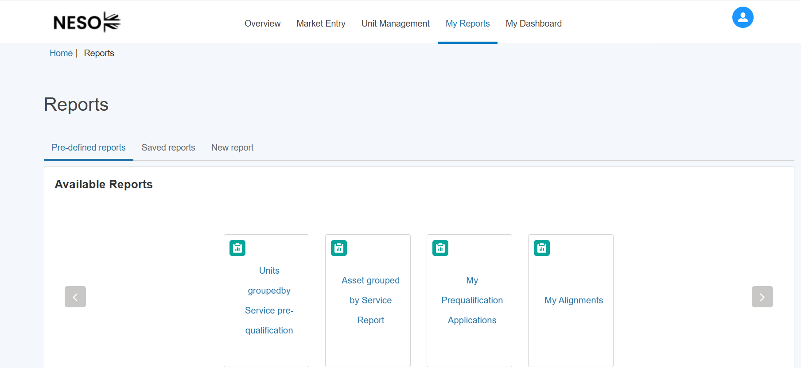

Pre-defined reports
Users are able to access ready made reports under the ‘Pre-defined reports’ tab.
Figure 18.3. Pre-defined reports

These reports show the following information:
- Units grouped by Service pre-qualification – this report shows units along with the statuses of the services they are qualifying for
- Asset Grouped by Service Report – this shows Assets along with the Services that the units they are aligned with are participating in
- My Prequalification Applications – this shows the statuses of the prequalification applications associated with the user’s account
- My Alignments – this shows units along with the assets that are aligned to those units

Clicking on any of the report titles will give the user a preview of up to 12 records, and the option to download the full report to view a complete list of records.

Figure 18.3.1 Run and Download Reports

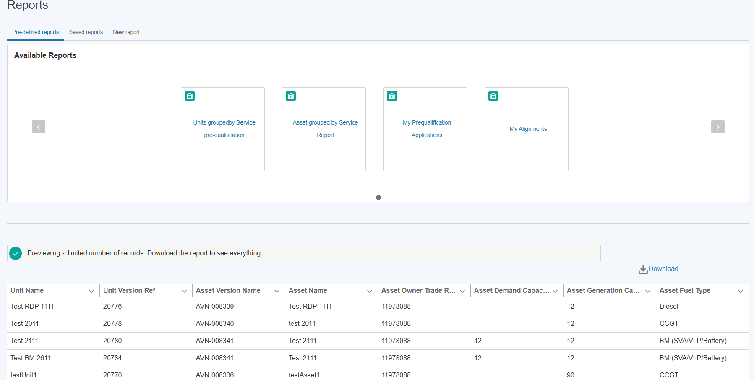

Pressing the ‘Download’ button will generate a .csv file, available to download from your browser. When opened, this will contain the full list of relevant records.

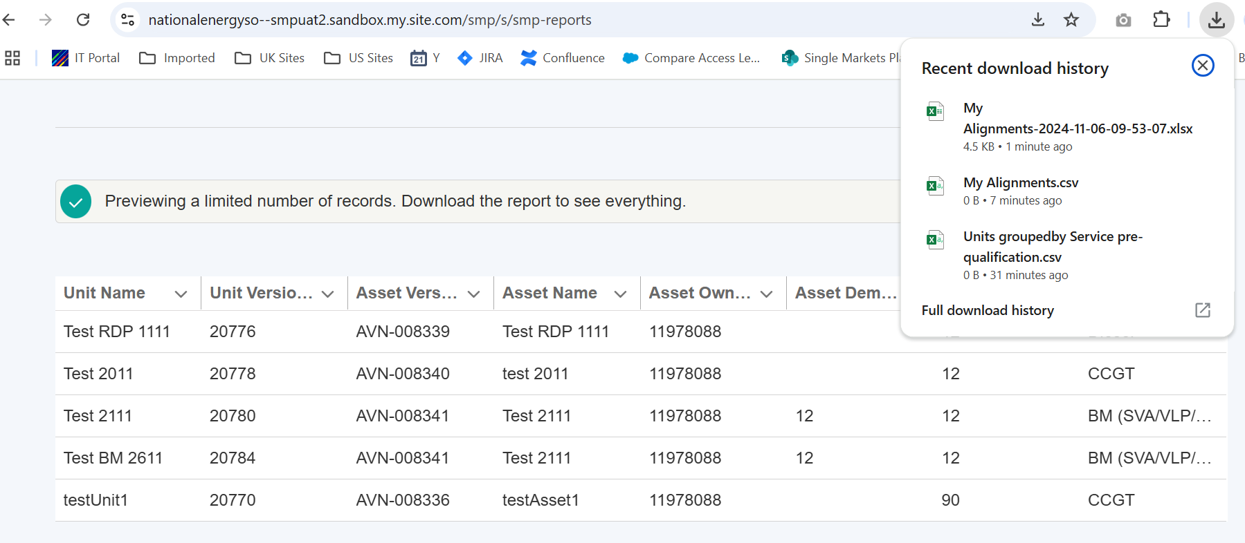

Creating New Reports

To create a new report, select the ‘New report’ tab.
Figure 18.4 New Report tab

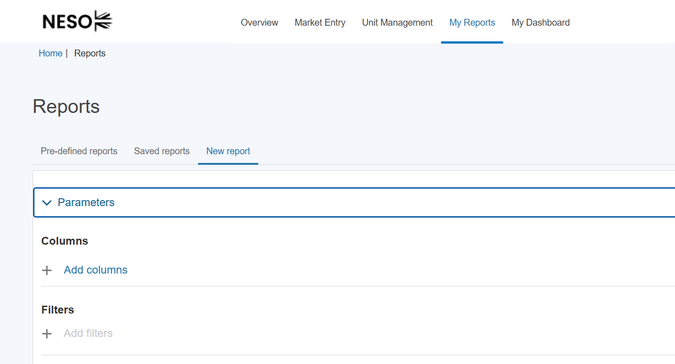

Collapse the ‘Parameters’ section then select ‘Add Columns’. These will be the data points that appear in your report. Here you can choose fields from the Units, Assets and Services that are in your portfolio. Use the ‘Search columns’ box to narrow down your list of potential fields.
Figure 18.4.1 Selecting Report Columns
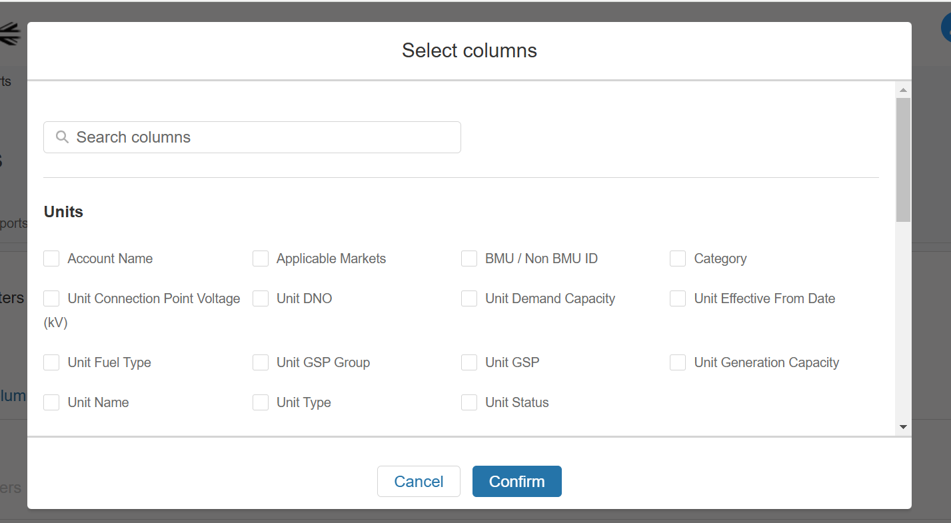

Once you have selected the columns you want to appear by ticking the box next to them, press the ‘Confirm’ button. 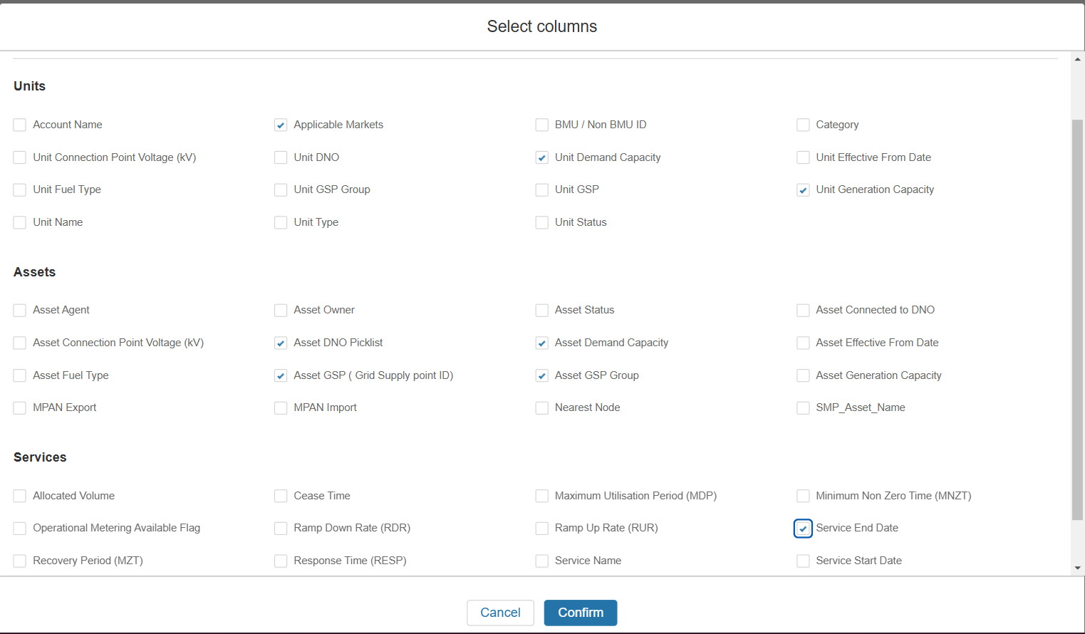

The columns will then appear in the list of selected Parameters. Please note as of Release 3.8 (December 2024) the option to add filters is disabled. This functionality will be enabled in a later release. Select ‘Run report’ to generate the report.

Figure 18.4.2 Viewing Report Columns and Running Report

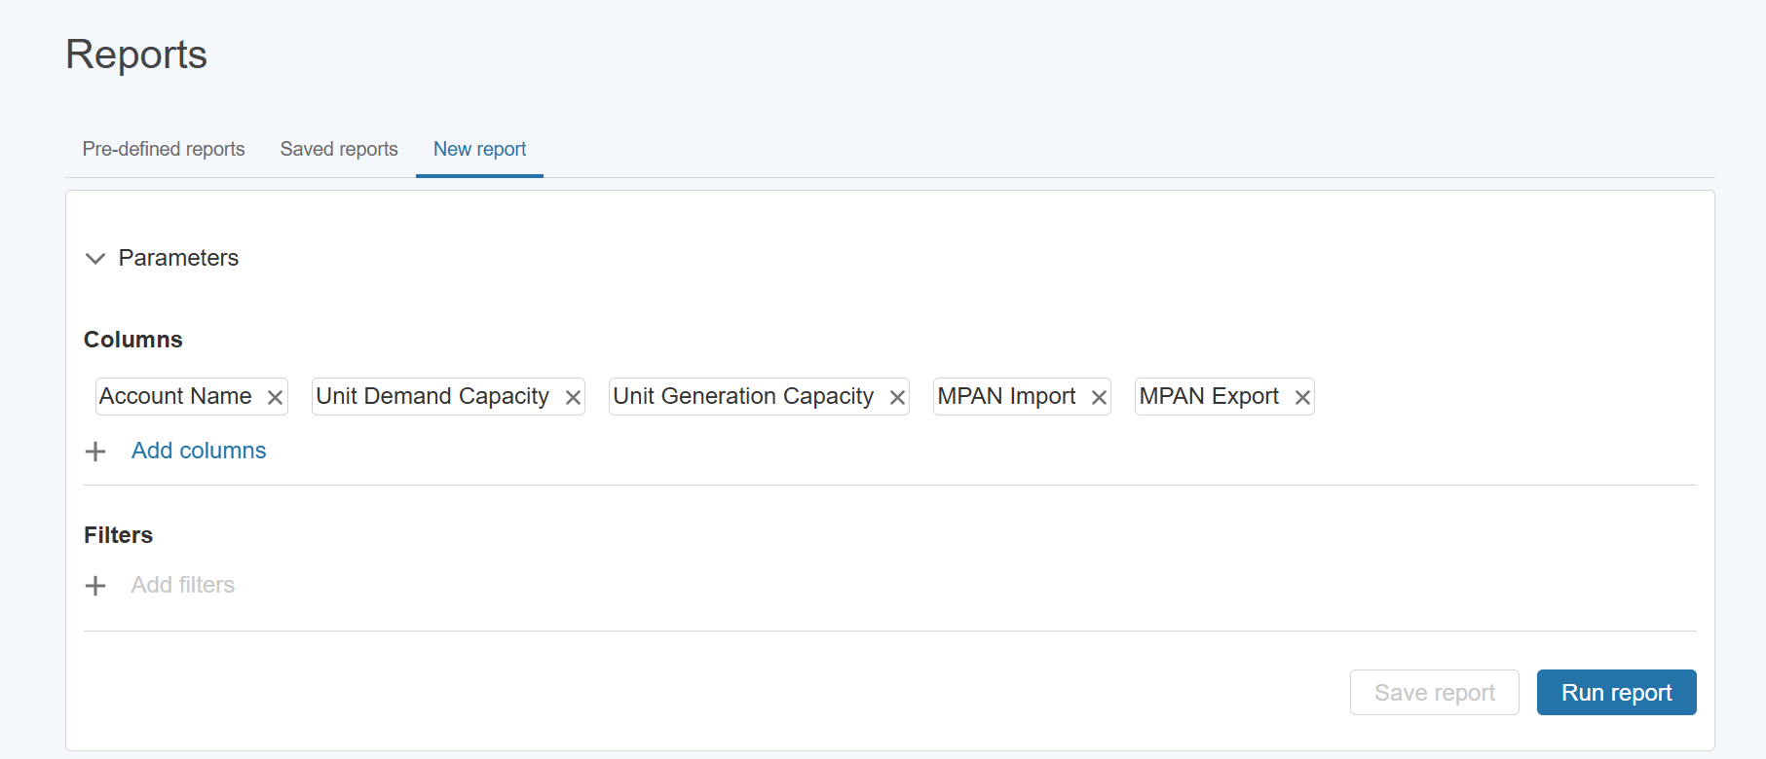

The preview will then generate and you will have the option to Download and Save the report.
Figure 18.4.3 Downloading and Saving a New Report

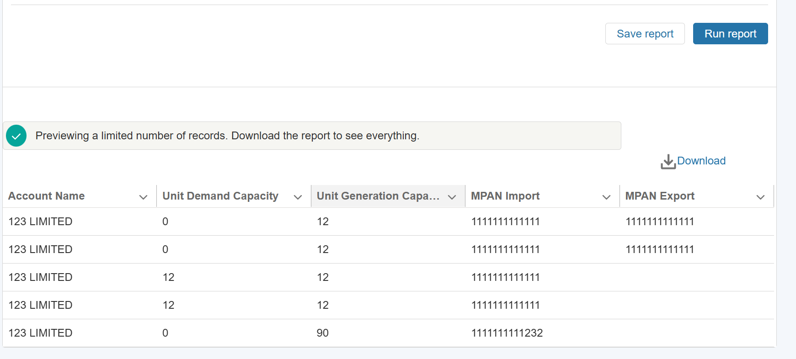

If you opt to Save the report, you will be prompted to give it a name.

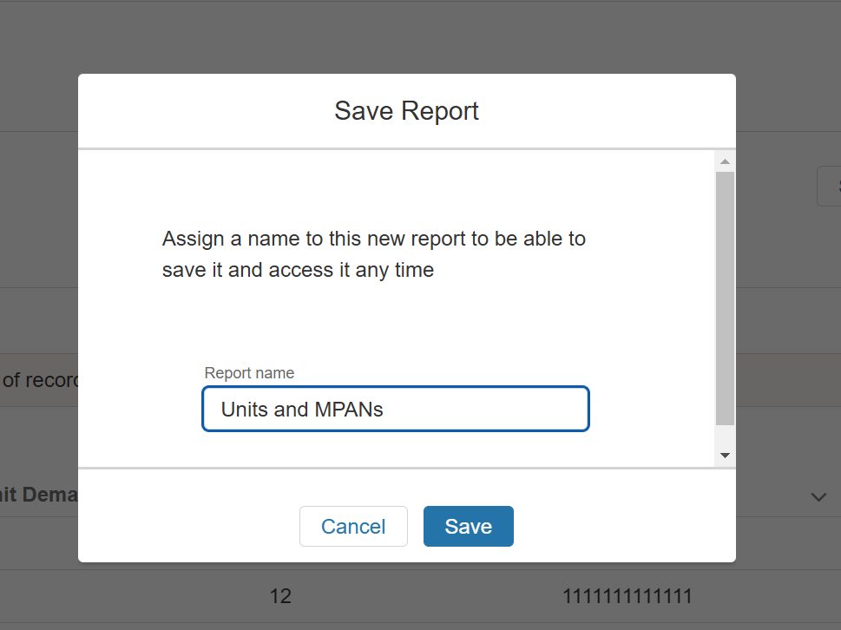

Pressing ‘Save’ here will save the report. Press the ‘Go back to reports’ button to return to the reports page.
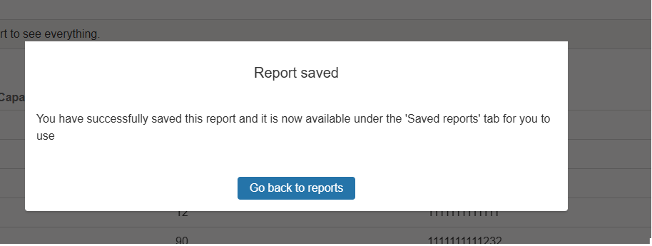

The report you created will then be accessible under the Saved Reports tab, for you to access at your convenience. Please note that the report is only accessible for your user record, and that other logged in users from your organisation will not be able to view it.

Figure 18.4.4 Viewing your Saved Reports

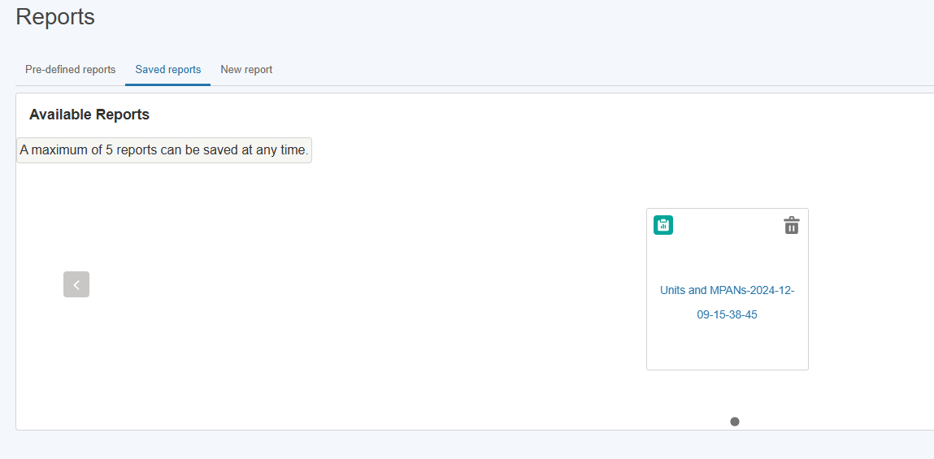

There is a maximum of 5 reports that can be saved at any time. If you have 5 reports and want to save a new report you will need to remove an existing one. Click the dustbin icon and press ‘Delete’ on the pop up to confirm removal.

Figure 18.4.5 Deleting your Saved Reports

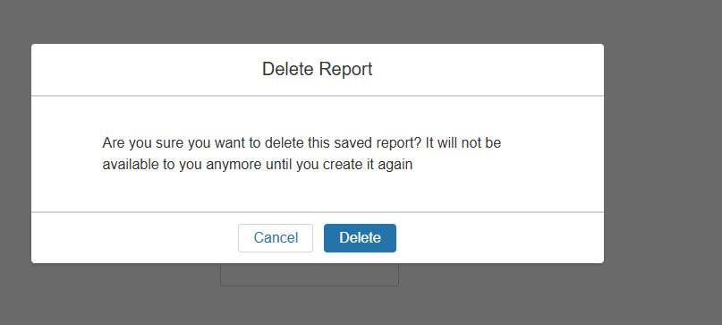

Registering RDP MW Dispatch Assets

Create an Asset
To register a new asset, the first step is to click on the ‘Create new asset’ button where a user will be presented with the screen illustrated in Figure ‘New Asset registration’ where a unique asset name will be required. Please note that firstly an asset cannot be created without an asset name and secondly the name must be unique in naming convention to the asset in question. Once the asset name is provided, the user will be able to progress to the next step by clicking create.
Figure 17.1: Creating Assets- Asset Registration

Asset Registration: Submitting Asset Information
The user is navigated to the Asset Registration Page as outlined in Figure 29.0, the format is similar to the Account Management Page structure with an accordion section on the left-hand side for direct navigation to a specific section or the user can select the sub section they wish to complete.
The figure illustrates the unique named asset for which the details are being registered; “Roe dean Windfarm.’’
Please note that the user is not able to progress the registration process for a created asset without completing all the sections and corresponding fields.
Figure 17.2 Asset Registration Detail Page
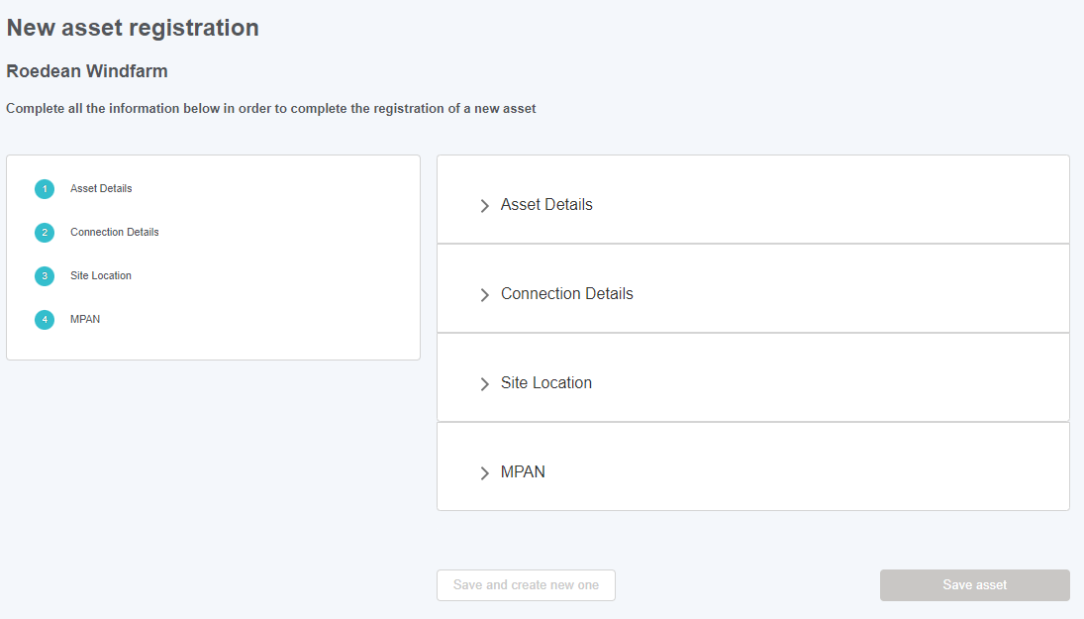

Asset Registration: Asset Details Section
Figure 17.3 illustrates the Detail Section for the Asset.
Please note that as the Applicable Market, Asset Ownership, Asset Type, the Effective from Date and Fuel Type are all mandatory and therefore marked in a red Asterix. It is essential that these fields have information submitted. The value selected in the Applicable Market field determines the behaviour of subsequent sections so please ensure RDP MW Dispatch is selected if applicable.
Please consult the Glossary Appendix for a translation of the Fields if the User is not clear about what is being requested.
Figure 17.3: Completing the ‘Asset Details’ Section
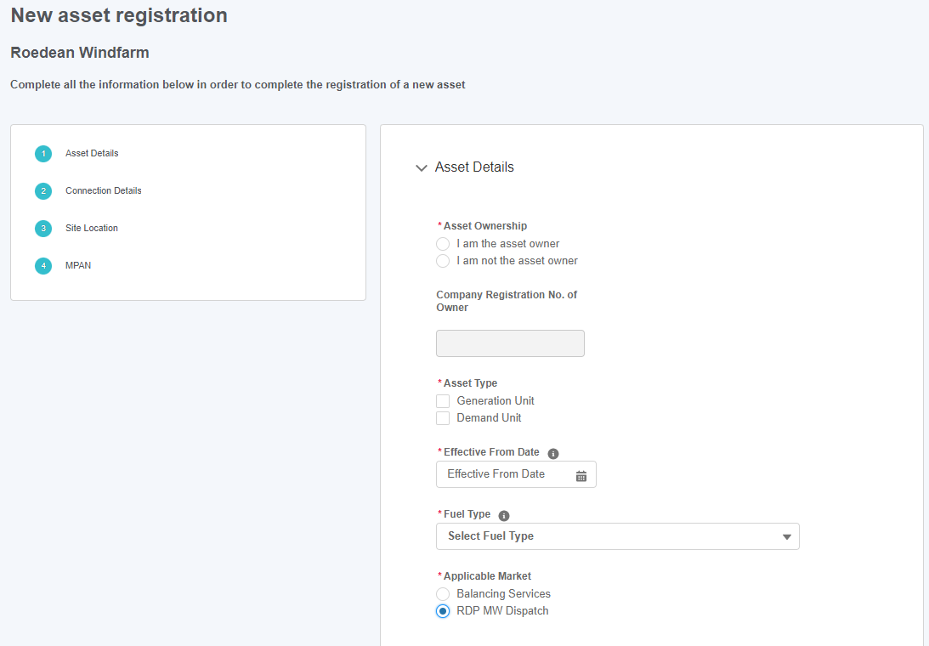

Asset Registration: Asset Connections Section
Figure illustrates the Asset Connection Details Section for the Asset.
If the user has selected Generation Unit as an Asset Type in the previous section, then Generation Capacity will appear here. If they have selected Demand Unit then Demand Capacity will appear. Please note that Generation Capacity, Demand Capacity (if visible) and Connection Type are all mandatory and therefore marked in a red Asterix. It is essential that these fields have information submitted. If RDP MW Dispatch has been selected as the Applicable Market in the previous section and Connected to DNO is ticked, the DNO Type options will be ‘ National Energy System Operator Limited Electricity Distribution’ and ‘UK Power Networks’.
Figure 17.4: Completing the ‘Asset Connection Details’ Section
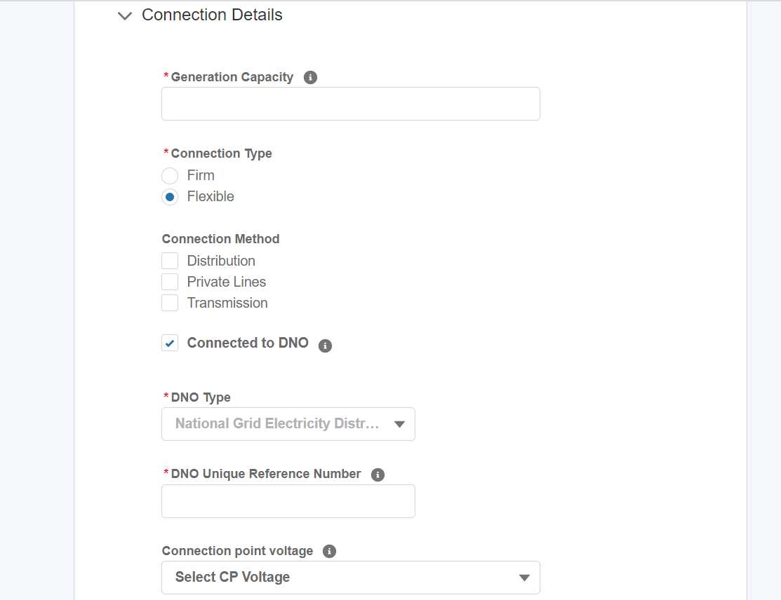

Asset Registration: Asset Site Location
Figure 17.5 illustrates the Site Location Section for the Asset.
Please note that the Post Code and Grid Supply Point (GSP) are both mandatory and therefore marked in a red Asterix. It is essential that these fields have information submitted. Post Codes must be submitted in a UK format.
For RDP MW Dispatch Assets, a maximum of one value can be selected in the Grid Supply Point (GSP) field. The GSP Group Id field is locked to Southwestern England if National Energy System Operator Limited Electricity Distribution is selected as the DNO Type or Southeastern England if UK Power Networks is selected as the DNO Type
Figure 17.5: Completing the ‘Asset Site Location Details’ Section
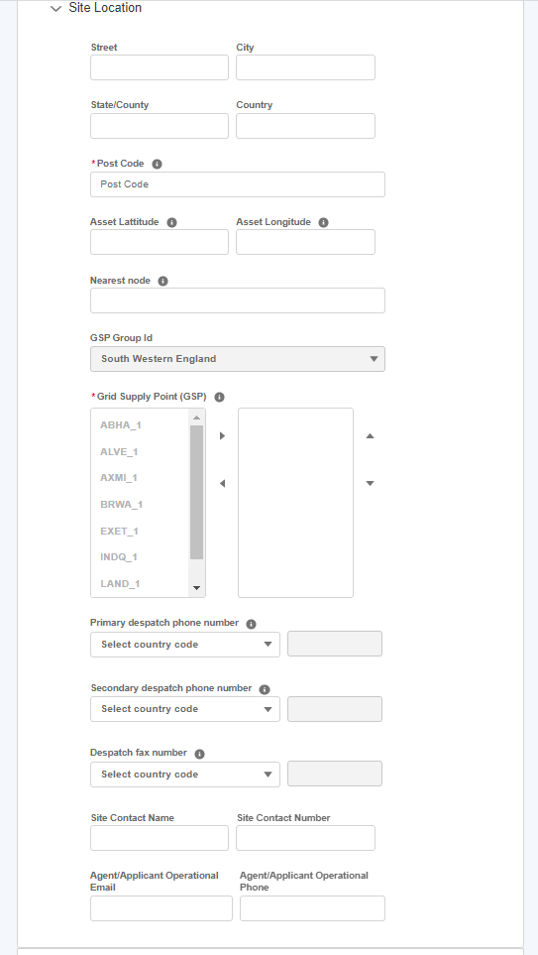

Asset Registration: Asset MPAN Details
Figure 17.6 illustrates the MPAN Details Section for the Asset.
Please note that as the Operational Metering Availability & MPAN Export Fields are all mandatory and therefore marked in a red Asterix. It is essential that these fields have information submitted.
For RDP MW Dispatch Assets, the user is unable to submit values for Additional MPAN Import and Additional MPAN Export and so these fields are uneditable.
For additional clarification, the user can hover over the ‘I’ icon for ‘Help Text’ as illustrated in the figure below.
Figure 17.6: Completing the ‘Asset MPAN Details’ Section
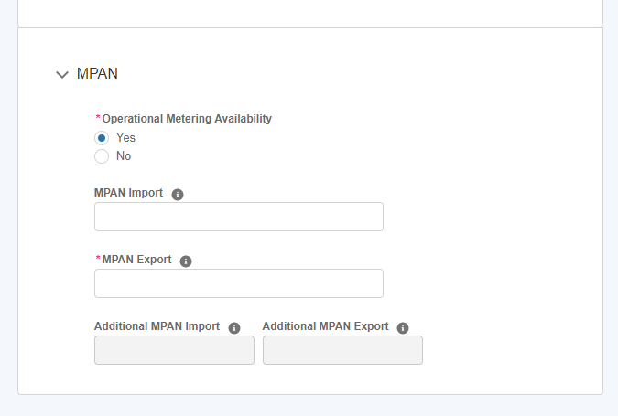

Asset Registration: Save Asset Detail Submission.
Once all the sections are completed correctly, then the ‘Save Asset’ button will appear in a blue background, enabling the user to complete the registration process for creating the asset.
If the User wishes to repeat the exercise and create subsequent assets, they can select the ‘save and create new one’ button instead.
Figure 17.7: Save Asset options.
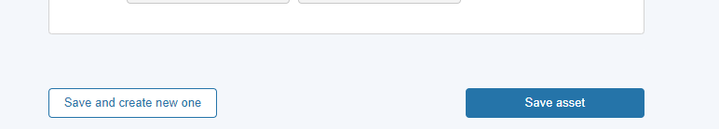

Asset Registered: Asset Tile & Updating the Asset
Following on from the Asset Registration, the asset tile will appear on the Unit Management Home Page under the ‘Asset’ tab. Each asset will have a corresponding tile. The tile displays the ‘key or summary information’. To view the full registration details, click on the three dots on the right-hand corner of the tile. The user then selects the ‘View Details’ link to be re-directed to the Asset Detail page expanded version.
Please note that for Release 1.0, Users will be expected to submit all asset information at once. Upon ‘saving the asset’ registration details, the Asset Status will appear as ‘Accepted’ automatically as illustrated in Figure.
Figure 17.8: Asset Tiles
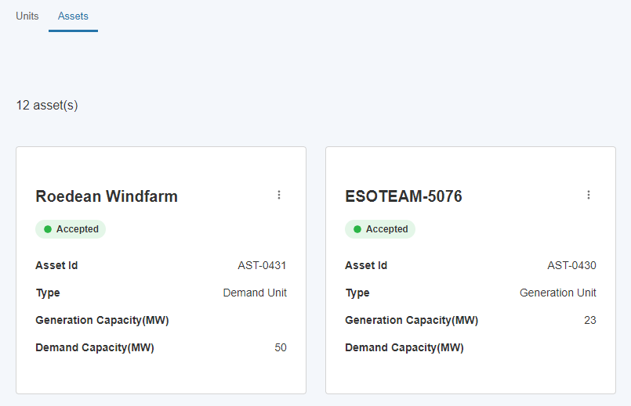

Prior to the Unit being Accepted and the Unit Service Pre-Qualification being Approved, the user is able to edit details of the Asset. Click on the ‘View Details’ link from the Asset title, then ‘Edit asset information’ on the Asset Details page.
Figure 17.8.2: Edit asset information link.

Asset Registered: Asset Tile & Updating the Asset

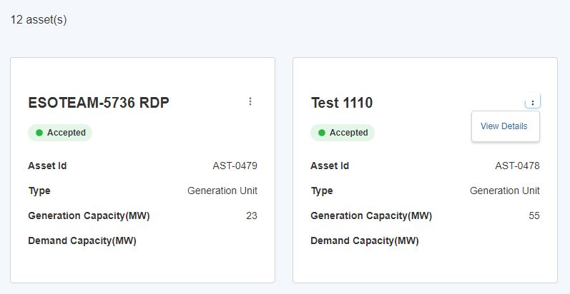
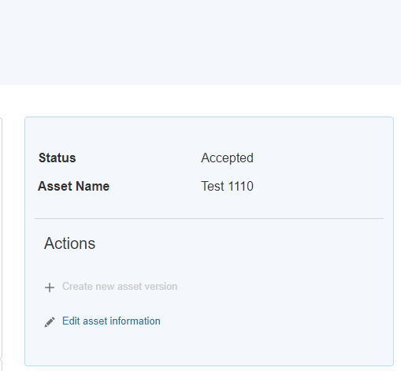

Asset Registered: Asset Tile & Updating the Asset

Press Update on the Update asset Information pop-up, then make changes as necessary. When finished, press the ‘Update asset’ button to update the Asset and corresponding Unit, or ‘Update and create new one’ to start creating another Asset.
Figure 17.8.3: Update Asset options.
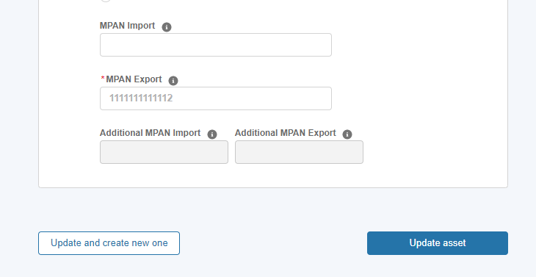

Unit Creation
When an Asset is created with RDP MW Dispatch selected as the value in the Applicable Market field a Unit is automatically created with the same name as the Asset. This Unit will have a status of ‘Draft’ prior to its approval by the NN NATIONAL ENERGY SYSTEM OPERATOR LIMITED Registration Team. The NN NATIONAL ENERGY SYSTEM OPERATOR LIMITED Registration Team will a) assign the Unit a Unit ID (which will auto populate on the Unit Id field) b) set the Unit Status field from ‘Draft’ to ‘Accepted’ or ‘Rejected’.
Figure 17.9: Unit Tiles
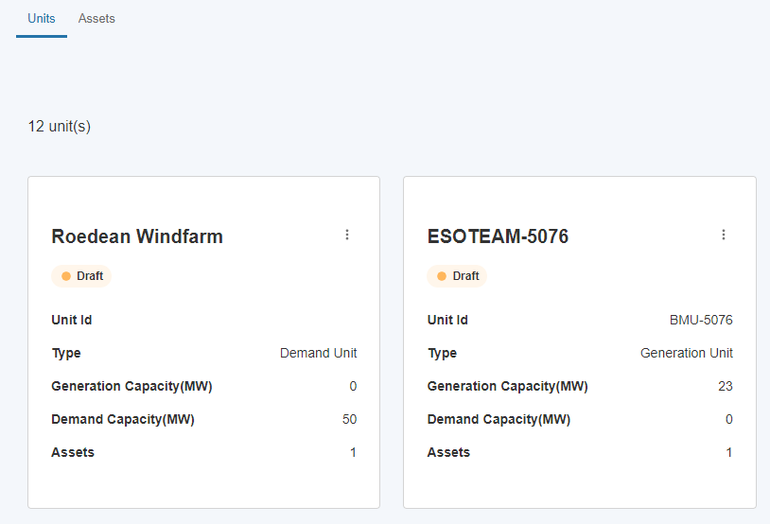

Identifying Units for RDP Unit Pricing
Once the Unit has been created the user can record the RDP unit price.
To do this, the user must navigate to the selected unit on the Unit Management home page and hover over the right hand three corner and click on the three dots on the Unit tile as highlighted in the Figure below. Then they must select ‘View Details’.
Figure 17.10 View Details on Unit link
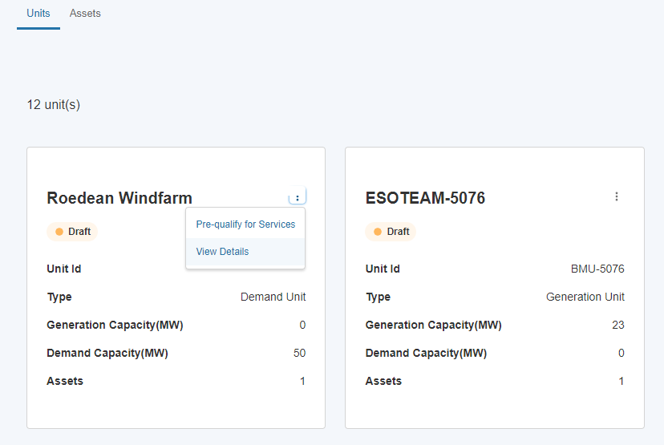

Recording RDP Unit Pricing
The user will then be presented with the Unit Details page, which features a section in which to enter the price of the RDP Unit in £/MWh. Please note that entering non-numeric characters into this section and pressing ‘Confirm pricing’ will cause the screen to become frozen so the user should enter numeric characters only. If the price is entered on or before 4pm on a given day, the price will be valid from 5am the next day. If the price is entered after 4pm on a given day, the price will be valid from 5am the day after the next day.
The user enters the price in the field in the left-hand side (this must be a numeric value with up to 2 decimal places i.e. pounds and pence), then presses Confirm pricing to record it. The details of the latest price will then be visible to the user in the row underneath.

Figure 17.11: RDP Unit Pricing section
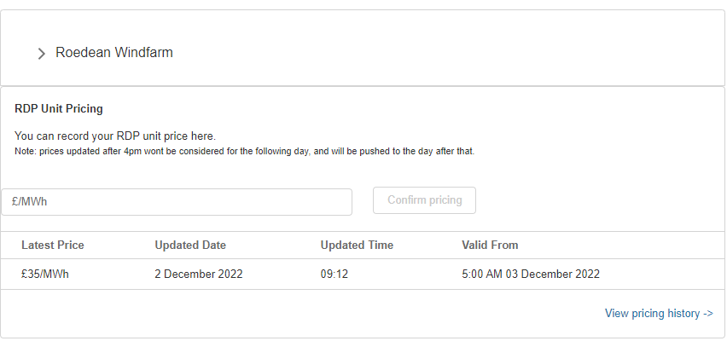

Unit Pricing History
To view the Pricing History of the Unit, the user can click the View Pricing history link of the RDP Unit Pricing section.
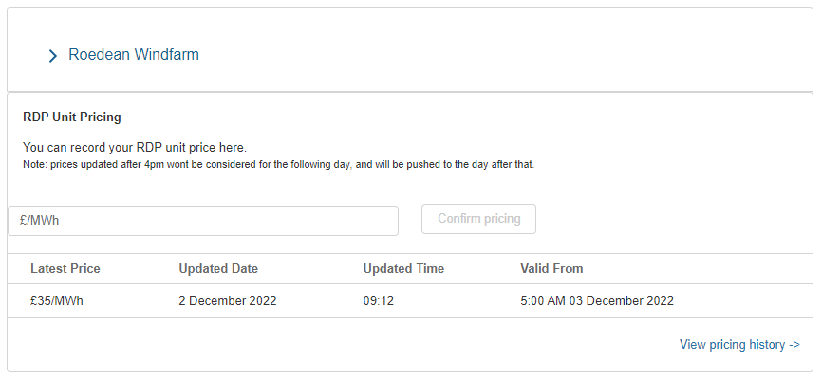
Here they are presented with the prices entered for the unit, the date and time it was entered and the date and time it was valid from.

Figure 17.11.2: RDP Unit Pricing History
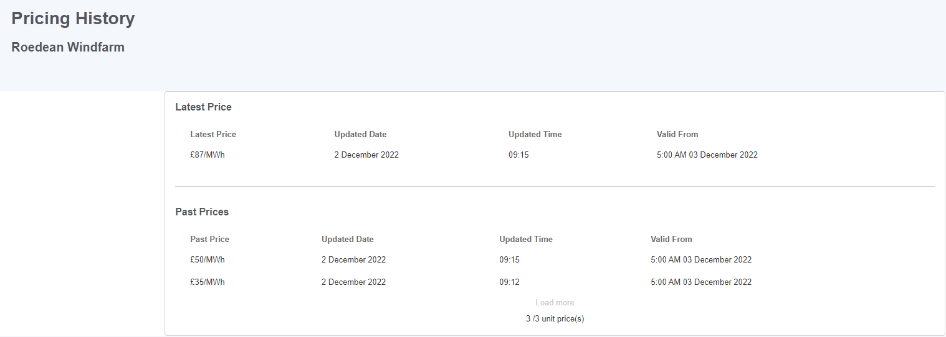

Onboarding Checklist

As of Release 2.13, users will be presented with a carousel displaying Onboarding Checklist cards when they log into SMP. This will appear on the Overview page, underneath the Account section.
Pressing the Arrow button on the left and right will move the carousel to reveal additional tasks.
Figure 15.1: Onboarding Checklist Location
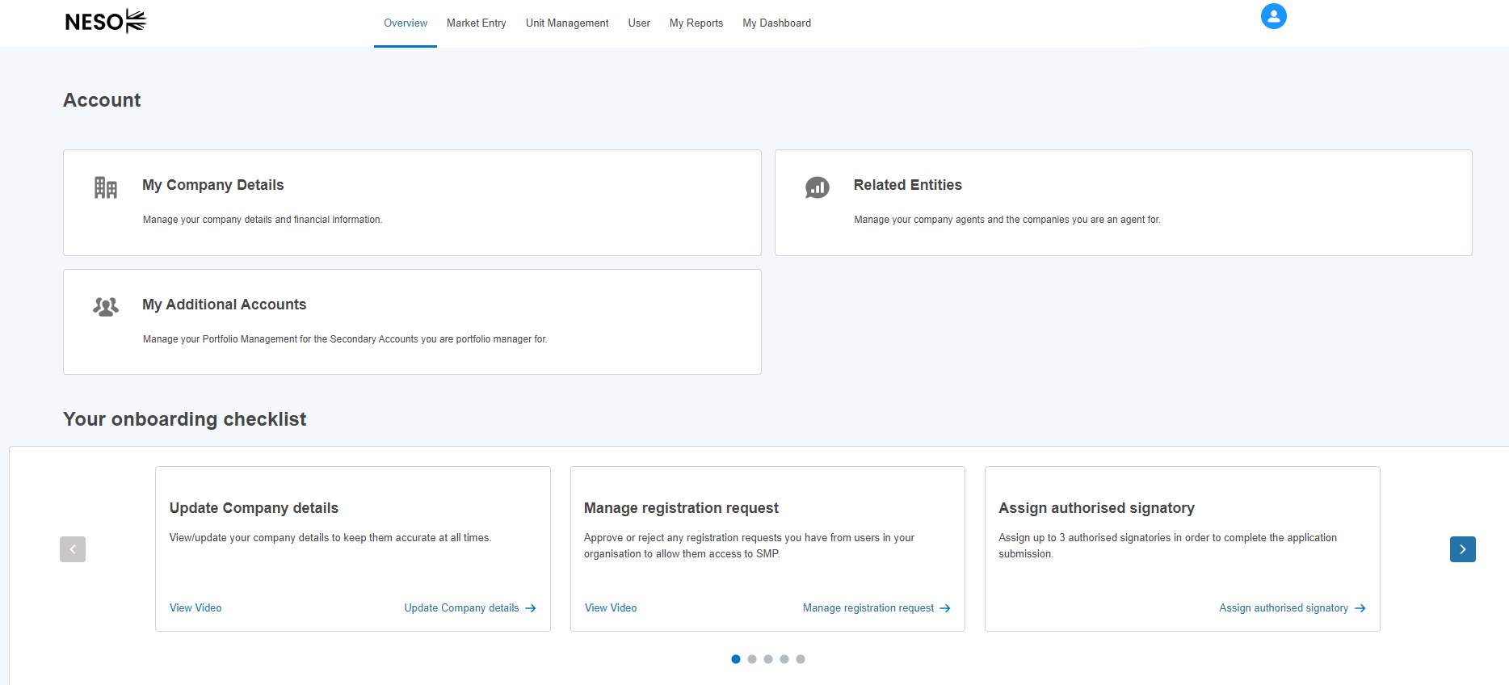The cards will contain text detail on the task, a link to video guidance where applicable and a link to the page on SMP where the user can undertake the task.
Figure 15.2: Onboarding Checklist Task
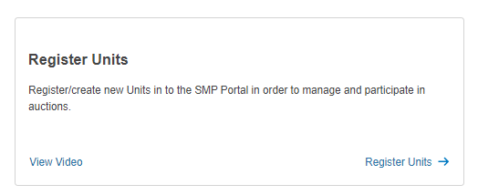
Users with different roles will see different items relevant to them. For instance, a user with the Super User role will see tasks such as Manage Registration Requests and Assign Authorised Signatories

Figure 15.3: Super User Onboarding Checklist

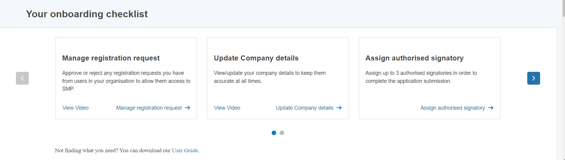

SMP Overview Dashboard

SMP Overview Dashboard
A dashboard has been created consisting of multiple reports to display data from the user’s SMP account’s portfolio. This is accessible on the Overview page to users with Unit Manager permissions. As of Release 2.13 the following components are displayed.

Total Numbers of Units, Assets and Alignments
These display the total number of Units and Assets (including versioned records) accessible to your account. The number of alignments between the two is displayed on the right hand component – this can be higher than the number of Units or Assets if a single Asset has been aligned to multiple Units.

Figure 17.1: Units, Assets and Asset Alignment Components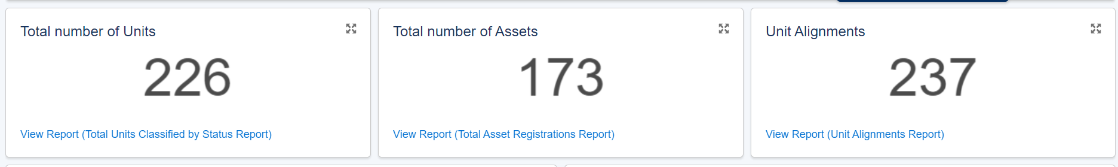

Units classified by Status and Category

The left hand component shows a doughnut chart with units grouped together by status, including a percentage of the total number of units for that status. On the right the user can see the same Units classified by the Category in relation to the BM.

Figure 17.2: Units classified by Status and Category Components
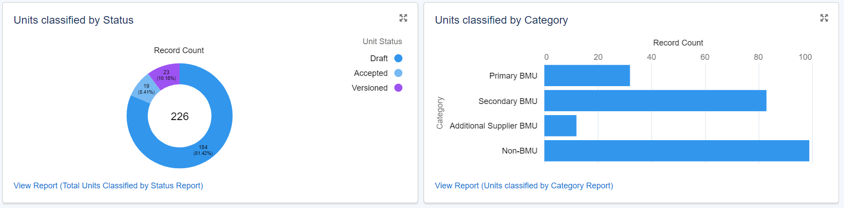

Prequalification requests by Status and Service

This will display the services that units accessible to this account have applied for, including the number of applications for each service. The status of these applications is grouped in each column and colour coded with a key for this on the right hand side of the component under Service Status.

Figure 17.3: Prequalification requests grouped by Service on the x-axis and Status on the y-axis
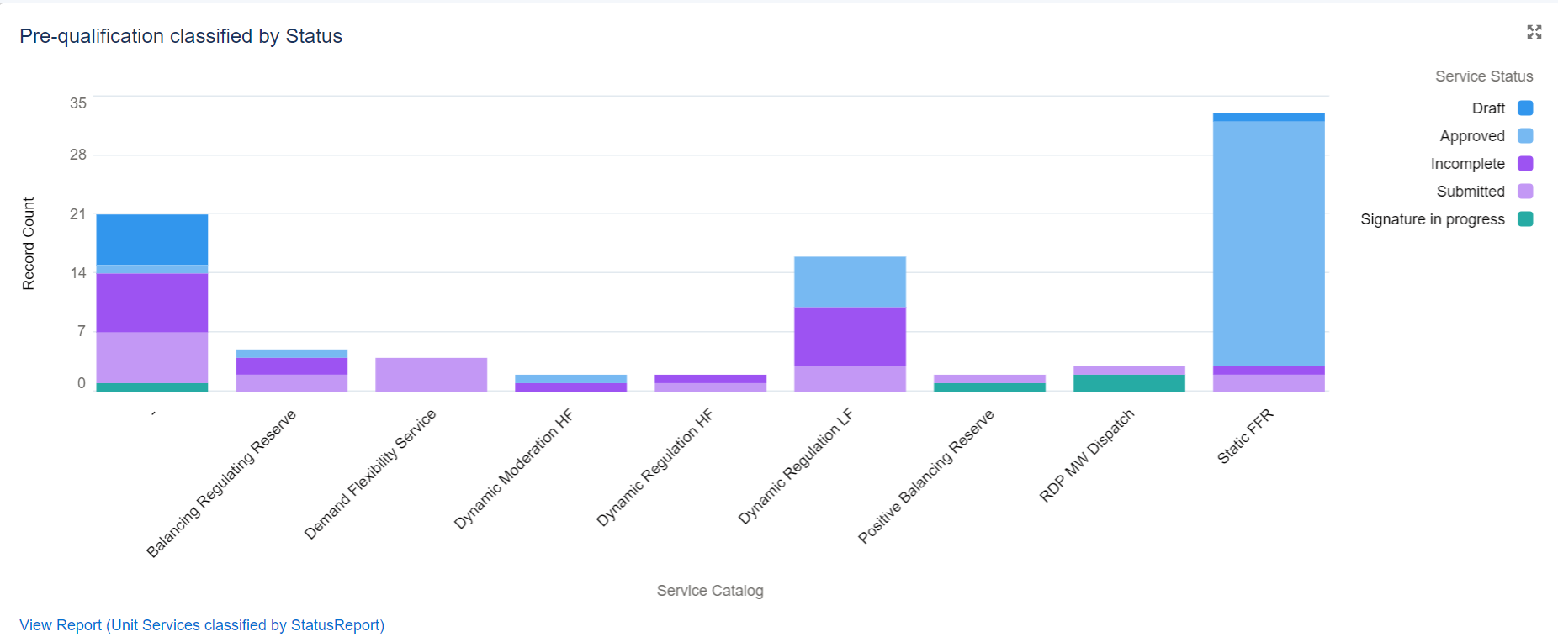

Units grouped by Service pre-qualification
Displayed here are Units grouped by their BMU/Non-BMU ID on the left then are grouped by services they have applied for. The services are colour coded, with the key for this again on the right hand side of the component, under Service Catalog:Service Name.
Figure 17.4: Units grouped by the service they are pre-qualifying for
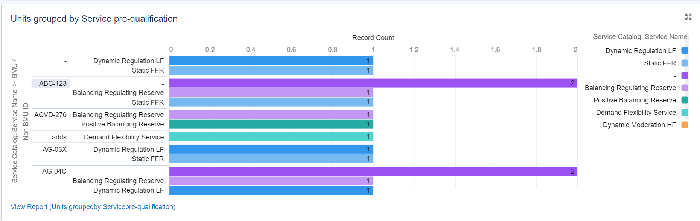

Units grouped by Assets and Assets grouped by Service
The component on the left can be used to determine which Assets are aligned to Units. This includes the Unit Name, Asset Name and BMU/Non-BMU ID of the Unit. The component on the right shows the relationship between Assets and Services that have been applied for via the Units those Assets are aligned now. The fields shown are the Asset Name, Service Name, Unit of Measurement (from the Service) and Generation and Demand Capacity (from the Asset).

Figure 17.5: Units by Assets and Assets by Service
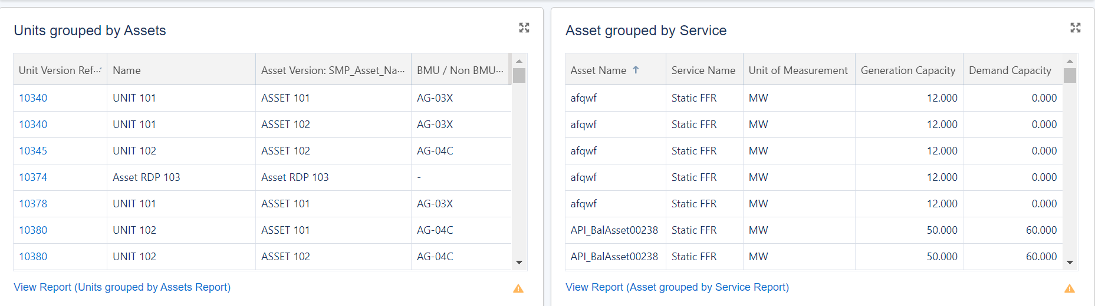

- Accessing Invoice Links

How to access Invoice Links
As a user with the Finance Manager role, there is a tab ‘My Invoices’ that can be accessed.
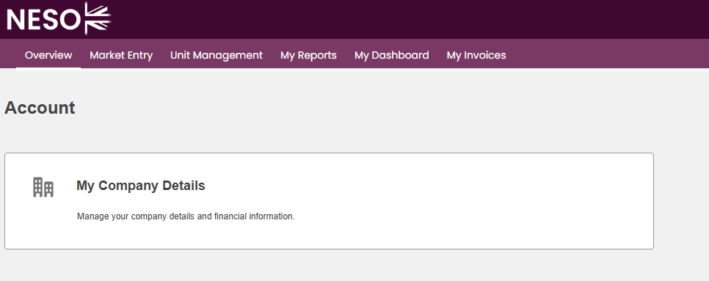

The page will show a list of Accepted Units associated with your account along with relevant links to the NESO Settlements Portal (Sharepoint)
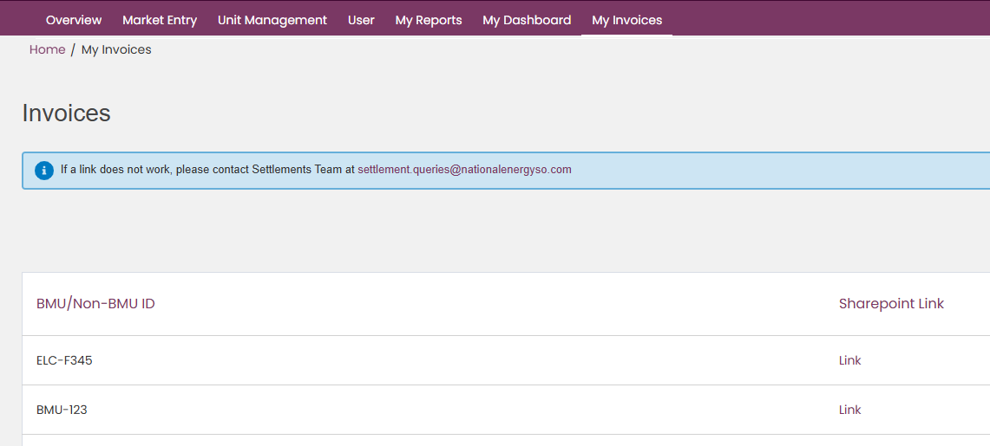
Clicking on the link will open the Settlements Portal in a new tab. Please note there is no single sign on between SMP and the Settlements Portal. If you require access to the portal please get in touch with settlement.queries@neso.energy

Glossary of Terms

Glossary of Terms

Term | Description
Account | A Salesforce account.
Alignment of Assets | Assign one or more assets to a unit.
Asset | One Plant and Apparatus located at the same Grid Supply Point that has a single physical connection.
Asset Testing | The Asset test records, MW, Date of testing by an Independent Technical Engineer (ITE), which will be aligned against a service.
Balancing Service Provider | A market participant as defined by the Electricity Balancing Guidelines who is NN NATIONAL ENERGY SYSTEM OPERATOR LIMITED ’s counterparty to a Balancing Services Contract.
Connection Type | This can be Firm or Flexible.
DNO Type | Distribution Network Operator.
Effective from Date | The date that an asset is live and connected to the Grid.
Grid Supply Point | The points where power is delivered from the transmission system to either a distribution network or a customer directly connected to the transmission system.
Pre-qualification for Services | Process of submitting data and evidence for a unit requesting approval for participation for a particular service.
Unit | A logical grouping of a single or multiple group of assets.
Unit Calibration | Process of assigning a unit across multiple services.
User | Registered user of SMP.

19. Updates - Release 2.13
As of release 2.10 users will be able to pre-qualify for 2 new services – Positive Balancing Reserve and Negative Balancing Reserve. These include 3 new parameters on the application screen:
- Telephony Available to
- Telephony Available from
- Time to Full Delivery (in mins)
Accounts that already submitted a pre-qualification for Balancing Regulating Reserve should find that they are able to use the same units to qualify for these new services, and that the values they inputted for their prior application should copy across to their new application for Positive Balancing Reserve.
Figure 19.1: Telephony Available from/to & Time to Full Delivery fields
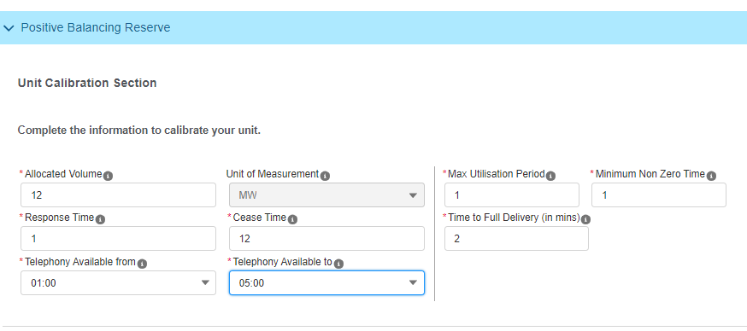
As of Release 2.13, there is a new field available when pre-qualifying for Positive and Negative Balancing Reserve titled ’Service Provision’. This is a mandatory picklist field with options for Generator, Supplier and Through Zero.
Figure 19.2: Service Provision Field
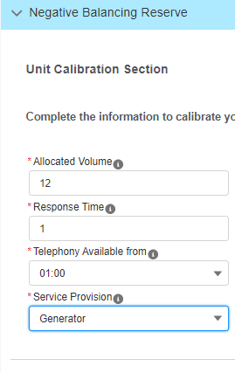

FAQs

FAQs

Topic | Question | Answer
SSO (User & Company Registration) | I’ve changed my mobile phone – do I have to do anything regarding my SSO Credentials | Your will need to approach your Contract Manager to raise a support desk ticket to update your mobile phone number. .
SSO (User & Company Registration) | I’m experiencing problems with my password | Please approach your Contract’s Manager who will raise an IT helpdesk ticket on your behalf
SSO (User & Company Registration) | I’d like to access more than one Account for SMP; however I have the same email address – how do I got about this | Please approach your Contract’s Manager who will raise an IT helpdesk ticket on your behalf to set up your credentials and access for a ‘Secondary Account’

If you have any feedback on this document please email: commercial.operation@neso.energy



