Supplementary Report 2
Data-Driven Online Monitoring and Early Warning for GB System Stability (DOME)
Independent expert analysis/opinion provided by:
Dr Yue Zhu, Dr Yunjie Gu, Prof. Tim Green
Department of Electrical and Electronic Engineering,
Imperial College London
Delivered in Partnership with Imperial College London

Contents
1 Contents 44
2 Introduction 47
3 Whole-system Impedance Model 47
3.1 Introduction 47
3.2 Whole-system impedance model for root-cause tracing 49
4 Whole-system Impedance Identification 51
4.1 Introduction 51
4.2 dq-Frame identification 52
4.3 Impedance/admittance identification 54
4.3.1 Time-domain identification (TDID) 54
4.3.2 Frequency-domain identification (FDID) 55
4.3.3 Discussions on the proper identification methods 56
4.4 Hybrid Data/Model-Driven Impedance Identification 57
4.4.1 Restoration of $Ysys$ from a single-column measurement. 59
4.4.2 Restoration of $Ysys$ from a partial-column measurement. 60
4.4.3 Restoration of $Ysys$ from multiple-column measurements. 61
4.5 Choice of injection/measurement numbers and locations 63
4.6 Model verification 64
5 Case Studies 64
5.1 4-Bus Test System – Demonstration of Identification Methods 65
5.1.1 System Introduction 65
5.1.2 TDID Application 66
5.1.3 FDID Application 73
5.1.4 Root-Cause Tracing 77
5.2 7-Bus Test Systems – Full Column Measurement 79
5.3 7-Bus Test Systems – Partial Column Measurement 86
6 Conclusions 89
7 References 90

TABLES
Table 1 Classifications of two new strength metrics 56

FIGURES

Figure 1 Formation of whole-system admittance model: by introducing small voltage perturbations at each port and taking out the current response forms the transfer function of whole-system admittance model. 48
Figure 2 Illustration of MIMO systems: (a) whole-system impedance model $Zsys$, (b) whole-system admittance model $Ysys$. 49
Figure 3 The Grey-box approach [2]. 51
Figure 4 small-signal injections for (a) whole-system impedance identification and (b) whole-system admittance identification. 52
Figure 5 MIMO system in dq-frame. 53
Figure 6 Three scenarios of grey-box identification of $Ysys$, from (a) a single-column measurement, (b) a partial-column measurement, and (c) multiple-column measurements. The elements highlighted in green are those measured from input and output. 58
Figure 7 Illustration of the hybrid data/model-driven impedance identification. 60
Figure 8 Average of the two estimations on $Ysys$. 62
Figure 9 Demonstration of the weighted average of the estimations on $Ysys$. 62
Figure 10 Grey-box model identification. 63
Figure 11 Partial-injection partial-measurement for whole-system impedance /admittance identification and root-cause tracing. 63
Figure 12 4-bus test system. 65
Figure 13 Illustration of the injection and measurement. 65
Figure 14 Current response in d-q frame at bus-2 corresponding to the voltage step change. Steady state value is removed. 66
Figure 15 Estimated result in d-q frame from ERA method versus theoretical results from analytical method: (a) $Y12sys$, (b) $Y22sys$ and (c) $Y32sys$. 68
Figure 16 Estimated modes from ERA method versus theoretical results 69
Figure 17 Estimated IBR impedance in d-q frame from ERA method VS theoretical results: (a) $ZA2$, (b) $ZA3$. 70
Figure 18 Estimated IBR impedance in d-q frame from ERA method VS theoretical results: (a) $Y11sys$,(b) $Y22sys$ and (c) $Y33sys$. 72
Figure 19 Frequency sweep waveforms. Blue is on d-axis and red is on q-axis. 73
Figure 20 Frequency sweep results (blue crosses) of (a) $Y12sys$, (b) $Y22sys$ and (c) $Y32sys$. Results are compared with both the theoretical and ERA results. 75
Figure 21 Restored diagonal elements (a) $Y11sys$, (b) $Y22sys$ and (c) $Y33sys$ from frequency sweep, compared with theoretical results. 76
Figure 22 Screenshot of the grey-box approach in Matlab APP. 77
Figure 23 Results from the Grey-box approach using estimation results: (a) layer-1, (b) layer-2. 78
Figure 24 A 7 bus system with one SG and 5 GFL IBRs. The voltage perturbation is added at bus-3 and current responses are taken at bus-1,3,4,5,6,7. 79
Figure 25 Perturbation and measurement in dq frame aligned to bus-1. 80
Figure 26 step response at bus-7. 81
Figure 27 Pole map of $Y3sys$: theoretical and estimated results. 82
Figure 28 Bode plots of estimated $Y33sys$ and $Y43sys$ and their theoretical models, showing accurate estimation of column elements of $Y3sys$ from the ERA method. 83
Figure 29 Bode plots of the restored diagonal elements $Y55sys(s)$ and $Y77sys(s)$, their theoretical models, and vector fitting results from the estimation, showing accurate estimations of diagonal elements of $Ysys$ from the proposed hybrid data/model-driven whole-system admittance identification. 84
Figure 30 Root cause analysis based on the grey-box approach: (a) estimated from the proposed hybrid data/model-driven method, (b) theoretical results 85
Figure 31 Estimations of (a) $Y53sys$ and (b) $Y73sys$, errors occur due to assumptions used in the system, while the estimation around the oscillating frequency 18.3 Hz, which are shown as ‘peak’ in the spectra, is still accurate. 87
Figure 32 Estimations of (a) $Y55sys$ and (b) $Y77sys$ and the vector fitting results. The estimation around the oscillating frequency 18.3 Hz, which is shown as a ‘peak’ in the spectra, are still accurate. 88
Figure 33 Impedance participation analysis (grey-box layer 1) on A3, A5, A7, correctly showing that A7 is the root cause of the18.3 Hz oscillatory mode. 89

Introduction
This report covers the topics of whole-system impedance/admittance models, methods of injecting different types of signals into the system, and identifying the whole-system impedance/admittance. Different methods for impedance identification, including time-domain identification (TDID) and frequency-domain identification (FDID), are discussed in this report with their relative merits analysed. A Hybrid Data/Model-Driven Impedance Identification method is proposed, which offers a way of restoring the whole-system impedance model from a combination of existing knowledge of the system network model and the time-domain voltage/current data. EMT simulation results will also be provided to demonstrate the process of impedance/admittance model identification, and its application in root-cause tracing. If not specifically stated otherwise, the impedance/admittance models mentioned in this report refer to frequency-domain models, rather than single (complex) values of impedance/admittance at the system base frequency. They could be state-space models, transfer functions, or frequency spectra in discrete format (frequency response data). Some results from this report have been concluded into a journal paper and submitted to IEEE Transactions on Industrial Electronics, with a preprint available online [1] .
This report serves as a supplementary report for DOME Final Report. It is developed originally from DOME WP2&3 Report but with updates in both theory and simulation results.

Whole-system Impedance Model

Introduction
The whole-system impedance model, or equivalently, whole-system admittance model is formalised based on a separation between the shunt-connected apparatus appearing at nodes and the lines and cables of the branches of the network that connect nodes. Thus, the system is separated into a nodal admittance matrix $Y_{N}$ and an apparatus matrix $Y_{A}$. The whole-system impedance model $Z_{}^{sys}$ and the whole-system admittance model $Y_{}^{sys}$ are formed as illustrated in Figure 1.

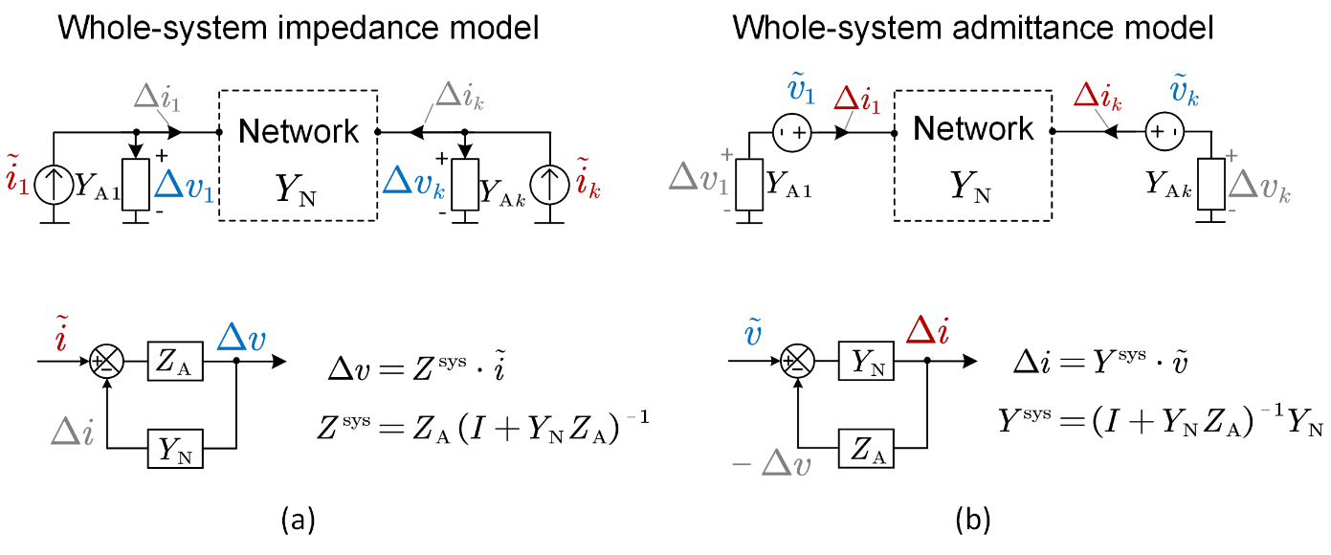
Figure 1 Formation of whole-system admittance model: by introducing small voltage perturbations at each port and taking out the current response forms the transfer function of whole-system admittance model.
Taking $Z_{}^{sys}$ as an example, the model is formed with a virtual nodal injection of current $\tilde{i}$ whereas for the nodal admittance model the injection is a nodal voltage. The current injection $\tilde{i}$ causes a change in current through the apparatus and therefore a change in the apparatus voltage $Δv$, which in turn creates a change of current flowing into the network $Δi$, which changes the current flow in the apparatus in a feedback fashion. This feedback arrangement is illustrated in Figure 1 (a). The response $Δv$ to perturbation $\tilde{i}$ is
$$\begin{aligned}Δv=Z_{A} {\left(I+Y_{N}Z_{A}\right)}^{-1}\tilde{i} \# LISTNUM NumberDefault \backslash l 4 \end{aligned}$$
where $I$ is identity matrix and $Z_{A}$ is the apparatus impedance matrix defined in the same fashion of $Y_{A}$ but with apparatus impedance as its diagonal elements, i.e.,
$$\begin{aligned}Z_{A}=\left[\begin{matrix}Z_{A1} & & \\ & ⋱ & \\ & & Z_{AN}\end{matrix}\right] \# LISTNUM NumberDefault \backslash l 4 \end{aligned}$$
and $Z_{Ak}={\left(Y_{Ak}\right)}^{-1}$.
The whole-system impedance model is defined from equation (1) as
$$\begin{aligned}Z_{}^{sys}=Z_{A} {\left(I+Y_{N}Z_{A}\right)}^{-1} \# LISTNUM NumberDefault \backslash l 4 \end{aligned}$$
Similarly, the formulation of the whole-system admittance model is shown in Figure 1(b), using a series injection of voltage and a response in terms of current. The model is defined as
$$\begin{aligned}Y_{}^{sys}={\left(I+Y_{N}Z_{A}\right)}^{-1}Y_{N} \# LISTNUM NumberDefault \backslash l 4 \end{aligned}$$
It is worth noting that $Z_{}^{sys}$ and $Y_{}^{sys}$ relate to the case where the system is complete: all devices are connected and form a closed-loop relationship.
The formulations $Z_{}^{sys}$ and $Y_{}^{sys}$ view the entire system as a multi-input multi-output (MIMO) system, as shown in Figure 2.
(a)
(b)
Figure 2 Illustration of MIMO systems: (a) whole-system impedance model $Z^{sys}$, (b) whole-system admittance model $Y^{sys}$.
Taking $Z_{}^{sys}$ as an example, its input $\left\{{\tilde{i}}_{1},{\tilde{i}}_{2},⋯, {\tilde{i}}_{N}\right\}$ are the current perturbations introduced at each point of common coupling (PCC), and its output $\left\{Δv_{1},Δv_{2},⋯, Δv_{N}\right\}$ are the corresponding voltage responses at each PCC. Since it is the closed-loop model of the system, the criteria for the system being stable is that all poles of $Z_{}^{sys}$ must be in the left-half plane. It is further proved in [1] that all elements in the matrix of $Z_{}^{sys}$ share the same poles, which equal to the eigenvalues of the system state-space model and represent the system oscillatory modes.

Whole-system impedance model for root-cause tracing
Oscillation analysis and root-cause tracing based on whole-system impedance model have been fully discussed in [3] and [4], and they are briefly introduced here.
Essentially, the system oscillatory behaviour is dependent on the eigenvalues of the state-space matrix $A$. For a physical system, an eigenvalue $λ$ is either a real number or a pair of conjugate complex values. When $λ$ is conjugate complex, i.e.,
$$\begin{aligned}λ=σ±jω, λ∈eig\left(A\right)\# LISTNUM NumberDefault \backslash l 4 \end{aligned}$$
$λ$ refers to an oscillatory mode in the system, where $σ$ refers to the damping of the mode (the rate at which an oscillation is dampened) and $ω$ is the oscillation frequency. When there is a mode with a small damping factor in the system, one expects to see long-lasting oscillations in the system variables following a small disturbance such as a small step change in the load or in the voltage, or an impulse like a lightning strike.
Now consider a small change added to the impedance of an IBR connected at bus-k, $ΔZ_{Ak}$, while the rest of the system unchanged. This change can be caused by a small perturbation of a control parameter of the IBR, a variation of its operating point, or scaling up or down by connecting or disconnecting a portion of apparatus from a farm of apparatuses (e.g. a wind farm). The change $ΔZ_{Ak}$ will lead to a variation on the system eigenvalue $λ$, i.e., $Δλ$. If in a single-phase system where $Z_{Ak}$ is a scalar transfer function, and within a small range around $s=λ$, $Δλ$ can be calculated as
$$\begin{aligned}Δλ=\frac{∂λ}{∂Z_{Ak}\left(λ\right)}⋅ΔZ_{Ak}\left(λ\right)\# LISTNUM NumberDefault \backslash l 4 \end{aligned}$$
where $\frac{∂λ}{∂Z_{Ak}\left(λ\right)}$ represents the sensitivity of $λ$ to the impedance of the IBR at bus-k at $s=λ$. According to the discussion in [3], such sensitivity equals the negative of the residue of $Y_{kk}^{sys}$ at its pole $s=λ$, i.e.,
$$\begin{aligned}\frac{∂λ}{∂Z_{Ak}\left(λ\right)}=-{Res}_{λ}Y_{kk}^{sys}\# LISTNUM NumberDefault \backslash l 4 \end{aligned}$$
where ${Res}_{λ}Y_{kk}^{sys}$ represents the residue of $Y_{kk}^{sys}$ at $s=λ$. Substituting (7) into (6) yields
$$\begin{aligned}Δλ=-{Res}_{λ}Y_{kk}^{sys} ⋅ΔZ_{Ak}\left(λ\right)\# LISTNUM NumberDefault \backslash l 4 \end{aligned}$$
In a more common scenario where the dq-synchronous frame is employed and $ΔZ_{Ak}\left(λ\right)$ and $Y_{kk}^{sys}$ are $2×2$ square matrices, (8) can be modified to become
$$\begin{aligned}Δλ=〈-{Res}_{λ}^{*}Y_{kk}^{sys},ΔZ_{Ak}\left(λ\right)〉\# LISTNUM NumberDefault \backslash l 4 \end{aligned}$$
where ${Res}_{λ}^{*}Y_{kk}^{sys}$ is the conjugate transpose of the matrix of residues of $Y_{kk}^{sys}$ at $s=λ$, and $\left\langle ⋅,⋅\right\rangle$ denotes the Frobenius inner product of the two matrices. It follows from (9) that ${Res}_{λ}^{*}Y_{kk}^{sys}$ quantifies how the perturbation of impedances yields the perturbation of eigenvalues and therefore is called impedance participation factor. For an observed oscillatory mode, the larger the value of ${Res}_{λ}^{*}Y_{kk}^{sys}$ that is found at bus-k, the larger is the participation of the apparatus at bus-k in the mode, and hence apparatus at buses with large residuals can be considered as the root-causes of the oscillation. For a more precise tracing, the impedance-based grey-box approach is available, as shown in Figure 2. Since this project is focused mainly on root-cause tracing, only Layer-1 (for participant analysis) and Layer-2 (for positive and negative damping provision) are of interest. This use of residuals of modes seen in impedance spectra to identify root-causes of oscillations is the fundamental method applied in this NIA project.
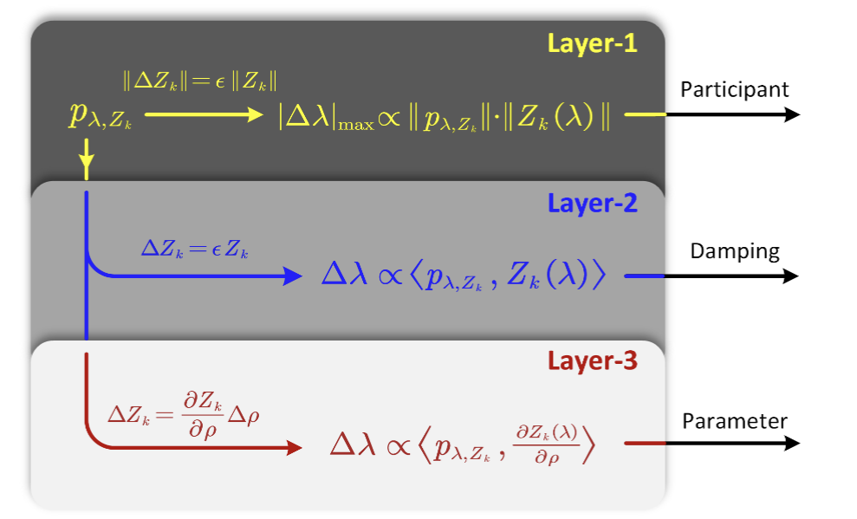
Figure 3 The Grey-box approach [3].

Whole-system Impedance Identification

Introduction
The process of system identification is performed by applying a known input to the system and observing the system output. The model is then estimated from the relationship between the input and output. For whole-system models based on Figure 2, it is clear that we will need to introduce small-signal current perturbations and measure the voltage responses at each PCC to estimate $Z^{sys}$. Alternatively, it is possible to introduce small-signal voltage perturbations and measure the current flow through the PCC to estimate $Y^{sys}$. The injection topologies at a PCC are illustrated in Figure 4.
(a)
(b)
Figure 4 small-signal injections for (a) whole-system impedance identification and (b) whole-system admittance identification.

dq-Frame identification
It is worth noting that since the system is a three-phase system, the impedance/admittance models are all represented in a dq synchronous frame, so that each input is a $2×1$ vector and each output is a $2×1$ vector. Taking $Z^{sys}$ as an example, Figure 2(a) should be modified to be as shown in Figure 5.
Figure 5 MIMO system in dq-frame.
Each element in $Z^{sys}$ is then a $2×2$ matrix block as
$$\begin{aligned}Z_{kk}^{sys}=\left[\begin{matrix}Z_{kk,dd}^{sys} & Z_{kk,dq}^{sys} \\ Z_{kk,qd}^{sys} & Z_{kk,qq}^{sys}\end{matrix}\right]\# LISTNUM NumberDefault \backslash l 4 \end{aligned}$$
To identify all elements of $Z_{ij}^{sys}$, at least two linearly independent inputs are needed: ${\left[{\tilde{i}}_{k,d}^{\left(1\right)}, {\tilde{i}}_{k,q}^{\left(1\right)}\right]}^{T}$, and ${\left[{\tilde{i}}_{k,d}^{\left(2\right)}, {\tilde{i}}_{k,q}^{\left(2\right)}\right]}^{T}$, where the superscripted number represents the round of the input. Under such inputs, the relationship between input and output could be represented as
$$\begin{aligned}\left[\begin{matrix}Z_{kk,dd}^{sys} & Z_{kk,dq}^{sys} \\ Z_{kk,qd}^{sys} & Z_{kk,qq}^{sys}\end{matrix}\right]⋅\left[\begin{matrix}{\tilde{i}}_{k,d}^{\left(1\right)} & {\tilde{i}}_{k,d}^{\left(2\right)} \\ {\tilde{i}}_{k,q}^{\left(1\right)} & {\tilde{i}}_{k,q}^{\left(2\right)}\end{matrix}\right]=\left[\begin{matrix}Δv_{d}^{\left(1\right)} & Δv_{d}^{\left(2\right)} \\ Δv_{q}^{\left(1\right)} & Δv_{q}^{\left(2\right)}\end{matrix}\right]\# LISTNUM NumberDefault \backslash l 4 \end{aligned}$$
Such that $Z_{kk}^{sys}$ can be solved from
$$\begin{aligned}\left[\begin{matrix}Z_{kk,dd}^{sys} & Z_{kk,dq}^{sys} \\ Z_{kk,qd}^{sys} & Z_{kk,qq}^{sys}\end{matrix}\right]=\left[\begin{matrix}Δv_{d}^{\left(1\right)} & Δv_{d}^{\left(2\right)} \\ Δv_{q}^{\left(1\right)} & Δv_{q}^{\left(2\right)}\end{matrix}\right]⋅{\left[\begin{matrix}{\tilde{i}}_{k,d}^{\left(1\right)} & {\tilde{i}}_{k,d}^{\left(2\right)} \\ {\tilde{i}}_{k,q}^{\left(1\right)} & {\tilde{i}}_{k,q}^{\left(2\right)}\end{matrix}\right]}^{-1}\# LISTNUM NumberDefault \backslash l 4 \end{aligned}$$
A typical example for linearly independent inputs is to inject only on d-axis first (e.g., active power), then inject only on q-axis (e.g., reactive power), as below:
$$\begin{aligned}\left[\begin{matrix}Z_{kk,dd}^{sys} & Z_{kk,dq}^{sys} \\ Z_{kk,qd}^{sys} & Z_{kk,qq}^{sys}\end{matrix}\right]⋅\left[\begin{matrix}{\tilde{i}}_{k,d}^{} & 0 \\ 0 & {\tilde{i}}_{k,q}^{}\end{matrix}\right]=\left[\begin{matrix}Δv_{d}^{\left(1\right)} & Δv_{d}^{\left(2\right)} \\ Δv_{q}^{\left(1\right)} & Δv_{q}^{\left(2\right)}\end{matrix}\right]\# LISTNUM NumberDefault \backslash l 4 \end{aligned}$$
In this special case, if only one injection is applied, e.g., ${\tilde{i}}_{k}^{}={\left[0, {\tilde{i}}_{k,q}^{}\right]}^{T}$, a single element $Z_{kk,qq}^{sys}$ can be acquired from an element-wise calculation. This would provide useful information but is limited and it is recommended to use two linearly independent inputs in order to identify a complete dq-frame model.
Another factor to consider is that the impedance in dq-frame is usually aligned with the local synchronous frame. To link them together and form a whole-system model, the local-frames should be aligned to a global synchronous frame. This is discussed in [5] and [6]. If the dynamics of phase-lock-loop (PLL) are omitted, the alignment can be fulfilled via the following equation:
$$\begin{aligned}Z_{k,dq^{'}}=\left[\begin{matrix}\cos\left(θ_{k}\right) & -\sin\left(θ_{k}\right) \\ \sin\left(θ_{k}\right) & \cos\left(θ_{k}\right)\end{matrix}\right]Z_{k,dq}\# LISTNUM NumberDefault \backslash l 4 \end{aligned}$$
where $Z_{k,dq^{'}}$ is the impedance aligned to the global synchronous frame, $θ_{k}$ is the voltage angle at the bus from power flow calculation. In the following discussion of this report, all impedance models are aligned to the slack bus ($θ=0)$.

Impedance/admittance identification
There are two essential approaches to impedance identification: the time-domain identification (TDID) approach and the frequency-domain identification (FDID) approach. These methods are introduced in [7]. It is worth noting that the system discussed in this report is considered a linear time-invariant (LTI) system. The system is linear in that it is a linearisation of a non-linear system around an operating point. The real system (the grid and its resources) will be time-varying because an ever-changing operating point and repeated re-linearisation will be required. That process is ignored here on the basis that changes in operating point are gradual enough or infrequent enough for a given linearisation to be applicable for a period of time, such as a half-hour settlement period. Approaches to dealing with time-variance, such as banks of linearised models and tracking via digital twins are being investigated elsewhere.

Time-domain identification (TDID)
TDID makes use of the data collected in discrete time, i.e., the input $u(t)$ and output $y(t)$. A system order $M$ (and therefore the order of the model) is usually selected using assumptions about the system or through repeated refinement. A set of algorithms are then applied to estimate the parameters in the state-space model based on the time-domain data. Example algorithms include the eigensystem realization algorithm (ERA) method and the dynamic mode decomposition (DMD) method. These methods have been successfully used for impedance identification in [8]. Commercial tools exist such as the Matlab System Identification Toolbox. This toolbox is sophisticated in that it first chooses the most appropriate algorithm based on the characteristics of the input data.
Time-domain techniques are often used when the system's behaviour can be adequately captured within a short timeframe and when the data is sampled at high frequencies. For example, it will be suited to cases where the system is excited by an impulse or a step change. However, if the system behaviour cannot be excited within a short timeframe due to inappropriate choice of input signal, such as a ramped change on the load, it becomes inaccurate to use TDID.

Frequency-domain identification (FDID)
FDID establishes the relationship between input and output in frequency-domain, such as using a Bode plot. This method is usually fulfilled via discrete Fourier Transformation (DFT) or Fast Fourier Transformation (FFT). Based on the input signal, it can be further classified into wide-band (or broad-band) injection and narrowband injection. The wideband injection use signals like an impulse, a step-change, or pseudorandom binary sequence (PBS) which contains rich frequency components to excite the system. By applying an FFT on the input and output, the frequency response is then acquired. Such methods can provide identified results with a very short period of signal injection [9]. However, the wide-band injection appears not to be robust to noise. One reason is that the energy of the noise in the measurement will increase along with the increase of sample-rate, but the energy of the signal stays constant. In such a way, signal-to-noise ratio (SNR) becomes lower for high sample rate. However, if a low sample rate is chosen, the dynamics of interest in the system may not be observable. In the real system, it is not always allowed to increase the amplitude of the injected input signal. Another reason why wideband injection is problematic is the spectral leakage when doing Fourier transform, which occurs when the periodic extension of a signal is discontinued at the ends of the sample window. This is very common for a wideband injection since the harmonics of the injected signal are not necessarily multiples of the sampling frequency (frequency resolution). To this end, wideband injection for FDID is not recommended in this report. If wideband signals are available, it is recommended to use time-domain identification directly.
Narrowband injection, which is mainly about a frequency-sweep, is injecting a series of sinewaves with different frequencies and obtain a set of frequency response data through DFT at each frequency. Compared with wideband injection, it is more noise-robust and can mitigate the spectral leakage problem by choosing proper frequency points. The downside of narrowband injection is the duration needed for the sweep. Through a set of simulations and experiments, we found that, if properly designed, the frequency sweep process can take less than 30 s to sweep from 1 Hz to 100 Hz, which is considered to be acceptable.
As discussed in Section 3.2, the value of the residue is needed for getting the impedance participation factor. This means the identification of the whole-system impedance / admittance model should be a parametric identification. As a result, either wideband or narrowband injection is applied, a parametric system needs to be estimated from the frequency response data. This is usually fulfilled via rational approximation [10]. A readily available tool is the vector fitting toolbox [11].

Discussions on the proper identification methods
First, as pointed out in [7], the two methods should not be in competition, but be complementary. If an ideal input for time-domain identification is readily available, such as a scheduled step change in the voltage, a time-domain identification will be suitable. This is particularly suitable for post-event analysis. An example is the power outage happened in August 2019 in GB, where oscillations were recorded from the reactive power output from Hornsea One ten minutes prior to the event in response to a 2% step change in voltage.
Alternatively, if sinewaves of different frequencies can be injected through an inverter designed for that purpose, the frequency-domain identification will be straightforward. This can be used for early warning for potential oscillation. Similar experiments have been performed by National Renewable Energy Laboratory (NREL) in a MW-level test system [13].
In this report, both methods will be tested. It will be seen that in a small-scale system, or a system with only local oscillatory modes, time-domain identification can provide a quick and easy solution for root-cause tracing whereas in a large-scale system, frequency-domain identification through frequency sweep perturbation provides more accurate results. Thus both methods are useful.
A comparison of the two methods is given in Table 1.
Table 1 Classifications of two new strength metrics
 | Time-domain Identification | Frequency-domain identification
Injected signal | - Any format.  - Ideally: impulse, step change. | - Sequence of sinusoidal waves with different frequencies.
Advantage | - Quick and easy to implement.  - Could use existing (ambient) signals in the system. | - Robust to noise  - Injection could be designed and configured flexibly (test range, injection amplitude, number of cycles, etc.).
Disadvantage | - Sensitive to noise.  - Dynamics are not guaranteed to be excited by the injected signals. | - Time consuming.  - Extra cost on the hardware  - Potential disturbance to system operation.
Suitable applications | - Post-event analysis with observed oscillations during known changes.  - Early warning through scheduled changes in the system.  - Small-scale network, or local-area oscillatory modes. | - System monitoring with specifically designed injections to identify potential risks.  - Large-scale system, and inter-area modes.

Hybrid Data/Model-Driven Impedance Identification
Given the MIMO nature of the black-box system illustrated in Figure 5, injections and measurements at each PCC are needed to identify the entire system. However, such a high-density of injections is not practicable in view of the equipment needed or the time taken. In reality, the system operator would have a certain degree of knowledge of the grid, among which the knowledge of the network nodal admittance matrix $Y_{N}$ and parameters of the synchronous generators (SGs) would be very useful for “seeding” whole-system impedance identification. This is known as the grey-box model identification.
If $Y_{N}$, which includes information about lines and load and is usually used for power flow calculation, is known beforehand, a single input with multiple outputs would be able to restore the whole system $Z^{sys}$ or $Y^{sys}$. Here we take $Y^{sys}$ as an example because we are going to introduce voltage perturbation in case studies.
The identification of $Y^{sys}$can be concluded in three scenarios: i) the current perturbation is added at one location and voltage response is measured at all other locations. In such a case, a single column of $Y^{sys}$ will be measured, so is called a single-column measurement, as shown in Figure 6 (a). ii) The scenario where measurements cannot be taken everywhere so that only part of the column can be measured is called a partial-column measurement, as shown in Figure 6 (b). 3) The scenario where injections are taken at multiple locations is called multiple-column measurements, as shown in Figure 6 (c). Restoration of $Y^{sys}$ in these 3 scenarios are introduced here.
(a)
(b)
(c)
Figure 6 Three scenarios of grey-box identification of $Y^{sys}$, from (a) a single-column measurement, (b) a partial-column measurement, and (c) multiple-column measurements. The elements highlighted in green are those measured from input and output.

Restoration of $Y^{sys}$ from a single-column measurement.
From (4) we have
$$\begin{aligned}{\left(Y_{}^{sys}\right)}^{-1}=Z_{N}+Z_{A}\# LISTNUM NumberDefault \backslash l 4 \end{aligned}$$
where $Z_{N}= Y_{N}^{-1}$. In theory $Y_{N}$ is a sparse matrix and may not be invertible. In such a case infinitesimally small shunt admittances can be added at the empty buses to make the matrix invertible. Such admittances are a reality anyway because of line parasitic capacitors. Right multiplying $Y^{sys}$ on both sides of (15) yields
$$\begin{aligned}\left(Z_{N}+Z_{A}\right)Y^{sys}=I\# LISTNUM NumberDefault \backslash l 4 \end{aligned}$$
(16) can be further re-written in a column format that
$$\begin{aligned}\left(Z_{N}+Z_{A}\right)⋅\left[Y_{c1}^{sys}\left|Y_{c2}^{sys}\right|⋯ | Y_{cN}^{sys}\right]=I,\# LISTNUM NumberDefault \backslash l 4 \end{aligned}$$
where $Y_{ck}^{sys}$ is the k-th column of $Y^{sys}$, i.e., $Y_{ck}^{sys}={\left[Y_{1k}^{sys},Y_{2k}^{sys},⋯,Y_{Nk}^{sys}\right]}^{T}$. If from a single input and multiple outputs we identify $Y_{ck}^{sys}$, the following equation can be easily derived from (17):
$$\begin{aligned}\left(Z_{N}+Z_{A}\right)⋅Y_{ck}^{sys}=I_{k}\# LISTNUM NumberDefault \backslash l 4 \end{aligned}$$
Where $I_{k}$ is the k-th column of the identity matrix. Such that
$$\begin{aligned}Z_{A}Y_{ck}^{sys}=I_{k}-Z_{N}Y_{ck}^{sys}\# LISTNUM NumberDefault \backslash l 4 \end{aligned}$$
Let $c=I_{k}-Z_{N}Y_{ck}^{sys}$, which is a column vector. Since $Z_{A}$ is a diagonal matrix, from (19) $Z_{A}$ can be calculated in elementwise, such that
$$\begin{aligned}Z_{Ai}=c_{i} ⋅{\left(Y_{cki}^{sys}\right)}^{-1}\# LISTNUM NumberDefault \backslash l 4 \end{aligned}$$
By having $Z_{A}$ and $Z_{N}$, the entire matrix $Y^{sys}$ can be acquired from (15), which can further be used for root-cause tracing, as introduced in Section 33.2. Although the full matrix of $Y^{sys}$ is restored, it is worth noting that only the diagonal elements are useful for root-cause tracing.
Because the above process utilises both the data collected in the system and the model known to the system operator, this approach is named as the hybrid data/model-driven impedance identification, as concluded in Figure 7.
Figure 7 Illustration of the hybrid data/model-driven impedance identification.

Restoration of $Y^{sys}$ from a partial-column measurement.
In many cases, measurement cannot be taken at all buses. In such cases, available information on buses without measurement unit, or reasonable assumptions on these buses can be used for $Y^{sys}$ restoration.
For buses with SG connected, we consider its impedance $Z_{Ak}$ known. This is because the SG’s parameters are usually disclosed to the system operator. From the known parameters we could establish a realisation of SG’s state-space equations, which further derives the transfer function from its port current to port voltage, i.e., $Z_{Ak}$.
For buses with IBR connected, especially when its model is not disclosed, it is recommended to implement a measurement unit. If not, some compromises are needed. One solution is to use a generic IBR model to represent the unmeasured IBR. Alternatively, a simple current source with very large impedance can be used, which implies the assumption that the unmeasured IBR does not participating in any of the oscillations.
For simplicity, we assume that bus-1,2,…,$j$-1 are those with known impedances or assumptions made, and bus-$j$, $j$+1,…, $N$ are those with measurement units. The input perturbation is added in bus-$k$. Under this assumption, (19) can be rewritten in block-matrix format as
$$\begin{aligned}\left[\begin{matrix}Z_{A,11} & \\ & Z_{A,22}\end{matrix}\right]\left[\begin{matrix}Y_{ck,1}^{sys} \\ Y_{ck,2}^{sys}\end{matrix}\right]=\left[\begin{matrix}I_{k,1} \\ I_{k,2}\end{matrix}\right]-\left[\begin{matrix}Z_{N,11} & Z_{N,12} \\ Z_{N,21} & Z_{N,22}\end{matrix}\right]\left[\begin{matrix}Y_{ck,1}^{sys} \\ Y_{ck,2}^{sys}\end{matrix}\right]\# LISTNUM NumberDefault \backslash l 4 \end{aligned}$$
where $Y_{ck,1}^{sys}$ is unknown, $Y_{ck,2}^{sys}$ is measured, $Z_{A,11}$ is known and $Z_{A,22}$ is unknown. By solving (21) we have
$$\begin{aligned}Z_{A,11} Y_{ck,1}^{sys}=I_{k,1}-Z_{N,11}Y_{ck,1}^{sys}-Z_{N,12}Y_{ck,2}^{sys} \\ Z_{A,22}Y_{ck,2}^{sys}=I_{k,2}-Z_{N,21}Y_{ck,1}^{sys}-Z_{N,22}Y_{ck,2}^{sys}\# LISTNUM NumberDefault \backslash l 4 \end{aligned}$$
from which the two unknowns $Y_{ck,1}^{sys}$ and $Z_{A,22}$ can be found. The rest of the process stays the same as single-column measurement.

Restoration of $Y^{sys}$ from multiple-column measurements.
If perturbations are introduced at more than one location, we will acquire data relevant to multiple columns of $Y^{sys}$. From each column we will be able to restore a whole-system admittance model $Y_{est}^{sys}$. In such a case, the system is overdetermined in that we will have multiple estimates of the same matrix and they will be somewhat different from each other.

Averaging:
A straightforward way to deal with overdetermined estimates is to average the estimated models. For example, if perturbations are introduced at two locations and measurements are taken at every bus, we will have $Y_{ci}^{sys}$ and $Y_{cj}^{sys}$, which would restore two admittances: $Y_{est,i}^{sys}$ and $Y_{est,j}^{sys}$. And the average would be
$$\begin{aligned}Y_{est_avg}^{sys}=\frac{1}{2}\left(Y_{est,i}^{sys}+Y_{est,j}^{sys}\right)\# LISTNUM NumberDefault \backslash l 4 \end{aligned}$$
where the plus symbol refers to the parallel connection of the two systems, as illustrated in Figure 8.
When parallel connecting the two systems, the ‘states’ will be appended, such that the order of the averaged result $Y_{est_avg}^{sys}$ will be the summation of the orders of the two estimated system $Y_{est,i}^{sys}$ and $Y_{est,j}^{sys}$. To avoid a high-order system, a model reduction is usually needed, such as using the minimal realisation.

Figure 8 Average of the two estimations on $Y^{sys}$.
Although this method provides a simple way to merge the over-determined results and make use of all the measured data, it does not really improve the accuracy of the estimate of the system and instead may lower the accuracy. One principle of system estimation is that when the electrical distance between the injection and measurement points is small, the signal becomes more obvious and the estimation becomes accurate. Conversely, if the electrical distance is large, then the signals would be attenuated and the noise becomes the dominant such that the estimation is inaccurate. By averaging the results, the elements which are accurate from the first estimation may be negatively affected by the poor accuracy of the second estimation, and vice versa.

Weighted Averaging:
Another option is to weight the terms in the average, i.e., the buses which are close to the input have a higher weight while those far from the injection has a lower weight. With appropriate weights, the two (or more) estimates can be combined so that the results are complementary. The idea is illustrated in Figure 9. It must be noted that a method to choose appropriate weight of whole-system impedance/admittance models has not yet been addressed and further work is needed. An initial idea is that the weights could be the reciprocal of the electric distance from each bus to the injection location.
Figure 9 Demonstration of the weighted average of the estimations on $Y^{sys}$.
Other methods such as using Bayesian optimisation or machine learning may be possible but are considered as topics for future work.
In general, with the available knowledge to the system, the identification is essentially a grey-box model identification, as illustrated in Figure 10.
Figure 10 Grey-box model identification.

Choice of injection/measurement numbers and locations
As mentioned in Section 4.4, injections and measurements do not have to be implemented at every node, instead, input at a few nodes and partial measurements will be able to provide useful information for tracing of root-causes of oscillations. This partial-injection partial-measurement identification is illustrated in Figure 11. Since the unmeasured nodes are based on some assumptions such as ideal current sources, they should NOT be considered further for root-cause tracing. The tracing is only carried among nodes which are measured. This is a compromise of such a method.
Figure 11 Partial-injection partial-measurement for whole-system impedance /admittance identification and root-cause tracing.
Theoretically, only one injection source in the system would be enough to restore the whole system impedance or admittance model. But this is not practical since signals will be attenuated due to long transmission lines, and obscured by noise. To better identify the model, multiple injections will be needed to cover the areas of interest.
The injection numbers and locations would be dependent on the system size and noise conditions. If the system is large and can be divided into several subregions which are connected via long transmission lines, a straightforward solution is to add at least one injection source in each subregion of interest. If noise is not considered at this stage, the exact location of the injection may be decided by the average electrical distance between the injection source and the IBR nodes which are measured. However, noise levels at each node may be different. As a result, it is desirable to place the injection source close to nodes with higher noise levels or add multiple injections as necessary to overcome the adverse effects of noise.
Ideally, measurement would be taken at every node, or at least at all nodes with IBR connected. But again, this may not be practicable. If only limited measurement units are to be implemented in the system, the ideal locations would be those where oscillations might be expected and areas with high density of IBRs.

Model verification
Once the system is identified, it is important to verify the estimated results. If the theoretical model is available, a comparison can be made between the estimated results and the theoretical model. Such a comparison could be a frequency-domain comparison, e.g., to compare the Bode plots. If theoretical model is not available, a time-domain comparison can be used, i.e., by applying a new input to both the estimated system, and the theoretical model and compare the match between the time-domain.

Case Studies
EMT simulations were performed to validate the proposed hybrid data/model-driven approach for whole-system admittance identification. The results demonstrate that this approach effectively identifies oscillatory modes and determines their root causes by applying perturbations at a single location, without requiring any knowledge of the internal design of IBRs.

4-Bus Test System – Demonstration of Identification Methods

System Introduction
A 4-bus, 2-IBR system is used here to demonstrate the process of model identification and root-cause tracing. The structure of the system is given in Figure 12. The current control bandwidth of IBR3 was deliberately tuned low to create an oscillatory mode.
Figure 12 4-bus test system.
A voltage perturbation is introduced at bus-2 and current flowing through buses 1, 2 and 3 are measured. Both inputs and outputs are recorded in a common d-q frame. The d-q inputs on bus-2 means that we can estimate for the 3rd and 4th columns of $Y^{sys}$, and the 3 measurement points allow the first 6 elements to be estimated, as illustrated in Figure 13. In the following of this case study, the d-q frame is aligned to bus-1.
Figure 13 Illustration of the injection and measurement.

TDID Application
Time-domain identification is first carried out in the system, where two step-increases to the voltage are applied separately to the d- and q-axes so that they are linearly independent, such that
$$\begin{aligned}\tilde{v}=\left[\begin{matrix}{\tilde{v}}_{d}^{\left(1\right)} & 0 \\ 0 & {\tilde{v}}_{q}^{\left(2\right)}\end{matrix}\right].\# LISTNUM NumberDefault \backslash l 4 \end{aligned}$$
The magnitude of the perturbation is 0.01 pu. Current response is measured and a 2 s window is selected for time-domain identification. Figure 14 shows the current response at bus-2, $Δi_{2}=\left[\begin{matrix}Δi_{d2}^{\left(1\right)} & Δi_{d2}^{\left(2\right)} \\ Δi_{q2}^{\left(1\right)} & Δi_{q2}^{\left(2\right)}\end{matrix}\right]$, where the steady state has been removed for further identification algorithms.
Figure 14 Current response in d-q frame at bus-2 corresponding to the voltage step change. Steady state value is removed.
The ERA method is applied to identify the data. The ERA method constructs two shifted Hankel matrix $H_{1}$ and $H_{2}$ from the measured response, after which a singular value decomposition (SVD) is performed on the Hankel matrices and eventually finds a state-space matrix $A$. The detailed process is introduced in [8]. It should be noted that ERA assumes the input $u$ is an impulse input, i.e.,
$$u\left(k\right)=\left\{\begin{matrix}1, k=0 \\ 0, k>0\end{matrix}\right.,$$
Where k refers to the number of samplings. Therefore, this method does not direct leads to an input/output model, but only the s-domain system of the output data. To get the input/output model, the input signal should be transferred to s-domain, either through ERA as well, or through Laplace transform. For example, applying ERA method on ${\left[Δi_{1}\left(t\right), Δi_{2}\left(t\right), Δi_{3}\left(t\right)\right]}^{T}$leads to a state-space representation of $Δi\left(s\right)={\left[Δi_{1}\left(s\right), Δi_{2}\left(s\right), Δi_{3}\left(s\right)\right]}^{T}$. Since the input is the step change with size of 0.01, it is easy to obtain its s-domain function:
$$\begin{aligned}\tilde{v}\left(s\right)=\frac{0.01}{s}\left[\begin{matrix}1 & \\ & 1\end{matrix}\right]\# LISTNUM NumberDefault \backslash l 4 \end{aligned}$$
As a result, the identified from input to the output can be derived as
$$\begin{aligned}Y^{sys}\left(s\right)=Δi\left(s\right)⋅\tilde{v}{\left(s\right)}^{-1}\# LISTNUM NumberDefault \backslash l 4 \end{aligned}$$
Figure 15 compares the bode diagrams from the estimated results of time-domain identification and theoretical results in d-q frame. It can be seen that the estimations have high accuracy, especially near the ‘peaks’ of the bode plots, which display the oscillatory modes.
(a)
(b)
(c)
Figure 15 Estimated result in d-q frame from ERA method versus theoretical results from analytical method: (a) $Y_{12}^{sys}$, (b) $Y_{22}^{sys}$ and (c) $Y_{32}^{sys}$.
Figure 16 compares the estimated modes and the theoretical modes between 0 and 100 Hz, from which it is clear that the modes are identified accurately, and a significant oscillatory mode, $λ=-0.48±28.46$ Hz is identified. It shows that modes can be successfully identified from the time-domain identification.
Figure 16 Estimated modes from ERA method versus theoretical results
Since bus-4 is an empty bus with no equipment connected, $Y_{42}^{sys}$ has a value of zero. As a result, we could give $Y_{42}^{sys}$ a very small value, e.g., $\left[\begin{matrix}{10}^{-6} & \\ & {10}^{-6}\end{matrix}\right]$. In such a way, a full column of $Y^{sys}$ is restored. From (15)-(20), the impedances of IBR-2 and IBR-3, i.e., $Z_{A2}$ and $Z_{A3}$ can be recovered, as shown in Figure 17. The estimated results generally match with theoretical values but errors are present. These errors are mainly caused by the inverse calculation in (20) which enlarges the error in $Y_{22}^{sys}$ and $Y_{32}^{sys}$. Nevertheless, the estimated values are in an acceptable range, and can be used for the next step which is the restoration of the matrix of $Y^{sys}$. For $Z_{A1}$, which is the impedance of the SG, the theoretical value is applied.
(a)
(b)
Figure 17 Estimated IBR impedance in d-q frame from ERA method VS theoretical results: (a) $Z_{A2}$, (b) $Z_{A3}$.
Eventually, the whole matrix of $Y^{sys}$ can be restored from (15). Since only the diagonal elements will be used for root-cause tracing, the restored $Y_{11}^{sys}$, $Y_{22}^{sys}$ and $Y_{33}^{sys}$ are shown in Figure 18. In general, the estimated results match reasonably closely with the theoretical results. Although some mismatches are observed in the bode plots, the estimation is accurate near the oscillation frequency. This means that the results can be used for tracing the root-causes of the oscillations.
(a)
(b)
(c)
Figure 18 Estimated IBR impedance in d-q frame from ERA method VS theoretical results: (a) $Y_{11}^{sys}$,(b) $Y_{22}^{sys}$ and (c) $Y_{33}^{sys}$.

FDID Application
Frequency-domain sweep is also applied showing the process of frequency identification. Instead of injecting step changes at PCCs, the frequency sweep injects sinusoidal waveforms at different frequencies, in d-axis and q-axis, successively. For each frequency, the injected amplitude and cycle can be different. In this case study, the sweep selected 47 frequency points from 1~100 Hz. For frequency below 20 Hz, 2 cycles are injected to reduce time. For frequency above 20 Hz, 5 cycles are injected to improve accuracy. The amplitude are chosen as 0.01 pu for all frequencies. The injected waveforms are shown in Figure 19. The entire process takes about 35 seconds.
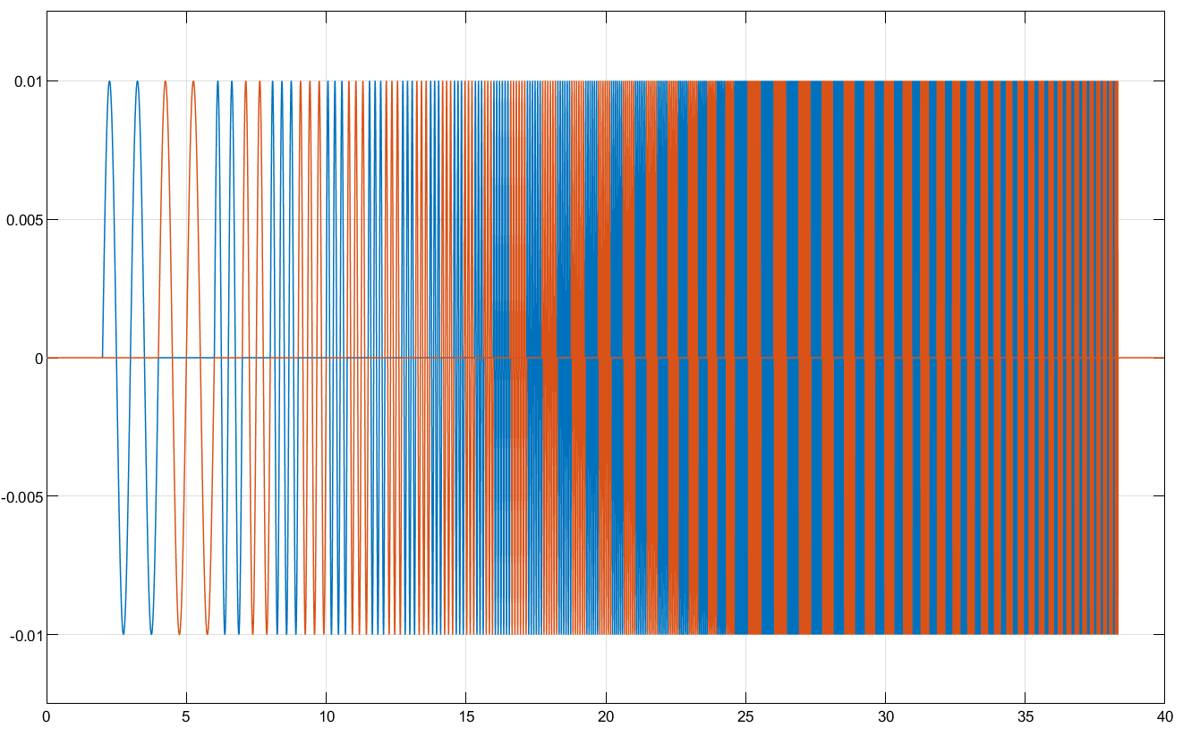
Figure 19 Frequency sweep waveforms. Blue is on d-axis and red is on q-axis.
If the input signal is
$$\tilde{v}=A_{c}cos2πf_{c}t$$
From the measured output, the system gain and phase can be calculated from DFT:
$$\begin{aligned}Y^{sys}\left(j2πf_{c}\right)=\frac{2}{{A_{c}k}_{c}T_{c}}\int_{0}^{k_{c}T_{c}}{Δi\left(t\right)⋅e^{-j2πf_{c}t}}dt,\# LISTNUM NumberDefault \backslash l 4 \end{aligned}$$
where $Δi(t)$ is the current output, $A_{c}$ is the injected amplitude, $k_{c}$is the cycle number, $T_{c}$ is the period of the injected frequency, and $f_{c}$ is the frequency. By having the response at all frequencies and in both d-axis and q-axis, the spectra of $Y_{12}^{sys}$, $Y_{22}^{sys}$ and $Y_{32}^{sys}$ can be acquired, as shown in Figure 20. Results are also compared with theoretical bodes and the ERA estimations. It can be seen that a good accuracy is achieved in frequency sweep.
(a)
(b)
(c)
Figure 20 Frequency sweep results (blue crosses) of (a) $Y_{12}^{sys}$, (b) $Y_{22}^{sys}$ and (c) $Y_{32}^{sys}$. Results are compared with both the theoretical and ERA results.
Diagonal elements $Y_{11}^{sys}$, $Y_{22}^{sys}$ and $Y_{33}^{sys}$are then restored using 4.4.1, as shown Figure 21, from which it can be seen that good accuracy are achieved.
(a)
(b)
(c)
Figure 21 Restored diagonal elements (a) $Y_{11}^{sys}$, (b) $Y_{22}^{sys}$ and (c) $Y_{33}^{sys}$ from frequency sweep, compared with theoretical results.
From the frequency sweep results, also known as frequency response, the state-space model, as well as the poles and residues of the system can be acquired through vector fitting techniques [14]. This is not further discussed in this report.

Root-Cause Tracing
With the estimations on diagonal elements of $Y_{}^{sys}$, root-cause tracing can be carried out among these buses, with the help of the grey-box approach, as introduced in 3.2. In this section, the estimation from the ERA method is used to trace the root-cause of the 28.46 Hz mode identified from Figure 16.
The Grey-box approach is first applied using the theoretical results. A screenshot of the developed Matlab APP is shown in Figure 22. It can be seen from Layer 1 that A3, which is the detuned IBR is the dominant. Further from Layer 2, A3 is found to be the major reason of the low damping of this mode. Layer 3 tells that by increasing the current control bandwidth of A3, the mode can be better damped. The results align with the system configuration as the current control bandwidth of A3 was deliberately detuned low.
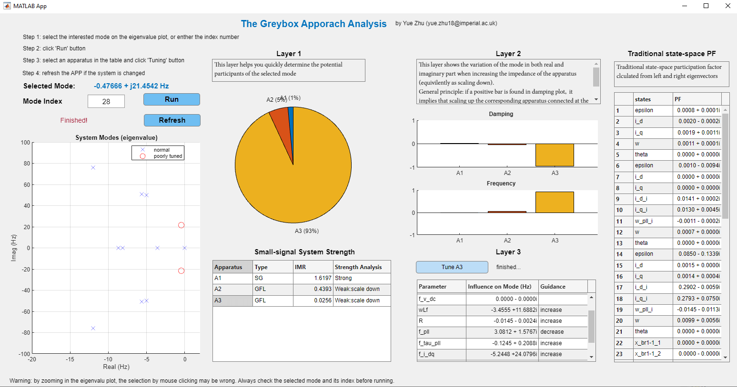
Figure 22 Screenshot of the grey-box approach in Matlab APP.
The estimation results from 4.3.1 is then employed for the Grey-box approach, and the results are shown in Figure 23. It can be clearly seen that the results from time-domain identification successfully match with theoretical results and indicate that the root-cause of the mode is A3. This demonstrates that by introducing two linearly independent step changes at one location and measuring response at other locations, the oscillatory modes and their root-cause can be successfully identified.
(a)
(b)
Figure 23 Results from the Grey-box approach using estimation results: (a) layer-1, (b) layer-2.

7-Bus Test Systems – Full Column Measurement
In order to verify the proposed method in a larger scale system with more IBRs present, a 7-bus system with 1 SG and 5 grid-following (GFL) IBRs was established in Matlab Simulink for EMT simulation, as shown in Figure 24. The voltage control bandwidth of IBR at bus-4 and 7 are deliberately detuned high to create an oscillatory mode of around 18.3 Hz, which is caused by the voltage control interaction of these two buses. A voltage perturbation ${\tilde{V}}_{3}$ was introduced at bus-3.
Figure 24 A 7 bus system with one SG and 5 GFL IBRs. The voltage perturbation is added at bus-3 and current responses are taken at bus-1,3,4,5,6,7.
The perturbation was selected as a step change with 0.02 pu size, adding at t = 1 s. Two rounds of perturbations were performed, in which the perturbation was added on d-axis and q-axis respectively. Therefore, the expressions of perturbations in time-domain and s-domain are
$$\begin{aligned}\# LISTNUM NumberDefault \backslash l 4 \end{aligned}$$
where the superscript represents the round of perturbation. Current responses were measured at all buses with apparatus connected, i.e., , where
$$\begin{aligned}\# LISTNUM NumberDefault \backslash l 4 \end{aligned}$$
To establish the whole-system model in dq frame, the voltage and current data shall be aligned to a global steady dq frame which contains very few dynamics during perturbations. This paper selected the rotating frame at bus-1 as the global reference. A phase-locked loop (PLL) on bus-1's voltage was employed to create a rotating angle $θ_{1}$. It is worth noting that the bandwidth of this PLL is configured low (1~Hz in this case) to minimise frame dynamics. $θ_{1}$ was then employed for dq to abc frame transformation of ${\tilde{v}}_{3}$, as well as for abc to dq transformations of current measurement $Δi$ at all buses. The employment of PLL for frame alignment, as well as the frame transformation of ${\tilde{v}}_{3}$ and $Δi_{k}$ are illustrated in Figure 25.
Figure 25 Perturbation and measurement in dq frame aligned to bus-1.
The time-domain data of $Δi(t)$ during the transient response period was used for TDID, sampled at 1200~Hz with a 2 s window length. Notably, the total simulation time required for identification can be kept very short—in this case, 3 s. ERA method was then applied to fit $Δi(t)$ with $Δi(s)$. It is worth noting that the ERA was performed to the whole column of $Δi$ collectively, rather than on an element-by-element basis. To select a proper system order, a small initial value can be used first, in this case, $M_{init}=10$. By applying ERA, a fitted state-space system $Δi(s)$ with order of M is acquired. To verify the accuracy, the impulse response of $Δi(s)$ can be compared with the original responses in time domain. The normalised root mean squared error (nRMSE), which quantifies the difference between predicted response and actual response, is applied to assess the model accuracy. nRMSE is defined in (30).
$$\begin{aligned}\# LISTNUM NumberDefault \backslash l 4 \end{aligned}$$
Figure 1 shows the original responses and the predicted responses with different selections of M for element $Δi_{7dq}$. It is found that with M=20, nRMSE are all below 1%, which is considered a very accurate fit. With a set of trial and error tests, M was selected as 20 for ERA in this case study.
Figure 26 step response at bus-7.
Combining the fitted $Δi(s)$ with the system input ${\tilde{v}}_{3}(s)$, the third column of $Y_{}^{sys}$ can be estimated as
$$\begin{aligned}\# LISTNUM NumberDefault \backslash l 4 \end{aligned}$$
Note that $Y_{3}^{sys}$ in (31) excludes the term $Y_{23}^{sys}$, which is corresponding to bus-2. Since no apparatus is connected at this bus, it is clear to set $Y_{23}^{sys}$ a very small number, e.g., ${10}^{-1}$, based on the definition of $Y_{}^{sys}$.
As a closed-loop model, the poles of $Y_{3}^{sys}$ are identical to the eigenvalue of the system state-space model, which represents the oscillatory modes. Figure 27 shows the system eigenvalue from the theoretical state-space model and the estimated model from ERA, and the two are matched accurately. It is identified from the estimated results that an 18.3 Hz mode is very close to the imaginary axis. This demonstrates the ability of the proposed hybrid data/model-driven method to identify the system's potential oscillation risks.
Figure 27 Pole map of $Y_{3}^{sys}$: theoretical and estimated results.
Bode plots of some randomly selected elements in $Y_{3}^{sys}$, compared with the theoretical model, are provided in Figure 28. It demonstrates that the estimation of the column $Y_{3}^{sys}$ from a step response using ERA is accurate.
Figure 28 Bode plots of estimated $Y_{33}^{sys}$ and $Y_{43}^{sys}$ and their theoretical models, showing accurate estimation of column elements of $Y_{3}^{sys}$ from the ERA method.
In order to reduce the computational complexity, frequency response data (FRD) sampling is performed on the estimated $Y_{3}^{sys}(s)$ and transform this analytical model into a numerical model $Y_{3}^{sys}(jω)$. Through this operation, the computational complexity can be reduced to , where $m$ is the total number of frequencies for FRD. Eventually, $Y_{3}^{sys}(jω)$ can be acquired. This information is then combined with the pre-known information of network nodal admittance $Y_{N}$ and yields the estimation of the apparatus impedance $Z_{A}(jω)$ from (10). Substituting $Z_{A}(jω)$ into (4) yields the full matrix of $Y_{}^{sys}(jω)$. And eventually, by applying the vector fitting on $Y_{}^{sys}(jω)$, the analytical model of $Y_{}^{sys}\left(s\right)$ can be acquired, including its diagonal elements which contain useful information for root-cause analysis. Two randomly chosen diagonal elements of $Y_{}^{sys}$ are demonstrated in, proving the efficacy of the proposed method in identifying the diagonal elements of the whole-system admittance model via single-point injection.
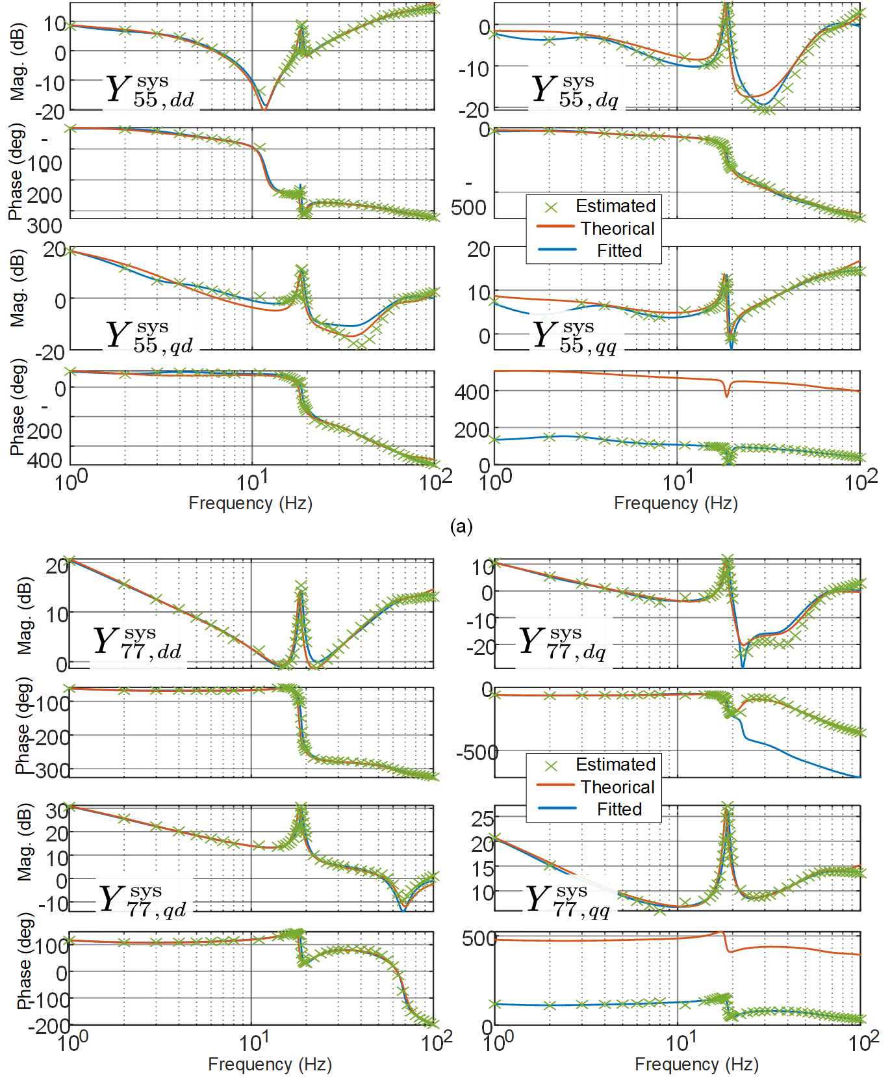
Figure 29 Bode plots of the restored diagonal elements $Y_{55}^{sys}(s)$ and $Y_{77}^{sys}(s)$, their theoretical models, and vector fitting results from the estimation, showing accurate estimations of diagonal elements of $Y_{}^{sys}$ from the proposed hybrid data/model-driven whole-system admittance identification.
The estimation of the diagonal elements $Y_{}^{sys}$, together with $Z_{A}$ can be used for root-cause analysis based on the grey-box approach proposed in [3], a powerful tool developed based on the relationship in (9). The results from the grey-box layer 1 and layer 2 are shown in Figure 30. It can be easily identified that IBRs at bus-4 and bus-7 are the root causes of this 18.3~Hz mode, which stand out in layer 1 and, in the meantime, provide negative damping in layer 2. It aligns with the fact that these two IBRs were deliberately detuned with higher AC voltage control bandwidth. Figure 30 also shows that the root-cause analysis based on the hybrid data/model-driven method matches with theoretical results from the grey-box approach.
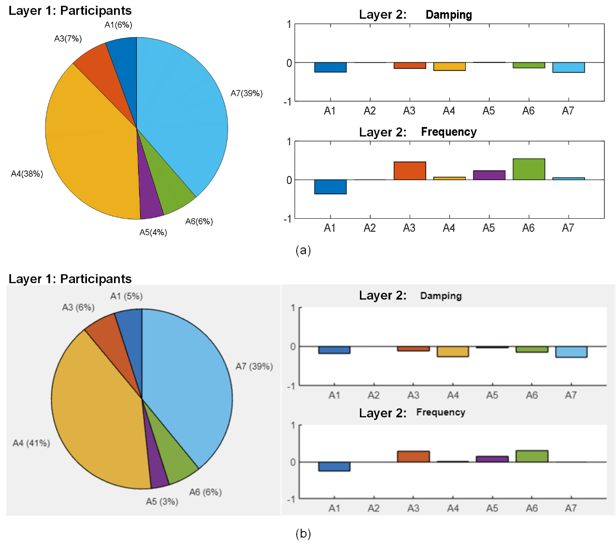
Figure 30 Root cause analysis based on the grey-box approach: (a) estimated from the proposed hybrid data/model-driven method, (b) theoretical results
This case study demonstrates that the proposed method can identify the oscillatory modes together with their root causes via a single-point injection in EMT simulations where only black-box IBR models are available. The entire simulation time can be maintained very short, and for this case, 3 s for each round with 2 rounds in total.

7-Bus Test Systems – Partial Column Measurement
This case demonstrates the partial measurement scenario, where the same 7-bus system is employed and only current at bus-3,5,7 are measured. The analytical model of SG1, i.e., $Z_{A1}$, is considered known. For places where current is unmeasured, the impedance of the corresponding IBR is considered as infinite, i.e., they are treated as ideal current source.
By Applying (21) and (22), an estimation of the column $Y_{3}^{sys}$ is acquired. The estimation of $Y_{33}^{sys}$ will be as accurate as shown in Figure 28 (a), while $Y_{53}^{sys}$ and $Y_{73}^{sys}$ encounter errors, as shown in Figure 31, since some assumptions (e.g., treating some IBR as ideal current source) were applied. However, it can be found from Figure 31 that the estimation around 18.3 Hz, which is of major concern for the oscillation, is still accurate. Meaning that such estimations from the partial measurements are still useful for oscillation analysis.
(a)
(b)
Figure 31 Estimations of (a) $Y_{53}^{sys}$ and (b) $Y_{73}^{sys}$, errors occur due to assumptions used in the system, while the estimation around the oscillating frequency 18.3 Hz, which are shown as ‘peak’ in the spectra, is still accurate.
And finally, the diagonal elements $Y_{55}^{sys}$ and $Y_{77}^{sys}$ can be restored. The restored frequency response, together with the fitting results are shown in Figure 32. It is found that the estimation around 18.3 Hz remains accurate. Impedance participation factor, which is layer 1 of the grey-box approach, is then applied to identify the root cause among the three IBRs, as shown in Figure 33. It is clearly seen that A7 is the dominant of the mode, which aligns with the fact the mode is caused by the voltage interaction within A4 and A7. It is proved from this case that even if the measurement is not taken at each of the bus, root-cause analysis can still be applied on those which are measured.

(a)
(b)
Figure 32 Estimations of (a) $Y_{55}^{sys}$ and (b) $Y_{77}^{sys}$ and the vector fitting results. The estimation around the oscillating frequency 18.3 Hz, which is shown as a ‘peak’ in the spectra, are still accurate.
Figure 33 Impedance participation analysis (grey-box layer 1) on A3, A5, A7, correctly showing that A7 is the root cause of the18.3 Hz oscillatory mode.

Conclusions
In this supplementary report, both time-domain identification and frequency-domain identification approaches for whole-system impedance/admittance identification is discussed. Furthermore, a hybrid data/model-driven approach whole-system impedance identification method is proposed and verified from simulation case studies. The conclusions drawn are:
- Impedance/admittance model identification is useful for analysing potential oscillations and for post-event analysis to identify the root-cause. Both the time-domain identification and frequency-domain identification methods can be used. Whereas the proper equipment for system frequency scan is still under study and is absent for now, the time-domain identification making use of responses during events like step changes in the voltage or in the load would be an appropriate solution. Various algorithms can be chosen for time-domain identification, such as least-square method and eigensystem realization algorithms.
- For time-domain impedance (or admittance) identification, it is important to know the details of the system input, including: the location where the event happened, the size of the change, and, preferably, a record of the waveform of the input. It also requires knowledge of system power flow, especially the information of loads and lines. It is preferable to know the parameters of synchronous generators (SG) so that analytical models of SGs can be applied as a priori information. A difficult case is buses which are not monitored by PMUs but with IBR connected where some assumptions have to make, such as using a generic model to represent the IBR, or, in a very simplified case, using an ideal current source. Most of the above knowledge will be accessible by the system operator so the issues raised can be dealt with.
- When the input location is far from the locations measured, the estimation of the relevant off-diagonal elements of the whole-system impedance matrix will be inaccurate. Multiple inputs at a variety of locations during a certain period would be useful to improve the accuracy but a proper method to merge the over-determined systems is needed. This needs further study.
- For a long-term system monitoring purposes, special equipment designed for frequency sweep, used in conjunction with frequency-domain identification, will be needed.

References
- Yue Zhu, Yunjie Gu, Jessica Santos Döhler, et al. Hybrid Data/Model-Driven Whole-System Admittance Identification via Single-Point Injections. TechRxiv. March 28, 2025. DOI: 10.36227/techrxiv.174319968.84007233/v1
- Y. Zhu, “Impedance model analysis and measurement for power system stability,” Ph.D. dissertation, Imperial College London, 2022.
- Y. Zhu, Y. Gu, Y. Li, T. C. Green, “Participation Analysis in Impedance Models: The Grey-Box Approach for Power System Stability” in IEEE Transactions on Power Systems, vol. 37, no. 1, pp. 343-353, Jan. 2022, doi: 10.1109/TPWRS.2021.3088345.
- Y. Zhu, Y. Gu, Y. Li and T. C. Green, "Impedance-Based Root-Cause Analysis: Comparative Study of Impedance Models and Calculation of Eigenvalue Sensitivity," in IEEE Transactions on Power Systems, vol. 38, no. 2, pp. 1642-1654, March 2023, doi: 10.1109/TPWRS.2022.3179143
- C. Zhang, M. Molinas, A. Rygg and X. Cai, "Impedance-Based Analysis of Interconnected Power Electronics Systems: Impedance Network Modeling and Comparative Studies of Stability Criteria," in IEEE Journal of Emerging and Selected Topics in Power Electronics, vol. 8, no. 3, pp. 2520-2533, Sept. 2020, doi: 10.1109/JESTPE.2019.2914560.
- Y. Gu, Y. Li, Y. Zhu and T. C. Green, "Impedance-Based Whole-System Modeling for a Composite Grid via Embedding of Frame Dynamics," in IEEE Transactions on Power Systems, vol. 36, no. 1, pp. 336-345, Jan. 2021, doi: 10.1109/TPWRS.2020.3004377.
- Ljung, L., & Glover, K. (1981). Frequency domain versus time domain methods in system identification. Automatica, 17(1), 71-86.
- L. Fan and Z. Miao, "Time-Domain Measurement-Based DQ -Frame Admittance Model Identification for Inverter-Based Resources," in IEEE Transactions on Power Systems, vol. 36, no. 3, pp. 2211-2221, May 2021, doi: 10.1109/TPWRS.2020.3040360.
- B. Matthias and K. Rudion. "Identification of grid impedance by broadband signals in power systems with high harmonics." Energies 14.21 (2021): 7398.
- B. Gustavsen and A. Semlyen, "Rational approximation of frequency domain responses by vector fitting", IEEE Trans. Power Delivery, vol. 14, no. 3, pp. 1052-1061, July 1999.
- https://www.sintef.no/en/software/vector-fitting/
- OFGEM, “9 August 2019 power outage report,” 2020. [Online]. Available: https://www.ofgem.gov.uk/publications/investigation-9-august-2019-power-outage
- S. Shah, P. Koralewicz, V. Gevorgian and R. Wallen, "Sequence Impedance Measurement of Utility-Scale Wind Turbines and Inverters – Reference Frame, Frequency Coupling, and MIMO/SISO Forms," in IEEE Transactions on Energy Conversion, vol. 37, no. 1, pp. 75-86, March 2022, doi: 10.1109/TEC.2021.3093516.
- SINTEF, "Vector Fitting," available at: https://www.sintef.no/en/software/vector-fitting/. Accessed: May 20, 2024.

