DATA REGISTRATION CODE

(DRC)

CONTENTS

(This contents page does not form part of the Grid Code)

Paragraph No/Title Page Number
DRC.1 INTRODUCTION 3
DRC.2 OBJECTIVE 3
DRC.3 SCOPE 3
DRC.4 DATA CATEGORIES AND STAGES IN REGISTRATION 4
DRC.4.2 Standard Planning Data 4
DRC.4.3 Detailed Planning Data 4
DRC.4.4 Operational Data 4
DRC.5 PROCEDURES AND RESPONSIBILITIES 4
DRC.5.1 Responsibility For Submission And Updating Of Data 4
DRC.5.2 Methods Of Submitting Data 4
DRC.5.3 Changes To Users Data 5
DRC.5.4 Data Not Supplied 5
DRC.5.5 Substituted Data 5
DRC.6 DATA TO BE REGISTERED 5
SCHEDULE 1 - POWER GENERATING MODULE, GENERATING UNIT (OR CCGT MODULE), POWER PARK MODULE, DC CONNECTED POWER PARK MODULE, HVDC SYSTEM AND DC CONVERTER TECHNICAL DATA 11
SCHEDULE 2 - GENERATION PLANNING PARAMETERS 37
SCHEDULE 3 - LARGE POWER STATION OUTAGE PROGRAMMES, OUTPUT USABLE AND INFLEXIBILITY INFORMATION 41
SCHEDULE 4 - LARGE POWER STATION DROOP AND RESPONSE DATA 42
SCHEDULE 5 - USERS SYSTEM DATA 43
SCHEDULE 6 - USERS OUTAGE INFORMATION 55
SCHEDULE 7 - LOAD CHARACTERISTICS AT GRID SUPPLY POINTS 60
SCHEDULE 8 - DATA SUPPLIED BY BM PARTICIPANTS 61
SCHEDULE 9 - DATA SUPPLIED BY THE COMPANY TO USERS 62
SCHEDULE 10 - DEMAND PROFILES AND ACTIVE ENERGY DATA 64
SCHEDULE 11 - CONNECTION POINT DATA 66
SCHEDULE 12 - DEMAND CONTROL 73
SCHEDULE 13 - FAULT INFEED DATA 77
SCHEDULE 14 - FAULT INFEED DATA (GENERATORS INCLUDING UNIT TRANSFORMERS AND STATION TRANSFORMERS) 79
SCHEDULE 15 - MOTHBALLED POWER GENERATING MODULE, MOTHBALLED GENERATING UNIT, MOTHBALLED POWER PARK MODULE (INCLUDING MOTHBALLED DC CONNECTED POWER PARK MODULES), MOTHBALLED HVDC SYSTEMS, MOTHBALLED HVDC CONVERTERS, MOTHBALLED DC CONVERTERS AT A DC CONVERTER STATION AND ALTERNATIVE FUEL DATA 85
SCHEDULE 16 - SYSTEM RESTORATION INFORMATION 88
SCHEDULE 17 - ACCESS PERIOD DATA 94
SCHEDULE 18 - OFFSHORE TRANSMISSION SYSTEM DATA 95
SCHEDULE 19 - USER DATA FILE STRUCTURE 122
SCHEDULE 20 - GRID FORMING PLANT CAPABILITY DATA 124
SCHEDULE 21 - GENERATION AND DEMAND OUTTURN AND FORECASTS 128
SCHEDULE 22 - DEMAND DATA 131
SCHEDULE 23 - NETWORK OPERATOR DEMAND PROFILES AND ACTIVE ENERGY DATA 132
SCHEDULE 24 - GENERATION LARGER THAN 1 MW 137
SCHEDULE 25 - NETWORK OPERATOR DEMAND CONTROL DATA 138
SCHEDULE 26 - DEMAND DATA 141
SCHEDULE 27 - NETWORK OPERATOR ACTIVE ENERGY DATA 143
SCHEDULE 28 - EMBEDDED POWER STATION FORECAST CAPACITY SCHEDULE 144
SCHEDULE 29 - EMBEDDED GENERATION SCHEDULE 145
SCHEDULE 30 - EMBEDDED GENERATION CONSTRAINTS SCHEDULE 147

DRC.1 INTRODUCTION
DRC.1.1 The Data Registration Code ("DRC") presents a unified listing of all data required by The Company from Users (including Restoration Contractors where they are not a User) and by Users (including Restoration Contractors where they are not a User) from The Company, from time to time under the Grid Code. The data which is specified in each section of the Grid Code is collated here in the DRC. Where there is any inconsistency in the data requirements under any particular section of the Grid Code and the Data Registration Code the provisions of the particular section of the Grid Code shall prevail.
DRC.1.2 The DRC identifies the section of the Grid Code under which each item of data is required.
DRC.1.3 The Code under which any item of data is required specifies procedures and timings for the supply of that data, for routine updating and for recording temporary or permanent changes to that data. All timetables for the provision of data are repeated in the DRC.
DRC.1.4 Various sections of the Grid Code also specify information which Users will receive from The Company. This information is summarised in a single schedule in the DRC (Schedule 9).
DRC.1.5 The categorisation of data into DPD I and DPD II is indicated in the DRC below.
DRC.1.6 For the purposes of this DRC, if a User is also a Restoration Contractor, they shall only need to submit the data once stating on their data submission they are also a Restoration Contractor. If a Restoration Contractor does not have a CUSC Contract then the data required to be submitted shall be pursuant to the terms of the Anchor Plant Contract or Top Up Restoration Contract.

DRC.2 OBJECTIVE
The objective of the DRC is to:
DRC.2.1 List and collate all the data to be provided by each category of User to The Company under the Grid Code.
DRC.2.2 List all the data to be provided by The Company to each category of User under the Grid Code.

DRC.3 SCOPE
DRC.3.1 The DRC applies to The Company, Users and Restoration Contractors, which in this DRC means:-
(a) Generators (including those undertaking OTSDUW and/or those who own and/or operate DC Connected Power Park Modules);
(b) Network Operators;
(c) DC Converter Station owners and HVDC System Owners;
(d) Suppliers;
(e) Non-Embedded Customers;
(f) Externally Interconnected System Operators;
(g) Interconnector Users;
(h) BM Participants; and
(i) Pumped Storage Generators and Generators in respect of Electricity Storage Modules.
(j) Restoration Contractors (which would be pursuant to the requirements of their Anchor Restoration Contract or Top Up Restoration Contract).

DRC.3.2 For the avoidance of doubt, the DRC applies to both GB Code Users and EU Code Users.

DRC.4 DATA CATEGORIES AND STAGES IN REGISTRATION
DRC.4.1.1 Within the DRC each data item is allocated to one of the following three categories:
(a) Standard Planning Data (SPD)
(b) Detailed Planning Data (DPD)
(c) Operational Data

DRC.4.2 Standard Planning Data (SPD)
DRC.4.2.1 The Standard Planning Data listed and collated in this DRC is that data listed in Part 1 of the Appendix to the PC.
DRC.4.2.2 Standard Planning Data will be provided to The Company in accordance with PC.4.4 and PC.A.1.2.
DRC.4.3 Detailed Planning Data (DPD)
DRC.4.3.1 The Detailed Planning Data listed and collated in this DRC is categorised as DPD I and DPD II and is that data listed in Part 2 of the Appendix to the PC.
DRC.4.3.2 Detailed Planning Data will be provided to The Company in accordance with PC.4.4, PC.4.5 and PC.A.1.2.
DRC.4.4 Operational Data
DRC.4.4.1 Operational Data is data which is required by the Operating Codes and the Balancing Codes. Within the DRC, Operational Data is sub-categorised according to the Code under which it is required, namely OC1, OC2, BC1 or BC2.
DRC.4.4.2 Operational Data is to be supplied in accordance with timetables set down in the relevant Operating Codes and Balancing Codes and repeated in tabular form in the schedules to the DRC.

DRC.5 PROCEDURES AND RESPONSIBILITIES
DRC.5.1 Responsibility For Submission And Updating Of Data
In accordance with the provisions of the various sections of the Grid Code, each User must submit data as summarised in DRC.6 and listed and collated in the attached schedules.
DRC.5.2 Methods Of Submitting Data
DRC.5.2.1 Wherever possible, the data schedules to the DRC are structured to serve as standard formats for data submission and such format must be used for the written submission of data to The Company.
DRC.5.2.2 Data must be submitted to the Transmission Control Centre notified by The Company, or to such other department or address as The Company may from time to time advise. The name of the person at the User Site who is submitting each schedule of data must be included.
DRC.5.2.3 Where a computer data link exists between a User and The Company, data may be submitted via this link. The Company will, in this situation, provide computer files for completion by the User containing all the data in the corresponding DRC schedule.
Data submitted can be in an electronic format using a proforma to be supplied by The Company or other format to be agreed annually in advance with The Company. In all cases the data must be complete and relate to, and relate only to, what is required by the relevant section of the Grid Code.
DRC.5.2.4 Other modes of data transfer, such as magnetic tape, may be utilised if The Company gives its prior written consent.
DRC.5.2.5 Generators, HVDC System Owners and DC Converter Station owners submitting data for a Power Generating Module, Generating Unit, DC Converter, HVDC System, Power Park Module (including DC Connected Power Park Modules) or CCGT Module before the issue of a Final Operational Notification should submit the DRC data schedules and compliance information required under the CP electronically using the User Data File Structure unless otherwise agreed with The Company. Data required from Restoration Contractors where not provided would be pursuant to the the terms of their Anchor Restoration Contract or Top Up Restoration Contract.
DRC.5.3 Changes To User’s Data
DRC.5.3.1 Whenever a User becomes aware of a change to an item of data which is registered with The Company, the User must notify The Company in accordance with each section of the Grid Code. The method and timing of the notification to The Company is set out in each section of the Grid Code. Data required from Restoration Contractors where not provided would be pursuant to the the terms of their Anchor Restoration Contract or Top Up Restoration Contract.
DRC.5.4 Data Not Supplied
DRC.5.4.1 Users and The Company are obliged to supply data as set out in the individual sections of the Grid Code and repeated in the DRC. If a User fails to supply data when required by any section of the Grid Code, The Company will estimate such data if and when, in The Company's view, it is necessary to do so. If The Company fails to supply data when required by any section of the Grid Code, the User to whom that data ought to have been supplied, will estimate such data if and when, in that User's view, it is necessary to do so. Such estimates will, in each case, be based upon data supplied previously for the same Plant or Apparatus or upon corresponding data for similar Plant or Apparatus or upon such other information as The Company or that User, as the case may be, deems appropriate.
DRC.5.4.2 The Company will advise a User in writing of any estimated data it intends to use pursuant to DRC.5.4.1 relating directly to that User's Plant or Apparatus in the event of data not being supplied.
DRC.5.4.3 A User will advise The Company in writing of any estimated data it intends to use pursuant to DRC.5.4.1 in the event of data not being supplied.
DRC.5.4.4 Data requirements defined in DRC5.4.1 – DRC5.4.3 as applicable to a Restoration Contractor where that Restoration Contractor is a not a User, would be pursuantto the the terms of the Anchor Restoration Contract or Top Up Restoration Contract.
DRC.5.5 Substituted Data
DRC.5.5.1 In the case of PC.A.4 only, if the data supplied by a User does not in The Company’s reasonable opinion reflect the equivalent data recorded by The Company, The Company may estimate such data if and when, in the view of The Company, it is necessary to do so. Such estimates will, in each case, be based upon data supplied previously for the same Plant or Apparatus or upon corresponding data for similar Plant or Apparatus or upon such other information as The Company deems appropriate.
DRC.5.5.2 The Company will advise a User in writing of any estimated data it intends to use pursuant to DRC.5.5.1 relating directly to that User's Plant or Apparatus where it does not in The Company’s reasonable opinion reflect the equivalent data recorded by The Company. Such estimated data will be used by The Company in place of the appropriate data submitted by the User pursuant to PC.A.4 and as such shall be deemed to accurately represent the User’s submission until such time as the User provides data to The Company’s reasonable satisfaction.

DRC.6 DATA TO BE REGISTERED
DRC.6.1 Schedules 1 to 20 attached cover the following data areas.
DRC.6.1.1 Schedule 1 – Power Generating Module, Generating Unit (or CCGT Module), Power Park Module (including DC Connected Power Park Module and Power Park Unit), HVDC System and DC Converter Technical Data.
Comprising Power Generating Module, Generating Unit (and CCGT Module), Power Park Module (including DC Connected Power Park Module and Power Park Unit) and DC Converter fixed electrical parameters. Any data required under DRC Schedule 1 from Restoration Contractors where not provided, would be pursuant to the terms of their Anchor Restoration Contract or Top Up Restoration Contract.
DRC.6.1.2 Schedule 2 - Generation Planning Parameters
Comprising Genset parameters and Restoration Contractors parameters required for Operational Planning studies.
DRC.6.1.3 Schedule 3 - Power Station Outage Programmes, Output Usable and Inflexibility Information.
Comprising generation and storage outage planning in respect of Large Power Stations, Output Usable and inflexibility information at timescales down to the daily BM Unit Data submission. In the case of Restoration Contractors, this data needs to only to be provided where such a Resoration Contractor has an Anchor Restoration Contract or Top Up Restoration Contract other than in respect of Large Power Stations where the data will already be required.
DRC.6.1.4 Schedule 4 - Large Power Station Droop and Response Data.
Comprising data on governor Droop settings and Primary, Secondary and High Frequency Response data for Large Power Stations.
DRC.6.1.5 Schedule 5 – User's System Data.
Comprising electrical parameters relating to Plant and Apparatus connected to the National Electricity Transmission System.
DRC.6.1.6 Schedule 6 – Users Outage and Restoration Service Provider Outage Information.
Comprising the information required by The Company for outages on the User’s System, including outages at Power Stations other than outages of Gensets. Outages of Plant and Apparatus of Restoration Contractors and key Plant and Apparatus of a Network Operator’s System associated with a Distribution Restoration Zone Plan also need to be co-ordinated with outages on the National Electricity Transmission System. The data submitted should therefore also include outages on Restoration Contractors Plant and Apparatus and Network Operator’s Plant and Apparatus which would prevent the operation of a Local Joint Restoration Plan or Distribution Restoration Zone Plan.

DRC.6.1.7 Schedule 7 - Load Characteristics.
Comprising the estimated parameters of load groups in respect of, for example, harmonic content and response to frequency.
DRC.6.1.8 Schedule 8 - BM Unit Data.
DRC.6.1.9 Schedule 9 - Data Supplied by The Company to Users.
DRC.6.1.10 Schedule 10 - Demand Profiles and Active Energy Data
Comprising information relating to the Network Operators’ and Non-Embedded Customers’ total Demand and Active Energy taken from the National Electricity Transmission System
DRC.6.1.11 Schedule 11 - Connection Point Data
Comprising information relating to Demand, demand transfer capability and the Small Power Station, Medium Power Station and Customer generation connected to the Connection Point
DRC.6.1.12 Schedule 12 - Demand Control Data
Comprising information related to Demand Control
DRC.6.1.13 Schedule 13 - Fault Infeed Data
Comprising information relating to the short circuit contribution to the National Electricity Transmission System from Users other than Generators, HVDC System Owners and DC Converter Station owners.
DRC.6.1.14 Schedule 14 - Fault Infeed Data (Generators Including Unit and Station Transformers)
Comprising information relating to the Short Circuit contribution to the National Electricity Transmission System from Generators, HVDC System Owners and DC Converter Station owners.
DRC.6.1.15 Schedule 15 – Mothballed Power Generating Module, Mothballed Generating Unit, Mothballed Power Park Module (including Mothballed DC Connected Power Park Modules), Mothballed HVDC Systems, Mothballed HVDC Converters, Mothballed DC Converters at a DC Converter Station and Alternative Fuel Data
Comprising information relating to estimated return to service times for Mothballed Power Generating Modules, Mothballed Generating Units, Mothballed Power Park Modules (including Mothballed DC Connected Power Park Modules), Mothballed HVDC Systems, Mothballed HVDC Converters and Mothballed DC Converters at a DC Converter Station and the capability of gas-fired Generating Units to operate using alternative fuels.
DRC.6.1.16 Schedule 16 – System Restoration Information
Comprising information relating to System Restoration.
DRC.6.1.17 Schedule 17 – Access Period Schedule
Comprising Access Period information for Transmission Interface Circuits within an Access Group.
DRC.6.1.18 Schedule 18 – Generators Undertaking OTSDUW Arrangements
Comprising electrical parameters relating to OTSDUW Plant and Apparatus between the Offshore Grid Entry Point and Transmission Interface Point.
DRC.6.1.19 Schedule 19 – User Data File Structure
Comprising information relating to the User Data File Structure.
DRC.6.1.20 Schedule 20 – Grid Forming Plant Data
Comprising information relating to Grid Forming Plant.

DRC.6.1.21 Schedule 21 – Generation and Demand Data (21A-C)
Comprising information relating to generation and demand at historic defined date/times plus forecast data.

DRC.6.1.22 Schedule 22 – Demand Data
Comprising information relating to Measured Demand at historic defined date/times plus forecast data.

DRC.6.1.23 Schedule 23 – Network Operator Demand Data (23A-C)
Comprising information relating to the Network Operators’ demand and Access Period data.

DRC.6.1.24 Schedule 24 – Access Group Schedule
Comprising Access Period information for Transmission Interface Circuits within an Access Group.

DRC.6.1.25 Schedule 25 – Network Operator Demand Control Data (25A-C)
Comprising information related to Demand Control on a Network Operator’s System.
DRC.6.1.26 Schedule 26 – Demand Data (26A-B)
Comprising information relating to Measured Demand at historic defined date/times plus forecast data.

DRC.6.1.27 Schedule 27 – Network Operator Active Energy Data
Comprising information relating to the Network Operators’ Active Energy.

DRC.6.1.28 Schedule 28 – Embedded Power Station Forecast Capacity Schedule
Comprising information relating to embedded generation a Network Operator forecasts to connect to their system.

DRC.6.1.29 Schedule 29 – Embedded Generation Schedule (29A-B)
Comprising information relating to embedded generation connected to a Network Operator’s system, split between those rated at greater than or equal to 1MW, and those rated below 1MW.

DRC.6.1.30 Schedule 30 – Embedded Generation Constraints Schedule
Comprising information relating to embedded generation connected to a Network Operator’s system where a constraint is applied to the output of either a Large Power Station or an Offshore Transmission System.

DRC.6.2 The Schedules applicable to each class of User before the PSM Implementation Date are as follows:
User | Schedule
Generators with Large Power Stations | 1, 2, 3, 4, 9, 14,  15, 16, 19
Generators with Medium Power Stations  (see notes 2, 3, 4) | 1, 2 (part), 9,  14, 15, 19
Generators with Small Power Stations directly connected to the National Electricity Transmission System | 1, 6, 14, 15, 19
Generators undertaking OTSDUW  (see note 5) | 18, 19
All Users connected directly to the National Electricity Transmission System | 5, 6, 9
All Users connected directly to the National Electricity Transmission System other than Generators | 10,11,13,17
All Users connected directly to the National Electricity Transmission System with Demand | 7, 9
A Pumped Storage Generator, a Generator in respect of one or more Electricity Storage Modules and an Externally Interconnected System Operator and Interconnector Users | 12  (as marked)
All Suppliers | 12
All Network Operators | 12, 16
All BM Participants | 8
All DC Converter Station owners | 1, 4, 9, 14, 15, 19
Restoration Contractors | 2, 3, 6, 16

DRC.6.2.1 The Schedules applicable to each class of User after the PSM Implementation Date are as follows:

User | Schedule
Generators with Large Power Stations | 1, 2, 3, 4, 9, 14,  15, 16, 19
Generators with Medium Power Stations  (see notes 2, 3, 4) | 1, 2 (part), 9,  14, 15, 19
Generators with Small Power Stations directly connected to the National Electricity Transmission System | 1, 6, 14, 15, 19
Generators undertaking OTSDUW  (see note 5) | 18, 19
All Users connected directly to the National Electricity Transmission System | 6, 9
All Users connected directly to the National Electricity Transmission System other than Generators or Network Operators | 10,11,13,17
All Users connected directly to the National Electricity Transmission System with Demand | 7, 9
A Pumped Storage Generator, a Generator in respect of one or more Electricity Storage Modules and an Externally Interconnected System Operator and Interconnector Users | 12  (as marked)
All Suppliers | 12
All Network Operators after the PSM Implementation Date  (see note 8, 9) | 12,16, 21, 22, 23, 24, 25, 26, 27, 28, 29, 30
All BM Participants | 8
All DC Converter Station owners | 1, 4, 9, 14, 15, 19
Restoration Contractors | 2, 3, 6, 16
Notes:
(1) Network Operators must provide data relating to Small Power Stations and/or Customer Generating Plant Embedded in their Systems when such data is requested by The Company pursuant to PC.A.3.1.4 or PC.A.5.1.4. After the PSM Implementation Date this information shall be provided pursuant to PC.9.
(2) The data in schedules 1, 14 and 15 need not be supplied in relation to Medium Power Stations connected at a voltage level below the voltage level of the Subtransmission System except in connection with a CUSC Contract or unless specifically requested by The Company.
(3) Each Network Operator within whose System an Embedded Medium Power Station not subject to a Bilateral Agreement or Embedded DC Converter Station not subject to a Bilateral Agreement is situated shall provide the data to The Company in respect of each such Embedded Medium Power Station or Embedded DC Converter Station or HVDC System. After the PSM Implementation Date this information shall be provided pursuant to PC.9.
(4) In the case of Schedule 2, Generators, HVDC System Owners, DC Converter Station owners or Network Operators in the case of Embedded Medium Power Stations not subject to a Bilateral Agreement or Embedded DC Converter Stations not subject to a Bilateral Agreement, would only be expected to submit data in relation to Standard Planning Data as required by the Planning Code.
(5) In the case of Generators undertaking OTSDUW, the Generator will need to supply User data in accordance with the requirements of Large or Small Power Stations (as defined in DRC.6.2) up to the Offshore Grid Entry Point. In addition, the User will also need to submit Offshore Transmission System data in between the Interface Point and its Connection Points in accordance with the requirements of Schedule 18.
(6) In the case of Restoration Contractors, data only needs to be provided by a Restoration Contractor where such a Restoration Contractor is not a CUSC Party and the data has not been submitted. In this case the data to be submitted would be would be pursuant to the the terms of the Anchor Restoration Contract or Top Up Restoration Contract.
(7) The changes to the PC driving the enhanced data exchange between Network Operators and The Company described in PC.9, PC.10 and PC.G together with the relevant schedules will take effect after the PSM Implementation Date.
(8) Schedule 12 does not form part of the Excel template found on The Company’s Website and is not part of the Network Operator’s week 2/28 data submissions.
(9) In the case of Schedules 16, 21-30, The Company shall publish these Schedules as an Excel template on their Website. Where there are discrepancies between the DRC legal text and the Website version, the DRC legal text shall be followed. Network Operators should use the Website version of Schedules 16, 21-30 where possible.

SCHEDULE 1 – POWER GENERATING MODULE, GENERATING UNIT (OR CCGT MODULE), POWER PARK MODULE, DC CONNECTED POWER PARK MODULE, HVDC SYSTEM AND DC CONVERTER TECHNICAL DATA
PAGE 1 OF 19

ABBREVIATIONS:
SPD = Standard Planning Data | DPD = Detailed Planning Data
% on MVA = % on Rated MVA | RC = Registered Capacity  MC = Maximum Capacity
% on 100 = % on 100 MVA | OC1, BC1, etc = Grid Code  for which data is required
CUSC Contract = User data which may be submitted to the Relevant Transmission Licensees by The Company, following the acceptance by a User of a CUSC Contract. | CUSC App. Form = User data which may be submitted to the Relevant Transmission Licensees by The Company, following an application by a User for a CUSC Contract.

Note:
All parameters, where applicable, are to be measured at nominal System Frequency
+ these SPD items should only be given in the data supplied with the application for a CUSC Contract.
* Asterisk items are not required for Small Power Stations and Medium Power Stations
Information is to be given on a Unit basis, unless otherwise stated. Where references to CCGT Modules are made, the columns "G1" etc should be amended to read "M1" etc, as appropriate
□ These data items may be submitted to the Relevant Transmission Licensees from The Company in respect of the National Electricity Transmission System. The data may be submitted to the Relevant Transmission Licensees in a summarised form e.g. network model; the data transferred will have been originally derived from data submitted by Users to The Company.
■ these data items may be submitted to the Relevant Transmission Licensee from The Company in respect to Relevant Units only. The data may be submitted to the Relevant Transmission Licensee in a summarised form e.g. network model; the data transferred will have been originally derived from data submitted by Users to The Company.
SCHEDULE 1 – POWER GENERATING MODULE, GENERATING UNIT (OR CCGT MODULE), POWER PARK MODULE, DC CONNECTED POWER PARK MODULE, HVDC SYSTEM AND DC CONVERTER TECHNICAL DATA
PAGE 2 OF 19

POWER STATION NAME: _________________________ DATE: _____________

DATA DESCRIPTION | UNITS | DATA to RTL |  | DATA CAT. | GENERATING UNIT OR STATION DATA
 |  | CUSC Cont ract | CUSC App. Form |  | F.Yr.  0 | F.Yr.  1 | F.Yr.  2 | F.Yr.  3 | F.Yr.  4 | F.Yr.  5 | F.Yr.  6
GENERATING STATION DEMANDS:
Demand associated with the Power Station supplied through the National Electricity Transmission System or the Generator's User System (PC.A.5.2)
- The maximum Demand that could occur. | MW  MVAr | □  □ |  | DPD I  DPD I
- Demand at specified time of annual peak half hour of National Electricity Transmission System Demand at Annual ACS Conditions. | MW  MVAr | □  □ |  | DPD II  DPD II
- Demand at specified time of annual minimum half-hour of National Electricity Transmission System Demand. | MW  MVAr | □  □ |  | DPD II  DPD II
(Additional Demand supplied through the unit transformers to be provided below)
INDIVIDUAL GENERATING UNIT (OR AS THE CASE MAY BE, SYNCHRONOUS POWER GENERATING MODULE OR CCGT MODULE) DATA |  |  |  |  | G1 | G2 | G3 | G4 | G5 | G6 | STN
Point of connection to the National Electricity Transmission System (or the Total System if embedded) of the Generating Unit or Synchronous Power Generating Module (other than a CCGT Unit) or the CCGT Module, as the case may be in terms of geographical and electrical location and system voltage (PC.A.3.4.1) | Text | □ | ■ | SPD
If the busbars at the Connection Point are normally run in separate sections identify the section to which the Generating Unit (other than a CCGT Unit) or Synchronous Power Generating Module or CCGT Module, as the case may be is connected (PC.A.3.1.5) | Section Number | □ | ■ | SPD
Type of Unit (steam, Gas Turbine Combined Cycle Gas Turbine Unit, tidal, wind, storage type etc.)  (PC.A.3.2.2 (h), PC.A.3.4.4) |  | □

SCHEDULE 1 – POWER GENERATING MODULE, GENERATING UNIT (OR CCGT MODULE), POWER PARK MODULE, DC CONNECTED POWER PARK MODULE, HVDC SYSTEM AND DC CONVERTER TECHNICAL DATA
PAGE 3 OF 19

INDIVIDUAL SYNCHRONOUS POWER GENERATING MODULE GENERATING UNIT (OR AS THE CASE MAY BE, CCGT MODULE) DATA |  |  |  |  | G1 | G2 | G3 | G4 | G5 | G6 | STN
A list of the Generating Units and CCGT Units within a Synchronous Power Generating Module or CCGT Module, identifying each CCGT Unit, and the Power Generating Module or CCGT Module of which it forms part, unambiguously. In the case of a Range CCGT Module, details of the possible configurations should also be submitted.  (PC.A.3.2.2 (g)) |  | □ | ■ | SPD

.
SCHEDULE 1 – POWER GENERATING MODULE, GENERATING UNIT (OR CCGT MODULE), POWER PARK MODULE, DC CONNECTED POWER PARK MODULE, HVDC SYSTEM AND DC CONVERTER TECHNICAL DATA
PAGE 4 OF 19

DATA DESCRIPTION | UNITS | DATA to RTL |  | DATA  CAT. | GENERATING UNIT (OR CCGT MODULE, AS THE CASE MAY BE)
 |  | CUSC Cont ract | CUSC App. Form |  | G1 | G2 | G3 | G4 | G5 | G6 | STN
Rated MVA (PC.A.3.3.1) | MVA | □ | ■ | SPD+
Rated MW (PC.A.3.3.1) | MW | □ | ■ | SPD+
Rated terminal voltage (PC.A.5.3.2.(a) & PC.A.5.4.2 (b)) | kV | □ |  | DPD I
*Performance Chart at Onshore Synchronous Generating Unit stator terminals (PC.A.3.2.2(f)(i))  * Performance Chart of the Offshore Synchronous Generating Unit at the Offshore Grid Entry Point (PC.A.3.2.2(f)(ii))  * Synchronous Generating Unit Performance Chart (PC.A.3.2.2(f))  * Power Generating Module Performance Chart of the Synchronous Power Generating Module (PC.A.3.2.2(f))  * Maximum terminal voltage set point (PC.A.5.3.2.(a) & PC.A.5.4.2 (b))  * Terminal voltage set point step resolution – if not continuous (PC.A.5.3.2.(a) & PC.A.5.4.2 (b)) | kV  kV | □  □ |  | SPD  DPD I  DPD I | (see OC2 for specification)
*Output Usable (on a monthly basis)  (PC.A.3.2.2(b)) | MW |  |  | SPD | (except in relation to CCGT Modules when required on a unit basis under the Grid Code, this data item may be supplied under Schedule 3)
Turbo-Generator inertia constant (for synchronous machines) (PC.A.5.3.2(a)) | MW secs  /MVA | □ | ■ | SPD+
Short circuit ratio (synchronous machines)  (PC.A.5.3.2(a)) |  | □ | ■ | SPD+
Normal auxiliary load supplied by the Generating Unit at rated MW output  (PC.A.5.2.1) | MW  MVAr | □  □ |  | DPD II  DPD II
Rated field current at rated MW and MVAr output and at rated terminal voltage (PC.A.5.3.2 (a)) | A | □ |  | DPD II
Field current open circuit saturation curve (as derived from appropriate manufacturers' test certificates): (PC.A.5.3.2 (a))  120% rated terminal volts  110% rated terminal volts  100% rated terminal volts  90% rated terminal volts  80% rated terminal volts  70% rated terminal volts  60% rated terminal volts  50% rated terminal volts | A  A  A  A  A  A  A  A | □  □  □  □  □  □  □  □ |  | DPD II  DPD II  DPD II  DPD II  DPD II  DPD II  DPD II  DPD II
IMPEDANCES:
(Unsaturated)
Direct axis synchronous reactance (PC.A.5.3.2(a)) | % on MVA | □ |  | DPD I
Direct axis transient reactance (PC.A.3.3.1(a)& PC.A.5.3.2(a) | % on MVA | □ | ■ | SPD+
Direct axis sub-transient reactance (PC.A.5.3.2(a)) | % on MVA | □ |  | DPD I
Quad axis synch reactance (PC.A.5.3.2(a)) | % on MVA | □ |  | DPD I
Quad axis sub-transient reactance (PC.A.5.3.2(a)) | % on MVA | □ |  | DPD I
Stator leakage reactance (PC.A.5.3.2(a)) | % on MVA | □ |  | DPD I
Armature winding direct current  resistance. (PC.A.5.3.2(a)) | % on MVA | □ |  | DPD I
In Scotland, negative sequence resistance  (PC.A.2.5.6 (a) (iv) | % on MVA | □ |  | DPD I
Note:- the above data item relating to armature winding direct-current resistance need only be provided by Generators in relation to Generating Units or Synchronous Generating Units within Power Generating Modules commissioned after 1st March 1996 and in cases where, for whatever reason, the Generator is aware of the value of the data item.

SCHEDULE 1 – POWER GENERATING MODULE, GENERATING UNIT (OR CCGT MODULE), POWER PARK MODULE DC CONNECTED POWER PARK MODULE, HVDC SYSTEM AND DC CONVERTER TECHNICAL DATA
PAGE 5 OF 19

DATA DESCRIPTION | UNITS | DATA to RTL |  | DATA CAT. | GENERATING UNIT OR STATION DATA
 |  | CUSC Contract | CUSC App. Form |  | G1 | G2 | G3 | G4 | G5 | G6 | STN
TIME CONSTANTS
(Short-circuit and Unsaturated)
Direct axis transient time constant (PC.A.5.3.2(a)) | S | □ |  | DPD I
Direct axis sub-transient time constant  (PC.A.5.3.2(a)) | S | □ |  | DPD I
Quadrature axis sub-transient time constant  (PC.A.5.3.2(a)) | S | □ |  | DPD I
Stator time constant (PC.A.5.3.2(a)) | S | □ |  | DPD I
MECHANICAL PARAMETERS
(PC.A.5.3.2(a))
The number of turbine generator masses |  | □ |  | DPD II
Diagram showing the Inertia and parameters for each turbine generator mass for the complete drive train | Kgm² | □ |  | DPD II  DPD II
Diagram showing Stiffness constants and parameters between each turbine generator mass for the complete drive train | Nm/rad | □ |  | DPD II  DPD II
Number of poles  Relative power applied to different parts of the turbine | % | □  □ |  | DPD II  DPD II
Torsional mode frequencies  Modal damping decrement factors for the different mechanical modes | Hz | □  □ |  | DPD II  DPD II
GENERATING UNIT STEP-UP TRANSFORMER
Rated MVA (PC.A.3.3.1 & PC.A.5.3.2) | MVA | □ | ■ | SPD+
Voltage Ratio (PC.A.5.3.2) | - | □ |  | DPD I
Positive sequence reactance: (PC.A.5.3.2)
Max tap | % on MVA | □ | ■ | SPD+
Min tap | % on MVA | □ | ■ | SPD+
Nominal tap | % on MVA | □ | ■ | SPD+
Positive sequence resistance: (PC.A.5.3.2)
Max tap | % on MVA | □ |  | DPD II
Min tap | % on MVA | □ |  | DPD II
Nominal tap | % on MVA | □ |  | DPD II
Zero phase sequence reactance (PC.A.5.3.2) | % on MVA | □ |  | DPD II
Tap change range (PC.A.5.3.2) | +% / -% | □ |  | DPD II
Tap change step size (PC.A.5.3.2) | % | □ |  | DPD II
Tap changer type: on-load or off-circuit (PC.A.5.3.2) | On/Off | □ |  | DPD II

SCHEDULE 1 – POWER GENERATING MODULE, GENERATING UNIT (OR CCGT MODULE), POWER PARK MODULE, DC CONNECTED POWER PARK MODULE, HVDC SYSTEM AND DC CONVERTER TECHNICAL DATA
PAGE 6 OF 19

DATA DESCRIPTION | UNITS |  | DATA to RTL |  | DATA CAT. | GENERATING UNIT OR STATION DATA
 |  |  | CUSC Contract | CUSC App. Form |  | G1 |  |  | G2 |  | G3 |  | G4 | G5 |  | G6 |  | STN
EXCITATION:
Note: The data items requested under Option 1 below may continue to be provided by Generators in relation to Generating Units on the System at 9 January 1995 (in this paragraph, the "relevant date") or they may provide the new data items set out under Option 2. Generators must supply the data as set out under Option 2 (and not those under Option 1) for Generating Unit and Synchronous Power Generating Unit excitation control systems commissioned after the relevant date, those Generating Unit or Synchronous Power Generating Unit excitation control systems recommissioned for any reason such as refurbishment after the relevant date and Generating Unit or Synchronous Power Generating Unit excitation control systems where, as a result of testing or other process, the Generator is aware of the data items listed under Option 2 in relation to that Generating Unit or Synchronous Power Generating Unit.

Option 1
DC gain of Excitation Loop (PC.A.5.3.2(c)) |  |  | □ |  | DPD II
Max field voltage (PC.A.5.3.2(c)) |  | V | □ |  | DPD II
Min field voltage (PC.A.5.3.2(c)) |  | V | □ |  | DPD II
Rated field voltage (PC.A.5.3.2(c)) |  | V | □ |  | DPD II
Max rate of change of field volts: (PC.A.5.3.2(c))
Rising |  | V/Sec | □ |  | DPD II
Falling |  | V/Sec | □ |  | DPD II
Details of Excitation Loop (PC.A.5.3.2(c))  Described in block diagram form showing transfer functions of individual elements |  | Diagram | □ |  | DPD II | (please attach)
Dynamic characteristics of over- excitation limiter (PC.A.5.3.2(c)) |  |  | □ |  | DPD II
Dynamic characteristics of under-excitation limiter (PC.A.5.3.2(c)) |  |  | □ |  | DPD II

Option 2
Exciter category, e.g. Rotating Exciter, or Static Exciter etc (PC.A.5.3.2(c)) |  | Text | □ | ■ | SPD
Excitation System Nominal (PC.A.5.3.2(c))  Response V_{E} |  | Sec⁻¹ | □ |  | DPD II
Rated Field Voltage (PC.A.5.3.2(c)) U_{fN} |  | V | □ |  | DPD II
No-load Field Voltage (PC.A.5.3.2(c)) U_{fO} |  | V | □ |  | DPD II
Excitation System On-Load (PC.A.5.3.2(c))  Positive Ceiling Voltage U_{pL+} |  | V | □ |  | DPD II
Excitation System No-Load (PC.A.5.3.2(c))  Positive Ceiling Voltage U_{pO+} |  | V | □ |  | DPD II
Excitation System No-Load (PC.A.5.3.2(c))  Negative Ceiling Voltage U_{pO-} |  | V | □ |  | DPD II
Power System Stabiliser (PSS) fitted (PC.A.3.4.2)  Stator Current Limit (PC.A.5.3.2(c)) |  | Yes/No  A | □  □ | ■ | SPD  DPD II
Details of Excitation System (PC.A.5.3.2(c))  (including PSS if fitted) described in block  diagram form showing transfer functions of  individual elements. |  | Diagram | □ |  | DPD II
Details of Over-excitation Limiter (PC.A.5.3.2(c))  described in block diagram form showing transfer functions of individual elements. |  | Diagram | □ |  | DPD II
Details of Under-excitation Limiter (PC.A.5.3.2(c))  described in block diagram form showing transfer functions of individual elements. |  | Diagram | □ |  | DPD II
SCHEDULE 1 – POWER GENERATING MODULE, GENERATING UNIT (OR CCGT MODULE), POWER PARK MODULE, DC CONNECTED POWER PARK MODULE, HVDC SYSTEM AND DC CONVERTER TECHNICAL DATA
PAGE 7 OF 19

DATA DESCRIPTION | UNITS | DATA to RTL |  | DATA CAT. | GENERATING UNIT OR STATION DATA
 |  | CUSC Contract | CUSC App. Form |  | G1 | G2 |  | G3 |  | G4 |  |  | G5 |  | G6 |  | STN
GOVERNOR AND ASSOCIATED PRIME MOVER PARAMETERS
Note: The data items requested under Option 1 below may continue to be provided by Generators in relation to Generating Units on the System at 9 January 1995 (in this paragraph, the "relevant date") or they may provide the new data items set out under Option 2. Generators must supply the data as set out under Option 2 (and not those under Option 1) for Generating Unit and Synchronous Power Generating Unit governor control systems commissioned after the relevant date, those Generating Unit and Synchronous Power Generating Unit governor control systems recommissioned for any reason such as refurbishment after the relevant date and Generating Unit and Synchronous Power Generating Unit governor control systems where, as a result of testing or other process, the Generator is aware of the data items listed under Option 2 in relation to that Generating Unit and Synchronous Power Generating Unit.

Option 1
GOVERNOR PARAMETERS (REHEAT UNITS) (PC.A.5.3.2(d) – Option 1(i))
HP Governor average gain | MW/Hz | □ |  | DPD II
Speeder motor setting range | Hz | □ |  | DPD II
HP governor valve time constant | S | □ |  | DPD II
HP governor valve opening limits |  | □ |  | DPD II
HP governor valve rate limits |  | □ |  | DPD II
Re-heat time constant (stored Active Energy in reheater) | S | □ |  | DPD II
IP governor average gain | MW/Hz | □ |  | DPD II
IP governor setting range | Hz | □ |  | DPD II
IP governor time constant | S | □ |  | DPD II
IP governor valve opening limits |  | □ |  | DPD II
IP governor valve rate limits |  | □ |  | DPD II
Details of acceleration sensitive |  | □ |  | DPD II | (please attach)
elements HP & IP in governor loop
Governor block diagram showing |  | □ |  | DPD II | (please attach)
transfer functions of individual elements
GOVERNOR (Non-reheat steam and Gas
Turbines) (PC.A.5.3.2(d) – Option 1(ii))

Governor average gain | MW/Hz | □ |  | DPD II
Speeder motor setting range |  | □ |  | DPD II
Time constant of steam or fuel governor valve | S | □ |  | DPD II
Governor valve opening limits |  | □ |  | DPD II
Governor valve rate limits |  | □ |  | DPD II
Time constant of turbine | S | □ |  | DPD II
Governor block diagram |  | □ |  | DPD II | (please attach)

SCHEDULE 1 – POWER GENERATING MODULE, GENERATING UNIT (OR CCGT MODULE), POWER PARK MODULE DC CONNECTED POWER PARK MODULE, HVDC SYSTEM AND DC CONVERTER TECHNICAL DATA
PAGE 8 OF 19

DATA DESCRIPTION | UNITS | DATA to RTL |  | DATA CAT. | GENERATING UNIT OR STATION DATA
 |  | CUSC Contract | CUSC App. Form |  | G1 | G2 | G3 | G4 | G5 | G6 | STN
(PC.A.5.3.2(d) – Option 1(iii))
BOILER & STEAM TURBINE DATA*
Boiler time constant (Stored Active Energy) | S |  |  | DPD II
HP turbine response ratio:  (Proportion of Primary Response arising from HP turbine) | % |  |  | DPD II
HP turbine response ratio:  (Proportion of High Frequency Response arising from HP turbine) | % |  |  | DPD II
 | End of Option 1

Option 2
All Generating Units and Synchronous Power Generating Units
Governor Block Diagram showing  transfer function of individual elements including acceleration sensitive elements |  | □ |  | DPD II
Governor Time Constant  (PC.A.5.3.2(d) – Option 2(i)) | Sec | □ |  | DPD II
#Governor Deadband  (PC.A.5.3.2(d) – Option 2(i))  - Maximum Setting  - Normal Setting  - Minimum Setting | ±Hz  ±Hz  ±Hz |  |  | DPD II  DPD II  DPD II
Speeder Motor Setting Range  (PC.A.5.3.2(d) – Option 2(i)) | % | □ |  | DPD II
Average Gain (PC.A.5.3.2(d) – Option 2(i)) | MW/Hz | □ |  | DPD II
Steam Units
(PC.A.5.3.2(d) – Option 2(ii))
HP Valve Time Constant | sec | □ |  | DPD II
HP Valve Opening Limits | % | □ |  | DPD II
HP Valve Opening Rate Limits | %/sec | □ |  | DPD II
HP Valve Closing Rate Limits | %/sec | □ |  | DPD II
HP Turbine Time Constant | sec | □ |  | DPD II
(PC.A.5.3.2(d) – Option 2(ii))
IP Valve Time Constant | sec | □ |  | DPD II
IP Valve Opening Limits | % | □ |  | DPD II
IP Valve Opening Rate Limits | %/sec | □ |  | DPD II
IP Valve Closing Rate Limits | %/sec | □ |  | DPD II
IP Turbine Time Constant | sec | □ |  | DPD II
(PC.A.5.3.2(d) – Option 2(ii))
LP Valve Time Constant | sec | □ |  | DPD II
LP Valve Opening Limits | % | □ |  | DPD II
LP Valve Opening Rate Limits | %/sec | □ |  | DPD II
LP Valve Closing Rate Limits | %/sec | □ |  | DPD II
LP Turbine Time Constant | sec | □ |  | DPD II
(PC.A.5.3.2(d) – Option 2(ii))
Reheater Time Constant | sec |  |  | DPD II
Boiler Time Constant | sec |  |  | DPD II
HP Power Fraction | % |  |  | DPD II
IP Power Fraction | % |  |  | DPD II
# Where the generating unit or synchronous power generating unit governor does not have a selectable deadband facility, then the actual value of the deadband need only be provided.

SCHEDULE 1 – POWER GENERATING MODULE, GENERATING UNIT (OR CCGT MODULE), POWER PARK MODULE, DC CONNECTED POWER PARK MODULE, HVDC SYSTEM AND DC CONVERTER TECHNICAL DATA
PAGE 9 OF 19

DATA DESCRIPTION | UNITS | DATA to RTL |  | DATA CAT. | GENERATING UNIT OR STATION DATA
 |  | CUSC Contract | CUSC App. Form |  | G1 | G2 | G3 | G4 | G5 | G6 | STN
Gas Turbine Units
(PC.A.5.3.2(d) – Option 2(iii))
Inlet Guide Vane Time Constant | sec | □ |  | DPD II
Inlet Guide Vane Opening Limits | % | □ |  | DPD II
Inlet Guide Vane Opening Rate Limits | %/sec | □ |  | DPD II
Inlet Guide Vane Closing Rate Limits | %/sec | □ |  | DPD II
(PC.A.5.3.2(d) – Option 2(iii))
Fuel Valve Time Constant | sec | □ |  | DPD II
Fuel Valve Opening Limits | % | □ |  | DPD II
Fuel Valve Opening Rate Limits | %/sec | □ |  | DPD II
Fuel Valve Closing Rate Limits | %/sec | □ |  | DPD II
(PC.A.5.3.2(d) – Option 2(iii))
Waste Heat Recovery Boiler Time Constant
Hydro Generating Units
(PC.A.5.3.2(d) – Option 2(iv))
Guide Vane Actuator Time Constant | sec | □ |  | DPD II
Guide Vane Opening Limits | % | □ |  | DPD II
Guide Vane Opening Rate Limits | %/sec | □ |  | DPD II
Guide Vane Closing Rate Limits | %/sec | □ |  | DPD II
Water Time Constant  Synchronous Electricity Storage Units and Modules  (PC.A.5.3.2(d) – Option 2(v)  Valve Actuator Time Constant  Valve Opening Limits  Valve Opening Rate Limits  Valve Closing Rate Limits  For Synchronous Electricity Storage Modules which are derived from compressed air energy storage systems the above data should be provided. For other Synchronous Electricity Storage Modules data should be supplied as required by The Company in accordance with PC.A.7. | sec  sec  %  %/sec %/sec | □  □  □  □  □ |  | DPD II  DPD II DPD II DPD II DPD II
 | End of Option 2
UNIT CONTROL OPTIONS*
(PC.A.5.3.2(e)
Maximum droop | % |  |  | DPD II
Normal droop | % | □ |  | DPD II
Minimum droop | % |  |  | DPD II
Maximum Governor Deadband  Normal Governor Deadband  Minimum Governor Deadband |  |  |  | DPD II  DPD II
Maximum Frequency Response Deadband¹ | ±Hz |  |  | DPD II
Normal Frequency Response Deadband¹ | ±Hz |  |  | DPD II
Minimum Frequency Response Deadband¹  Maximum Frequency Response Insensitivity¹  Normal Frequency Response Insensitivity¹  Minimum Frequency Response Insensitivity¹ | ±Hz  ±Hz  ±Hz  ±Hz |  |  | DPD II  DPDII  DPDII  DPDII
±Hz
±Hz
±Hz
Frequency settings between which
Unit Load Controller droop applies:
Maximum | Hz |  |  | DPD II
Normal | Hz |  |  | DPD II
Minimum | Hz |  |  | DPD II
Sustained response normally selected | Yes/No |  |  | DPD II
¹ Data required only in respect of Large Power Stations comprising Type C and Type D Power Generating Modules owned and operated by EU Code Generators.

SCHEDULE 1 – POWER GENERATING MODULE, GENERATING UNIT (OR CCGT MODULE), POWER PARK MODULE, DC CONNECTED POWER PARK MODULE, HVDC SYSTEM AND DC CONVERTER TECHNICAL DATA
PAGE 10 OF 19

DATA DESCRIPTION | UNITS | DATA to RTL |  | DATA  CAT. | POWER PARK UNIT (OR POWER PARK MODULE, AS THE CASE MAY BE)
 |  | CUSC Contract | CUSC App. Form |  | G1 | G2 | G3 | G4 | G5 | G6 | STN
Power Park Module Rated MVA  (PC.A.3.3.1(a)) | MVA | □ | ■ | SPD+
Power Park Module Rated MW  (PC.A.3.3.1(a)) | MW | □ | ■ | SPD+
*Performance Chart of a Power Park Module at the connection point (PC.A.3.2.2(f)(ii)) |  |  |  | SPD | (see OC2 for specification)
*Output Usable (on a monthly basis)  (PC.A.3.2.2(b)) | MW |  |  | SPD | (except in relation to CCGT Modules when required on a unit basis under the Grid Code, this data item may be supplied under Schedule 3)
Number & Type of Power Park Units within each Power Park Module (PC.A.3.2.2(k))  Number & Type of Offshore Power Park Units within each Offshore Power Park String and the number of Offshore Power Park Strings and connection point within each Offshore Power Park Module (PC.A.3.2.2.(k)) |  | □ |  | SPD  SPD
In the case where an appropriate Manufacturer’s Data & Performance Report is registered with The Company then subject to The Company’s agreement, the report reference may be given as an alternative to completion of the following sections of this Schedule 1 to the end of page 11 with the exception of the sections marked thus # below. | Reference the Manufacturer’s Data & Performance Report |  |  | SPD
Power Park Unit Model (including Non Synchronous Electricity Storage Units) - A validated mathematical model in accordance with PC.5.4.2 (a) | Transfer function block diagram and algebraic equations, simulation and measured test results | □ |  | DPD II

SCHEDULE 1 – POWER GENERATING MODULE, GENERATING UNIT (OR CCGT MODULE), POWER PARK MODULE DC CONNECTED POWER PARK MODULE, HVDC SYSTEM AND DC CONVERTER TECHNICAL DATA
PAGE 11 OF 19

DATA DESCRIPTION | UNITS | DATA to RTL |  | DATA  CAT. | POWER PARK UNIT (OR POWER PARK MODULE, AS THE CASE MAY BE)
 |  | CUSC Contract | CUSC App. Form |  | G1 | G2 | G3 | G4 | G5 | G6 | STN
Power Park Unit Data (where applicable)
Rated MVA (PC.A.3.3.1(e)) | MVA | □ | ■ | SPD+
Rated MW (PC.A.3.3.1(e)) | MW | □ | ■ | SPD+
Rated terminal voltage (PC.A.3.3.1(e)) | V | □ | ■ | SPD+
Site minimum air density (PC.A.5.4.2(b)) | kg/m³ | □ | ■ | DPD II
Site maximum air density | kg/m³ | □ | ■ | DPD II
Site average air density | kg/m³ | □ | ■ | DPD II
Year for which air density data is submitted |  | □ | ■ | DPD II
Number of pole pairs |  | □ |  | DPD II
Blade swept area | m² | □ |  | DPD II
Gear Box Ratio |  | □ |  | DPD II
Stator Resistance (PC.A.5.4.2(b)) | % on MVA | □ | ■ | SPD+
Stator Reactance (PC.A.3.3.1(e)) | % on MVA | □ | ■ | SPD+
Magnetising Reactance (PC.A.3.3.1(e)) | % on MVA | □ | ■ | SPD+
Rotor Resistance (at starting).  (PC.A.5.4.2(b)) | % on MVA | □ |  | DPD II
Rotor Resistance (at rated running)  (PC.A.3.3.1(e)) | % on MVA | □ | ■ | SPD+
Rotor Reactance (at starting).  (PC.A.5.4.2(b)) | % on MVA | □ |  | DPD II
Rotor Reactance (at rated running)  (PC.A.3.3.1(e)) | % on MVA | □ | ■ | SPD
Equivalent inertia constant of the first mass (e.g. wind turbine rotor and blades) at minimum speed  (PC.A.5.4.2(b)) | MW secs  /MVA | □ | ■ | SPD+
Equivalent inertia constant of the first mass (e.g. wind turbine rotor and blades) at synchronous speed (PC.A.5.4.2(b)) | MW secs  /MVA | □ | ■ | SPD+
Equivalent inertia constant of the first mass (e.g. wind turbine rotor and blades) at rated speed  (PC.A.5.4.2(b)) | MW secs  /MVA | □ | ■ | SPD+
Equivalent inertia constant of the second mass (e.g. generator rotor) at minimum speed (PC.A.5.4.2(b)) | MW secs  /MVA | □ | ■ | SPD+
Equivalent inertia constant of the second mass (e.g. generator rotor) at synchronous speed (PC.A.5.4.2(b)) | MW secs  /MVA | □ | ■ | SPD+
Equivalent inertia constant of the second mass (e.g. generator rotor) at rated speed (PC.A.5.4.2(b)) | MW secs  /MVA | □ | ■ | SPD+
Equivalent shaft stiffness between the two masses (PC.A.5.4.2(b)) | Nm / electrical radian | □ | ■ | SPD+

SCHEDULE 1 – POWER GENERATING MODULE, GENERATING UNIT (OR CCGT MODULE), POWER PARK MODULE, DC CONNECTED POWER PARK MODULE, HVDC SYSTEM AND DC CONVERTER TECHNICAL DATA
PAGE 12 OF 19

DATA DESCRIPTION | UNITS | DATA to RTL |  | DATA  CAT. | POWER PARK UNIT (OR POWER PARK MODULE, AS THE CASE MAY BE)
 |  | CUSC Contract | CUSC App. Form |  | G1 | G2 | G3 | G4 |  | G5 |  | G6 |  | STN
Minimum generator rotor speed (Doubly Fed Induction Generators) (PC.A.3.3.1(e)) | RPM | □ | ■ | SPD+
Maximum generator rotor speed (Doubly Fed Induction Generators) (PC.A.3.3.1(e)) | RPM | □ | ■ | SPD+
The optimum generator rotor speed versus wind speed (PC.A.5.4.2(b)) | tabular format | □ |  | DPD II
Power Converter Rating (Doubly Fed Induction Generators) (PC.A.5.4.2(b)) | MVA | □ | ■ | DPD II
The rotor power coefficient (C_{p}) versus tip speed ratio (λ) curves for a range of blade angles (where applicable) (PC.A.5.4.2(b)) | Diagram + tabular format | □ |  | DPD II
# The electrical power output versus generator rotor speed for a range of wind speeds over the entire operating range of the Power Park Unit. (PC.A.5.4.2(b)) | Diagram + tabular format | □ |  | DPD II
The blade angle versus wind speed curve  (PC.A.5.4.2(b)) | Diagram + tabular format | □ |  | DPD II
The electrical power output versus wind speed over the entire operating range of the Power Park Unit.  (PC.A.5.4.2(b)) | Diagram + tabular format | □ |  | DPD II
Transfer function block diagram, parameters and description of the operation of the power electronic converter including fault ride though capability (where applicable). (PC.A.5.4.2(b)) | Diagram | □ |  | DPD II
For a Power Park Unit consisting of a synchronous machine in combination with a back to back DC Converter or HVDC Converter, or for a Power Park Unit not driven by a wind turbine, the data to be supplied shall be agreed with The Company in accordance with PC.A.7. (PC.A.5.4.2(b)) |  | □

SCHEDULE 1 – POWER GENERATING MODULE, GENERATING UNIT (OR CCGT MODULE), POWER PARK MODULE, DC CONNECTED POWER PARK MODULE, HVDC SYSTEM AND DC CONVERTER TECHNICAL DATA
PAGE 13 OF 19

DATA DESCRIPTION | UNITS | DATA to RTL |  |  | DATA  CAT. | POWER PARK UNIT (OR POWER PARK MODULE, AS THE CASE MAY BE)
DATA DESCRIPTION | UNITS | CUSC Contract |  | CUSC App. Form | DATA  CAT. | G1 | G2 | G3 | G4 | G5 | G6 | STN
Torque / Speed and blade angle control systems and parameters (PC.A.5.4.2(c))  For the Power Park Unit, details of the torque / speed controller and blade angle controller in the case of a wind turbine and power limitation functions (where applicable) described in block diagram form showing transfer functions and parameters of individual elements | Diagram | □ |  |  | DPD II
# Voltage/Reactive Power/Power Factor control system parameters (PC.A.5.4.2(d))  # For the Power Park Unit and Power Park Module details of Voltage/Reactive Power/Power Factor controller (and PSS if fitted) described in block diagram form including parameters showing transfer functions of individual elements. | Diagram | □ |  |  | DPD II
# Frequency control system parameters  (PC.A.5.4.2(e))  # For the Power Park Unit and Power Park Module details of the Frequency controller described in block diagram form showing transfer functions and parameters of individual elements. | Diagram | □ |  |  | DPD II
As an alternative to PC.A.5.4.2 (a), (b), (c), (d), (e) and (f), is the submission of a single complete model that consists of the full information required under PC.A.5.4.2 (a), (b), (c), (d) (e) and (f) provided that all the information required under PC.A.5.4.2 (a), b), (c), (d), (e) and (f) individually is clearly identifiable. (PC.A.5.4.2(g)) | Diagram | □ |  |  | DPD II
# Harmonic Assessment Information
(PC.A.5.4.2(h))
(as defined in IEC 61400-21 (2001)) for each Power Park Unit:-
# Flicker coefficient for continuous operation |  | □ |  |  | DPD I
# Flicker step factor |  | □ |  |  | DPD I
# Number of switching operations in a 10 minute window |  | □ |  |  | DPD I
# Number of switching operations in a 2 hour window |  | □ |  |  | DPD I
# Voltage change factor |  | □ |  |  | DPD I
# Current Injection at each harmonic for each Power Park Unit and for each Power Park Module | Tabular format | □ |  |  | DPD I
Note:- Generators who own or operate DC Connected Power Park Modules shall supply all data for their DC Connected Power Park Modules as applicable to Power Park Modules.

SCHEDULE 1 – POWER GENERATING MODULE, GENERATING UNIT (OR CCGT MODULE), POWER PARK MODULE, DC CONNECTED POWER PARK MODULE, HVDC SYSTEM AND DC CONVERTER TECHNICAL DATA
PAGE 14 OF 19

HVDC SYSTEM AND DC CONVERTER STATION TECHNICAL DATA

HVDC SYSTEM OR DC CONVERTER STATION NAME DATE:___________

Data Description | Units | DATA to RTL |  | Data  Category | DC Converter Station Data
(PC.A.4) |  | CUSC Contract | CUSC App. Form
HVDC SYSTEM AND DC CONVERTER STATION DEMANDS:  Demand supplied through Station Transformers associated with the DC Converter Station and HVDC System [PC.A.4.1]  - Demand with all DC Converters and HVDC Converters within and HVDc System operating at Rated MW import.  - Demand with all DC Converters and HVDC Converters within an HVDC System operating at Rated MW export.  Additional Demand associated with the DC Converter Station or HVDC System supplied through the National Electricity Transmission System. [PC.A.4.1]  - The maximum Demand that could occur.  - Demand at specified time of annual  peak half hour of The Company Demand at  Annual ACS Conditions.  - Demand at specified time of annual  minimum half-hour of The Company Demand.  DC CONVERTER STATION AND HVDC SYSTEM DATA  Number of poles, i.e. number of DC Converters or HVDC Converters within the HVDC System  Pole arrangement (e.g. monopole or bipole)  Details of each viable operating configuration  Configuration 1  Configuration 2  Configuration 3  Configuration 4  Configuration 5  Configuration 6  Remote ac connection arrangement | MW  MVAr  MW  MVAr  MW  MVAr  MW  MVAr  MW  MVAr  Text  Text  Diagram  Diagram  Diagram  Diagram  Diagram  Diagram  Diagram | □  □  □  □  □  □  □  □  □  □  □  □  □  □  □  □  □  □  □  □  □  □  □  □  □ | ■  ■  ■  ■  ■  ■  ■  ■  ■ | DPD II  DPD II  DPD II  DPD II  DPD II  DPD II  DPD II  DPD II  DPD II  DPD II  SPD+  SPD+  SPD+  SPD

SCHEDULE 1 – POWER PARK MODULE, GENERATING UNIT (OR CCGT MODULE), POWER PARK MODULE, DC CONNECTED POWER PARK MODULE, HVDC SYSTEM AND DC CONVERTER TECHNICAL DATA
PAGE 15 OF 19

Data Description | Units | DATA to RTL |  | Data  Category | Operating Configuration
 |  | CUSC Contract | CUSC App. Form |  | 1 | 2 | 3 | 4 | 5 | 6
DC CONVERTER STATION AND HVDC SYSTEM DATA (PC.A.3.3.1d)  DC Converter or HVDC Converter Type (e.g. current or Voltage source)  Point of connection to the National Electricity Transmission System (or the Total System if Embedded) of the DC Converter Station or HVDC System configuration in terms of geographical and electrical location and system voltage  If the busbars at the Connection Point are normally run in separate sections identify the section to which the DC Converter Station or HVDC System configuration is connected  Rated MW import per pole [PC.A.3.3.1]  Rated MW export per pole [PC.A.3.3.1] | Text  Text  Section  Number  MW  MW | □  □  □  □  □ | ■  ■  ■  ■  ■ | SPD  SPD  SPD  SPD +  SPD +
ACTIVE POWER TRANSFER CAPABILITY (PC.A.3.2.2)  Registered Capacity  Registered Import Capacity  Minimum Generation  Minimum Import Capacity  Maximum HVDC Active Power Transmission Capacity  Minimum Active Power Transmission Capacity  Import MW available in excess of Registered Import Capacity and Maximum Active Power Transmission Capacity  Time duration for which MW in excess of Registered Import Capacity is available  Export MW available in excess of Registered Capacity and Maximum Active Power Transmission Capacity.  Time duration for which MW in excess of Registered Capacity is available | MW  MW  MW  MW  MW  MW  MW  Min  MW  Min | □  □  □  □  □  □  □  □  □  □ | ■  ■  ■  ■ | SPD  SPD  SPD  SPD  SPD  SPD  SPD  SPD

SCHEDULE 1 –POWER GENERATING MODULE, GENERATING UNIT (OR CCGT MODULE), POWER PARK MODULE, DC CONNECTED POWER PARK MODULE, HVDC SYSTEM AND DC CONVERTER TECHNICAL DATA
PAGE 16 OF 19

Data Description | Units | DATA to RTL |  | Data  Category | Operating Configuration
 |  | CUSC Contract | CUSC App. Form |  | 1 | 2 | 3 | 4 | 5 | 6
DC CONVERTER AND HVDC CONVERTER TRANSFORMER [PC.A.5.4.3.1]  Rated MVA  Winding arrangement  Nominal primary voltage  Nominal secondary (converter-side) voltage(s)  Positive sequence reactance  Maximum tap  Nominal tap  Minimum tap  Positive sequence resistance  Maximum tap  Nominal tap  Minimum tap  Zero phase sequence reactance  Tap change range  Number of steps | MVA  kV  kV  % on MVA  % on MVA  % on MVA  % on MVA  % on MVA  % on MVA  % on MVA  +% / -% | □  □  □  □  □  □  □  □  □  □  □  □ |  | DPD II  DPD II  DPD II  DPD II  DPD II  DPD II  DPD II  DPD II  DPD II  DPD II  DPD II  DPD II
SCHEDULE 1 – POWER GENERATING MODULE, GENERATING UNIT (OR CCGT MODULE), DC CONNECTED POWER PARK MODULE, HVDC SYSTEM, POWER PARK MODULE AND DC CONVERTER TECHNICAL DATA
PAGE 17 OF 19

Data Description | Units | DATA to RTL |  | Data  Category | Operating configuration
 |  | CUSC Contract | CUSC App. Form |  | 1 | 2 | 3 | 4 | 5 | 6
DC NETWORK [PC.A.5.4.3.1 (c)]  Rated DC voltage per pole  Rated DC current per pole  Details of the DC Network  described in diagram form including resistance, inductance and capacitance of all DC cables and/or DC lines. Details of any line reactors (including line reactor resistance), line capacitors, DC filters, earthing electrodes and other conductors that form part of the DC Network should be shown. | kV  A  Diagram | □  □  □ |  | DPD II  DPD II  DPD II
DC CONVERTER STATION AND HVDC SYSTEM AC HARMONIC FILTER AND REACTIVE COMPENSATION EQUIPMENT  [PC.A.5.4.3.1 (d)]  For all switched reactive compensation equipment  Total number of AC filter banks  Diagram of filter connections  Type of equipment (e.g. fixed or variable)  Capacitive rating; or  Inductive rating; or  Operating range  Reactive Power capability as a function of various MW transfer levels | Diagram  Text  Diagram  Text  MVAr  MVAr  MVAr  Table | □  □  □  □  □  □  □  □ | ■  ■  ■ | DPD II  DPD II  DPD II  DPD II  DPD II  DPD II  DPD II  DPD II

SCHEDULE 1 – POWER GENERATING MODULE, GENERATING UNIT (OR CCGT MODULE), POWER PARK MODULE, DC CONNECTED POWER PARK MODULE, HVDC SYSTEM AND DC CONVERTER TECHNICAL DATA
Data Description | Units | DATA to RTL |  | Data  Category | Operating configuration
 |  | CUSC Contract | CUSC App. Form |  | 1 | 2 | 3 | 4 | 5 | 6
CONTROL SYSTEMS [PC.A.5.4.3.2]  Static V_{DC} – P_{DC} (DC voltage – DC power) or  Static V_{DC} – I_{DC} (DC voltage – DC current) characteristic (as appropriate) when operating as  –Rectifier  –Inverter  Details of rectifier mode control system,  in block diagram form together with parameters showing transfer functions of individual elements.  Details of inverter mode control system,  in block diagram form showing transfer functions of individual elements including parameters.  Details of converter transformer tap changer control system in block diagram form showing transfer functions of individual elements including parameters. (Only required for DC Converters and HVDC Systems connected to the National Electricity Transmission System.)  Details of AC filter and reactive compensation equipment control systems in block diagram form showing transfer functions of individual elements including parameters. (Only required for DC Converters and HVDC Systems connected to the National Electricity Transmission System.)  Details of any frequency and/or load control systems in block diagram form showing transfer functions of individual elements including parameters.  Details of any large or small signal modulating controls, such as power oscillation damping controls or sub-synchronous oscillation damping controls, that have not been submitted as part of the above control system data.  Details of HVDC Converter unit models and/or control systems in block diagram form showing transfer functions of individual elements including parameters.  Details of AC component models and/or control systems in block diagram form showing transfer functions of individual elements including parameters.  Details of DC Grid models and/or control systems in block diagram form showing transfer functions of individual elements including parameters.  Details of Voltage and power controller and/or control systems in block diagram form showing transfer functions of individual elements including parameters.  Details of Special control features if applicable (e.g., power oscillation damping (POD) function, subsynchronous torsional interaction (SSTI) control and/or control systems in block diagram form showing transfer functions of individual elements including parameters.  Details of Multi terminal control, if applicable and/or control systems in block diagram form showing transfer functions of individual elements including parameters.  Details of HVDC System protection models as agreed between The Company the HVDC System Owner and/or control systems in block diagram form showing transfer functions of individual elements including parameters.  Transfer block diagram representation of the reactive power control at converter ends for a voltage source converter  Transfer block diagram representation of the reactive power control at converter ends for a voltage source converter. | Diagram  Diagram  Diagram  Diagram  Diagram  Diagram  Diagram  Diagram  Diagram  Diagram  Diagram  Diagram  Diagram  Diagram  Diagram | □  □  □  □  □  □  □  □  □  □  □  □  □  □  □  □  □  □  □  □  □  □ |  | DPD II  DPD II  DPD II  DPD II  DPD II  DPD II  DPD II  DPD II  DPD II  DPD II  DPD II  DPD II  DPD II  DPD II  DPD II
PAGE 18 OF 19

SCHEDULE 1 – POWER GENERATING MODULE, GENERATING UNIT (OR CCGT MODULE), POWER PARK MODULE, DC CONNECTED POWER PARK MODULE, HVDC SYSTEM AND DC CONVERTER TECHNICAL DATA
PAGE 19 OF 19

Data Description | Units | DATA to RTL |  | Data  Category | Operating configuration
 |  | CUSC Contract | CUSC App. Form |  | 1 | 2 | 3 | 4 | 5 | 6
LOADING PARAMETERS [PC.A.5.4.3.3]  MW Export  Nominal loading rate  Maximum (emergency) loading rate  MW Import  Nominal loading rate  Maximum (emergency) loading rate  Maximum recovery time, to 90% of pre-fault loading, following an AC system fault or severe voltage depression.  Maximum recovery time, to 90% of pre-fault loading, following a transient DC Network fault. | MW/s  MW/s  MW/s  MW/s  s  s | □  □ |  | DPD I  DPD I  DPD I  DPD I  DPD II  DPD II

NOTE: Users are referred to Schedules 5 & 14 which set down data required for all Users directly connected to the National Electricity Transmission System, including Power Stations. Generators undertaking OTSDUW Arrangements and are utilising an OTSDUW DC Converter are referred to Schedule 18.
SCHEDULE 2 - GENERATION PLANNING PARAMETERS
PAGE 1 OF 3

This schedule contains the Genset Generation Planning Parameters required by The Company to facilitate studies in Operational Planning timescales.
For a Generating Unit including those within a Power Generating Module (other than a Power Park Unit) at a Large Power Station, the information is to be submitted on a unit basis and for a CCGT Module or Power Park Module at a Large Power Station the information is to be submitted on a module basis, unless otherwise stated.
Where references to CCGT Modules or Power Park Modules at a Large Power Station are made, the columns "G1" etc should be amended to read "M1" etc, as appropriate.
Restoration Contractors, data only needs to be provided by a Restoration Contractor where they are not a CUSC Party and the data has not been submitted. In this case the data to be submitted would be pursant to the the terms of the Anchor Restoration Contract or Top Up Restoration Contract if required.
Power Station: _________________________

Generation Planning Parameters
DATA DESCRIPTION | UNITS | DATA to RTL |  | DATA CAT. | GENSET OR STATION DATA
 |  | CUSC Contract | CUSC App. Form |  | G1 | G2 | G3 | G4 | G5 | G6 | STN
OUTPUT CAPABILITY
(PC.A.3.2.2)
Registered Capacity on a station and unit basis (on a station and module basis in the case of a CCGT Module or Power Park Module at a Large Power Station)  Maximum Capacity on a Power Generating Module basis and Synchronous Generating Unit basis and Registered Capacity on a Power Station basis) | MW  MW | □  □ | ■  ■ | SPD  SPD
Minimum Generation (on a module  basis in the case of a CCGT Module or Power Park Module at a Large Power Station)  Minimum Stable Operating Level (on a module basis in the case of a Power Generating Module at a Large Power Station | MW  MW | □  □ | ■  ■ | SPD  SPD
MW available from Power Generating Modules and Generating Units or Power Park Modules in excess of Registered Capacity or Maximum Capacity | MW | □ | ■ | SPD
REGIME UNAVAILABILITY
These data blocks are provided to
allow fixed periods of unavailability to be registered.
Expected Running Regime. Is Power Station normally available for full output 24 hours per day, 7 days per week? If No please provide details of unavailability below.  (PC.A.3.2.2.) |  | □ | ■ | SPD
Earliest Synchronising time: OC2.3.2.1(a)
Monday | hr/min | ■ |  | OC2 |  |  |  |  |  |  | -
Tuesday – Friday | hr/min | ■ |  | OC2 |  |  |  |  |  |  | -
Saturday – Sunday | hr/min | ■ |  | OC2 |  |  |  |  |  |  | -
Latest De-Synchronising time: OC2.3.2.1(a)
Monday – Thursday | hr/min | ■ |  | OC2 |  |  |  |  |  |  | -
Friday | hr/min | ■ |  | OC2 |  |  |  |  |  |  | -
Saturday – Sunday | hr/min | ■ |  | OC2 |  |  |  |  |  |  | -
SYNCHRONISING PARAMETERS
OC2.3.2.1(a)
Notice to Deviate from Zero (NDZ) after 48 hour Shutdown | Mins | ■ |  | OC2
Station Synchronising Intervals (SI) after  48 hour Shutdown | Mins | ■ |  |  | - | - | - | - | - | -
Synchronising Group (if applicable) | 1 to 4 | ■ |  | OC2 |  |  |  |  |  |  | -

SCHEDULE 2 - GENERATION PLANNING PARAMETERS
PAGE 2 OF 3

DATA DESCRIPTION | UNITS | DATA to RTL |  | DATA  CAT. | GENSET OR STATION DATA
 |  | CUSC Contract | CUSC App. Form |  | G1 | G2 |  | G3 |  | G4 |  | G5 |  | G6 | STN
Synchronising Generation (SYG) after  48 hour Shutdown  PC.A.5.3.2(f) & OC2.3.2.1(a) | MW | ■ |  | DPD II  &  OC2 |  |  |  |  |  |  |  |  |  |  | -
De-Synchronising Intervals (Single value)  OC2.3.2.1(a) | Mins | ■ |  | OC2 | - | - |  | - |  | - |  | - |  | -
RUNNING AND SHUTDOWN PERIOD LIMITATIONS:
Minimum Non Zero time (MNZT) after 48 hour Shutdown OC2.3.2.1(a) | Mins | ■ |  | OC2
Minimum Zero time (MZT) OC2.3.2.1(a) | Mins |  |  | OC2
Existing AGR Plant Flexibility Limit (Existing AGR Plant only) | No. |  |  | OC2
80% Reactor Thermal Power (expressed as Gross-Net MW) (Existing AGR Plant only) | MW |  |  | OC2
Frequency Sensitive AGR Unit Limit (Frequency Sensitive AGR Units only) | No. |  |  | OC2
RUN-UP PARAMETERS
PC.A.5.3.2(f) & OC2.3.2.1(a)
Run-up rates (RUR) after 48 hour Shutdown: | (Note that for DPD only a single value of run-up rate from Synch Gen to Registered Capacity is required)
(See note 2 page 3)
MW Level 1 (MWL1) | MW | ■ |  | DPD II  OC2 |  |  |  |  |  |  |  |  |  |  | -
MW Level 2 (MWL2) | MW | ■ |  | DPD II  OC2 |  |  |  |  |  |  |  |  |  |  | -
RUR from Synch. Gen to MWL1 | MW/Mins | ■ |  | DPD II  OC2
RUR from MWL1 to MWL2 | MW/Mins | ■ |  | OC2
RUR from MWL2 to RC | MW/Mins | ■ |  | OC2
Run-Down Rates (RDR): | (Note that for DPD only a single value of run-down rate from Registered Capacity to de-synch is required)
MWL2 | MW | ■ |  | DPD II  OC2
RDR from RC to MWL2 | MW/Min | ■ |  | DPD II  OC2
MWL1 | MW | ■ |  | DPD II  OC2
RDR from MWL2 to MWL1 | MW/Min | ■ |  | DPD II  OC2
RDR from MWL1 to de-synch | MW/Min | ■ |  | DPD II  OC2

SCHEDULE 2 - GENERATION PLANNING PARAMETERS
PAGE 3 OF 3

DATA DESCRIPTION | UNITS | DATA to RTL |  | DATA CAT. | GENSET OR STATION DATA
 |  | CUSC Contract | CUSC App. Form |  | G1 | G2 | G3 | G4 |  |  | G5 | G6 | STN
REGULATION PARAMETERS
OC2.3.2.1(a)
Regulating Range | MW | ■ |  | DPD II
Load rejection capability while still Synchronised and able to supply Load. | MW | ■ |  | DPD II
GAS TURBINE LOADING PARAMETERS:
OC2.3.2.1(a)
Fast loading | MW/Min | ■ |  | OC2
Slow loading | MW/Min | ■ |  | OC2
CCGT MODULE PLANNING MATRIX |  |  |  | OC2 | (please attach)
POWER PARK MODULE PLANNING MATRIX |  |  |  | OC2 | (please attach)
Power Park Module Active Power Output/ Intermittent Power Source Curve  (e.g., MW output / Wind speed) |  |  |  | OC2 | (please attach)

NOTES:
(1) To allow for different groups of Gensets within a Power Station (e.g., Gensets with the same operator) each Genset may be allocated to one of up to four Synchronising Groups. Within each such Synchronising Group the single synchronising interval will apply but between Synchronising Groups a zero synchronising interval will be assumed.
(2) The run-up of a Genset from synchronising block load to Registered Capacity or Maximum Capacity is represented as a three stage characteristic in which the run-up rate changes at two intermediate loads, MWL1 and MWL2. The values MWL1 & MWL2 can be different for each Genset.

SCHEDULE 3 - LARGE POWER STATION OUTAGE PROGRAMMES, OUTPUT USABLE AND INFLEXIBILITY INFORMATION
PAGE 1 OF 1

(Also outline information on contracts involving External Interconnections)
For a Generating Unit at a Large Power Station the information is to be submitted on a unit basis and for a CCGT Module or Power Park Module at a Large Power Station the information is to be submitted on a module basis, unless otherwise stated.
In the case of Restoration Contractors, data only needs to be provided by a Restoration Contractor where such a Resoration Contractor is not a CUSC Party and the data has not been submitted previously. In this case, the data to be submitted would be would be pursant to the the terms of the Anchor Restoration Contract or Top Up Restoration Contract.

DATA DESCRIPTION | UNITS | TIME  COVERED | UPDATE  TIME | DATA  CAT | DATA to RTL
OUTPUT PROFILES
 |  |  |  |  | CUSC Contract | CUSC App. Form
In the case of Large Power Stations whose output may be expected to vary in a random manner (e.g., wind power) or to some other pattern (e.g., Tidal) sufficient information is required to enable an understanding of the possible profile | MW | F. yrs 1 - 7 | Week 24 | SPD

Notes: 1. The week numbers quoted in the Update Time column refer to standard weeks in the current year.
SCHEDULE 4 - LARGE POWER STATION DROOP AND RESPONSE DATA
PAGE 1 OF 1
GOVERNOR DROOP AND RESPONSE (PC.A.5.5 ■ CUSC Contract)
The Data in this Schedule 4 is to be supplied by Generators with respect to all Large Power Stations, HVDC System Owners and by DC Converter Station owners (where agreed), whether directly connected or Embedded
Data Description | Normal Value | MW | Data CAT | Droop% |  |  | Response Capability
 |  |  |  | Unit 1 | Unit 2 | Unit 3 | Primary | Secondary | High Frequency
MLP1 | Designed Minimum Operating Level or Minimum Regulating Level (for a CCGT Module or Power Park Module, on a modular basis assuming all units are Synchronised)
MLP2 | Minimum Generation or Minimum Stable Operating Level (for a CCGT Module or Power Park Module, or Power Generating Module on a modular basis assuming all units are Synchronised)
MLP3 | 70% of Registered Capacity or Maximum Capacity
MLP4 | 80% of Registered Capacity or Maximum Capacity
MLP5 | 95% of Registered Capacity or Maximum Capacity
MLP6 | Registered Capacity or Maximum Capacity
Notes:
- The data provided in this Schedule 4 is not intended to constrain any Ancillary Services Agreement.
- Registered Capacity or Maximum Capacity should be identical to that provided in Schedule 2.
- The Governor Droop should be provided for each Generating Unit (excluding Power Park Units), Power Park Module, HVDC Converter or DC Converter. The Response Capability should be provided for each Genset or DC Converter.
- Primary, Secondary and High Frequency Response are defined in CC.A.3.2 or ECC.A.3.2 and are based on a frequency ramp of 0.5Hz over 10 seconds. Primary Response is the minimum value of response between 10s and 30s after the frequency ramp starts, Secondary Response between 30s and 30 minutes, and High Frequency Response is the minimum value after 10s on an indefinite basis.
- For plants which have not yet Synchronised, the data values of MLP1 to MLP6 should be as described above. For plants which have already Synchronised, the values of MLP1 to MLP6 can take any value between Designed Operating Minimum Level or Minimum Regulating Level and Registered Capacity or Maximum Capacity. If MLP1 is not provided at the Designed Minimum Operating Level, the value of the Designed Minimum Operating Level should be separately stated.
- For the avoidance of doubt Transmission DC Converters and OTSDUW DC Converters must be capable of providing a continuous signal indicating the real time frequency measured at the Transmission Interface Point to the Offshore Grid Entry Point (as detailed in CC.6.3.7(e)(vii) and CC.6.3.7(e)(viii) or ECC.6.3..3.1.1(f) to enable Offshore Power Generating Modules, Offshore Generating Units, Offshore Power Park Modules and/or Offshore DC Converters to satisfy the frequency response requirements of CC.6.3.7 or ECC.6.3.7.
- Alternative governor settigs shall be supplied by Generators, HVDC System Owners and DC Converter Owners where operation is required as part of System Restoration - as required in CC.6.3.5 or ECC.6.3.5.2 and ECC.6.3.5.5(vii).

SCHEDULE 5 - USERS SYSTEM DATA
PAGE 1 OF 11

The data in this Schedule 5 is required from Users who are connected to the National Electricity Transmission System via a Connection Point (or who are seeking such a connection). Generators undertaking OTSDUW should use DRC Schedule 18 although they should still supply data under Schedule 5 in relation to their User’s System up to the Offshore Grid Entry Point.
Table 5 (a)

DATA DESCRIPTION | UNITS | DATA to RTL |  | DATA  CATEGORY
 |  | CUSC Contract | CUSC App. Form
USERS SYSTEM LAYOUT (PC.A.2.2)
A Single Line Diagram showing all or part of the User’s System is required. This diagram shall include:- |  |  |  | SPD
- all parts of the User’s System, whether existing or proposed, operating at Supergrid Voltage, and in Scotland and Offshore, also all parts of the User System operating at 110kV and greater, |  | ■ | ■
(b) all parts of the User’s System operating at a voltage of 50kV and greater, and in Scotland and Offshore greater than 30kV, or higher which can interconnect Connection Points, or split bus-bars at a single Connection Point, |  | ■ | ■
(c) all parts of the User’s System between Embedded Medium Power Stations or Large Power Stations or Offshore Transmission Systems connected to the User’s Subtransmission System and the relevant Connection Point or Interface Point, |  | ■ | ■
(d) all parts of the User’s System at a Transmission Site. |  | ■ | ■
The Single Line Diagram may also include additional details of the User’s Subtransmission System, and the transformers connecting the User’s Subtransmission System to a lower voltage. With The Company’s agreement, it may also include details of the User’s System at a voltage below the voltage of the Subtransmission System. |  | ■ | ■
This Single Line Diagram shall depict the arrangement(s) of all of the existing and proposed load current carrying Apparatus relating to both existing and proposed Connection Points, showing electrical circuitry (i.e., overhead lines, underground cables, power transformers and similar equipment), operating voltages. In addition, for equipment operating at a Supergrid Voltage, and in Scotland and Offshore also at 110kV and greater, circuit breakers and phasing arrangements shall be shown. |  | ■ | ■

SCHEDULE 5 - USERS SYSTEM DATA
PAGE 2 OF 11
Table 5(b)

DATA DESCRIPTION | UNITS | DATA  EXCH |  | DATA  CATEGORY
 |  | CUSC Contract | CUSC App. Form
REACTIVE COMPENSATION (PC.A.2.4)

For independently switched reactive compensation equipment not owned by a Relevant Transmission Licensee connected to the User's System at 132kV and above, and also in Scotland and Offshore, connected at 33kV and above, other than power factor correction equipment associated with a customer’s Plant or Apparatus:
Type of equipment (e.g., fixed or variable) | Text | ■ | ■ | SPD
Capacitive rating; or | MVAr | ■ | ■ | SPD
Inductive rating; or | MVAr | ■ | ■ | SPD
Operating range | MVAr | ■ | ■ | SPD
Details of automatic control logic to enable operating characteristics to be determined | text and/or diagrams | ■ | ■ | SPD
Point of connection to User's System (electrical location and system voltage) | Text | ■ | ■ | SPD
SUBSTATION INFRASTRUCTURE (PC.A.2.2.6(b))
For the infrastructure associated with any User’s equipment at a Substation owned by a Relevant Transmission Licensee or operated or managed by The Company:-

Rated 3-phase rms short-circuit withstand current | kA | ■ | ■ | SPD
Rated 1-phase rms short-circuit withstand current | kA | ■ | ■ | SPD
Rated Duration of short-circuit withstand | s | ■ | ■ | SPD
Rated rms continuous current | A | ■ | ■ | SPD

SCHEDULE 5 – USERS SYSTEM DATA
PAGE 3 OF 11
Table 5 (c)

DATA DESCRIPTION |  | UNITS | DATA  EXCH |  | DATA  CATEGORY
 |  |  | CUSC Contract | CUSC App. Form
LUMPED SUSCEPTANCES (PC.A.2.3)
Equivalent Lumped Susceptance required for all parts of the User’s Subtransmission System which are not included in the Single Line Diagram. |  |  | ■ | ■
This should not include: |  |  | ■ | ■
(a) | independently switched reactive compensation equipment identified above. |  | ■ | ■
(b) | any susceptance of the User’s System inherent in the Demand (Reactive Power) data provided in Schedule 1 (Generator Data) or Schedule 11 (Connection Point data). |  | ■ | ■
Equivalent lumped shunt susceptance at nominal Frequency. |  | % on 100 MVA | ■ | ■ | SPD
SCHEDULE 5 – USERS SYSTEM DATA
PAGE 4 OF 11

USER’S SYSTEM DATA

Circuit Parameters (PC.A.2.2.4) (■ CUSC Contract & ■ CUSC Application Form)

The data below is all Standard Planning Data. Details are to be given for all circuits shown on the Single Line Diagram
Table 5 (d)
Years Valid | Node 1 | Node 2 | Rated Voltage kV | Operating Voltage kV | Positive Phase Sequence % on 100 MVA |  |  | Zero Phase Sequence (self) % on 100 MVA |  |  | Zero Phase Sequence (mutual) % on 100 MVA
 |  |  |  |  | R | X | B | R | X | B | R | X | B

Notes
- Data should be supplied for the current, and each of the nine succeeding Financial Years. This should be done by showing for which years the data is valid in the first column of the Table.

SCHEDULE 5 – USERS SYSTEM DATA
PAGE 5 OF 11
USERS SYSTEM DATA

Transformer Data (PC.A.2.2.5) (■ CUSC Contract & ■ CUSC Application Form)

The data below is all Standard Planning Data, and details should be shown below of all transformers shown on the Single Line Diagram. Details of Winding Arrangement, Tap Changer and earthing details are only required for transformers connecting the User’s higher voltage system with its Primary Voltage System.
Table 5 (e)

Years valid | Name of Node of Conne-ction | Trans-former | Rating MVA | Voltage Ratio |  | Positive Phase Sequence Reactance % on Rating |  |  | Positive Phase Sequence Resistance % on Rating |  |  | Zero Sequence Reactance % on Rating | Winding Arr | Tap Changer |  |  | Earthing Details (delete as app)*
 |  |  |  | HV | LV | Max Tap | Min Tap | Nom Tap | Max Tap | Min Tap | Nom Tap | Zero Sequence Reactance % on Rating | Winding Arr | Range +% to -% | Step size % | Type (delete) | Earthing Details (delete as app)*
 |  |  |  |  |  |  |  |  |  |  |  |  |  |  |  | ON/  OFF | Direct/  Res/  Rea
 |  |  |  |  |  |  |  |  |  |  |  |  |  |  |  | ON/  OFF | Direct/  Res/  Rea
 |  |  |  |  |  |  |  |  |  |  |  |  |  |  |  | ON/  OFF | Direct/  Res/  Rea
 |  |  |  |  |  |  |  |  |  |  |  |  |  |  |  | ON/  OFF | Direct/  Res/  Rea
 |  |  |  |  |  |  |  |  |  |  |  |  |  |  |  | ON/  OFF | Direct/  Res/  Rea
 |  |  |  |  |  |  |  |  |  |  |  |  |  |  |  | ON/  OFF | Direct/  Res/  Rea
*If Resistance or Ractance please give impedance value
Notes
- Data should be supplied for the current, and each of the nine succeeding Financial Years. This should be done by showing for which years the data is valid in the first column of the Table
2. For a transformer with two secondary windings, the positive and zero phase sequence leakage impedances between the HV and LV1, HV and LV2, and LV1 and LV2 windings are required.
SCHEDULE 5 –USERS SYSTEM DATA
PAGE 6 OF 11

USER’S SYSTEM DATA

Switchgear Data (PC.A.2.2.6(a)) (■ CUSC Contract & CUSC Application Form ■)
The data below is all Standard Planning Data, and should be provided for all switchgear (i.e., circuit breakers, load disconnectors and disconnectors) operating at a Supergrid Voltage, and also in Scotland and Offshore, operating at 132kV. In addition, data should be provided for all circuit breakers irrespective of voltage located at a Connection Site which is owned by a Relevant Transmission Licensee or operated or managed by The Company.
Table 5(f)

Years Valid | Connection Point | Switch No | Rated Voltage kV rms | Operating Votage kV rms | Rated short-circuit breaking current |  | Rated short-circuit peak making current |  | Rated rms continuous current (A) | DC time constant at testing of asymmetrical breaking ability (s)
 |  |  |  |  | 3 Phase kA rms | 1 Phase kA rms | 3 Phase kA | 1 Phase kA | Rated rms continuous current (A)

Notes

- Rated Voltage should be as defined by IEC 694.
Data should be supplied for the current, and each of the nine succeeding Financial Years. This should be done by showing for which years the data is valid in the first column of the Table
SCHEDULE 5 –USERS SYSTEM DATA
PAGE 7 OF 11
Table 5(g)

DATA DESCRIPTION | UNITS | DATA to RTL |  | DATA  CATEGORY
PROTECTION SYSTEMS (PC.A.6.3) |  | CUSC Contract | CUSC App. Form
The following information relates only to Protection equipment which can trip or inter-trip or close any Connection Point circuit breaker or any Transmission circuit breaker. The information need only be supplied once, in accordance with the timing requirements set out in PC.A.1.4 (b) and need not be supplied on a routine annual basis thereafter, although The Company should be notified if any of the information changes.
(a) A full description, including estimated settings, for all relays and Protection systems installed or to be installed on the User's System; |  | ■ |  | DPD II
(b) A full description of any auto-reclose facilities installed or to be installed on the User's System, including type and time delays; |  | ■ |  | DPD II
(c) A full description, including estimated settings, for all relays and Protection systems installed or to be installed on the Power Generating Module, Power Park Module or Generating Unit's generator transformer, unit transformer, station transformer and their associated connections; |  | ■ |  | DPD II
(d) For Generating Units (other than Power Park Units) having a circuit breaker at the generator terminal voltage clearance times for electrical faults within the Generating Unit zone must be declared. |  | ■ |  | DPD II
(e) Fault Clearance Times:
Most probable fault clearance time for electrical faults on any part of the Users System directly connected to the National Electricity Transmission System.  (f) Alternative Protection data as submitted under (a) to (e) above in respect of System Restoration | msec | ■  ■ |  | DPD II  DPD II

DATA DESCRIPTION | UNITS | DATA to RTL |  | DATA  CATEGORY
POWER PARK MODULE/UNIT PROTECTION SYSTEMS |  | CUSC Contract | CUSC App. Form
Details of settings for the Power Park Module/Unit protection relays (to include): (PC.A.5.4.2(f))
(a) Under frequency, |  | ■ |  | DPD II
(b) Over Frequency, |  | ■ |  | DPD II
(c) Under Voltage, Over Voltage, |  | ■ |  | DPD II
(d) Rotor Over current, |  | ■ |  | DPD II
(e) Stator Over current, |  | ■ |  | DPD II
(f) High Wind Speed Shut Down Level, |  | ■ |  | DPD II
(g) Rotor Underspeed, |  | ■ |  | DPD II
(h) Rotor Overspeed. |  | ■ |  | DPD II

SCHEDULE 5 - USERS SYSTEM DATA
PAGE 8 OF 11

Information for Transient Overvoltage Assessment (DPD I) (PC.A.6.2 ■ CUSC Contract)
The information listed below may be requested by The Company from each User with respect to any Connection Site between that User and the National Electricity Transmission System. The impact of any third party Embedded within the Users System should be reflected.
(a) Busbar layout plan(s), including dimensions and geometry showing positioning of any current and voltage transformers, through bushings, support insulators, disconnectors, circuit breakers, surge arresters, etc. Electrical parameters of any associated current and voltage transformers, stray capacitances of wall bushings and support insulators, and grading capacitances of circuit breakers;
(b) Electrical parameters and physical construction details of lines and cables connected at that busbar. Electrical parameters of all plant e.g., transformers (including neutral earthing impedance or zig-zag transformers if any), series reactors and shunt compensation equipment connected at that busbar (or to the tertiary of a transformer) or by lines or cables to that busbar;
(c) Basic insulation levels (BIL) of all Apparatus connected directly, by lines or by cables to the busbar;
(d) Characteristics of overvoltage Protection devices at the busbar and at the termination points of all lines, and all cables connected to the busbar;
(e) Fault levels at the lower voltage terminals of each transformer connected directly or indirectly to the National Electricity Transmission System without intermediate transformation;
(f) The following data is required on all transformers operating at Supergrid Voltage throughout Great Britain and, in Scotland and Offshore, also at greater than 110kV: three or five limb cores or single phase units to be specified, and operating peak flux density at nominal voltage.
(g) An indication of which items of equipment may be out of service simultaneously during Planned Outage conditions.
Harmonic Studies (DPD I) (PC.A.6.4 ■ CUSC Contract)
The information given below, both current and forecast, where not already supplied in this Schedule 5 may be requested by The Company from each User if it is necessary for The Company to evaluate the production/magnification of harmonic distortion on the National Electricity Transmission System and User’s systems. The impact of any third party Embedded within the User’s System should be reflected:
(a) Overhead lines and underground cable circuits of the User's Subtransmission System must be differentiated and the following data provided separately for each type:
Positive phase sequence resistance
Positive phase sequence reactance
Positive phase sequence susceptance
(b) for all transformers connecting the User's Subtransmission System to a lower voltage:
Rated MVA
Voltage Ratio
Positive phase sequence resistance
Positive phase sequence reactance
SCHEDULE 5 – USERS SYSTEM DATA
PAGE 9 OF 11

(c) at the lower voltage points of those connecting transformers:
Equivalent positive phase sequence susceptance
Connection voltage and MVAr rating of any capacitor bank and component design parameters if configured as a filter
Equivalent positive phase sequence interconnection impedance with other lower voltage points
The minimum and maximum Demand (both MW and MVAr) that could occur
Harmonic current injection sources in Amps at the Connection voltage points
Details of traction loads, e.g., connection phase pairs, continuous variation with time, etc.

(d) an indication of which items of equipment may be out of service simultaneously during Planned Outage conditions

Voltage Assessment Studies (DPD I) (PC.A.6.5 ■ CUSC Contract)
The information listed below, where not already supplied in this Schedule 5, may be requested by The Company from each User with respect to any Connection Site if it is necessary for The Company to undertake detailed voltage assessment studies (e.g., to examine potential voltage instability, voltage control co-ordination or to calculate voltage step changes). The impact of any third party Embedded within the Users System should be reflected:
(a) For all circuits of the User’s Subtransmission System:
Positive Phase Sequence Reactance
Positive Phase Sequence Resistance
Positive Phase Sequence Susceptance
MVAr rating of any reactive compensation equipment

(b) for all transformers connecting the User's Subtransmission System to a lower voltage:
Rated MVA
Voltage Ratio
Positive phase sequence resistance
Positive Phase sequence reactance
Tap-changer range
Number of tap steps
Tap-changer type: on-load or off-circuit
AVC/tap-changer time delay to first tap movement
AVC/tap-changer inter-tap time delay
SCHEDULE 5 – USERS SYSTEM DATA
PAGE 10 OF 11

(c) at the lower voltage points of those connecting transformers:-
Equivalent positive phase sequence susceptance
MVAr rating of any reactive compensation equipment
Equivalent positive phase sequence interconnection impedance with other lower voltage points
The maximum Demand (both MW and MVAr) that could occur
Estimate of voltage insensitive (constant power) load content in % of total load at both winter peak and 75% off-peak load conditions

Short Circuit Analyses:(DPD I) (PC.A.6.6 ■ CUSC Contract)
The information listed below, both current and forecast, and where not already supplied under this Schedule 5, may be requested by The Company from each User with respect to any Connection Site where prospective short-circuit currents on equipment owned by a Relevant Transmission Licensee or operated or managed by The Company are close to the equipment rating. The impact of any third party Embedded within the User’s System should be reflected:-
(a) For all circuits of the User’s Subtransmission System:
Positive phase sequence resistance
Positive phase sequence reactance
Positive phase sequence susceptance
Zero phase sequence resistance (both self and mutuals)
Zero phase sequence reactance (both self and mutuals)
Zero phase sequence susceptance (both self and mutuals)
(b) for all transformers connecting the User's Subtransmission System to a lower voltage:
Rated MVA
Voltage Ratio
Positive phase sequence resistance (at max, min and nominal tap)
Positive phase sequence reactance (at max, min and nominal tap)
Zero phase sequence reactance (at nominal tap)
Tap changer range
Earthing method: direct, resistance or reactance
Impedance if not directly earthed
(c) at the lower voltage points of those connecting transformers:-
The maximum Demand (in MW and MVAr) that could occur
Short-circuit infeed data in accordance with PC.A.2.5.6(a) unless the User’s lower voltage network runs in parallel with the Subtransmission System, when to prevent double counting in each node infeed data, a π equivalent comprising the data items of PC.A.2.5.6(a) for each node together with the positive phase sequence interconnection impedance between the nodes shall be submitted.
SCHEDULE 5 – USERS SYSTEM DATA
PAGE 11 OF 11

Dynamic Models:(DPD II) (PC.A.6.7 ■ CUSC Contract)
The information listed below, both current and forecast, and where not already supplied under this Schedule 5, may be requested by The Company from each EU Code User or in respect of each EU Grid Supply Point with respect to any Connection Site
- Dynamic model structure and block diagrams including parameters, transfer functions and individual elements (as applicable)
- Power control functions and block diagrams including parameters, transfer functions and individual elements (as applicable)
- Voltage control functions and block diagrams including parameters, transfer functions and individual elements (as applicable)
- Converter control models and block diagrams including parameters, transfer functions and individual elements (as applicable)

SCHEDULE 6 – USERS OUTAGE INFORMATION
PAGE 1 OF 3
DATA DESCRIPTION | UNITS | DATA to RTL |  | TIMESCALE  COVERED | UPDATE  TIME | DATA  CAT.
 |  | CUSC Contract | CUSC App. Form
Details are required from Network Operators of proposed outages in their User Systems and from Generators with respect to their outages, which may affect the performance of the Total System (e.g., at a Connection Point or constraining Embedded Large Power Stations or constraints to the Maximum Import Capacity or Maximum Export Capacity at an Interface Point) (OC2.3.1.3.2(a) & (b)). Outages of Plant and Apparatus of Restoration Contractors and key Plant and Apparatus of a Network Operator’s System associated with a Distribution Restoration Zone Plan also need to be co-ordinated with outages on the National Electricity Transmission System. This includes data from Network Operators and Restoration Contractors which would impact the ability to operate a Local Joint Restoration Plan or Distribution Restoration Zone Plan. |  | ■ |  | Years 2-5 | Week 8  (Network Operator etc)  Week 13  (Generators) | OC2  OC2  PC.A.5.7.2
(The Company advises Network Operators of National Electricity Transmission System outages affecting their Systems) |  |  |  | Years 2-5 | Week 28)
Network Operator informs The Company if unhappy with proposed outages) |  | ■ |  | " | Week 30 | OC2
(The Company draws up revised National Electricity Transmission System |  |  |  | " | Week 34)
(outage plan advises Users of operational effects)
Generators and Non-Embedded Customers provide  Details of Apparatus owned by them (other than Gensets) at each Grid Supply Point (OC2.3.1.3.3) |  | ■ |  | Year 1 | Week 13 | OC2
(The Company advises Network Operators of outages affecting their Systems) (OC2.3.1.3.3) |  |  |  | Year 1 | Week 28)
Network Operator details of relevant outages affecting the Total System (OC2.3.1.3.3) |  | ■ |  | Year 1 | Week 32 | OC2
Details of:-  Maximum Import Capacity for each Interface Point  Maximum Export Capacity for each Interface Point  Changes to previously declared values of the Interface Point Target Voltage/Power Factor (OC2.3.1.4(c )). | MVA / MW  MVA / MW  V (unless power factor control |  |  | Year 1 | Week 32 | OC2
(The Company informs Users of aspects that may affect their Systems) (OC2.3.1.4) |  |  |  | Year 1 | Week 34)
Users inform The Company if unhappy with aspects as notified  (OC2.3.1.4) |  | ■ |  | Year 1 | Week 36 | OC2
(The Company issues final National Electricity Transmission System |  | ■ |  | Year 1 | Week 49 | OC2
(outage plan with advice of operational) (OC2.3.1.4)
(effects on Users System)
Generator, Network Operator and Non-Embedded Customers to inform The Company of changes to outages previously requested |  |  |  | Week 8 ahead to year end | As occurring | OC2
Details of load transfer capability of 12MW or  more between Grid Supply Points in England and Wales and 10MW or more between Grid Supply Points in Scotland. |  |  |  | Within Yr 0 | As The Company request | OC2
Details of:-  Maximum Import Capacity for each Interface Point  Maximum Export Capacity for each Interface Point  Changes to previously declared values of the Interface Point Target Voltage/Power Factor | MVA / MW  MVA / MW  V (unless power factor control |  |  | Within Yr 0 | As occurring | OC2
Note: Users should refer to OC2 for full details of the procedure summarised above and for the information which The Company will provide on the Programming Phase.

SCHEDULE 6 – USERS OUTAGE INFORMATION
PAGE 2 OF 3

The data below is to be provided to The Company as required for compliance with the applicable Assimilated Law (Chapter III, Article 8(1) of the retained REMIT Implementing Regulation 1348/2014).

ECR ARTICLE No. | DATA DESCRIPTION | USERS PROVIDING DATA | FREQUENCY OF SUBMISSION
7.1(a) | Planned unavailability of the Apparatus belonging to a Non-Embedded Customer where OC2.3.6 (a) applies  - Unavailable demand capacity during the event (MW)  - Estimated start date and time (dd.mm.yy hh:mm)  - Estimated end date and time (dd.mm.yy hh:mm)  - Reason for unavailability from the list below:  . Maintenance  . Failure  . Shutdown  . Other | Non-Embedded Customer | To be received by The Company as soon as reasonably possible but in any case, to facilitate publication of data no later than 1 hour after a decision has been made by the Non-Embedded Customer regarding the planned unavailability
7.1(b) | Changes in actual availability of the Apparatus belonging to a Non-Embedded Customer where OC2.3.6 (b) applies  - Unavailable demand capacity during the event (MW)  - Start date and time (dd.mm.yy hh:mm)  - Estimated end date and time (dd.mm.yy hh:mm)  - Reason for unavailability from the list below :  . Maintenance  . Failure  . Shutdown  . Other | Non-Embedded Customer | To be received by The Company as soon as reasonably possible but in any case, to facilitate publication of data no later than 1 hour after the change in actual availability
8.1 | Year Ahead Forecast Margin information as provided in accordance with OC2.3.1.2.6  - Output Usable | Generator | In accordance with OC2.3.1.2.6
14.1(a) | Registered Capacity or Maximum Capacity for Generating Units or Power Generating Modules with greater than 1 MW Registered Capacity or Maximum Capacity provided in accordance with PC.4.3.1 and PC.A.3.4.3 or PC.A.3.1.4  - Registered Capacity or Maximum Capacity (MW)  - Production type (from that listed under PC.A.3.4.3) | Generator | Week 24
14.1(b) | Power Station Registered Capacity for units with equal or greater than 100 MW Registered Capacity provided in accordance with PC.4.3.1 and PC.A.3.4.3  - Power Station name  - Location of Generating Unit  - Production type (from that listed under PC.A.3.4.3)  - Voltage connection levels  - Registered Capacity or Maximum Capacity (MW) | Generator | Week 24
14.1(c) | Estimated output of Active Power of a BM Unit or Generating Unit for each per Settlement Period of the next Operational Day provided in accordance with BC1.4.2  - Physical Notification | Generator | In accordance with BC1.4.2
15.1(a) | Planned unavailability of a Generating Unit where OC2.3.6(c) applies  - Power Station name  - Generating Unit and/or Power Generating Module name  - Location of Generating Unit and/or Power Generating Module  - Generating Unit Registered Capacity (MW)  - Production type (from that listed under PC.A.3.4.3)  - Output Usable (MW) during the event  - Start date and time (dd.mm.yy hh:mm)  - Estimated end date and time (dd.mm.yy hh:mm)  - Reason for unavailability from the list below:  . Maintenance  . Shutdown  . Other | Generator | To be received by The Company as soon as reasonably possible but in any case, to facilitate publication of data no later than 1 hour after a decision has been made by the Generator regarding the planned unavailability
15.1(b) | Changes in availability of a Generating Unit and/or Power Generating Module where OC2.3.6 (d) applies  - Power Station name  - Generating Unit and/or Power Generating Module name  - Location of Generating Unit and/or Power Generating Module  - Generating Unit Registered Capacity and Power Generating Module Maximum Capacity (MW)  - Production type (from that listed under PC.A.3.4.3)  - Maximum Export Limit (MW) during the event  - Start date and time (dd.mm.yy hh:mm)  - Estimated end date and time (dd.mm.yy hh:mm)  - Reason for unavailability from the list below:  . Maintenance  . Shutdown  . Other | Generator | To be received by The Company as soon as reasonably possible but in any case, to facilitate publication of data no later than 1 hour after the change in actual availability
15.1(c) | Planned unavailability of a Power Station where OC2.3.6(e) applies  - Power Station name  - Location of Power Station  - Power Station Registered Capacity (MW)  - Production type (from that listed under PC.A.3.4.3)  - Power Station aggregated Output Usable (MW) during the event  - Start date and time (dd.mm.yy hh:mm)  - Estimated end date and time (dd.mm.yy hh:mm)  - Reason for unavailability from the list below:  . Maintenance  . Shutdown  . Other | Generator | To be received by The Company as soon as reasonably possible but in any case, to facilitate publication of data no later than 1 hour after a decision has been made by the Generator regarding the planned unavailability
15.1(d) | Changes in actual availability of a Power Station where OC2.3.6 (f) applies  - Power Station name  - Location of Power Station  - Power Station Registered Capacity (MW)  - Production type (from that listed under PC.A.3.4.3)  - Power Station aggregated Maximum Export Limit (MW) during the event  - Start date and time (dd.mm.yy hh:mm)  - Estimated end date and time (dd.mm.yy hh:mm)  - Reason for unavailability from the list below:  . Maintenance  . Shutdown  . Other | Generator | To be received by The Company as soon as reasonably possible but in any case, to facilitate publication of data no later than 1 hour after the change in actual availability
15.1(e) | Outage data from a Network Operator relating to an outage on the Network Operator’s System or an outage of a Restoration Contractor’s Plant and Apparatus (not already supplied) which would prevent the operation of a Restoration Plan. Outages of Plant and Apparatus of Restoration Contractors and key Plant and Apparatus of a Network Operator’s System associated with a Distribution Restoration Zone Plan also need to be co-ordinated with outages on the National Electricity Transmission System | Network Operators and Restoration Service Contractors | In accordance with the requirements of OC2

SCHEDULE 7 - LOAD CHARACTERISTICS AT GRID SUPPLY POINTS
PAGE 1 OF 1

All data in this schedule 7 is categorised as Standard Planning Data (SPD) and is required for existing and agreed future connections. This data is only required to be updated when requested by The Company.

 |  |  |  | DATA FOR FUTURE YEARS
DATA DESCRIPTION | UNITS | DATA to RTL |  | Yr 1 | Yr 2 | Yr 3 | Yr 4 | Yr 5 |  | Yr 6 | Yr 7
 |  | CUSC Contract | CUSC App. Form
FOR ALL TYPES OF DEMAND FOR EACH GRID SUPPLY POINT
The following information is required infrequently and should only be supplied, wherever possible, when requested by The Company (PC.A.4.7) |  | □
Details of individual loads which have  Characteristics significantly different from the typical range of domestic or commercial and industrial load supplied: (PC.A.4.7(a)) |  | □ |  | (Please Attach)
Sensitivity of demand to fluctuations in voltage  And frequency on National Electricity Transmission System at time of peak Connection Point Demand (Active Power) (PC.A.4.7(b)) |  | □
Voltage Sensitivity (PC.A.4.7(b)) | MW/kV MVAr/kV | □
Frequency Sensitivity (PC.A.4.7(b)) | MW/Hz MVAr/Hz | □
Reactive Power sensitivity should relate to the  Power Factor information given in Schedule 11 (or for Generators, Schedule 1) and note 6 on Schedule 11 relating to Reactive Power therefore applies: (PC.A.4.7(b)) |  | □
Phase unbalance imposed on the National Electricity Transmission System (PC.A.4.7(d))
- maximum | % | □
- average | % | □
Maximum Harmonic Content imposed on National Electricity Transmission System (PC.A.4.7(e)) | % | □
Details of any loads which may cause Demand  Fluctuations greater than those permitted under Engineering Recommendation P28, Stage 1 at the Point of Common Coupling including Flicker Severity (Short Term) and Flicker Severity (Long Term) (PC.A.4.7(f)) |  | □

SCHEDULE 8 - DATA SUPPLIED BY BM PARTICIPANTS
PAGE 1 OF 1

CODE | DESCRIPTION
BC1  BC1 & BC2  BC1  BC1  BC2  BC1 & BC2 | Physical Notifications  Export and Import Limits  Bid-Offer Data  Dynamic Parameters (Day Ahead)  Dynamic Parameters (For use in Balancing Mechanism)  Other Relevant Data

- No information collated under this Schedule will be transferred to the Relevant Transmission Licensees

SCHEDULE 9 - DATA SUPPLIED BY THE COMPANY TO USERS
PAGE 1 OF 1

(Example of data to be supplied)

CODE | DESCRIPTION
CC or ECC | Operation Diagram
CC or ECC | Site Responsibility Schedules
PC | Day of the peak National Electricity Transmission System Demand
 | Day of the minimum National Electricity Transmission System Demand
OC1.7 | From 31 December 2026 and during normal system operation, The Company shall publish on a daily basis, 60% and 100% of the peak National Demand, under pre System shutdown conditions for the following day, based on the latest forecast that would feed into the System Restoration Regional targets by means of messages inputted by The Company to the Balancing Mechanism Reporting Service (BMRS).  From 31 December 2026 and during System Restoration, The Company shall publish for each System Restoration Region, the Demand that is used to calculate the National Demand on an hourly basis on a reasonable endeavours basis by means of messages inputted by The Company to the Balancing Mechanism Reporting Service (BMRS).
OC2 | Surpluses and Output Useable (OU) requirements for each Generator over varying timescales
 | Equivalent networks to Users for Outage Planning
 | Negative Reserve Active Power Margins (when necessary)
 | Operating Reserve information
BC1 | Demand Estimates, Indicated Margin and Indicated Imbalance, indicative Synchronising and Desynchronising times of Embedded Power Stations to Network Operators, special actions.
BC2 | Bid-Offer Acceptances, Ancillary Services instructions to relevant Users, Emergency Instructions
BC3 | Location, amount, and Low Frequency Relay settings of any Low Frequency Relay initiated Demand reduction for Demand which is Embedded.

- No information collated under this Schedule will be transferred to the Relevant Transmission Licensees
- In respect of OC1, the data would also be supplied to Restoration Contractors

DATA TO BE SUPPLIED BY THE COMPANY TO USERS

PURSUANT TO THE ESO LICENCE

1. The ESO Licence (condition C12: Production of information about the National Electricity Transmission System) requires The Company to publish annually an Electricity Ten Year Statement which is designed to provide Users and potential Users with information to enable them to identify opportunities for continued and further use of the National Electricity Transmission System.

When a User is considering a development at a specific site, certain additional information may be required in relation to that site which is of such a level of detail that it is inappropriate to include it in the Electricity Ten Year Statement. In these circumstances, the User may contact The Company who will be pleased to arrange a discussion and the provision of such additional information relevant to the site under consideration as the User may reasonably require.

2. The ESO Licence also requires The Company to offer terms for an agreement for connection to and use of the National Electricity Transmission System and further information will be given by The Company to the potential User in the course of the discussions of the terms of such an agreement.
SCHEDULE 10 - DEMAND PROFILES AND ACTIVE ENERGY DATA
PAGE 1 OF 2

The following information is required from each Network Operator and from each Non-Embedded Customer. The data should be provided in calendar week 24 each year (although Network Operators may delay the submission until calendar week 28).

DATA DESCRIPTION | F. Yr.  0 | F. Yr.  1 | F. Yr.  2 | F. Yr.  3 | F. Yr.  4 | F. Yr.  5 | F. Yr.  6 | F. Yr.  7 | UPDATE TIME | DATA CAT
Demand Profiles | (PC.A.4.2) (■ – CUSC Contract & ■ CUSC Application Form)
Total User's  system profile (please delete as applicable) | Day of User's annual Maximum demand at Annual ACS Conditions (MW)  Day of annual peak of National Electricity Transmission System Demand at Annual ACS Conditions (MW)  Day of annual minimum National Electricity Transmission System Demand at average conditions (MW)
0000 : 0030 |  |  |  |  |  |  |  |  | Wk.24 | SPD
0030 : 0100 |  |  |  |  |  |  |  |  | :
0100 : 0130 |  |  |  |  |  |  |  |  | :
0130 : 0200 |  |  |  |  |  |  |  |  | : | :
0200 : 0230 |  |  |  |  |  |  |  |  | : | :
0230 : 0300 |  |  |  |  |  |  |  |  | : | :
0300 : 0330 |  |  |  |  |  |  |  |  | : | :
0330 : 0400 |  |  |  |  |  |  |  |  | : | :
0400 : 0430 |  |  |  |  |  |  |  |  | : | :
0430 : 0500 |  |  |  |  |  |  |  |  | : | :
0500 : 0530 |  |  |  |  |  |  |  |  | : | :
0530 : 0600 |  |  |  |  |  |  |  |  | : | :
0600 : 0630 |  |  |  |  |  |  |  |  | : | :
0630 : 0700 |  |  |  |  |  |  |  |  | : | :
0700 : 0730 |  |  |  |  |  |  |  |  | : | :
0730 : 0800 |  |  |  |  |  |  |  |  | : | :
0800 : 0830 |  |  |  |  |  |  |  |  | : | :
0830 : 0900 |  |  |  |  |  |  |  |  | : | :
0900 : 0930 |  |  |  |  |  |  |  |  | : | :
0930 : 1000 |  |  |  |  |  |  |  |  | : | :
1000 : 1030 |  |  |  |  |  |  |  |  | : | :
1030 : 1100 |  |  |  |  |  |  |  |  | : | :
1100 : 1130 |  |  |  |  |  |  |  |  | : | :
1130 : 1200 |  |  |  |  |  |  |  |  | : | :
1200 : 1230 |  |  |  |  |  |  |  |  | : | :
1230 : 1300 |  |  |  |  |  |  |  |  | : | :
1300 : 1330 |  |  |  |  |  |  |  |  | : | :
1330 : 1400 |  |  |  |  |  |  |  |  | : | :
1400 : 1430 |  |  |  |  |  |  |  |  | : | :
1430 : 1500 |  |  |  |  |  |  |  |  | : | :
1500 : 1530 |  |  |  |  |  |  |  |  | : | :
1530 : 1600 |  |  |  |  |  |  |  |  | : | :
1600 : 1630 |  |  |  |  |  |  |  |  | : | :
1630 : 1700 |  |  |  |  |  |  |  |  | : | :
1700 : 1730 |  |  |  |  |  |  |  |  | : | :
1730 : 1800 |  |  |  |  |  |  |  |  | : | :
1800 : 1830 |  |  |  |  |  |  |  |  | : | :
1830 : 1900 |  |  |  |  |  |  |  |  | : | :
1900 : 1930 |  |  |  |  |  |  |  |  | : | :
1930 : 2000 |  |  |  |  |  |  |  |  | : | :
2000 : 2030 |  |  |  |  |  |  |  |  | : | :
2030 : 2100 |  |  |  |  |  |  |  |  | : | :
2100 : 2130 |  |  |  |  |  |  |  |  | : | :
2130 : 2200 |  |  |  |  |  |  |  |  | : | :
2200 : 2230 |  |  |  |  |  |  |  |  | : | :
2230 : 2300 |  |  |  |  |  |  |  |  | : | :
2300 : 2330 |  |  |  |  |  |  |  |  | : | :
2330 : 0000 |  |  |  |  |  |  |  |  | : | :
SCHEDULE 10 - DEMAND PROFILES AND ACTIVE ENERGY DATA
PAGE 2 OF 2

DATA DESCRIPTION | Out-turn |  | F.Yr. | Update | Data Cat | DATA to RTL
 | Actual | Weather | 0 | Time
 |  | Corrected.
(PC.A.4.3) |  |  |  |  |  | CUSC Contract | CUSC App. Form
Active Energy Data |  |  |  | Week 24 | SPD | ■ | ■
Total annual Active Energy requirements under average conditions of each Network Operator and each Non-Embedded Customer in the following categories of Customer Tariff:- |  |  |  |  |  | ■ | ■
LV1 |  |  |  |  |  | ■ | ■
LV2 |  |  |  |  |  | ■ | ■
LV3 |  |  |  |  |  | ■ | ■
EHV |  |  |  |  |  | ■ | ■
HV |  |  |  |  |  | ■ | ■
Traction |  |  |  |  |  | ■ | ■
Lighting |  |  |  |  |  | ■ | ■
User System Losses |  |  |  |  |  | ■ | ■
Active Energy from Embedded |  |  |  |  |  | ■ | ■
Small Power Stations and
Embedded Medium Power Stations

NOTES:

1. 'F. yr.' means 'Financial Year'

2. Demand and Active Energy Data (General)

Demand and Active Energy data should relate to the point of connection to the National Electricity Transmission System and should be net of the output (as reasonably considered appropriate by the User) of all Embedded Small Power Stations, Medium Power Stations and Customer Generating Plant. Auxiliary demand of Embedded Power Stations should be included in the demand data submitted by the User at the Connection Point. Users should refer to the PC for a full definition of the Demand to be included.

3. Demand profiles and Active Energy data should be for the total System of the Network Operator, including all Connection Points, and for each Non-Embedded Customer. Demand Profiles should give the numerical maximum demand that in the User's opinion could reasonably be imposed on the National Electricity Transmission System.

4. In addition the demand profile is to be supplied for such days as The Company may specify, but such a request is not to be made more than once per calendar year.

SCHEDULE 11 - CONNECTION POINT DATA
PAGE 1 OF 5

The following information is required from each Network Operator and from each Non-Embedded Customer. The data should be provided in calendar week 24 each year (although Network Operators may delay the submission until calendar week 28).
Table 11(a)

Connection Point:
Connection Point Demand at the time of - (select each one in turn)  (Provide data for each Access Period associated with the Connection Point) |  | a) maximum Demand  b) peak National Electricity Transmission System Demand (specified by The Company)  c) minimum National Electricity Transmission System Demand (specified by The Company)  d) maximum Demand during Access Period  e) specified by either The Company or a User
Name of Transmission Interface Circuit out of service during Access Period (if reqd). |  |  |  |  |  |  |  |  |  |  |  |  |  |  |  |  |  |  | PC.A.4.1.4.2
DATA DESCRIPTION  (CUSC Contract □ & CUSC Application Form ■) |  |  | Outturn | Outturn | F.Yr |  | F.Yr |  |  | F.Yr. |  | F.Yr. |  | F.Yr. |  | F.Yr | F.Yr | F.Yr |  | DATA CAT
 |  |  |  | Weather Corrected | 1 |  | 2 |  |  | 3 |  | 4 |  | 5 |  | 6 | 7 | 8
Date of a), b), c), d) or e) as denoted above. |  |  |  |  |  |  |  |  |  |  |  |  |  |  |  |  |  |  |  | PC.A.4.3.3
Time of a), b), c), d) or e) as denoted above. |  |  |  |  |  |  |  |  |  |  |  |  |  |  |  |  |  |  |  | PC.A.4.3.3
Connection Point Demand (MW) |  |  |  |  |  |  |  |  |  |  |  |  |  |  |  |  |  |  |  | PC.A.4.3.1
Connection Point Demand (MVAr) |  |  |  |  |  |  |  |  |  |  |  |  |  |  |  |  |  |  |  | PC.A.4.3.1
Deduction made at Connection Point for Small Power Stations, Medium Power Stations and Customer Generating Plant (MW) |  |  |  |  |  |  |  |  |  |  |  |  |  |  |  |  |  |  |  | PC.A.4.3.2(a)
Reference to valid Single Line Diagram |  |  |  |  |  |  |  |  |  |  |  |  |  |  |  |  |  |  |  | PC.A.4.3.5
Reference to node and branch data. |  |  |  |  |  |  |  |  |  |  |  |  |  |  |  |  |  |  |  | PC.A.2.2
Note: The following data block can be repeated for each post fault network revision that may impact on the Transmission System.
Reference to post-fault revision of Single Line Diagram |  |  |  |  |  |  |  |  |  |  |  |  |  |  |  |  |  |  | PC.A.4.5
Reference to post-fault revision of the node and branch data associated with the Single Line Diagram |  |  |  |  |  |  |  |  |  |  |  |  |  |  |  |  |  |  | PC.A.4.5
Reference to the description of the actions and timescales involved in effecting the post-fault actions (e.g. auto-switching, manual, teleswitching, overload protection operation etc) |  |  |  |  |  |  |  |  |  |  |  |  |  |  |  |  |  |  | PC.A.4.5
Access Group:
Note: The following data block to be repeated for each Connection Point with the Access Group.
Name of associated Connection Point within the same Access Group: |  |  |  |  |  |  |  |  |  |  |  |  |  |  |  |  |  |  | PC.A.4.3.1
Demand at associated Connection Point (MW) |  |  |  |  |  |  |  |  |  |  |  |  |  |  |  |  |  |  | PC.A.4.3.1
Demand at associated Connection Point (MVAr) |  |  |  |  |  |  |  |  |  |  |  |  |  |  |  |  |  |  | PC.A.4.3.1
Deduction made at associated Connection Point for Small Power Stations, Medium Power Stations and Customer Generating Plant (MW) |  |  |  |  |  |  |  |  |  |  |  |  |  |  |  |  |  |  | PC.A.4.3.2(a)

SCHEDULE 11 - CONNECTION POINT DATA
PAGE 2 OF 5

Table 11(b)
Embedded Generation Data
Connection Point:
DATA DESCRIPTION | Outturn | Outturn | F.Yr | F.Yr | F.Yr. | F.Yr. | F.Yr. | F.Yr | F.Yr | F.Yr | DATA CAT
DATA DESCRIPTION |  | Weather Corrected | 1 | 2 | 3 | 4 | 5 | 6 | 7 | 8 | DATA CAT
Small Power Station, Medium Power Station and Customer Generation Summary | For each Connection Point where there are Embedded Small Power Stations, Medium Power Stations or Customer Generating Stations the following information is required:
No. of Small Power Stations, Medium Power Stations or Customer Power Stations |  |  |  |  |  |  |  |  |  |  | PC.A.3.1.4(a)
Number of Generating Units within these stations |  |  |  |  |  |  |  |  |  |  | PC.A.3.1.4(a)
Summated Capacity of all these Generating Units |  |  |  |  |  |  |  |  |  |  | PC.A.3.1.4(a)
Where the Network Operator’s System places a constraint on the capacity of an Embedded Large Power Station
Station Name |  |  |  |  |  |  |  |  |  |  | PC.A.3.2.2(c)
Generating Unit |  |  |  |  |  |  |  |  |  |  | PC.A.3.2.2(c)
System Constrained Capacity |  |  |  |  |  |  |  |  |  |  | PC.A.3.2.2(c)(i)
Reactive Despatch Network Restriction |  |  |  |  |  |  |  |  |  |  | PC.A.3.2.2(c)(ii)

Where the Network Operator’s System places a constraint on the capacity of an Offshore Transmission System at an Interface Point
Offshore Transmission System Name |  |  |  |  |  |  |  |  |  |  | PC.A.3.2.2(c)
Interface Point Name |  |  |  |  |  |  |  |  |  |  | PC.A.3.2.2(c)
Maximum Export Capacity |  |  |  |  |  |  |  |  |  |  | PC.A.3.2.2(c)
Maximum Import Capacity |  |  |  |  |  |  |  |  |  |  | PC.A.3.2.2(c)

SCHEDULE 11 - CONNECTION POINT DATA
PAGE 3 OF 5

Table 11(c)

For each Embedded Small Power Station of 1MW and above, the following information is required, effective 2015 in line with the Week 24 data submissions.
DATA DESCRIPTION | An Embedded Small Power Station reference unique to each Network Operator | Connection Date (Financial Year for generator connecting after week 24 2015 | Generator unit Reference | Technology Type  / Production type | CHP (Y/N) | Registered capacity in MW (as defined in the Distribution Code) | Lowest voltage node on the most up-to-date Single Line Diagram to which it connects or where it will export most of its power | Where it exports electricity from wind PV or storage, the geographical location of the primary or higher voltage substation to which it connects | Control mode | Control mode voltage target and reactive range or target pf (as appropriate) | Loss of mains protection type | Loss of mains protection settings
DATA CAT | PC.A.3.1.4 (a) |  | PC.A.3.1.4 (a) | PC.A.3.1.4  (a) | PC.A.3.1.4 | PC.A.3.1.4  (a) | PC.A.3.1.4  (a) | PC.A.3.1.4  (a) | PC.A.3.1.4  (a) | PC.A.3.1.4  (a) | PC.A.3.1.4  (a) | PC.A.3.1.4  (a)
Table 11(c)

SCHEDULE 11 - CONNECTION POINT DATA
PAGE 4 OF 5

NOTES:

1. 'F.Yr.' means 'Financial Year'. F.Yr. 1 refers to the current financial year.

2. All Demand data should be net of the output (as reasonably considered appropriate by the User) of all Embedded Small Power Stations, Embedded Medium Power Stations and Customer Generating Plant. Generation and / or Auxiliary demand of Embedded Large Power Stations should not be included in the demand data submitted by the User. Users should refer to the PC for a full definition of the Demand to be included.

3. Peak Demand should relate to each Connection Point individually and should give the maximum demand that in the User's opinion could reasonably be imposed on the National Electricity Transmission System. Users may submit the Demand data at each node on the Single Line Diagram instead of at a Connection Point as long as the User reasonably believes such data relates to the peak (or minimum) at the Connection Point.

In deriving Demand any deduction made by the User (as detailed in note 2 above) to allow for Embedded Small Power Stations, Embedded Medium Power Stations and Customer Generating Plant is to be specifically stated as indicated on the Schedule.

4. The Company may at its discretion require details of any Embedded Small Power Stations or Embedded Medium Power Stations whose output can be expected to vary in a random manner (e.g. wind power) or according to some other pattern (e.g. tidal power)

5. Where more than 95% of the total Demand at a Connection Point is taken by synchronous motors, values of the Power Factor at maximum and minimum continuous excitation may be given instead. Power Factor data should allow for series reactive losses on the User's System but exclude reactive compensation network susceptance specified separately in Schedule 5.

- Where a Reactive Despatch Network Restriction is in place which requires the generator to maintain a target voltage set point this should be stated as an alternative to the size of the Reactive Despatch Network Restriction.

SCHEDULE 11 - CONNECTION POINT DATA
PAGE 5 OF 5

Table 11 (d)

Embedded Small Power Stations <1MW

Network
Operator

Fuel Type | Aggregate  Registered  Capacity  Total MW | Number of  PGMs | Comments
Biomass
Fossil brown coal/lignite
Fossil coal-derived gas
Fossil gas
Fossil hard coal
Fossil oil
Fossil oil shale
Fossil peat
Geothermal
Hydro pumped storage
Hydro run-of-river and poundage
Hydro water reservoir
Marine
Nuclear
Other renewable
Solar
Waste
Wind offshore
Wind onshore
Other

SCHEDULE 12 - DEMAND CONTROL
PAGE 1 OF 2

The following information is required from each Network Operator and where indicated with an asterisk from Externally Interconnected System Operators and/or Interconnector Users and a Pumped Storage Generator and Generators in respect of Electricity Storage Modules. Where indicated with a double asterisk, the information is only required from Suppliers.
Where indicated by a hash symbol (#), the information should not be provided by
Network Operators after the PSM Implemtation Date.

DATA DESCRIPTION | UNITS |  | UPDATE TIME
Demand Control
Demand met or to be relieved by Demand Control (averaging at the Demand Control Notification Level or more over a half hour) at each Connection Point.
Demand Control at time of National Electricity Transmission System weekly peak demand
Amount | MW | ) F.yrs 0 to 5 | Week 24 # | OC1
Duration | Min | )
For each half hour | MW | Wks 2-8 ahead | 1000 Mon | OC1
For each half hour | MW | Days 2-12 ahead | 1200 Wed | OC1
For each half hour | MW | Previous calendar day | 0600 daily | OC1
**Customer Demand Management
(at the Customer Demand Management Notification Level or more at the Connection Point)

For each half hour | MW | Any time in Control Phase |  | OC1
For each half hour | MW | Remainder of period | When changes occur to previous plan | OC1
For each half hour | MW | Previous calendar day | 0600 daily | OC1
**In Scotland, Load Management Blocks  For each block of 5MW or more, for each half hour | MW | For the next day | 11:00 | OC1

SCHEDULE 12 - DEMAND CONTROL
PAGE 2 OF 2

DATA DESCRIPTION | UNITS | TIME COVERED | UPDATE TIME | DATA CAT.
*Demand Control or Pump
Tripping Offered as Reserve
Magnitude of Demand or pumping  load or Electricity Storage charging load which is tripped | MW | Year ahead from week 24 # | Week 24 # | DPD I
System Frequency at which  tripping is initiated | Hz | " | " | "
Time duration of System Frequency  below trip setting for tripping to be initiated | S | " | " | "
Time delay from trip initiation to  Tripping  Electricity Storage Module data Maximum Capacity  Maximum Import Power  Registered Import Capability  Charge Time  Discharge time  Operating periods | S  MW  MW  MW  Min  Min  Min | "  "  "  "  "  "  “  “  “ | "  "  "  "  "  "  “  “  “ | "  "  "  "  "  "  “  “  “
Emergency Manual Load Disconnection
Method of achieving load disconnection | Text | Year ahead from week 24 # | Annual in week 24 # | OC6
Annual ACS Peak Demand  (Active Power) at Connection Point (requested under Schedule 11 - repeated here for reference) | MW | " | " | "
Cumulative percentage of
Connection Point Demand
(Active Power) which can be disconnected by the following times from an instruction from The Company
5 mins | % | " | " | "
10 mins | % | " | " | "
15 mins | % | " | " | "
20 mins | % | " | " | "
25 mins | % | " | " | "
30 mins | % | " | " | "

Notes:
1. Network Operators may delay the submission until calendar week 28.
2. No information collated under this Schedule will be transferred to the Relevant Transmission Licensees (or Generators undertaking OTSDUW).

SCHEDULE 12A - AUTOMATIC LOW FREQUENCY DEMAND DISCONNECTION
PAGE 1 OF 1

Time Covered: Year ahead from week 24 Data Category: OC6
Update Time: Annual in week 24

 | GSP  Demand | Low Frequency Demand Disconnection Blocks MW |  |  |  |  |  |  |  |  | Residual
Grid Supply Point | GSP  Demand | 1 | 2 | 3 | 4 | 5 | 6 | 7 | 8 | 9 | demand
Grid Supply Point | MW | 48.8Hz | 48.75Hz | 48.7Hz | 48.6Hz | 48.5Hz | 48.4Hz | 48.2Hz | 48.0Hz | 47.8Hz | MW
GSP1
GSP2
GSP3
Total demand disconnected MW
per block %
Total demand disconnection MW ( % of aggregate demand of MW)

Note: All demand refers to that at the time of forecast National Electricity Transmission System peak demand.
Network Operators may delay the submission until calendar week 28
No information collated under this schedule will be transferred to the Relevant Transmission Licensees (or Generators undertaking OTSDUW).
SCHEDULE 13 - FAULT INFEED DATA
PAGE 1 OF 2

The data in this Schedule 13 is all Standard Planning Data, and is required from all Users other than Generators who are connected to the National Electricity Transmission System via a Connection Point (or who are seeking such a connection). A data submission is to be made each year in Week 24 (although Network Operators may delay the submission until Week 28). A separate submission is required for each node included in the Single Line Diagram provided in Schedule 5.

DATA DESCRIPTION | UNITS | F.Yr  0 | F.Yr.  1 | F.Yr.  2 | F.Yr.  3 | F.Yr.  4 | F.Yr.  5 | F.Yr.  6 | F.Yr. 7 |  | DATA to RTL
SHORT CIRCUIT INFEED TO THE NATIONAL ELECTRICITY TRANSMISSION SYSTEM FROM USERS SYSTEM AT A CONNECTION POINT |  |  |  |  |  |  |  |  |  |  | CUSC Contract | CUSC App. Form
(PC.A.2.5)
Name of node or Connection Point |  |  |  |  |  |  |  |  |  | □ |  |  | ■
Symmetrical three phase
short-circuit current infeed

- at instant of fault | kA |  |  |  |  |  |  |  |  | □ |  |  | ■
- after subtransient fault  current contribution has  substantially decayed | Ka |  |  |  |  |  |  |  |  | □ |  |  | ■
Zero sequence source
impedances as seen from the
Point of Connection or node on the Single Line Diagram (as appropriate) consistent with the maximum infeed above:

- Resistance | % on 100 |  |  |  |  |  |  |  |  | □ |  |  | ■
- Reactance | % on 100 |  |  |  |  |  |  |  |  | □ |  |  | ■
Positive sequence X/R ratio  at instance of fault |  |  |  |  |  |  |  |  |  | □ |  |  | ■
Pre-Fault voltage magnitude  at which the maximum fault  currents were calculated | p.u. |  |  |  |  |  |  |  |  | □ |  |  | ■
SCHEDULE 13 - FAULT INFEED DATA
PAGE 2 OF 2

DATA DESCRIPTION | UNITS | F.Yr  0 | F.Yr.  1 | F.Yr.  2 | F.Yr.  3 | F.Yr.  4 | F.Yr.  5 | F.Yr.  6 | F.Yr. 7 | DATA to RTL
SHORT CIRCUIT INFEED TO THE NATIONAL ELECTRICITY TRANSMISSION SYSTEM FROM USERS SYSTEM AT A CONNECTION POINT |  |  |  |  |  |  |  |  |  | CUSC Contract | CUSC App. Form
Negative sequence impedances
of User’s System as seen from
the Point of Connection or node on the Single Line Diagram (as appropriate). If no data is given, it will be assumed that they are equal to the positive sequence values.

- Resistance | % on 100 |  |  |  |  |  |  |  |  | □ | ■
- Reactance | % on 100 |  |  |  |  |  |  |  |  | □ | ■

SCHEDULE 14 - FAULT INFEED DATA (GENERATORS INCLUDING UNIT TRANSFORMERS AND STATION TRANSFORMERS)
PAGE 1 OF 5

The data in this Schedule 14 is all Standard Planning Data, and is to be provided by Generators, with respect to all directly connected Power Stations, all Embedded Large Power Stations and all Embedded Medium Power Stations connected to the Subtransmission System. A data submission is to be made each year in Week 24.
Fault infeeds via Unit Transformers
A submission should be made for each Generating Unit (including those which are part of a Synchronous Power Generating Module) with an associated Unit Transformer. Where there is more than one Unit Transformer associated with a Generating Unit, a value for the total infeed through all Unit Transformers should be provided. The infeed through the Unit Transformer(s) should include contributions from all motors normally connected to the Unit Board, together with any generation (e.g. Auxiliary Gas Turbines) which would normally be connected to the Unit Board, and should be expressed as a fault current at the Generating Unit terminals for a fault at that location.

DATA DESCRIPTION |  |  | UNITS |  | F.Yr.  0 |  | F.Yr.  1 |  |  | F.Yr  2 |  |  | F.Yr.  3 |  |  | F.Yr.  4 |  |  | F.Yr.  5 |  |  | F.Yr.  6 |  |  | F.Yr.  7 | DATA to RTL
(PC.A.2.5) |  |  |  |  |  |  |  |  |  |  |  |  |  |  |  |  |  |  |  |  |  |  |  |  |  | CUSC Contract |  |  | CUSC App. Form
Name of Power Station  Number of Unit Transformers |  |  |  |  |  |  |  |  |  |  |  |  |  |  |  |  |  |  |  |  |  |  |  |  |  | □  □ |  |  | ■  ■
Symmetrical three phase short- circuit current infeed through the Unit Transformers(s) for a fault at the Generating Unit terminals

- at instant of fault |  | kA |  |  |  |  |  |  |  |  |  |  |  |  |  |  |  |  |  |  |  |  |  |  |  |  | □ | ■
- after subtransient fault  current contribution has  substantially decayed  Positive sequence X/R ratio  at instance of fault  Subtransient time constant (if significantly different from 40ms)  Pre-fault voltage at fault point (if different from 1.0 p.u.)  The following data items need only be supplied if the Generating Unit Step-up Transformer can supply zero sequence current from the Generating Unit side to the National Electricity Transmission System |  | kA  ms |  |  |  |  |  |  |  |  |  |  |  |  |  |  |  |  |  |  |  |  |  |  |  |  | □  □  □  □ | ■  ■  ■  ■
Zero sequence source
impedances as seen from the
Generating Unit terminals consistent with the maximum infeed above:

- Resistance |  | % on 100 |  |  |  |  |  |  |  |  |  |  |  |  |  |  |  |  |  |  |  |  |  |  |  |  | □ | ■
- Reactance |  | % on 100 |  |  |  |  |  |  |  |  |  |  |  |  |  |  |  |  |  |  |  |  |  |  |  |  | □ | ■
SCHEDULE 14 - FAULT INFEED DATA (GENERATORS INCLUDING UNIT TRANSFORMERS AND STATION TRANSFORMERS)
PAGE 2 OF 5

Fault infeeds via Station Transformers
A submission is required for each Station Transformer directly connected to the National Electricity Transmission System. The submission should represent normal operating conditions when the maximum number of Gensets are Synchronised to the System, and should include the fault current from all motors normally connected to the Station Board, together with any Generation (e.g. Auxiliary Gas Turbines) which would normally be connected to the Station Board. The fault infeed should be expressed as a fault current at the hv terminals of the Station Transformer for a fault at that location.
If the submission for normal operating conditions does not represent the worst case, then a separate submission representing the maximum fault infeed that could occur in practice should be made.
DATA DESCRIPTION | UNITS | F.Yr.  0 | F.Yr.  1 | F.Yr.  2 | F.Yr.  3 | F.Yr.  4 | F.Yr.  5 | F.Yr.  6 | F.Yr.  7 | DATA to RTL
(PC.A.2.5) |  |  |  |  |  |  |  |  |  | CUSC Contract | CUSC App. Form
Name of Power Station |  |  |  |  |  |  |  |  |  | □ | ■
Number of Station Transformers |  |  |  |  |  |  |  |  |  | □ | ■
Symmetrical three phase
short-circuit current infeed for a fault at the Connection Point

- at instant of fault | kA |  |  |  |  |  |  |  |  | □ | ■
- after subtransient fault  current contribution has substantially decayed | kA |  |  |  |  |  |  |  |  | □ | ■
Positive sequence X/R ratio  At instance of fault |  |  |  |  |  |  |  |  |  | □ | ■
Subtransient time constant (if significantly different from 40ms) | ms |  |  |  |  |  |  |  |  | □ | ■
Pre-fault voltage (if different from 1.0 p.u.) at fault point (See note 1) |  |  |  |  |  |  |  |  |  | □ | ■
Zero sequence source Impedances as seen from the Point of Connection Consistent with the maximum Infeed above:

- Resistance | % on 100 |  |  |  |  |  |  |  |  | □ | ■
- Reactance | % on 100 |  |  |  |  |  |  |  |  | □ | ■

Note 1. The pre-fault voltage provided above should represent the voltage within the range 0.95 to 1.05 that gives the highest fault current
Note 2. % on 100 is an abbreviation for % on 100 MVA
SCHEDULE 14 - FAULT INFEED DATA (GENERATORS INCLUDING UNIT TRANSFORMERS AND STATION TRANSFORMERS)
PAGE 3 OF 5

Fault infeeds from Power Park Modules
A submission is required for the whole Power Park Module and for each Power Park Unit type or equivalent. The submission shall represent operating conditions that result in the maximum fault infeed. The fault current from all motors normally connected to the Power Park Unit’s electrical system shall be included. The fault infeed shall be expressed as a fault current at the terminals of the Power Park Unit, or the Common Collection Busbar if an equivalent Single Line Diagram and associated data as described in PC.A.2.2.2 is provided, and the Grid Entry Point, or User System Entry Point if Embedded, for a fault at the Grid Entry Point, or User System Entry Point if Embedded.
Should actual data in respect of fault infeeds be unavailable at the time of the application for a CUSC Contract or Embedded Development Agreement, a limited subset of the data, representing the maximum fault infeed that may result from all of the plant types being considered, shall be submitted. This data will, as a minimum, represent the root mean square of the positive, negative and zero sequence components of the fault current for both single phase and three phase solid faults at the Grid Entry Point (or User System Entry Point if Embedded) at the time of fault application and 50ms following fault application. Actual data in respect of fault infeeds shall be submitted to The Company as soon as it is available, in line with PC.A.1.2
DATA DESCRIPTION | UNITS | F.Yr.  0 |  | F.Yr.  1 | F.Yr.  2 |  | F.Yr.  3 |  | F.Yr.  4 |  | F.Yr.  5 |  | F.Yr.  6 |  | F.Yr.  7 |  | DATA to RTL
(PC.A.2.5) |  |  |  |  |  |  |  |  |  |  |  |  |  |  |  |  | CUSC Contract | CUSC App. Form
Name of Power Station |  |  |  |  |  |  |  |  |  |  |  |  |  |  |  |  | □ | ■
Name of Power Park Module |  |  |  |  |  |  |  |  |  |  |  |  |  |  |  |  | □ | ■
Power Park Unit type |  |  |  |  |  |  |  |  |  |  |  |  |  |  |  |  | □ | ■
A submission shall be provided for the contribution of the entire Power Park Module and each type of Power Park Unit or equivalent to the positive, negative and zero sequence components of the short circuit current at the Power Park Unit terminals, or Common Collection Busbar, and Grid Entry Point or User System Entry Point if Embedded for  (i) a solid symmetrical three phase short circuit  (ii) a solid single phase to earth short circuit  (iii) a solid phase to phase short circuit  (iv) a solid two phase to earth short circuit  at the Grid Entry Point or User System Entry Point if Embedded.  If protective controls are used and active for the above conditions, a submission shall be provided in the limiting case where the protective control is not active. This case may require application of a non-solid fault, resulting in a retained voltage at the fault point. |  |  |  |  |  |  |  |  |  |  |  |  |  |  |  |  | □  □  □  □  □ | ■  ■  ■  ■  ■

SCHEDULE 14 - FAULT INFEED DATA (GENERATORS INCLUDING UNIT TRANSFORMERS AND STATION TRANSFORMERS)
PAGE 4 OF 5

DATA DESCRIPTION | UNITS | F.Yr.  0 | F.Yr.  1 | F.Yr.  2 | F.Yr.  3 | F.Yr.  4 | F.Yr.  5 | F.Yr.  6 | F.Yr.  7 | DATA to RTL | DATA DESCRIPTION
 |  |  |  |  |  |  |  |  |  | CUSC Contract | CUSC App. Form
- A continuous time trace and table showing the root mean square of the positive, negative and zero sequence components of the fault current from the time of fault inception to 140ms after fault inception at 10ms intervals | Graphical and tabular  kA  versus s |  |  |  |  |  |  |  |  | □ | ■
- A continuous time trace and table showing the positive, negative and zero sequence components of retained voltage at the terminals or Common Collection Busbar, if appropriate | pu versus s |  |  |  |  |  |  |  |  | □ | ■
- A continuous time trace and table showing the root mean square of the positive, negative and zero sequence components of retained voltage at the fault point, if appropriate | pu versus s |  |  |  |  |  |  |  |  | □ | ■

SCHEDULE 14 - FAULT INFEED DATA (GENERATORS INCLUDING UNIT TRANSFORMERS AND STATION TRANSFORMERS)
PAGE 5 OF 5

DATA DESCRIPTION | UNITS | F.Yr.  0 | F.Yr.  1 | F.Yr.  2 | F.Yr.  3 | F.Yr.  4 | F.Yr.  5 | F.Yr.  6 | F.Yr.  7 | DATA to RTL | DATA DESCRIPTION
 |  |  |  |  |  |  |  |  |  | CUSC Contract | CUSC App. Form
For Power Park Units that utilise a protective control, such as a crowbar circuit,  - additional rotor resistance applied to the Power Park Unit under a fault situation  - additional rotor reactance  applied to the Power Park Unit under a fault situation. | % on MVA  % on MVA |  |  |  |  |  |  |  |  | □  □ | ■  ■
Positive sequence X/R ratio of the equivalent at time of fault at the Common Collection Busbar |  |  |  |  |  |  |  |  |  | □ | ■
Minimum zero sequence impedance of the equivalent at a Common Collection Busbar |  |  |  |  |  |  |  |  |  | □ | ■
Active Power generated pre-fault | MW |  |  |  |  |  |  |  |  | □ | ■
Number of Power Park Units in equivalent generator |  |  |  |  |  |  |  |  |  | □ | ■
Power Factor (lead or lag) |  |  |  |  |  |  |  |  |  | □ | ■
Pre-fault voltage (if different from 1.0 pu) at fault point (See note 1) | pu |  |  |  |  |  |  |  |  | □ | ■
Items of reactive compensation switched in pre-fault |  |  |  |  |  |  |  |  |  | □ | ■

Note 1. The pre-fault voltage provided above should represent the voltage within the range 0.95 pu to 1.05 pu that gives the highest fault current

SCHEDULE 15 – MOTHBALLED POWER GENERATING MODULE, MOTHBALLED GENERATING UNIT, MOTHBALLED POWER PARK MODULE (INCLUDING MOTHBALLED DC CONNECTED POWER PARK MODULES), MOTHBALLED HVDC SYSTEMS, MOTHBALLED HVDC CONVERTERS, MOTHBALLED DC CONVERTERS AT A DC CONVERTER STATION AND ALTERNATIVE FUEL DATA
PAGE 1 OF 3

MOTHBALLED POWER GENERATING MODULES, MOTHBALLED GENERATING UNIT, MOTHBALLED POWER PARK MODULE (INCLUDING MOTHBALLED DC CONNECTED POWER PARK MODULES), MOTHBALLED HVDC SYSTEMS, MOTHBALLED HVDC CONVERTERS OR MOTHBALLED DC CONVERTER AT A DC CONVERTER STATION AND ALTERNATIVE FUEL DATA
The following data items must be supplied with respect to each Mothballed Power Generating Module, Mothballed Generating Unit, Mothballed Power Park Module (including Mothballed DC Connected Power Park Modules), Mothballed HVDC Systems, Mothballed HVDC Converters or Mothballed DC Converters at a DC Converter station

Power Station Generating Unit, Power Park Module or DC Converter Name (e.g. Unit 1)

Data Description | Units | Data CAT | Generating Unit Data
Data Description | Units | Data CAT | <1 month | 1-2 months | 2-3 months | 3-6 months | 6-12 months | >12 months | Total MW being returned
MW output that can be returned to service | MW | DPD II

Notes
- The time periods identified in the above table represent the estimated time it would take to return the Mothballed Power Generating Module, Mothballed Generating Unit, Mothballed Power Park Module (Mothballed DC Connected Power Park Modules), Mothballed HVDC Systems, Mothballed HVDC Converters or Mothballed DC Converter at a DC Converter Station to service once a decision to return has been made.
- Where a Mothballed Power Generating Module, Mothballed Generating Unit, Mothballed Power Park Module (including a Mothballed DC Connected Power Park Module), Mothballed HVDC System, Mothballed HVDC Converter or Mothballed DC Converter at a DC Converter Station can be physically returned in stages covering more than one of the time periods identified in the above table then information should be provided for each applicable time period.
- The estimated notice to physically return MW output to service should be determined in accordance with Good Industry Practice assuming normal working arrangements and normal plant procurement lead times.
- The MW output values in each time period should be incremental MW values, e.g. if 150MW could be returned in 2 – 3 months and an additional 50MW in 3 – 6 months then the values in the columns should be Nil, Nil, 150, 50, Nil, Nil, 200 respectively.
- Significant factors which may prevent the Mothballed Power Generating Module, Mothballed Generating Unit, Mothballed Power Park Module (Mothballed DC Connected Power Park Module). Mothballed HVDC System, Mothballed HVDC Converter or Mothballed DC Converter at a DC Converter Station achieving the estimated values provided in this table, excluding factors relating to Transmission Entry Capacity, should be appended separately.
SCHEDULE 15 – MOTHBALLED POWER GENERATING MODULES, MOTHBALLED GENERATING UNIT, MOTHBALLED POWER PARK MODULE (INCLUDING DC CONNECTED POWER PARK MODULES), MOTHBALLED HVDC SYSTEMS, MOTHBALLED HVDC CONVERTERS, MOTHBALLED DC CONVERTERS AT A DC CONVERTER STATION AND ALTERNATIVE FUEL DATA
PAGE 2 OF 3

ALTERNATIVE FUEL INFORMATION

The following data items for alternative fuels need only be supplied with respect to each Generating Unit whose primary fuel is gas including those which form part of a Power Generating Module.

Power Station Generating Unit Name (e.g. Unit 1)

Data Description | Units | Data CAT | Generating Unit Data
Data Description | Units | Data CAT | 1 | 2 | 3 | 4
Alternative Fuel Type (*please specify) | Text | DPD II | Oil distillate | Other gas* | Other* | Other*
CHANGEOVER TO ALTERNATIVE FUEL
For off-line changeover:
Time to carry out off-line fuel changeover | Minutes | DPD II
Maximum output following off-line changeover | MW | DPD II
For on-line changeover:
Time to carry out on-line fuel changeover | Minutes | DPD II
Maximum output during on-line fuel changeover | MW | DPD II
Maximum output following on-line fuel changeover | MW | DPD II
Maximum operating time at full load assuing:
Typical stock levels | Hours | DPD II
Maximum possible stock levels | Hours | DPD II
Maximum rate of replacement of depleted stocks of alternative fuels on the basis of Good Industry Practice | MWh (electrical)/day | DPD II
Is changeover to alternative fuel used in normal operating arrangements? | Text | DPD II
Number of successful changeovers carried out in the last Financial Year  (**delete as appropriate) | Text | DPD II | 0 / 1-5 / 6-10 /  11-20 / >20 ** | 0 / 1-5 / 6-10 /  11-20 / >20 ** | 0 / 1-5 / 6-10 /  11-20 / >20 ** | 0 / 1-5 / 6-10 /  11-20 / >20 **

SCHEDULE 15 – MOTHBALLED POWER GENERATING MODULES, MOTHBALLED GENERATING UNIT, MOTHBALLED POWER PARK MODULE (INCLUDING MOTHBALLED DC CONNECTED POWER PARK MODULES), MOTHBALLED HVDC SYSTEMS, MOTHBALLED HVDC CONVERTERS MOTHBALLED DC CONVERTERS AT A DC CONVERTER STATION AND ALTERNATIVE FUEL DATA
PAGE 3 OF 3

Data Description | Units | Data CAT | Generating Unit Data
Data Description | Units | Data CAT | 1 | 2 | 3 | 4
CHANGEOVER BACK TO MAIN FUEL

For off-line changeover:
Time to carry out off-line fuel changeover | Minutes
For on-line changeover
Time to carry out on-line fuel changeover | Minutes
Maximum output during on-line fuel changeover | MW

Notes
- Where a Generating Unit has the facilities installed to generate using more than one alternative fuel type details of each alternative fuel should be given.
- Significant factors and their effects which may prevent the use of alternative fuels achieving the estimated values provided in this table (e.g. emissions limits, distilled water stocks etc.) should be appended separately.

- No information collated under this Schedule will be transferred to the Relevant Transmission Licensees

SCHEDULE 16 – SYSTEM RESTORATION INFORMATION
PAGE 1 OF 2
PART I

SYSTEM RESTORATION INFORMATION (EXCLUDING PARTIES PARTICIPATING IN DISTRIBUTION RESTORATION ZONES)
The following data/text items are required from each Generator for each BM Unit at a Large Power Station as detailed in PC.A.5.7. Data is not required for Restoration Contractors Plant and Apparatus. The data should be provided in accordance with PC.A.1.2 and also, where possible, upon request from The Company during a System Restoration. For Restoration Contractors who are party to a Distribution Restoration Zone Plan, the data submitted should be supplied as part of Schedule 16 Part III of this Data Registration Code.
Data Description  (PC.A.5.7.1) (■ CUSC Contract) | Units | Data Category
Assuming all BM Units were running immediately prior to the Total Shutdown or Partial Shutdown and in the event of loss of all external power supplies, provide the following information:
a) Expected time for the first and subsequent BM Units to be Synchronised, at time intervals of 12 hours, 24 hours, 36 hours, 48 hours and 72 hours from the restoration of external power supplies, assuming external power supplies are not available at the User’s Site. | Tabular or Graphical | DPD II
b) Describe any likely issues that would have a significant impact on a BM Unit’s time to be Synchronised arising as a direct consequence of the inherent design or operational practice of the Power Station and/or BM Unit, e.g. limited barring facilities, time from a Total Shutdown or Partial Shutdown at which batteries would be discharged or the availability of primary fuel supplies . | Text | DPD II
Block Loading Capability:
c) Provide estimated Block Loading Capability from 0MW to Registered Capacity and the time between each incremental step of each BM Unit based on when the unit was running immediately prior to the Shutdown) and at time intervals of 12 hours, 24 hours, 36 hours, 48 hours and 72 hours after the BM Unit had been Shutdown. The Block Loading Capability should be valid for a frequency deviation of 49.5Hz – 50.5Hz. The data should identify any required ‘hold’ points. | Tabular or Graphical | DPD II

SCHEDULE 16 – SYSTEM RESTORATION INFORMATION
PAGE 2 OF 2
PART I

SYSTEM RESTORATION INFORMATION (EXCLUDING PARTIES PARTICIPATING IN DISTRIBUTION RESTORATION ZONES)
The following data/text items are required from each HVDC System Owner or DC Converter Station Owner for each HVDC System and DC Converter as detailed in PC.A.5.7. Data is not required for Restoration Contractors Plant and Apparatus. The data should be provided in accordance with PC.A.1.2 and also, where possible, upon request from The Company during a System Restoration.
Data Description  (PC.A.5.7.1) (■ CUSC Contract) | Units | Data Category
Assuming all BM Units were running immediately prior to the Total Shutdown or Partial Shutdown and in the event of loss of all external power supplies, provide the following information:
a) Expected time for the first and subsequent BM Units to be Synchronised, at time intervals of 12 hours, 24 hours, 36 hours, 48 hours and 72 hours from the restoration of external power supplies, assuming external power supplies are not available at the User’s Site. | Tabular or Graphical | DPD II
b) Describe any likely issues that would have a significant impact on a BM Units time to be Synchronised arising as a direct consequence of the inherent design or operational practice of the HVDC System or DC Converter Station and/or BM Unit, e.g. time from a Total Shutdown or Partial Shutdown at which batteries would be discharged. | Text | DPD II
Block Loading Capability:
c) Provide estimated incremental Active Power steps, from no load to Rated MW and the time between each incremental step which an HVDC System or DC Converter Station can instantaneously supply without causing it to trip or go outside the Frequency range of 47.5Hz – 52Hz (or an otherwise agreed Frequency range). The time between each incremental step shall also be provided. In addition data shall be provided from 0MW to Registered Capacity for each BM Unit which was running immediately prior to the Shutdown) and at time intervals of 12 hours, 24 hours, 36 hours, 48 hours and 72 hours after the BM Unit had been Shutdown. The data supplied should be valid for a Frequency deviation of 49.5Hz – 50.5Hz and should identify any required ‘hold’ points. | Tabular or Graphical | DPD II
Governor Setting Information
From 2025 onwards, Generators, HVDC System Owners and DC Converter owners, shall supply the governor setting information in accordance with the applicable requirements of CC.6.3.7 (h) or ECC.6.3.7.3.8. | Text | DPD II

SCHEDULE 16 – SYSTEM RESTORATION INFORMATION
PAGE 1 OF 1
PART II

DISTRIBUTION RESTORATION ZONE INFORMATION (PC.A.5.7.2 – DPD)
Where a Network Operator has a Distribution Restoration Zone Plan in place, the following data specified shall be submitted by Network Operators and Restoration Contractors, party to a Distribution Restoration Zone Plan. Restoration Contractors shall, where reasonably practicable, submit the relevant information to the Network Operator who shall then supply that information to The Company.
Data Description  (PC.A.5.7.2) | Units | Data Category
The expected time for each Restoration Contractor’s Plant to connect to the Network Operator’s System following a Total Shutdown or Partial Shutdown. The assessment should include the Restoration Contractor’s ability to reconnect or re-synchronise all their Plant, to the Total System at time intervals of 12 hours, 24 hours, 36 hours, 48 hours and 72 hours from the restoration of external power supplies. | Tabular or Graphical | DPD II
Additionally, the data and supporting text should highlight any specific issues (eg those that would affect the time before which the Restoration Contractor’s Plant could be energised) that may arise as time progresses from Shutdown without external supplies being restored or the availability of primary fuel supplies. | Tabular or Graphical | DPD II
Block Loading Capability
Provide estimated Block Loading Capability from 0MW to Registered Capacity and the time between each incremental step of each Restoration Contractor’s Plant and Apparatus based on when the Restoration Contractor’s Plant and Apparatus was running immediately prior to the Shutdown) and at time intervals of 12 hours, 24 hours, 36 hours, 48 hours and 72 hours after the Restoration Contractor’s Plant and Apparatus had been Shutdown. The Block Loading Capability should be valid for a frequency deviation of 49.5Hz – 50.5Hz. The data should identify any required ‘hold’ points. | Tabular or Graphical | DPD II
Governor Setting Information
From 2025 onwards, Restoration Contractors, Generators, HVDC System Owners and DC Converter owners, shall supply the governor setting information in accordance with the applicable requirements of CC.6.3.7 (h) or ECC.6.3.7.3.8. | Tabular or Graphical | DPD II

SCHEDULE 16 – SYSTEM RESTORATION INFORMATION
PAGE 1 OF 3
PART III
All Users and Restoration Contractors are required to confirm annually they comply with the applicable requirements of OC5.7. In the case of Generators, HVDC System Owners, DC Converter owners, and Non-Embedded Customers, this confirmation shall be provided in their week 24 submission. In the case of Network Operators prior to the PSM Implementation Date, this confirmation shall be provided in their week 24 submission; after the PSM Implementation Date this confirmation shall be provided in their week 28 submission.
SCHEDULE 16 – SYSTEM RESTORATION INFORMATION
PART III
(3 Pages)

Assurance Activity | Grid Code Reference | Parties Involved | Frequency of Assurance Activity | The Company Witness required | Date of test result submission/visit | Annual Statement of Compliance (Y/N/Not applicable)
System Restoration Power Island review | OC9.4.7.6  OC5.7.4.2(iv) | Relevant Transmission Licensees, Network Operators and The Company | Every 3 years | Not applicable
System Restoration Power Island availability assessment | OC9.4.7.6  OC5.7.4.2(iv) | Relevant Transmission Licensees, Network Operators and The Company | Yearly | Not applicable
Remote Synchronisation test - TO/DNO | OC5.7.2.1(g)  OC5.7.2.3 (d) | Relevant Transmission Licensees, relevant Network Operators, Restoration Contractors and The Company | Every 3 years | No
Low Frequency Demand Disconnection Relay test | CC.A.5.4.3 / ECC.A.5.4.3 | Relevant Transmission Licences, relevant Network Operators, Non-Embedded Customers and The Company | Every 3 years although this may be extended to no more than every five years if considered to be required for operational purposes | No
Anchor Restoration Contractor test | OC5.7.2.1 /OC5.7.2.2  / OC5.7.2.3 | Relevant Transmission Licensees, Network Operators, Anchor Restoration Contractors and The Company | Every 3 years | Yes
Top Up Restoration Contractor test | OC.5.7.2.4 | Relevant Transmission Licensees, Network Operators, Top Up Restoration Contractors and The Company | Every 3 years | Yes
Resilience to Partial Shutdown or Total Shutdown of Restoration Contractor | OC9.4.7.6.2  OC5.7.4.2(iii)  CC/ECC.7.11 | Restoration Contractors and The Company | Yearly | No
Quick Resynchronisation Unit Test | OC5.7.2.5 | EU Generators in respect of Type C and Type D Power Generating Modules, relevant Network Operators and The Company | Yearly | Yes
Distribution Restoration Zone Control System test | OC5.7.2.6 | Network Operators, Restoration Contractors and The Company | Every 3 years | Yes
Dead Line Charge test | OC5.7.2.1(g)(a)  OC5.7.2.3(d)(a) | Transmission Licensees, relevant Network Operators Anchor Restoration Contractors and The Company | Every 3 years | Yes
Remote Synchronisation test -Restoration Contractor | OC5.7.2.1(g)(b)  OC5.7.2.3(d)(b) | Relevant Transmission Licensees, relevant Network Operators, Restoration Contractors and The Company | Every 3 years | Yes
Assurance Visits | OC5.7.4  OC5.7.5 | The Company, Relevant Transmission Licensees, relevant Network Operators to visit Restoration Contractors | Every 3 years | Yes
Voice Systems Resilience test or equivalent | OC5.7.4.2(vi) | CUSC Parties, relevant Network Operators, Relevant Transmission Licensees Restoration Contractors and The Company | Yearly | No
Critical Tools and Facilities  control systems resilience demonstration –power resilience including power resilience demonstration & connectivity and alarm event handling | OC.5.7.4.2(iii)  OC5.7.4.2(ix)  OC5.7.4.3  CC.7.10.7  ECC.7.10.7 | CUSC Parties, relevant Network Operators, Relevant Transmission Licensees, Restoration Contractors and The Company | Every 3 years | No
Control systems resilience demonstration – diagram & topology | OC5.7.2.6 | CUSC Parties, relevant Network Operators, Relevant Transmission Licensees, Restoration Contractors and The Company | Every 3 years (as set out in the DRZCS RES)' | No
Cyber-Security | CC.7.10.6  ECC.7.10.6  OC.5.7.4.2(iii)  OC5.7.4.2(x) | CUSC Parties, relevant Network Operators, Relevant Transmission Licensees, Restoration Contractors and The Company | Yearly | No
Telephony services test as per CC/ECC.6.5.4. | CC.6.5.1 – CC.6.5.5  ECC.6.5.1 – ECC.6.5.5  OC.5.7.4.2(vi)  OC5.7.4.2(xi)  OC5.7.4.2(xii) | CUSC Parties, relevant Network Operators, relevant Transmission Licensees, Restoration Contractors and The Company | Yearly (or as in accordance with CC/ECC.6.5.4.) | No
Resilience to Partial Shutdown or Total Shutdown of CUSC Parties | OC5.7.4  OC5.7.5 | CUSC Parties and The Company | Yearly | No
Restoration Procedure review | OC9.4.7.6.2  OC5.7.4.2(iv) | The Company, Relevant Transmission Licensees, relevant Network Operators, CUSC Parties and Restoration Contractors | Every 3 years | Not applicable
LJRP & DRZP reviews | OC9.4.7.6  OC5.7.4.2(iv) | The Company, Network Operators, Transmission Licensees and Restoration Plan signatories | Every 3 years | Not applicable
Awareness training for Restoration Contractor and CUSC Parties | OC9.4.7.6.2  OC5.7.4 | The Company, relevant Network Operators, Transmission Licensees, CUSC Parties and Restoration Contractors | Every 3 years | Not applicable
Cross industry training | OC9.4.7.6.2  OC5.7.4 | The Company, Network Operators, Transmission Licensees, CUSC Parties and Restoration Contractors | Every 3 years | Not applicable

SCHEDULE 16 – SYSTEM RESTORATION INFORMATION PAGE 2 OF 5
PART III

PAGE 4 OF 5
PART III

SCHEDULE 17 - ACCESS PERIOD DATA
PAGE 1 OF 1

(PC.A.4 - CUSC Contract ■)

Submissions by Users using this Schedule 17 shall commence in 2011 and shall then continue in each year thereafter

Access Group

Asset Identifier | Start Week | End Week | Maintenance Year (1, 2 or 3) | Duration | Potential Concurrent Outage (Y/N)

Comments

SCHEDULE 18 - OFFSHORE TRANSMISSION SYSTEM DATA
PAGE 1 OF 24

The data in this Schedule 18 is required from Generators who are undertaking OTSDUW and connecting to a Transmission Interface Point.

DATA DESCRIPTION | UNITS | DATA to RTL |  | DATA CAT. | GENERATING UNIT OR STATION DATA
 |  | CUSC Cont ract | CUSC App. Form |  | F.Yr0 | F.Yr1 | F.Yr2 | F.Yr3 | F.Yr4 | F.Yr5 | F.Yr 6
INDIVIDUAL OTSDUW DATA
Interface Point Capacity (PC.A.3.2.2 (a))  Performance Chart at the Transmission Interface Point for OTSDUW Plant and Apparatus (PC.A.3.2.2(f)(iv) | MW  MVAr | □  □ | ■  ■
OTSDUW DEMANDS

Demand associated with the OTSDUW Plant and Apparatus (excluding OTSDUW DC Converters – see Note 1)) supplied at each Interface Point. The User should also provide the Demand supplied to each Connection Point on the OTSDUW Plant and Apparatus. (PC.A.5.2.5)
- The maximum Demand that could occur. | MW  MVAr | □  □ |  | DPD I  DPD I
- Demand at specified time of annual peak half hour of National Electricity Transmission System Demand at Annual ACS Conditions. | MW  MVAr | □  □ |  | DPD II  DPD II
- Demand at specified time of annual minimum half-hour of National Electricity Transmission System Demand. | MW  MVAr | □  □ |  | DPD II  DPD II
(Note 1 – Demand required from OTSDUW DC Converters should be supplied under page 2 of Schedule 18).

SCHEDULE 18 - OFFSHORE TRANSMISSION SYSTEM DATA
PAGE 2 OF 24

OTSDUW USERS SYSTEM DATA

DATA DESCRIPTION |  | UNITS | DATA to RTL |  | DATA  CATEGORY
 |  |  | CUSC Contract | CUSC App. Form
OFFSHORE TRANSMISSION SYSTEM LAYOUT
(PC.A.2.2.1, PC.A.2.2.2 and P.C.A.2.2.3)
A Single Line Diagram showing connectivity of all of the Offshore Transmission System including all Plant and Apparatus between the Interface Point and all Connection Points is required. |  |  | ■ | ■ | SPD
This Single Line Diagram shall depict the arrangement(s) of all of the existing and proposed load current carrying Apparatus relating to both existing and proposed Interface Points and Connection Points, showing electrical circuitry (i.e. overhead lines, underground cables (including subsea cables), power transformers and similar equipment), operating voltages, circuit breakers and phasing arrangements |  |  | ■ | ■ | SPD
Operational Diagrams of all substations within the OTSDUW Plant and Apparatus |  |  | ■ | ■ | SPD
SUBSTATION INFRASTRUCTURE (PC.A.2.2.6)
For the infrastructure associated with any OTSDUW Plant and Apparatus

Rated 3-phase rms short-circuit withstand current |  | kA | ■ | ■ | SPD
Rated 1-phase rms short-circuit withstand current |  | kA | ■ | ■ | SPD
Rated Duration of short-circuit withstand |  | s | ■ | ■ | SPD
Rated rms continuous current |  | A | ■ | ■ | SPD
LUMPED SUSCEPTANCES (PC.A.2.3)
Equivalent Lumped Susceptance required for all parts of the User’s Subtransmission System (including OTSDUW Plant and Apparatus) which are not included in the Single Line Diagram. |  |  | ■ | ■
This should not include: |  |  | ■ | ■
(a) | independently switched reactive compensation equipment identified above. |  | ■ | ■
(b) | any susceptance of the OTSDUW Plant and Apparatus inherent in the Demand (Reactive Power) data provided on Page 1 and 2 of this Schedule 14. |  | ■ | ■
Equivalent lumped shunt susceptance at nominal Frequency. |  | % on 100 MVA | ■ | ■

SCHEDULE 18 - OFFSHORE TRANSMISSION SYSTEM DATA
PAGE 3 OF 24

OFFSHORE TRANSMISSION SYSTEM DATA
Branch Data (PC.A.2.2.4)

Node 1 | Node 2 | Rated Voltage (kV) | Operating Voltage (kV) | Circuit | PPS PARAMETERS |  |  | ZPS PARAMETERS |  |  | Maximum Continuous Ratings |  |  | Length (km)
 |  |  |  |  | R1 %100MVA | X1 %100MVA | B1 %100MVA | R0 %100MVA | X0 %100MVA | B0 %100MVA | Winter (MVA) | Spring Autumn (MVA) | Summer (MVA) | Length (km)

Notes
- For information equivalent STC Reference: STCP12-1m Part 3 – 2.1 Branch Data
- In the case where an overhead line exists within the OTSDUW Plant and Apparatus the Mutual inductances should also be provided.
SCHEDULE 18 - OFFSHORE TRANSMISSION SYSTEM DATA
PAGE 4 OF 24

OFFSHORE TRANSMISSION SYSTEM DATA

2 Winding Transformer Data (PC.A.2.2.5)

The data below is Standard Planning Data, and details should be shown below of all transformers shown on the Single Line Diagram

HV Node | HV (kV) | LV Node | LV (kV) | Rating (MVA) | Transformer | Positive Phase Sequence Reactance % on 100MVA |  |  | Positive Phase Sequence Resistance % on 100MVA |  |  | Tap Changer |  |  | Winding Arr | Earthing method (Direct/  Res/  Reac) | Earthing Impedance method
 |  |  |  |  |  | Max Tap | Min Tap | Nom Tap | Max Tap | Min Tap | Nom Tap | Range +% to -% | Step size % | Type | Winding Arr | Earthing method (Direct/  Res/  Reac) | Earthing Impedance method

Notes

1 For information the corresponding STC Reference is STCP12-1: Part 3 – 2.4 Transformers

SCHEDULE 18 - OFFSHORE TRANSMISSION SYSTEM DATA
PAGE 5 OF 24

USERS SYSTEM DATA (OTSUA)

Auto Transformer Data 3-Winding (PC.A.2.2.5)

The data below is all Standard Planning Data, and details should be shown below of all transformers shown on the Single Line Diagram

HV NODE | V_{H} (kV) | LV NODE | V_{L} (kV) | PSS/E  Circuit | Rating (MVA) | Trans-former | Positive Phase Sequence Reactance % on 100MVA |  |  | Positive Phase Sequence Resistance % on 100MVA |  |  | Taps |  |  | Win-ding Arrangement | Earth-ing Impe-dance method | EQUIVALENT ZPS PARAMETERS (FLIP) |  |  |  |  |  | The Com-pany Sheet | The Com-pany Code
 |  |  |  |  |  |  | Max Tap | Min Tap | Nom Tap | Max Tap | Min Tap | Nom Tap | Range +% to -% | Step size % | Type (Onload Offload) | Win-ding Arrangement | Earth-ing Impe-dance method | ZOH |  | ZOL |  | ZOT  Dflt X/R=20 |  | The Com-pany Sheet | The Com-pany Code
 |  |  |  |  |  |  |  |  |  |  |  |  |  |  |  |  |  | R_{OH} % 100 MVA | X_{OH} % 100 MVA | R_{OL} % 100 MVA | X_{OL} % 100 MVA | R_{OT} % 100 MVA | X_{OT} % 100 MVA | The Com-pany Sheet | The Com-pany Code

Notes

1.For information STC Reference: STCP12-1: Part 3 - 2.4 Transformers

SCHEDULE 18 - OFFSHORE TRANSMISSION SYSTEM DATA
PAGE 6 OF 24

OFFSHORE TRANSMISSION SYSTEM DATA

Circuit Breaker Data (PC.A.2.2.6(a))

The data below is all Standard Planning Data, and should be provided for all OTSUA switchgear (i.e. circuit breakers, load disconnectors and disconnectors)

 | Circuit Breaker Data |  |  |  |  |  |  | Assumed Operating Times |  |  | Conti-nuos Rating (A) | 3 Phase |  |  |  | 1 Phase |  |  |  | DC time constant at testing of asymmetrical breaking ability (s)
Location | Name | Rated Voltage | Oper-ating Voltage | Make | Model | Type | Year Comm-issioed | Circuit Breaker (ms) | Minimum Protection & Trip Relay (ms) | Total Time  (ms) | Conti-nuos Rating (A) | Fault Rating (RMS Symmerical) (3 phase MVA) | Fault Break Rating (RMS Symmertrical) (3 phase) (kA) | Fault Break Rating (Peak Asymmetrical) (3 phase) (kA) | Fault Make Rating (Peak Asymmetrical) (3 phase) (kA) | Fault Rating (RMS Symmerical) (1 phase MVA) | Fault Break Rating (RMS Symmertrical) (1 phase) (kA) | Fault Break Rating (Peak Asymmetrical) (1 phase) (kA) | Fault Make Rating (Peak Asymmetrical) (1 phase) (kA)

SCHEDULE 18 - OFFSHORE TRANSMISSION SYSTEM DATA
PAGE 7 OF 24

OFFSHORE TRANSMISSION SYSTEM DATA

REACTIVE COMPENSATION EQUIPMENT (PC.A.2.4(e))

Item | Node | kV | Device No. | Rating (MVAr) | P Loss (kW) | Tap range | Connection  Arrangement
Notes:

1.For information STC Reference: STCP12-1: Part 3 - 2.5 Reactive Compensation Equipment

2. Data relating to continuously variable reactive compensation equipment (such as statcoms or SVCs) should be entered on the SVC Modelling table.

3. For the avoidance of doubt this includes any AC Reactive Compensation equipment included within the OTSDUW DC Converter other than harmonic filter data which is to be entered in the harmonic filter data table.

PC.A.2.4.1(e) | A mathematical representation in block diagram format to model the control of any dynamic compensation plant. The model should be suitable for RMS dynamic stability type studies in which the time constants used should not be less than 10ms.

SCHEDULE 18 - OFFSHORE TRANSMISSION SYSTEM DATA
PAGE 8 OF 24

OFFSHORE TRANSMISSION SYSTEM DATA
REACTIVE COMPENSATION - SVC Modelling Data (PC.A.2.4.1(e)(iii))

HV Node | LV Node | Control Node | Nominal Voltage (kV) | Target Voltage (kV) | Max MVAr at HV | Min MVAr at HV | Slope % | Voltage Dependent Q Limit | Normal Running Mode | R1 PPS_R | X1 PPS_X | R0 ZPS_R | Z0 ZPS_X | Trasnf Winding Type | Connection (Direct/ Tertiary)

Notes:

1.For information the equivalent STC Reference is: STCP12-1: Part 3 - 2.7 SVC Modelling Data

SCHEDULE 18 - OFFSHORE TRANSMISSION SYSTEM DATA
PAGE 9 OF 24

OFFSHORE TRANSMISSION SYSTEM DATA
Harmonic Filter Data (including OTSDUW DC Converter harmonic Filter Data)
(PC.A.5.4.3.1(d) and PC.A.6.4.2)

Site Name |  | SLD Reference |  | Point of Filter Connection
Filter Description
Manufacturer |  | Model |  | Filter Type |  | Filter connection type (Delta/Star, Grounded/ Ungrounded) |  | Notes
Bus Voltage |  | Rating |  | Q factor |  | Tuning Frequency |  | Notes
Component Parameters (as per SLD)
 | Parameter as applicable
Filter Component (R, C or L) | Capacitance (micro-Farads) |  | Inductance (milli-Henrys) |  |  | Resistance (Ohms) |  | Notes
Filter frequency characteristics (graphs) detailing for frequency range up to 10kHz and higher
1. Graph of impedance (ohm) against frequency (Hz)
2. Graph of angle (degree) against frequency (Hz)
3. Connection diagram of Filter & Elements

Notes:
- For information STC Reference: STCP12-1: Part 3 - 2.8 Harmonic Filter Data

SCHEDULE 18 - OFFSHORE TRANSMISSION SYSTEM DATA
PAGE 10 OF 24

Information for Transient Overvoltage Assessment (DPD I) (PC.A.6.2 ■ CUSC Contract)

The information listed below may be requested by The Company from each User undertaking OTSDUW with respect to any Interface Point or Connection Point to enable The Company to assess transient overvoltage on the National Electricity Transmission System.

(a) Busbar layout plan(s), including dimensions and geometry showing positioning of any current and voltage transformers, through bushings, support insulators, disconnectors, circuit breakers, surge arresters, etc. Electrical parameters of any associated current and voltage transformers, stray capacitances of wall bushings and support insulators, and grading capacitances of circuit breakers;

(b) Electrical parameters and physical construction details of lines and cables connected at that busbar. Electrical parameters of all plant e.g., transformers (including neutral earthing impedance or zig-zag transformers if any), series reactors and shunt compensation equipment connected at that busbar (or to the tertiary of a transformer) or by lines or cables to that busbar;

(c) Basic insulation levels (BIL) of all Apparatus connected directly, by lines or by cables to the busbar;

(d) Characteristics of overvoltage Protection devices at the busbar and at the termination points of all lines, and all cables connected to the busbar;

(e) Fault levels at the lower voltage terminals of each transformer connected to each Interface Point or Connection Point without intermediate transformation;

(f) The following data is required on all transformers within the OTSDUW Plant and Apparatus.

(g) An indication of which items of equipment may be out of service simultaneously during Planned Outage conditions.

Harmonic Studies (DPD I) (PC.A.6.4 ■ CUSC Contract)

The information given below, both current and forecast, where not already supplied in this Schedule 14 may be requested by The Company from each User if it is necessary for The Company to evaluate the production/magnification of harmonic distortion on National Electricity Transmission System. The impact of any third party Embedded within the User’s System should be reflected:-

(a) Overhead lines and underground cable circuits (including subsea cables) of the User's OTSDUW Plant and Apparatus must be differentiated and the following data provided separately for each type:-

Positive phase sequence resistance
Positive phase sequence reactance
Positive phase sequence susceptance

(b) for all transformers connecting the OTSDUW Plant and Apparatus to a lower voltage:-

Rated MVA
Voltage Ratio
Positive phase sequence resistance
Positive phase sequence reactance
SCHEDULE 18 - OFFSHORE TRANSMISSION SYSTEM DATA
PAGE 11 OF 24

(c) at the lower voltage points of those connecting transformers:-

Equivalent positive phase sequence susceptance

Connection voltage and MVAr rating of any capacitor bank and component design parameters if configured as a filter

Equivalent positive phase sequence interconnection impedance with other lower voltage points
The minimum and maximum Demand (both MW and MVAr) that could occur
Harmonic current injection sources in Amps at the Connection Points and Interface Points

(d) an indication of which items of equipment may be out of service simultaneously during Planned Outage conditions

Voltage Assessment Studies (DPD I) (PC.A.6.5 ■ CUSC Contract)

The information listed below, where not already supplied in this Schedule 14, may be requested by The Company from each User undertaking OTSDUW with respect to any Connection Point or Interface Point if it is necessary for The Company to undertake detailed voltage assessment studies (e.g. to examine potential voltage instability, voltage control co-ordination or to calculate voltage step changes on the National Electricity Transmission System).

(a) For all circuits of the User’s OTSDUW Plant and Apparatus:-

Positive Phase Sequence Reactance
Positive Phase Sequence Resistance
Positive Phase Sequence Susceptance
MVAr rating of any reactive compensation equipment

(b) for all transformers connecting the User's OTSDUW Plant and Apparatus to a lower voltage:-

Rated MVA
Voltage Ratio
Positive phase sequence resistance
Positive Phase sequence reactance
Tap-changer range
Number of tap steps
Tap-changer type: on-load or off-circuit
AVC/tap-changer time delay to first tap movement
AVC/tap-changer inter-tap time delay

(c) at the lower voltage points of those connecting transformers

Equivalent positive phase sequence susceptance
MVAr rating of any reactive compensation equipment
Equivalent positive phase sequence interconnection impedance with other lower voltage points
The maximum Demand (both MW and MVAr) that could occur
Estimate of voltage insensitive (constant power) load content in % of total load at both winter peak and 75% off-peak load conditions
SCHEDULE 18 - OFFSHORE TRANSMISSION SYSTEM DATA
PAGE 12 OF 24

Short Circuit Analyses:(DPD I) (PC.A.6.6 ■ CUSC Contract)

The information listed below, both current and forecast, and where not already supplied under this Schedule 14, may be requested by The Company from each User undertaking OTSDUW with respect to any Connection Point or Interface Point where prospective short-circuit currents on Transmission equipment are close to the equipment rating.

- For all circuits of the User’s OTSDUW Plant and Apparatus:-
Positive phase sequence resistance
Positive phase sequence reactance
Positive phase sequence susceptance
Zero phase sequence resistance (both self and mutuals)
Zero phase sequence reactance (both self and mutuals)
Zero phase sequence susceptance (both self and mutuals)

- For all transformers connecting the User's OTSDUW Plant and Apparatus to a lower voltage:-
Rated MVA
Voltage Ratio
Positive phase sequence resistance (at max, min and nominal tap)
Positive Phase sequence reactance (at max, min and nominal tap)
Zero phase sequence reactance (at nominal tap)
Tap changer range
Earthing method: direct, resistance or reactance
Impedance if not directly earthed

(c) At the lower voltage points of those connecting transformers:-

The maximum Demand (in MW and MVAr) that could occur
Short-circuit infeed data in accordance with PC.A.2.5.6(a) unless the User’s OTSDUW Plant and Apparatus runs in parallel with the Subtransmission System, when to prevent double counting in each node infeed data, a π equivalent comprising the data items of PC.A.2.5.6(a) for each node together with the positive phase sequence interconnection impedance between the nodes shall be submitted.
SCHEDULE 18 - OFFSHORE TRANSMISSION SYSTEM DATA
PAGE 13 OF 24

Fault infeed data to be submitted by OTSDUW Plant and Apparatus providing a fault infeed (including OTSDUW DC Converters) (PC.A.2.5.5)

A submission is required for OTSDUW Plant and Apparatus (including OTSDUW DC Converters at each Transmission Interface Point and Connection Point. The submission shall represent operating conditions that result in the maximum fault infeed. The fault current from all auxiliaries of the OTSDUW Plant and Apparatus at the Transmission Interface Point and Connection Point shall be included. The fault infeed shall be expressed as a fault current at the Transmission Interface Point and also at each Connection Point.

Should actual data in respect of fault infeeds be unavailable at the time of the application for a CUSC Contract or Embedded Development Agreement, a limited subset of the data, representing the maximum fault infeed that may result from the OTSDUW Plant and Apparatus, shall be submitted. This data will, as a minimum, represent the root mean square of the positive, negative and zero sequence components of the fault current for both single phase and three phase solid faults at each Connection Point and Interface Point at the time of fault application and 50ms following fault application. Actual data in respect of fault infeeds shall be submitted to The Company as soon as it is available, in line with PC.A.1.2.

DATA DESCRIPTION | UNITS | F.Yr.  0 | F.Yr.  1 | F.Yr.  2 | F.Yr.  3 | F.Yr.  4 | F.Yr.  5 | F.Yr.  6 | F.Yr.  7 | DATA to RTL
(PC.A.2.5) |  |  |  |  |  |  |  |  |  | CUSC Contract | CUSC App. Form
Name of OTSDUW Plant and Apparatus

OTSDUW DC Converter type (i.e. voltage or current source)
A submission shall be provided for the contribution of each OTSDUW Plant and Apparatus to the positive, negative and zero sequence components of the short circuit current at the Interface Point and each Connection Point for  (i) a solid symmetrical three phase short circuit  (ii) a solid single phase to earth short circuit  (iii) a solid phase to phase short circuit  (iv) a solid two phase to earth short circuit  If protective controls are used and active for the above conditions, a submission shall be provided in the limiting case where the protective control is not active. This case may require application of a non-solid fault, resulting in a retained voltage at the fault point. |  |  |  |  |  |  |  |  |  | □  □  □  □  □ | ■  ■  ■  ■  ■

SCHEDULE 18 - OFFSHORE TRANSMISSION SYSTEM DATA
PAGE 14 OF 24

DATA DESCRIPTION | UNITS | F.  Yr.  0 | F.  Yr.  1 | F.  Yr.  2 | F.  Yr.  3 | F.  Yr.  4 | F.  Yr.  5 | F.  Yr.  6 | F.  Yr.  7 | DATA to RTL
 |  |  |  |  |  |  |  |  |  | CUSC Contract | CUSC App. Form
- A continuous time trace and table showing the root mean square of the positive, negative and zero sequence components of the fault current from the time of fault inception to 140ms after fault inception at 10ms intervals | Graphical and tabular  kA  versus s |  |  |  |  |  |  |  |  | □ | ■
- A continuous time trace and table showing the positive, negative and zero sequence components of retained voltage at the Interface Point and each Connection Point, if appropriate | p.u. versus s |  |  |  |  |  |  |  |  | □ | ■
- A continuous time trace and table showing the root mean square of the positive, negative and zero sequence components of retained voltage at the fault point, if appropriate | p.u. versus s |  |  |  |  |  |  |  |  | □ | ■
Positive sequence X/R ratio of the equivalent at time of fault at the Interface Point and each Connection Point |  |  |  |  |  |  |  |  |  | □ | ■
Minimum zero sequence impedance of the equivalent at the Interface Point and each Connection Point |  |  |  |  |  |  |  |  |  | □ | ■
Active Power transfer at the Interface Point and each Connection Point pre-fault | MW |  |  |  |  |  |  |  |  | □ | ■
Power Factor (lead or lag) |  |  |  |  |  |  |  |  |  | □ | ■
Pre-fault voltage (if different from 1.0 p.u.) at fault point (See note 1) | p.u. |  |  |  |  |  |  |  |  | □ | ■
Items of reactive compensation switched in pre-fault |  |  |  |  |  |  |  |  |  | □ | ■

Note 1. The pre-fault voltage provided above should represent the voltage within the range 0.95 to 1.05 that gives the highest fault current

SCHEDULE 18 - OFFSHORE TRANSMISSION SYSTEM DATA
PAGE 15 OF 24

Thermal Ratings Data (PC.A.2.2.4)
 |  |  | CIRCUIT RATING SCHEDULE
Voltage | Offshore TO Name |  |  |  |  |  |  |  |  |  |  |  |  |  |  |  |  |  |  | Issue Date
132kV
CIRCUIT Name from Site A – Site B
 |  | Winter |  |  |  |  |  |  |  | Spring/Autumn |  |  |  |  |  | Summer
OVERALL CCT RATINGS |  | %Nom | Limit |  | Amps |  |  | MVA |  | %Nom |  | Limit |  | Amps | MVA | %Nom |  |  | Limit | Amps |  |  | MVA
Pre-Fault Continuous |  | 84% | Line |  | 485 |  |  | 111 |  | 84% |  | Line |  | 450 | 103 | 84% |  |  | Line | 390 |  |  | 89
Post-Fault Continuous |  | 100% | Line |  | 580 |  |  | 132 |  | 100% |  | Line |  | 540 | 123 | 100% |  |  | Line | 465 |  |  | 106
Prefault load  exceeds line prefault  continuous rating | 6hr | 95% | Line |  | 580 |  |  | 132 |  | 95% |  | Line |  | 540 | 123 | 95% |  |  | Line | 465 |  |  | 106
Prefault load  exceeds line prefault  continuous rating | 20m |  | Line |  | 580 |  |  | 132 |  |  |  | Line |  | 540 | 123 |  |  |  | Line | 465 |  |  | 106
Prefault load  exceeds line prefault  continuous rating | 10m | mva | Line |  | 580 |  |  | 132 |  | mva |  | Line |  | 540 | 123 | mva |  |  | Line | 465 |  |  | 106
Prefault load  exceeds line prefault  continuous rating | 5m | 125 | Line |  | 580 |  |  | 132 |  | 116 |  | Line |  | 540 | 123 | 100 |  |  | Line | 465 |  |  | 106
Prefault load  exceeds line prefault  continuous rating | 3m |  | Line |  | 580 |  |  | 132 |  |  |  | Line |  | 540 | 123 |  |  |  | Line | 465 |  |  | 106
 | 6hr | 90% | Line |  | 580 |  |  | 132 |  | 90% |  | Line |  | 540 | 123 | 90% |  |  | Line | 465 |  |  | 106
 | 20m |  | Line |  | 580 |  |  | 132 |  |  |  | Line |  | 540 | 123 |  |  |  | Line | 465 |  |  | 106
Short Term | 10m | mva | Line |  | 580 |  |  | 132 |  | mva |  | Line |  | 540 | 123 | mva |  |  | Line | 465 |  |  | 106
Overloads | 5m | 118 | Line |  | 580 |  |  | 132 |  | 110 |  | Line |  | 540 | 123 | 95 |  |  | Line | 465 |  |  | 106
 | 3m |  | Line |  | 580 |  |  | 132 |  |  |  | Line |  | 540 | 123 |  |  |  | Line | 465 |  |  | 106
Limiting Item  and permitted  overload  values  for different  times and  pre-fault loads | 6hr | 84% | Line |  | 580 |  |  | 132 |  | 84% |  | Line |  | 540 | 123 | 84% |  |  | Line | 465 |  |  | 106
 | 20m |  | Line |  | 590 |  |  | 135 |  |  |  | Line |  | 545 | 125 |  |  |  | Line | 470 |  |  | 108
 | 10m | mva | Line |  | 630 |  |  | 144 |  | mva |  | Line |  | 580 | 133 | mva |  |  | Line | 495 |  |  | 113
 | 5m | 110 | Line |  | 710 |  |  | 163 |  | 103 |  | Line |  | 655 | 149 | 89 |  |  | Line | 555 |  |  | 126
 | 3m |  | Line |  | 810 |  |  | 185 |  |  |  | Line |  | 740 | 170 |  |  |  | Line | 625 |  |  | 143
 | 6hr | 75% | Line |  | 580 |  |  | 132 |  | 75% |  | Line |  | 540 | 123 | 75% |  |  | Line | 465 |  |  | 106
 | 20m |  | Line |  | 595 |  |  | 136 |  |  |  | Line |  | 555 | 126 |  |  |  | Line | 475 |  |  | 109
 | 10m | mva | Line |  | 650 |  |  | 149 |  | mva |  | Line |  | 600 | 137 | mva |  |  | Line | 510 |  |  | 116
 | 5m | 99 | Line |  | 760 |  |  | 173 |  | 92 |  | Line |  | 695 | 159 | 79 |  |  | Line | 585 |  |  | 134
 | 3m |  | Line |  | 885 |  |  | 203 |  |  |  | Line |  | 810 | 185 |  |  |  | Line | 685 |  |  | 156
 | 6hr | 60% | Line |  | 580 |  |  | 132 |  | 60% |  | Line |  | 540 | 123 | 60% |  |  | Line | 465 |  |  | 106
 | 20m |  | Line |  | 605 |  |  | 138 |  |  |  | Line |  | 560 | 128 |  |  |  | Line | 480 |  |  | 110
 | 10m | mva | Line |  | 675 |  |  | 155 |  | mva |  | Line |  | 620 | 142 | mva |  |  | Line | 530 |  |  | 121
 | 5m | 79 | Line |  | 820 |  |  | 187 |  | 73 |  | Line |  | 750 | 172 | 63 |  |  | Line | 635 |  |  | 145
 | 3m |  | Line |  | 985 |  |  | 226 |  |  |  | Line |  | 900 | 206 |  |  |  | Line | 755 |  |  | 173
 | 6hr | 30% | Line |  | 580 |  |  | 132 |  | 30% |  | Line |  | 540 | 123 | 30% |  |  | Line | 465 |  |  | 106
 | 20m |  | Line |  | 615 |  |  | 141 |  |  |  | Line |  | 570 | 130 |  |  |  | Line | 490 |  |  | 112
 | 10m | mva | Line |  | 710 |  |  | 163 |  | mva |  | Line |  | 655 | 150 | mva |  |  | Line | 555 |  |  | 127
 | 5m | 39 | Line |  | 895 |  |  | 205 |  | 36 |  | Line |  | 820 | 187 | 31 |  |  | Line | 690 |  |  | 158
 | 3m |  | Line |  | 1110 |  |  | 255 |  |  |  | Line |  | 1010 | 230 |  |  |  | Line | 845 |  |  | 193

SCHEDULE 18 - OFFSHORE TRANSMISSION SYSTEM DATA
PAGE 16 OF 24

6hr
20m
10m
5m
3m
6hr
20m
10m
5m
3m
Notes or Restrictions Detailed
Notes: 1. For information the equivalent STC Reference: STCP12-1: Part 3 - 2.6 Thermal Ratings
2. The values shown in the above table is example data.
SCHEDULE 18 - OFFSHORE TRANSMISSION SYSTEM DATA
PAGE 17 OF 24

Protection Policy (PC.A.6.3)

To include details of the protection policy

Protection Schedules(PC.A.6.3)

Data schedules for the protection systems associated with each primary plant item including:
Protection, Intertrip Signalling & operating times
Intertripping and protection unstabilisation initiation
Synchronising facilities

Delayed Auto Reclose sequence schedules

Automatic Switching Scheme Schedules (PC.A.2.2.7)

A diagram of the scheme and an explanation of how the system will operate and what plant will be affected by the scheme’s operation.
SCHEDULE 18 - OFFSHORE TRANSMISSION SYSTEM DATA
PAGE 18 OF 24

GENERATOR INTERTRIP SCHEMES (PC.A.2.2.7(b))

Substation: _______________________________

Details of Generator Intertrip Schemes:

A diagram of the scheme and an explanation of how the system will operate and what plant will be effected by the schemes operation.

DEMAND INTERTRIP SCHEMES (PC.A.2.2.7(b))

Substation:________________________________

Details of Demand Intertrip Schemes:

A diagram of the scheme and an explanation of how the system will operate and what plant will be effected by the schemes operation

SCHEDULE 18 - OFFSHORE TRANSMISSION SYSTEM DATA
PAGE 19 OF 24

Specific Operating Requirements (CC.5.2.1 or ECC.5.2.1)

SUBSTATION OPERATIONAL GUIDE

Substation: __________________________

Location Details:

Postal Address: | Telephone Nos. | Map Ref.
Transmission Interface
Generator Interface

- Substation Type:

- Voltage Control: (short description of voltage control system. To include mention of modes i.e. Voltage, manual etc. Plus control step increments i.e. 0.5% or 0.33kV)

- Energisation Switching Information: (The standard energisation switching process from dead.)

- Intertrip Systems:

- Reactive Plant Outage: (A short explanation of any system re-configurations required to facilitate the outage of any reactive plant which form part of the OTSDUW Plant and Apparatus equipment. Also any generation restrictions required).

- Harmonic Filter Outage: (An explanation as to any OTSDUW Plant and Apparatus reconfigurations required to facilitate the outage and maintain the system within specified Harmonic limits, also any generation restrictions required).
SCHEDULE 18 - OFFSHORE TRANSMISSION SYSTEM DATA
PAGE 20 OF 24

OTSDUW DC CONVERTER TECHNICAL DATA
OTSDUW DC CONVERTER NAME DATE:___________

Data Description | Units | DATA to RTL |  | Data  Category | DC Converter Station Data
(PC.A.4 and PC.A.5.2.5) |  | CUSC Contract | CUSC App. Form
OTSDUW DC CONVERTER (CONVERTER DEMANDS):  Demand supplied through Station Transformers associated with the OTSDUW DC Converter at each Interface Point and each Offshore Connection Point Grid Entry Point [PC.A.4.1]  - Demand with all OTSDUW DC Converters operating at Interface Point Capacity .  - Demand with all OTSDUW DC Converters operating at maximum Interface Point flow from the Interface Point to each Offshore Grid Entry Point .  - The maximum Demand that could occur.  - Demand at specified time of annual  peak half hour of The Company Demand at  Annual ACS Conditions.  - Demand at specified time of annual  minimum half-hour of The Company Demand.  OTSDUW DC CONVERTER DATA  Number of poles, i.e. number of OTSDUW DC Converters  Pole arrangement (e.g. monopole or bipole)  Return path arrangement  Details of each viable operating configuration  Configuration 1  Configuration 2  Configuration 3  Configuration 4  Configuration 5  Configuration 6 | MW  MVAr  MW  MVAr  MW  MVAr  MW  MVAr  MW  MVAr  Text  Text  Diagram  Diagram  Diagram  Diagram  Diagram  Diagram  Diagram | □  □  □  □  □  □  □  □  □  □  □  □  □  □  □  □  □  □  □ | ■  ■  ■  ■  ■  ■  ■  ■ | DPD II  DPD II  DPD II  DPD II  DPD II  DPD II  DPD II  DPD II  DPD II  SPD+  SPD+  SPD+

SCHEDULE 18 - OFFSHORE TRANSMISSION SYSTEM DATA
PAGE 21 OF 24

Data Description | Units | DATA to RTL |  | Data  Category | Operating Configuration
 |  | CUSC Contract | CUSC App. Form |  | 1 | 2 | 3 | 4 | 5 | 6
OTSDUW DC CONVERTER DATA  (PC.A.3.3.1(d))  OTSDUW DC Converter Type (e.g. current or Voltage source)  If the busbars at the Interface Point or Connection Point are normally run in separate sections identify the section to which the OTSDUW DC Converter configuration is connected  Rated MW import per pole (PC.A.3.3.1)  Rated MW export per pole (PC.A.3.3.1) | Text  Section  Number  MW  MW | □  □  □  □ | ■  ■  ■  ■ | SPD  SPD  SPD+  SPD+
ACTIVE POWER TRANSFER CAPABILITY (PC.A.3.2.2)  Interface Point Capacity | MW  MVAr | □  □ | ■  ■ | SPD  SPD
OTSDUW DC CONVERTER TRANSFORMER  (PC.A.5.4.3.1)  Rated MVA  Winding arrangement  Nominal primary voltage  Nominal secondary (converter-side) voltage(s)  Positive sequence reactance  Maximum tap  Nominal tap  Minimum tap  Positive sequence resistance  Maximum tap  Nominal tap  Minimum tap  Zero phase sequence reactance  Tap change range  Number of steps | MVA  kV  kV  % on MVA  % on MVA  % on MVA  % on MVA  % on MVA  % on MVA  % on MVA  +% / -% | □  □  □  □  □  □  □  □  □  □  □  □ |  | DPD II  DPD II  DPD II  DPD II  DPD II  DPD II  DPD II  DPD II  DPD II  DPD II  DPD II  DPD II

SCHEDULE 18 - OFFSHORE TRANSMISSION SYSTEM DATA
PAGE 22 OF 24

Data Description | Units | DATA to RTL |  | Data  Category | Operating configuration
 |  | CUSC Contract | CUSC App. Form |  | 1 | 2 | 3 | 4 | 5 | 6
OTSDUW DC CONVERTER NETWORK DATA  (PC.A.5.4.3.1 (c))  Rated DC voltage per pole  Rated DC current per pole  Details of the OTSDUW DC Network  described in diagram form including resistance, inductance and capacitance of all DC cables and/or DC lines. Details of any line reactors (including line reactor resistance), line capacitors, DC filters, earthing electrodes and other conductors that form part of the OTSDUW DC Network should be shown. | kV  A  Diagram | □  □  □ |  | DPD II  DPD II  DPD II

SCHEDULE 18 - OFFSHORE TRANSMISSION SYSTEM DATA
PAGE 23 OF 24
Data Description | Units | DATA to RTL |  | Data  Category | Operating configuration
 |  | CUSC Contract | CUSC App. Form |  | 1 | 2 | 3 | 4 | 5 | 6
OTSDUW DC CONVERTER CONTROL SYSTEMS  (PC.A.5.4.3.2)  Static V_{DC} – P_{DC} (DC voltage – DC power) or  Static V_{DC} – I_{DC} (DC voltage – DC current) characteristic (as appropriate) when operating as  –Rectifier  –Inverter  Details of rectifier mode control system,  in block diagram form together with parameters showing transfer functions of individual elements.  Details of inverter mode control system,  in block diagram form showing transfer functions of individual elements including parameters (as applicable).  Details of OTSDUW DC Converter transformer tap changer control system in block diagram form showing transfer functions of individual elements including parameters.  Details of AC filter control systems in block diagram form showing transfer functions of individual elements including parameters  Details of any frequency and/or load control systems in block diagram form showing transfer functions of individual elements including parameters.  Details of any large or small signal modulating controls, such as power oscillation damping controls or sub-synchronous oscillation damping controls, that have not been submitted as part of the above control system data.  Transfer block diagram representation of the reactive power control at converter ends for a voltage source converter.  For Generators in respect of OTSDUW who are also EU Code Users details of OTSDUW DC Converter unit models and/or control systems in block diagram form showing transfer functions of individual elements including parameters.  For Generators in respect of OTSDUW who are also EU Code Users details of AC component models and/or control systems in block diagram form showing transfer functions of individual elements including parameters.  For Generators in respect of OTSDUW who are also EU Code Users details of DC Grid models and/or control systems in block diagram form showing transfer functions of individual elements including parameters.  For Generators in respect of OTSDUW who are also EU Code Users details of Voltage and power controller and/or control systems in block diagram form showing transfer functions of individual elements including parameters.  For Generators in respect of OTSDUW who are also EU Code Users details of Special control features if applicable (e.g. power oscillation damping (POD) function, subsynchronous torsional interaction (SSTI) control and/or control systems in block diagram form showing transfer functions of individual elements including parameters.  For Generators in respect of OTSDUW who are also EU Code Users details of Multi terminal control, if applicable and/or control systems in block diagram form showing transfer functions of individual elements including parameters.  For Generators in respect of OTSDUW who are also EU Code Users details of OTSDUW DC Converter protection models as agreed between The Company and the Generator (in respect of OTSDW) and/or control systems in block diagram form showing transfer functions of individual elements including parameters. | Diagram  Diagram  Diagram  Diagram  Diagram  Diagram  Diagram  Diagram  Diagram  Diagram  Diagram  Diagram  Diagram  Diagram  Diagram  Diagram  Diagram | □  □  □  □  □  □  □  □  □  □  □  □  □  □  □  □  □  □ |  | DPD II  DPD II  DPD II  DPD II  DPD II  DPD II  DPD II  DPD II  DPD II  DPD II  DPD II  DPD II  DPD II  DPD II  DPD II  DPD II  DPD II

SCHEDULE 18 - OFFSHORE TRANSMISSION SYSTEM DATA
PAGE 24 OF 24

Data Description | Units | DATA to RTL |  | Data  Category | Operating configuration
 |  | CUSC Contract | CUSC App. Form |  | 1 | 2 | 3 | 4 | 5 | 6
LOADING PARAMETERS (PC.A.5.4.3.3)  MW Export from the Offshore Grid Entry Point to the Transmission Interface Point  Nominal loading rate  Maximum (emergency) loading rate  Maximum recovery time, to 90% of pre-fault loading, following an AC system fault or severe voltage depression.  Maximum recovery time, to 90% of pre-fault loading, following a transient DC Network fault. | MW/s  MW/s  s  s | □  □  □  □ |  | DPD I  DPD I  DPD II  DPD II

SCHEDULE 19 – USER DATA FILE STRUCTURE
PAGE 1 OF 2

The structure of the User Data File Structure is given below.

i.d. | Folder name | Description of contents
Part A: Commercial & Legal
A2 | Commissioning | Commissioning & Test Programmes
A3 | Statements | Statements of Readiness
A9 | AS Monitoring | Ancillary Services Monitoring
A10 | Self-Certification | User Self Certification of Compliance
A11 | Compliance statements | Compliance Statement
Part 1: Safety & System Operation
1.1 | Interface Agreements | Interface Agreements
1.2 | Safety Rules | Safety Rules
1.3 | Switching Procedures | Local Switching Procedures
1.4 | Earthing | Earthing
1.5 | SRS | Site Responsibility Schedules
1.6 | Diagrams | Operational and Gas Zone Diagrams
1.7 | Drawings | Site Common Drawings
1.8 | Telephony | Control Telephony
1.9 | Safety Procedures | Local Safety Procedures
1.10 | Co-ordinators | Safety Co-ordinators
1.11 | RISSP | Record of Inter System Safety Precautions
1.12 | Tel Numbers | Telephone Numbers for Joint System Incidents
1.13 | Contact Details | Contact Details (fax, tel, email)
1.14 | Restoration Plan | Local Joint Restoration Plan (incl. System Restoration if applicable)
1.15 | Maintenance | Maintenance Standards
Part 2: Connection Technical Data
2.1 | DRC Schedule 5 | DRC Schedule 5 – Users System Data
2.2 | Protection Report | Protection Settings Reports
2.3 | Special Automatic Facilities | Special Automatic Facilities e.g. intertrip
2.4 | Operational Metering | Operational Metering
2.5 | Tariff Metering | Tariff Metering
2.6 | Operational Comms | Operational Communications
2.7 | Monitoring | Performance Monitoring
2.8 | Power Quality | Power Quality Test Results (if required)

SCHEDULE 19 – USER DATA FILE STRUCTURE
PAGE 2 OF 2

Part 3: Generator Technical Data
3.1 | DRC Schedule 1 | DRC Schedule 1 - Generating Unit, Power Generating Module, HVDC System and DC Converter Technical Data
3.2 | DRC Schedule 2 | DRC Schedule 2 - Generation Planning Data
3.3 | DRC Schedule 4 | DRC Schedule 4 – Frequency Droop & Response
3.4 | DRC Schedule 14 | DRC Schedule 14 – Fault Infeed Data – Generators
3.5 | Special Generator Protection | Special Generator Protection e.g. Pole slipping; islanding
3.6 | Compliance Tests | Compliance Tests & Evidence
3.7 | Compliance Studies | Compliance Simulation Studies
3.8 | Site Specific | Bilateral Connections Agreement Technical Data & Compliance
3.9 | DRC Schedule 20 | DRC Schedule 20 - Grid Forming Plant Data
Part 4: General DRC Schedules
4.1 | DRC Schedule 3 | DRC Schedule 3 – Large Power Station Outage Information
4.2 | DRC Schedule 6 | DRC Schedule 6 – Users Outage Information
4.3 | DRC Schedule 7 | DRC Schedule 7 – Load Characteristics
4.4 | DRC Schedule 8 | DRC Schedule 8 – BM Unit Data (if applicable)
4.5 | DRC Schedule 10 | DRC Schedule 10 –Demand Profiles
4.6 | DRC Schedule 11 | DRC Schedule 11 – Connection Point Data
Part 5: OTSDUW Data and Information
(if applicable and prior to OTSUA Transfer Time)
 |  | Diagrams
 |  | Circuits Plant and Apparatus
 |  | Circuit Parameters
 |  | Protection Operation and Autoswitching
 |  | Automatic Control Systems
 |  | Mathematical model of dynamic compensation plant

SCHEDULE 20 – GRID FORMING PLANT CAPABILITY DATA

The following data need only be supplied by Users (be they a GB Code User or EU Code User) or Non-CUSC Parties who wish to offer a Grid Forming Capability as provided for ECC.6.3.19.3. Where such a Grid Forming Capability is provided then the following data items and models are to be supplied in respect of each Grid Forming Plant.

DATA DESCRIPTION |  | GRID FORMING PLANT DATA
 |  | 1 | 2 | 3
Submission of Network Frequency Perturbation Plot and Nichols Chart for each GBGF-I (PC.A.5.8.1) | Graphs
High level equivalent architecture diagram of Grid Forming Plant (PC.A.5.8.1) | Diagram
GBGF-I Grid Forming Plant Block Diagram (Laplace Operator) in the general form shown in Figure PC.A.5.8.1 or as agreed with The Company.  When submitting either Figure PC.A.5.8.1 (a) or Figure PC.A.5.8.1 (b), each User or Non-CUSC Party can use their own design, that may be very different to Figures PC.A.5.8.1 (a) or PC.A.5.8.1 (b), but should contain all relevant functions that can include simulation models and other equivalent data and documentation | Block Diagram (Laplace Operator)  Documentation
Each User or Non-CUSC Party shall provide a model of their Grid Forming Plant which provides a true and accurate reflection of its Grid Forming Capability. | Model and documentation – format to be agreed with The Company

In order to participate in the Grid Forming Capability market, User’s and Non-CUSC Parties are required to provide data of their GBGF-I in accordance with Figures PC.A.5.8.1(a) and PC.A.5.8.1(b) Users and Non-CUSC Parties in respect of Grid Forming Plants should indicate if the data is submitted on a unit or aggregated basis. Table 1 below defines the notation used in Figure PC.5.8.1

Parameter | Symbol | Units
The primary reactance of the Grid Forming Unit, in pu. | Xin or Xts | pu on MVA Rating of Grid Forming Unit
The additional reactance, in pu, between the terminals of the Grid Forming Unit and the Grid Entry Point or User System Entry Point (if Embedded). | X_{tr} | pu on MVA Rating of Grid Forming Unit
The rated angle between the Internal Voltage Source and the input terminals of the Grid Forming Unit. |  | radians
The rated angle between the Internal Voltage Source and Grid Entry Point or User System Entry Point (if Embedded). |  | radians
The rated voltage and phase of the Internal Voltage Source of the Grid Forming Unit. |  | Voltage - pu  Phase - radians
The rated electrical angle between current and voltage at the input to the Grid transformer. |  | radians

Table 1

In order to participate in a Grid Forming Capability market, User’s and Non-CUSC Parties are also required to provide the data of their GBGF-I in accordance with the Table below to The Company. The details and arrangements for Users and Non-CUSC Parties participating in this market shall be published on The Company’s Website.

Quantity | Units | Range  (where Applicable) | User Defined Parameter
Type of Grid form Plant (eg Generating Unit, Electricity Storage Module, Dynamic Reactive Compensation Equipment | N/A
Maximum Continuous Rating at Registered Capacity or Maximum Capacity | MVA
Primary reactance Xin or Xts(see Table 1) | pu on MVA
Additional reactance X_{tr} (See Table 1) | pu on MVA
Maximum Capacity | MW
Active ROCOF Response Power (MW) supplied or absorbed at 1Hz/s System Frequency change (which is the maximum frequency change for linear operation of the Grid Forming Plant) | MW
Phase Jump Angle Withstand | degrees |  | 60 degrees specified
Phase Jump Angle limit | degrees |  | 5 degrees recommended
Phase Jump Power (MW) at the rated angle | MW
Defined Active Damping Power for a Grid Oscillation Value of 0.05 Hz peak to peak at 1 Hz | MW
The cumulative energy delivered for a 1Hz/s System Frequency fall from 52 Hz to 47 Hz This is the total Active Power transient output of the Grid Forming Plant | MWs or MJ
Inertia Constant (H) using equation 1 or declared in accordance with the simulation results of ECP.A.3.9.4 | MWs/MVA
Inertia Constant (He) using equation 2 or declared in accordance with the simulation results of ECP.A.3.9.4 | MWs/MVA
Continuous Overload Capability | % on MVA
Short Term duration Overload capability
Duration of Short Term Overload Capability | s
Peak Current Rating | pu
Nominal Grid Entry Point or User System Entry Point voltage | kV
Grid Entry Point or User System Entry Point | - Location
Continuous or defined time duration MVA Rating | MVA
Continuous or defined time duration MW Rating | MW
For a GBGF-I the inverters maximum Internal Voltage Source (IVS) for the worst case condition – for example operation at maximum exporting Reactive Power at the maximum AC System voltage | pu
Maximum Three Phase Short Circuit Infeed at Grid Entry Point or User System Entry Point | kA
Maximum Single Phase Short Circuit Infeed at Grid Entry Point or User System Entry Point | kA
Will the Grid Forming Plant contribute to any other form of commercial service – for example Dynamic Containment, Firm Frequency Response, | Details to be provided
Equivalent Damping Factor. | ζ |  | 0.2 to 5.0 allowed

Table 2
H = Installed MWs / Rated installed MVA
(equation 1)
He = (Active ROCOF Response Power at 1 Hz / s x System Frequency) / ( Installed MVA x 2 )
(equation 2)

SCHEDULE 21 – GENERATION AND DEMAND OUTTURN AND FORECASTS
PAGE 1 OF 3

(PC.9) Submissions by Network Operators using this Schedule 21 shall commence on the PSM Implementation Date and shall then continue in each year thereafter.

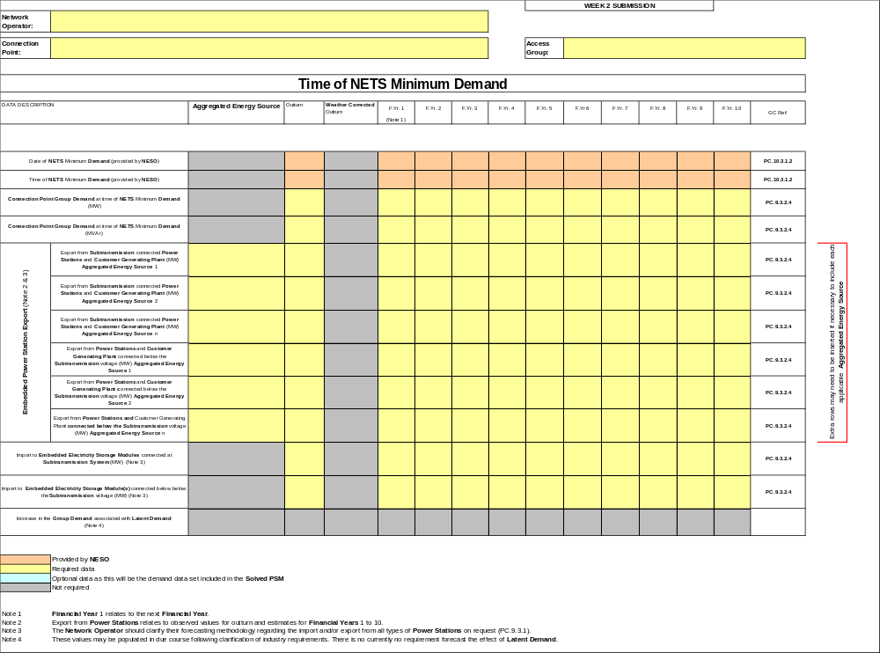
SCHEDULE 21 – GENERATION AND DEMAND OUTTURN AND FORECASTS
PAGE 2 OF 3

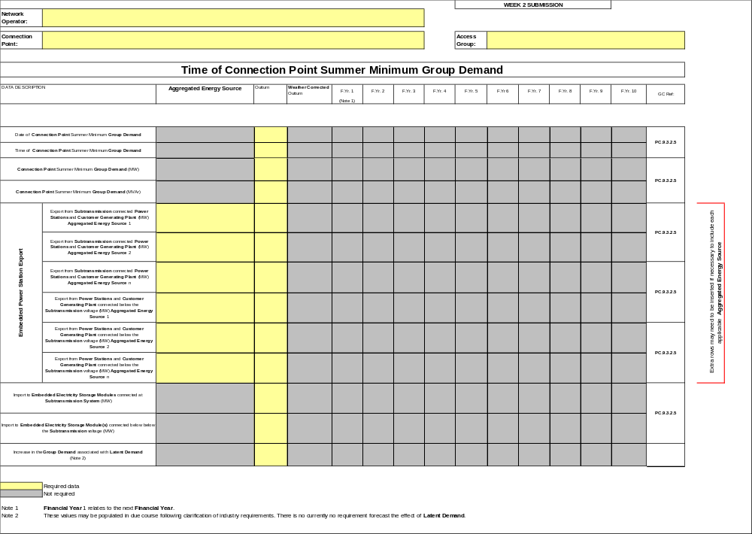

SCHEDULE 21 – GENERATION AND DEMAND OUTTURN AND FORECASTS
PAGE 3 OF 3

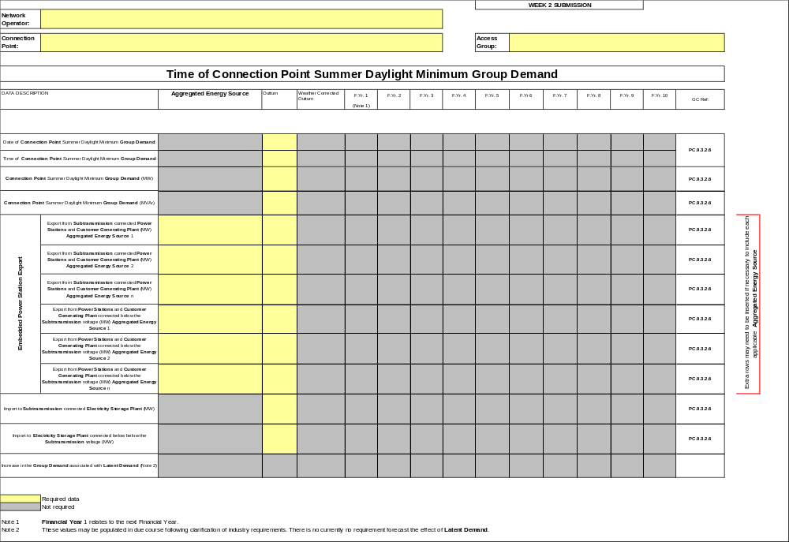
SCHEDULE 22 – DEMAND DATA
PAGE 1 OF 1

(PC.9)

Submissions by Network Operators using this Schedule 22 shall commence on the PSM Implementation Date and shall then continue in each year thereafter.

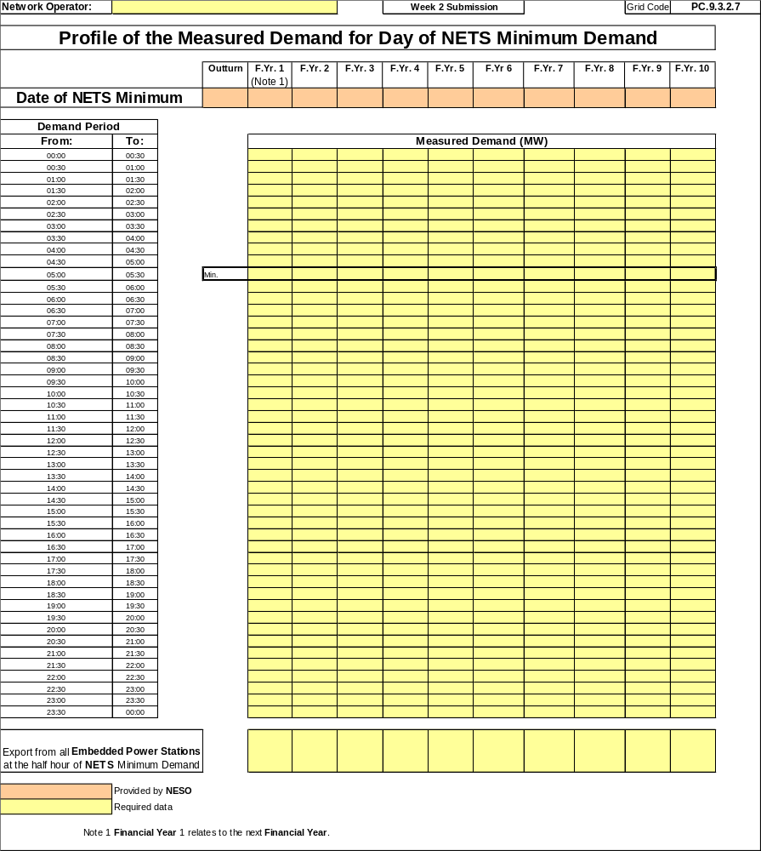

SCHEDULE 23 – NETWORK OPERATOR DEMAND PROFILES AND ACTIVE ENERGY DATA
PAGE 1 OF 3

(PC.9)

Submissions by Network Operators using this Schedule 23 shall commence on the PSM Implementation Date and shall then continue in each year thereafter.

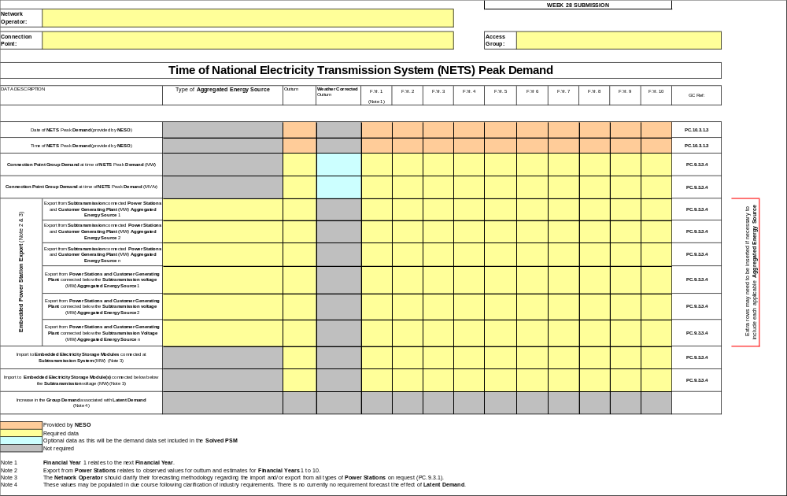
PAGE 2 OF 3
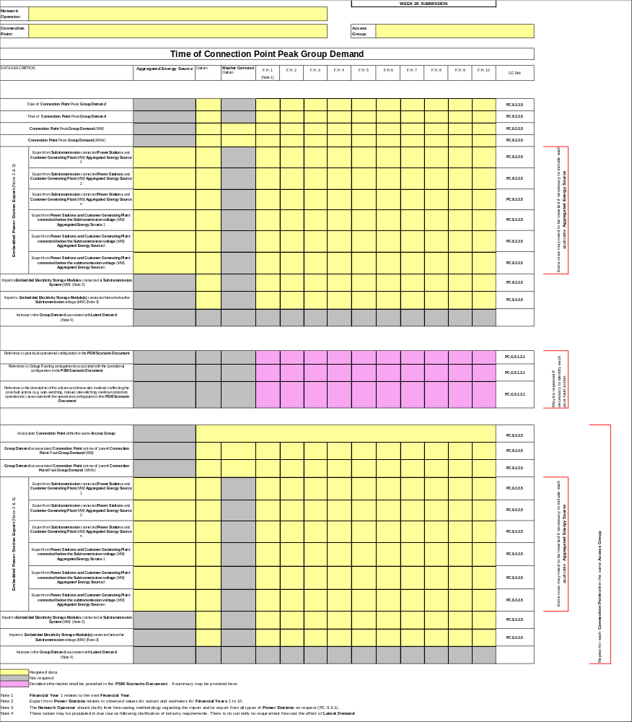

PAGE 3 OF 3
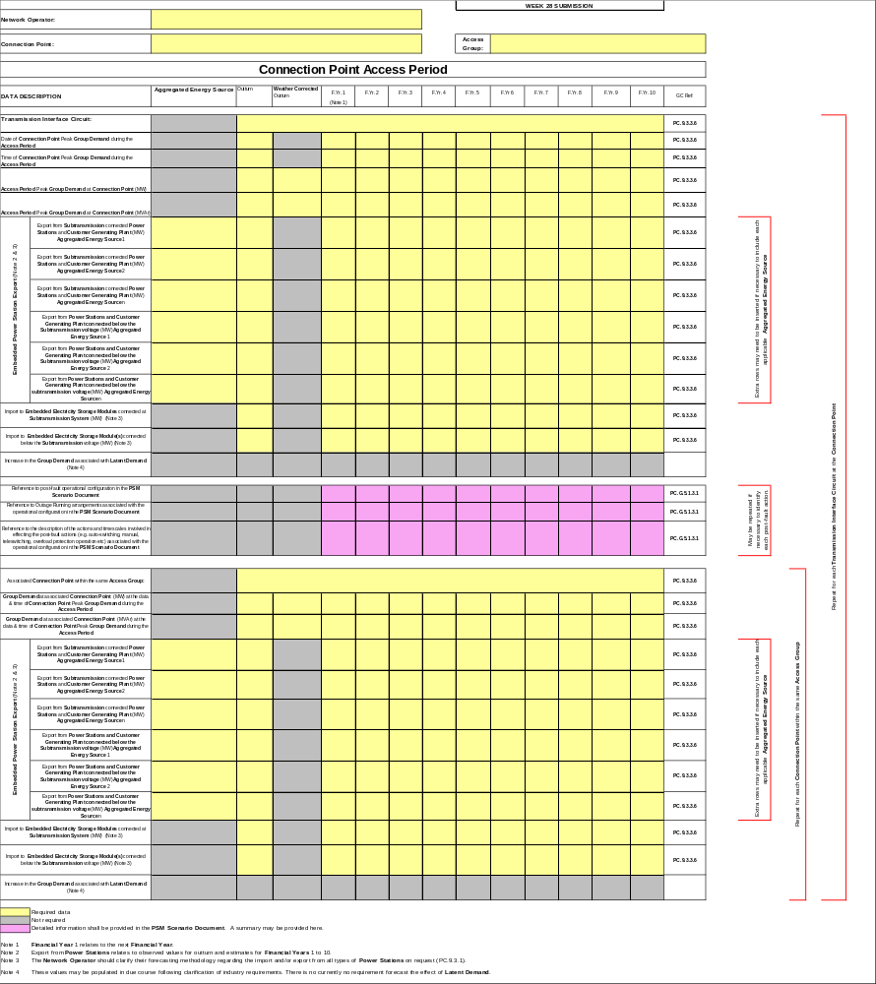
SCHEDULE 24 – GENERATION LARGER THAN 1 MW
PAGE 1 OF 1

(PC.9)

Submissions by Network Operators using this Schedule 24 shall commence on the PSM Implementation Date and shall then continue in each year thereafter.

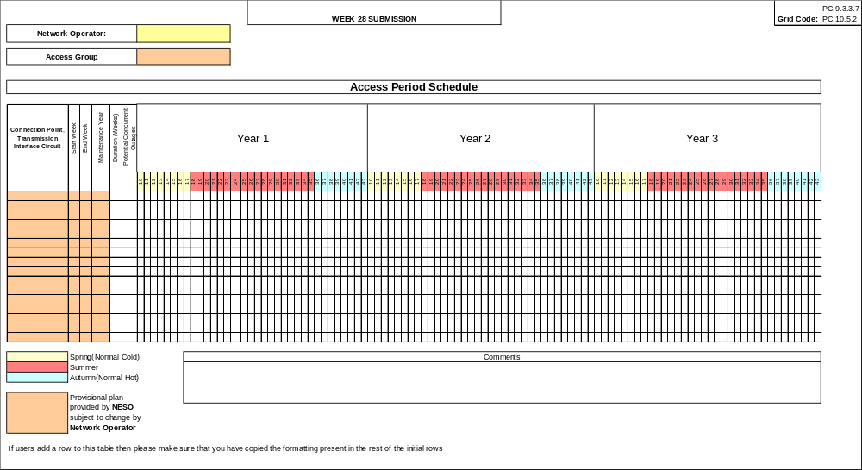

SCHEDULE 25 – NETWORK OPERATOR DEMAND CONTROL DATA
PAGE 1 OF 3

(PC.9)

Submissions by Network Operators using this Schedule 25 shall commence on the PSM Implementation Date and shall then continue in each year thereafter.
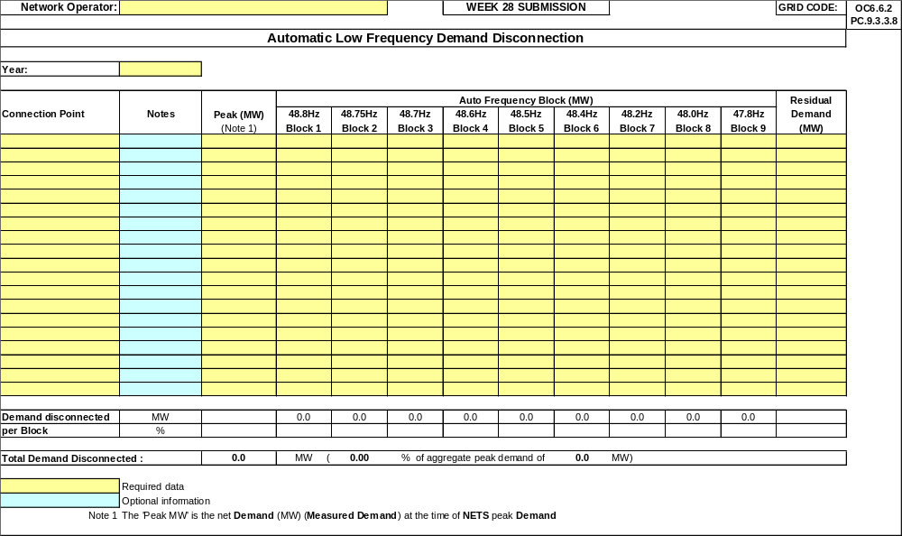

PAGE 2 OF 3
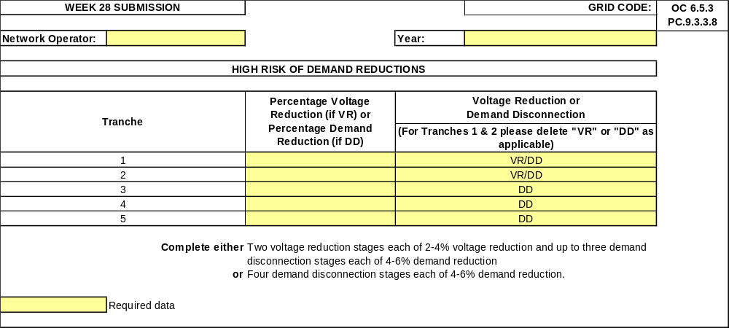

PAGE 3 OF 3
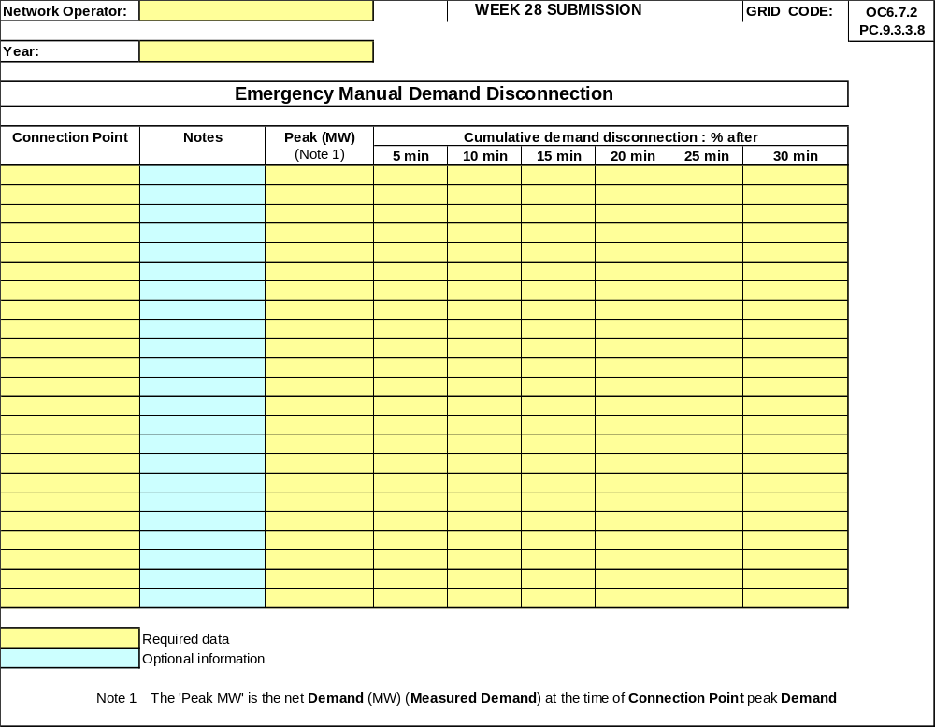

SCHEDULE 26 – DEMAND DATA
PAGE 1 OF 2

(PC.9)

Submissions by Network Operators using this Schedule 26 shall commence on the PSM Implementation Date and shall then continue in each year thereafter.

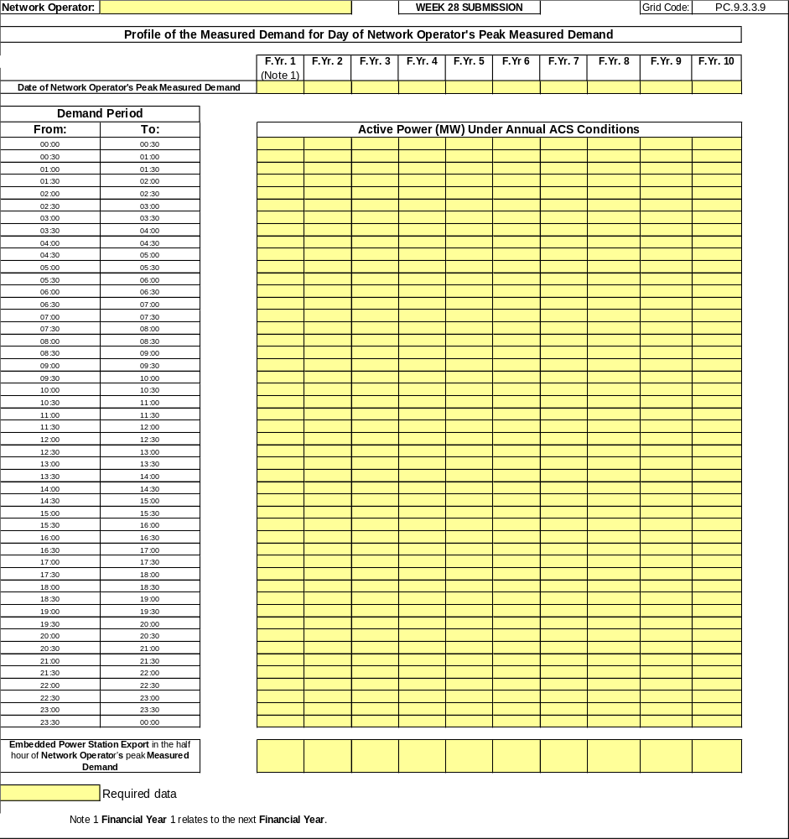
PAGE 2 OF 2
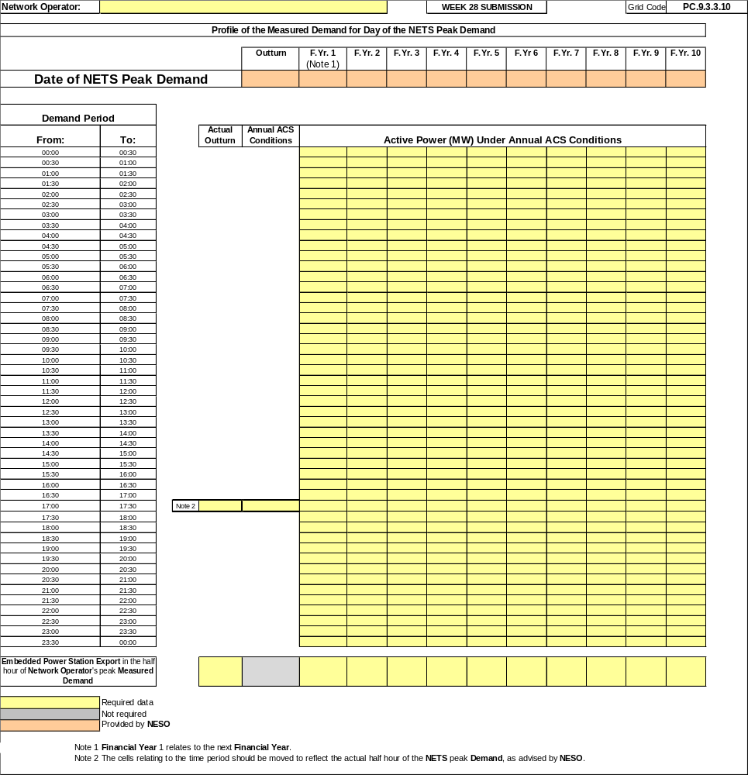
SCHEDULE 27 – NETWORK OPERATOR ACTIVE ENERGY DATA
PAGE 1 OF 1
Submissions by Network Operators using this Schedule 27 shall commence on the PSM Implementation Date and shall then continue in each year thereafter.

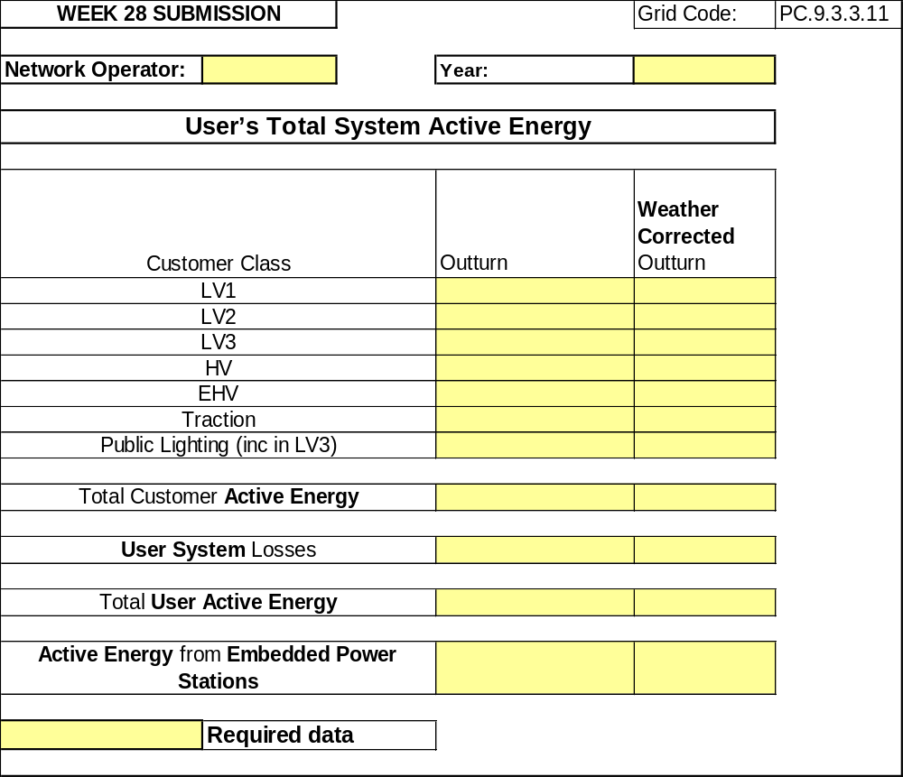

SCHEDULE 28 – EMBEDDED POWER STATION FORECAST CAPACITY SCHEDULE
PAGE 1 OF 1

(PC.9)

Submissions by Network Operators using this Schedule 28 shall commence on the PSM Implementation Date and shall then continue in each year thereafter.
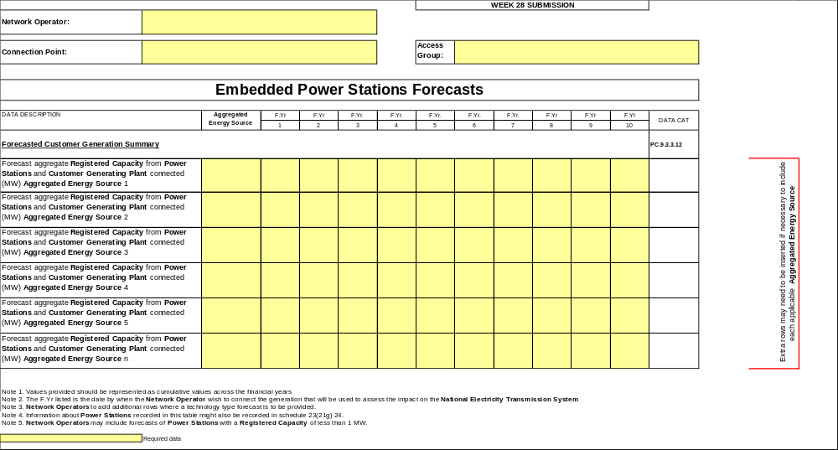

SCHEDULE 29 – EMBEDDED GENERATION SCHEDULE
PAGE 1 OF 2

(PC.9)

Submissions by Network Operators using this Schedule 29 shall commence on the PSM Implementation Date and shall then continue in each year thereafter.

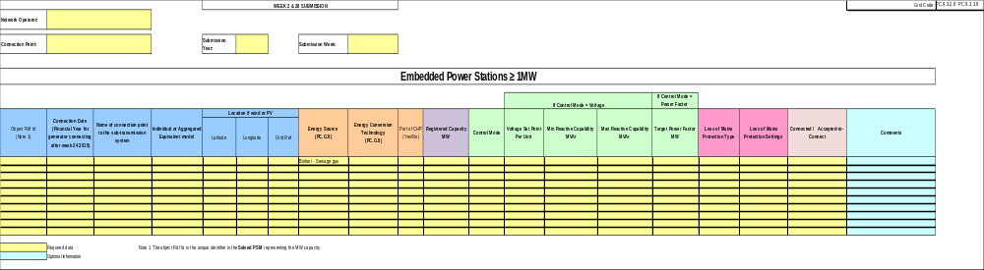

PAGE 2 OF 2

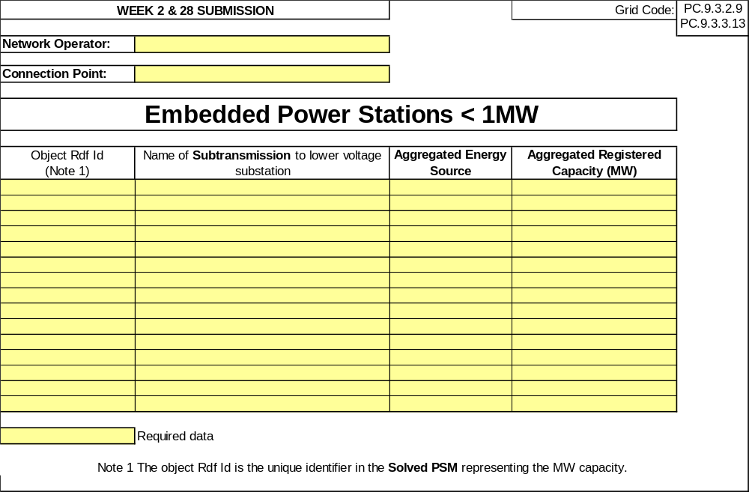

SCHEDULE 30 – EMBEDDED GENERATION CONSTRAINTS SCHEDULE
PAGE 1 OF 1

(PC.9)

Submissions by Network Operators using this Schedule 30 shall commence on the PSM Implementation Date and shall then continue in each year thereafter.
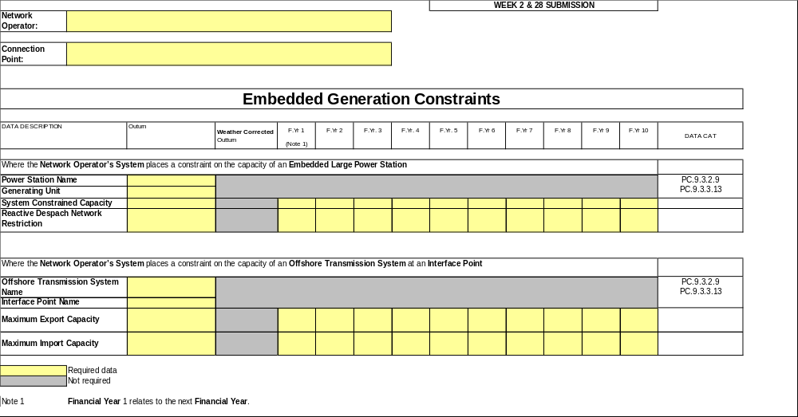
<END OF DATA REGISTRATION CODE>

