Workgroup Consultation
GC0151:  Grid Code Compliance with Fault Ride Through Requirements  Overview: A letter issued by the ESO on 7th May 2021 and a presentation to be made to the 27th May 2021 GCRP have identified concerns about demonstrating compliance with the Fault Ride Through Requirements in the Grid Code. This proposal seeks to apply a workable, non-discriminatory, legally compliant solution based on Good Industry Practice to address this significant operational concern in an expedited manner. |  | Modification process & timetable  Proposal Form  23 June 2021  Workgroup Report  01 September 2021  Code Administrator Consultation  09 September 2021 – 23 September 2021  Draft Modification Report  05 October 2021  Final Modification Report  07 October 2021  1  2  3  4  5  6  7  Implementation  One working day after Authority Decision  Workgroup Consultation  30 July 2021 – 16 August 2021
Have 5 minutes? Read our Executive summary
Have 20 minutes? Read the full Workgroup Consultation
Have 30 minutes? Read the full Workgroup Consultation and Annexes.
Status summary: The Workgroup are seeking your views on the work completed to date to form the final solution(s) to the issue raised.
This modification is expected to have a: High impact on Generators, Transmission System Operators, Interconnectors; Medium impact on Network Operators
Modification drivers: Efficiency, EU Compliance, GB Compliance, Harmonisation, System Operability, System Security, Transparency
Governance route | Urgent modification to proceed under a timetable agreed by the Authority (with an Authority decision)
Who can I talk to about the change? | Proposer:  Garth Graham  garth.graham@sse.com  01738 456000 |  | Code Administrator Chair:  Nisar Ahmed  Nisar.Ahmed@nationalgrideso.com  Phone: 07773 043068

Contents

Contents 2
Executive summary 3
What is the issue? 4
Why change? 10
What is the solution? 11
Proposer’s solution 11
Workgroup considerations 13
Workgroup consultation summary 28
Workgroup Alternatives 29
What is the impact of this change? 32
Proposer’s assessment against Code Objectives 32
Proposer’s assessment against Grid Code Objectives 32
Workgroup Vote 32
When will this change take place? 33
Implementation date 33
Date decision required by 34
Implementation approach 34
Interactions 34
Acronyms, key terms and reference material 35
Reference material 35
Annexes 36

Executive summary
A letter issued by the ESO on 7th May 2021 to stakeholders and a presentation to be made to the 27th May 2021 Grid Code Review Panel (GCRP) have identified concerns about demonstrating compliance with the Fault Ride Through Requirements in the Grid Code.
What is the issue?
This proposal seeks to apply a workable, non-discriminatory, legally compliant solution based on Good Industry Practice to address this significant operational concern in an expedited manner.
What is the solution and when will it come into effect?
Proposer’s solution: To codify a solution in the Grid Code which will:

- 1) Be placing Users (and in particular Generators) in compliance of a relevant legal requirement;
- 2) Have minimal commercial impact on Users and consumers;
- 3) Have a positive effect on the safety and security of the electricity system;
- 4) Apply a reasonable timing obligation on all stakeholders;
- 5) Apply a non-discriminatory process to all stakeholders; and
- 6) Ensure and enhance transparency of the FRT situation in GB

Implementation date: This modification is to be implemented one working day, following the Authority decision.

Summary of potential alternative solution(s) and implementation date(s):
The ESO has developed a draft alternative which can be found in Annex 9. This alternative emphasises what was set out in the May 2021 open letter written by NGESO; reminding Users of their requirements under the Grid Code and that the inability of Users to ride through ‘normal’ faults on the NETS is a serious risk to system security. NGESO needs to have the ability to manage fault ride through (FRT) non-compliances quickly and effectively.
What is the impact if this change is made?
This change will have a High impact on Generators, Transmission System Operators, Interconnectors and a medium impact on Network Operators.
Interactions
This modification has potential interactions with REMIT Article 5 obligations and ACER Guidance.

What is the issue?
The ESO’s Head of Networks wrote to stakeholders on 7th May 2021 about “Grid Code Compliance with Fault Ride Through Requirements”.

Fault Ride Through (FRT) is defined in the Grid Code as:
“The capability of Power Generating Modules (including DC Connected Power Park Modules) and HVDC Systems to be able to remain connected to the System and operate through periods of low voltage at the Grid Entry Point or User System Entry Point caused by secured faults.”

In that letter it set out three actions and; in the Appendix to that letter; an interim process that the ESO was proposing be applied by them on Users and Network Operators.
Subsequently, following as we understand meetings on 10th June 2021 with stakeholders (Energy UK in the morning and the wind community in the afternoon) the ESO issued on 16th June 2021 (as part of the papers for the 24th June 2021 GCRP meeting) a short presentation which seems to set out amendments to the (7th May) interim process that the ESO was proposing be applied by them on Users and Network Operators.
These steps by the ESO have, inadvertently, given rise to concerns, by stakeholders, that if they were to follow this uncodified ‘voluntary’ ESO interim process this would:
- Be placing Users (and in particular Generators) in breach of a relevant legal requirement;
- Have a significant commercial impact on Users and consumers;
- Have a significant impact on the safety and security of the electricity system;
- Apply an unreasonable timing obligation on some stakeholders;
- Apply a discriminatory process to some stakeholders; and
- Not ensure and enhance transparency of the FRT situation in GB.
Therefore, a codified process is required to ensure legal compliance and certainty whilst maintaining security of supply and minimising the significant commercial impact on stakeholders as well as providing a reasonably timed, non-discriminatory process and enhanced transparency for stakeholders.

- Legal Compliance
It is highly relevant, when considering the ESO’s proposed interim process, to note that generators that voluntarily reduce their MEL to zero (or to an undefined ‘safe level’) whilst investigating the root cause of any FRT related issue would be at risk of being deemed to have physically withheld generation capacity, potentially in breach of the REMIT Article (5) prohibition of market manipulation.
This risk would be higher in scenarios where, during the period of reduced output, the system experiences a period of very tight generation margins.
  - ACER Guidance
When considering compliance with REMIT Article (5), it is necessary to take into account the 20th November 2020 (5th edition) version of ACER’s guidance on REMIT and in particular section 6.4.1 (‘Examples of the various types of practice which could constitute market manipulation’) of which item (i) is directly relevant to the ESO’s proposed approach with respect to the FRT interim process, namely:
- “Actions undertaken by persons that artificially cause prices to be at a level not justified by market forces of supply and demand (including actual availability of production, storage or transportation capacity)

Manipulative capacity withholding occurs, for example, when a market participant with the relative ability to influence the price or the interplay of supply and demand of a wholesale energy product, decides, without justification, not to offer or to economically withhold the available production, storage or transportation capacity on the market. This includes the unduly limiting of infrastructure or transmission capacities, resulting in prices that likely do not reflect the fair and competitive interplay of supply and demand.
In particular, electricity generation capacity withholding refers to the practice of keeping available generation capacity from being competitively offered on the wholesale electricity market, even though offering it competitively would lead to profitable transactions at the prevailing market prices. Electricity generation capacity withholding can occur in two ways, namely via economic withholding32 [footnote 32 Actions undertaken to offer available generation capacity at prices which are above the market price and do not reflect the marginal cost (including opportunity cost) of the market participant’s asset, which results in the related wholesale energy product not being traded or related asset not being dispatched] or physical withholding33 [footnote 33: Actions undertaken in the form of not offering the available generation capacity at any price.]. Electricity generation capacity withholding may be performed by one or more market participants34, acting independently or in collaboration. REMIT applies to electricity generation capacity withholding irrespective of whether competition law (also) applies. Electricity generation capacity withholding does not automatically amount to a breach of Article 5 of REMIT. A case-by-case analysis that takes into account the circumstances and specificities of the market35 is therefore needed. REMIT does not prohibit prices to be high, provided that they reflect a fair and competitive interplay between supply and demand.
The following approach, based on two concurrent elements, can assess whether a behaviour involving electricity generation capacity withholding amounts to a breach of Article 5 of REMIT in view of the market manipulation criteria as defined in Article 2(2) of REMIT36. The first element to assess is whether the market participant concerned is able, in the case specific circumstances, to influence the price or the interplay of supply and demand of a wholesale energy product by engaging in such behaviour37. The second element to assess is whether the market participant has no legitimate technical, regulatory38 and/or economic39, justification for its behaviour when it does not offer its available generation capacity or has offered it above marginal cost.40 In case of intent, any action involving capacity withholding, even beyond the issuing of orders to trade or the entering into transactions, can amount to an attempt to manipulate the market.” [emphasis added]
  - Conclusion on Legal Compliance
For the reasons set out above, and in order to give legal certainty as regards compliance with the REMIT Article 5 obligations, it is necessary to proceed with a code modification to ensure that generators are able to both follow a process set out in regulation in the circumstances described by the ESO and also be certain as to what a ‘safe level’ is.

- Significant commercial impact on Users and consumers
If Users were to follow the ESO’s proposed interim process, it is not clear, following the 24th June 2021 GCRP update, as to whether they should go to zero output (as per the 7th May letter which stipulates a generator ‘remaining out of operation’ in item 3 and item 4 of Appendix 1) or a ‘safe level’ (as per 24th June 2021GCRP update).
However, if they were to go to, and maintain, till the situation is resolved to the ESO’s satisfaction (as per Appendix 1 item 3 and item 4), a zero-output level this would amount to a significant commercial impact on Users.
This also needs to be considered in the context of the User being effectively treated, according to the ESO’s interim process, as being ‘guilty until proven innocent’, even though (i) they will, in the case of a FON, have proven to the ESO’s satisfaction Grid Code Compliance and (ii) in the case of a fault where there is an over-voltage situation the generator may actually be required to trip off according to Grid Code requirement CC.6.3.15.3. – so rather than being non-compliant if they tripped off, they would actually be non-compliant if they did not trip off (in that situation).
Absent (a) the necessary technical information from the ESO as to what occurred on the NETS, and, (b) time to investigate the route cause; it will be difficult for the User to determine, within two hours, that non-compliance with the Grid Code has arisen and thus avoid going to zero output or an undefined ‘safe level’ with the associated significant commercial impact.
Notwithstanding the above, if Users (be that one or more generators or one or more interconnectors) or Network Operator(s) were to hold their plant and apparatus (including network assets) to zero output or a ‘safe level’ this could, particularly at times of market tightness (such as a winter peak or, as with the Bank Holidays in spring 2020, summer troughs), lead to additional, higher cost and actions needing to be taken by the ESO to maintain system balance.
This in turn could lead to a significant commercial impact on Suppliers and, over time, to higher costs for end consumers.

- Significant impact on the safety and security of the electricity system
As noted under (2) above, if Users (be that one or more generators or one or more interconnectors) or Network Owners were to hold their plant and apparatus (including network assets) to zero output or a ‘safe level’ this could, particularly at times of market tightness (such as a winter peak or, as with the Bank Holiday’s in spring 2020, summer troughs) lead to shortages of available plant and apparatus (including network assets) necessary to safely and securely operate the NETS. This, in turn, could significantly impact on the safety and security of the electricity system in GB.

- Unreasonable timing obligation on some stakeholders
Notwithstanding the above, the ESO is proposing, with the interim process, to not provide stakeholders with a realistic timeframe for them to:
- Carry out an initial investigation; and
- Perform the enduring investigation as, for example, was seen following the 9th August 2019 event in terms of how long Orsted and RWE had to report to ESO in that case, which, it be could argue sets ‘Good Industry Practice’ in terms of FRT reporting to the ESO.

In our view, in the event of a trip coincident with a system fault, more detail is required from the ESO and then more time is required for the User or Network Operator to investigate the situation with their plant or apparatus (including network assets).
We elaborate further on this in the ‘What is the proposed solution’ section below.

- Apply a discriminatory process to some stakeholders
According to the ESO’s 7th May 2021 interim process, as detailed in Appendix 1, a number of materially different (and, in our view, discriminatory) approaches are inadvertently proposed to be applied by the ESO where an FRT event occurs.
For example, the opening sentence of Appendix 1 sets out that the:
“ESO expects to follow the below steps to manage the system security risk following an unexpected generation loss/de-load coincided with a normally cleared transmission fault.” [emphasis added]
This is reinforced by the wording on slide 3 of the ESO’s presentation to the 24th June 2021 GCRP meeting which states the:
“ESO’s expectations of Users”
Notwithstanding the references to HVDC Systems and Network Operators etc., elsewhere in Appendix 1, this suggests that the ESO only actually intend that its interim process be applied to generators and not, for example, to interconnectors or Network Operators.
If so this would, in our view, be discriminatory.
Another example is shown in item 4 of Appendix 1 where a User (but not a Network Operator) has to respond to the SIR from the ESO within two hours, whilst the Network Operator “must respond as soon as reasonably practicable”.
Depending on the timing of the event be that, for example, on a Friday morning, like the 5th September 2003 event or a Thursday evening or Friday evening like the 28th August 2003 and the 9th August 2019 events could mean that many or few staff are available either on-site or off-site for the User or Network Operator to provide the technical analysis etc., in order to determine the situation with the plant or apparatus (including network assets) and report back accordingly to the ESO.
In the case of the Network Operator, as they only have to respond as soon as reasonably practicable, they will be able to respond, timing wise, differently on, say, a Friday morning (like 5th September 2003) compared to a Friday evening (like 9th August 2019) or over the weekend or a Bank Holiday; whereas a User (such as a generator or interconnector) will not.
As such this, in our view, is discriminatory.

- Ensure and enhance transparency of the FRT situation in GB
In respect of ensuring transparency of matters pertaining to FRT we are mindful that following the decision by the Authority to approve modification GC0105, that the ESO has, to date, yet to issue the Grid Code Review Panel with a report of the ESO’s progress towards reporting of voltage transients as it is required under OC3.4.1(c).
In addition to ensuring compliance with existing transparency requirements relating to FRT, we also believe that further enhancements; to the transparency requirements relating to FRT; are now required to be codified within the Grid Code in light of the concerns the ESO has raised in its 7th May 2021 letter and the 24th June 2021 GCRP presentation to ensure that Users, Network Operators, the ESO and Ofgem are fully aware of what is required of them and other parties.

6.1) Safe Limit
In its presentation to the 24th June 2021 GCRP meeting, the ESO has made reference to “Users are asked to restrict their output until a FRT issue is ruled out (either MEL to zero or to a safe level)”. [emphasis added]
However, as noted under (1) ‘Legal Compliance’ above, there is no transparency (for Users or Network Operators or Ofgem) of what the ESO is referring to.
Is it, for example, (i) ‘safe’ for the system only; or (ii) ‘safe’ for the User(s) and / or Network Operator(s) only; or (iii) ‘safe’ for the system, the User(s) and / or the Network Operator(s)?
Given this uncertainty, we believe it important for Users, Network Operators, the ESO and Ofgem that there is transparency (in the form of it being set out in the Grid Code, having been approved by Ofgem, via this Modification proposal) of what the ‘safe level’ is along with when (and when not) it applies.
We elaborate further; in the ‘What is the proposed solution’ section below; what for the purposes of plant and apparatus (including network assets) could be considered as being a ‘safe level’ in our view.

6.2) Historic fault information
There is a lack of transparency for stakeholders of the historic fault data in GB and therefore, we propose that the ESO be obliged (in the Grid Code) to provide the industry with historic fault data (i.e. timestamped records of voltage dips at GSPs or key nodes) that would enable Users (and Network Operators) to check for any unexpected changes in station output (or network asset performance) that could signify an apparent FRT compliance issue.
The provision of this data by the ESO and the subsequent checking by the User (or Network Operator) of any unexpected changes in station output (or network asset performance) would provide significant confidence that a User’s site (or network asset) was compliant and would be far more meaningful than, for example, a one-off confirmation letter.
Given that this is historical data that already exists and given the importance that the ESO attached to this matter (as witnessed, for example, by the statements in the 7th May 2021 letter itself) we would expect that the ESO would wish to make this historic fault data available to stakeholders with the utmost alacrity (and thus perhaps ahead of the change needing to be codified).

6.3) Real-time post-event data
It has come to our attention that when an FRT event occurs in Ireland that the system operator, EirGrid, provides to stakeholders, within 24 hours, the minimum retained / maximum voltage and duration associated with that event. This is not something that occurs in GB.
In our view, the ESO should be obliged (within the Grid Code) to provide to Users and Network Operators the waveform data (or at least the minimum retained / maximum voltage and duration) following any Fault Ride Through incident on the NETS in a timely manner, as EirGrid does.
This will allow Users and Network Operators to investigate and resolve the fault (if one has occurred on their equipment/asset(s)) and thus, in our view, is the starting point for the timeframe for reporting back to the ESO on matters pertaining to FRT compliance.
We also note that following the introduction of GC0105, the Grid Code now requires the ESO to report to the Panel its progress with reporting voltage transients²⁰.
In respect of items 6.2 and 6.3 above, we are also mindful of the current Ofgem consultation on the publication of data by Network Operators (including, in this case the ESO) where the emphasis on justification would switch from a presumption of not publishing (unless justified as to why to publish) to a presumption of publication (unless having justified why not).
For the avoidance of doubt, we believe that our proposed approach, in this Modification proposal, as regards data publication by the ESO in respect of both ‘Historic fault information’ and ‘Real time post event data’ conforms with the Ofgem’s intentions (as set out in its consultation).

6.4) After event reporting
It is important that lessons learnt from FRT events in terms of the impacts etc., on User or Network Operator plant or apparatus (including network assets) are shared with stakeholders as, for example, happened after the 9th August 2019 event where information on the lessons learnt by the two transmission connected generators was shared with the wider stakeholder community to ensure, collectively as well as individually, that steps were taken to learn from what went ‘right’ or ‘wrong’ on the day.
Therefore, in our view, the ESO should be obliged (within the Grid Code) to make available, in a timely manner, to Users and Network Operators any lessons learnt information that is provide to the ESO by any User(s) and / or Network Operator(s) after an FRT event.

6.5) Dynamic Largest infeed loss
There is currently no visibility to Users of the dynamic largest infeed loss that is being applied by the ESO to operate the NETS. Whilst it has been generally set to 1,320MW there are, we understand, periods of time, such as when inertia is low, where the level has dropped to circa 800MW. There is little real time visibility to stakeholders of this.
In our view, as we set out in ‘What is the proposed solution’ below, and in order to support system security it is appropriate for the ESO to be obliged (in the Grid Code) to provide the industry (via the BMRS?) with the current largest infeed loss level at any moment in time that the ESO is operating the NETS to.

Why change?
As set out above in ‘What is the issue’ there is a need to change the Grid Code with respect to the process followed by Users, Network Operators and the ESO in the event of a Fault Ride Through occurrence where a User’s site or Network Operator’s asset(s) coincidently trips/de-loads.

This is to ensure that Users, Network Operators and the ESO have clarity and legal certainty as to the steps/actions etc., they need to take if an FRT event and coincident trip/de-load occurred.
This will:
- Be placing Users (and in particular Generators) in compliance of a relevant legal requirement;
- Have minimal commercial impact on Users and consumers;
- Have a positive effect on the safety and security of the electricity system;
- Apply a reasonable timing obligation on all stakeholders;
- Apply a non-discriminatory process to all stakeholders; and
- Ensure and enhance transparency of the FRT situation in GB.
Therefore, a codified process is required to ensure legal compliance and certainty whilst maintain security of supply and minimising the significant commercial impact on stakeholders as well as providing a reasonably timed, non-discriminatory process and enhancing transparency for stakeholders and that is why this change to the Grid Code should be made.

What is the solution?

Proposer’s solution
[Please Note: The Proposer’s solution shown below has changed from the version that was included in the Workgroup Consultation. These changes followed careful consideration of the responses to that consultation and the Workgroup discussion of those responses.]

- Response in the event of an apparent trip/de-load coincident with a system fault
In the event of a User site or Network Operator asset trip/de-load coincident with a system fault, data is required from the ESO to help the User or Network Operator investigate the problem and time is required for the User or Network Operator to investigate the root cause of the trip/de-load.
Therefore, we propose the following process applies:

- Where User’s site or Network Asset TEC/ asset capability is < 100 MW; no immediate export limitation would be immediately applied but the User or Network Operator would have three months from the date of submission of waveform data by NGESO to investigate and if necessary, resolve the cause of any non-compliance.
- Where Users’ sites or Network Asset TEC/ asset capability is > 100 MW:

  - Where the User or Network Operator is in receipt of a FON or an ION: a MW export constraint would be applied immediately to a level of either:
- 70% of the station TEC/ asset capability; or
- the prevailing largest infeed limit (whichever is lowest)
Note – the export limit will not be reduced below 100 MW (i.e a User with 130 MW would only be constrained to 100 MW)
The User or Network Operator would have 3 months from the date of submission of waveform data by NGESO to investigate and if necessary, resolve the cause of any non-compliance.
  - Where the User or Network Operator is in receipt of a LON:
    - if the reason for the LON relates to equipment changes that could reasonably be expected to affect the FRT performance (e.g. a generator replacement or software update that fundamentally changes the FRT capability or protection settings that are tighter than were applied previously) then the User or Network Operator would be managed as for a FON or an ION (see (a) above).
- For any User or Network Operator: if the cause of the FRT non-compliance is not resolved after three months from issue of the waveform data by NGESO, the User or Network Operator would have to constrain the station TEC/ asset capability to 50% until the non-compliance was resolved

Justification for this process:
- Three Months to Investigate
The existing LON process permits generators/interconnectors up to two years to rectify grid compliance issues. We recognise this is unnecessarily long for a User or Network Operator to correct a fault that could present a risk to the system but in our experience three months is the minimum reasonable time that User or Network Operator would need to complete the tasks that would be expected to fully investigate the fault, namely:
  - gather relevant SCADA error logs and protection settings
  - obtain system fault level data at the time of the fault
  - if required, commission consultants to provide the necessary modelling services to model generator/interconnector/network asset controls
  - repeat required FRT modelling scenarios
  - Implement any setting changes

- 100 MW Threshold
The degree of constraint that should be applied is clearly dependent on the impact repeated FRT failures of a generator/interconnector/network asset could have on the wider system which in turn depends on the User’s Transmission Entry Capacity or Network Operator’s asset capability.

The FRT requirements apply to interconnectors and all ‘Large’ generators, i.e those above 10 MW in the north of Scotland but do not apply to many distribution connected generators < 50 MW in England and Wales.
Therefore, for simplicity we propose the Licence threshold of 100 MW is used since this was chosen to imply that below this level the User’s asset (or, by inference, Network Operator’s asset) would not have a significant impact on the system.

- Degree of Forced Constraint: Lowest of 70% TEC or Largest Infeed Limit
The sudden loss of a large User (or large network asset) will erode frequency response the ESO holds to cater for the loss of a normal infeed. The larger the User’s site (or network asset(s)), the greater the risk that the response holding could be eroded and therefore it could be argued that some action is needed to mitigate the potential risk that the generator (or interconnector or Network Operator) could be non-compliant and could trip again, in effect requiring the ESO to hold ‘extra’ response at a cost that would be passed through to BSUOS and the end customer.
However, there is also the possibility:
  - the User’s site (or Network Operator asset) had received a FON or an ION (i.e deemed by the ESO to have satisfactorily demonstrated Grid Code FRT compliance) and the resulting investigation shows it had tripped for valid reasons but the investigation takes several days/weeks to conclude (e.g > 50% turbines unavailable, network over-voltages, repeated network faults). Imposing a hasty constraint on a User site that it turns out is (and was at the time of the event in question) Grid Code FRT compliant could put the User at risk of infringing REMIT Article 5 obligations and would be unreasonable given that the User may have operated for many years without issue and the balance of probability is that they are Grid Code FRT compliant.

  - Any forced outage of an in-merit generator or interconnector (or forced outage of network assets) will lead to higher costs to the end customer. Where this applies to a large generator (e.g. one with a low CfD) or interconnector or substantial network asset this could add significantly to balancing costs and/or erode system margins creating other system security risks
  - On many windfarms, operating at a reduced output should improve the FRT capability such that, even though a windfarm may not be compliant at full output, the additional ‘headroom’ obtained from operating at a lower output (such as 70%) will increase the likelihood of a non-compliant windfarm (if that is actually the case) riding through faults.
  - If the constrained User is a windfarm then by setting the windfarm to Frequency Sensitive Mode (FSM) rather than applying a fixed MW, the ‘headroom’ could be used to obtain additional frequency response, which while it cannot be fully relied upon, would be fast-acting and would generally be expected to contribute to the stability of the system in the event of a fault of another User site or Network Operator asset.

In summary, a forced constraint to a maximum of 70% of the station’s TEC / network asset capability or Largest Infeed Limit (whichever is lower) for a User or Network Operator in receipt of a FON or an ION seems a reasonable compromise between the cost of holding additional response due to a potential FRT non-compliance and the cost impact on the User or Network Operator and end consumers from unnecessarily constraining a User site or Network Operator asset.
The Proposer therefore believes:
- By taking a pragmatic and ‘risk-based approach’ to the likelihood of a non-compliance, this process strikes the right balance between ensuring the security of the system whilst also minimising the cost to Users or Network Operator and the consumer.
- It also provides certainty to all Users and Network Operators (as well as the ESO and Ofgem) of what is required such that they (as well as the ESO and Ofgem) can be confident they are meeting their licence obligations.
- It uses existing established processes in the Grid Code; if the issue of a FON cannot be relied upon to have confidence of a User’s site or Network Operator’s asset FRT capability then it suggests there could be a defect in the application of the Compliance process. Similarly, it highlights that until a FON is issued, the User or Network Operator is at risk of potential restrictions in its output/operation – which may in turn, encourage Users and Network Operators to complete the ION stage more quickly than has historically been the case.

Workgroup considerations
The Workgroup convened 7 times to discuss the perceived issue, detail the scope of the proposed defect, consider the responses to the Workgroup consultation, devise potential solutions and assess the proposal in terms of the Applicable Code Objectives.

A workgroup member provided information on the historical context that is relevant to GC0151 to the Workgroup. Originally when the Electricity Supply Industry was privatised, and the new code processes introduced; including the Grid Code(s); there were no codified requirements for any User’s plant or apparatus to be capable of Fault Ride Through (FRT) in either the Scottish Grid Code or the England and Wales Grid Code. Similarly, there were no codified FRT requirements included in the GB Grid Code when the British Electricity Transmission & Trading Arrangements BETTA were introduced in 2005.

However, at this time all the TOs and System Operators (which included the predecessor body to the ESO today) were becoming concerned that the growing introduction of non-synchronous Power Park Modules were eroding system security by replacing existing synchronous generators which were believed to have good inherent FRT capabilities. To evaluate these concerns FRT was included in modifications H/04 and SA/2004, which were primarily introducing new requirements for non-synchronous Power Park Modules, however whilst the main aim of the modification was to introduce requirements for non-synchronous units in-order to appear even-handed FRT requirements for synchronous units were also added. The modification was introduced into the GB Grid Code on the 1 June 2005 as per the Authority’s Decision Letter dated 27 May 2005^{[ref 1]}. As well as applying these new FRT requirements to new units some requirements were also applied retrospectively to existing units as discussed in the Impact Assessment sections 6.4 & 6.5 of the Authority’s consultation^{[ref 2]} issued on the 17 January 2005 and the responses^{[ref 3]}. However, in these letters it is clear that it is not the intention to introduce unachievable requirements to existing Users and these will be addressed as required.

Whilst all these requirements were codified into the Connection Conditions (‘CC’) section CC.6.3.15 of the Grid Code and have been subject to a number of minor modifications since June 2005 the next big change to the FRT requirements in GB were introduced by the EU Network Codes. Specifically, the new FRT obligations in the EU Requirement for Generators (RfG) and HVDC Network Codes were introduced into the Grid Code in a new section called European Connection Conditions (ECC) for new plants installed after around 2018 with FRT being specifically dealt with in section ECC.6.3.15.

These requirements are all currently in force and require Users to be compliant with Fault Ride Through (FRT) which is defined in the Grid Code as:
“The capability of Power Generating Modules (including DC Connected Power Park Modules) and HVDC Systems to be able to remain connected to the System and operate through periods of low voltage at the Grid Entry Point or User System Entry Point caused by secured faults.”

In general, FRT requires that should a plant be capable of continuing to operate through a 3-phase short circuit applied at its connection point for a period of 140ms then removed. The reason this condition has been adopted is it is considered to be the theoretical worst event that a unit could be subjected to and hence should be capable of withstanding any normal voltage dips occurring on the transmission system. It should be considered that these events are particularly stressful for the User’s Plant and / or Apparatus. In terms of a synchronous generator when a 3-phase short circuit is applied to the connection point(s) the current flowing in the generator is significantly increased resulting in the mechanical forces on the generator and turbine will significantly increase with the generator trying to pull itself out of its foundations. Equally the power transmission torque down the turbine train increases significantly causing large forces down the machine. The current assessment of compliance is wholly based on simulation studies to confirm the unit will stay electrical stable with the system and not pole slip and although the significant mechanical force which in-principle have been assessed during design they may never have been applied. In general terms older units may not have been required to perform these assessments; even if they have this is only based on modelling, and it is not a guarantee that the unit will perform as anticipated. In general units may have operated for years with no issues but this might be due to the proximity of the fault depending on the distance the unit may be capable of riding through electrically distant faults.

Unlike synchronous generators most non-synchronous technologies use current limiters to keep mechanical forces lower, however as they require a source AC voltage signal to operate, the longer they are unable to see the mains supply the harder it is for the control system to maintain in synchronism. Again, compliance is only assessed on the basis of model simulations these are only as good as the models and again may not be capable of local faults.

Following the initial concerns in 2004 and the introduction of the FRT requirements in 2005 the GB system has generally operated acceptably, until the 9 August 2019 when two transmission connected units and a number of distribution connected units simultaneously failed to ride through a fault and resulted in demand disconnection. This has again raised concerns with the ESO about the failure of Units to FRT and for some reason this situation appears to be getting worse with the number of units failing to ride though increasing concerns about system security.

Consideration of the proposer’s solution
The Proposer has identified three core aspects of the solution, these are:
  - (i) Time to investigate;
  - (ii) MW Threshold; and
  - (iii) Degree of forced constraint

Time to investigate
- Proposer’s view: Proposer is suggesting that the User or Network Operator should have 12 weeks from the date of submission of the voltage waveform data by the ESO to investigate and if necessary, resolve the cause of any non-compliance to enable correct investigations to be carried out in a timely manner. It was also noted that there is currently a distribution consultation that examined compliance by distribution connected plant, but this consultation does not set out a process for assets connected to the network if a party is non-compliant. For instance, a Distribution connector Generator which is identical to a transmission connected Generator in terms of having an FRT requirement that does not meet the FRT technical requirements do not have to disconnect within two hours. Also, according to the process set out on ESO 7th May letter or the process being suggested by the ESO in their alternatives, Distribution connected Generators are not held to the same account as transmission connected Generators. There is thus no level playing field - parties who are Distribution connected with fault ride through obligations are not being held to the same level of risk as those connected at Transmission.
- ESO view: ESO Workgroup member stated that Users have a responsibility to explain a sudden unexpected loss of output when requested. OC5.4.2 does not have clear timelines to manage unexpected generation losses. This could be modified with the agreement of industry to better manage system risks. Thus, the ESO would like to engage with Users to understand their concerns and to formulate a better process.
- Workgroup view: Workgroup members affirmed that the suggested timeline in the ESO’s 7th May letter is too short to investigate, make relevant contacts and review information required to make an informed response to the ESO. The time to carry out an investigation is not a ‘one size fits all’ approach. In nearly all cases the cause of an issue will be straightforward and readily identifiable while a few will be more complex and require a longer time to investigate fully. Also, this is not an appropriate timescale for a fault that has system security risk issues which have been identified as significant by the System Operator. Most Workgroup members expressed that the increase in time, as per this modification, will allow prudent operators to investigate the issue without being disadvantaged from a lack of information. In the case of a wind farm, for example, the response data for all the affected turbines will need to be downloaded collated and analysed. A Workgroup member noted that extensions should be made available for the procurement of equipment that will be needed to resolve any identified fault, for example, currently there is a 3-month delivery time for protection relays.

MW Threshold
- Proposer’s view: Currently, the FRT requirements apply to interconnectors, HVDC systems and all ‘Large’ generators, i.e. those above 10 MW in the north of Scotland but do not apply to many distribution connected generators < 50 MW in England and Wales. Hence, the Proposer is suggesting the Licence threshold of 100 MW is used since this was chosen to imply that below this level the User’s asset (or, by inference, Network Operator’s asset) would not have a significant impact on the system.
- Proposer’s view: Proposer suggests that a forced constraint to a maximum of 70% of the station’s TEC / network asset capability or Largest Infeed Limit (whichever is lower) for a User or Network Operator in receipt of a FON or an ION seems a reasonable compromise between the cost of holding additional response due to a potential FRT non-compliance and the cost impact on the User or Network Operator and end consumers from unnecessarily constraining a User site or Network Operator asset whilst taking into account that technical the risk of a further FRT event resulting in a similar trip/de-load is significantly reduced where an asset is operating at substantially below its maximum output.
- Workgroup view: The proposed threshold is fair, ideally the power constraint should be only implemented if it is technically demonstrated after an investigation that a FRT non-compliance occurred. Any limits or proposals should affect all Grid Code Users in a consistent way. Discussion on constraint needs to be had with ESO rather than draconian one size fits all. Also, there should be clarification on how the 100MW threshold level of risk has been determined. One respondent did not support thresholds or tolerances as they believe that multiple small units will have the same effect as larger ones.

Constraint Limitation
- Proposer view: The Proposer explained that as the FRT requirements apply to all large generators which differs across the GB network, a simple clear threshold of 100MW best defines sites that will have a significant impact on the system in the event of a FRT trip. A range with a defined maximum may be a better solution, which can be corelated with a perceived risk/impact on the system.
- Workgroup view: Some Workgroup members disagreed with the proposed constraint level expressing that if a limitation must be applied then it should be at BMU level and a minimum of SEL or a level that reflects the site/system risk following a transparent risk assessment/methodology. Furthermore, if one must be used it should be based on the SQSS. A workgroup member suggests that a potential requirement to constrain volume could be identified through a small amount of additional modelling by the ESO that would provide a risk based assessment given prevailing conditions at the time and the “strength” of a particular part of the network. This approach is already used for taking circuit outages etc. It could therefore be possible to follow the same approach for this scenario to cover the loss of a generator not meeting FRT requirements as a balance to instructing it off the system.

Voltage Protection Setting
- Proposer’s view: Proposer noted that the Grid Code is silent on the need for Users or Network Operators to remain connected for transient over-voltages, particularly those that are expected to occur after the clearance of a fault. Also, the Grid Code is silent on what over-voltage settings are permissible that would not conflict with requirement to ride through faults and in particular the over-voltage that could be expected upon fault clearance.
- Workgroup view: Workgroup members expressed concerns about the insufficiency of the Grid Code provisions in this area claiming that it is ambiguous and unclear. Workgroup members also addressed concerns about the lack of sufficiency of voltage data stating that data relating to voltage on grid/voltage traces should not be confidential, but rather it should be publicly available in a public domain except where there is case to not publish. In Ireland there is an auto email to subscribe to a list that sends out voltage info of faults. The Proposer noted that recent events highlighted by the ESO had identified that an FRT event in one part of GB could manifest itself some 250 miles / 400 kms away. The Proposer noted that without timely visibility of this information; from the ESO to Users; that an interconnector or generator at, say, Medway in Kent, would be none the wiser of an FRT event which occurred at, say, Heysham in Lancashire and could not therefore be expected to take that event into account when considering how they deal with FRT events on the network. Conversely, by making this information more widely available, this would, in the view of the Proposer, allow all relevant stakeholders to examine if / how their asset(s) had performed during the FRT event for which data was being report by the ESO.

Consideration of other options

Security of Supply
The ESO workgroup member stated that is has an obligation to make all parties/network assets (Generators, Interconnectors, Network Operators etc) aware and up to date where there is a reported FRT risk, and everyone connected to the system has an obligation to ensure system security and integrity. The original solution in the view of the ESO restricts the ability of the ESO to safely operate the system, to ensure users’ compliance with the Grid Code, and to manage risk and costs for consumers.

Workgroup members noted that it was important to agree on a method to protect the system, such that the ESO can make their concerns and complaints known to Generators or Interconnectors or Network Operators and that those parties can respond in a timely manner to the ESO’s concerns. During the investigation period, the ESO may prevent the asset returning to service resulting in large commercial impacts for both the Interconnector and the Generator and potentially a significant impact on the safety and security of the electricity system.
.

The Workgroup reiterated that a trip/de-load co-incident when an FRT event occurs, may give rise to both an over and / or under voltage situation. Depending on which of these it is (and the duration), an asset would be fully compliant with the Grid Code in tripping off or de-loading whilst in a different set of circumstances it would not. It therefore would take longer that the two hours set out in the ESO’s 7 May 2021 letter to fully investigate and determine what, if anything, needed to be done to correct the situation. The Proposer also noted that there was already a process within the Grid Code (as summarised in “CP.A.1.4 Illustrative Compliance Process for Ongoing Compliance”) where the ESO (or User) identifies plant and / or apparatus as not meeting Grid Code (or BCA) obligations. The Proposer noted that with GC0151 Original, where the ESO finds non-compliance with a party’s FRT obligations that a non-discriminatory approach will be applied to all parties; be they a Network Operator, Interconnectors, Generators and, if relevant, Demand.

Managing System Risk
A Workgroup member raised issues of the accuracy of the model predicting FRT failure and the level of support to be given by Users when there is a failure and the necessity of validating the model and methods. Workgroup members explained that validation of an asset’s FRT compliance may be achieved through site-testing and simulation, type testing, validating turbine (5MW threshold) and factory acceptance testing.

Relevance to REMIT Regulation
There were concerns as to lack of clarity in the letter in respect to legal obligations of parties. The ESO Workgroup member explained that where a party is contacted before they have attempted to reconnect, the ESO requirement is that they will need to first self-certify. The FRT compliance requirements are set out in EREC G99 which basically replicate those in the Grid Code. The generators need to provide information set out in G99 as part of the commissioning process to demonstrate compliance and this information is assessed by us as part of the process. There are provisions in G99 relating to reviewing compliance after an incident, replacement, or relevant equipment etc. and for ad-hoc testing.

A Distribution Code consultation was published week prior to Workgroup 5 meeting setting out a compliance enforcement process for material non-compliances with the Distribution Code (including EREC G99), which it may be appropriate to apply (if approved by Ofgem) ^{[ref 5]}. Thus, actions are being taken with regards to the Distribution side as well.

There was a common view that the Distribution Code does not provide the process to identify and inform non-complying customers, what is required of them and lack of clarity of consequences for distribution or connected parties who failed to comply with fault ride through obligations. In response to this, the ESO Workgroup member explained that there are no clear similarities between Transmissions and Distribution because for instance, distribution energy resources are widely spread in many small units hence it is not practical to apply the same process to them. The important focus here is to work on making the proposed process work in relation to transmissions related issues and not get drawn into the distribution side. A Workgroup member however added that it is worth noting and passing to the relevant forum to consider that aggregate distribution connected kit can have a significant impact on the transmissions system hence Distribution may also be affected by the process the Workgroup seeks to codify.

The Proposer noted that the REMIT impact, in terms of ‘withholding capacity’, would apply to market participants if the process set out in the ESO’s 7th May 2021 letter was not codified as such a party could have been technically compliant with the Grid Code (following investigation after the event) so the ESO’s suggested ‘defence’ (for the market participant) of there being a technical reason for withholding the capacity would not be applicable in that case – thus the market participant could be held to have breached their REMIT obligations.

Current Interim process of FRT
A Workgroup member expressed concerns that there has been a lack of clarity from ESO with regards to safeguards around SIRs. The ESO Workgroup member responded that they have taken liaised with the Control Room to clarify guidance on SIRs and when they would be issued. Whilst this modification is looking at information to go from the industry to the ESO, it is also important to recognise that is there is work that needs to be done by the ESO to improve on their communications to the industry in general. A Workgroup member requested that the ESO could explain to stakeholders what steps it has taken to comply with Article 40, paragraph 2 of the emergency and Restoration Network code as discussed at GC0148. That, for example, places obligations on the ESO to inform Generators of certain information such as the system state in an emergency so the generator can in turn help to resolve. The Proposer hopes the ESO can address this at some point in the very near future. A Workgroup member remarked that the system is changed and is now a more dynamic system, it cannot handle the sorts of losses it used to handle. A Workgroup member voiced concerns that a significant number of costs are being picked up by Transmission-connected Generators, who are already having to fund the Loss of Mains Protection scheme ^{[ref 4]}. They suggested that the ESO should work collaboratively with industry to come to a solution that is a suitable compromise between parties, and which could also deal with some of the issues stemming from the SQSS that are driving this.

A Workgroup member suggested that in effect, the value of the ESO letter was that it highlighted the importance of fault ride through. However, the view that the generators could have up to two years to correct an apparent fault ride through non-compliance under the long process is unduly pessimistic. Trips are detrimental to plant, but also, a generator would not want the reputational impact of being caught up in a wider system disturbance if they can avoid it. In most cases, responsible Generators will try and fix any apparent non compliances quickly or within a few weeks.

Other Issues with Existing Fault Ride Through (FRT) Text
It was highlighted by a Workgroup member that whilst carrying out a review of FRT compliance, as requested by the letter of the 7th May 2021, that a number of other issues were found with the existing legal text within the Grid Code relating to FRT. These issues suggested that there might be technical compliance issues due to the current drafting of the Grid Code and other issues dealing with the understanding of the current legal text. To encourage discussion and a way forward with these issues a strawman of potentially improved legal text was put forward by a Workgroup member and is attached in appendix 8. The Workgroup considered these aspects further after the Workgroup consultation and three alternatives have been developed that address these concerns.

Clarification of Fault Ride Through Requirement
Currently (with the baseline legal text) the way CC.6.3.15(a)(i) was written it deals both with a plant capability and actions to be taken during a fault but does not clearly distinguish between both leading to confusion. It was suggested that the current CC.6.3.5(a)(i) is split into two section one dealing with the required capability CC.6.3.15(a)(i)(a) and a second section CC.6.3.15(a)(i)(b) dealing with actions to be taken during a fault. Note that originally it was thought that adding a new section and renumbering the following sections would work but this had significant knock-on effects with renumbering.

Plant Capabilities
The new section CC.6.3.15(a)(i)(a) would only deal with plant capabilities by clarifying that it has to be capable of riding through the worst fault that the network could impose on the plant which is a 3-phase short circuit at the connection point which lasts for 140ms as shown in figure 1 below. To achieve this the words “be design to” will be added to section CC.6.3.15(a)(i)(a) as can be seen in the legal text in Annex 12.

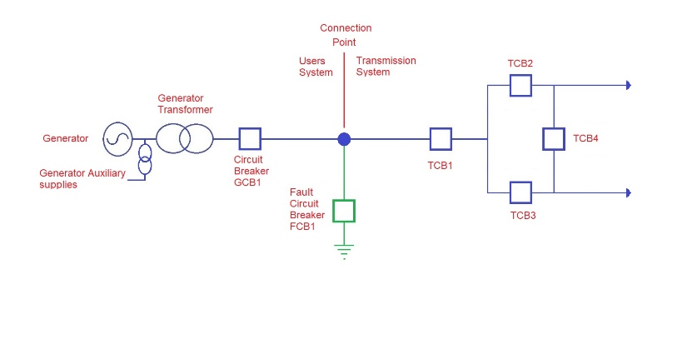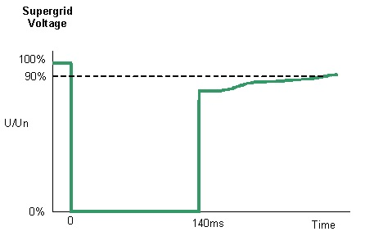

Figure 1 showing a theoretical worse case fault which plant has to be capable of riding though.

Operating Requirements During a Fault
The new section CC.6.3.15(a)(i)(b) should deal with the actions to be taken in the event that a fault occurs firstly by requiring that plants ride through faults in the transmission system which can be cleared but transmission system circuit breaker as shown in Figure 2 below and by adding the following text as the introduction to the section

(b) Each Generating Unit, DC Converter, or Power Park Module and any constituent Power Park Unit thereof and OTSDUW Plant and Apparatus shall remain transiently stable and connected to the System without tripping of any Generating Unit, DC Converter or Power Park Module and / or any constituent Power Park Unit, OTSDUW Plant and Apparatus, and for Plant and Apparatus installed on or after 1 December 2017, reactive compensation equipment, for any balanced and unbalanced fault where subjected to a voltage dip at the Connection Point where the voltage remains either on or within the envelope shown in figure CC.6.3.15(a)(i)(a) except where:

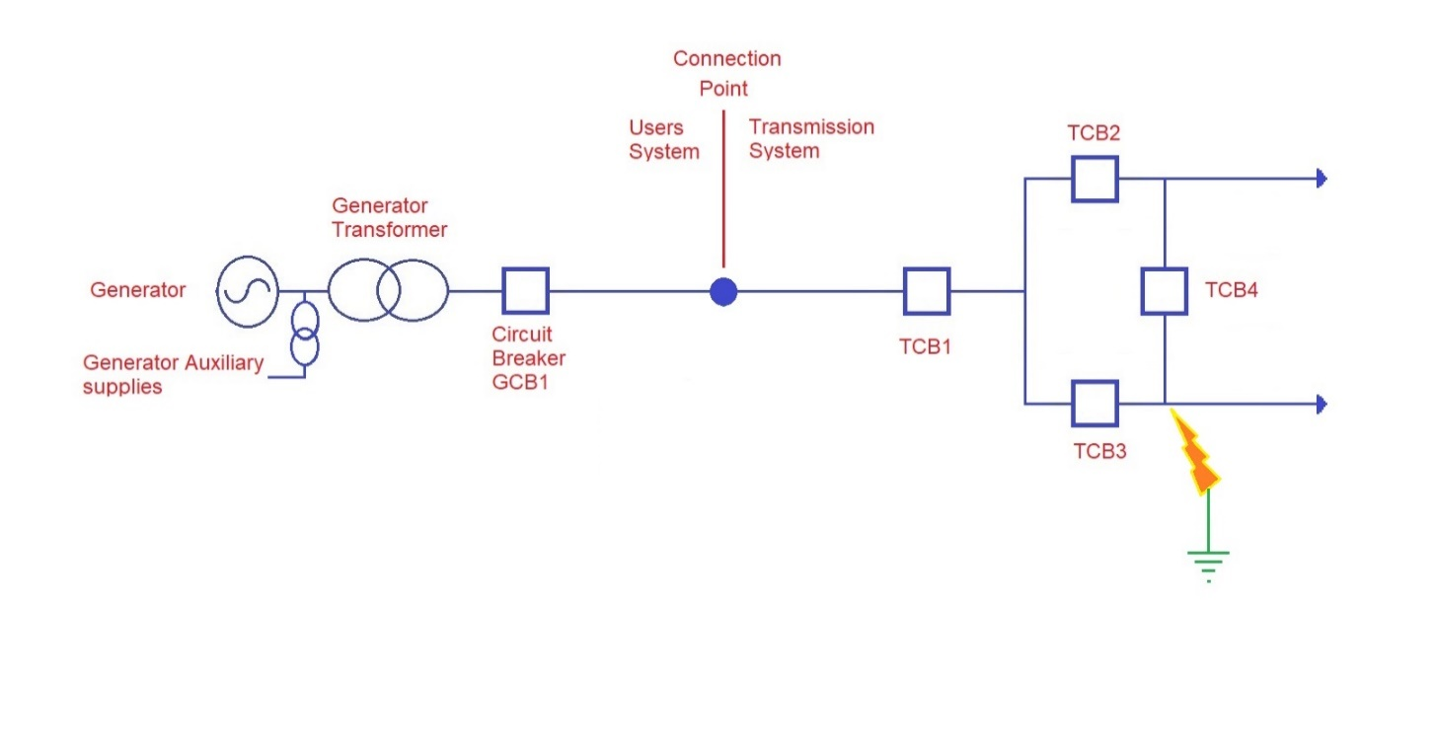
Figure 2 showing a fault which can be cleared by transmission system breakers TCB3 & 4

Whilst the introduction to this section deals with plants riding through faults as it is currently drafted in the Grid Code, it is not clear what is supposed to happen where the plant’s circuit breaker has to open to clear the fault. There are concerns that the current text could be interpreted that the plant has to remain connected feeding the fault for 140ms which could lead to dangerous situations. In discussion with the ESO it is quite clear that was not their expectation of what would happen, and that plant should trip in these circumstances. It is proposed that the following subclauses are added to clarify each situation where tripping is permitted.

Firstly if the fault is on the generators equipment then the generator shall be required to trip to clear the fault from the transmission system as detailed in the proposed new sections CC.6.3.15(a)(ii)(b)(i) and ECC.6.3.15.8(vi)(i), as follows:-

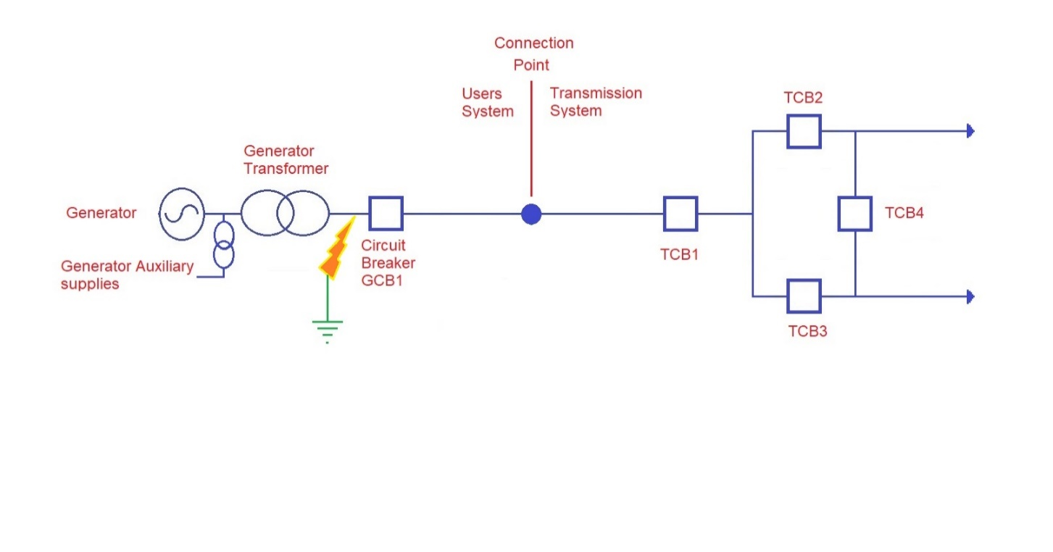
Figure 3 showing a fault which can only be cleared by generator breakers GCB1

the fault is on the User’s System, when the Generating Unit, DC Converter, or Power Park Module and any constituent Power Park Unit thereof and OTSDUW Plant and Apparatus shall trip to clear the fault from the Transmission System. The protection schemes and settings should not jeopardise Fault Ride Through performance as specified in CC.6.3.15.1

Secondly if the fault is at a location on the network that means that the fault can only be cleared by operation of both transmission and the generator circuit breaker as shown in Figure 4, again the generator will be permitted to trip to clear the fault as detailed in the proposed new section CC.6.3.15(a)(i)(b)(ii) and ECC.6.3.15.8(vi)(ii), as follows:-
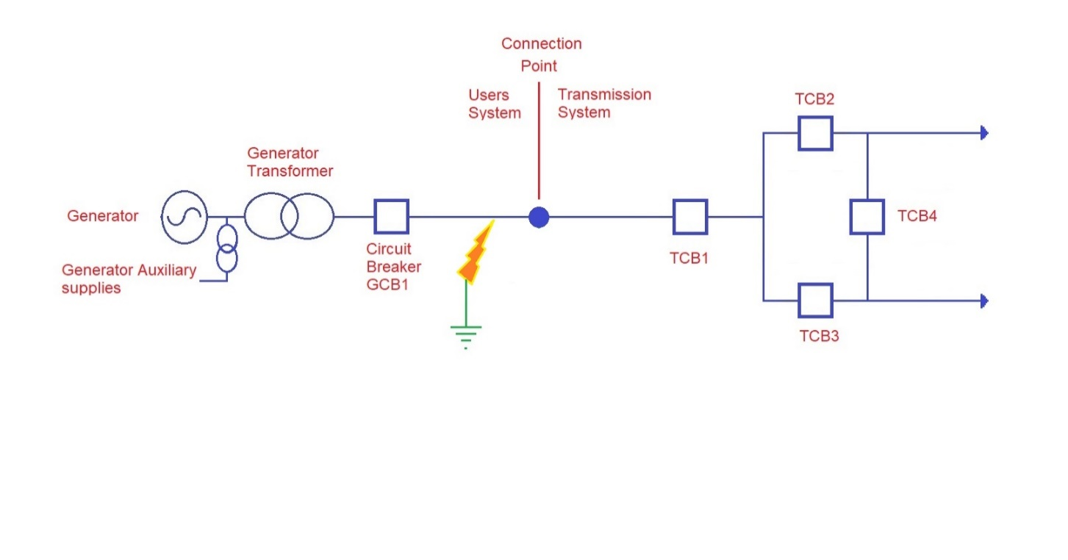

Figure 4 showing a fault which can only be cleared by generator breaker GCB1 & transmission circuit breaker TCB1

the location of the fault means it cannot be fully cleared without tripping the of Generating Unit, DC Converter, or Power Park Module and any constituent Power Park Unit thereof and OTSDUW Plant shall trip as required.

Thirdly if the fault is at a location on the network that means the generator will become islanded by the operation of the transmission circuit breakers as shown in Figure 5 as detailed in the proposed new sections CC.6.3.15(a)(ii)(b)(iii) and ECC.6.3.15.8(vi)(iii), as follows:-
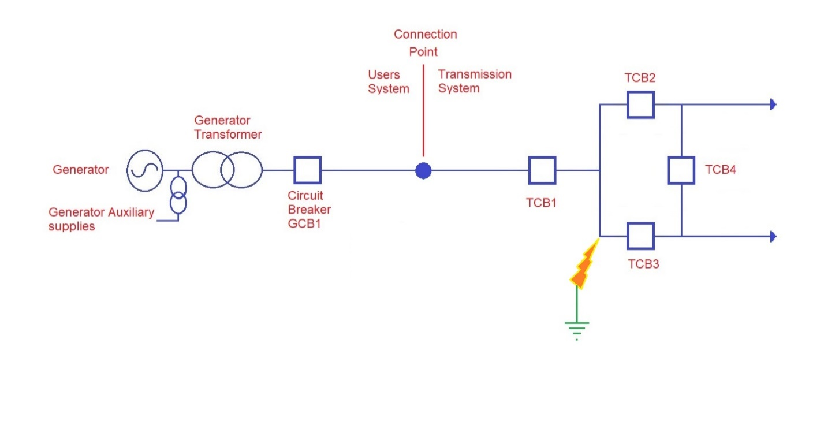

Figure 5 showing a fault which can be cleared by transmission breakers TCB1,2&3, however this results in the generator separated from the main transmission system and needs to be removed.

clearance of the fault results in the Generating Unit, DC Converter, or Power Park Module or OTSDUW Plant becoming islanded and disconnected from the Total System and not supplying Customers (where CC.6.3.7(c)(i) applies), then the Generating Unit, DC Converter, or OTSDUW Plants shall be permitted to trip as required.

Also if there were inter-trip, arrangements with the TO or ESO in relation to protection schemes or to prevent cascade overloading, etc then plants shall be required to trip as per these arrangements as detailed in the proposed new section CC.6.3.15(a)(i)(b)(iv & v) and ECC.6.3.15.8(vi)(iv & v), as follows:-

the Generating Unit, DC Converter, or Power Park Module and any constituent Power Park Unit thereof and OTSDUW Plant is part of combined protection scheme with the Transmission Operator, then the Generating Unit, DC Converter, or Power Park Module and any constituent Power Park Unit thereof and OTSDUW Plants shall be permitted to trip as required.
the Generating Unit, DC Converter, or Power Park Module and any constituent Power Park Unit thereof and OTSDUW Plant is part of and intertrip scheme which is switched into service and triggered, then the Generating Unit, DC Converter, or Power Park Module and any constituent Power Park Unit thereof and OTSDUW Plants shall be permitted to trip as required.
As previously described in this report, there is an issue relating to what plants are supposed to do in the event that during the fault clearance the voltage at the connection point exceeds the plants overvoltage protection settings. This section of the new text appears to be the correct place to propose the introduction of new legal text and as such the text below is proposed for section CC.6.3.15(i)(b)(vii) and ECC.6.3.15.8(vi)(vii), however the detailed discussion on overvoltage setting was in the previous section.

during the fault clearance the voltage exceeds, the Generating Unit, DC Converter, or Power Park Module and any constituent Power Park Unit, over-voltage protection setting when the Generating Unit, DC Converter, or Power Park Module and any constituent Power Park Unit thereof and OTSDUW Plants shall be permitted to trip as required.

There is a final section on Offshore transmission that already exists and has been moved as it related to operational actions and not a capability which is similar to the original text as detailed in section CC.6.3.15(a)(i)(b)(vi) and ECC.6.3.15.8(vi)(vi).

in the case of an Offshore Generating Unit, Offshore DC Converter or Offshore Power Park Module (including any Offshore Power Park Unit thereof) which is connected to an Offshore Transmission System which includes a Transmission DC Converter as part of that Offshore Transmission System, the Offshore Grid Entry Point voltage may not indicate the presence of a fault on the Onshore Transmission System. The fault will affect the level of Active Power that can be transferred to the Onshore Transmission System and therefore subject the Offshore Generating Unit, Offshore DC Converter or Offshore Power Park Module (including any Offshore Power Park Unit thereof) to a load rejection

Fault Current Injection
The area of the current (baseline) legal text which technically creates the biggest problem in relation to the ESO’s letter of the 7th May 2021 are in sections CC.6.3.15 (a)(ii) and ECC.6.3.15.9.2.1(a)(i) which currently state “for which the voltage at the Grid Entry Point (or Interface Point in the case of OTSDUW Plant and Apparatus) is outside the limits specified in CC.6.1.4, each Generating Unit or Power Park Module or OTSDUW Plant and Apparatus shall generate maximum reactive current “. If this requirement is drawn out on the figure 6 below where the current and voltage must always either be within the green shaded area or on the red line.

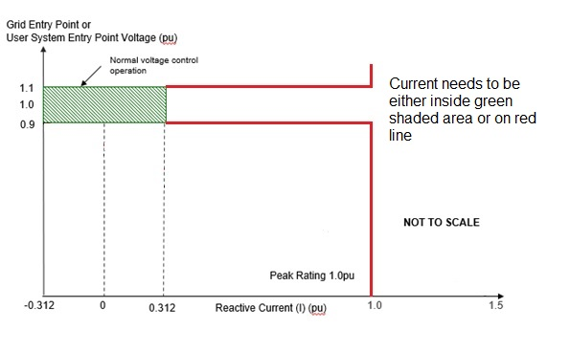
Figure 6 shows an interpretation of the existing legal text requiring the current to either be in the green box or on the red line.

This creates a particular problem in relation to the part of the letter which requires Parties to confirm compliance as the Grid Code particularly FRT sections, because as drafted very few plants (if any) actually do this and it has presumably drifted in as a drafting oversight relating to PPM requirements. This issue has previously been identified in the Workgroup GC0111 on Fast Fault Current injection and in the GC0137 VSM Workgroup and has been fixed for new PPMs, however currently all synchronous generator and older PPM will technically be non-compliant with this FRT requirement as drafted. This issue was dealt with in GC0111 by adding a new figure as shown in Figure 7 and changing the text as follows.

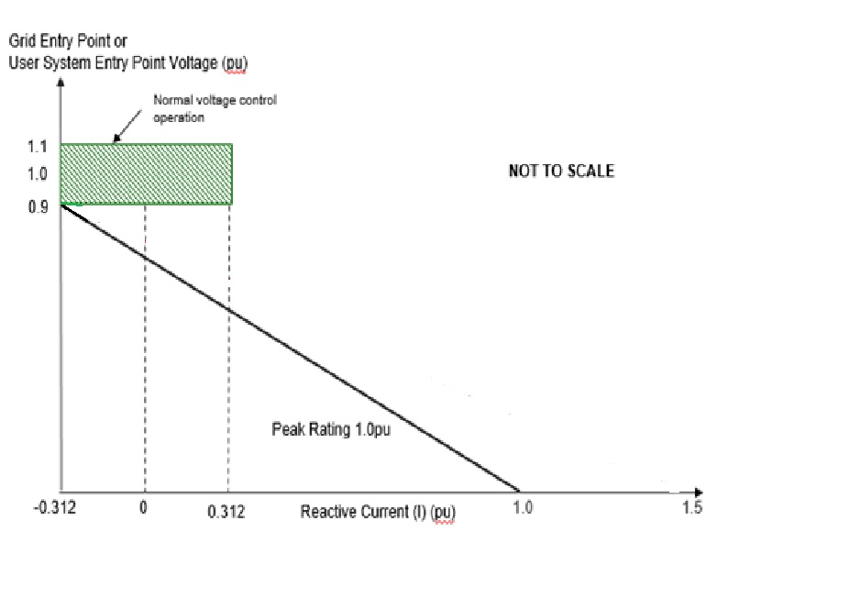
Figure 7 showing the proposed reactive current injection requirements, requiring the current to always remain above the black line

(iv) During the period of the fault as detailed in CC.6.3.15.1 (a) (i) for which the voltage at the Grid Entry Point (or Interface Point in the case of OTSDUW Plant and Apparatus) is outside the limits specified in CC.6.1.4, each Generating Unit or Power Park Module or OTSDUW Plant and Apparatus shall inject a reactive current above the heavy black line shown in Figure CC.6.3.15(b) without exceeding the transient rating limit of the Generating Unit, OTSDUW Plant and Apparatus or Power Park Module and / or any constituent Power Park Unit or reactive compensation equipment.

Active Power Requirements

The final area of concern relating to the existing (baseline) legal text is the minimum active Power requirement after the fault has cleared. Original as drafted the 2005 original as “(or within 0.5 seconds of restoration of the voltage at the User System Entry Point to 90% of nominal or greater if Embedded), Active Power output or in the case of OTSDUW Plant and Apparatus, Active Power transfer capability, shall be restored to the level available immediately before the fault”. Subsequently it has been realised that the real response is oscillatory and not very constant so a modification ^{[ref1]} has added the following words
“- the total Active Energy delivered during the period of the oscillations is at least that which would have been delivered if the Active Power was constant
- the oscillations are adequately damped of oscillations”

Whilst this works in principle at higher loads, it does create an issue at lower loads if at a real event for a unit operating as a synchronous condenser in figure 8.

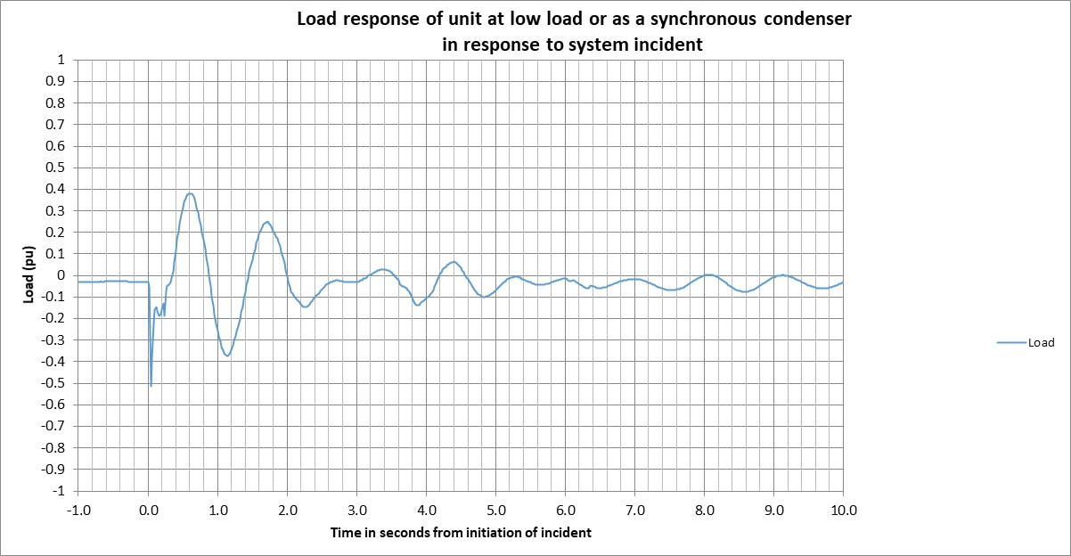
Figure 8 showing a typical active power response of a unit at low load to a fault

When considering that the initial load is 0.02 pu; 90% of this is a very small number. It could be argued that it is difficult to carry out a sensible compliance assessment at these levels and it is hence suggested that the tolerance should be changed to 10% of rated capacity as follows
“Active Power transfer capability, shall be restored to the level available immediately before the fault within plus or minus 10% of the Rated Capacity”

Implications/requirements for Network Operators
Workgroup members demanded that the ESO provide clarity to ensure that the same principles for failure of a fault ride through will be applied to National Grid Electricity Transmission plc (“NGET”) as per all other network operators. There needs to be consistency for Generators, OFTOs, and DNOs and onshore TSOs. In any decision not to return to service a transmission circuit following an unexplained fault involving a protection mal operation. It would be helpful if the workgroup could set out the implications for Distribution Owners so that that can be fully understood. Furthermore, the Workgroup generally expressed that the 2-day timescale to follow up the preliminary report with a full explanation is impracticable in most cases for Users. The 2-day timescale should be supplemented with ‘as soon as reasonably practicable’. Also, two (2) hours for a User to produce a preliminary report is insufficient time.
Currently it is uncertain what the obligation on Network operators is compared to other users.

Workgroup discussions on Drax’s strawman
There was a strawman presented by a workgroup member and this has now been further developed through the course of the workgroup meetings and superseded by WAGCM 2.

Lessons learned
Workgroup members agreed that there was merit in sharing lessons learned to avoid future issues. It was noted that if the ESO provides a report outlining what happened, how parties were affected and how the issue was rectified, this would be appropriate. A Workgroup member noted that obtaining information can sometimes be difficult as manufacturers tend to resolve issues with customers directly. The Proposer noted that there would be no need to request to share intellectual property but rather obtain publicly available information such as aircraft investigation reports or the lessons learned from 9 August system event (as, for example, was shared with the June 2020 GCRP meeting); the think was to share the broad lessons learnt so that collectively we can all learn from each other and thus better improve how we deal, as a community, with FRT events in the future.

ESO Sharing of information
- Infeed Loss Information
This was partly prompted by the 9th August 2019 investigation report which highlighted some interesting and useful lessons for other generators. It is no intention of the Proposer that industry share intellectually confidential information. Without sharing lessons learned it would be hard to build a resilient network and the same faults will be repeated. For example, some offshore wind farms that tripped in the last year where there were three individual connection points and the nature of the OFTO design was such that the same fault occurred at the same time on each of the BM use. There were no lessons learned shared following this occurrence despite requests made by the Proposer from ESO. that event despite requests. As a result, industry is not any more informed with regards to what happened in that event and how it could have been prevented for other parties.

The Proposer confirmed that what is required to be shared is up to the agreement between the concerned party and the ESO about what is relevant in context.

- Fault information with or without identified FRT issues
Workgroup members unanimously agreed that the ESO should share information on faults. An obligation should be placed on Transmission Owners to provide this information to the ESO where the information is available to them.

Fault Data – Voltage waveform
The grid code defines RFT requirements in terms of the voltage at the GSP as a function of time. Currently no instrumentation is mandated to record voltage waveforms at all GSP. This makes investigating potential noncompliance with FRT requirements difficult as there is no reliable data source directly corelated with the grid code FRT requirements.

Other sources of data must be used to infer what voltage waveform is likely to have been present at the GSP during a fault and therefore if the User connected to the GSP should have ridden through the fault. Transmission and distribution operators record data at a range of locations on the grid. These however will often at a significant distance from GSP and will not fully represent the voltage at the GSP. Also, this data is currently not available to Users. Some, but not all, Users are required to have recording equipment on site, however this may be behind various equipment, for example a transformer, rather than directly at the GSP. So, it will not accurately reflect the voltage waveform at the GSP.

Open Data
The Workgroup support greater visibility of system performance information. The Proposer noted that with the original, where an asset was believed to have had a co-incident trip/de-load that they should receive information from the ESO, in a timely manner, of the voltage waveform data from the FRT monitor equipment closes to that asset whilst other users would receive the voltage waveform data from the FRT monitor equipment closes to the fault itself. The Workgroup noted that the provision of this open data will help Generators, Interconnectors and Network Operators to act more proactively. Developers of equipment and academic research will benefit from this open data as well. A Workgroup member raised the need for clarity on whether there will be a required retention policy and what that will look like. The Proposer noted that with the original there would also be an obligation on the ESO to publish historical data associated with FRT events. The Proposer suggested this could go back five or ten years and that allowing the ESO a reasonable period (90 days was suggested) to publish this voltage waveform data; from the FRT monitor equipment closes to the fault itself; would be appropriate.

Interaction with Derogation process
A Workgroup member highlighted at the third Workgroup meeting a possible interaction between the proposed original solution and the existing Grid Code derogation proves. The Proposer and the Workgroup member discussed this off-line and reported back to the Workgroup. Some views on this were that assessment should be done on a site by site basis since derogation applications are assessed on a site by site basis; operation whilst in application for a derogation is per the existing CP, that operation should be accordance with the prevailing LON. A contrasting opinion is that if a derogation was granted then a factor in the decision would be to consider how the non-compliance would be resolved and what the consequence would be in advance of this.

Workgroup consultation summary
The Workgroup held the Workgroup Consultation between 13 July and 16 August 2021 and received 17 responses including 1 confidential response which has been anonymised with the approval of the respondent to be shared with the Workgroup. A summary and the full detail of the responses can be found in the Annexes.

Overall – Majority of Workgroup Members affirmed that the original proposal better facilitates the Applicable Grid Code objectives however there were split responses to the proposed implementation approach with about a third of the respondents having no comment. Some key points and aspects of the proposed changes are summarised below:
- There was a popular view that the same operational restrictions should be applied to all Network operators i.e. NGET should be subject to the same restrictions. Also, workgroup members agreed with a respondent’s suggestion that additional modelling by the ESO that would provide a risk based assessment given prevailing conditions at the time and the “strength” of a particular part of the network will be useful in identifying constraint volume.
- Most respondents disagreed with the proposed ESO’s ability to constrain a User over suspected of non FRT compliance. Respondents that agreed to such a constraint by the ESO did so with a caveat that if the ESO must do so they must hold sufficient evidence and where a User is proven innocent and had turned off at the ESO’s request, the User must be duly compensated. The SQSS covers aspects of how the ESO should manage constraints in situations but it does not explicitly cover FRT failures. Hence SQSS Panel should be notified to consider examining FRT issues.
- With regards to whether the methodology should apply differently to projects in receipt of an ION or a FON, majority of Workgroup members were not in support. The ESO would make no distinction between plant suspected of failing to ride through a fault dependent on their ION/FON status claiming that the suspected failure will have the same system impact. Most Workgroup members disagreed with this ION/FON and that the treatment of some Users is different because HVDC and interconnectors have different licence requirements. The Proposer agreed to treat FON and ION the same and supported amending the legal text to add "network operator" where "User" is stated in relation to FRT.
- Largest Infeed Loss information is already published via the ESO data portal and should continue to be published in the most easily accessible and user-friendly format. The ESO has no objection to this requirement being codified. Voltage Wave Form will be best presented in most basic format Excel/csv and shared via the ESO data portal. Noting that this is the only format the ESO currently accept. Also, this is cost effective for Users as they will not need to use a costly proprietary software to access the data. There was a popular view that codifying the required format will be limiting although a respondent expressed that it should be clearly stated either in the Grid Code, or in a separate Guidance Note on Voltage wave form data as high resolution milliseconds data prior to, and directly after fault
- For security reasons there was an agreement that commercially sensitive information or any other sensitive personal data should not be disclosed in the lessons learnt report. The onus to ensure that any manufacturer details that could cause breach of confidentiality needs to be removed by the party sharing information. The ESO will not carry this responsibility. All respondents agreed that ESO should share information on faults. The ESO also is in support as set out in their tabled Alternative
- Generators operational history may be considered when deciding the constraint level however some respondents expressed that other factors such as root cause of incident, plant details etc. should also be considered along with this, history should not be the only deciding factor.

Workgroup Alternatives
Following review of the Workgroup Consultation responses, the Workgroup assessed the Original and the potential solutions they had previously identified. Further potential solutions were brought forward by the Workgroup in line with the themes previously identified.

In total, 4 alternative solutions were put forward to be voted on, and 4 of these became Workgroup Alternative Grid Code Modifications (WAGCM) to be taken forwards by the Workgroup.

The WAGCM forms can be found in Annex 12. The WAGCMs are outlined below

-WAGCM 1 - This alternative submitted by the ESO differs from the original in the process described following a suspected FRT failure. It maintains the right of the ESO to manage the system by seeking to agree immediate restrictions with users and hence in the ESO’s view allows a better and more immediate management of system risk and compliance.

-WAGCM 2 - This proposed alternative solution clarifies the existing current fault ride text in the Grid Code and removes various discrepancies in the legal text which Generators cannot achieve as required in item ‘j’ of the workgroup’s terms of reference. If these issues are not fixed then either the Original Proposal or ESO Alternative were to be introduced then technically Users would have to take action as there are currently non-compliances which could result in users being constrained. Originally both the Proposer of the Original and ESO were going to include this in their proposals, however this would prevent these clarifications and corrections from being introduced if the final chosen route was the Baseline and this Alternative has been raised to allow that option also there are 2 other alternatives to give all options.
This proposal clarifies and corrects various existing grid code issues relating to FRT which will benefit the various other Proposal by removing other issues which are likely to be caught up in the other proposals.

-WAGCM 3 - This proposed alternative solution combines the legal text changes of the Original and WAGCM2 (Drax stand-alone alternative).

-WAGCM 4 - This proposed alternative solution combines the legal text changes of the WAGCM1 (ESO Alternative) and WAGCM2 (Drax stand-alone alternative).

Other discussion points in relation to ESO Alternative WAGCM 1
The ESO responded to queries from a workgroup member in relation to their Legal Text (with some parts highlighted) as shown below:
- How does the 2 hours interacts with OC10. The process (below OC10.4.1.4 ) is how we expect to respond to a notice under OC10 so after 2 hours we can submit a preliminary report that can be followed up as soon as is reasonably practical with our engineering report and meets the requirement. With agreement with ESO we can delay the primary repots beyond the 2 hours. Is this the process that you are trying to capture here?

ESO Response:
The ESO recognise that there may need to be some flexibility here hence the scope for longer timescales to be agreed, although the vast majority of potential FRT issues are more likely to be easily resolved. Please note also that in effect Users are self-certifying for compliance with FRT prior to their reconnection. When contacted, Users should self-certify if they found no evidence of FRT shortcomings in their part or re-demonstrate compliance if there are issues found and corrected e.g. plant setting changes.

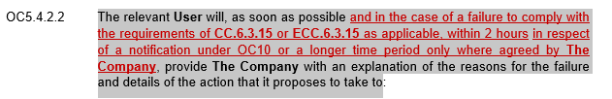

OC10.4.1.4
Timing A full written report under OC10.4.1 must, if possible, be received by The Company or the User, as the case may be, within 2 hours of The Company or the User, as the case may be, receiving oral notification under OC7. If this is not possible, the User or The Company, as the case may be, shall, within this period, submit a preliminary report setting out, as a minimum, those matters specified in the Appendix to OC10. As soon as reasonably practical thereafter, the User or The Company, as the case may be, shall submit a full written report containing the information set out in OC10.4.1.3.

- Once we are notified of a possible issue any restriction the ESO may wish to impose needs to be agreed with the User if there is no agreement then the user can continue to operates as normal and there is no obligation on the user to agree to any such restrictions as it continues to investigate the issue. The user may not be comfortable agree to any restriction during its investigation.
ESO Response:
Any restrictions are to be agreed. Where either party with-holds agreement this could, as is always the case, be escalated to the regulator. The decision to reconnect is however one for the User to make where they are confident that they can confirm Grid Code compliance.

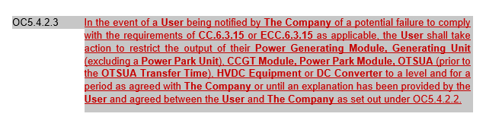
- How does this work? LON need to be agreed with the user and cannot be issued unilaterally where does the agreement phase take place? Presumably the user is the only party that can confirm it has failed to comply so LON can’t be issue until this has taken place i.e. after the user final report under OC10.

If the User is unable to self-certify with respect to FRT capability following a suspected failure and is therefore assumed to be non-compliant then as in the proposed OC5.4.2.6 the ESO would issue a LON as soon as possible, that is, if there is an issue found and need to be corrected.

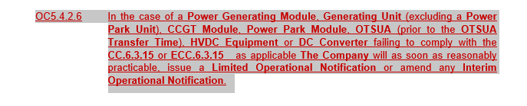

Legal text
At the third Workgroup meeting the Proposer went through a draft of the proposed Business Rules for the original (upon which the Legal Text will then be based) and this can be found in Annex 8. In addition, the legal text for the Original and the WAGCMs has been developed by the ESO in conjunction with the Proposer and other Workgroup members. These can be found in Annex 13 of this report.

What is the impact of this change?

Proposer’s assessment against Code Objectives
The Proposer has provided their views on the assessment of this Modification against the applicable Grid Code Objectives as shown in the table below:

Proposer’s assessment against Grid Code Objectives
Relevant Objective | Identified impact
(a) To permit the development, maintenance and operation of an efficient, coordinated and economical system for the transmission of electricity | Positive  Takes a risk-based approach to managing the cost of constraints from potential FRT non-compliance.  Minimises risk of unnecessary constraints being applied to Users or Network Operator that could otherwise lead to higher costs to the end consumers.
(b) Facilitating effective competition in the generation and supply of electricity (and without limiting the foregoing, to facilitate the national electricity transmission system being made available to persons authorised to supply or generate electricity on terms which neither prevent nor restrict competition in the supply or generation of electricity); | Neutral  No impact
(c) Subject to sub-paragraphs (i) and (ii), to promote the security and efficiency of the electricity generation, transmission and distribution systems in the national electricity transmission system operator area taken as a whole; | Positive  Places a time-limitation on Users and Network Operators to quickly correct FRT compliance issues.
(d) To efficiently discharge the obligations imposed upon the licensee by this license and to comply with the Electricity Regulation and any relevant legally binding decisions of the European Commission and/or the Agency; and | Positive  Clarifies the action expected by a User in the event their station or Interconnector trips or de-loads coincident with a fault so they can fulfil their REMIT obligations
(e) To promote efficiency in the implementation and administration of the Grid Code arrangements | Neutral  No impact.

Workgroup Vote

The workgroup met on 27 August 2021 to agree that the Terms of Reference had been met and conduct the workgroup vote.

The full vote can be found in Annex 14.

GC0151 - Assessment of the Original and WAGCM1 to WAGCM4 vs Baseline
The Workgroup concluded by split vote that the Original, WAGCM1 and WAGCM3 better facilitated the Applicable Objectives than the Baseline.

11 Workgroup Members were eligible and present at the workgroup meeting to conduct the vote.

Option | Number of voters that voted this option is best
Original | 3
WAGCM1 | 3
WAGCM2 | 0
WAGCM3 | 3
WAGCM4 | 1
Baseline | 1

When will this change take place?

Implementation date
Within one Working Day of an Authority decision.

Date decision required by
In light of the ESO’s statement in its 7th May 2021 letter, a decision is required as soon as reasonably practicable.

Implementation approach
Changes to systems and processes are expected to be required as clarified; by the Workgroup and in the Business Rules; in due course based on the broad outline of the solution.

Interactions
☐CUSC | ☐BSC | ☐STC | ☐SQSS
☐European Network Codes | ☐ EBGL Article 18 T&Cs | ☐Other modifications | ☒Other
There is an interaction with REMIT.

Acronyms, key terms and reference material
Acronym / key term | Meaning
AC | Alternating Current
BCA | Bilateral Connection Agreement
BSC | Balancing and Settlement Code
BSUOS | Balancing Services Use of System
CfD | Contracts for Difference
CMP | CUSC Modification Proposal
CUSC | Connection and Use of System Code
DC | Direct Current
EBGL | Electricity Balancing Guideline
ECC | European Connection Conditions
ESO | Electricity System Operator
EU | European Union
FON | Final Operational Notification
FRT | Fault Ride Through
GB | Great Britain
GCRP | Grid Code Review Panel
HVDC | High Voltage Direct Current
ION | Interim Operational Notification
LON | Limited Operational Notification
MEL | Maximum Export Limit
MW | Mega Watt
NETS | National Electricity Transmission System
NGESO | National Grid Electricity System Operator
OTSDUW | Offshore Transmission System Development User Works
PPM | Power Park Module
PU | Per Unit
SCADA | Supervisory Control and Data Acquisition
SIR | System Incidence Report
STC | System Operator Transmission Owner Code
SQSS | Security and Quality of Supply Standards
TCB | Transmission Circuit Breaker
TEC | Transmission Entry Capacity
TO | Transmission Owner
T&Cs | Terms and Conditions
VSM | Virtual Synchronous Machine

Reference material

Ref 1 – Decision and direction in relation to consultations H/04, “Grid Code Changes to Incorporate New Generation Technologies and DC Inter-connector (Generic Provisions)” and SA/2004, “Consultation on Technical Requirements for Windfarms”

https://www.ofgem.gov.uk/sites/default/files/docs/2005/05/10870-binder1.pdf

Ref 2 – Consultation on Technical Requirements for Windfarms The Authority's Minded To decision letter and Impact Assessment relating to the Scottish transmission licensees SA/2004 Report to the Authority
https://www.ofgem.gov.uk/sites/default/files/docs/2005/01/9348-0805.pdf

Ref 3 – Grid Code Modification H/04 & SA/2004 Response to OFGEM’s consultations 07/05 & 08/05

https://www.ofgem.gov.uk/sites/default/files/docs/2005/05/10873-14205b.pdf

- NGESO’s letter of 7th May 2021 “Grid Code Compliance with Fault Ride Through Requirements”

- NGESO’s presentation to June 2021 Grid Code Review Panel meeting “Unexpected Generation Failure Management”

Ref 4 – Loss of Mains Protection Scheme
Non-domestic distributed generators to apply to the Accelerated Loss of Mains Change Programme (known as ALoMCP) to claim potentially thousands of pounds to make mandatory Loss of Mains protection changes.

https://www.nationalgrideso.com/industry-information/accelerated-loss-mains-change-programme-alomcp

Ref 5 - DCRP/21/05/PC - Distribution Code Compliance
Link: http://www.dcode.org.uk/consultations/open-consultations/.

Annexes
Annex | Information
Annex 1 | Proposal form
Annex 2 | Terms of reference
Annex 3a | Urgency Letter to Ofgem
Annex 3b | Urgency Letter to Ofgem – Revised Timetable
Annex 4 | Proposer Presentation
Annex 5 | ESO Presentation
Annex 6 | FRT – Draft Business Rules
Annex 7 | Continental Split v2
Annex 8 | Fault Ride Through Strawman Legal Text
Annex 9 | ESO Draft Alternative
Annex 10 | Workgroup Consultant Responses
Annex 11 | Workgroup Consultation Response Summary
Annex 12 | WAGCM Forms (Alternatives)
Annex 13 | Legal Text
Annex 14 | Full Workgroup Vote Form

The ESO’s 7th May 2021 letter and the 24th June 2021 GCRP presentation strongly infers that the ESO expects and requires Users (and Network Operators) to comply with the ESO’s proposed interim process. This infers a ‘voluntary’ in name only approach for stakeholders – you are damned if you do (to suffer legal compliance and commercial impacts) and damned if you don’t (to be vilified by the ESO - and possibly BEIS and Ofgem? - for not having followed the interim process).
As noted in the 24th June 2021 GCRP presentation and elaborated in items 3 and 4 of Appendix 1 in the 7th May 2021 ESO letter [3] “If this cannot be confirmed, the relevant Generator, HVDC System and Network asset(s) should remain out of operation.” [emphasis added]” [4] “If there is a potential compliance issue, the ESO expectation is that the Generator, HVDC System, Network asset(s) should remain out of operation until a resolution is in place.” [emphasis added]
It is not clear here to what the ESO is referring: ‘safe’ for the system only? ‘safe’ for the User(s) only? ‘safe’ for both the system and the User(s)?
As per the first bullet point on slide 3 of the ESO’s June GCRP presentation “Users are asked to restrict their output until a FRT issue is ruled out (either MEL to zero or to a safe level)” [emphasis added]
Further details on REMIT can be found on the Ofgem website at: https://www.ofgem.gov.uk/energy-policy-and-regulation/policy-and-regulatory-programmes/remit-and-wholesale-market-integrity?sort=publication_date
https://extranet.acer.europa.eu/en/remit/Documents/5th-Edition-ACER-Guidance-updated.pdf
Footnote 34 “For example, producer or storage asset owners.”
Footnote 35 “For example, there are different timeframes and types of market places to be taken into account.”
Footnote 36 “E.g., and not limited to, setting prices at an artificial level”
Footnote 37 “For example, but not limited to, being a ‘pivotal supplier’ i.e., a power supplier whose capacity must be used to meet peak demand and whose capacity exceeds the market’s supply margin.”
Footnote 38 “For instance, in situation of force majeure or localised transmission constraints. The validity of reasons for unavailability of a power plant could be assessed against the ‘would be’ behaviour of a competitive market participant.”
Footnote 39 “I.e. opportunity costs. Opportunity costs represent the expected value of the most valuable choice that was not taken. In wholesale electricity markets, this can, for example, represent producing at a different point in time for energy-limited generation assets, e.g. reservoir hydropower units, or producing in a different sequential market for capacity-limited generation assets.”
Footnote 40 “ACER is committed to provide further clarifying guidance with respect to justifications mentioned in Section 6.4.1.(i)”
“If this cannot be confirmed, the relevant Generator, HVDC System and Network asset(s) should remain out of operation.” [emphasis added]
“If there is a potential compliance issue, the ESO expectation is that the Generator, HVDC System, Network asset(s) should remain out of operation until a resolution is in place.” [emphasis added]
And its ECC equivalent.
“For any SIR request, in line with Grid Code OC10.4.1.4 and STCP 03-1 Section 3.2.9, the User will have 2 hours to respond and Network Operators must respond as soon as reasonably practicable with a preliminary report into the loss of output. ”
Further details on the two 2003 incidents can be found in the Ofgem report https://www.ofgem.gov.uk/ofgem-publications/37681/sectoralinvestigations-36.pdf
https://www.nationalgrideso.com/document/169821/download
OC3.4.1 (c): “The Company shall prepare and submit to the Grid Code Review Panel monthly a report titled the System Incidents Report, which shall contain” … “An outline of progress towards reporting events and associated data on the National Electricity Transmission System including: (i) three phase faults; (ii) three phase to earth faults; phase to phase faults; (iv) phase to earth faults; (v) the associated voltage dips – durations and spreads; over-voltages; (vii) under-voltages; (viii) voltage dips of >50%; and (ix) lightning strikes.”
Further details on Ofgem’s consultation can be found at:https://www.ofgem.gov.uk/publications-and-updates/consultation-data-best-practice-guidance-and-digitalisation-strategy-and-action-plan-guidance
During the Workgroup deliberations it came to light that the Largest Infeed Loss information is publicly available and it was noted by the Proposer and the Workgroup
This could, for example, be a power station or an interconnector in the form of plant and / or apparatus.
As well as by reference to the time permitted following the 9th August 2019 event.
DCRP/21/05/PC Distribution Code Compliance
This can be found on page 18 of the ‘Compliance Process’ section of the Grid Code at: https://www.nationalgrideso.com/document/33916/download
https://www.nationalgrideso.com/industry-information/codes/grid-code-old/meetings/grid-code-panel-meeting-25-june-2020
“An inability of generation, interconnector or Other transmission connected plant and apparatus being able to ride through ‘normal’ faults on the NETS is a situation that we cannot tolerate and is a serious risk that we need to manage quickly and effectively.” [emphasis added]
If your modification amends any of the clauses mapped out in Annex GR.B of the Governance Rules section of the Grid Code, it will change the Terms & Conditions relating to Balancing Service Providers. The modification will need to follow the process set out in Article 18 of the European Electricity Balancing Guideline (EBGL – EU Regulation 2017/2195). All Grid Code modifications must be consulted on for 1 month in the Code Administrator Consultation phase, unless they are Urgent modifications which have no impact on EBGL Article 18 T&Cs. N.B. This will also satisfy the requirements of the NCER process.

