Draft Grid Code – Grid Forming Converter Specification
21st December 2020
Key – Black Text – Original Grid Code
Red Underlined Text – New requirements introduced for GC0137

Grid Forming Capability | Is a Power Generating Module, HVDC System, Generating Unit, Power Park Module, DC Converter, OTSDUW Plant and Apparatus, Electricity Storage Module or Dynamic Reactive Compensation Equipment whose Active Power output is directly proportional to the magnitude and phase of its Internal Voltage Source, the magnitude and phase of the voltage at the Grid Entry Point or User System Entry Point and the sine of the Load Angle without any control actions occurring in the associated control system. As a consequence, a Plant which has a Grid Forming Capability is one where the frequency of rotation of the Internal Voltage Source is the same as the System Frequency for normal operation, with only the Load Angle defining the relative position between the two.  The associated control system can vary the magnitude of the Control Based Real Power and Control Based Reactive Power supplied at the Grid Entry Point or User System Entry Point either to add damping or to respond to defined external control requirements, however these Control Based changes can only happen slowly with a bandwidth below 5 Hz.
Grid Forming Plant | A Power Generating Module, HVDC System, Generating Unit, Power Park Module, DC Converter, OTSDUW Plant and Apparatus, Electricity Storage Module or Dynamic Reactive Compensation Equipment which have a Grid Forming Capability.
Grid Forming Electronic Power Converter | A Grid Forming Plant whose output is derived from a static solid state electronic power converter.
Grid Forming Unit | A Power Park Unit or Electricity Storage Unit with a Grid Forming Capability or a Synchronous Power Generating Unit. with a Grid Forming Capability
Fast Fault Current Injection | The ability of a Grid Forming Plant to supply reactive current, that starts to rise in less than 5 ms, into the Total System when the voltage falls below 90% of its nominal value.
Inertia Active Power | The transfer of Active Power injected or absorbed by a Grid Forming Plant to and from the Total System during a System Frequency change.  Since the frequency of rotation of the Internal Voltage Source of a Grid Forming Plant is the same as the System Frequency for normal operation, the Active Power supplied or absorbed by the Grid Forming Plant is a function of the energy storage capability of the Internal Voltage Source. For the avoidance of doubt, this includes the rotational inertial energy of the complete drive train of a Synchronous Generating Unit.  For the avoidance of doubt, Inertia Active Power is an inherent capability of a Grid Forming Plant to respond naturally, within less than 5 ms, to System Phase and Frequency changes without any supplementary control and is automatically produced when there is a difference between the generated Power and supplied Load at a magnitude that varies with the resulting rate of change of frequency up to at least 1 Hz/s
Internal Voltage Source | For a Grid Forming Synchronous Generating Unit a real magnetic field, that rotates synchronously with the System Frequency under normal operating conditions, which induces an Internal Voltage Source in the stationary generator winding that has a real impedance.  For a Grid Forming Electronic Power Converter it uses switched power electronic devices to produce a real voltage waveform, with harmonics, that has a fundamental component that rotates synchronously with the System Frequency under normal operating conditions to produce the real Internal Voltage Source that is connected to a one or more real impedances.
Load Angle | The angle in radians between the voltage of the Internal Voltage Source and the voltage at the Grid Entry Point or User System Entry Point.
Non-CUSC Party | A Party who does not accede to the Connection and Use of System Code (CUSC).
Damping Active Power | The Active Power naturally supplied by a Grid Forming Plant as a result of oscillations in the Total System. More specifically, Damping Active Power is the result of an oscillation between the voltage at the terminals of a Grid Forming Unit and the voltage of the Internal Voltage Source of the Grid Forming Unit.  For the avoidance of doubt, Damping Active Power is an inherent capability of a Grid Forming Plant that starts to respond naturally, within less than 5 ms.  The Damping Active Power has three components that are detailed in ECC.6.3.19.3 (vi)
Peak Current Rating | The larger of either the:-  Maximum current to supply the Inertia Active Power plus the Damping Active Power; or  The maximum current to supply the maximum Phase Jump Angle power.
Phase Jump Active Power | The transient Active Power transferred from a Grid Forming Plant to the Total System as a result of a step change in the phase angle between the Internal Voltage Source of the Grid Forming Plant and phase angle at the Grid Entry Point or User System Entry Point.  In the event of a disturbance or fault on the Total System, a Grid Forming Plant will instantaneously supply Phase Jump Active Power to the Total System as a result of the phase angle change.  For the avoidance of doubt, Phase Jump Active Power is an inherent capability of a Grid Forming Plant that starts to respond naturally, within less than 5 ms.
Control Based Real Power | Control Based Real Power output supplied by a Grid Forming Plant through controlled means (be it manual or automatic)
Control Based Reactive Power | Control Based Reactive Power output supplied by a Grid Forming Plant through controlled means (be it manual or automatic)
Voltage Jump Reactive Power | The transient Reactive Power transferred from a Grid Forming Plant to the Total System as a result of a step change of the difference in voltage magnitude between the Internal Voltage Source of the Grid Forming Plant and phase angle at the Grid Entry Point or User System Entry Point.  In the event of a voltage magnitude change at the Grid Entry Point or User System Entry Point, a Grid Forming Plant will instantaneously supply Voltage Jump Reactive Power to the Total System as a result of the voltage magnitude change.
Dynamic Reactive Compensation Equipment | Plant capable of supplying or absorbing Reactive Power in a controlled manner which could include but not limited to a Synchronous Compensator, Static Var Compensator (SVC), or STATCOM.
Network Frequency Perturbation Plot | A form of Bode Plot which plots the amplitude (%) of the output oscillation and Phase (degrees) to the frequency of an applied input oscillation. The purpose of which is to assess the capability and performance of a Grid Forming Plant and to ensure it does not pose a risk to other Plant and Apparatus connected to the Total System.  The input is oscillations in the System’s Frequency and the output can either be oscillations in the System’s power or oscillations in the Internal Voltage Source.
Electronic Power Converter | An electronic power converter which uses switched solid state power electronic devices to produce a real voltage waveform, with harmonics, that has a fundamental component that rotates to produce the real Internal Voltage Source.
Control Based | Control Based are changes in the System’s Real Power or Reactive Power produced by the control system of a Grid Forming Unit that occur due to changes in the Grid Forming Plant or as a result of change in a parameter at the Grid Entry Point or User System Entry Point (if Embedded) connected to the control system. These Control based changes have a bandwidth limited to 5 Hz.

…………..
Extracts from the Connection Conditions
…………………
CC.6.3.5 It is an essential requirement that the National Electricity Transmission System must incorporate a Black Start Capability. This will be achieved by agreeing a Black Start Capability with a number of strategically located Black Start Service Providers. For each Black Start Service Provider The Company will state in the Bilateral Agreement whether or not a Black Start Capability is required. For the avoidance of doubt, a Plant with a Black Start Capability would be required to have a Grid Forming Capability in accordance with the requirements of ECC.6.3.19

Extracts from the European Connection Conditions
………………….
ECC.6.3.5.3 Where an EU Code User has entered into a Black Start Contract to provide a Black Start Capability in respect of a Type C Power Generating Module or Type D Power Generating Module (including DC Connected Power Park Modules) the following requirements shall apply.
- The Power-Generating Module or DC Connected Power Park Module shall be capable of starting from shutdown without any external electrical energy supply within a time frame specified by The Company in the Black Start Contract.
- Each Power Generating Module or DC Connected Power Park Module shall be able to synchronise within the frequency limits defined in ECC.6.1.2 and, where applicable, voltage limits specified in ECC.6.1.4;
- The Power Generating Module or DC Connected Power Park Module shall be capable of connecting on to an unenergised System.
- The Power-Generating Module or DC Connected Power Park Module shall be capable of automatically regulating dips in voltage caused by connection of demand;
- The Power Generating Module or DC Connected Power Park Module shall:
be capable of Block Load Capability,
be capable of operating in LFSM-O and LFSM-U, as specified in ECC.6.3.7.1 and ECC.6.3.7.2
control Frequency in case of overfrequency and underfrequency within the whole Active Power output range between the Minimum Regulating Level and Maximum Capacity as well as at houseload operation levels
be capable of parallel operation of a few Power Generating Modules including DC Connected Power Park Modules within an isolated part of the Total System that is still supplying Customers, and control voltage automatically during the system restoration phase
capable of satisfying the Grid Forming Capability requirements defined in ECC.6.3.19;
………………………………..

ECC.6.3.16 FAST FAULT CURRENT INJECTION

ECC.6.3.16.1 General Fast Fault Current injection, principles and concepts applicable to Type B, Type C and Type D Power Park Modules and HVDC Equipment

ECC.6.3.16.1.1 In addition to the requirements of ECC.6.1.4, ECC.6.3.2, ECC.6.3.8 and ECC.A.7, each Type B, Type C and Type D Power Park Module or each Power Park Unit within a Type B, Type C and Type D Power Park Module or HVDC Equipment shall be required to satisfy the following requirements. For the purposes of this requirement, current and voltage are assumed to be positive phase sequence values. For the avoidance of doubt, any Type B, Type C and Type D Power Park Module or HVDC Equipment which has a Grid Forming Capability need only satisfy the requirements of ECC.6.3.19 and the requirements of ECC.6.3.16 shall not apply.
………………………………..

ECC.6.3.19 GRID FORMING CAPABILITY FOR GREAT BRITAIN (GFC-GB)

ECC.6.3.19.1 In order for the National Electricity Transmission System to satisfy the stability requirements defined in the National Electricity Transmission System Security and Quality of Supply Standards, it is an essential requirement that an appropriate volume of Grid Forming Plant is available and capable of providing a Grid Forming Capability.
ECC.6.3.19.2 Grid Forming Capability is not a mandatory requirement but one which will be delivered through market arrangements, the details of which shall be published on The Company’s Website. Grid Forming Capability can be implemented by any technology including Electronic Power Converters and rotating synchronous machines or a combination of the two.
ECC.6.3.19.3 As noted in ECC.6.3.19.2, Grid Forming Capability is not a mandatory requirement, however where a User (be they a GB Code User or EU Code User) or Non-CUSC Party wishes to offer a Grid Forming Capability, then they will be required to ensure their Grid Forming Plant meets the following requirements.

- The Grid Forming Plant must fully comply with the applicable requirements of the Grid Code including but not limited to the Planning Code (PC), Connection Conditions (CC’s) or European Connection Conditions (ECC’s) (as applicable), Compliance Processes (CP’s) or European Compliance Processes (ECP’s) as applicable, Operating Codes (OC’s), Balancing Codes (BC’s) and Data Registration Code (DRC).
- Each Grid Forming Plant shall comprise an Internal Voltage Source and reactance. For the avoidance of doubt, the reactance between the Internal Voltage Source and Grid Entry Point or User System Entry Point (if Embedded) within the Grid Forming Plant can be made up of several discrete reactances including but not limited to the reactance of the Synchronous Generating Unit or Power Park Unit or HVDC System or Electricity Storage Unit or Dynamic Reactive Compensation Equipment and the electrical Plant connecting the Synchronous Generating Unit or Power Park Unit or HVDC System or Electricity Storage Unit (such as a transformer) to the Grid Entry Point or User System Entry Point (if Embedded).
- In addition to meeting the requirements of CC.6.3.15 or ECC.6.3.15, each Grid Forming Plant is required to remain in synchronism with the Total System and maintain a Load Angle whose value can vary between 0 and 90 degrees and between 0 and 180 degrees transiently unless abnormal conditions or fault conditions prevail.
- When subject to a fault or disturbance, or System Frequency change, each Grid Forming Plant shall be capable of supplying Inertia Active Power, Phase Jump Active Power, Damping Active Power, Control Based Real Power, Control Based Reactive Power, Voltage Jump Reactive Power and Fast Fault Current Injection.
- The Grid Forming Plant shall be capable of:-
- Providing a symmetrical ability for importing and exporting Inertia Active Power, Phase Jump Active Power, Damping Active Power and Control Based real power under both rising and falling System Frequency conditions.
- Exporting within the limitations of CC.6.1.2, CC.6.1.3 CC.6.3.3 and CC.6.3.7 (as applicable for GB Code User’s) or ECC.6.1.2, ECC.6.3.3 and ECC.6.3.7 (as applicable for EU Code User’s and Non-CUSC Parties) during System Frequencies between 47Hz – 52Hz, excluding CC.6.1.3 or ECC.6.1,2.1,2 for system with time limited output ratings
- Importing Inertia Active Power, Phase Jump Active Power, Damping Active Power and Control Based Real Power during System Frequencies between 47Hz – 52Hz within the limitations of CC.6.1.2, CC.6.1.3 and BC.3.7.2.1 (as applicable) or ECC.6.1.2 and ECC.6.3.7.1 (as applicable) in addition to limiting importing Active power below 49.6 Hz with an adjustable output limiting droop between 20 % and 100 % per Hz in line with BC3.7.2.1(b)(i) or ECC 6.3.7.1.2.
- Operating as a voltage source behind an effective reactance.
- For frequencies below 5Hz additional power can occur due to Control Based Active Power requirements”
- The Grid Forming Plant shall be designed so as not to cause any undue or harmful interactions with the Total System or other User’s Plant and Apparatus connected to the Total System.
- The control system can respond to changes in the Grid Forming Plant or external signals from the Total System available at the Grid Entry Point or User System Entry Point but with a bandwidth below 5 Hz to avoid AC System resonance problems.

- A Grid Forming Converter comprising an Electronic Power Converter is required to have a rate of change of Frequency withstand setting of 2Hz/s. A Grid Forming Converter comprising a Synchronous Generating Unit is required to have a rate of change of Frequency withstand capability of 1 Hz/s in accordance with ECC.6.3.13.2

- Operating over the range shown in Figure ECC.6.3.19.3. Grid Forming Plants with an importing capability mode of operation such as DC Converters, HVDC Systems and Electricity Storage Modules are required to operate over the full import and export range. For the avoidance of doubt, Grid Forming Plants which are only capable of exporting Active Power to the Total System are only required to operate over the exporting power region

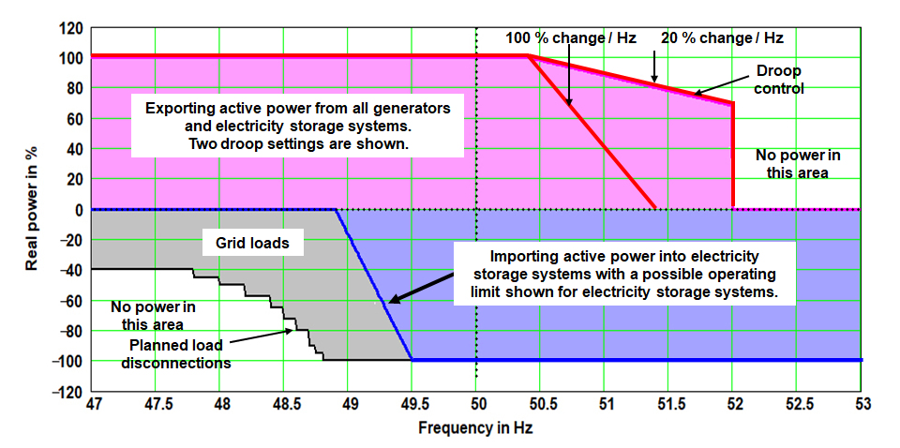.
Figure ECC.6.3.19.3
- Each User shall design their Grid Forming Plant with a Damping Factor of between 0.2 and 1.0, where 1.0 is critically damped. It is down to the User or Non-CUSC Party to determine the Damping Factor whose value shall be specified in the Bilateral Agreement but a value in the region of 0.7 would be considered appropriate for this application.
For a Grid Forming Synchronous Power Generator the three circuits providing damping are shown on Figure 1.0

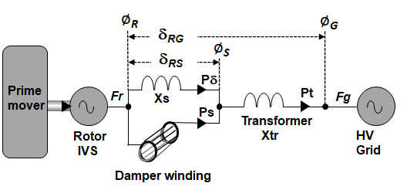
Figure 1.0
For the avoidance of doubt the circuits providing damping are:
- The real damping current Pδ flowing in the Synchronous Generating Unit’s windings Xs.
- The real damping current Ps flowing in the Synchronous Generating Unit’s damper windings X”d
- The real damping current Pc produced by the action of the control system
The Control Based Damping Power produced by the control system has a bandwidth limit of 5 Hz and can be varied but is turned off for testing and specifying the system’s Damping Factor.
The sum of P_{δ} and P_{c} is the Damping Power Pt that is fixed by the design of the Synchronous Power Generating Unit and Pt is used to specify the Damping Factor
For a Grid Forming Electronic Power Converter the three circuits providing damping are shown on Figure 2.0.
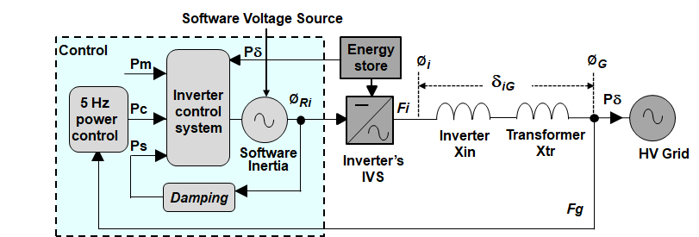
Figure 2.0
The circuits providing Damping are:
- The real damping current Pδ flowing in the converter’s impedances Xin plus Xtr.
- The software damping current Ps produced by software to damp the software based inertia.
- The Control Based damping current Pc also produced by the action of the Control system.
The Control Based Damping power produced by the control system has a bandwidth limit of 5 Hz and can be varied but is turned off for testing and specifying the system’s Damping Factor
The sum of P_{δ} and P_{c} is the Damping Power Pt that can be varied by the systems software and Pt is used to specify the systems Damping Factor.
The User or Non-CUSC Party can choose to implement these settings internally within the Grid Forming Unit’s control system or through the selective use of external electrical elements within the Grid Forming Plant. The correct selection of the Damping Factor would be assessed through a Network Frequency Perturbation Plot or equivalent as agreed with the Company.
In addition, the output of the Grid Forming Plant shall be designed such that following a disturbance on the System, the Active Power output and Reactive Power output shall be adequately damped.
- Each Grid Forming Plant shall be designed so as not to interact and affect the operation, performance, safety or capability of other User’s Plant and Apparatus connected to the Total System. To achieve this requirement, each User shall be required to submit a Network Frequency Perturbation Plot (or equivalent as agreed with The Company) which shall be assessed in accordance with the requirements of ECP.A.3.9.3.
- Each Grid Forming Plant owner is also required to supply an equivalent model of their Grid Forming Plant which should be in the general form shown in Figure 3.0.
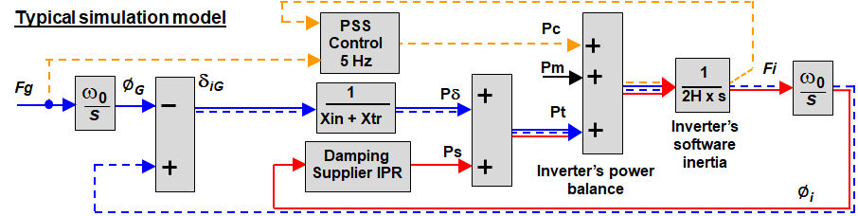
Figure 3.0
- In order to participate in the Grid Forming Capability market, User’s and Non-CUSC Parties are required to provide data of their Grid Forming Plant in accordance with Figures 1.0, 2.0 and 3.0. Users and Non-CUSC Parties in respect of Grid Forming Plants should indicate if the data is submitted on a unit or aggregated basis. Table 1.0 defines the notation used in Figure 1.0 and 2.0. Figure 3.0 is the equivalent block diagram from which the User or Non CUSC Party should derive the transfer function of the Grid Forming Plant. In Table 1.0 the upper symbol is for Synchronous Generating Units and the lower symbol is for Grid Forming Electronic Power Converters.

Parameter | Symbol | Units
The primary reactance of the Grid Forming Unit, in pu. | X”d  Xi | pu on MVA Rating of Grid Forming Unit
The additional reactance, in pu, between the terminals of the Grid Forming Unit and the Grid Entry Point or User System Entry Point (if Embedded). | X_{tr}  X_{tr} | pu on MVA Rating of Grid Forming Unit
The rated angle between the Internal Voltage Source and stator terminals of the Grid Forming Unit. | δ_{RS}  δi_{S} | radians
The rated angle between the Internal Voltage Source and Grid Entry Point or User System Entry Point (if Embedded). | δ_{RG}  δi_{G} | radians
The rated voltage and phase of the Internal Voltage Source of the Grid Forming Unit. The voltage is taken to be 1pu. | 1∠φ_{R}  1∠φi | Voltage - 1pu  Phase - radians
The rated voltage and phase of the Total System at the Grid Entry Point or User System Entry Point. The voltage is taken to be 1pu | 1∠φ_{G}  1∠φ_{G} | Voltage – 1pu  Phase - radians
The rated electrical angle between current and voltage at the stator terminals. | Power Factor  Power Factor | radians
Damping Factor. | Ζ  ζ

Table 1.0

- In order to participate in a Grid Forming Capability market, User’s and Non-CUSC Parties are also required to provide the data of their Grid Forming Plant in in accordance with Table 2.0 to The Company. The details and arrangements for Users and Non-CUSC Parties participating in this market shall be published on The Company’s Website.

Quantity | Units | Range  (where Applicable) | User Defined Parameter
Type of Plant (eg Generating Unit, Electricity Storage Module, Dynamic Reactive Compensation Equipment | N/A
Primary reactance X (see Table 1) | pu on MVA
Additional reactance X_{tr} (See Table 1) | pu on MVA
Maximum Capacity | MW
Rated output time duration if not continuously rated
Real Inertia Power (MW) supplied or absorbed at 1Hz/s frequency change | MW
Maximum Phase Jump withstand | degrees | 60 degrees
Maximum Phase Jump angle for rated Phase Jump Active Power | degrees | 5 degrees
Phase Jump Power (MW) at the rated angle | MW
Damping Power type P for a Grid oscillation of 0.5 Hz peak to peak at 1 Hz | MW
The cumulative energy delivered for a 1Hz/s frequency fall from 52 Hz to 47 Hz This is the total real transient output of the Grid Forming Plant | MWs
Inertia Constant using equation 1 |  | 2 – 25MWs
Overload Capability | % on MVA
Continuous Overload capability
Duration of Short Term Overload Capability | s
Peak Current Rating | pu | 1.5pu or better
Nominal Grid Entry Point or User System Entry Point voltage | kV
Grid Entry Point or User System Entry Point | N/A - Location
Continuous or defined time duration MVA Rating | MVA
Continuous or defined time duration MW Rating | MW
Method of delivery – Defined time, Overating, Deloading or Continuous Operation | N/A
Maximum Three Phase Short Circuit Infeed at Grid Entry Point or User System Entry Point | kA
Maximum Single Phase Short Circuit Infeed at Grid Entry Point or User System Entry Point | kA
Diagram of single phase and three phase fault infeed during the first 0.5 seconds following fault inception | Diagram
Additional transient or continuous steady state power available either before or after the supplied Inertia Power. | MW and MVAr  Time duration
Will the Grid Forming Plant contribute to any other form of commercial service – for example Dynamic Containment, Firm Frequency Response, | Details to be provided
Damping Factor. | ζ | 0.2 – 1.0

Table 2.0
H = ( Real Inertia Power at 1 Hz / s x Frequency ) / ( Installed MVA x 2 )
Equation 1

ECC.6.3.19.4 In addition to the requirements of ECC.6.3.19.1 – ECC.6.3.19.4 each Grid Forming Plant shall be capable of:-
- Satisfy the requirements of ECC.6.3.19.5.
- As a minimum, each Grid Forming Plant shall be capable of operating over a minimum short circuit level as defined by The Company which would be dependent upon the location of the Grid Entry Point or User System Entry Point.
- In addition to the requirements of ECC.6.3.19.3(vii), each User or Non CUSC Party should provide a model of their Grid Forming Plant which provides a true an accurate reflection of its Grid Forming Capability in accordance with the requirements of ECP.A.3.9.2.
- In addition to the quality of supply requirements detailed in CC.6.1.5, CC.6.1.6 and CC.6.1.7 (as applicable) or ECC.6.1.5, ECC.6.1.6 and ECC.6.1.7 (as applicable), each Grid Forming Plant owner shall agree any additional quality of supply requirements, including but not limited to Temporary Over-voltage limits (TOV’s) and frequency bandwidth limitations, with The Company.
ECC.6.3.19.5 Fast Fault Current Injection applicable to Grid Forming Plant

ECC.6.3.19.5.1 For any balanced fault which results in the positive phase sequence voltage falling below the voltage levels specified in CC.6.1.4 or ECC.6.1.4 (as applicable) at the Grid Entry Point or User System Entry Point (if Embedded), a Grid Forming Plant shall, as a minimum be required to inject a reactive current above the heavy black line shown in Figure ECC.16.3.19.5(a).
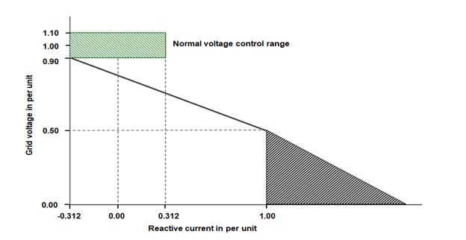
Figure ECC.6.3.19.5(a)

ECC.6.3.19.5.2 Figure ECC.6.3.19.5(a) defines the reactive current (I_{R}) to be supplied under a faulted condition which shall be dependent upon the pre-fault operating condition and the retained voltage at the Grid Entry Point or User System Entry Point voltage. For the avoidance of doubt, each Grid Forming Plant (and any constituent element thereof), shall be required to inject a reactive current (I_{R}) which shall be not less than its pre-fault reactive current and which shall as a minimum, increase with the fall in the retained voltage each time the voltage at the Grid Entry Point or User System Entry Point (if Embedded) falls below 0.9pu whilst ensuring the overall rating of the Grid Forming Plant (or constituent element thereof) shall not be exceeded.

ECC.6.3.19.5.3 In addition to the requirements of ECC.6.3.19.5.1 and ECC.6.3.19.5.2, each Grid Forming Plant shall be required to inject reactive current above the shaded area shown in Figure ECC.6.3.19.5(b) which illustrates how the current shall be injected over time from fault inception in which the value of I_{R} is determined from Figure ECC.6.3.19.5(a). In this context, fault inception is taken to be when the voltage at the Grid Entry Point or User System Entry Point falls below 0.9pu.
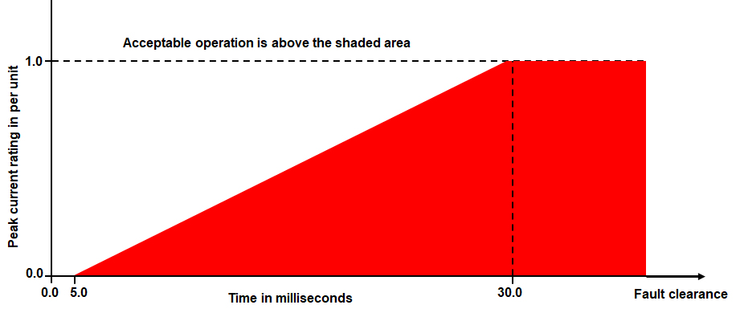
Figure ECC.16.3.19.5(b)
ECC.6.3.19.5.4 The injected current shall be above the shaded area shown in Figure ECC.6.3.19.5(b). Under any faulted condition, where the voltage falls outside the limits specified in CC.6.1.4 or ECC.6.1.4 (as applicable), there would be no requirement for each Grid Forming Plant or constituent part to exceed its transient or steady state rating as defined in ECC.6.3.19.6.
ECC.6.3.19.5.5 For any planned or switching events (as outlined in CC.6.1.7 or ECC.6.1.7 of the Grid Code) or unplanned events which results in temporary power Frequency over voltages (TOV’s), each Grid Forming Plant will be required to satisfy the transient overvoltage limits specified in the Bilateral Agreement.
ECC.6.3.19.5.6 For the purposes of this requirement, the maximum rated current would be the Peak Current Rating declared by the Grid Forming Plant owner in accordance with Table 2.0 of ECC.6.3.19.3(ix).
ECC.6.3.19.5.7 Each Grid Forming Plant shall be designed to ensure a smooth transition between voltage control mode and Fault Ride Through mode in order to prevent the risk of instability which could arise in the transition between the steady state voltage operating range as defined under CC.6.1.4 or ECC.6.1.4 (as applicable) and abnormal conditions where the retained voltage falls below 90% of nominal voltage. Such a requirement is necessary to ensure adequate performance between the pre-fault operating condition of the Grid Forming Plant and its subsequent behaviour under faulted conditions. Grid Forming Plant owners are required to both advise and agree with The Company the control strategy employed to mitigate the risk of such instability.
ECC.6.3.19.5.8 Each Grid Forming Plant shall be designed to reduce the risk of transient over voltage levels arising following clearance of the fault and in order to mitigate the risk of any form of instability which could result. The requirements for the maximum transient overvoltage withstand capability and associated time duration, shall be agreed between the Grid Forming Plant owner and The Company as part of the Bilateral Agreement.
ECC.6.3.19.5.9 In addition to the requirements of CC.6.3.15 or ECC.6.3.15, each Grid Forming Plant owner is required to confirm to The Company, their repeated ability to supply Fast Fault Current to the System each time the voltage at the Grid Entry Point or User System Entry Point falls outside the limits specified in CC.6.1.4 or ECC.6.1.4 (as applicable). Grid Forming Plant owners should inform The Company of the maximum number of repeated operations that can be performed under such conditions and any limiting factors to repeated operation such as protection or thermal rating.
ECC.6.3.19.5.10 To permit additional flexibility for example from Power Park Modules made up of full converter machines, DFIG machines, induction generators or HVDC Systems or Remote End HVDC Converters, The Company will permit transient or marginal deviations below the shaded area shown in Figure ECC.6.3.19.5(b) provided the injected current supplied exceeds the area bound in Figure ECC.6.3.19.5(b). Such agreement would be confirmed and agreed between The Company and the Grid Forming Plant owner.
ECC.6.3.19.5.11 In the case of a Power Park Module or DC Connected Power Park Module, where it is not practical to demonstrate the compliance requirements of ECC.6.3.19.5.1 to ECC.6.3.19.5.5 at the Grid Entry Point or User System Entry Point, The Company will accept compliance of the above requirements at the Power Park Unit terminals.
ECC.6.3.19.5.12 In the case of an unbalanced fault, each Grid Forming Plant, shall be required to inject current which shall as a minimum increase with the fall in the retained unbalanced voltage without exceeding the transient Peak Current Rating of the Grid Forming Plant (or constituent element thereof).
ECC.6.3.19.5.13 In the case of a unbalanced fault, the Grid Forming Plant Owner shall confirm to The Company their ability to prevent transient overvoltages arising on the remaining healthy phases and the control strategy employed.
…………………….
ECC.6.6.1.8 The facilities for quality of supply and dynamic system behaviour monitoring shall include arrangements for the HVDC System Owner and The Company and/or Relevant Transmission Licensee to access the information electronically. The communications protocols for recorded data shall be agreed between the HVDC System Owner, The Company and the Relevant Transmission Licensee.
ECC.6.6.1.9 In order to accurately monitor the performance of a Grid Forming Plant, each Grid Forming Plant shall be equipped with a facility to accurately record the following parameters:-
- System Frequency
- Rate of change of System Frequency
- Grid Phase Jumps

ECC.6.6.1.10 Detailed specifications for Grid Forming Capability dynamic performance including triggering criteria and sample rates are listed as Electrical Standards in the Annex to the General Conditions. For Grid Forming Capability dynamic monitoring, the specification for the communication protocol and recorded data shall also be included in the Electrical Standard.
……………………….
ECC.6.6.3.2 The signals which shall be provided by the User to The Company for onsite monitoring shall be of the following resolution, unless otherwise agreed by The Company:
(i) 1 Hz for reactive range tests
(ii) 10 Hz for frequency control tests
(iii) 100 Hz for voltage control tests
(iv) 1000 kHz for Grid Forming Plant tests
…………………….

Extracts from the European Compliance Processes

APPENDIX 3
ECP.A.3.9 Grid Forming Plant verification and validation
ECP.A.3.9.1 This section applies to Users and Non CUSC Parties who own and operate Grid Forming Plant to demonstrate the ability of their Grid Forming Plant to satisfy the requirements of ECC.6.3.19.
ECP.A.3.9.2 Users and Non CUSC Parties are required to submit the following data of their Grid Forming Plant:-
- The equivalent representation of their Grid Forming Plant in the same format as shown in Figure 1.0 and Figure 2.0 of ECC.6.3.19.3(vi) and Figure 3.0 of ECC.6.3.19.3(viii) and the data associated with their Grid Forming Plant as required in Table 1.0 and Table 2.0 of ECC.6.3.19.3(vi).
- A linearised model and parameters of the Grid Forming Plant.
- The transfer function of the Grid Forming Plant.
ECP.A.3.9.3 The User or Non-CUSC Party are also required to supply a Network Frequency Perturbation Plot or equivalent as agreed with The Company for the following conditions.
- Active Power responses to frequency modulations
- Reactive Power responses to voltage modulations
- Cross linkage of Active Power to voltage modulations
- Cross linkage of Reactive Power responses to System Frequency modulations.
ECP.A.3.9.4 To demonstrate the Grid Forming Plant model is capable of supplying phase based Inertia Active Power and Phase Jump Active Power, the Grid Forming Plant owner shall submit a simulation study representing the response of the Grid Forming Plant. To demonstrate the performance of the Grid Forming Plant over a range of operating conditions, the simulation study shall comprise of the following stages.

- The Grid Forming Plant owner should supply a simulation study to The Company equivalent to Figure ECP.A.3.9.4.

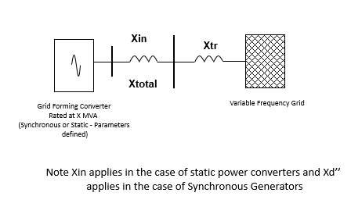
Figure ECP.A.3.9.4

- The first simulation test is to demonstrate the Grid Forming Plant is capable of supplying phase based Inertia Active Power to the Total System as a result of a System Frequency change. In this simulation, with the Grid Forming Plant initially running at full load the Grid System Frequency is increased from 50Hz – 50,5Hz at a rate of 1Hz/s with measurements of the Grid Forming Plant’s Inertia Active Power, System Frequency and time in (ms). The simulation is required to assess correct operation of the Grid Forming Plant without saturating.
- The second simulation test is to demonstrate the Grid Forming Plant’s ability to supply phase based Inertia Active Power and asses its withstand capability under extreme System Frequencies. For Grid Forming Plant comprising a static power converter the Grid System Frequency is increased from 50Hz – 52Hz at a rate of 2Hz/s with measurements of the Grid Forming Plant’s Inertia Active Power, System Frequency and time in (ms). For a Grid Forming Plant comprising a rotary Synchronous Generating Unit the Grid System Frequency is increased from 50Hz – 52Hz at a rate of 1Hz/s with measurements of the Grid Forming Plant’s Inertia Active Power, System Frequency and time in (ms). The simulation is required to assess the withstand characteristics of the Grid Forming Plant when operating under extreme Frequency conditions.
- The third simulation is to demonstrate the Grid Forming Plant’s ability to supply phase based Inertia Active Power over the full frequency range.

- With the System Frequency set to 50Hz, the Grid Forming Plant should be initially running at 75% Maximum Capacity, zero MVAr output and both Limited Frequency Sensitive Mode and Frequency Sensitive Mode disabled.
- The System Frequency is then increased from 50Hz – 52Hz at a rate of 1Hz/s over a 2 second period. Allow conditions to stabilise for 5 seconds and then decrease the System Frequency from 52Hz – 47Hz at a rate of 1Hz/s over a 5 second period. Allow conditions to stabilise.
- Record results of phase based Inertia Power, Active Power, Reactive Power, voltage and System Frequency.
- The simulation now needs to be re-run in the opposite direction. The same initial conditions should be applied as per ECP.A.3.9.2iv)(a).
- The System Frequency is then decreased from 50Hz – 47Hz at a rate of 1Hz/s over a 3 second period. Allow conditions to stabilise for 5 seconds and then increase the System Frequency from 47Hz – 52Hz at a rate of 1Hz/s over a 5 second period. Allow conditions to stabilise.
- Record results of phase based Inertia Power, Active Power, Reactive Power, voltage and System Frequency.
- The simulation is required to ensure the Grid Forming Plant can deliver phase based Inertia Active Power without going into saturation and pole slipping does not occur. The simulation should demonstrate the Grid Forming Plant delivers phase based Inertia Active Power as declared pursuant to ECC.6.3.19(xiii).

- The fourth simulation is to demonstrate the Grid Forming Plant’s ability to supply Phase Jump Active Power under normal operation.

- With the System Frequency set to 50Hz, the Grid Forming Plant should be initially running at Maximum Capacity, zero MVAr output and all control actions (eg Limited Frequency Sensitive Mode, Frequency Sensitive Mode and voltage control) disabled.
- Apply a phase jump of 10 degrees at the Grid Entry Point or User System Entry Point (if Embedded)
- Record traces of Active Power, Reactive Power, voltage , current and Frequency for a period of 10 seconds after the step change in phase has been applied.

- The fifth simulation is to demonstrate the Grid Forming Plant’s ability to supply Phase Jump Active Power under extreme conditions.

- With the System Frequency set to 50Hz, the Grid Forming Plant should be initially running at its Minimum Stable Operating Level, zero MVAr output and all control actions (eg Limited Frequency Sensitive Mode, Frequency Sensitive Mode and voltage control) disabled.
- Apply a phase jump of 60 degrees at the Grid Entry Point or User System Entry Point (if Embedded)
- Record traces of Active Power, Reactive Power, voltage, current and Frequency for a period of 10 seconds after the step change in phase has been applied.

- The fifth simulation is to demonstrate the Grid Forming Plant’s ability to supply Phase Jump Active Power, Fault Ride Through and Fast Fault Current Injection during a faulted condition

- With the System Frequency set to 50Hz, the Grid Forming Plant should be initially running at its Maximum Capacity, zero MVAr output and all control actions (eg Limited Frequency Sensitive Mode, Frequency Sensitive Mode and voltage control) disabled.
- Apply a solid three phase short circuit fault at the Grid Entry Point or User System Entry Point (if Embedded) for 140ms.
- Record traces of Active Power, Reactive Power, voltage , current and Frequency for a period of 10 seconds after the fault has been applied.
- Repeat steps (a) to (c) but on this occasion with fault ride through, fast fault current injection, Limited Frequency Sensitive Mode and voltage control switched into service.
- Record traces of Active Power, Reactive Power, voltage, current and Frequency for a period of 10 seconds after the step change in phase has been applied and confirm correct operation.

ECP.A.3.9.5 To demonstrate the Grid Forming Plant model is capable of supplying phase based Inertia Active Power and Phase Jump Active Power, under extreme conditions the Grid Forming Plant owner shall submit a simulation study representing the response of the Grid Forming Plant. To demonstrate the performance of the Grid Forming Plant under these conditions, the simulation study shall represent the following scenario.

- The Grid Forming Plant owner should supply a simulation study to The Company equivalent to Figure ECP.A.3.9.5.
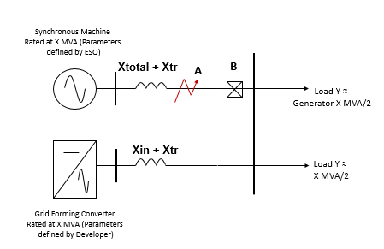
Figure ECP.A.3.9.5

- In this model the parameters of the rotating Synchronous Generating Unit are supplied by The Company. The parameters of the Grid Forming Plant are supplied by the Generator or HVDC System Owner in accordance with the parameters supplied in ECC6.3.19.3(vii). Load Y is also defined by The Company this being twice the rating (X) of the Grid Forming Plant.
- With the system running in steady state the Grid Forming Plant and rotating Synchronous Generating Unit should each be running at load X feeding Load Y with the frequency of the test network being 50Hz. All control actions (eg Limited Frequency Sensitive Mode, Frequency Sensitive Mode and voltage control) should be disabled.
- With the system in steady state, apply a solid (zero impedance) three phase short circuit fault at point A of Figure ECP.A.3.9.3 and then open circuit breaker B, 140ms after the fault has been applied.
- Record traces of Active Power, Reactive Power, voltage and Frequency and record for a period of time after fault inception after allowing conditions to stabilise.
ECP.A.3.9.6 To demonstrate the Grid Forming Plant model is capable of contributing to Damping Active Power, the Grid Forming Plant owner is required to supply a simulation study by injecting a 2Hz sine wave into the Grid Forming Plant model as supplied in ECPA.3.9.2. The results supplied need to verify the following criteria:-
- Demonstration of phase based Damping Active Power (or Pδ) by injecting a 2Hz sine wave into the Grid Forming Plant controller to demonstrate damping power supplied through the Grid Forming Plant’s impedance. An acceptable performance would be judged where the overshoot or decay matches the damping factor declared by the Grid Forming Plant owner as submitted in ECC.6.3.19.3(viii).
- Demonstration of phase based real control output power (or Pc) by injecting a 2Hz sine wave into the Grid Forming Plant controller to demonstrate the controlled power output is supplied below the 5Hz bandwidth limit An acceptable performance would be judged where the overshoot or decay matches the damping factor declared by the Grid Forming Plant owner as submitted in ECC.6.3.19.3(viii).
- In the case of a Grid Forming Plant comprising an Grid Forming Electronic Power Converter demonstration, of the software damping power (Ps) by injecting a 2Hz sine wave into the Grid Forming Plant controller. An acceptable performance would be judged where the overshoot or decay matches the damping factor declared by the Grid Forming Plant owner as submitted in ECP.A.3.9.2. For the avoidance of doubt this simulation is not required from Grid Forming Plant comprising a rotating Synchronous Generating Unit.
- In addition to demonstrating adequate Damping Active Power (Pδ), real control output power (Pc) and software damping (Ps) simulation studies should be run to ensure the combined adequate damping of Pδ and Pc, Pδ and Ps, Pc and Ps, Ps and Pδ and the total combination of Pδ, Pc and Ps as references in ECC.6.3.19.3(vi).
……………………………
Extracts from ECP Appendix 4
…………………………..
ECP.A.4.3.6 In the case of a Grid Forming Plant, the following signals shall be supplied to The Company by the Grid Forming Plant owner in accordance with ECC.6.6.3. For the avoidance of doubt, User’s would also be required to undertake the necessary testing of their Plant in accordance with the requirements of ECC.A.4 and OC5 as applicable.

Each Grid Forming Plant
at Grid Entry Point or User System Entry Point
ECP.A.4.3.6(a)  Real Time Downloadable / Phase | - Rate of change of System Frequency  - Grid phase jumps  - Inertia Active Power  - Damping Active Power (Pδ), (Ps) an (Pc) as referred to in ECP.A.9.1.9.8  - Phase Jump Active Power  - Load angle  - Injected signals applied to the Grid Forming Plant

APPENDIX 9
COMPLIANCE TESTING FOR GRID FORMING PLANT
ECP.A.9.1 SCOPE
ECP.A.9.1.1 This Appendix outlines the general testing requirements for Users or Non-CUSC Parties to demonstrate compliance with the relevant aspects of the Grid Code, Ancillary Services Agreement and Bilateral Agreement. The tests specified in this Appendix will normally be sufficient to demonstrate compliance however The Company may:
- agree an alternative set of tests provided The Company deem the alternative set of tests sufficient to demonstrate compliance with the Grid Code, Ancillary Services Agreement and Bilateral Agreement; and/or

- require additional or alternative tests if information supplied to The Company during the compliance process suggests that the tests in this Appendix will not fully demonstrate compliance with the relevant section of the Grid Code, Ancillary Services Agreement or Bilateral Agreement; and/or

- require additional tests if control functions to improve damping of power system oscillations or additional functions to prove the capability of the Grid Forming Plant is required by the Bilateral Agreement or included in the control scheme; and/or

- agree a reduced set of tests for subsequent Grid Forming Plant following successful completion of the first Grid Forming tests in the case of an installation comprising of two or more Grid Forming Plants which The Company reasonably considers to be identical if:-

(a) the tests performed pursuant to ECP.A..9.1.9 in respect of subsequent Grid Forming Plant do not replicate the full tests for the first Grid Forming Plant; or
(b) any of the tests performed pursuant to ECP.A.9.1.9 do not fully demonstrate compliance with the relevant aspects of the Grid Code, Ancillary Services Agreement and / or Bilateral Agreement.

ECP.A.9.1.2 The User or Non-CUSC Party is responsible for carrying out the tests set out in and in accordance with this Appendix and the User or Non-CUSC Party retains the responsibility for the safety of personnel and plant during the test. The Company will witness all of the tests outlined or agreed in relation to this Appendix unless The Company decides and notifies the User or Non-CUSC Party otherwise. For all on site at The Company witnessed tests, the User or Non-CUSC Party must ensure suitable representatives from the Grid Forming Plant’s manufacturer (if appropriate) are available on site for the entire testing period. In all cases and in addition to any recording of signals conducted by The Company, the User or Non-CUSC Party shall record all relevant test signals as outlined in ECP.A.4.

ECP.A.9.1.3 In addition to the dynamic signals supplied in ECP.A.4 the User or Non-CUSC Party shall inform The Company of the following information prior to the commencement of the tests and any changes to the following, if any values change during the tests:
- All relevant transformer tap numbers.
- Number of Grid Forming Units in operation.

ECP.A.9.1.4 The User or Non-CUSC Party shall submit a detailed schedule of tests to The Company in accordance with ECP.6.3.1, and this Appendix.

ECP.A.9.1.5 Prior to the testing of the Grid Forming Plant, the User or Non-CUSC Party shall complete the Integral Equipment Tests procedure in accordance with OC.7.5.

ECP.A.9.1.6 Full Grid Forming Plant testing as required by ECP.7.2 is to be completed as defined in ECP.A.9.1.9.

ECP.A.9.1.7 The Company will permit relaxation from the requirements in ECP.A.9.1.9 where an Equipment Certificate for Grid Forming Plant has been provided which details the characteristics from tests on a representative installation with the same equipment and settings and the performance of the Grid Forming Plant can, in The Company’s opinion, reasonably represent that of the installed Grid Forming Plant at that site. The relevant Equipment Certificate must be supplied in the Users Data File structure.
ECP.A.9.1.8 Prior to any Grid Forming Plant tests taking place, the User or Non-CUSC Party shall have completed the relevant compliance tests on the Synchronous Power Generating Module or Generating Unit as required under ECP.A.5 or OC5.A.2 (as relevant) or Power Park Module as required under ECP.A.6 or OC5.A.3 (as applicable) or HVDC Systems or DC Converters as required under ECP.A.7 or OC5.A.4 (as applicable).

ECP.A.9.1.9 Demonstration of Grid Forming Capability

ECP.A.9.1.9.1 This section details the procedure for demonstrating phase based Inertia Active Power. Ideally if the test is being completed as part of a type test on an isolated network and it is possible to change the Frequency of the isolated network then the tests should be completed using a variable network Frequency, The Company fully appreciate that it is not possible in a large number of cases to adjust the Frequency of the network to which the Grid Forming Plant is connected. In which case Frequency changes applied to the control system of the Grid Forming Plant should be applied so that the Grid Forming Plant is seeing the equivalent of a Grid Frequency change.
ECP.A.9.1.9.2 In this test, with the Grid Forming Plant initially running at full load the Grid System Frequency is increased from 50Hz – 50,5Hz at a rate of 1Hz/s with measurements of the Grid Forming Plant’s Inertia Active Power, System Frequency and time in (ms). The test is required to assess correct operation of the Grid Forming Plant without saturating.
ECP.A.9.1.9.3 These tests are required to assess the Grid Forming Plant’s withstand capabilities under extreme System Frequencies.
(i) For Grid Forming Plant comprising a static power converter the frequency of the test network is increased from 50Hz – 52Hz at a rate of 2Hz/s with measurements of the Grid Forming Plant’s Inertia Active Power, System Frequency and time in (ms).
(ii) For a Grid Forming Plant comprising a rotary Synchronous Generating Unit the frequency of the test network is increased from 50Hz – 52Hz at a rate of 1Hz/s with measurements of the Grid Forming Plant’s Inertia Active Power, System Frequency and time in (ms).
ECP.A.9.1.9.4 This test is to demonstrate the Grid Forming Plant’s ability to supply phase based Inertia Active Power over the full frequency range.

- With the frequency of the test network set to 50Hz, the Grid Forming Plant should be initially running at 75% Maximum Capacity, zero MVAr output and both Limited Frequency Sensitive Mode and Frequency Sensitive Mode disabled.
- The frequency is then increased from 50Hz – 52Hz at a rate of 1Hz/s over a 2 second period. Allow conditions to stabilise for 5 seconds and then decrease the frequency from 52Hz – 47Hz at a rate of 1Hz/s over a 5 second period. Allow conditions to stabilise.
- Record results of phase based Inertia Power, Active Power, Reactive Power, voltage and frequency.
- The test now needs to be re-run in the opposite direction. The same initial conditions should be applied as per ECP.A.9.1.9.4(a).
- The frequency is then decreased from 50Hz – 47Hz at a rate of 1Hz/s over a 3 second period. Allow conditions to stabilise for 5 seconds and then increase the frequency from 47Hz – 52Hz at a rate of 1Hz/s over a 5 second period. Allow conditions to stabilise.
- Record results of phase based Inertia Power, Active Power, Reactive Power, voltage and frequency.
ECP.A.9.1.9.5 This test is to demonstrate the Grid Forming Plant’s ability to supply Phase Jump Active Power under normal operation.

- With the frequency of the test network set to 50Hz, the Grid Forming Plant should be initially running at Maximum Capacity, zero MVAr output and all control actions (eg Limited Frequency Sensitive Mode, Frequency Sensitive Mode and voltage control) disabled.
- Apply an equivalent phase jump of between 0 and 10 degrees at the Grid Entry Point or User System Entry Point (if Embedded). This could be achieved by an injection into the Grid Forming Plant’s control system (as indicatively shown in Figure ECP.A.9.1.9.5) or a tap change
- Record traces of Active Power, Reactive Power, voltage, current and Frequency for a period of 10 seconds after the step change in phase has been applied.

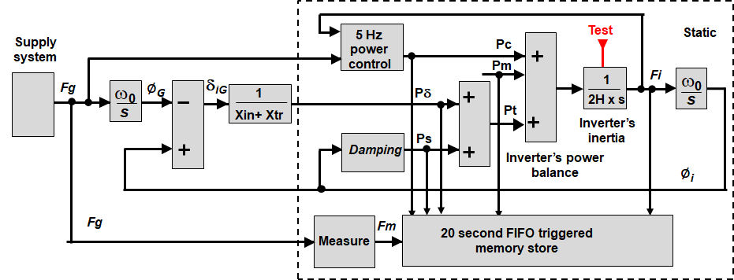

Figure ECP.A.9.1.9.5

ECP.A.9.1.9.6 This test is to demonstrate the Grid Forming Plant’s ability to supply Phase Jump Active Power under extreme conditions. Where it is not possible to undertake this test as part of a type test, The Company will accept demonstration through a combination of simulation studies as required under ECP.A.3.9.4(vi) and online monitoring as required under ECC.6.6.1.9.

- With the frequency of the test network set to 50Hz, the Grid Forming Plant should be initially running at its Minimum Stable Operating Level or Minimum Stable Generation, zero MVAr output and all control actions (eg Limited Frequency Sensitive Mode, Frequency Sensitive Mode and voltage control) disabled.
- Apply a phase jump of 60 degrees at the connection point of the Grid Forming Plant to the test network or into the Grid Forming Plant’s control system as shown in Figure ECP.A.9.1.9.5.
- Record traces of Active Power, Reactive Power, voltage, current and frequency for a period of 10 seconds after the step change in phase has been applied.
ECP.A.9.1.9.7 This test is to demonstrate the Grid Forming Plant’s ability to supply Phase Jump Active Power, Fault Ride Through and Fast Fault Current Injection during a faulted condition. Where it is not possible to undertake this test as part of a type test, The Company will accept demonstration through a combination of simulation studies as required under ECP.A.3.9.4(vii) and online monitoring as required under ECC.6.6.1.9.

- With the System Frequency set to 50Hz, the Grid Forming Plant should be initially running at its Maximum Capacity or Registered Capacity, zero MVAr output and all control actions (eg Limited Frequency Sensitive Mode, Frequency Sensitive Mode and voltage control) disabled.
- Apply a solid three phase short circuit fault at the connection point in the test network forming part of the type test for 140ms.
- Record traces of Active Power, Reactive Power, voltage, current and Frequency for a period of 10 seconds after the fault has been applied.
- Repeat steps (a) to (c) but on this occasion with fault ride through, fast fault current injection, Limited Frequency Sensitive Mode and voltage control switched into service.
- Record traces of Active Power, Reactive Power, voltage, current and Frequency for a period of 10 seconds after the step change in phase has been applied and confirm correct operation.
ECP.A.9.1.9.8 The final test required is to demonstrate the Grid Forming Plant is capable of contributing to Damping Active Power. The Grid Forming Plant owner should configure their Grid Forming Plant in form or equivalent (as agreed with The Company) as shown in Figure ECP.A.9.1.9.8.
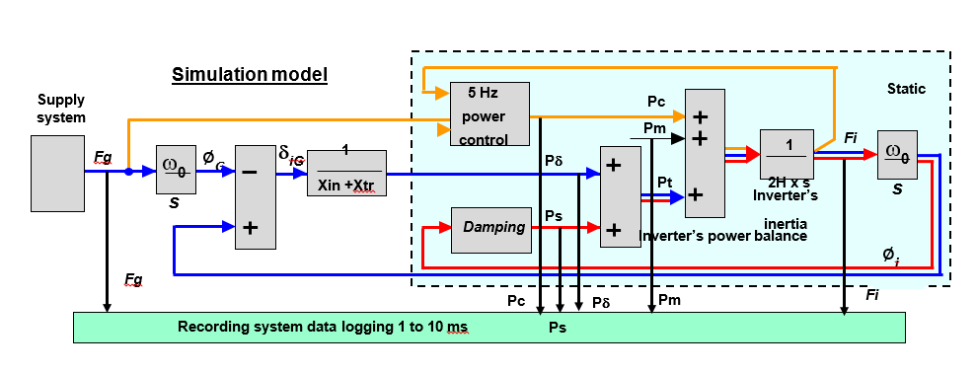
Figure ECP.A.9.1.9.8

As part of this test, the Grid Forming Plant owner is required to inject a signal into the Grid Forming Plant controller. The results supplied need to verify the following criteria:-
- Demonstration of phase based Damping Active Power (or Pδ) by injecting a 2Hz sine wave into the Grid Forming Plant controller to demonstrate damping power supplied through the Grid Forming Plant’s impedance. An acceptable performance would be judged where the overshoot or decay matches the damping factor declared by the Grid Forming Plant owner as submitted in ECC.6.3.19.3(viii).
- Demonstration of phase based real control output power (or Pc) by injecting a 2Hz sine wave into the Grid Forming Plant controller to demonstrate the controlled power output is supplied below the 5Hz bandwidth limit An acceptable performance would be judged where the overshoot or decay matches the damping factor declared by the Grid Forming Plant owner as submitted in ECC.6.3.19.3(viii).
- In the case of a Grid Forming Plant comprising an electronic power converter demonstration, of the software damping power (Ps) by injecting a 2Hz sine wave into the Grid Forming Plant controller. An acceptable performance would be judged where the overshoot or decay matches the damping factor declared by the Grid Forming Plant owner as submitted in ECC.6.3.19.3(viii). For the avoidance of doubt this simulation is not required from Grid Forming Plant comprising a rotating Synchronous Generating Unit.
- In addition to demonstrating adequate Damping Active Power (Pδ), real control output power (Pc) and software damping (Ps) tests should be run to ensure the combined adequate damping of Pδ and Pc, Pδ and Ps, Pc and Ps, Ps and Pδ and the total combination of Pδ, Pc and Ps.

